FINAL PROJECT PROPOSAL
A Time Series Analysis of Daily Wheat and Corn Futures Prices

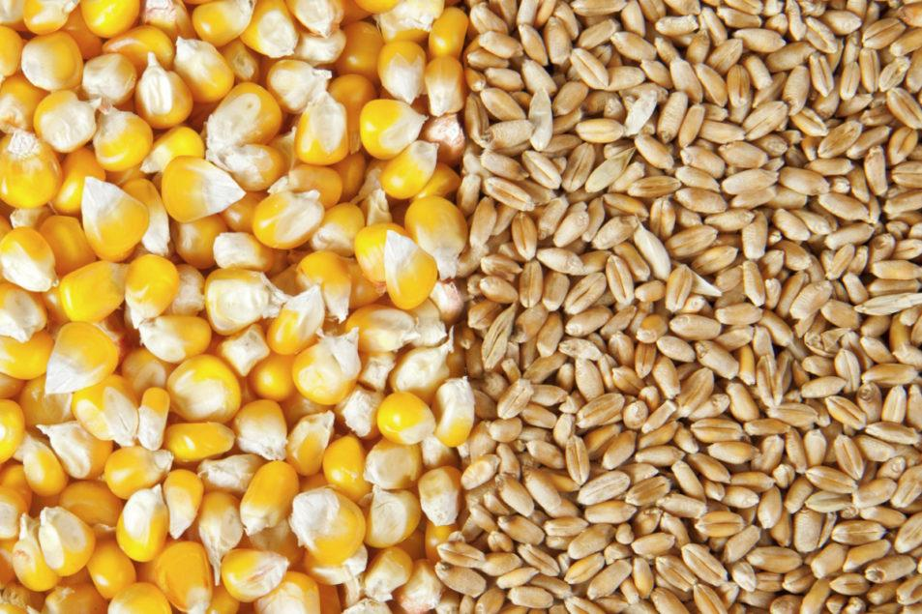
Photo: Adobe stock. | Credit: ©VITALS - STOCK.ADOBE.COM

Introduction
The agricultural commodities market is integral to global trade and economic stability, supplying food, feed, and raw materials for diverse industries. Prices in this sector, however, are highly volatile due to weather-dependent production, geopolitical events, and macroeconomic fluctuations. Futures markets for commodities like wheat and corn provide a vital platform for buyers and sellers to trade standardized contracts for future delivery. These markets facilitate price discovery, risk management, and hedging against price volatility, especially in times of uncertainty (Pawlowski, Rechtsteiner, and Joscha Schabram 2024).

Wheat and corn, among the most widely traded agricultural commodities, are essential to food security. Their prices are heavily influenced by global supply and demand dynamics, weather events, and macroeconomic factors. Futures prices for these commodities serve as critical indicators of market expectations, offering stakeholders tools to manage risks (M. Ates, Marsh, and Hubbs 2024).

This project focuses on analyzing daily wheat and corn futures prices over the past decade (November 2014–November 2024). Using advanced time series techniques, we aim to uncover trends, seasonal patterns, and volatility in these markets, examine the interdependence between wheat and corn futures prices, and make forecasts for trading prices for December 2024. By doing so, we aim to provide actionable insights into market behavior and create predictive models that benefit agricultural and financial stakeholders.

Data Sets
The data analyzed in this project consists of daily closing prices for wheat and corn futures contracts from November 2014 to November 2024, retrieved in CSV format from Nasdaq Composite. Each futures contract represents 5,000 bushels (~136 metric tons) of the respective commodity, with prices quoted in U.S. cents per bushel. This granularity enables tracking of even minor price fluctuations, as the minimum price change is a quarter of one cent ($0.0025) per bushel. The following graph illustrates U.S. wheat and corn futures prices over the last decade.

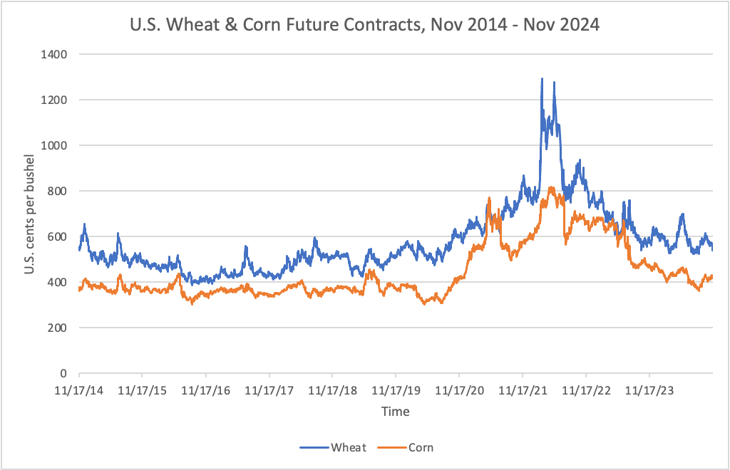

Over the observed period, futures prices exhibited notable trends. Before the COVID-19 pandemic, wheat futures traded within $4.00–$6.00 per bushel, and corn futures ranged from $3.50–$4.00 per bushel. However, the pandemic's disruption to global supply chains caused unprecedented spikes in prices. Wheat futures surged to record highs of $13.00 per bushel, while corn futures nearly doubled to $8.00 per bushel in 2021 and 2022 (Hobby, 2022). Three years later, the prices of these financial contracts have been significantly stabilized and brought down to pre-COVID levels.

Methods
Our analysis seeks to understand how volatility influences the trading prices of wheat and corn futures contracts and how these two commodities interact with one another. By leveraging ARIMA (autoregressive integrated moving average) models, GARCH (generalized autoregressive conditional heteroskedasticity) models, and bivariate regression (xreg) models, we aim to capture the overall behavior of these assets. Furthermore, we hope to forecast future prices with reasonable confidence, specifically predicting the trading price for December 2024 as new data becomes available. This new data will facilitate cross-validation tests, enhancing the practicality and reliability of our models.
Additionally, we plan to examine price data alongside trading volume data, another critical factor in understanding the volatility of financial assets. Trading volume often reflects market activity and investor sentiment, making it an important complement to price analysis. To detect potential regime shifts or nonlinearities, we will also explore advanced models such as Markov Switching AR or threshold autoregressive models. These methods are particularly valuable for identifying structural changes caused by events such as global crises, including the COVID-19 pandemic.

The dataset for this analysis is sourced from the Chicago Board of Trade (CBOT), representing a segment of the broader market. Other significant exchanges, such as NYSE Euronext (Euronext), Kansas City Board of Trade (KCBT), Minneapolis Grain Exchange (MGEX), and CME Group, also trade wheat and corn futures. Thus, while the data from CBOT is robust, it reflects only a portion of global trading activity and may introduce sampling bias if market dynamics differ significantly across exchanges. Moreover, we also acknowledge that trading volume data, though valuable, can be prone to reporting discrepancies or missing values, hence complicating its use in the analysis. Having these concerns in mind, we aim to apply robust preprocessing steps, cross-validation techniques, and interpretative care in our analysis to mitigate potential biases and limitations.

References
Hobby, Jolyon. 2022. “Looking beyond the Record-Breaking Wheat Market of 2021.” Czapp. January 13, 2022. https://www.czapp.com/analyst-insights/looking-beyond-the-record-breaking-wheat-market-of-2021/.

M. Ates, Aaron, Christele Marsh, and Todd Hubbs. 2024. “Corn and Other Feed Grains.” USDA ERS. June 6, 2024. https://www.ers.usda.gov/topics/crops/corn-and-other-feed-grains/.

Pawlowski, Piotr, Roland Rechtsteiner, and Joscha Schabram. 2024. “The Critical Role of Commodity Trading in Times of Uncertainty.” McKinsey & Company. April 4, 2024. https://www.mckinsey.com/industries/electric-power-and-natural-gas/our-insights/the-critical-role-of-commodity-trading-in-times-of-uncertainty#.

