**Validations**

**HTML :** <https://validator.w3.org/>

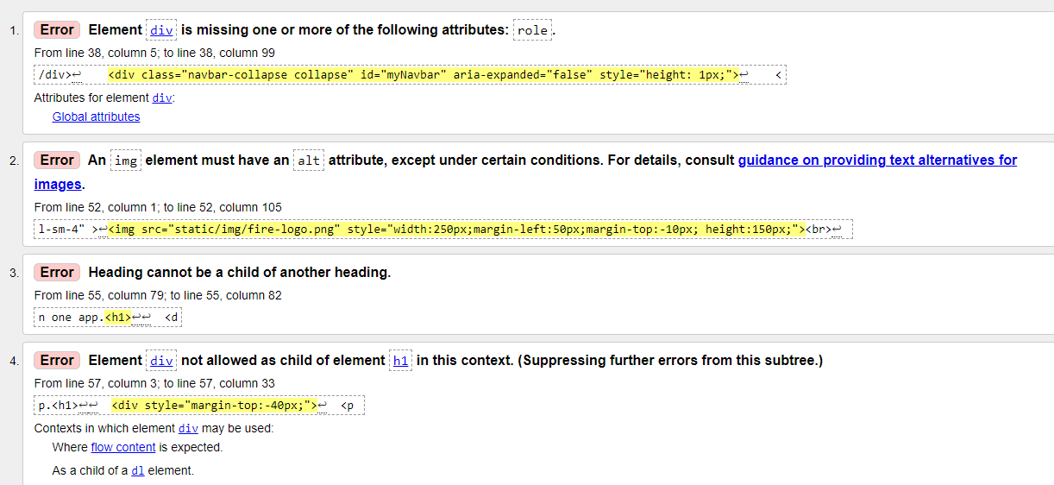

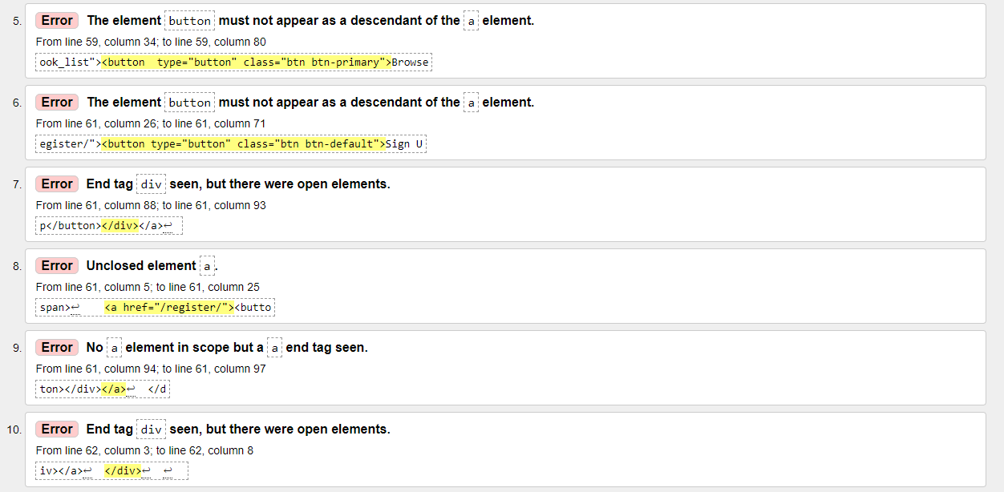

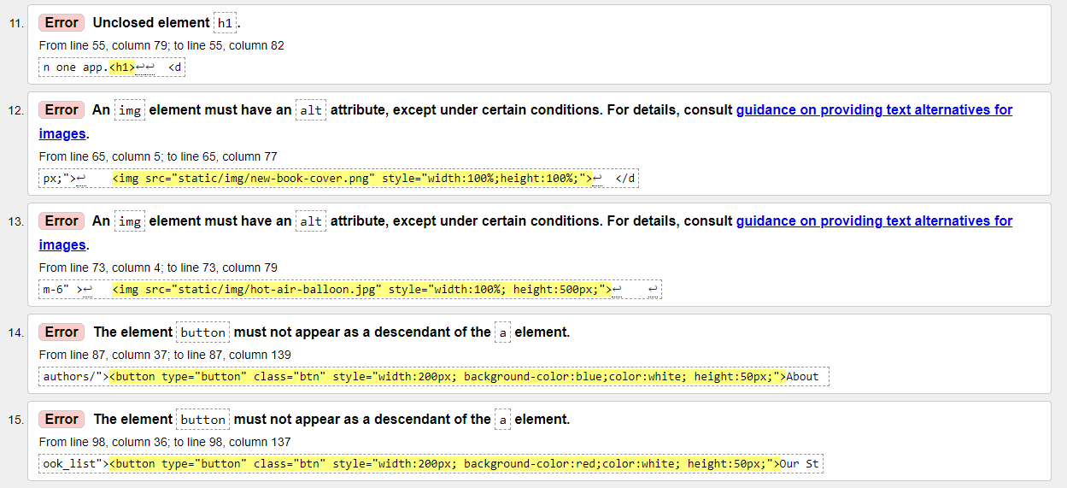

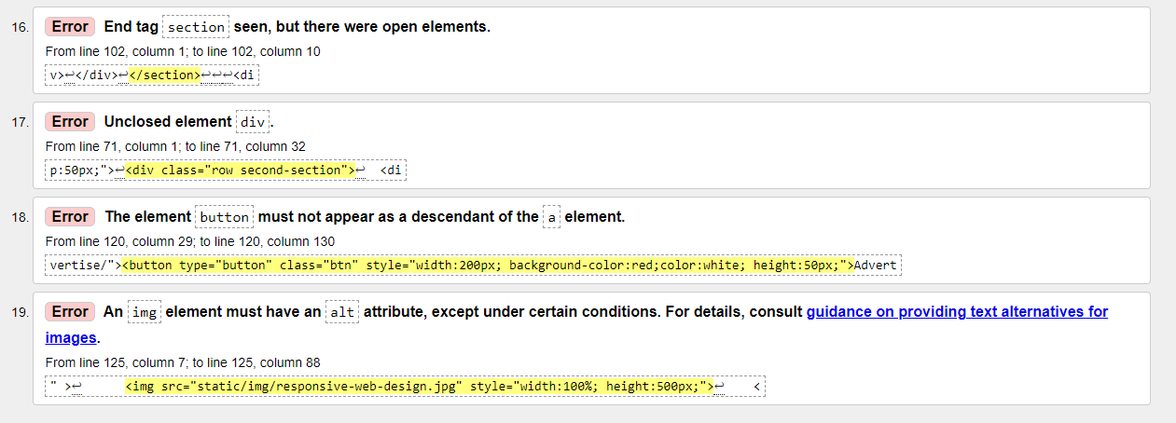

CSS: <https://jigsaw.w3.org/css-validator/>

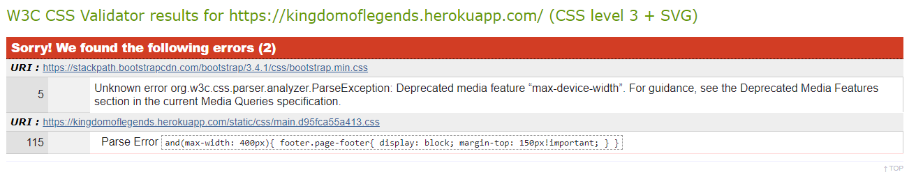

JavaScript: <https://jshint.com/>

Python: <http://pep8online.com/>

| **Code** | **Line** | **Column** | **Text** |
| --- | --- | --- | --- |
| **E225** | 1 | 2 | missing whitespace around operator |
| **E225** | 1 | 25 | missing whitespace around operator |
| **E225** | 1 | 29 | missing whitespace around operator |
| **E225** | 1 | 44 | missing whitespace around operator |
| **W291** | 1 | 45 | trailing whitespace |
| **E225** | 3 | 2 | missing whitespace around operator |
| **E225** | 3 | 19 | missing whitespace around operator |
| **E225** | 4 | 11 | missing whitespace around operator |
| **E225** | 4 | 23 | missing whitespace around operator |
| **E111** | 5 | 3 | indentation is not a multiple of four |
| **E113** | 5 | 3 | unexpected indentation |
| **E225** | 5 | 13 | missing whitespace around operator |
| **E225** | 6 | 9 | missing whitespace around operator |
| **E225** | 6 | 42 | missing whitespace around operator |
| **E501** | 6 | 80 | line too long (109 > 79 characters) |
| **E225** | 6 | 105 | missing whitespace around operator |
| **E225** | 6 | 106 | missing whitespace around operator |
| **E225** | 6 | 109 | missing whitespace around operator |
| **E111** | 7 | 3 | indentation is not a multiple of four |
| **E113** | 7 | 3 | unexpected indentation |
| **E225** | 7 | 11 | missing whitespace around operator |
| **E501** | 7 | 80 | line too long (133 > 79 characters) |
| **E225** | 7 | 111 | missing whitespace around operator |
| **E225** | 7 | 130 | missing whitespace around operator |
| **E225** | 7 | 133 | missing whitespace around operator |
| **E111** | 8 | 3 | indentation is not a multiple of four |
| **E225** | 8 | 6 | missing whitespace around operator |
| **E113** | 9 | 5 | unexpected indentation |
| **E225** | 9 | 14 | missing whitespace around operator |
| **E225** | 9 | 34 | missing whitespace around operator |
| **E225** | 9 | 79 | missing whitespace around operator |
| **E501** | 9 | 80 | line too long (82 > 79 characters) |
| **E225** | 9 | 82 | missing whitespace around operator |
| **E111** | 11 | 3 | indentation is not a multiple of four |
| **E225** | 11 | 13 | missing whitespace around operator |
| **E225** | 11 | 33 | missing whitespace around operator |
| **E111** | 12 | 3 | indentation is not a multiple of four |
| **E225** | 12 | 11 | missing whitespace around operator |
| **E225** | 12 | 60 | missing whitespace around operator |
| **E225** | 12 | 79 | missing whitespace around operator |
| **E501** | 12 | 80 | line too long (168 > 79 characters) |
| **E225** | 12 | 90 | missing whitespace around operator |
| **E225** | 12 | 108 | missing whitespace around operator |
| **E225** | 12 | 114 | missing whitespace around operator |
| **E225** | 12 | 117 | missing whitespace around operator |
| **E225** | 12 | 127 | missing whitespace around operator |
| **E225** | 12 | 142 | missing whitespace around operator |
| **E225** | 12 | 162 | missing whitespace around operator |
| **E225** | 12 | 168 | missing whitespace around operator |
| **E225** | 12 | 169 | missing whitespace around operator |
| **E225** | 12 | 172 | missing whitespace around operator |
| **E113** | 13 | 5 | unexpected indentation |
| **E225** | 13 | 12 | missing whitespace around operator |
| **E225** | 13 | 36 | missing whitespace around operator |
| **E225** | 13 | 37 | missing whitespace around operator |
| **E225** | 13 | 50 | missing whitespace around operator |
| **E225** | 13 | 65 | missing whitespace around operator |
| **E501** | 13 | 80 | line too long (102 > 79 characters) |
| **E225** | 13 | 83 | missing whitespace around operator |
| **E225** | 13 | 90 | missing whitespace around operator |
| **E225** | 13 | 98 | missing whitespace around operator |
| **E225** | 13 | 99 | missing whitespace around operator |
| **E225** | 13 | 102 | missing whitespace around operator |
| **E225** | 14 | 16 | missing whitespace around operator |
| **E225** | 14 | 34 | missing whitespace around operator |
| **E225** | 14 | 40 | missing whitespace around operator |
| **E225** | 15 | 12 | missing whitespace around operator |
| **E225** | 15 | 35 | missing whitespace around operator |
| **E225** | 15 | 36 | missing whitespace around operator |
| **E225** | 15 | 48 | missing whitespace around operator |
| **E225** | 15 | 63 | missing whitespace around operator |
| **E501** | 15 | 80 | line too long (107 > 79 characters) |
| **E225** | 15 | 81 | missing whitespace around operator |
| **E225** | 15 | 89 | missing whitespace around operator |
| **E225** | 15 | 97 | missing whitespace around operator |
| **E225** | 15 | 98 | missing whitespace around operator |
| **E225** | 15 | 103 | missing whitespace around operator |
| **E225** | 15 | 104 | missing whitespace around operator |
| **E225** | 15 | 107 | missing whitespace around operator |
| **E111** | 16 | 3 | indentation is not a multiple of four |
| **E225** | 16 | 8 | missing whitespace around operator |
| **W293** | 17 | 1 | blank line contains whitespace |
| **E111** | 18 | 3 | indentation is not a multiple of four |
| **E225** | 18 | 13 | missing whitespace around operator |
| **E225** | 18 | 42 | missing whitespace around operator |
| **E225** | 18 | 62 | missing whitespace around operator |
| **E113** | 19 | 5 | unexpected indentation |
| **E225** | 19 | 13 | missing whitespace around operator |
| **E225** | 19 | 51 | missing whitespace around operator |
| **E225** | 19 | 77 | missing whitespace around operator |
| **E111** | 20 | 3 | indentation is not a multiple of four |
| **E225** | 20 | 8 | missing whitespace around operator |
| **W293** | 21 | 1 | blank line contains whitespace |
| **E225** | 22 | 6 | missing whitespace around operator |
| **E225** | 23 | 11 | missing whitespace around operator |
| **E225** | 23 | 27 | missing whitespace around operator |
| **E225** | 23 | 28 | missing whitespace around operator |
| **E225** | 23 | 33 | missing whitespace around operator |
| **E225** | 24 | 15 | missing whitespace around operator |
| **E225** | 24 | 34 | missing whitespace around operator |
| **E225** | 25 | 11 | missing whitespace around operator |
| **E225** | 25 | 32 | missing whitespace around operator |
| **E111** | 26 | 3 | indentation is not a multiple of four |
| **E113** | 26 | 3 | unexpected indentation |
| **E225** | 26 | 13 | missing whitespace around operator |
| **E111** | 27 | 4 | indentation is not a multiple of four |
| **E113** | 27 | 4 | unexpected indentation |
| **E225** | 27 | 12 | missing whitespace around operator |
| **E225** | 27 | 51 | missing whitespace around operator |
| **E225** | 27 | 79 | missing whitespace around operator |
| **W293** | 28 | 1 | blank line contains whitespace |
| **E111** | 29 | 3 | indentation is not a multiple of four |
| **E225** | 29 | 8 | missing whitespace around operator |
| **E111** | 32 | 3 | indentation is not a multiple of four |
| **E303** | 32 | 3 | too many blank lines (2) |
| **E225** | 32 | 13 | missing whitespace around operator |
| **E225** | 32 | 24 | missing whitespace around operator |
| **E111** | 34 | 3 | indentation is not a multiple of four |
| **E225** | 34 | 12 | missing whitespace around operator |
| **E225** | 34 | 62 | missing whitespace around operator |
| **E501** | 34 | 80 | line too long (100 > 79 characters) |
| **E225** | 34 | 96 | missing whitespace around operator |
| **E225** | 34 | 100 | missing whitespace around operator |
| **W293** | 35 | 1 | blank line contains whitespace |
| **W293** | 36 | 1 | blank line contains whitespace |
| **E111** | 37 | 3 | indentation is not a multiple of four |
| **E303** | 37 | 3 | too many blank lines (2) |
| **E225** | 37 | 11 | missing whitespace around operator |
| **E225** | 37 | 26 | missing whitespace around operator |
| **E501** | 37 | 80 | line too long (140 > 79 characters) |
| **E231** | 37 | 89 | missing whitespace after ',' |
| **E225** | 37 | 90 | missing whitespace around operator |
| **E225** | 37 | 93 | missing whitespace around operator |
| **E225** | 37 | 137 | missing whitespace around operator |
| **E225** | 37 | 140 | missing whitespace around operator |
| **W293** | 38 | 1 | blank line contains whitespace |
| **E113** | 40 | 5 | unexpected indentation |
| **E303** | 40 | 5 | too many blank lines (2) |
| **E225** | 40 | 9 | missing whitespace around operator |
| **E111** | 41 | 7 | indentation is not a multiple of four |
| **E113** | 41 | 7 | unexpected indentation |
| **E225** | 41 | 14 | missing whitespace around operator |
| **E225** | 41 | 42 | missing whitespace around operator |
| **E225** | 41 | 43 | missing whitespace around operator |
| **E225** | 41 | 55 | missing whitespace around operator |
| **E225** | 41 | 70 | missing whitespace around operator |
| **E501** | 41 | 80 | line too long (171 > 79 characters) |
| **E225** | 41 | 82 | missing whitespace around operator |
| **E225** | 41 | 145 | missing whitespace around operator |
| **E225** | 41 | 163 | missing whitespace around operator |
| **E225** | 41 | 171 | missing whitespace around operator |
| **E111** | 42 | 7 | indentation is not a multiple of four |
| **E225** | 42 | 10 | missing whitespace around operator |
| **E225** | 43 | 10 | missing whitespace around operator |
| **E225** | 44 | 4 | missing whitespace around operator |
| **E225** | 44 | 5 | missing whitespace around operator |
| **E225** | 44 | 8 | missing whitespace around operator |
| **E225** | 44 | 9 | missing whitespace around operator |
| **E225** | 44 | 12 | missing whitespace around operator |
| **E225** | 44 | 13 | missing whitespace around operator |
| **E225** | 44 | 16 | missing whitespace around operator |
| **E113** | 45 | 5 | unexpected indentation |
| **E225** | 45 | 14 | missing whitespace around operator |
| **E225** | 45 | 65 | missing whitespace around operator |
| **E501** | 45 | 80 | line too long (94 > 79 characters) |
| **E225** | 45 | 90 | missing whitespace around operator |
| **E225** | 45 | 94 | missing whitespace around operator |
| **W293** | 46 | 1 | blank line contains whitespace |
| **W293** | 47 | 1 | blank line contains whitespace |
| **E901** | 48 | 3 | IndentationError: unindent does not match any outer indentation level |