**Validations**

* **HTML :** <https://validator.w3.org/>

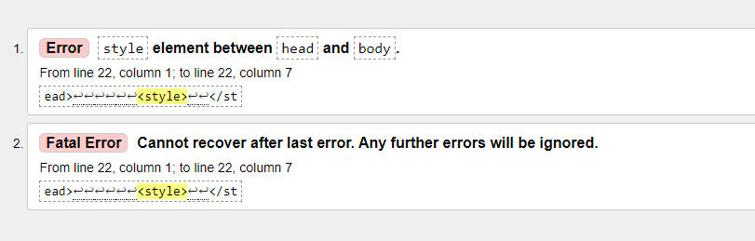

* **CSS:** <https://jigsaw.w3.org/css-validator/>

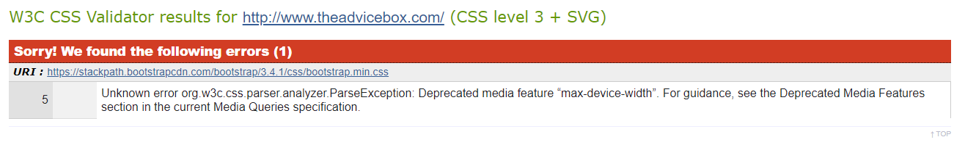

* **JavaScript:** <https://jshint.com/>
* **Python:** <http://pep8online.com/>

| **Code** | **Line** | **Column** | **Text** |
| --- | --- | --- | --- |
| **E225** | 1 | 2 | missing whitespace around operator |
| **E225** | 1 | 25 | missing whitespace around operator |
| **E303** | 5 | 1 | too many blank lines (3) |
| **E225** | 5 | 2 | missing whitespace around operator |
| **E225** | 5 | 19 | missing whitespace around operator |
| **W291** | 5 | 20 | trailing whitespace |
| **E225** | 6 | 11 | missing whitespace around operator |
| **E225** | 6 | 48 | missing whitespace around operator |
| **E701** | 6 | 66 | multiple statements on one line (colon) |
| **E501** | 6 | 80 | line too long (161 > 79 characters) |
| **E702** | 6 | 107 | multiple statements on one line (semicolon) |
| **E701** | 6 | 126 | multiple statements on one line (colon) |
| **E702** | 6 | 137 | multiple statements on one line (semicolon) |
| **E701** | 6 | 154 | multiple statements on one line (colon) |
| **E703** | 6 | 161 | statement ends with a semicolon |
| **E701** | 7 | 20 | multiple statements on one line (colon) |
| **E225** | 7 | 24 | missing whitespace around operator |
| **E228** | 7 | 28 | missing whitespace around modulo operator |
| **E703** | 7 | 29 | statement ends with a semicolon |
| **E113** | 8 | 5 | unexpected indentation |
| **E701** | 8 | 15 | multiple statements on one line (colon) |
| **E231** | 8 | 22 | missing whitespace after ';' |
| **E702** | 8 | 22 | multiple statements on one line (semicolon) |
| **E221** | 8 | 24 | multiple spaces before operator |
| **W293** | 9 | 1 | blank line contains whitespace |
| **E901** | 10 | 3 | IndentationError: unindent does not match any outer indentation level |