Google Play Store Data Analysis

Anthony Le

## Loading required package: lattice

## Loading required package: grid

## Loading required package: ggplot2

## randomForest 4.6-14

## Type rfNews() to see new features/changes/bug fixes.

##   
## Attaching package: 'randomForest'

## The following object is masked from 'package:ggplot2':  
##   
## margin

## -- Attaching packages ---------------------------------------------------------------------------------------------- tidyverse 1.2.1 --

## v tibble 1.4.2 v purrr 0.2.4  
## v tidyr 0.8.0 v dplyr 0.7.4  
## v readr 1.1.1 v stringr 1.3.0  
## v tibble 1.4.2 v forcats 0.3.0

## -- Conflicts ------------------------------------------------------------------------------------------------- tidyverse_conflicts() --  
## x dplyr::combine() masks randomForest::combine()  
## x dplyr::filter() masks stats::filter()  
## x dplyr::lag() masks stats::lag()  
## x purrr::lift() masks caret::lift()  
## x randomForest::margin() masks ggplot2::margin()

##   
## Attaching package: 'lubridate'

## The following object is masked from 'package:base':  
##   
## date

## Data Import

Import Data

playstore <- read.csv('googleplaystore.csv', header = TRUE)

Initial Data

## 'data.frame': 10841 obs. of 13 variables:  
## $ App : Factor w/ 9660 levels "- Free Comics - Comic Apps",..: 7229 2563 8998 8113 7294 7125 8171 5589 4948 5826 ...  
## $ Category : Factor w/ 34 levels "1.9","ART_AND_DESIGN",..: 2 2 2 2 2 2 2 2 2 2 ...  
## $ Rating : num 4.1 3.9 4.7 4.5 4.3 4.4 3.8 4.1 4.4 4.7 ...  
## $ Reviews : Factor w/ 6002 levels "0","1","10","100",..: 1183 5924 5681 1947 5924 1310 1464 3385 816 485 ...  
## $ Size : Factor w/ 462 levels "1,000+","1.0M",..: 55 30 368 102 64 222 55 118 146 120 ...  
## $ Installs : Factor w/ 22 levels "0","0+","1,000,000,000+",..: 8 20 13 16 11 17 17 4 4 8 ...  
## $ Type : Factor w/ 4 levels "0","Free","NaN",..: 2 2 2 2 2 2 2 2 2 2 ...  
## $ Price : Factor w/ 93 levels "$0.99","$1.00",..: 92 92 92 92 92 92 92 92 92 92 ...  
## $ Content.Rating: Factor w/ 7 levels "","Adults only 18+",..: 3 3 3 6 3 3 3 3 3 3 ...  
## $ Genres : Factor w/ 120 levels "Action","Action;Action & Adventure",..: 10 13 10 10 12 10 10 10 10 12 ...  
## $ Last.Updated : Factor w/ 1378 levels "1.0.19","April 1, 2016",..: 562 482 117 825 757 901 76 726 1317 670 ...  
## $ Current.Ver : Factor w/ 2834 levels "","0.0.0.2","0.0.1",..: 121 1020 466 2827 279 115 279 2393 1457 1431 ...  
## $ Android.Ver : Factor w/ 35 levels "","1.0 and up",..: 17 17 17 20 22 10 17 20 12 17 ...

## App   
## ROBLOX : 9   
## CBS Sports App - Scores, News, Stats & Watch Live: 8   
## 8 Ball Pool : 7   
## Candy Crush Saga : 7   
## Duolingo: Learn Languages Free : 7   
## ESPN : 7   
## (Other) :10796   
## Category Rating Reviews   
## FAMILY :1972 Min. : 1.000 0 : 596   
## GAME :1144 1st Qu.: 4.000 1 : 272   
## TOOLS : 843 Median : 4.300 2 : 214   
## MEDICAL : 463 Mean : 4.193 3 : 175   
## BUSINESS : 460 3rd Qu.: 4.500 4 : 137   
## PRODUCTIVITY: 424 Max. :19.000 5 : 108   
## (Other) :5535 NA's :1474 (Other):9339   
## Size Installs Type Price   
## Varies with device:1695 1,000,000+ :1579 0 : 1 0 :10040   
## 11M : 198 10,000,000+:1252 Free:10039 $0.99 : 148   
## 12M : 196 100,000+ :1169 NaN : 1 $2.99 : 129   
## 14M : 194 10,000+ :1054 Paid: 800 $1.99 : 73   
## 13M : 191 1,000+ : 907 $4.99 : 72   
## 15M : 184 5,000,000+ : 752 $3.99 : 63   
## (Other) :8183 (Other) :4128 (Other): 316   
## Content.Rating Genres Last.Updated   
## : 1 Tools : 842 August 3, 2018: 326   
## Adults only 18+: 3 Entertainment: 623 August 2, 2018: 304   
## Everyone :8714 Education : 549 July 31, 2018 : 294   
## Everyone 10+ : 414 Medical : 463 August 1, 2018: 285   
## Mature 17+ : 499 Business : 460 July 30, 2018 : 211   
## Teen :1208 Productivity : 424 July 25, 2018 : 164   
## Unrated : 2 (Other) :7480 (Other) :9257   
## Current.Ver Android.Ver   
## Varies with device:1459 4.1 and up :2451   
## 1.0 : 809 4.0.3 and up :1501   
## 1.1 : 264 4.0 and up :1375   
## 1.2 : 178 Varies with device:1362   
## 2.0 : 151 4.4 and up : 980   
## 1.3 : 145 2.3 and up : 652   
## (Other) :7835 (Other) :2520

## Transform Data

1. Remove columns and duplicated rows
2. App ratings should have a maximum value of 5
3. Remove extra characters, convert Size to consistent format, remove apps under 1MB, and remove apps with 0 installs
4. Convert columns to appropriate variable types

## Warning: NAs introduced by coercion

## 'data.frame': 6998 obs. of 9 variables:  
## $ Category : Factor w/ 33 levels "ART_AND_DESIGN",..: 1 1 1 1 1 1 1 1 1 1 ...  
## $ Rating : num 4.1 3.9 4.7 4.5 4.3 4.4 3.8 4.1 4.4 4.7 ...  
## $ Reviews : num 1183 5924 5681 1947 5924 ...  
## $ Size : num 19 14 8.7 25 2.8 5.6 19 29 33 3.1 ...  
## $ Installs : num 1e+04 5e+05 5e+06 5e+07 1e+05 5e+04 5e+04 1e+06 1e+06 1e+04 ...  
## $ Type : Factor w/ 2 levels "Free","Paid": 1 1 1 1 1 1 1 1 1 1 ...  
## $ Price : num 0 0 0 0 0 0 0 0 0 0 ...  
## $ Content.Rating: Factor w/ 7 levels "","Adults only 18+",..: 3 3 3 6 3 3 3 3 3 3 ...  
## $ Android.Ver : Factor w/ 21 levels "1.0","1.5","1.6",..: 11 11 11 13 15 7 11 13 8 11 ...  
## - attr(*, "na.action")=Class 'omit' Named int [1:113] 1385 1386 1387 1427 1430 1452 1457 1468 1470 2075 ...  
## .. ..- attr(*, "names")= chr [1:113] "2172" "2173" "2174" "2244" ...

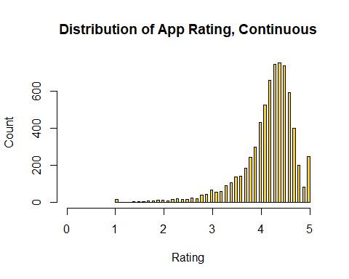

There is a clear class imbalance, as there are far more apps rated 4.0 and above

## Create Ratings Intervals

Split continuous rating (1.0-5.0) into 2 intervals and convert to factor

playstore$Rating <- cut(as.numeric(playstore$Rating), breaks = c(1,4,5), labels = c('Mediocre','High'))  
plot(playstore$Rating, main = "Distribution of App Rating, Categorical", xlab = "Rating", ylab = "Count", col="red")

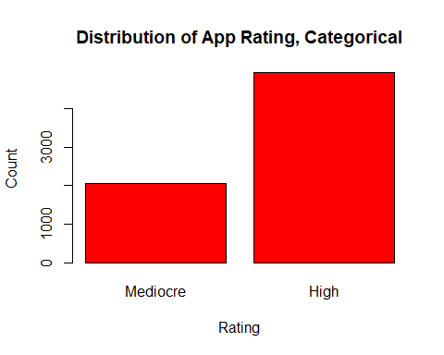

playstore$Rating = factor(playstore$Rating)  
playstore <- na.omit(playstore)

## Training/Test Split

Inital training and test split ratio will be 70/30

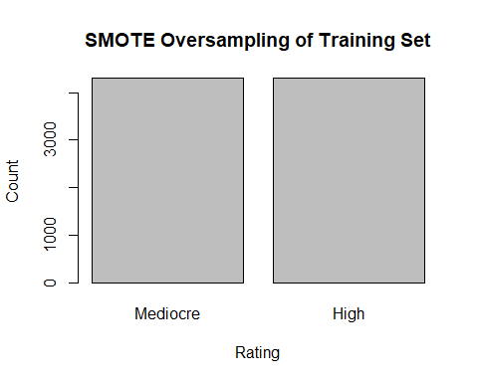

## [,1]  
## [1,] 0.7  
## [2,] 1.9

## Random Forest

model1 <- randomForest(Rating ~ ., ps_training)  
predict_rf <- predict(model1, ps_test)  
plot(predict_rf, main = 'Random Forest Classification', xlab = 'Rating', ylab = 'Count',col = 'darkgreen')

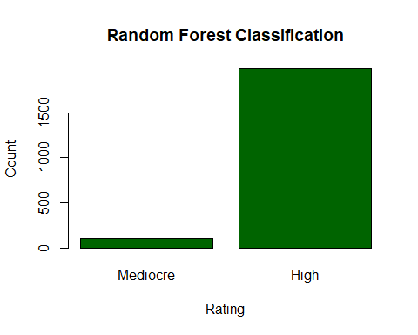

rf_confusion_matrix <- confusionMatrix(data = predict_rf, reference = ps_test$Rating, positive = 'High')  
print(rf_confusion_matrix)

## Confusion Matrix and Statistics  
##   
## Reference  
## Prediction Mediocre High  
## Mediocre 42 62  
## High 572 1418  
##   
## Accuracy : 0.6972   
## 95% CI : (0.677, 0.7169)  
## No Information Rate : 0.7068   
## P-Value [Acc > NIR] : 0.8375   
##   
## Kappa : 0.035   
## Mcnemar's Test P-Value : <2e-16   
##   
## Sensitivity : 0.9581   
## Specificity : 0.0684   
## Pos Pred Value : 0.7126   
## Neg Pred Value : 0.4038   
## Prevalence : 0.7068   
## Detection Rate : 0.6772   
## Detection Prevalence : 0.9503   
## Balanced Accuracy : 0.5133   
##   
## 'Positive' Class : High   
##

## Naive Bayes

model2 <- naiveBayes(Rating ~ .,ps_training)  
predict_nb <- predict(model2,ps_test)  
plot(predict_nb, main = 'Naive Bayes Classification', xlab = 'Rating', ylab = 'Count',col = 'lightblue')

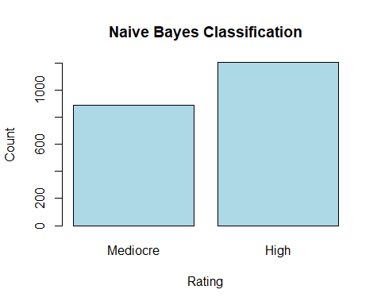

nb_confusion_matrix <- confusionMatrix(data = predict_nb, reference = ps_test$Rating, positive = 'High')  
print(nb_confusion_matrix)

## Confusion Matrix and Statistics  
##   
## Reference  
## Prediction Mediocre High  
## Mediocre 278 610  
## High 336 870  
##   
## Accuracy : 0.5482   
## 95% CI : (0.5266, 0.5697)  
## No Information Rate : 0.7068   
## P-Value [Acc > NIR] : 1   
##   
## Kappa : 0.0359   
## Mcnemar's Test P-Value : <2e-16   
##   
## Sensitivity : 0.5878   
## Specificity : 0.4528   
## Pos Pred Value : 0.7214   
## Neg Pred Value : 0.3131   
## Prevalence : 0.7068   
## Detection Rate : 0.4155   
## Detection Prevalence : 0.5759   
## Balanced Accuracy : 0.5203   
##   
## 'Positive' Class : High   
##