Anthony Martuscelli

Use Cases for a Parking System

ICT-4305

Part 1: Use Case Diagram

Parking System Use Case Diagram built with plantuml

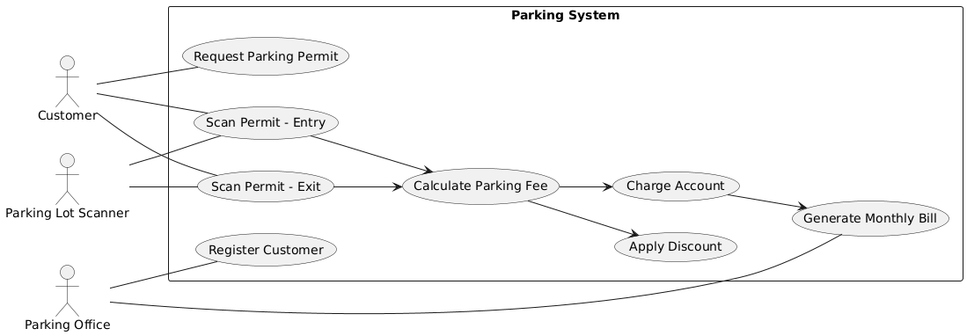

|  |  |
| --- | --- |
| **Field** | **Description** |
| ID | Id_Generation |
| Name | ParkingSystemApp |
| Short Description | When user enters a university parking lot, the parking lot scanner reads permit attached to the user vehicle. System verifies the permit, records the transaction, determines entry fee or discount, and charges account. |
| Goal | Allow expedited entry to the parking structures and eliminate the need for cash parking |
| Preconditions | * Customer is registered in system * Customer has at least one active permit * Parking lot scanner is connected and functional |
| Success End Condition | Permit is confirmed by system, gate opens, entry time is recorded, account is charged |
| Fail End Condition | Permit is not valid. Entry denied. |
| Stakeholder | Primary Actor: Customer |
| Trigger | Customer approaches entrance and permits are scanned. |
| Normal Flow | 1. Customer approaches lot entrance 2. Parking scanner reads permit attached for vehicle 3. System validates permit against registration records 4. System checks parking lot rules 5. System then calculates fee 6. IF compact, system applies discount of 20% 7. System charges customer account 8. Gate Opens |
| Alternative Flow | Invalid Permit   * If permit is expired or not found, entry denied * Transaction not recorded * Customer prompted to contact Parking Office   System Offline   * If a component is not functional, manual entry will need to be performed by parking office staff |
| Includes | Calculating fee  Applying discount(s)  Charging account |
| Frequency of Use | Whenever a customer enters lot |
| Constraints and Special Requirements | Permits must be accessible to be scanned by system. |
| Assumptions | Accounts are charged immediately upon entry. |
| Notes and Issues | Grace periods. Overnight. |