# CS 255 Business Requirements Document Template

## System Components and Design

### Purpose

* DriverPass’s vision is to train future drivers to successfully pass their DMV driving tests by developing an online application that provides classes and tests. Additionally, an option for in-person practice driving will be available to all students.

### System Background

* The system will provide online classes, practice tests, and schedule in-person driving sessions.
* The system data must be accessible both on a desktop and mobile devices with valid internet access.
* The system must implement the *least privilege principle* for security purposes. There will be three main user types – admin, employee, and student.
* The system database must track user reservations and changes. The student will have user privileges to make and change their own reservations online or by calling the office.
* The system must have a scheduling tracker that links drivers and students.
* The system will include options for three packages. The packages can be made unavailable by the client or modified later.
* The database must track the following student information – first name, last name, address, phone number, state, credit card number, expiration date, security code, and pickup/drop-off location.
* The students will have the ability to reset/change/recover their own passwords.
* The system will have access to the DMV through a DMV API which should notify DriverPass of any upcoming changes to DMV requirements and regulations.
* The system shall be integrated with an offsite serverless cloud architecture provider that incorporates backup and security of the system as part of a subscription.
* The student interface shall be implemented based on the client's diagram and shall include the following components:

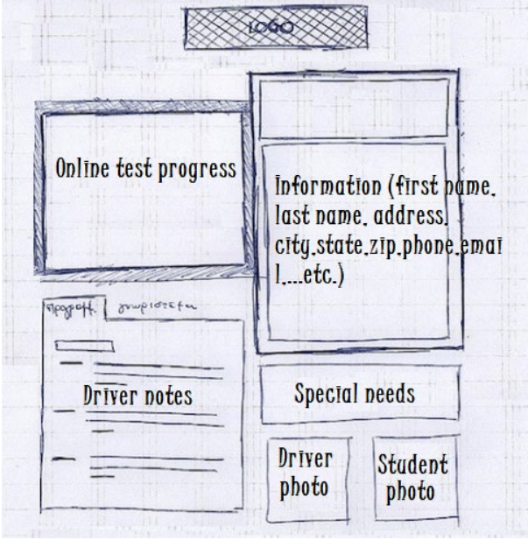

* In addition to the student interface the application should include the following pages: driving reservation form, contact us page, and about page.

### Objectives and Goals

* Once completed, the system shall provide the students and staff with the following functions:
* Provide students with online driver training classes.
* Provide students with online driving tests.
* Provide students with the ability to schedule in-person driving sessions based on three packages.
* Provide students with an interface to view past tests, view past driving sessions. notes, schedule driving sessions, and take classes.
* Provide staff with the ability to view system data.
* Provide staff with the ability to process transactions between the students and DriverPass.
* Provide staff with the ability to view any changes in the DMV.

## Requirements

### Nonfunctional Requirements

#### Performance Requirements

* The time it takes to connect to the DMV API and transmit information to and from the application must be less than 5 seconds.
* The application will utilize cloud-based architecture and will be use offsite servers in order to scale with a growing user base without the need to purchase more servers and equipment. The routine backup of the system will be incorporated into the cost of the cloud-based subscription.
* At a minimum, the system will be evaluated and updated on a quarterly basis.

#### Platform Constraints

* The system will be able to run on desktop operating systems (Windows, Apple, and Unix) as well as mobile devices with internet access.
* A database shall be utilized to store user data.

#### Accuracy and Precision

* Usernames shall be unique
* Input will be case sensitive
* The system will keep an error log that will be transmitted to the system administrator for daily review. Critical errors will be transmitted instantly for review.

#### Adaptability

* Users will have access to schedule or change their currently scheduled driving appointments
* The system will have access to the DMV API in order to adapt to any new regulations

#### Security

* The system will utilize the principle of least privileges
* The database will be located off premises and secured by a third party
* User accounts will utilize two-factor authentication
* Account passwords will have minimum requirements such as the use of capital letters, non-alphanumeric characters, numbers, etc.

### Functional Requirements

* The system shall validate user credentials when logging in.
* The system shall provide a scheduling interface for in-person driving sessions.
* The system shall administer timed online driving tests for students.
* The system shall automatically grade and provide statistical feedback for online driving tests.
* The system shall provide students with the option to schedule in-person driving sessions.
* The system shall allow students to cancel or reschedule their in-person driving sessions.
* The system shall link driving instructors with driving students based on availability.
* The system shall provide driving instructor feedback to students through the student portal.
* The system shall provide updates to instructors and students regarding changes in regulations issued by the DMV.
* The system shall provide the option for students to purchase predefined packages which grant the student certain privileges and resources.
* The system shall be functional via mobile devices as well as desktop computers.

### User Interface

* The interface will be used through a web browser and is mobile friendly.
* On desktop mouse and keyboard will be used but on mobile devices it will be responsive to touch screen.
* There will be a homepage that includes a sign-up page and log-in page.
* The homepage will include a list of plans and a description of features.
* The students will have a student portal to interact with the different features.
* The instructors will have an employee portal to interact with the different features.
* The admins will have an admin portal to interact with all the features.
* When students are taking a test.

### Assumptions

* Users have access to a modern web browser on either a desktop or mobile device.
* Students are of driving age based on their state regulation.
* Users have access to the internet.
* Users qualify to apply for a driver license in the United States of America.

### Limitations

*Any system you build will naturally have limitations. What limitations do you see in your system design? What limitations do you have as far as resources, time, budget, or technology?*

* The system is not accessible to users without an internet connection.
* The system is not accessible without a modern internet browser.
* The features are not free and require a paid subscription.

### Gantt Chart

