# CS 255 System Design

## UML Diagrams

### UML Use Case Diagram

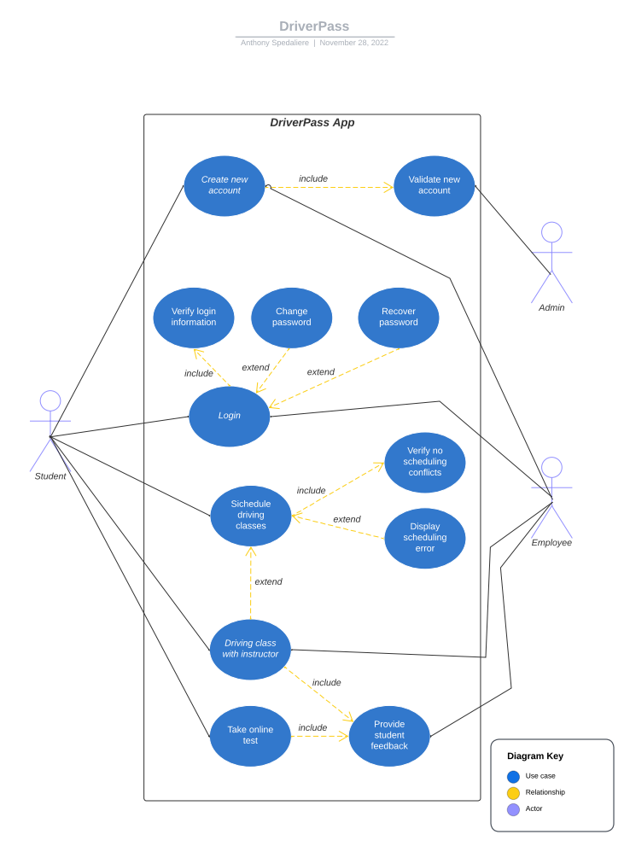

### UML Activity Diagrams

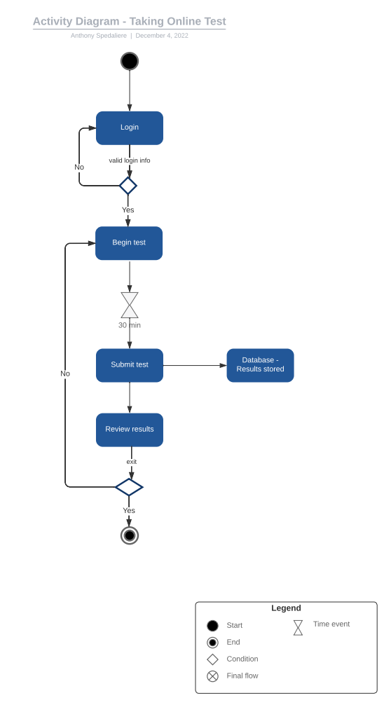

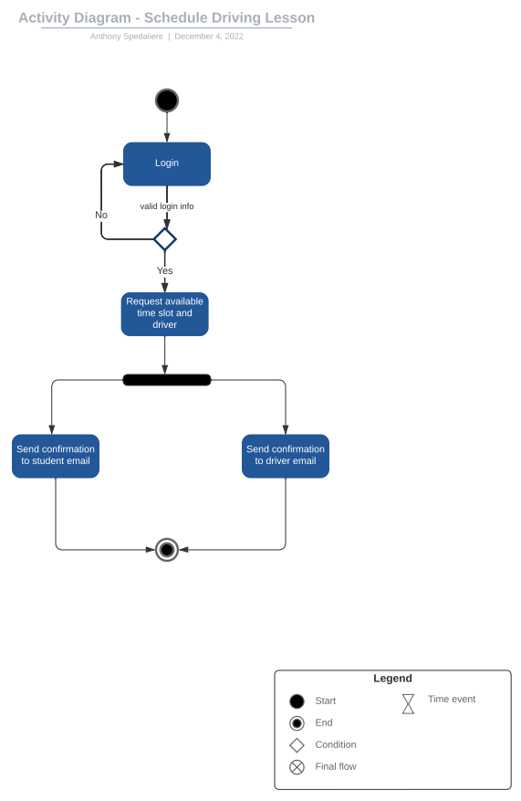

### UML Sequence Diagram

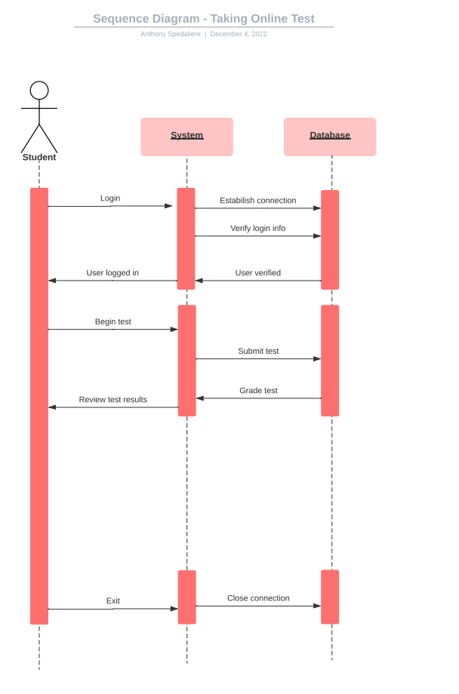

### UML Class Diagram

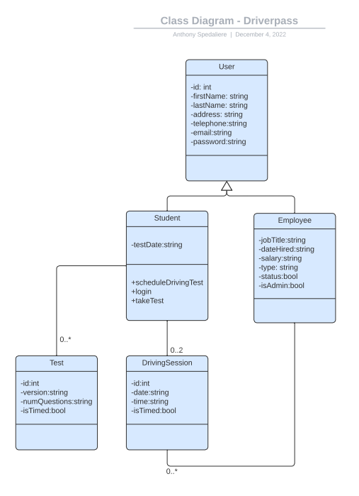

## Technical Requirements

The DriverPass application is only accessible with a valid internet connection. The application is intended to run in any modern web browser within any modern Windows, Mac, or Unix operating system platform. Moden is defined as an operating system that is still actively receiving adequate and significant updates by its developers or its open-source community.

The application will be implemented using the following technology stack - JavaScript, Node.js, Express, MongoDB and React.js. The front end and back end of the application will be hosted through Amazon Web Services (AWS). AWS provides a fully managed cloud-based service for fast and secure websites on desktop and mobile devices. Utilizing a cloud-based service like AWS provides DriverPass with the necessary hardware and software while minimizing the up-front costs for those resources. The hardware is owned by AWS and stored offsite, saving valuable space and resources. As the application grows in users, AWS services can scale in conjunction with the growth in users. This is a cost-effective way for future growth. In addition to scalability AWS provides support for all the most popular development platforms like Java, PHP, Node.js and .Net. AWS also has datacenters worldwide, so DriverPass could eventually expand to international markets by only changing a couple of settings. At a certain threshold of growth in annual revenue DriverPass may wish to purchase in-house hardware to implement its own servers and databases.

Amazon Web Services also address the areas of latent capacity and performance by scaling with traffic in real time. As the application experiences an increase or decrease in users throughout the day, week, month, or year AWS can fluctuate in real time to accommodate the ebbs and flows of user traffic.

The uptime of the application is expected to be 24 hours per day and 7 days a week, except for predetermined maintenance days which will be performed at times when user traffic is at its minimum.

The application will implement two-factor authentication to increase security for users logging in and https protocol to provide safe transfer of information using the most up to date industry standard encryption algorithms. In addition to these security measures Amazon Web Services also provides an array of security measures that secure the database and actively scan the system for vulnerabilities. The principle of least privileges will be utilized to ensure that only specific users are allowed access to critical areas of the system. For all files uploaded by the user the system will utilize upload verification by checking file extensions, ensuring the files are not too large, and validation of any zipped files. All user input will be validated to ensure zero malicious information is transmitted to the application's back end. Security is essential.