# Southern New Hampshire University

# 7-1 Project Reflection Paper

Anthony Spedaliere

Professor Wabara

CS-330-T2833 Computer Graphics and Visualization

December 7th, 2022

When I originally chose my objects, I tried to pick objects that were similar in shape to the primitive objects that I was required to work with. As a beginner I did not want to get bogged down with complex objects. It is important to build a strong foundation in the beginning and to incrementally increase the complexity. I chose the baseball because it is essentially a sphere. At the time I thought a sphere would be easy. However, it took me quite a long time before I figured out a process to create a sphere. The use of blender was essential in visually the coordinates in 3D space. I chose the book because it is essentially an elongated and flattened cube. The brick in my scene is the most irregular shape. I chose to simplify this shape in my rendering. The pen represents the object in my scene that is comprised of two different shapes. The main tube of the pen is a cylinder, and the tip of the pen is made from a rotated sphere.

I also paid attention to the colors of the objects that I chose. I tried to choose objects that were consistent in texture and did not contain too much detail. I think the most complex object texture would be the baseball. I chose to not include the stitching on the baseball as it would be too complex.

My scene is controlled using keyboard and mouse inputs. I chose to use the traditional WASD keys to navigate the scene. The “W” key moves you forward in space. The “S” key moves you backwards in space. The “A” key moves you left in space. The “D” key moves you right in space. I implemented the “Q” key to move you up in space and the “E” key to move you down in space. The cursor is used to change the orientation of the camera to look up, down. left and right. The “P” key is used to switch to perspective view while the “O” key is used to switch to orthographic view. The program starts from a perspective view.

Here is the list of prototype functions used in my scene for reference.

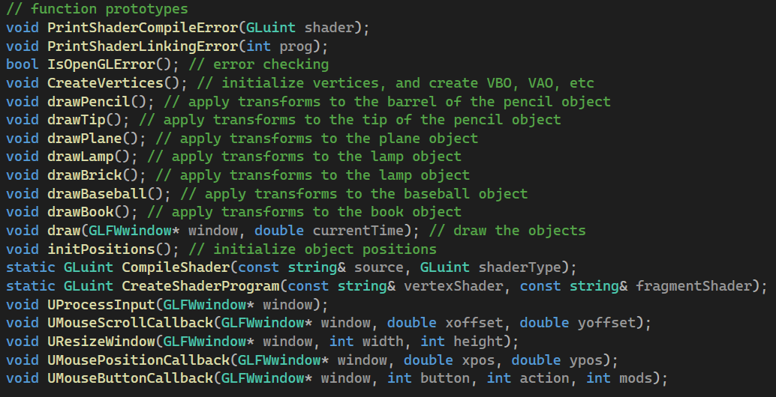 Some of them I created from scratch and some of them I modified from code taken from tutorials, class webinars and other class resources. Each object I created is modularized within a function called **drawObjectName( )**. For example, the baseball object is called **drawBaseball**. I implemented this technique so that if I wanted to duplicate objects, I simply had to call this function an additional time. There is a main draw function that is used to call all the other draw functions. This function is simply called **draw()**. It is only called once in the program.

References

*Learn OpenGL, extensive tutorial resource for learning Modern OpenGL*. (n.d.-b). https://learnopengl.com/