**Project Two Screenshots**

**Prompt 1 – Starting State**

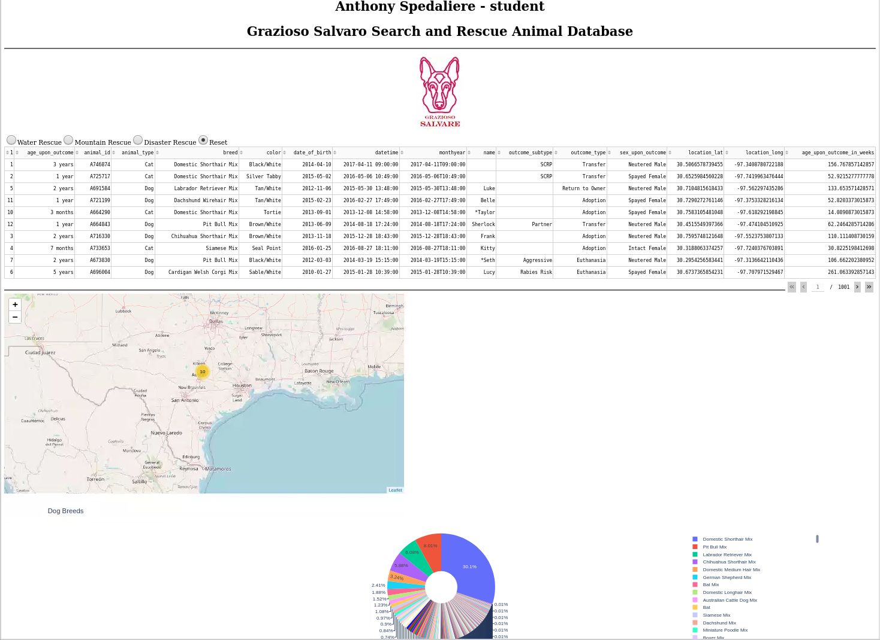

**Prompt 2 – Water Rescue data filter**

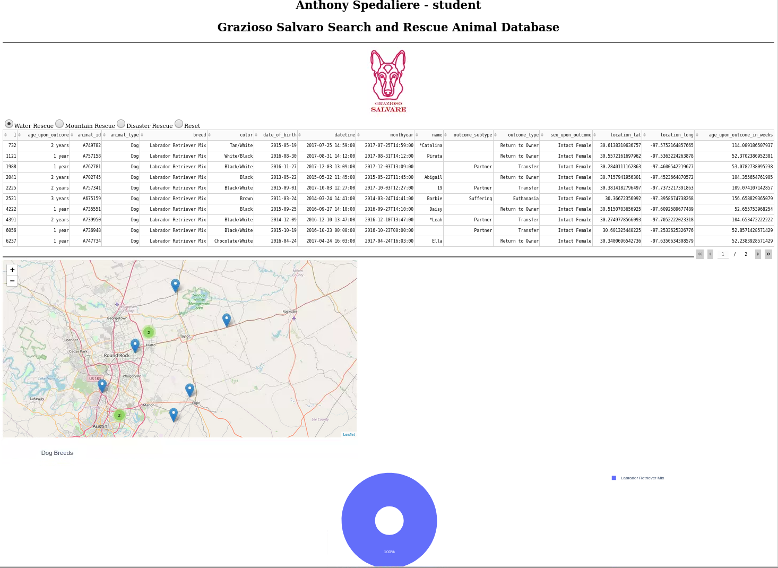

**Prompt 3 – Mountain Rescue data filter**

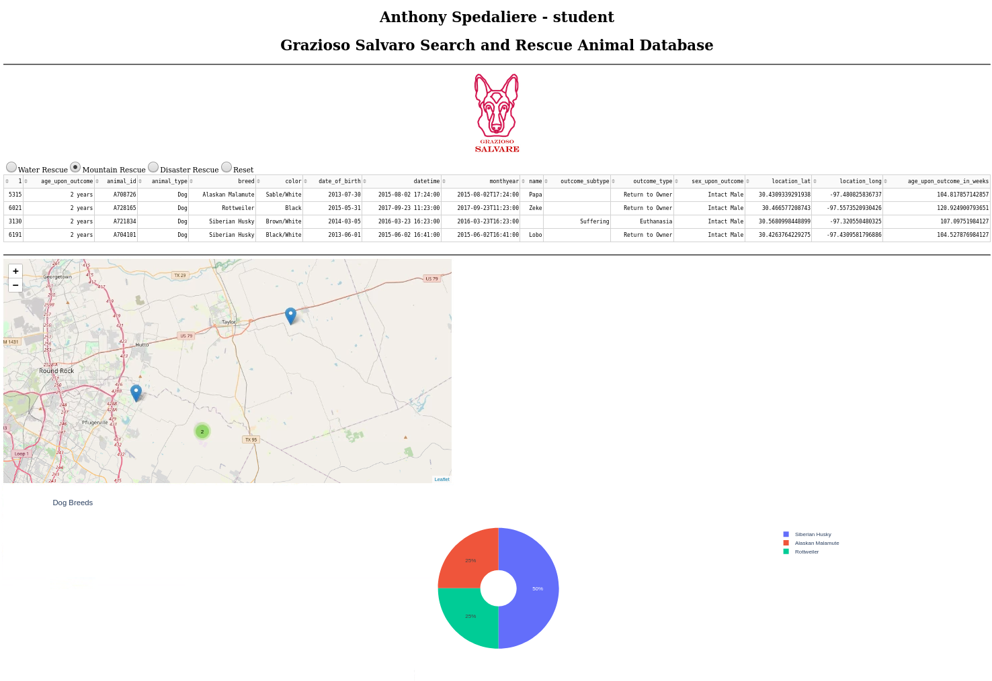

**Prompt 4 – Disaster Rescue data filter**

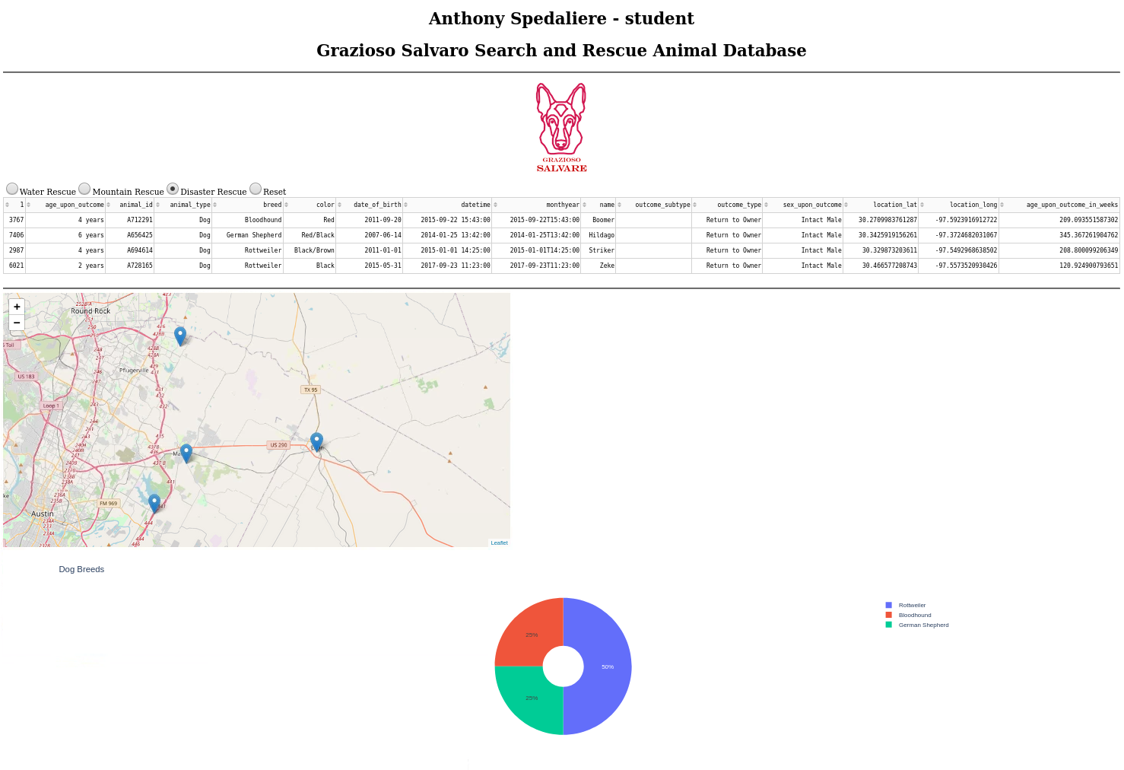

**Prompt 5 – Reset data filter**

