Octavian Bot
Setup:

Run the following commands:
- npm install
- npm start
And open http://localhost:3978/api/messages in your emulator.
Features:

- Welcoming message:
When a user joins, they are greeted with a welcoming message:
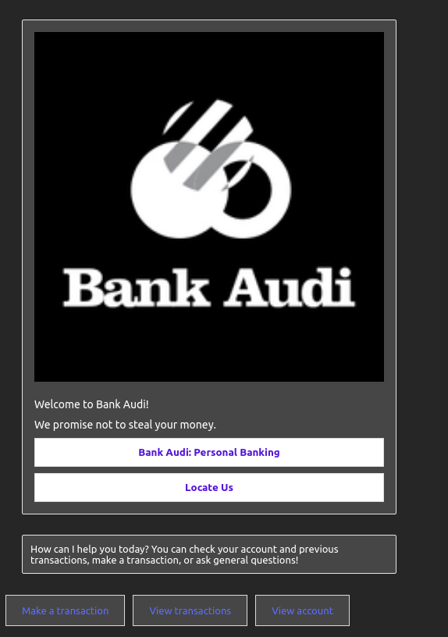
- FAQ:
The bot can answer questions with the QnA Maker. Currently, the Knowledge Base contains questions and answers from Bank Audi’s FAQ and some “Friendly” responses.
https://www.bankaudi.com.lb/common/faq
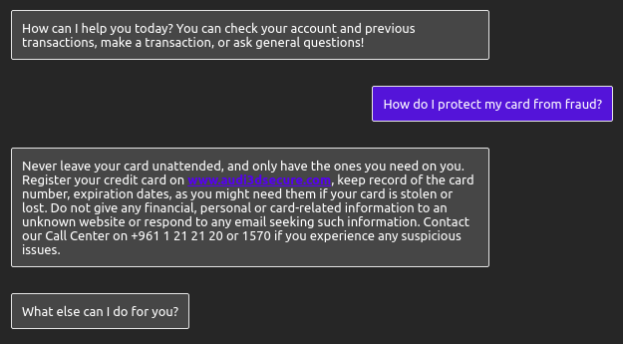
- LUIS classification:
The bot can process input from the user and try to match it with an intent. The intents are “View Account”, “Make a transaction”, and “View transaction(s)”.
- View Account: The user is assumed to be “John Doe”, starting with an amount off $500 at the start of the conversation.
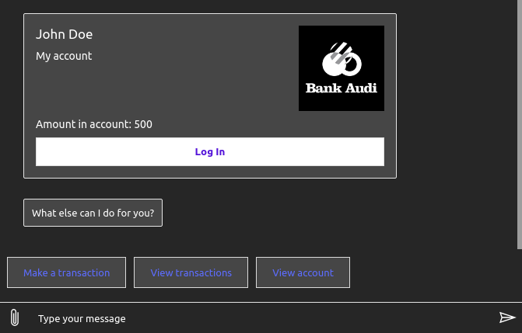
Note: If a transaction is made, the “Amount in account” decreases by the value in the transaction.

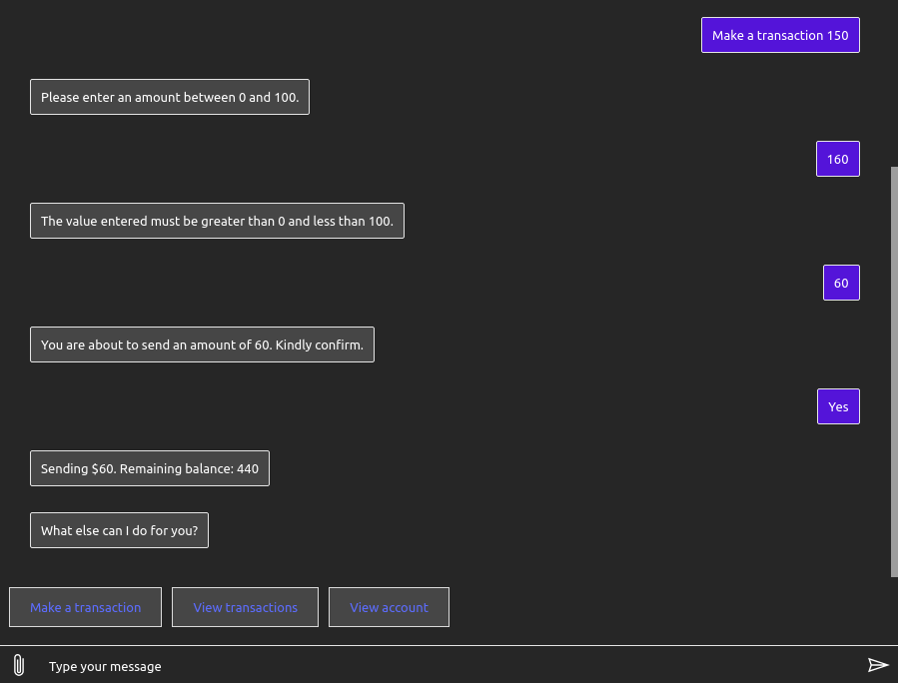
- Make a transaction: The user can pay from their account. If the user does not specify the amount to be paid, the bot asks for that amount, which can only be between 0 and 100. After a valid input, the bot asks the user to confirm transaction with the amount given by the user. If the user declines, the operation is dropped and the user can ask new questions. If the user accepts, the bot performs the transaction if enough credit is available in the account.
- View transaction(s): The user can ask the bot to display current and historical transactions.
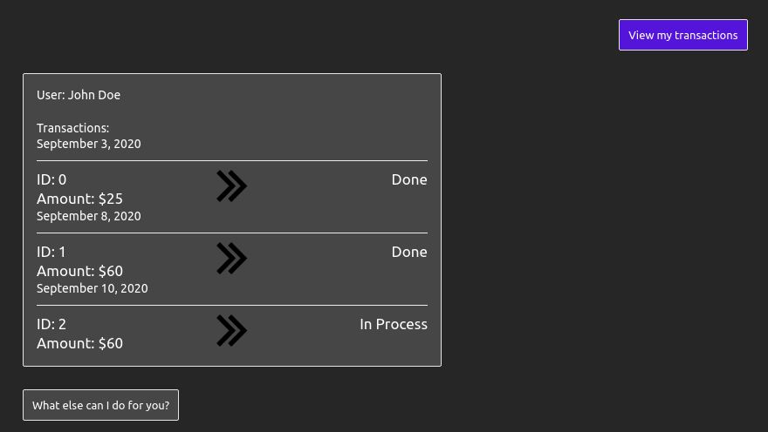
If needed, the user can choose to view one transaction instead of all, by giving the transaction ID.
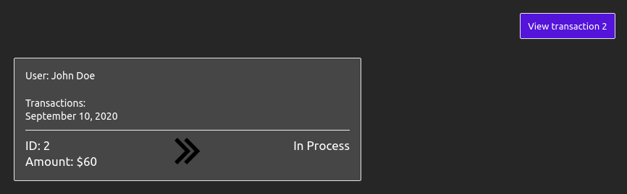
The new transactions will have status “In Progress”, and the ones created upon starting a new chat (#0 and #1) will have status “Done”.

- Survey:
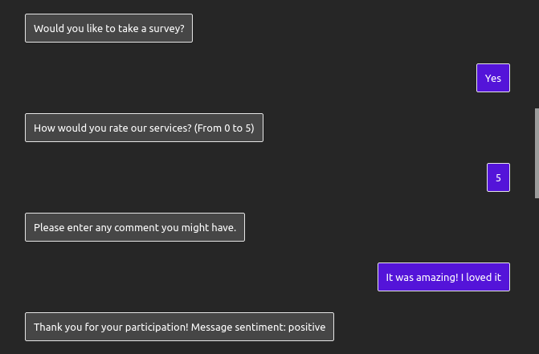
After each 3 main operations done, the bot will prompt the user if they would like to fill a satisfaction survey. The survey is done in two steps, the first step is the rating from 0 to 5, and the second step is to enter any comment. Sentiment analysis is run on the user’s comment (second step) and the sentiment is show back.

The user can be dissatisfied with the service as well:
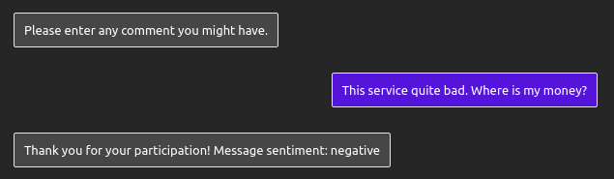
- Recommendation:
After 3 successful transactions initiated by the user, the bot will simply recommend the user checks out the “Golden Account” for better transaction services.
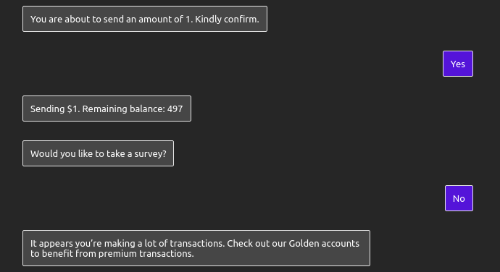
- Validation:
Data input is validated where needed. When viewing a specific transaction, the given ID is checked in the data storage for existing matches. In the survey, the rating is validated to make sure it is inside the range 0-5. When making a transaction, the amount to be paid is valid if it is between 0 and 100, and less than the amount available in the account.
- Canceling operations:
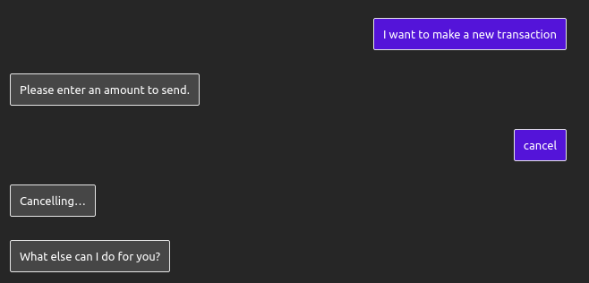
Filling surveys and making transactions are multi-step dialogs. The user can cancel mid operation by typing “quit” or “cancel”.

- Telemetry:
An App-Insights is linked to this chatbot. Data from LUIS is also available to see the amount of Endpoint hits per day.
