Project Report for the UCU Innovators Hub
1. Introduction
The UCU Innovators Hub is a web-based collection that shows off, organizes, and promotes student ideas at Uganda Christian University. The system brings together project submissions, approvals, documentation, and analytics to help with visibility, collaboration, and academic value.
2. Defining the Problem
UCU doesn't have a single place to store and show off research projects, prototypes, and new ideas. Students and teachers have a hard time finding old work, which leads to repetition and missed chances to work together.
3. Goals
Create a central digital storage space for student innovations.
- Allow projects to be submitted, approved, and shown to the public.
- Give admins access to analytics.
- Help people work together by leaving comments and feedback.
4. The project's scope
The minimum viable product (MVP) has user management, project submission, approvals, a public gallery, dashboards, and basic collaboration tools.
5. The structure of the system
The system is built on a client-server model, with a React front end, a Node.js/Express back end, and a PostgreSQL database. JWT is what you use to log in.
6. ER Diagram (Description)
Users, Projects, Categories, Technologies, Comments, and Approvals are the most important entities.
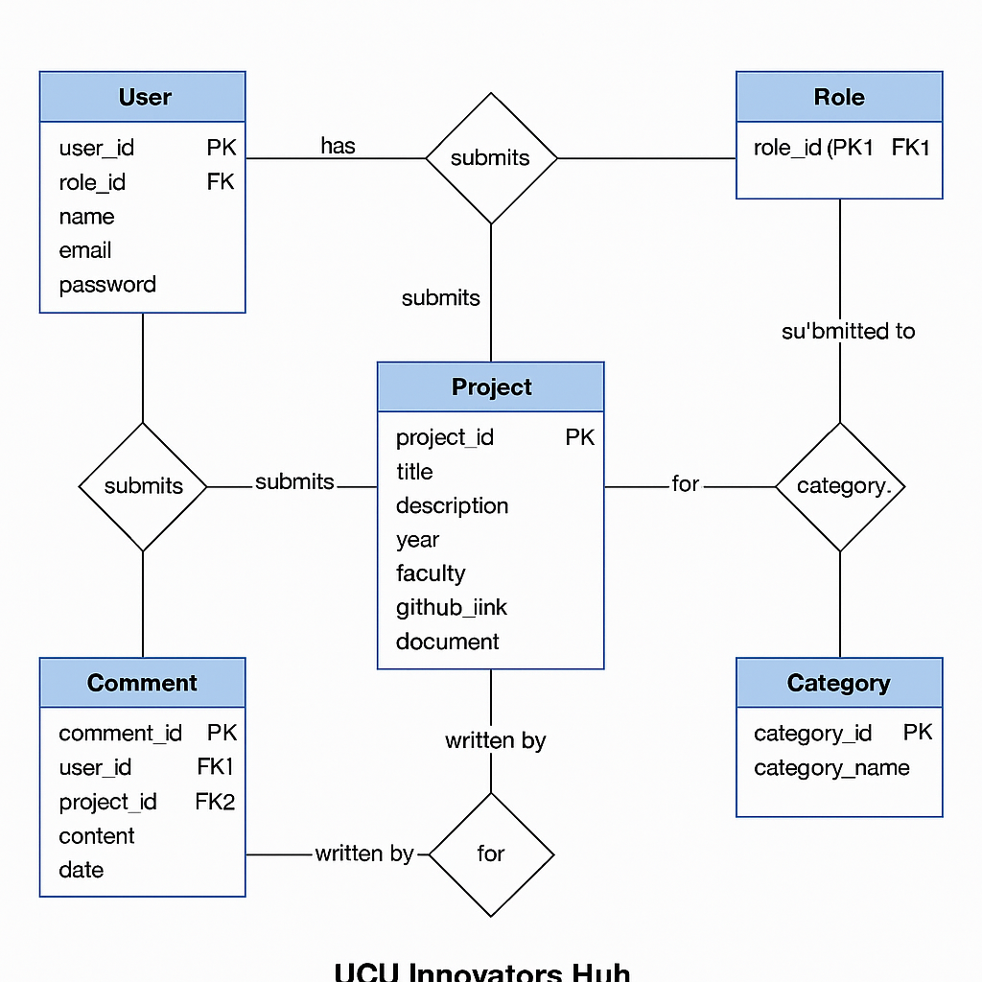

7. Technology Stack
Frontend: React
Node.js (Express) is the backend.
MySQL is the database.
Where to host: Local or Cloud
8. APIs
User APIs: sign up, log in, and get access based on your role.
Project APIs: send, change, get, and approve.
Analytics APIs: counts, trends, and charts.
9. Summary of Testing
Testing included unit tests for APIs, checks on how responsive the UI is, and validation tests.
10. Conclusion
The Innovators Hub is a scalable platform for UCU to manage and show off student innovation.

