To take CS 130 we will be working in Linux. This will require a Linux installation. There are multiple ways to this:

* Install it on a system overwriting your current OS.
* Dual-boot (Multiple OS on the same system)
* Virtual OS installation (recommended, and can work in your current OS)
  + This is the easiest method but also will tax systems depending on the speed of your current system.

I will be using an Open Source program called Virtual Box. Download the software here and following the installation instructions for your operating system. <https://www.virtualbox.org/wiki/Downloads>. Current version tested on is 5.2.6 but slightly newer or older versions should work the same. Install all available options.

During installation your internet connection may stop working while the program is installing. Make sure you aren’t downloading your Ubuntu installation as it will kill the download.

Once Virtual Box is installed you will need to download Ubuntu LTS 16.04. The current version of Ubuntu is 16.10 but we will be using the one that is a little bit more stable, LTS stands for Long Term Support. In addition, please use the 32 bit installation of Ubuntu, depending on the setting of your computer 64-bit may or may not work. Here is the image location: <http://releases.ubuntu.com/16.04/>

In Virtual Box create a new OS image by clicking New. If you name it Ubuntu, virtual box should prefill in the selection with the correct OS (Type) and you may need to change the version to 32-bit. It should look like below:

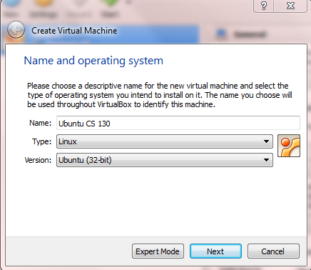

RAM should ideally be 4096 (but depending on your sytem you may have to use 2048) but this can be adjusted later if you have speed issues. Use the standard options for Hard Disk but you should create a disk of at least 20 GB we wont be using all the space but allows room for growth. Use the dynamic allocation option.

Before starting the OS image you need to add the Ubuntu disk so that you can install it. Click on the storage (you need to click setting to get here) and in the cd image choose the location of where you downloaded Ubuntu. The file should be the .iso image file (This screen shot shows Ubuntu 14.4 but you should see 16.04). See the screen shot below:

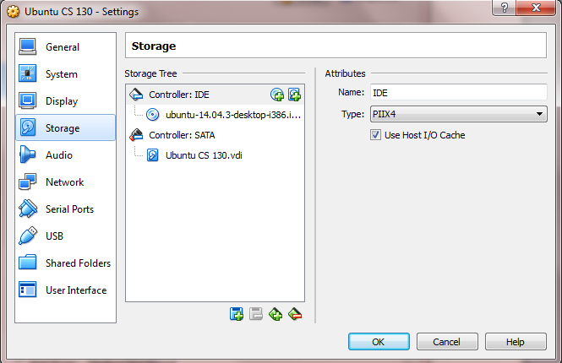

Now you are ready to click Start on the Main Virtual Box menu. Choose Install Ubuntu. You should end up with something like this:

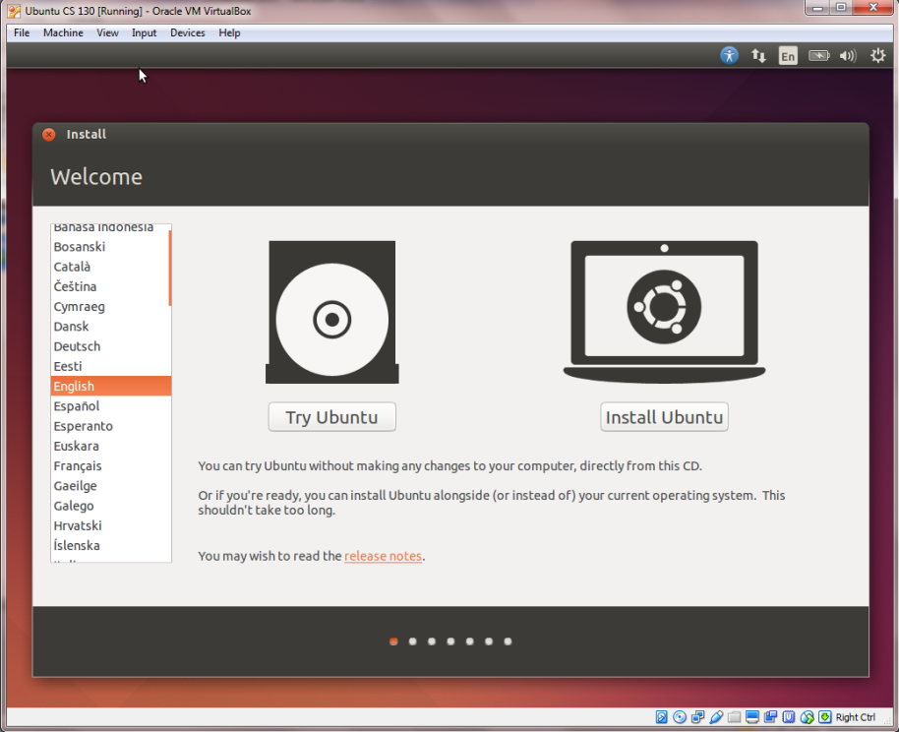

Click the install 3rd-party software.and download updates while installing. Erase the disk if using Virtual Box. Use default settings, choose your username and password (remember this password)

When the installation is done it will ask for a restart. Instead click the gear in the upper right corner and choose shutdown. You may have to move the restart box as the shutdown message might appear behind it (not a very good design).

Start up the Ubuntu.

In the terminal run the followining. You can reach the terminal by clicking the Ubuntu logo and typing terminal.

sudo apt-get update

sudo apt-get upgrade

sudo apt-get install apache2 mysql-client mysql-server php7.0 php7.0-mysql php php-cli libapache2-mod-php

During the install it will ask you for a password at least once fill it in with the same one used to access the system.

Add the following packages

sudo apt-get install graphviz aspell php7.0-pspell php7.0-curl php7.0-gd php7.0-intl php7.0-xmlrpc php7.0-ldap php7.0-mcrypt clamav

Verify the Apache Installation

Open up Firefox and type 127.0.0.1 in the address bar. You should now have Apache Web Server running.

Note: Use the Firefox that is in Ubuntu not on your regular OS as it won’t be able to access your server.

Verify PHP Installation

sudo nano /etc/apache2/mods-enabled/dir.conf

Add index.php to the front of DirectoryIndex(it should be later in the list). To save/exit Ctrl+X will work and follow the prompts.

Next let’s create a test php page

sudo nano /var/www/html/info.php

Add the following to the file

<?php

phpinfo();

?>

Then save and exit.

Verify php by going to 127.0.0.1/info.php in firefox.

Setup MySQL

Verify that your MySQL is started

sudo systemctl status mysql

That’s all that for MySQL. Typically we should run a security script here but it can make it harder for us to use so we will omit that. However, if you ever setup a webserver that will be on the internet you should run the security script. (You may need to hit q to type next)

Install phpMyAdmin

sudo apt-get install phpmyadmin

Make sure that during installation you choose Apach2 as the server. Yes when asked to configure the database for phpmyadmin with dbconfig-common. You will enter the MySQL password (which should be the same as your Ubuntu password). Next use the same password for PhpMyAdmin. Again we want to make this simple so we are using the same password but to make the system more secure different passwords should be used.

Next run:

sudo nano /etc/apache2/apache2.conf

Add the phpmyadmin config to the file.Go below the # Global configuration which on mine was about 4 or 5 screens down using the down arrow key.

Include /etc/phpmyadmin/apache.conf

Restart apache:

sudo systemctl restart apache2

Now verify that phpMyAdmin works. Go to 127.0.0.1/phpmyadmin in firefox your username is root and the password should be the same as what you used to install it.

Most of the instruction can also be found online at the following two locations. Most of the security stuff has been omitted as we aren’t going to be deploying these systems to the web for public use.

* [https://www.unixmen.com/how-to -install-lamp-stack-on-ubuntu-16-04/](https://www.unixmen.com/how-to%20-install-lamp-stack-on-ubuntu-16-04/)
* <https://www.digitalocean.com/community/tutorials/how-to-install-linux-apache-mysql-php-lamp-stack-on-ubuntu-14-04>

Good Basic Linux Tutorials that should be read.

* https://www.digitalocean.com/community/tutorials/an-introduction-to-the-linux-terminal
* https://www.digitalocean.com/community/tutorials/basic-linux-navigation-and-file-management
* https://www.digitalocean.com/community/tutorials/an-introduction-to-linux-permissions