**Computer Organization Lab 05**

**Pipelined CPU with Forwarding and Detection Unit**

**0016110 洪茂榮、0016328江振皓**

**Architecture diagrams:**

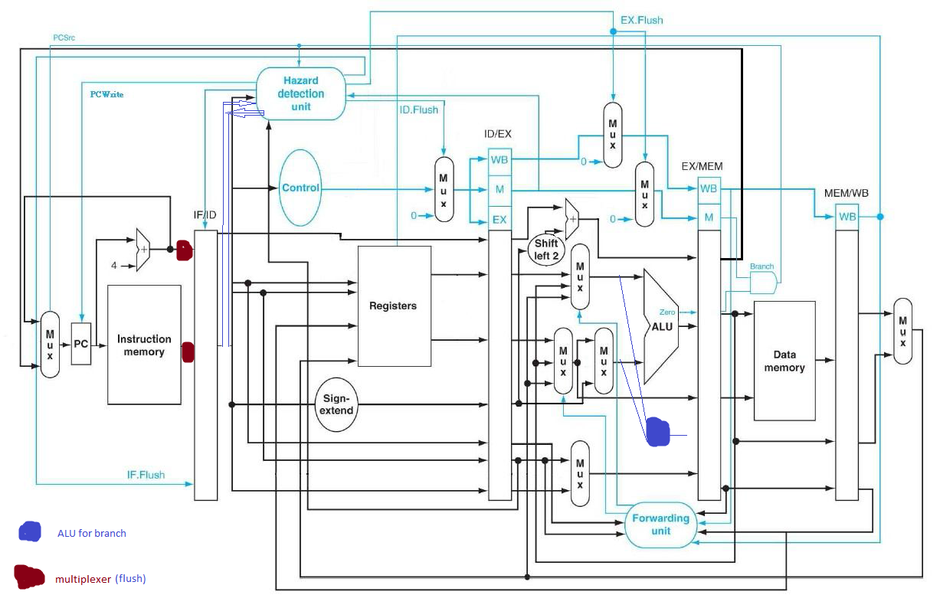

**Hardware module analysis:**

**In this assignment, other than the Forwarding and Hazard Detection Unit, some multiplexers are added to accomplish the flushing or remain the same condition at IF/ID stage.**

**Experiment result:**

**We eventually implemented the basic and the advanced parts with branch decision checking done at stage 4.**

**Problems you met and solutions:**

**At first we were trying to do the branch decision at stage 2, as we know that it will reduce the penalty when branch is taken. However, it turned out that we need to add additional forwarding unit in order to solve the data dependency from stage 3, 4 to stage 2 which was so cumbersome.**

**Finally, we decided to do the branch decision at stage 4 that make life easier.**

**Summary:**

**0016328江振皓:**

**In this lab, we dealt with data hazard and control hazard properly by adding a forwarding unit and a detection unit. Many problems emerge during the stage of debugging and they stimulated us to think carefully about the architecture of our project and come up with various methods to help us solve the problems.**

**0016110 洪茂榮:**

**I learnt the implementation of data forwarding and dependency detection in pipelined CPU and experienced that reducing the branch penalty into 1 cycle really needs a lot works.**

**Job distribution:**

**Basic, Advanced 1, Advanced 2 – 0016110 洪茂榮、0016328江振皓**

**Additional Reports:**

**We also done the branch at stage 2 that works without dependency.**