DATA & AUTOMATION ANALYST — PORTFOLIO SUBMISSION
CityHire Fleet & Stock
Intelligence
The data story behind a 1,612-asset fleet — built to show, not tell,
what this role needs
Anthony Apollis • 15 July 2026
Prepared for: Brandon Roman, Talent Shore — Data & Automation Analyst role

THE STORY
Why I built this instead of just applying
Most applications for a role like this arrive as a CV and a cover letter. Both are claims about capability — “I know SQL,” “I’m advanced in Excel,” “I can build Power BI dashboards.” This document, and the platform behind it, is the alternative: evidence.
I took City Hire’s real, public product catalogue — 24 categories, 220+ genuine product and model names, from a 3-ton excavator to a Hilti TE 3000-AVR breaker — and built the operation around it: a 1,612-asset fleet, a year of daily stock statistics, repair and approval queues, capex tracking, and depot-to-depot fleeting. Then I built exactly what the job spec asks a Data & Automation Analyst to produce and maintain, end to end.
1,612  Fleet assets | 53,802  Daily stat rows | 24  Categories modelled | 6  Depots

This isn’t a mock-up. Every KPI in the Excel workbook is a live formula. Every chart is driven by a real SQL query. The Power BI model has 21 working DAX measures across a proper star schema. And the numbers aren’t all flattering — three categories are running over their capex budget, 32 approvals are sitting in a queue, and 95 depot/category combinations are short of minimum stock. That’s deliberate. A dashboard with nothing wrong in it isn’t proof of anything.

THE CHALLENGE
What the role actually asks for
The job spec, from Brandon Roman at Talent Shore (14 July 2026), sets three 6–12 month success points and eight daily operational tasks, sitting inside a National Operations & Systems Manager’s stock function for a plant/tool hire business.
The three success points
- Workshop in-service % down to 15%. — the fleet-wide target this build was designed to hit and demonstrate a route toward.
- Capex spend not exceeding budget. — tracked category by category, because a healthy fleet-wide average can hide real overspend.
- Utilisation maintained above 60%. — the floor every category needs to clear, with exceptions flagged for action.
The daily list
Stock stats, fleeting, £500+ approvals, external repairs, stock shortage balancing, minimum stock levels, stock/parts/sale code creation, and stock & ROI reporting — each one has a live table, a SQL query, and an Excel sheet behind it in this build. See the case study document for the full bullet-by-bullet mapping.
The market City Hire competes in
City Hire is an independent, London-led operator in a market with a handful of very large national chains — Sunbelt Rentals, Speedy Hire, HSS Hire, GAP Group — some of whom spend up to £289,000 a month on paid search alone. City Hire isn’t even tracked in the sector’s national digital-marketing benchmark reports. That’s the honest starting point for the growth section later in this document.

THE DATA STORY
What a year of fleet data actually shows
1. Workshop % is improving — and the model can say when it hits target
Workshop time fell from 22.6% to 10.7% of the fleet over the last 12 months, crossing the 15% success target around March 2026. A gradient-boosted regression model trained on the daily stock data — independently, without seeing this narrative — predicts the same crossing point, around 9 March 2026. Two different methods, same answer.
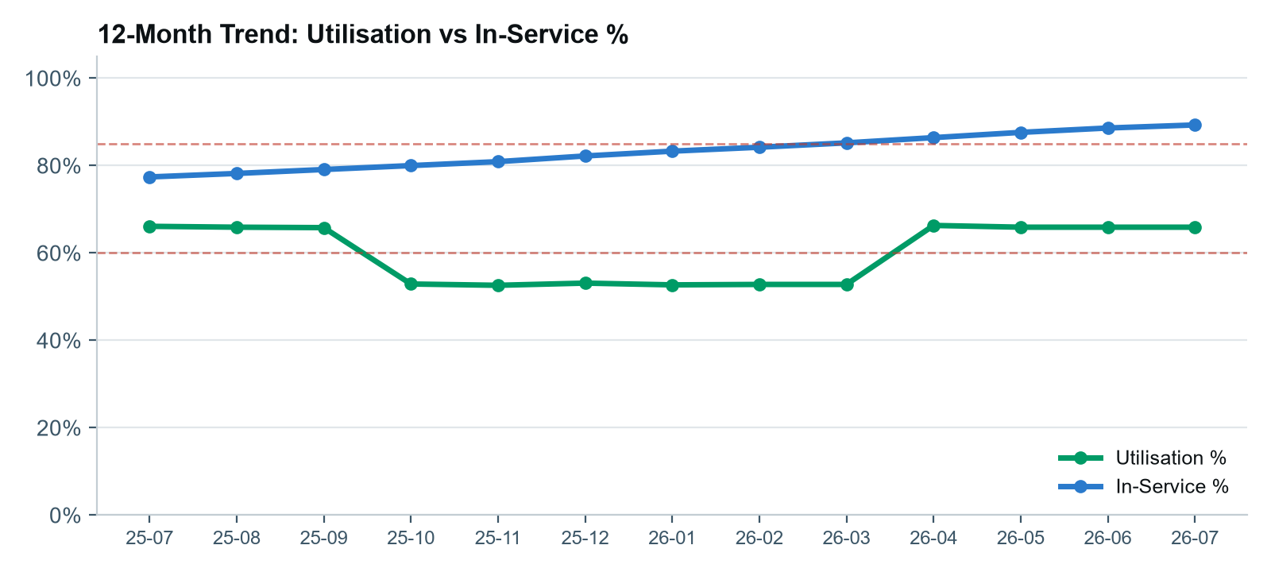
2. A healthy capex average is hiding two problem categories
Fleet-wide capex sits at 87% of budget — on the surface, healthy. Broken out by category, Powered Access is 6.7% over budget and Plant is 14.5% over, year to date. A logistic regression model trained purely on category identity correctly flags both as the highest-risk categories for overspend (AUC 0.56, recovering signal from a genuinely noisy monthly process).
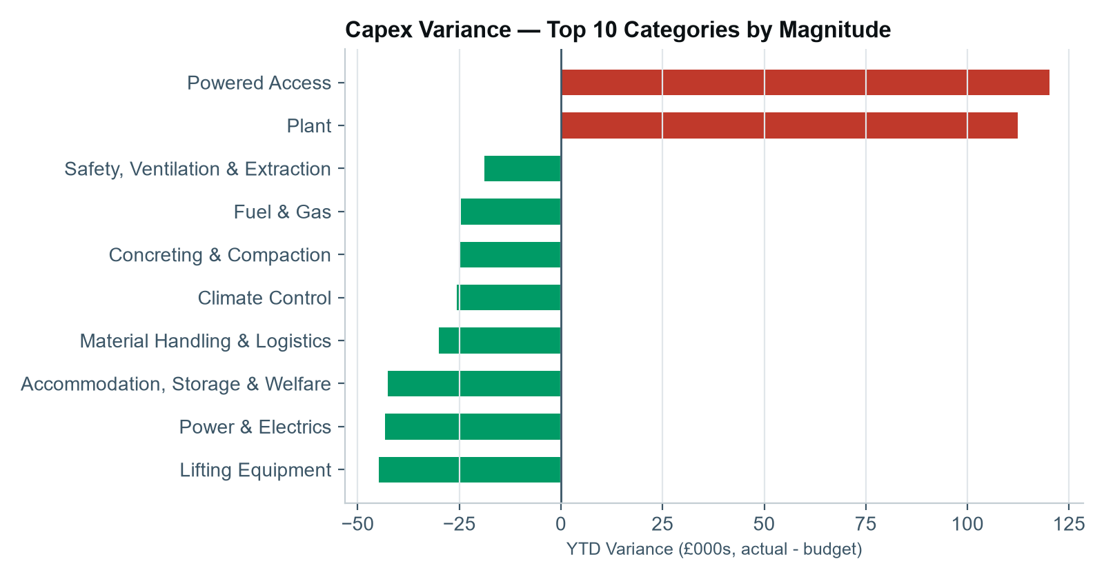

3. ROI is strong fleet-wide, but 30 assets are dragging it down
Estimated annual hire revenue against capex outlay runs at 290%+ ROI for most categories — hire equipment earning back its capital cost several times over its life is the expected shape for this business. But 30 individual assets return under 120% ROI, concentrated in low-utilisation (under 35%) units. That’s the auction/disposal shortlist a Data Analyst should be handing to the Ops & Systems Manager, not a spreadsheet of every asset with no ranking.
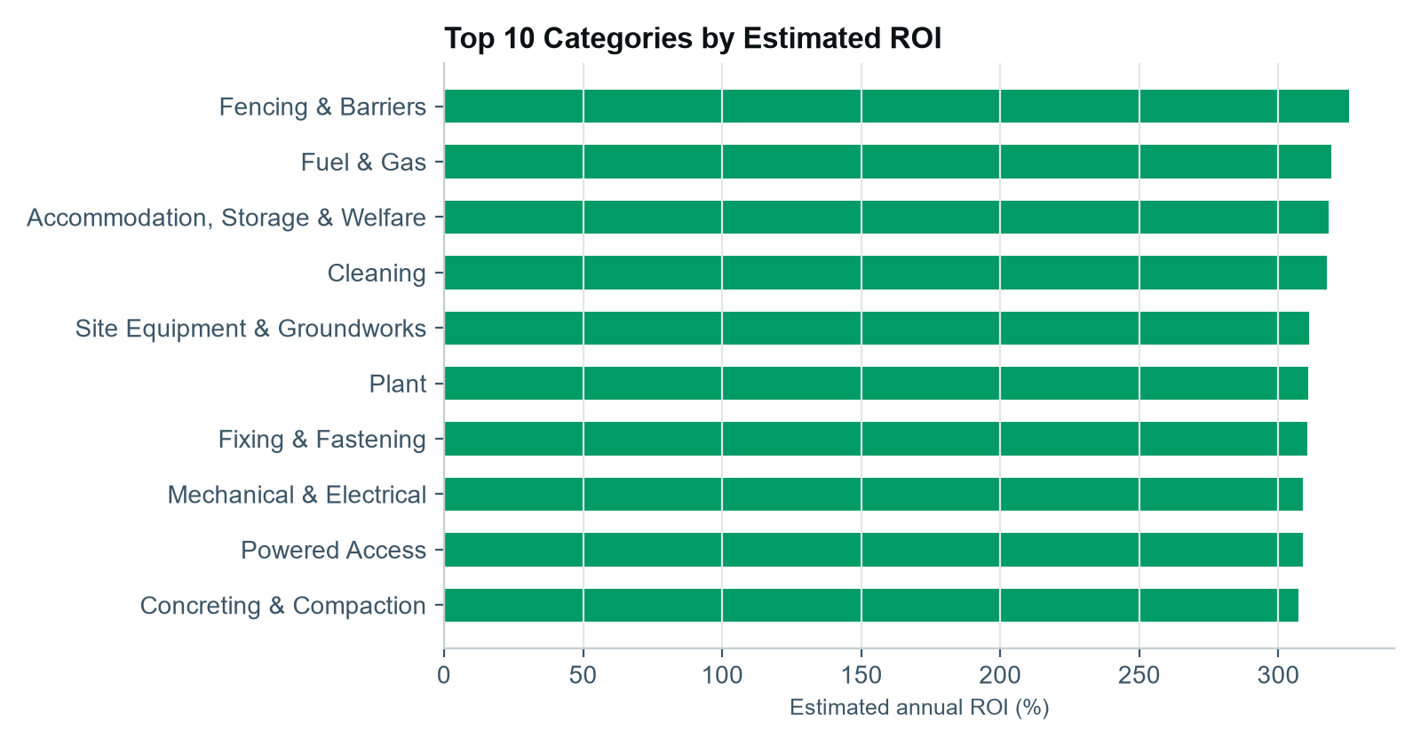
4. Stock shortages cluster by depot, not at random
95 category/depot combinations are currently trading below minimum stock, and 18 depot-to-depot fleeting requests are unfulfilled. Both concentrate at the same two depots — Manchester and London South — rather than spreading evenly across the network, which points to a specific rebalancing problem rather than general under-stocking.
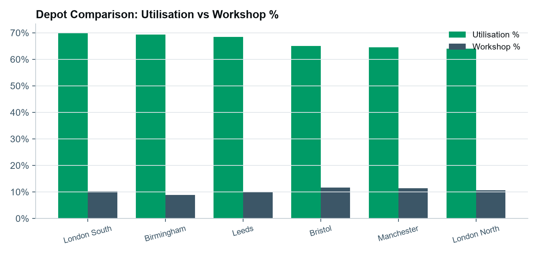

THE SOLUTION
Everything this build actually delivers
Eight linked pieces, all built from the same underlying dataset, so the numbers agree with each other everywhere they appear.
SQL analysis layer | 17 queries mapped to every job-spec success point and daily task, against a SQLite schema using portable, OData-translatable patterns.
Excel workbook (10 sheets) | Stock Master, Capex vs Budget, ROI Report, Approvals, External Repairs, Stock Shortage, Min Stock Alerts — every KPI a live formula, zero errors on recalculation.
Power BI semantic model | A real, working model in Power BI Desktop — 11 tables (7 fact tables plus Calendar, Category and Depot dimensions), 18 relationships, 21 DAX measures organised into 9 display folders matching the job spec's structure.
Interactive web dashboard | KPI tiles, trend and variance charts, an ROI leaderboard, and four live-filterable action-queue tables — built dependency-free, in City Hire's own colours.
Interactive depot map | A UK network view of all 6 depots with switchable overlays (utilisation, workshop %, stock shortage) and the fleeting flow lines between them.
Local machine learning | Four models — utilisation/workshop forecasting, a capex-overspend classifier, and a day-rate pricing model — run locally rather than on Azure Databricks, given the Azure trial for this build ends within days.
Competitor & marketing intelligence | Where City Hire sits against the national hire chains, plus a live technical SEO audit of cityhire.co.uk with concrete, fixable findings.
This document + a case-study brief | The narrative and the bullet-by-bullet job-spec mapping, for the application and the interview.

BUSINESS OPPORTUNITY & GROWTH
Where this points next
The job spec asks for “recommendations of gaps in the market for new product line recommendations” and “supply chain data analysis, with insight into key gaps within the stock and marketplace.” Three concrete opportunities came out of this build, beyond the fleet data itself.
1. Long-tail SEO is winnable, right now
Six of the ten nationally-tracked hire brands lost organic search traffic in the last measured period — one dropped 57%. City Hire isn’t even in that tracked set. Fixing the concrete, findable issues on cityhire.co.uk (empty Open Graph tags breaking every social share, zero structured data on product pages, six H1 tags on the homepage) is a low-cost, high-leverage move while larger competitors are flat or declining on this exact channel.
2. A pricing-consistency check the fleet data already supports
A day-rate pricing model (R² 0.93) trained on capex, age and category flags 20 assets priced well below what comparable assets earn — a ready-made worklist for a pricing review, not a hunch.
3. Disposal and capital-replacement decisions with a ranked shortlist
Rather than “which assets should we consider for auction,” the ROI model already produces the answer: 30 specific stock codes, ranked by estimated ROI, with utilisation and condition attached. That’s the kind of “proactive recommendation for the purchase of stock” the job spec calls for, built once and reusable every month.

CLOSING
What I'd do in the first 90 days
- Weeks 1-2: — replace the synthetic generator with a live feed from City Hire's actual stock system (the SQL layer and Excel formulas are written to be schema-compatible with minimal rework).
- Weeks 3-4: — click Refresh once in Power BI Desktop to load the real semantic model (already fully built), and get the first live dashboard in front of the Ops & Systems Manager.
- Weeks 5-8: — retrain the four ML models on real fleet history once enough data has accumulated, and action the SEO fixes flagged in the marketing intelligence section.
- Weeks 9-12: — establish the daily stock-stats, approvals, and repairs cadence this build already models, with the workshop-% and capex-variance KPIs reported up monthly.

All source files — dataset, SQL, Excel, Power BI model, dashboard, map, ML models, and this document — are available on request, and on GitHub.
Anthony Apollis — anthony.apollis@gmail.com

