APPLIED DATA & AUTOMATION — A FLEET INTELLIGENCE PLATFORM
CityHire Fleet
& Stock Intelligence
SQL. Excel. Power BI. A live Azure database. Network graphs, funnels, seasonal
forecasting and a recommendation engine — built on a 1,612-asset fleet.
Anthony Apollis · Data & Automation Analyst



THE PLATFORM
Nine analytics layers, one fleet
This platform is a full-stack demonstration of applied data and automation work: real product data grounding a synthetic fleet, then nine layers of analysis built on top of it — SQL, Excel, Power BI, a live cloud database, an interactive dashboard, network graphs, funnels, seasonal forecasting, and a recommendation engine. Every number in every layer traces back to the same 1,612-asset fleet, so nothing here is a disconnected demo chart.
1,612  Fleet assets | 53,802  Daily stat rows | 5,000  Synthetic hire orders | 9  Analytics layers | 6  UK depots

Category structure and 220+ individual product/model names — from a 3-ton excavator to a Hilti TE 3000-AVR breaker — are real, extracted from City Hire's public product catalogue. Fleet quantities, costs, utilisation, repairs, approvals, orders and transfers are synthetic, generated to give every layer below genuine, non-trivial signal to find.

FLEET PERFORMANCE
The core numbers, live
Three metrics drive fleet operations: how much of the fleet is earning (utilisation), how much is off the road (workshop time), and whether capital spend is under control (capex vs budget). All three trace to daily stock-count data across the full 12-month history.
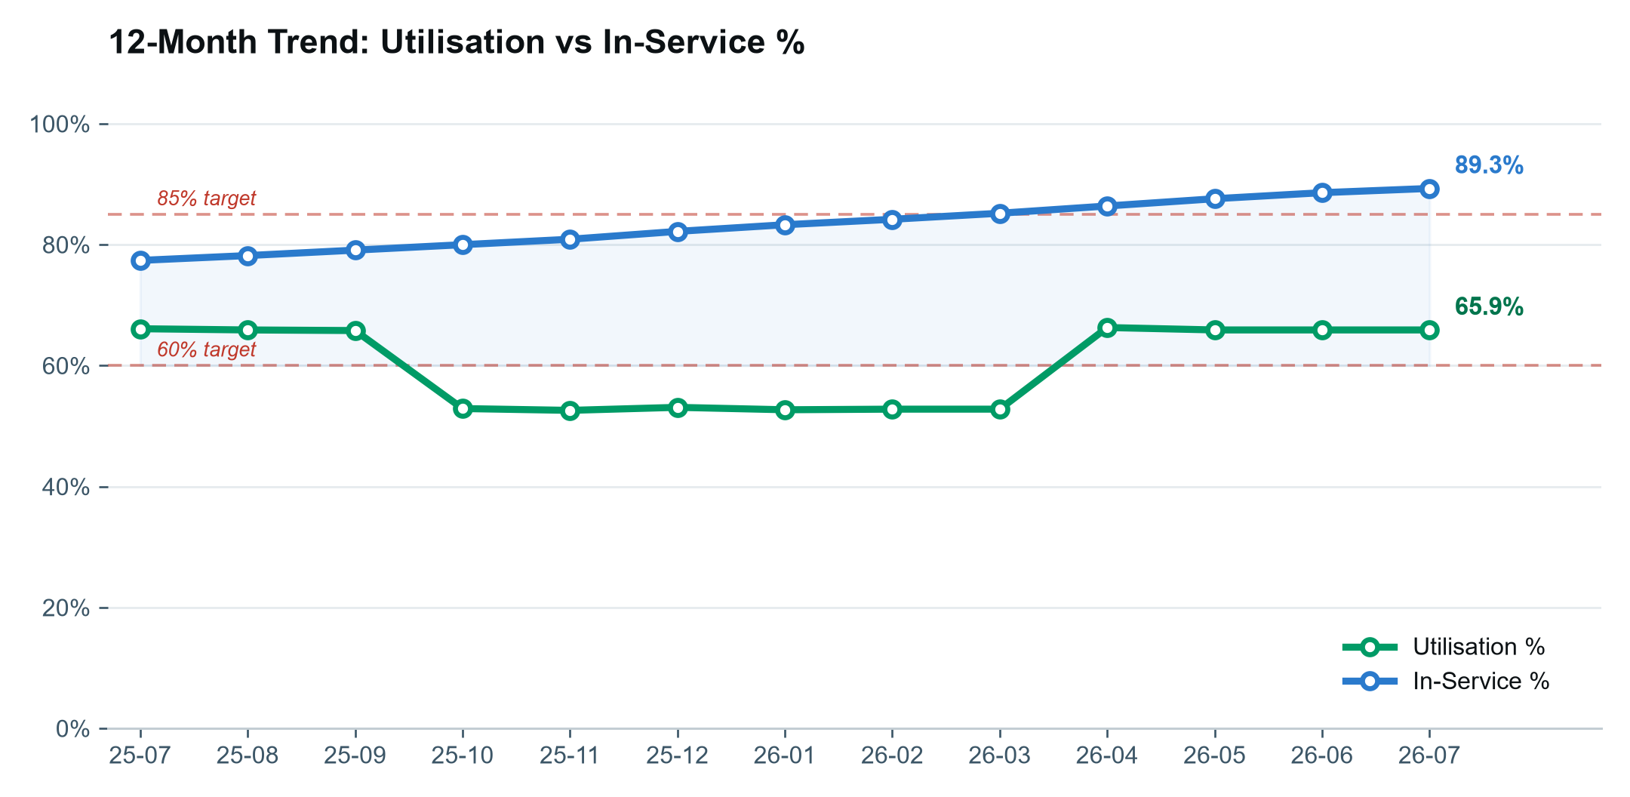
USE Track the two headline KPIs against their targets month by month — the gap between utilisation and 60%, and between in-service % and 85%, is the number to report upward each period.
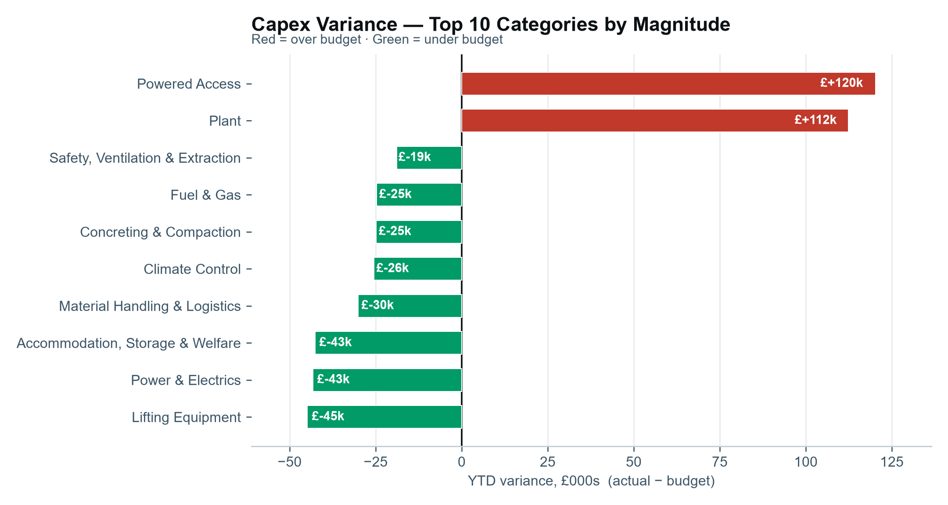
USE A category-level breakdown catches what a fleet-wide capex average hides — here, Powered Access and Plant are the two categories actually over budget, everything else is under.

14m Telehandler — one of the Plant category's highest-capex assets in the fleet

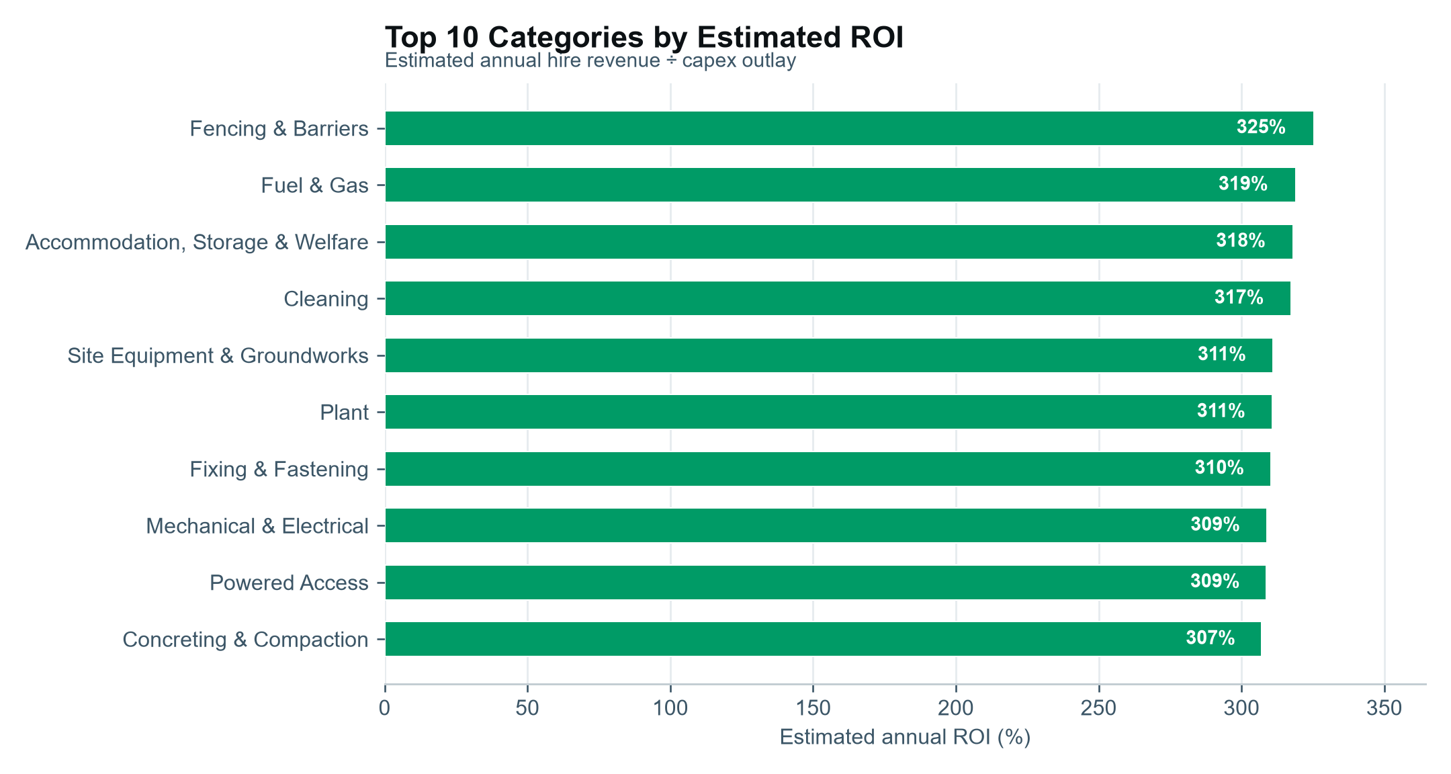
USE Rank categories by estimated ROI to prioritise the next capital purchase toward the categories already paying back fastest.
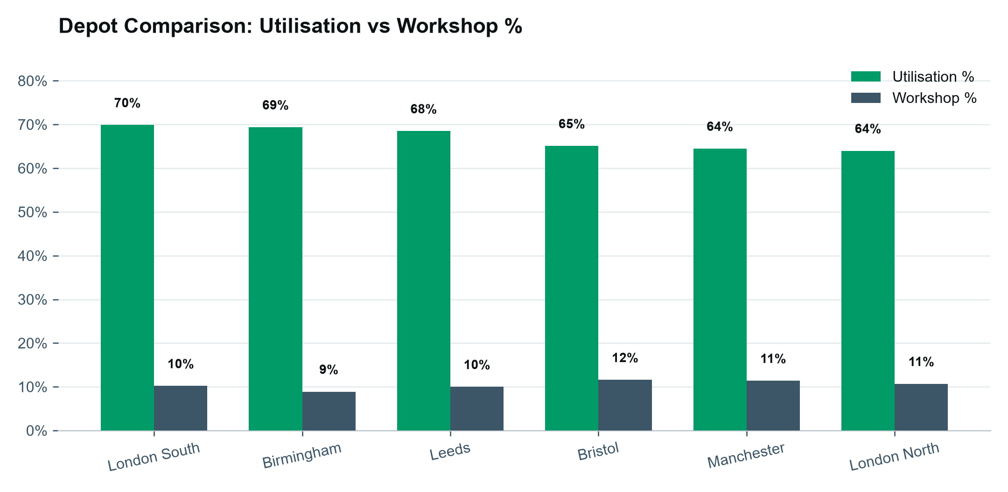
USE Compare depots side by side to spot which site needs operational attention — Bristol and Manchester run the highest workshop % here, worth a maintenance-scheduling review.

SEASONAL INTELLIGENCE
When demand actually moves, and why
A classical time-series decomposition splits fleet utilisation into trend, seasonal cycle and residual noise — the standard technique for separating "is this really seasonal" from random day-to-day variation.
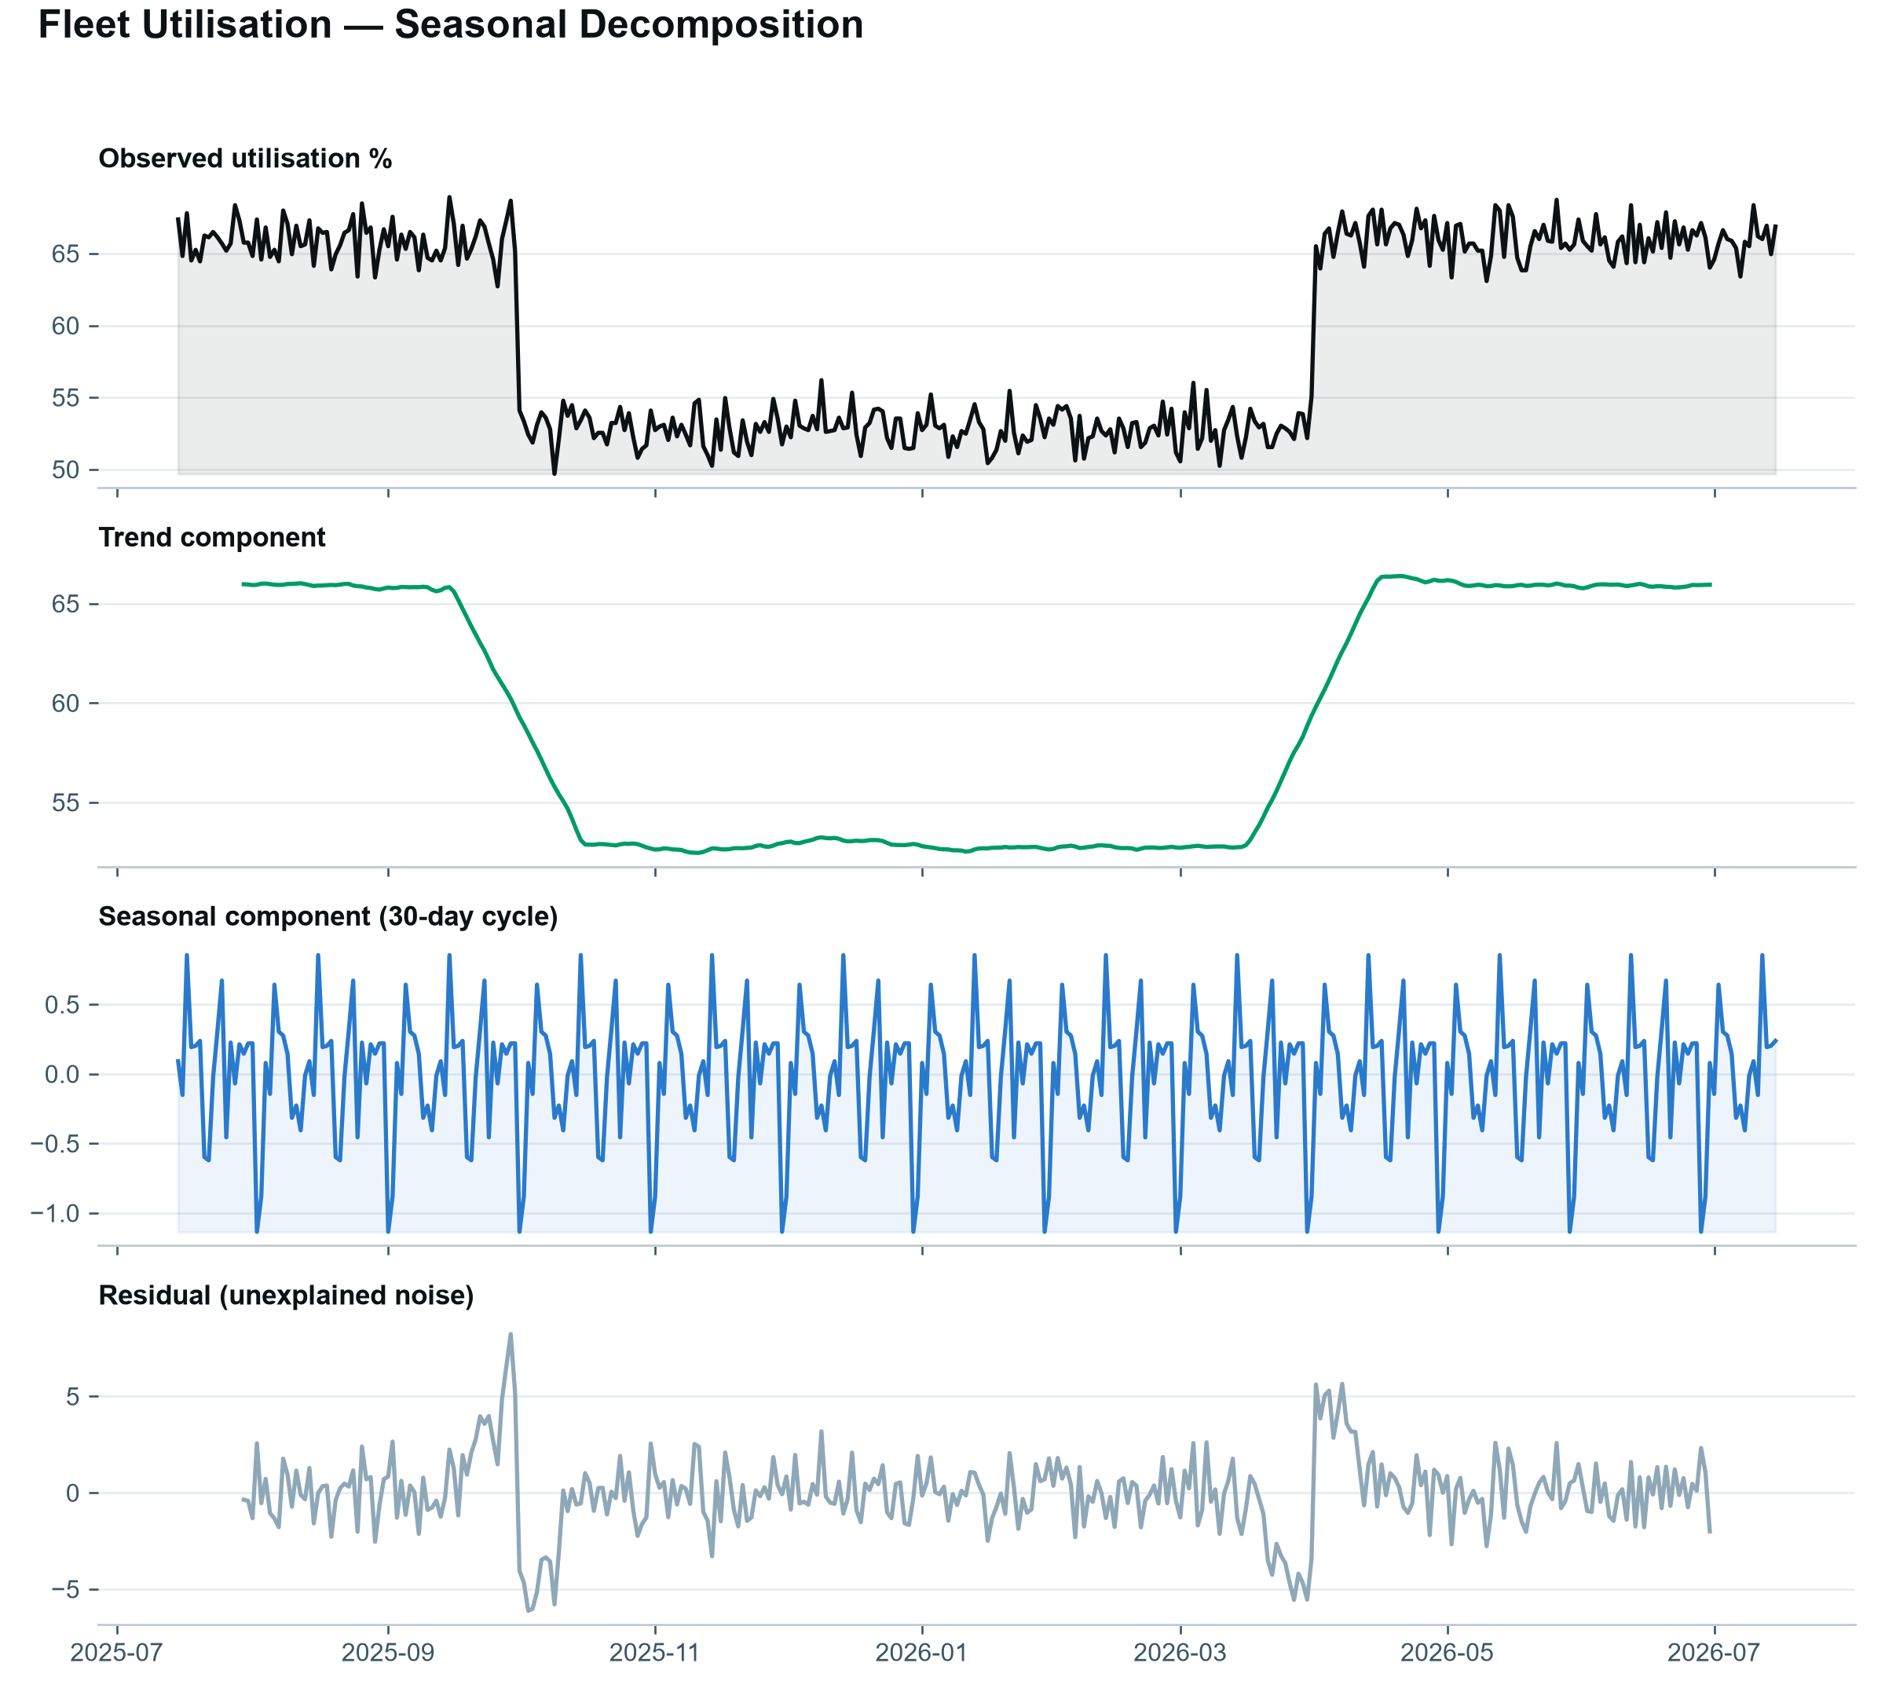
USE Confirms the seasonal effect is real and roughly 30-day cyclical, not noise — the trend line is what to report as the underlying direction of travel.

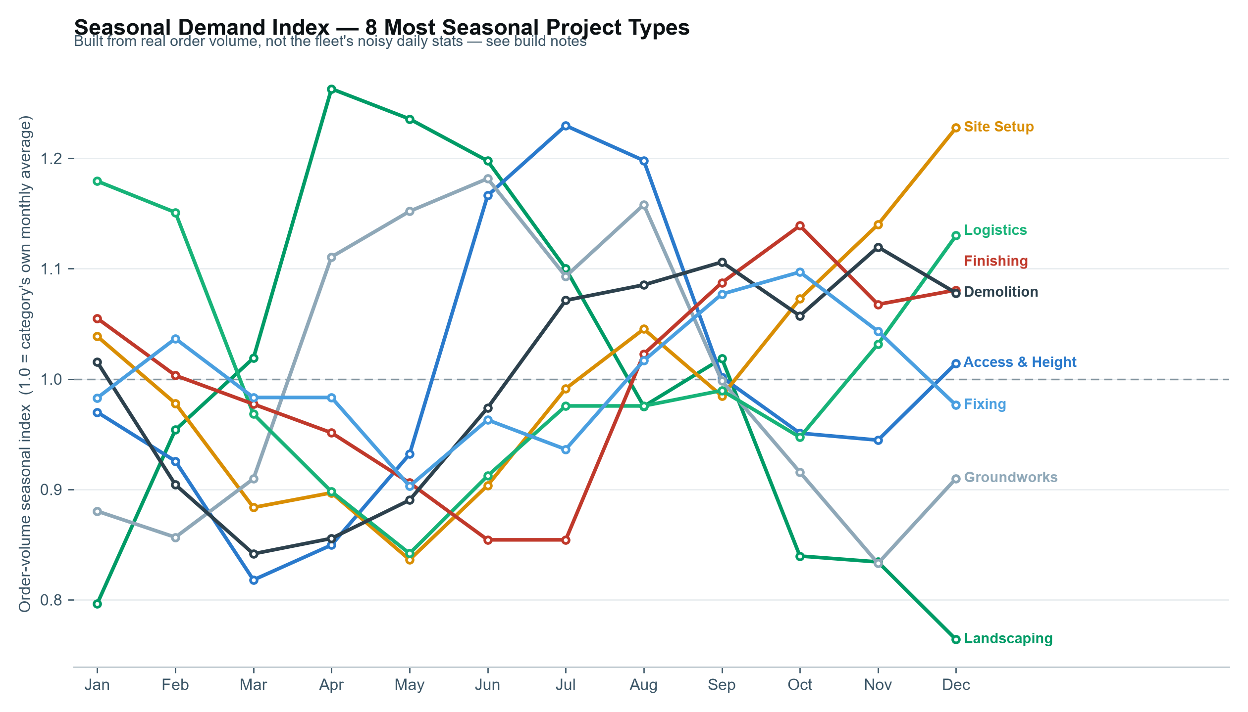
USE Read each project type's peak month directly off its line, then check it against current stock levels ahead of time — Landscaping peaking in April is a February purchasing decision, not an April one.
Network intelligence — graph analysis
Two graph models, built with NetworkX: which categories get hired together (a cross-sell network), and how stock actually moves between depots (a fleeting network). Centrality and community-detection algorithms turn raw transaction/transfer data into a structural map of the business.
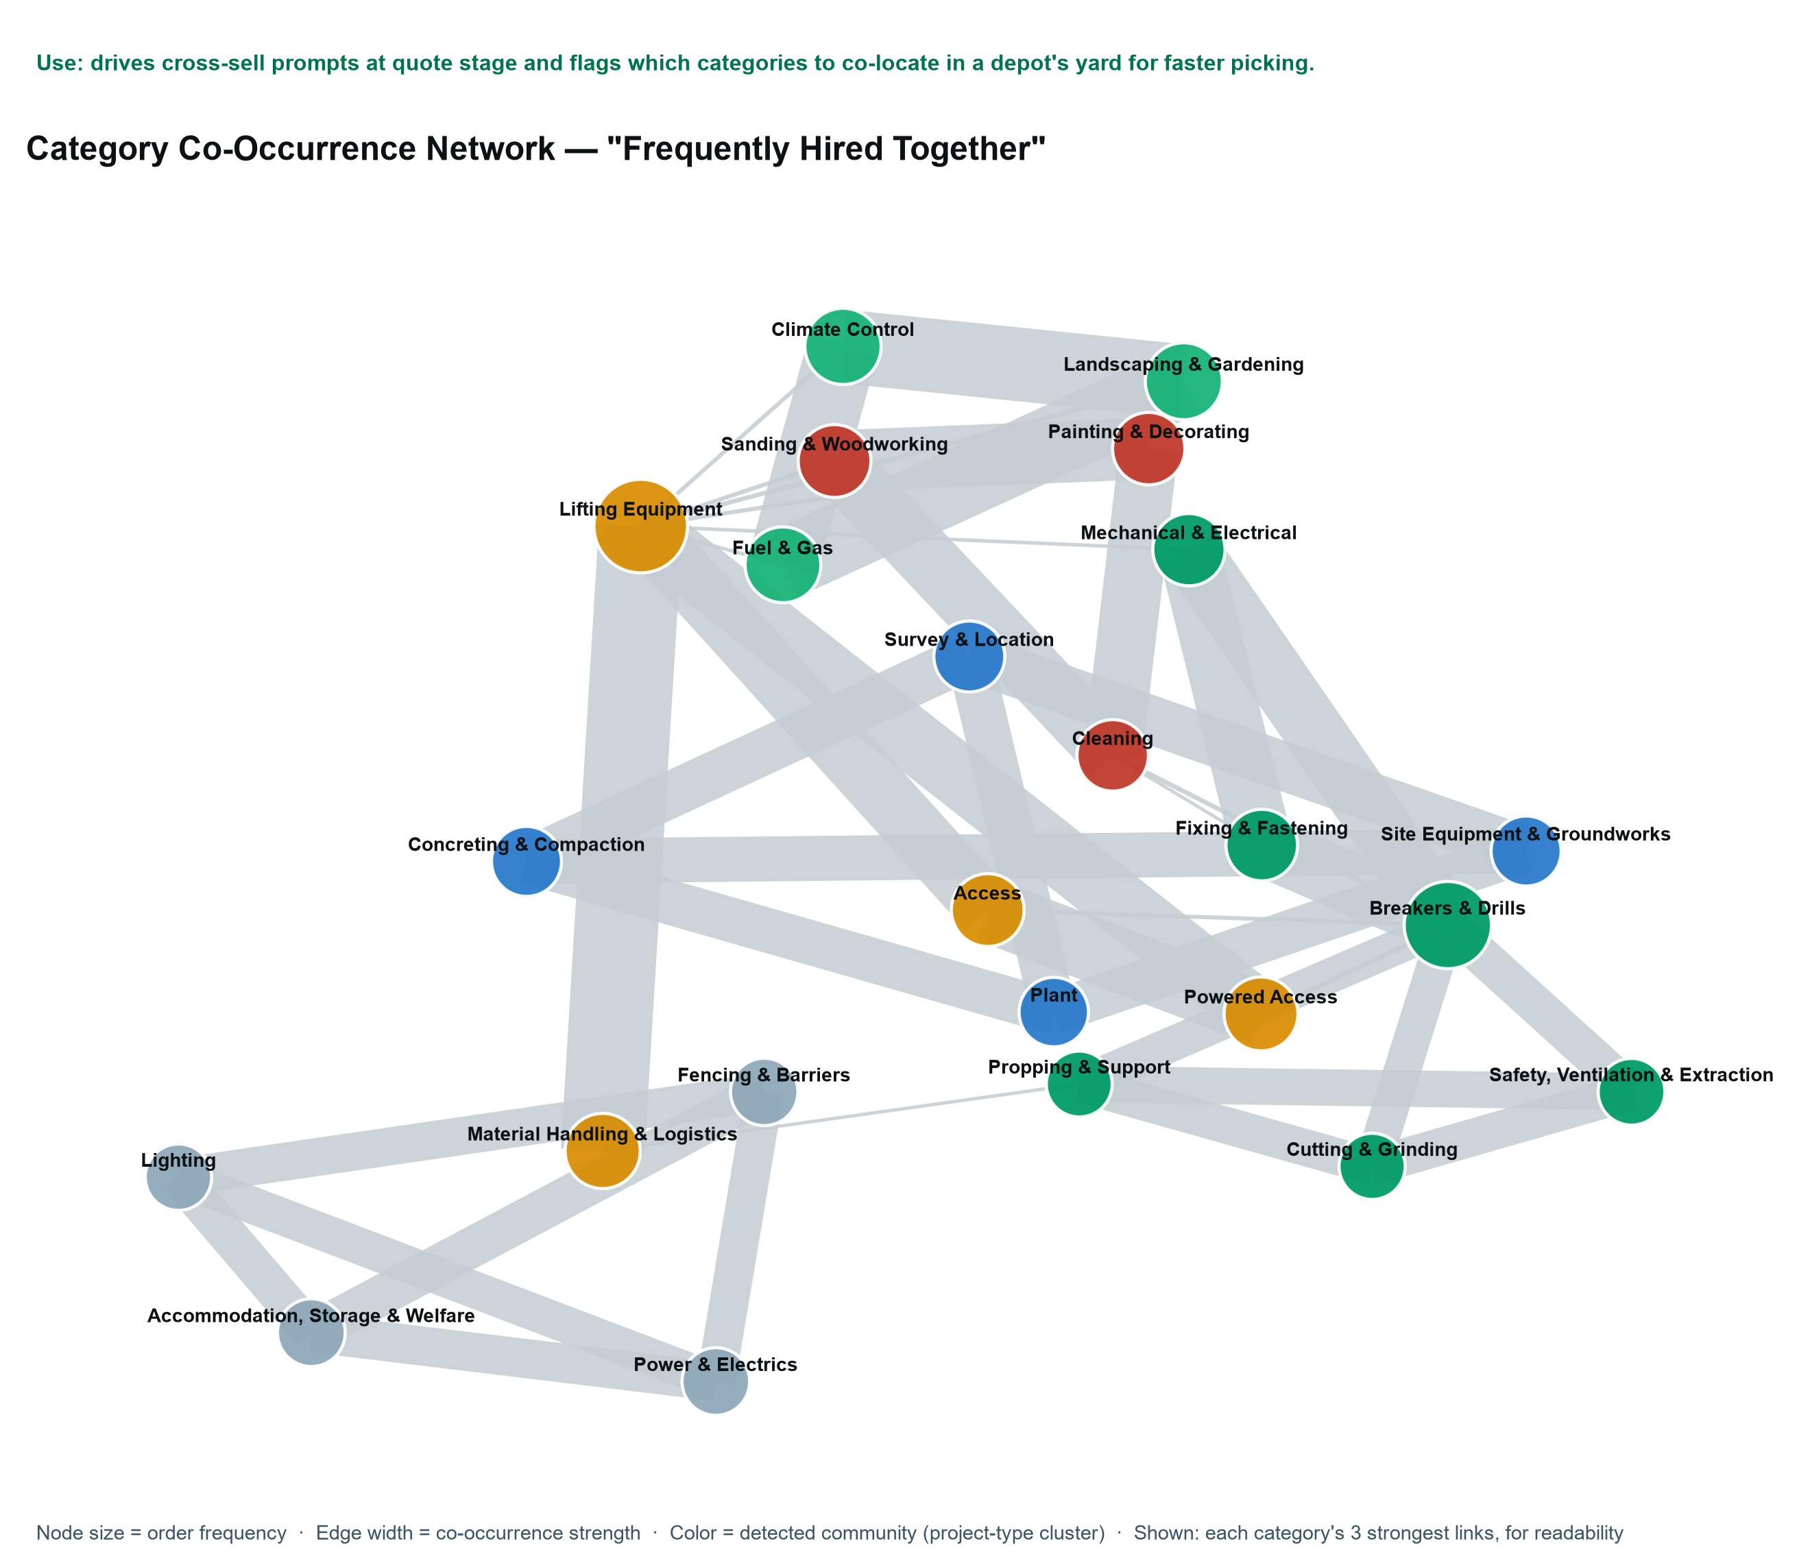

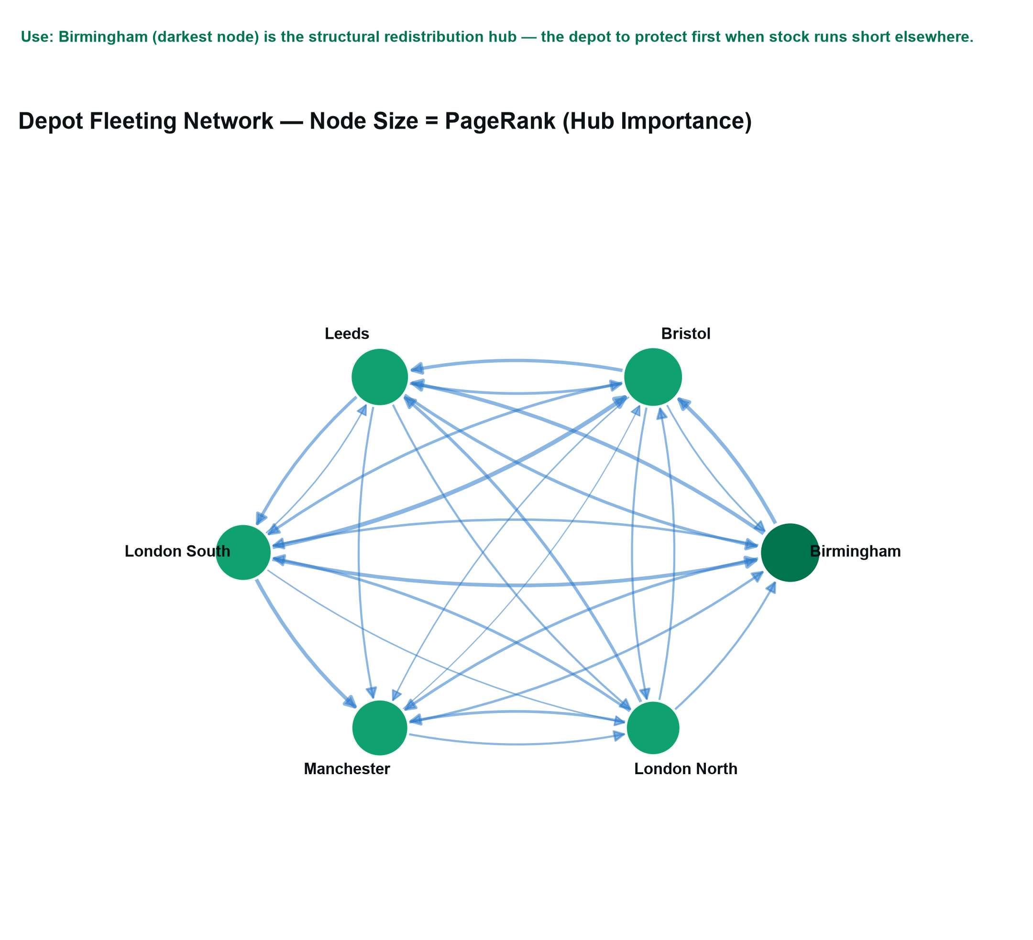
Funnel intelligence
Three funnels, each answering a different operational question: how many quotes actually become completed hires, how quickly approvals clear, and (directionally) how the digital side of the business converts.
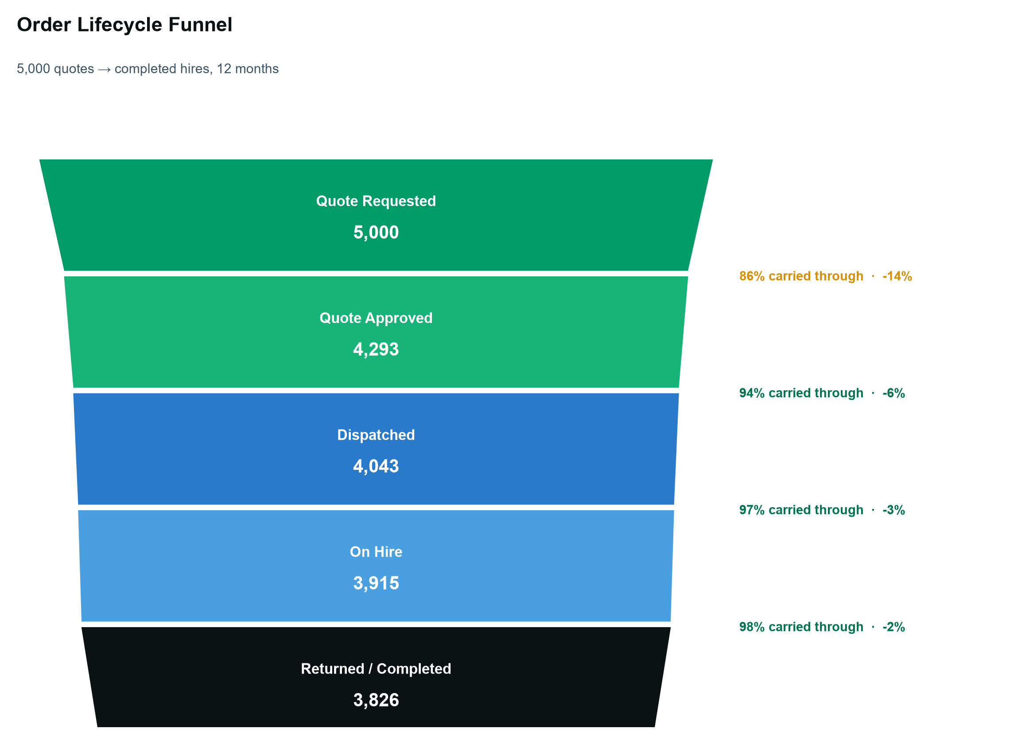
USE The biggest single drop is quote-to-approval (86% carried through) — the stage worth instrumenting first if conversion needs to improve.

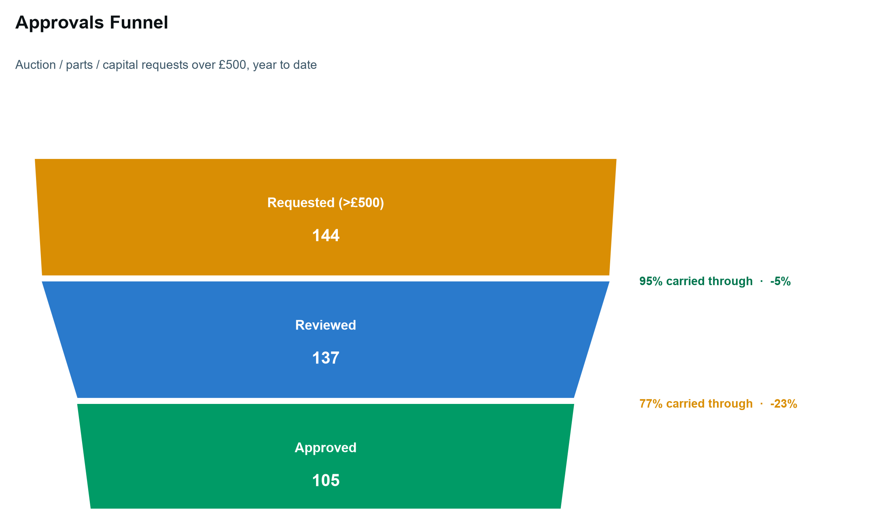
USE A live approval-rate benchmark (72.9% here) — track this monthly to catch a slowing approvals process before it becomes a bottleneck.
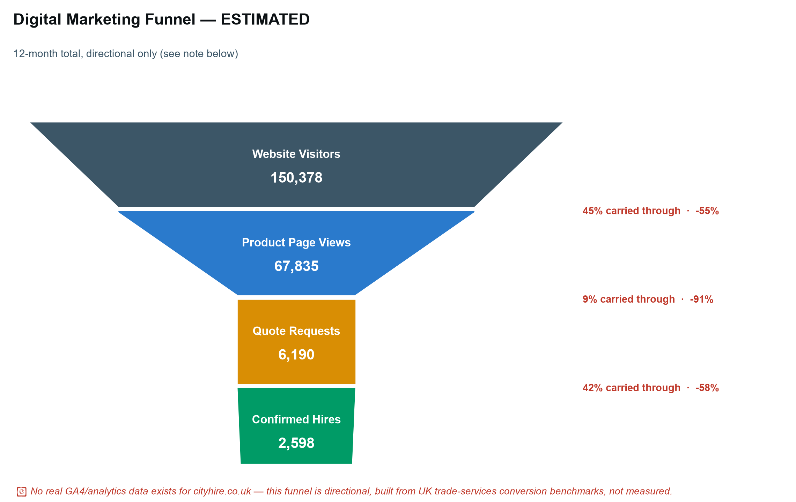
USE No real analytics exist for cityhire.co.uk yet — this shape is what a working GA4 instrumentation would need to measure for real, not a finding to act on directly.

RECOMMENDATION ENGINE
What to sell, and what to buy, next
Market-basket association rules (support, confidence, lift) over 5,000 orders, the same technique behind "customers who bought X also bought Y" — applied here to hire equipment rather than retail.
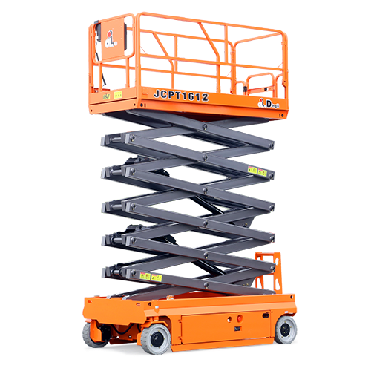
16m Electric Scissor Lift — Powered Access, the category with the largest capex footprint in the fleet
If hired… | → also recommend… | Confidence | Lift
Propping & Support | Cutting & Grinding | 57.3% | 7.5x
Fixing & Fastening | Mechanical & Electrical | 74.9% | 7.4x
Safety, Ventilation & Extraction | Cutting & Grinding | 55.6% | 7.3x
Lighting | Accommodation, Storage & Welfare | 59.2% | 7.1x
USE A lift above 1.0 means the pairing happens more than chance would predict — feed the top few rows straight into a quote-screen cross-sell prompt.

Proactive stock purchase recommendations
Three signals combined into one worklist: which project types are entering their seasonal peak, which of their categories are already short of minimum stock, and what their historical ROI has been — directly answering "what should we buy, and when."
Project type | Time to seasonal peak | Current shortage | Category ROI
Access & Height | 0 months (now) | 5 depots short | 304%
Finishing | 3 months | 6 depots short | 305%
Fixing | 3 months | 6 depots short | 305%
Demolition | 4 months | 5 depots short | 291%
USE Sort by time-to-peak — Access & Height is short of stock right now, at its seasonal peak already, which makes it the most urgent line on this list.

MARKET POSITION
Where City Hire sits in the UK hire market

3 Ton Straight Dumper — one of the 220+ real product/model names grounding this platform's category structure
City Hire competes against a small number of very large national chains — Sunbelt Rentals, Speedy Hire, HSS Hire, GAP Group — some spending up to £289,000/month on paid search alone. The honest read: City Hire isn't tracked in the sector's national digital-marketing benchmark reports at all.
- The category's SEO is currently weak, fleet-wide. — six of ten tracked national hire brands lost organic search traffic in the last measured period (one dropped 57%) — a real opening while larger players are flat or declining.
- Long-tail search is winnable. — Brandon Hire Station's strength is long-tail keyword positions, not head terms, proof a smaller player can win specific, high-intent searches without matching majors on ad spend.
A live technical SEO check of cityhire.co.uk
Finding | Severity | Detail
Multiple H1 tags on homepage | Critical | 6 <h1> elements where feature cards should be <h2>/<h3>
Open Graph tags present but empty | Critical | Every product page shares with a blank preview
No structured data on product pages | High | Zero JSON-LD - a missed local-SEO opportunity
4 of 37 images missing alt text | Medium | Accessibility and image-search gap
USE Fix Open Graph tags first — single template change, restores every shared-link preview site-wide.

THE TECHNICAL BUILD
How it's actually built
Nine layers, each doing a different job, all reading from the same fleet dataset:
Layer | What it is
SQL analysis layer | 17 queries against a SQLite schema, portable to OData - covers every stock/fleet metric a National Ops function tracks daily.
Live Azure database | Fleet data loaded live into Azure Database for PostgreSQL (Flexible Server) and queried directly against the cloud instance, not a local stand-in.
Excel workbook, 10 sheets | Every KPI a live formula (SUMIFS/AVERAGEIFS/COUNTIFS/SUMPRODUCT) - zero hardcoded results, zero errors on recalculation.
Power BI semantic model | Built live in Power BI Desktop via its modeling API - 11 tables, 18 relationships, 21 DAX measures across 9 display folders.
Interactive dashboard & map | Self-contained, dependency-free HTML/SVG - KPI tiles, trend/variance charts, an ROI leaderboard, a UK depot network map.
Local machine learning | Four models (utilisation/workshop forecasting, capex-overspend classification, day-rate pricing) - deliberately local, not cloud, given the Azure trial window.
Graph, funnel & recommendation layers | NetworkX network analysis, funnel conversion tracking, and market-basket recommendations - all detailed above.

The live Azure database, in detail
Rather than claim cloud-database experience, this build used one: an Azure Database for PostgreSQL Flexible Server, provisioned, loaded with 55,414 rows across two tables, and queried directly.
- Query executed: — SELECT category, SUM(capex_gbp), AVG(utilisation_pct_ytd), and an ROI calculation, grouped and ranked, returned in under a second against the live instance.
- Result: — Powered Access led on estimated annual revenue (£13.8m) among all categories, matching the local SQLite analysis exactly - the same numbers, a different engine.
- A genuine constraint, handled: — a subscription-level policy blocks Azure ML, Databricks, Azure SQL Server, VMs, and Cosmos DB on this trial account. PostgreSQL Flexible Server is not on that list, so it's what got used - the resource group was deleted immediately after capturing results, so nothing was left running or billing.

SUMMARY
What this demonstrates
SQL, Excel, Power BI, a live cloud database, network analysis, funnel tracking, seasonal forecasting, and a working recommendation engine - applied to one coherent fleet, not nine disconnected tutorials. Every number agrees with every other number, because they all come from the same source.
The synthetic dataset was deliberately built with real signal to find, not sanitised for a good demo: three categories over capex budget, 32 approvals in queue, 95 depot/category combinations short of stock, 30 assets dragging down fleet ROI. Finding and ranking those is the actual job.

Source files - dataset, SQL, Excel, Power BI model, dashboard, map, and ML models - available on request.
Anthony Apollis — anthony.apollis@gmail.com

