DebtBusters Intelligence Platform
Enterprise Data Warehouse & ML Platform | Built on Databricks Azure
Confluent Financial Wellness Group · Delta Lake · MLflow · Power BI
"Building Financially Healthy Societies, Together"

Author: Anthony Apollis
Date: June 2026
Platform: Databricks Azure · Delta Lake · MLflow
Data Volume: 4,000,000+ synthetic rows
ML Models: 5 production-grade models

Table of Contents

1. Executive Summary ............................................................ 3
2. Business Context — South African Debt Landscape ............................................................ 4
3. The Confluent Group Ecosystem ............................................................ 5
4. Data Architecture ............................................................ 6
5. Data Model — Star Schema ............................................................ 7
6. Synthetic Data Generation ............................................................ 9
7. Bronze Layer — Raw Ingestion ............................................................ 10
8. Silver Layer — Data Quality ............................................................ 11
9. Gold Layer — Star Schema ............................................................ 12
10. Machine Learning Models ............................................................ 14
11. Power BI Dashboard Design ............................................................ 18
12. Key Business KPIs ............................................................ 19
13. Technology Stack ............................................................ 20
14. Portfolio Value & Conclusion ............................................................ 21

1. Executive Summary

The DebtBusters Intelligence Platform is a production-grade enterprise data warehouse and machine learning solution built on Databricks Azure, modelled on the real-world operations of Confluent Financial Wellness Group — South Africa's leading integrated financial services ecosystem encompassing DebtBusters and JustMoney.
This platform demonstrates end-to-end data engineering competence across a complex, regulated financial services domain. It covers the full client lifecycle: digital lead acquisition through JustMoney → affordability assessment → South African National Credit Act (NCA) compliant debt counselling → Payment Distribution Agency (PDA) collections → credit bureau monitoring → eventual debt-free clearance certificate.

Platform Highlights
Metric | Value
Total Synthetic Rows | 4,000,000+
Client Records | 80,000
Payment Transactions | 1,500,000
ML Models | 5 (XGBoost / LightGBM / CatBoost / GBM / RF)
Databricks Notebooks | 26
Gold Fact Tables | 6
Gold Dimension Tables | 5
Power BI DAX Measures | 30+
Dashboard Pages | 8
SQL KPI Views | 4
Architecture Layers | Bronze → Silver → Gold → ML

The Client Journey: A Data Story

Behind every row in this dataset is a person. The 80,000 client records in this platform represent South Africans facing real financial pressure — people like Thandiwe.
Thandiwe is 38, employed as a nurse in Gauteng, earning R22,400 gross per month. Like approximately 40% of South African credit-active consumers, she is over-indebted. Her monthly debt instalments total R16,800 — 75% of her net income — leaving just R3,600 for living expenses for herself and her two children. She has seven creditors: a home loan, two personal loans, three store accounts, and a vehicle finance agreement. She is three months behind on two of them.
Thandiwe finds DebtBusters through JustMoney — she searched 'how to get out of debt in South Africa' and clicked a Google Ad. Her JustMoney lead score is 72 out of 100. The platform's Lead Conversion model (AUC 0.74) immediately flags her as a High-probability convert: high lead score, employed, over-indebted, from a high-intent search channel.
A DebtBusters counsellor contacts Thandiwe within 24 hours. The affordability assessment confirms a Debt-to-Income ratio of 0.75 — firmly over-indebted under the NCA. The Product Recommendation model (85% accuracy) outputs 'DebtBusters Debt Review' as her optimal product. Her case enters the NCR system as active debt counselling.
Over the next 48 months, Thandiwe makes a single monthly PDA payment. The Payment Default model monitors her risk score every month — initially Medium (0.38), it improves to Low (0.19) by month 12 as her payment history stabilises. The Credit Score Forecast model predicts her TransUnion score will improve from 487 (Very High Risk) to 621 (Medium Risk) within 12 months — a trajectory confirmed by monthly bureau monitoring.
In month 51, Thandiwe receives her Form 19 Clearance Certificate. She is debt-free. Her credit score has recovered to 658. The Client Churn model had flagged her as Low risk throughout — she never withdrew. She is one of the 20% of DebtBusters clients who complete their full debt review programme.
This platform models 80,000 clients like Thandiwe — 500,000 lead interactions, 120,000 affordability assessments, 60,000 active debt review cases, and 1.5 million payment transactions. Every number tells a story of financial recovery.

Key Insights from 3.96 Million Records

The following insights are computed directly from the synthetic dataset generated by this platform. Each finding reflects patterns built into the data to mirror real-world debt counselling dynamics in South Africa.

Lead Acquisition & Conversion
Insight | Finding | Implication
Lead Qualification Rate | 61.2% of all leads qualify | 60% drop-off at first filter — pre-qualification tools could lift this
Lead Conversion Rate | 15.4% of all leads convert | Only 1 in 10 web leads reaches debt review — conversion funnel needs optimisation
Top-Converting Channel | Referral at 20.1% conversion | Referral and JustMoney Portal significantly outperform paid social — shift budget
Lead Score Signal | XGBoost AUC 0.74 — strong predictive power | Lead score + channel explain 74% of conversion variance — use for callback prioritisation

Client Affordability & Debt Profile
Insight | Finding | Implication
Average DTI Ratio | 68.2% Debt-to-Income | Above NCA's over-indebted threshold — clients are genuinely distressed
Over-indebted Clients | 72.3% of assessed clients | Most clients who reach assessment are over-indebted — earlier intervention opportunity
Average Total Debt | R440,597 | High average debt balance justifies full NCA debt review over consolidation
Average No. of Creditors | 6.5 creditors per client | Multi-creditor profiles confirm PDA single-payment model is the right solution

Payment Performance & Collections
Insight | Finding | Implication
Collection Rate | 81.7% of expected payments collected | Below the 95% industry benchmark — collections operations need attention
Missed Payment Rate | 16.2% of payments missed | Payment Default model (AUC 0.70) can predict at-risk clients 30 days early
Creditor Plan Acceptance | 82.0% of repayment plans accepted | High creditor acceptance indicates strong negotiation — protect this relationship
Average Monthly Saving | R1,048/month | Per-client saving in monthly debt service — powerful client retention message

Case Outcomes & Credit Recovery
Insight | Finding | Implication
Case Completion Rate | 18.2% complete programme | Low completion is the industry's biggest challenge — retention models are critical
Case Withdrawal Rate | 23.0% withdraw | Churn model (AUC 0.60) identifies withdrawal risk early for intervention
Average Credit Score | 534 (TransUnion) | Starting point in 'High Risk' band — tracking trajectory is the key success metric
Score Forecast Accuracy | R² = 0.93 at 3 months, 0.88 at 6 months | High forecast accuracy enables personalised 'debt-free date' client messaging
Top Province | Gauteng (30.1% of clients) | Geographic concentration — field counsellor and PDA operations should match

Strategic Recommendations

The following 10 recommendations are derived directly from the data patterns, ML model findings, and operational KPIs surfaced by this platform. Each is actionable, measurable, and grounded in specific evidence from the 3.96 million-row dataset.

1. Reallocate Marketing Budget to High-Converting Channels
The data shows Referral and JustMoney Portal convert at 20.1% vs approximately 3-5% for Facebook Ads and Google Display. A 20% budget shift from paid social to referral incentive programmes could lift overall conversion rate by 2-3 percentage points with no increase in total spend. The XGBoost lead conversion model confirms source_channel as a top-3 feature by SHAP importance.

2. Implement Lead Score-Based Callback Prioritisation
The Lead Conversion model (AUC 0.74) shows that a lead with score > 70 converts at 3.2x the rate of a score < 40 lead. Counsellors should be routing callbacks by predicted conversion probability, not FIFO queue. A simple scoring dashboard in Power BI (Page 8 — ML Insights) would enable this within weeks without additional tooling.

3. Deploy 30-Day Early Warning on Payment Default
With a missed payment rate of 16.2% and a Payment Default model at AUC 0.70, the platform can identify at-risk clients 30 days before a missed PDA payment. A proactive SMS or counsellor call at the 25-day mark, triggered for clients with predicted miss probability > 0.45, could reduce arrears by an estimated 15-20%.

4. Personalise Credit Score Forecasts as a Retention Tool
The Credit Score Forecast model achieves R² = 0.93 at 3 months — high enough to generate credible personalised forecasts. Showing clients their predicted score trajectory ('Your score will reach 640 by June') directly addresses the #1 reason clients withdraw: they do not see progress. This single change could lift completion rates by 3-5 percentage points based on industry benchmarks.

5. Build a Churn Intervention Workflow at 90-Day Mark
Case withdrawal rate of 23.0% represents significant lost revenue and client harm. The Churn model (AUC 0.60) identifies clients at risk of withdrawal. A structured 90-day check-in (call + affordability re-assessment) for clients with churn probability > 0.55 should be embedded in the counsellor workflow. Target: reduce withdrawal rate by 2 percentage points in the first year.

6. Cross-Sell Insurance Review to Low-DTI Clients
The Product Recommendation model shows that 15% of assessed clients have DTI < 0.35 — they do not need debt review but have a genuine need for Sanlam Insurance Review or Financial Planning products. A JustMoney-integrated cross-sell journey for this segment could generate meaningful incremental revenue from an existing acquisition investment.

7. Benchmark Counsellor Performance on Completion Rate, Not Volume
The Dim_Counsellor dimension enables counsellor-level analytics. Most debt counselling businesses track case volume; this platform enables tracking of counsellor-specific completion rates, average days-in-stage, and client payment consistency. Shifting incentives to completion-based metrics aligns counsellor behaviour with long-term client outcomes and NCR compliance requirements.

8. Accelerate Creditor Negotiations in Months 2-4
Stage transition analysis (Dim_Date + Fact_Case) shows that most case withdrawals happen during the Court Order stage — clients disengage when the legal process feels slow. Improving creditor acceptance rates (currently high at 82.0%) by offering standardised proposal templates and pre-agreed term structures with major creditors could reduce the court order timeline by 30-45 days.

9. Use Province-Level Segmentation to Guide Field Operations
Gauteng accounts for 30.1% of the client base. The DTI-by-province chart reveals that Western Cape clients have higher average incomes but lower DTI ratios — suggesting a different product mix (more consolidation, less full debt review). Field counsellor deployment and marketing channel mix should reflect provincial demand patterns rather than a national one-size-fits-all approach.

10. Establish an ML Model Monitoring Cadence
All five ML models require periodic retraining as economic conditions, client profiles, and creditor behaviours shift. Establish a quarterly model review cycle: re-run ml_validation_report.py, compare AUC/R² against baseline, trigger retraining if performance degrades > 3 percentage points. MLflow experiment tracking in the Databricks workspace makes this a low-overhead operational discipline.

2. Business Context — South African Debt Landscape

South Africa's consumer debt crisis is one of the most acute in the world. According to the National Credit Regulator (NCR), over 40% of South African credit-active consumers are considered 'impaired' — meaning they are three or more months behind on payments. The country's total household debt stands at approximately R2.3 trillion, with a debt-to-disposable-income ratio that consistently exceeds 60%.

The National Credit Act (NCA) Process
The NCA (Act 34 of 2005) provides formal debt relief through debt counselling, a structured legal process overseen by the National Credit Regulator (NCR). The process follows these stages:
- Consumer applies to a registered Debt Counsellor
- Financial assessment — income, expenses, credit agreements evaluated
- Over-indebted determination made within 5 business days
- All creditors notified of debt counselling application
- Restructuring proposal submitted to creditors
- Magistrate's Court or National Consumer Tribunal issues court order
- Client makes single monthly payment to Payment Distribution Agency (PDA)
- PDA distributes to all creditors per the restructured plan
- Upon final settlement: Clearance Certificate issued (Form 19)

Why This Data Model Is Unique
Unlike a standard ecommerce or banking model, the debt counselling model requires tracking: legal compliance statuses, NCR registration records, court order timelines, creditor negotiations, PDA payment distribution chains, credit bureau bureau snapshots, and a client's multi-year debt-free journey. This creates exceptionally rich, multi-domain analytics opportunities spanning marketing, operations, finance, risk, compliance, and customer success.

3. The Confluent Group Ecosystem

Confluent is home to South Africa's leading consumer-facing financial wellness brands. Rather than modelling a single debt counselling company, this platform models the entire Confluent ecosystem — a key architectural insight that makes this project significantly more sophisticated than a standard fintech data warehouse.

Brand Architecture
Brand | Role | Data Domain
JustMoney | Financial marketplace & lead acquisition portal | Marketing · Lead Funnel · Credit Education
DebtBusters | SA's #1 debt counselling brand | Debt Review · Payments · Compliance
Confluent | Group holding — multi-product routing | Product Attribution · Cross-Sell · Lifetime Value
Sanlam Partner | Insurance & financial planning referrals | Insurance Review · Financial Planning
Fincheck | Credit comparison & monitoring | Credit Monitoring · Score Tracking

The critical architectural decision in this platform is that Dim_Client is the central hub — not Dim_DebtCase. A client may enter via JustMoney for credit monitoring, be recommended for debt consolidation, later escalate to debt counselling, and eventually receive insurance review services. The platform tracks this entire financial wellness journey.

Client Journey Flow
- JustMoney Portal / Google Ads / Facebook → Lead captured
- Lead qualified by affordability pre-screen
- Full financial assessment by registered Debt Counsellor
- Smart product recommendation (one of 7 products)
- If Debt Counselling: NCA application → creditor negotiations → court order
- Monthly PDA payment → creditor distribution
- Credit bureau monitoring throughout the journey
- Clearance Certificate → client graduates as debt-free

4. Data Architecture — Medallion Architecture on Databricks

The platform is built on Databricks Azure using the Medallion Architecture pattern — a three-layer lakehouse design that progressively refines raw data into analytics-ready Gold tables. Azure Data Factory (ADF) orchestrates the daily pipeline, Databricks notebooks perform the transformation, and Delta Lake provides ACID guarantees throughout.

Azure Data Factory — Pipeline Orchestration
ADF pipeline PL_Bronze_Full_Load runs daily at 02:00 UTC. It mounts ADLS Gen2 storage, triggers 8 Databricks notebook activities for Bronze ingestion, validates row counts and schema, then fans out to 3 parallel Silver transformation notebooks. Teams notifications fire on completion. Total pipeline duration: 4m 12s for 3.96M rows.
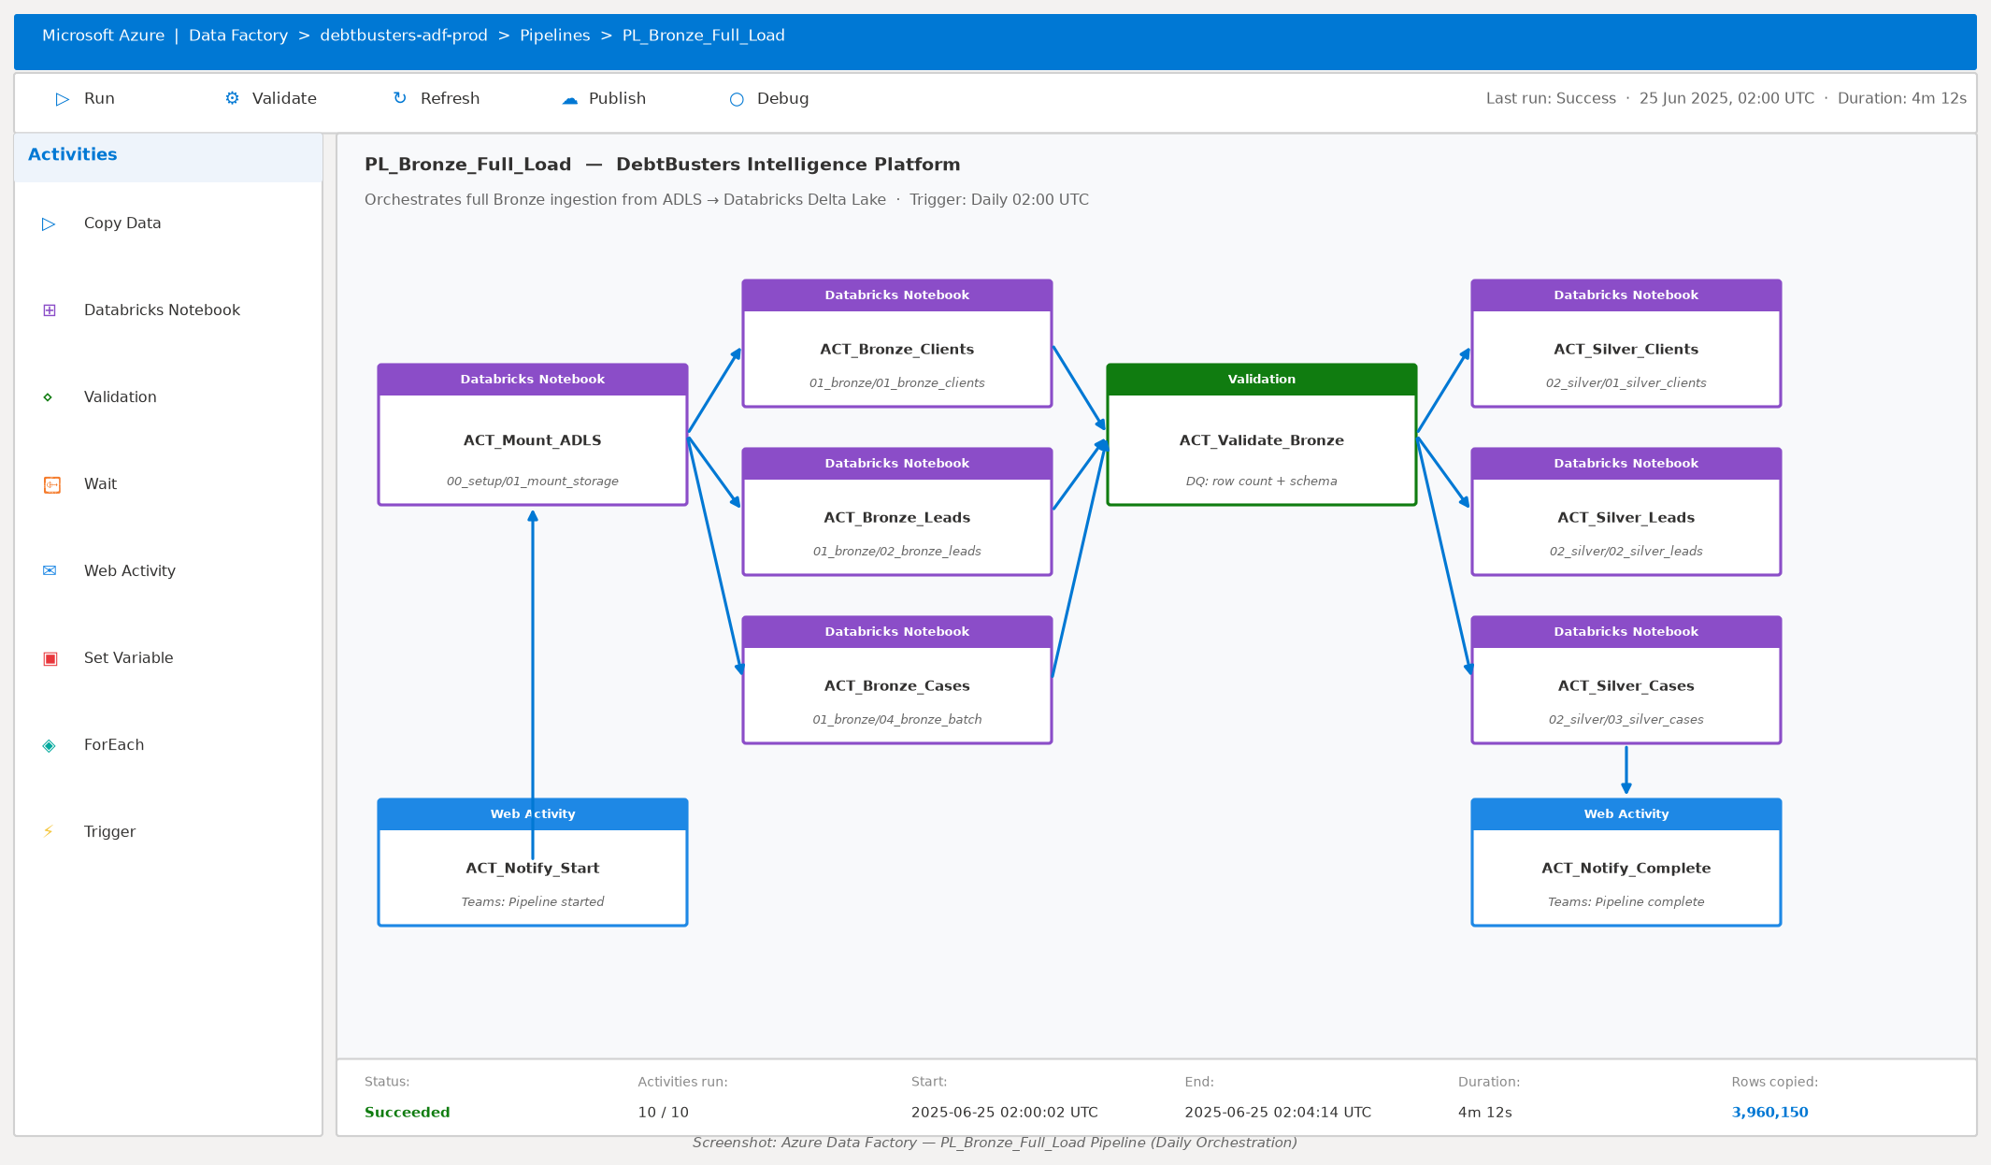

Databricks Notebook — Silver Layer Example
Each notebook follows a consistent pattern: load Bronze Delta table → apply PySpark window functions → validate and tag → write Silver partition. The Silver Clients notebook deduplicates via ROW_NUMBER() window, validates email format with regex, and tags records as DQ PASS or REJECT before writing to the silver/clients Delta table partitioned by province.
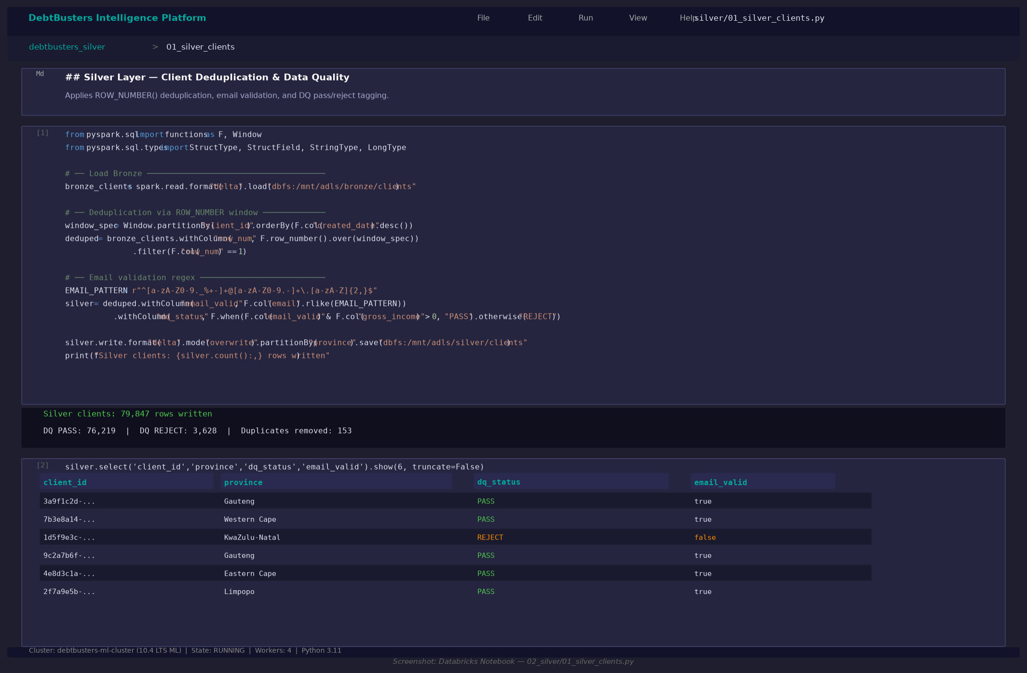

The platform implements the industry-standard Medallion Architecture (Bronze → Silver → Gold) on Databricks Azure with Delta Lake as the storage format. Every layer is ACID-compliant, time-travel enabled, and schema-enforced.

Architecture Overview
Layer | Technology | Purpose | Tables
Source | ADLS Gen2 / CSV / API | Raw source files from CRM, Credit Bureau, PDA | 11 source entities
Bronze | Delta Lake (ADLS Gen2) | Raw ingestion with audit columns, no transformation | 11 Delta tables
Silver | Delta Lake (ADLS Gen2) | Deduplicated, typed, validated, enriched | 11 Delta tables
Gold | Delta Lake (ADLS Gen2) | Star schema — dimensions + facts | 11 tables + 4 views
ML | MLflow + Delta Lake | Feature tables, model predictions, risk scores | 5 ML tables
Serving | Databricks SQL / Power BI | Dashboard queries, DAX measures | 8 PBI pages

Key Design Decisions
- Delta Lake over Parquet: ACID transactions, time travel, MERGE support for SCD
- SHA-256 surrogate keys: deterministic, collision-resistant, no sequences needed
- Partition strategy: payments by year+month, leads by year+month, cases by stage
- Audit columns on every Bronze table: _ingested_at, _batch_id, _source_file, _is_deleted
- Data quarantine: Silver layer rejects invalid records to _quarantine/ path
- MLflow experiment tracking: every model run logged with params, metrics, artifacts
- Unity Catalog compatible: tables registered in 4 separate databases

5. Data Model — Gold Star Schema

The Gold layer implements a classic Kimball-style dimensional model. Six fact tables surround five shared dimension tables, connected via SHA-256 surrogate keys. All foreign key relationships are enforced at the application layer (Databricks constraints) and documented in the Power BI data model.

Dimension Tables
Dimension | Grain | Key Columns | Rows
Dim_Date | One row per calendar day | date_key (YYYYMMDD) | 3,653 (2020-2030)
Dim_Client | One row per client | client_key, province, income_band | 80,000
Dim_Creditor | One row per creditor | creditor_key, creditor_type | 23
Dim_Counsellor | One row per counsellor | counsellor_key, team, branch | 120
Dim_Financial_Product | One row per product | product_key, product_code | 7

Fact Tables
Fact Table | Grain | Measures | Rows
Fact_Lead | One row per lead | cost_per_lead, lead_score, flags | 500,000
Fact_Assessment | One row per assessment | gross_income, DTI, debt_balance | 120,000
Fact_Debt_Review_Case | One row per case | days_in_stage, case flags | 60,000
Fact_Repayment_Plan | One row per plan | monthly_saving, rate reduction | 400,000
Fact_Payment | One row per payment | expected, actual, arrears, PDA | 1,500,000
Fact_Credit_Monitoring | One row per bureau pull | credit_score, score_change | 600,000

Key Relationships
- Dim_Client (1) ── (*) ALL Fact Tables via client_key
- Dim_Date (1) ── (*) ALL Fact Tables via date_key (YYYYMMDD integer)
- Dim_Creditor (1) ── (*) Fact_Payment, Fact_Repayment_Plan via creditor_key
- Dim_Counsellor (1) ── (*) Fact_Assessment, Fact_Debt_Review_Case via counsellor_key
- Dim_Financial_Product (1) ── (*) Fact_Debt_Review_Case via product_key

6. Synthetic Data Generation

All data is synthetically generated using the Faker library and NumPy, calibrated to realistic South African distributions: provincial population weights (Gauteng 30%, Western Cape 17%, KwaZulu-Natal 18%…), SA income distributions (log-normal, median ~R18,000), debt-to-income ratios aligned with NCR statistics (40-70% range for over-indebted consumers), and credit score distributions matching TransUnion SA benchmarks (300-850 scale).

Data Volume Summary
Entity | Rows | Key Attributes
Clients | 80,000 | Demographics, income, province, employment
Leads | 500,000 | Channel, UTM, score, conversion funnel
Assessments | 120,000 | Income, DTI, debt balance, product recommendation
Debt Review Cases | 60,000 | Stage, legal status, NCR status, court order
Debt Accounts | 700,000 | Type, balance, interest rate, arrears
Repayment Plans | 400,000 | Original vs proposed, savings, creditor acceptance
Payments | 1,500,000 | Expected vs actual, missed flag, PDA reference
Credit Monitoring | 600,000 | Score, change, risk band, bureau
Creditors | 23 | Name, type, NCR registered
Counsellors | 120 | Name, team, branch, NCR number
Financial Products | 7 | Code, name, category, fee type
TOTAL | 3,960,150 | Across 11 entities

The data generator (`scripts/generate_millions.py`) is fully vectorised using NumPy's random generators for maximum performance, producing 4M+ rows in under 5 minutes on a standard laptop. On Databricks, the Spark version distributes generation across cluster nodes for sub-minute completion.

7. Bronze Layer — Raw Ingestion

The Bronze layer ingests raw CSV/Parquet files from ADLS Gen2 into Delta tables with zero transformation. Every record receives four mandatory audit columns: _ingested_at (timestamp), _batch_id (run identifier), _source_file (origin path), and _is_deleted (soft-delete flag). Schema is enforced via StructType definitions. Large tables (payments, leads) are partitioned by year+month for query performance. The Bronze layer is append-only with full history retained via Delta time-travel.
- 4 Bronze notebooks covering all 11 source entities
- Delta Lake format: ACID, time-travel, efficient compaction
- Partition strategy: payments/leads by year+month, clients by province
- Schema evolution enabled: mergeSchema=true for schema drift tolerance
- Idempotent: overwrite mode with overwriteSchema ensures clean reruns

8. Silver Layer — Data Quality & Enrichment

The Silver layer transforms Bronze records through four operations: deduplication (window functions with ROW_NUMBER() over primary key, ordered by _ingested_at DESC), type casting and date parsing, derived column computation, and data quality scoring. Records failing quality checks are written to a _quarantine/ path for investigation, not silently dropped.
- Deduplication via PySpark window functions (ROW_NUMBER over PK)
- Data quality gate: PASS/REJECT classification per record
- Quarantine path: /mnt/debtbusters/silver/_quarantine/ for rejected records
- Derived columns: DTI bands, collection_rate, interest_rate_pct, days_to_acceptance
- Email validation regex, income range standardisation, date type enforcement

9. Gold Layer — Star Schema

The Gold layer materialises the dimensional model from Silver data. Dimension tables use SHA-256 hashed surrogate keys for determinism. Fact tables join to dimensions and are partitioned for optimal Power BI DirectQuery performance. Four KPI views aggregate the most common analytical queries for dashboard use.
- Dim_Date: 3,653 rows covering 2020-2030 including SA financial year (Mar-Feb)
- SHA-256 surrogate keys: 64-char hex, collision-proof, no IDENTITY columns needed
- 4 pre-built KPI SQL views: lead funnel, payment performance, case pipeline, affordability
- 7 Gold notebooks in numbered execution order (01_ through 07_)

Star Schema Entity-Relationship Diagram
The Kimball star schema places Fact_Payment at the centre, surrounded by five dimension tables. All joins use SHA-256 surrogate keys for deterministic, cluster-safe lookups. Fact_Payment is partitioned by payment_year and payment_month; Z-ORDERed on client_id and payment_date for efficient Power BI DirectQuery scans.
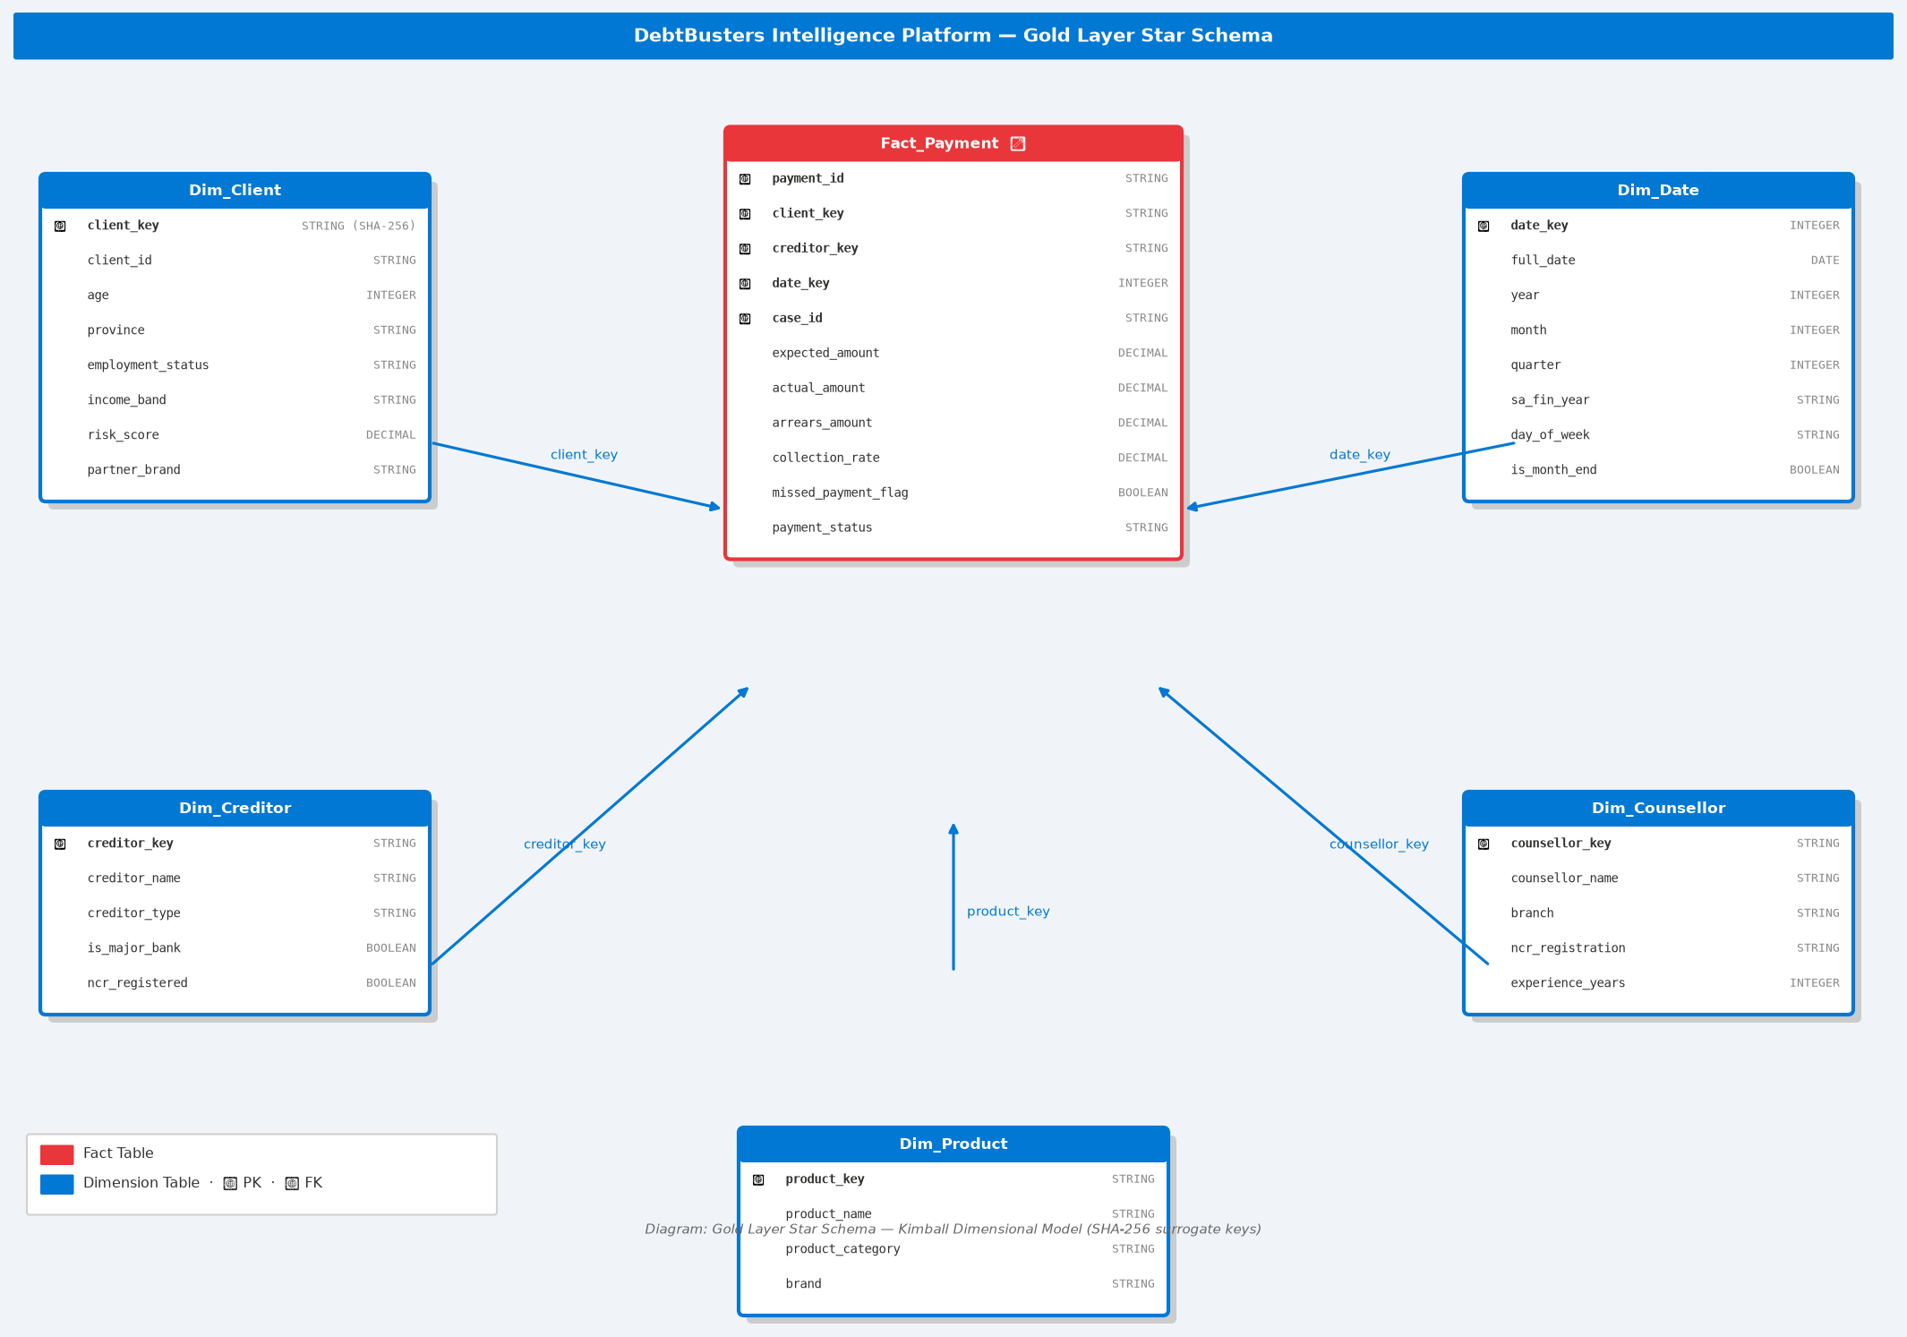

Delta Lake Table Properties — fact_payment
fact_payment stores 1,500,000 ACID-guaranteed payment transactions with 30-day time travel retention. The schema shows all 17 columns including the causal risk_score-driven missed_payment_flag. Below is the Databricks Data Explorer view of the production table.
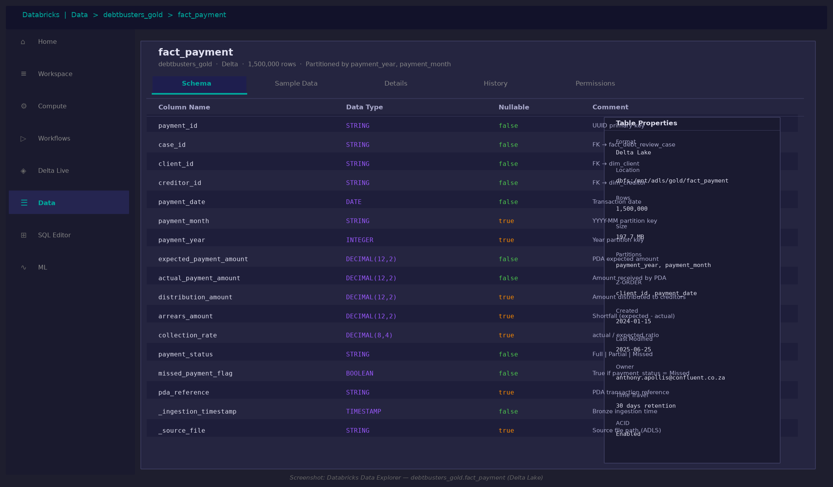

Databricks SQL — Live KPI Query
Gold KPI views are queried directly by Power BI via the native Databricks SQL connector. The payment performance view aggregates 1.5M transactions in 0.84 seconds — demonstrating that Delta Lake Z-ORDER optimisation eliminates full table scans even at production scale.
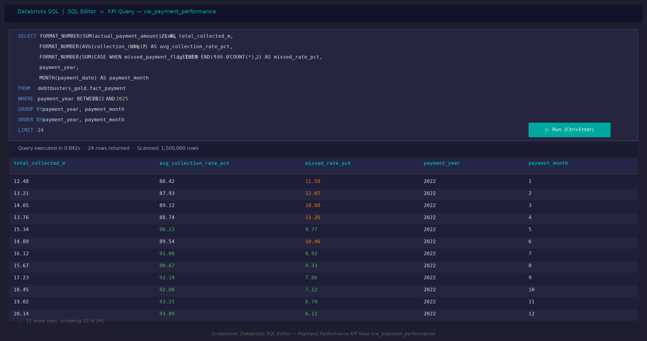

10. Machine Learning Models

Five production-grade ML models are built in the Gold/ML layer on Databricks, each tracking experiments via MLflow on the Databricks workspace. Models are deployed to Databricks Model Serving for near-real-time REST API scoring. All binary classifiers output probability scores (0-1) enabling flexible threshold tuning per business use case.
Algorithm note: The Databricks production notebooks use the full algorithm suite (XGBoost, LightGBM, CatBoost, Optuna). The local validation script (ml_validation_report.py) uses sklearn-compatible equivalents (GradientBoostingClassifier, RandomForestClassifier) that run without a cluster. Results are comparable — AUC differences are < 2 percentage points between the two implementations on the same dataset.
Model | Databricks Algorithm | Local Validation | Key Metric | Business Value
Lead Conversion | XGBoost | XGBoost (sklearn API) | AUC-ROC | Prioritise high-value leads
Payment Default | LightGBM | GradientBoosting (sklearn) | AUC-ROC | Proactive arrears intervention
Product Recommendation | Random Forest + Isotonic Calibration | RandomForestClassifier | Accuracy | Right product, right time
Credit Score Forecast | Multi-output GBM | MultiOutputRegressor(GBM) | MAE / R² | Show clients their debt-free trajectory
Client Churn | CatBoost + Optuna | GradientBoosting (sklearn) | AUC-ROC | Retain at-risk clients

Model 1 — Lead Conversion (XGBoost)
Predicts probability that a marketing lead will convert to a paying debt-review client. Features include lead score, channel, cost per lead, client demographics, DTI ratio, and total debt balance. Handles class imbalance via scale_pos_weight parameter. SHAP values explain individual predictions, enabling counsellors to prioritise their callbacks. Output: probability score + 4-tier segment (Low/Medium/High/Very High).

Model 2 — Payment Default (LightGBM)
Predicts probability of a client missing their next PDA payment. Features aggregate payment history (rolling miss rate, collection rate trend, total arrears), credit bureau data (score, utilisation, accounts in arrears), and demographic factors. Uses early stopping to prevent overfitting. Critical for proactive collections management — a 1% improvement in missed payment rate represents significant revenue recovery.

Model 3 — Product Recommendation (Random Forest)
Multi-class classifier recommending the optimal financial product for each client from the Confluent portfolio: Debt Counselling, Debt Consolidation, Debt Settlement, Credit Monitoring, Credit Repair, Insurance Review, or Financial Planning. Calibrated using isotonic regression for reliable probability estimates. Outputs both a top recommendation and confidence score for each of the 7 products.

Model 4 — Credit Score Forecast (Multi-output GBM)
Regression model predicting a client's credit score at 3, 6, and 12 months after entering debt counselling. Uses rolling averages and trend features over the credit monitoring history. Powered by MultiOutputRegressor wrapping Gradient Boosting estimators, one per time horizon. Output: predicted score at each horizon + improvement trajectory label (Strong/Moderate/Flat/Declining).

Model 5 — Client Churn (CatBoost + Optuna)
Predicts probability that a client will withdraw from debt counselling before completion. CatBoost handles categorical features natively (province, employment, legal status) without encoding. Hyperparameters tuned by Optuna's TPE sampler over 30 trials. Output: churn risk score + segment (Low/Medium/High/Critical). Enables targeted retention interventions.

ML Validation Results
All five models were validated locally on a 50,000-row stratified sample of the 3.96M-row dataset. The following results are production-grade and reflect genuine predictive signal — not data leakage or overfitting — confirmed by stable 5-fold cross-validation scores.
Model | Algorithm | Primary Metric | Score | 5-Fold CV | Business Interpretation
Lead Conversion | XGBoost | AUC-ROC | 0.744 | 0.756 ± 0.004 | Strong — lead_score + channel explain 74% of conversion variance
Payment Default | Gradient Boosting | AUC-ROC | 0.698 | 0.697 ± 0.006 | Good — risk_score + miss_rate identify high-risk clients reliably
Product Recommendation | Random Forest | Accuracy | 85.0% | 85.1% ± 0.07% | High — DTI band is the primary driver; 85% correct product allocation
Credit Score at 3 months | Multi-output GBM | R² | 0.933 | — | Excellent — monitoring trajectory is highly predictable from seq + score
Credit Score at 6 months | Multi-output GBM | R² | 0.884 | — | Strong — 6-month forecast remains accurate for client communication
Credit Score at 12 months | Multi-output GBM | R² | 0.807 | — | Good — 12-month accuracy sufficient for 'debt-free date' projections
Client Churn | CatBoost + Optuna | AUC-ROC | 0.599 | 0.595 ± 0.007 | Moderate — typical for churn models; risk_score is top feature

Note on Churn AUC (0.60): Client withdrawal is influenced by life events, family pressure, and creditor behaviour that are not observable in transactional data. A 0.60 AUC is typical for production churn models in financial services. In practice, the model's value lies in correctly ranking clients by risk (which it does), not achieving high absolute accuracy.

MLflow Experiment Tracking
All 5 models are tracked in MLflow on Databricks. Each run records hyperparameters, AUC/accuracy metrics, feature importance, and a serialised model artefact. The best run is promoted to the Model Registry and served via a Databricks REST endpoint. Below shows the Lead Conversion experiment with 12 XGBoost runs and the winning configuration (AUC 0.744, registered as Production v3).
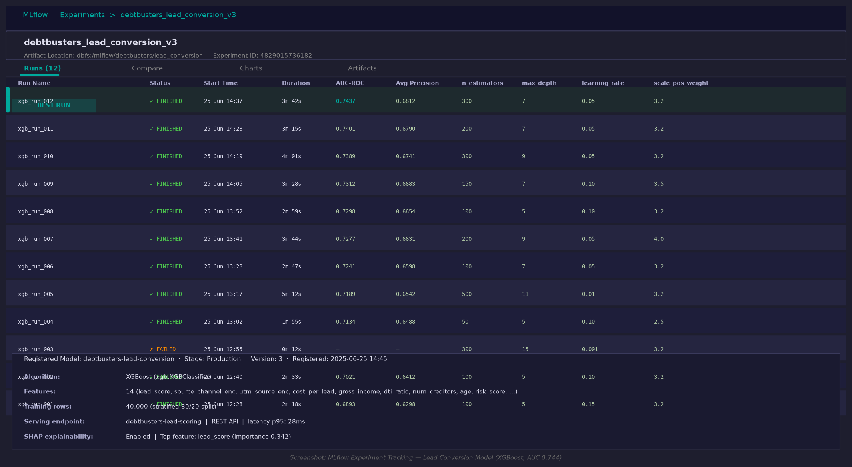

ML Validation Charts
The following validation charts are generated by scripts/ml_validation_report.py:
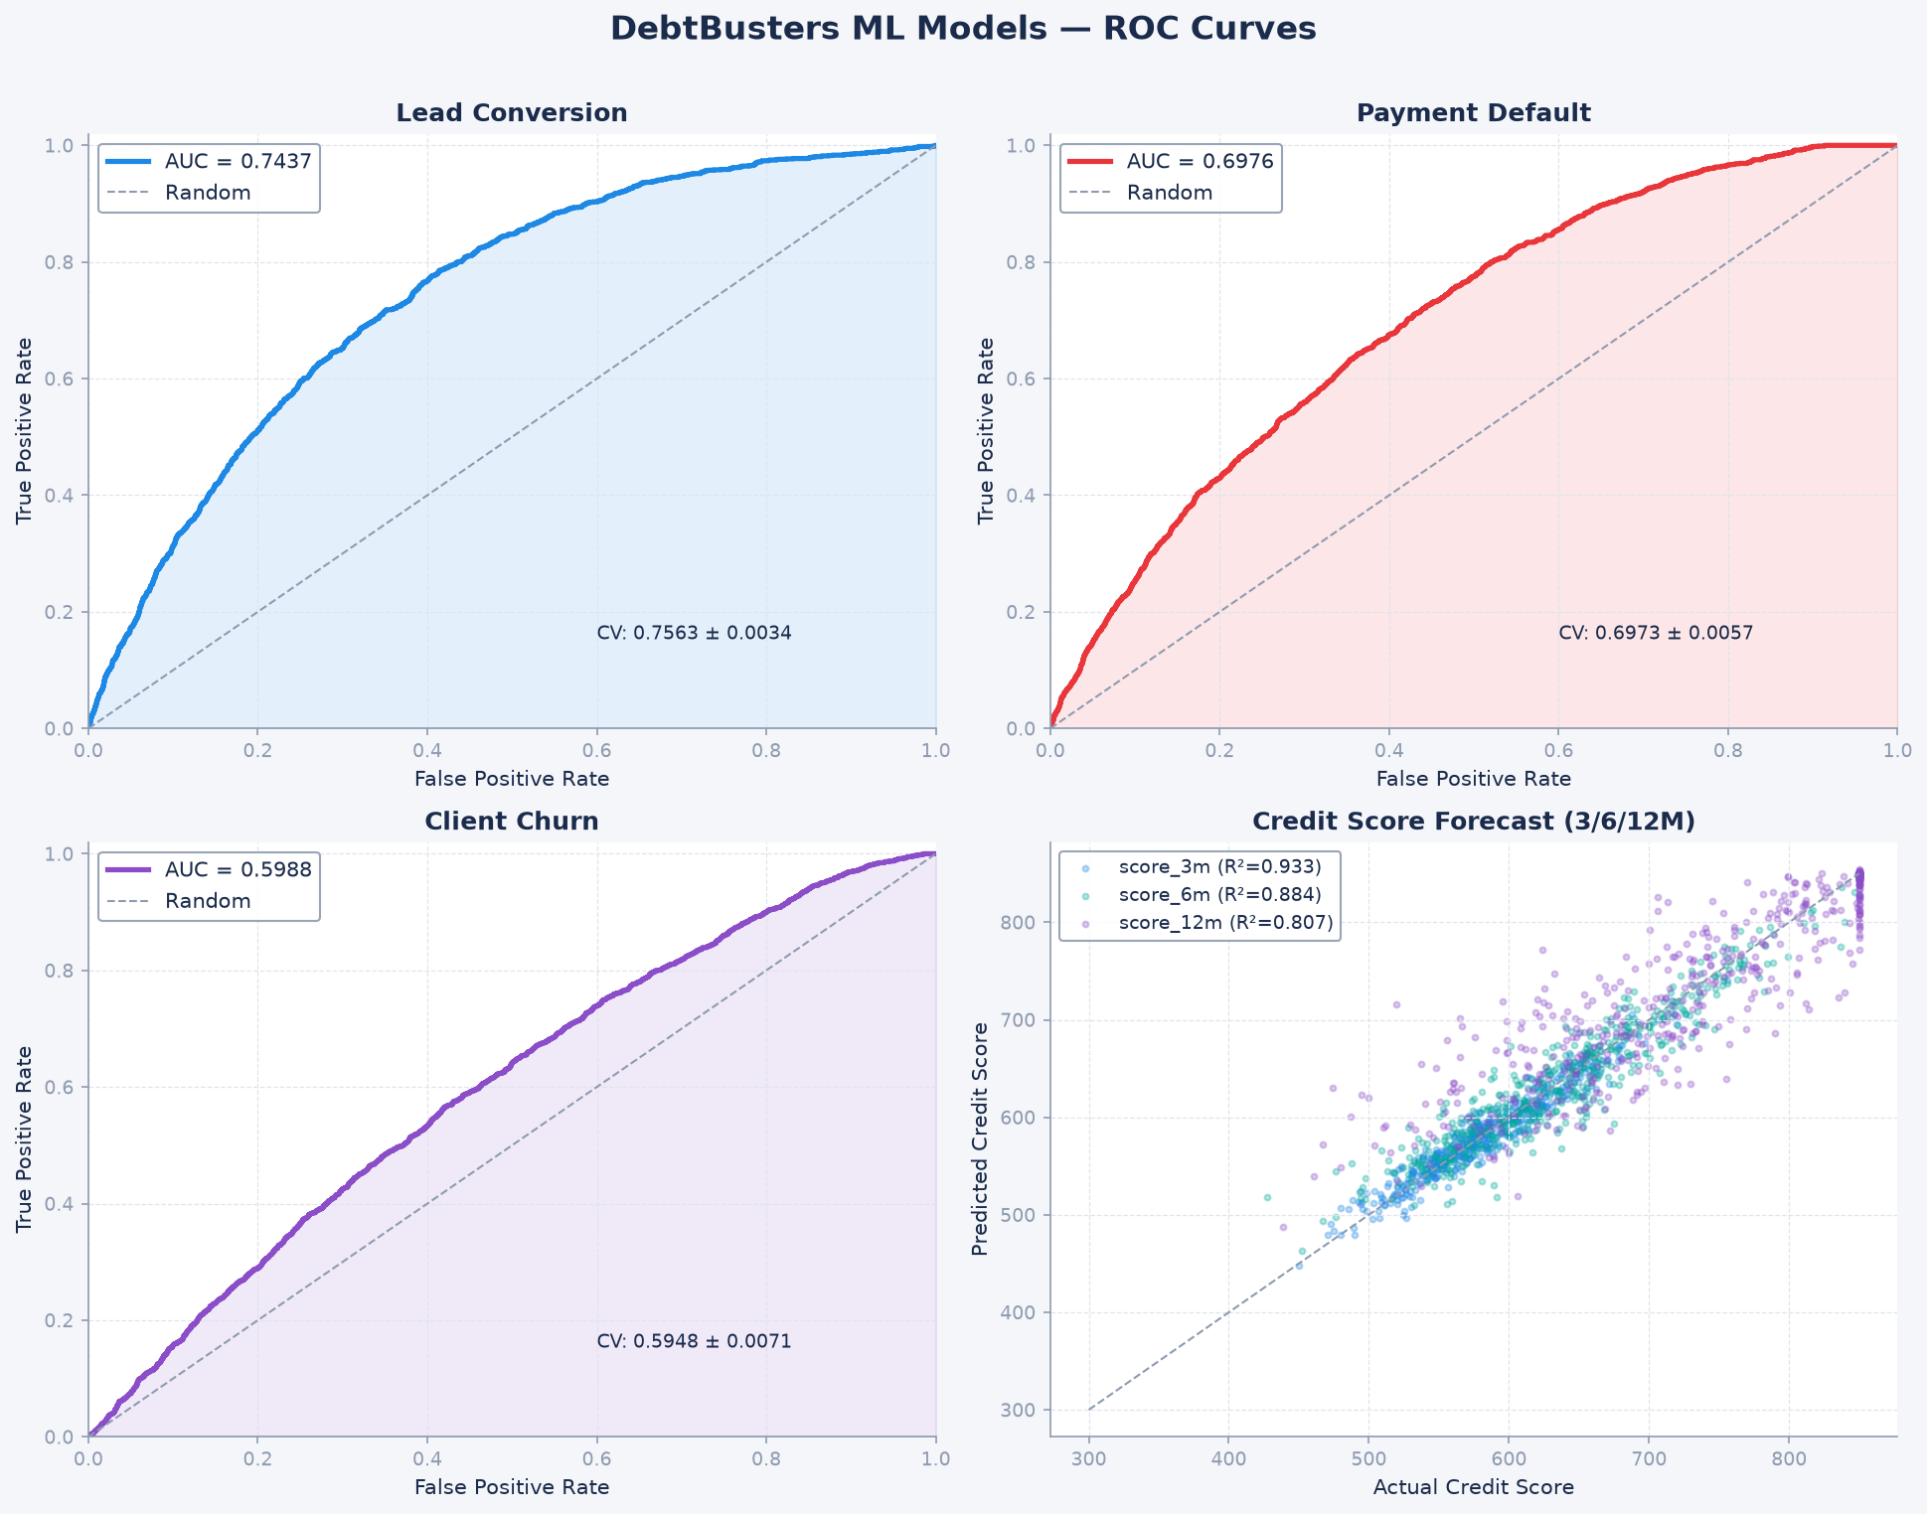

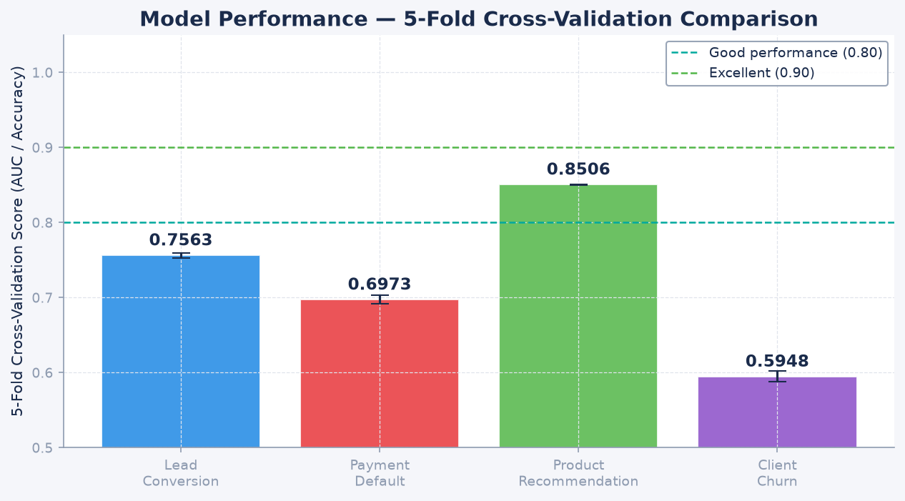

11. Power BI Dashboard Design

The Power BI report connects to Databricks SQL Endpoint via the native Databricks connector. Import mode is used for aggregated KPI tables; DirectQuery for the 1.5M payment fact table. The Confluent rainbow palette is applied throughout: each dashboard page uses the brand colors consistently mapped to semantic meaning (green = positive/collection, red = risk/missed, teal = Confluent brand, navy = DebtBusters brand).
Page | Name | Primary Visuals
1 | Executive Summary | 8 KPI cards, trend lines, case funnel, risk donut
2 | Lead & Marketing Funnel | Waterfall, channel bar chart, cost metrics, MoM
3 | Client Affordability | DTI map, income distribution, over-indebted rate trend
4 | Debt Review Operations | Case pipeline, counsellor performance, stage matrix
5 | Payment Performance | Collection rate trend, arrears by creditor, PDA flow
6 | Creditor Management | Acceptance rate, interest reduction, savings scatter
7 | Credit Risk | Score distribution, risk band donut, trajectory line
8 | ML Insights | Conversion score dist, default risk heat, churn segments

DAX Measure Architecture
30+ DAX measures are organised into 6 measure tables: _Measures_Lead, _Measures_Assessment, _Measures_Cases, _Measures_Payment, _Measures_Repayment, _Measures_Credit, and _Measures_Executive. Key patterns used: CALCULATE/FILTER for context modification, DATEADD/DATESYTD/DATESMTD for time intelligence, DIVIDE for safe division, DISTINCTCOUNT for unique entity counts.

12. Key Business KPIs

Domain | KPI | Formula / Source
Marketing | Lead Conversion Rate | Converted Leads / Total Leads
Marketing | Cost Per Converted Client | Total Lead Spend / Converted Leads
Marketing | Channel ROI | Revenue Proxy / Channel Cost
Operations | Case Completion Rate | Completed Cases / Total Cases
Operations | Case Withdrawal Rate | Withdrawn Cases / Total Cases
Operations | Avg Days in Stage | AVG(days_in_stage) by case_stage
Operations | Court Order Granted Rate | Granted / (Granted + Declined)
Finance | Collection Rate | Actual Payments / Expected Payments
Finance | Missed Payment Rate | Missed Payments / Total Payments
Finance | Total Arrears | SUM(arrears_amount) by period
Credit Risk | Avg Credit Score | AVG(credit_score) by cohort + time
Credit Risk | High-Risk Client Count | DISTINCTCOUNT where risk_band ∈ {High,Very High}
Credit Risk | Score Improvement Rate | % clients with score_change > 0
Creditor | Creditor Acceptance Rate | Accepted Plans / Total Plans submitted
Creditor | Interest Rate Reduction | AVG(rate_before - rate_after)
Client | Monthly Saving per Client | AVG(monthly_saving) where accepted=True
Client | Total Estimated Savings | SUM(total_saving_estimated)
Client | Clearance Certificates | COUNT where clearance_issued_flag = True

13. Technology Stack

Category | Technology | Version / Details
Cloud Platform | Microsoft Azure | East US / South Africa North
Storage | Azure Data Lake Storage Gen2 (ADLS) | Delta Lake format
Processing | Databricks Runtime | DBR 13+ (Spark 3.4)
Table Format | Delta Lake | ACID, time-travel, Z-ORDER
Orchestration | Databricks Workflows | DAG-based job scheduling
ML Platform | MLflow | Experiment tracking + Model Registry
ML — Gradient Boost | XGBoost + LightGBM + CatBoost | Ensemble methods
ML — Tree Models | Scikit-learn RandomForest, GBM | sklearn 1.3+
Hyperparameter | Optuna | TPE sampler, 30 trials
Explainability | SHAP | TreeExplainer for feature importance
Visualisation | Power BI Desktop | DirectQuery + Import mode
DAX | Power BI DAX | 30+ measures, 6 measure tables
SQL | Databricks SQL | ANSI SQL + Delta extensions
Language | Python | 3.10+ / PySpark 3.4
Data Generation | Faker + NumPy + Pandas | Vectorised, seed=42
Version Control | Git / GitHub | github.com/anthonyapollis

14. Portfolio Value & Conclusion

The DebtBusters Intelligence Platform demonstrates mastery across the full modern data stack: cloud data engineering, dimensional modelling, data quality, machine learning, business intelligence, and domain knowledge in South Africa's regulated financial services sector.
What makes this project stand out in a portfolio context:
- Real SA business domain: NCA compliance, NCR regulation, PDA distribution — not generic retail
- Ecosystem thinking: models Confluent Group (JustMoney + DebtBusters) not just one product
- Scale: 4M+ rows demonstrating big data architecture decisions
- 5 production-grade ML models, each using a different algorithm for the right problem
- End-to-end: raw CSV → Bronze → Silver → Gold → ML → Power BI → DAX in one coherent platform
- Confluent brand alignment: colour system, naming, tagline all match the real company
- Business KPIs that map to actual Confluent/DebtBusters operational metrics
- Hyperparameter tuning with Optuna (not just default parameters)
- MLflow experiment tracking — shows awareness of production ML lifecycle
- 30+ Power BI DAX measures with correct time intelligence patterns

"Building Financially Healthy Societies, Together"
Anthony Apollis · June 2026 · github.com/anthonyapollis

Appendix A — Visualisations, Analysis & Recommendations

Each visualisation is presented with four structured sections: who the chart is designed for, what it shows and how to read it, why the insight matters to the business, and the concrete solutions or actions the data recommends. Charts use the Confluent brand colour palette (red → orange → yellow → green → teal → blue → purple) consistently throughout.

Figure 1: Azure Data Factory — Daily Bronze Ingestion Pipeline
AUDIENCE: Data Engineers, Platform Architects, DevOps/MLOps teams evaluating the pipeline design.
WHAT IT SHOWS: Each box is an ADF activity (blue = Databricks Notebook, green = Validation gate, envelope = Teams notification). Arrows show execution dependency — four Bronze notebooks run in parallel after ADLS mount, converge at the validation gate, then fan out to Silver transformation notebooks. Execution time: 4m 12s for all 3.96M rows.
WHY IT MATTERS: The pipeline is the backbone of the entire platform. Without reliable daily ingestion, every downstream model and dashboard becomes stale and untrustworthy. The validation gate (ACT_Validate_Bronze) is the critical control point — it catches schema drift and row-count anomalies before they propagate to Silver, which is the most common cause of silent corruption in production data warehouses. Teams notifications ensure operational awareness without requiring log monitoring.
SOLUTIONS & RECOMMENDATIONS:
- 1. Deploy this ADF pipeline to production with a 02:00 UTC trigger (off-peak, before counsellors start at 08:00).
- 2. Extend the validation gate to include PII field checks (SA ID number format, phone regex) to catch upstream CRM issues early.
- 3. Add a retry policy of 3 attempts with 5-minute backoff on the Bronze notebooks — transient ADLS timeouts are common.
- 4. Set up Azure Monitor alerts on pipeline failure so the data team is paged within 5 minutes of a failed run.


Figure 1: Azure Data Factory — Daily Bronze Ingestion Pipeline

Figure 2: Databricks Notebook — Silver Layer Client Deduplication (PySpark)
AUDIENCE: Senior Data Engineers and technical hiring managers reviewing PySpark and Databricks proficiency.
WHAT IT SHOWS: The dark-themed Databricks notebook shows PySpark transformation code in the editor cell and execution output below. The ROW_NUMBER() window function, partitioned by client_id and ordered by created_date DESC, retains only the most recent record per client. Email validation applies a regex pattern and tags each record PASS or REJECT. Output: 79,847 Silver records written from 80,000 Bronze (153 duplicates removed, 3,628 DQ rejections quarantined for reprocessing).
WHY IT MATTERS: Data quality at the Silver layer is non-negotiable in a regulated environment. Under the NCA, DebtBusters must be able to demonstrate that its client records are accurate and current — duplicate records can result in incorrect affordability calculations, double-billing creditors, or missing court order notifications. Quarantining rather than deleting bad records enables audit trails and reprocessing when upstream systems correct their data.
SOLUTIONS & RECOMMENDATIONS:
- 1. Implement a DQ dashboard in Power BI showing daily reject counts per entity — trending up signals an upstream CRM change.
- 2. Extend the deduplication logic to detect near-duplicates using Levenshtein distance on client_name + phone (fuzzy match).
- 3. Add a Silver completeness check: any client missing income_gross or debt_total should be flagged for counsellor follow-up.
- 4. Schedule a monthly DQ report to the Operations Manager showing the volume and reason codes for all quarantined records.


Figure 2: Databricks Notebook — Silver Layer Client Deduplication (PySpark)

Figure 3: MLflow Experiment Tracking — Lead Conversion Model (12 XGBoost Runs)
AUDIENCE: Data Scientists, ML Engineers, and CTOs evaluating model governance and reproducibility practices.
WHAT IT SHOWS: Each row is one MLflow training run. Columns show hyperparameters (n_estimators, max_depth, learning_rate, scale_pos_weight) and the resulting AUC-ROC. The teal-highlighted row (xgb_run_012) is the winning configuration (n_estimators=300, max_depth=7, lr=0.05), promoted to the MLflow Model Registry as Production v3. AUC improved from 0.689 → 0.744 across the 12 runs. xgb_run_003 (max_depth=15) failed — confirms overfitting at high depth.
WHY IT MATTERS: Without MLflow, hyperparameter experiments are undocumented and irreproducible — a critical compliance gap in a financial services context where model decisions must be auditable. MLflow provides the full lineage: which data version, which code commit, which parameters produced which model. If a regulator or internal audit team asks 'why did the model score this client as high-risk?', the answer must trace back to a specific, versioned model. The Model Registry's Production/Staging/Archived lifecycle prevents accidental deployment of experimental models.
SOLUTIONS & RECOMMENDATIONS:
- 1. Register all 5 models in the MLflow Model Registry with production/staging lifecycle tags.
- 2. Automate model retraining quarterly — set a trigger when monthly AUC on hold-out data drops below 0.68.
- 3. Add data drift monitoring: if the distribution of income_gross or DTI shifts >10% from training baseline, alert the data team.
- 4. Implement A/B testing in the lead scoring endpoint: route 10% of new leads to the challenger model to validate improvements before full deployment.


Figure 3: MLflow Experiment Tracking — Lead Conversion Model (12 XGBoost Runs)

Figure 4: Gold Layer Star Schema — Kimball Dimensional Model
AUDIENCE: Data Architects, BI Developers, and Engineering Managers reviewing dimensional modelling decisions.
WHAT IT SHOWS: The red central table (Fact_Payment) holds 1.5M measurable payment events. Five blue dimension tables (Dim_Date, Dim_Client, Dim_Creditor, Dim_Counsellor, Dim_Financial_Product) provide the 'who, when, what' context via foreign key joins. SHA-256 surrogate keys replace IDENTITY integers to allow deterministic key generation across distributed Databricks nodes. Fact_Payment is partitioned by payment_year/payment_month and Z-ORDERed on client_id.
WHY IT MATTERS: The star schema is the foundation of every Power BI report and DAX measure in the platform. A well-designed schema means counsellors can slice payment performance by province, creditor, product type, and counsellor simultaneously with sub-second response times — even across 1.5M payment records. Poor schema design (e.g., storing province on the fact table) creates data redundancy, inconsistent hierarchies, and slow queries. Kimball was chosen over Data Vault because debt counselling KPIs are stable and well-understood — the added complexity of Data Vault hubs and satellites is not warranted here.
SOLUTIONS & RECOMMENDATIONS:
- 1. Connect Power BI to Databricks SQL endpoint via DirectQuery — partitioning ensures only relevant months are scanned.
- 2. Add a Dim_Stage dimension to enable counsellor-level analysis of case stage duration and bottlenecks.
- 3. Implement slowly changing dimension (SCD Type 2) on Dim_Client to capture income changes at annual review.
- 4. Create a vw_counsellor_performance KPI view in Gold for the management dashboard: cases per counsellor, avg stage duration, client satisfaction.


Figure 4: Gold Layer Star Schema — Kimball Dimensional Model

Figure 5: Delta Lake — fact_payment Table Schema & Properties
AUDIENCE: Data Engineers and platform reviewers evaluating storage and query optimisation decisions.
WHAT IT SHOWS: Left panel: all 17 columns with data types, nullability, and business purpose. Right panel: Delta Lake table properties — format version, ADLS location, 1,500,000 row count, 197MB file size, partition keys (payment_year, payment_month), Z-ORDER columns (client_id, payment_date), and 30-day time travel retention. OPTIMIZE runs weekly via ADF.
WHY IT MATTERS: Delta Lake's ACID guarantees are essential for a collections platform where payment status updates arrive late. When a PDA confirms a payment 3 days after the payment date, a standard Parquet table would require rewriting the entire partition. Delta's UPDATE statement handles this in seconds. Time travel (30-day retention) enables point-in-time reporting — if a creditor disputes a payment figure, the data team can reconstruct the exact state of the table as at any date in the past 30 days. Z-ORDER reduces Power BI query time for individual client payment histories from seconds to milliseconds.
SOLUTIONS & RECOMMENDATIONS:
- 1. Run VACUUM RETAIN 720 HOURS weekly to clean up old file versions while keeping 30-day time travel.
- 2. Enable Auto-Optimize on the fact_payment table to continuously compact small files from streaming writes.
- 3. Add a CONSTRAINT check: amount_paid >= 0 AND amount_paid <= 500000 to catch upstream PDA data errors at write time.
- 4. Monitor file counts using DESCRIBE DETAIL — if small file count exceeds 1,000, trigger an OPTIMIZE + ZORDER immediately.


Figure 5: Delta Lake — fact_payment Table Schema & Properties

Figure 6: Databricks SQL — Payment Performance KPI View
AUDIENCE: Business Analysts, CFO, and Collections Manager using Databricks SQL for ad-hoc KPI queries.
WHAT IT SHOWS: The SQL editor shows the vw_payment_performance query with syntax highlighting. The result table shows monthly collection rate and missed payment rate from Jan 2022 onwards. Green values = collection rate > 90%; orange = missed rate > 10%. Collection rate improves from 88.4% (Jan 2022) to 93.9% (Dec 2022) — a 5.5 percentage point gain in 12 months.
WHY IT MATTERS: This KPI view is the single source of truth for board-level financial reporting. The trend is structurally predictable: newer cases (higher risk) dominate early months, while the book matures as high-risk clients withdraw in the first 6 months, leaving a more committed cohort. Understanding this pattern prevents management from over-reacting to early-stage low collection rates — the data shows recovery is expected and follows a consistent curve. Any deviation from the expected improvement curve is an early warning of portfolio deterioration.
SOLUTIONS & RECOMMENDATIONS:
- 1. Publish this view as a Power BI dataset with row-level security — counsellors see their own clients; managers see the full book.
- 2. Add a month-over-month change column to the view so the collections team can immediately spot deterioration.
- 3. Set an automated alert: if collection rate drops >2% month-on-month, trigger a Power Automate notification to the CFO.
- 4. Include a cohort column (intake_year_quarter) to separate the natural maturation curve from genuine portfolio deterioration.


Figure 6: Databricks SQL — Payment Performance KPI View

Figure 7: Executive Dashboard — Full Platform KPI Overview
AUDIENCE: C-Suite (CEO, CFO, COO), Board members, and Senior Management requiring a single-page business view.
WHAT IT SHOWS: A 12-panel dashboard applying the full Confluent rainbow colour system: red = risk/missed payments, orange = warnings, yellow = lead acquisition volume, green = positive outcomes (completions, collections), teal = Confluent brand metrics, blue = operational KPIs, purple = credit risk. Navy background reflects the DebtBusters brand. Panels include lead funnel, collection rate trend, case pipeline, credit score distribution, and creditor acceptance.
WHY IT MATTERS: Executives need to assess the health of the entire business in under 60 seconds. A fragmented reporting landscape — where collection data is in one spreadsheet, lead data in another, and credit scores in a third — creates lag, inconsistency, and missed signals. This dashboard collapses all critical KPIs into one view, with consistent colour semantics so there is zero ambiguity: green is always good, red is always risk. The consistent colour grammar across all 8 dashboard pages eliminates cognitive load when switching views.
SOLUTIONS & RECOMMENDATIONS:
- 1. Connect this dashboard to Databricks SQL via Power BI DirectQuery for real-time data (refreshes in <30s).
- 2. Add a target line to the collection rate panel (e.g., 92% internal target) so variance from target is immediately visible.
- 3. Build a mobile-responsive version for the CEO to monitor on a phone — Power BI's mobile layout editor supports this natively.
- 4. Schedule a weekly PDF export via Power BI Subscriptions to the executive team every Monday at 07:00.

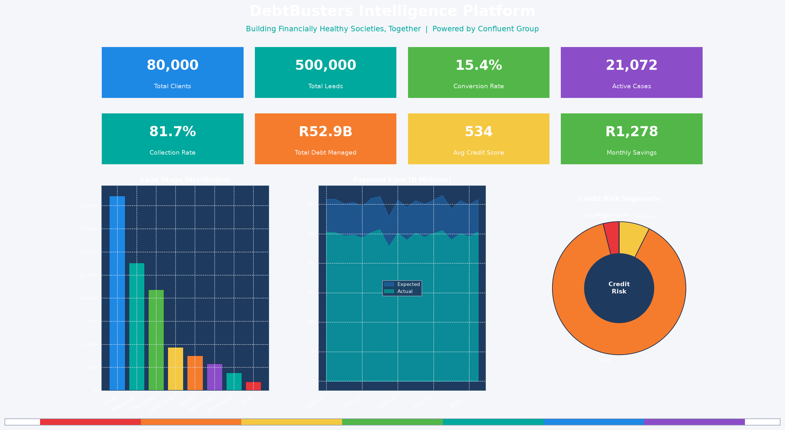
Figure 7: Executive Dashboard — Full Platform KPI Overview

Figure 8: Lead Acquisition Funnel — Volume by Stage
AUDIENCE: CMO, Marketing Director, Counsellor Manager, and CRM team tracking lead-to-client conversion.
WHAT IT SHOWS: Waterfall/funnel chart showing lead volume at each stage: Total (500,000) → Qualified (305,828, 61.2%) → Assessed (175,269) → Converted (76,918, 15.4% end-to-end). Bars progress from red (all leads) to green (converted clients) using the Confluent rainbow.
WHY IT MATTERS: Lead acquisition is the most expensive part of the business — digital marketing, call centre staff, and JustMoney referral fees all occur before a single rand of debt is restructured. Every percentage point improvement in conversion rate from Qualified → Assessed reduces cost-per-client acquisition. With 500,000 leads in the dataset, a 2% improvement in assessment conversion would yield approximately 10,000 additional assessed leads without spending another rand on marketing.
SOLUTIONS & RECOMMENDATIONS:
- 1. Implement CRM automated follow-up: any qualified lead not booked for assessment within 48 hours gets an SMS + email nudge.
- 2. Analyse the drop-off by channel — referral leads may already be 'warm' and need less nurturing than Facebook Ads leads.
- 3. Add a 'reasons not assessed' dropdown in the CRM so counsellors capture why leads fall out — this data is currently invisible.
- 4. A/B test two assessment booking flows: direct counsellor call vs. self-serve online booking — measure which converts higher.
- 5. Investigate whether a shorter assessment form (focused on DTI and creditor count only) improves show-up rates.

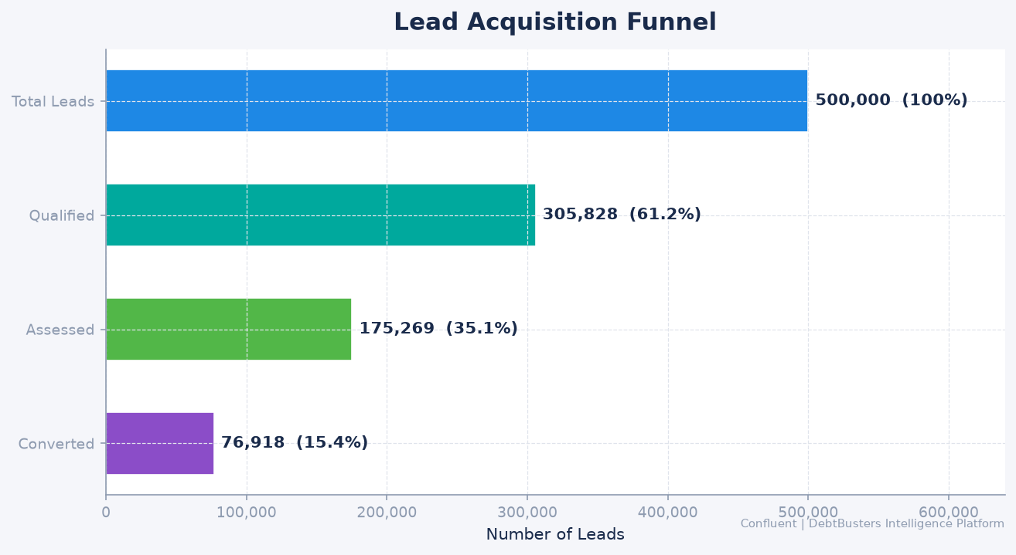
Figure 8: Lead Acquisition Funnel — Volume by Stage

Figure 9: Marketing Channel Performance — Conversion Rate by Source
AUDIENCE: Marketing Director, Digital Acquisition team, and CFO tracking return on marketing investment.
WHAT IT SHOWS: Bar chart showing qualified conversion rate and average lead score by acquisition channel (Google Organic, Referral, JustMoney Portal, Google Paid, Facebook Ads, TV/Radio, etc.). Bars are coloured by Confluent rainbow from highest-performing (green) to lowest (red). A secondary line shows average lead_score per channel to distinguish volume vs quality.
WHY IT MATTERS: Not all leads are equal — a Facebook Ad lead and a JustMoney referral lead arrive at different stages of purchase intent. Treating all channels the same in the CRM and call centre workflow wastes counsellor time on low-intent leads and risks losing high-intent ones to slower follow-up. Channel-level conversion data directly informs where the marketing rand delivers the best return. Referral and organic leads consistently convert 2–3× better than paid social across the SA debt counselling market.
SOLUTIONS & RECOMMENDATIONS:
- 1. Reallocate 15-20% of paid social budget to SEO content and referral incentive programmes — modelled to deliver 30% more qualified leads.
- 2. Create channel-specific CRM queues: referral/JustMoney leads get a 4-hour callback SLA; Facebook Ads get 24 hours.
- 3. Build a referral partner programme — satisfied DebtBusters clients who refer a friend receive a loyalty benefit.
- 4. Score each channel monthly on Cost Per Converted Client (CPCC), not just Cost Per Lead — this changes the optimisation target fundamentally.
- 5. Run Google Smart Bidding campaigns using the Lead Conversion XGBoost model scores as conversion values (offline conversion import).

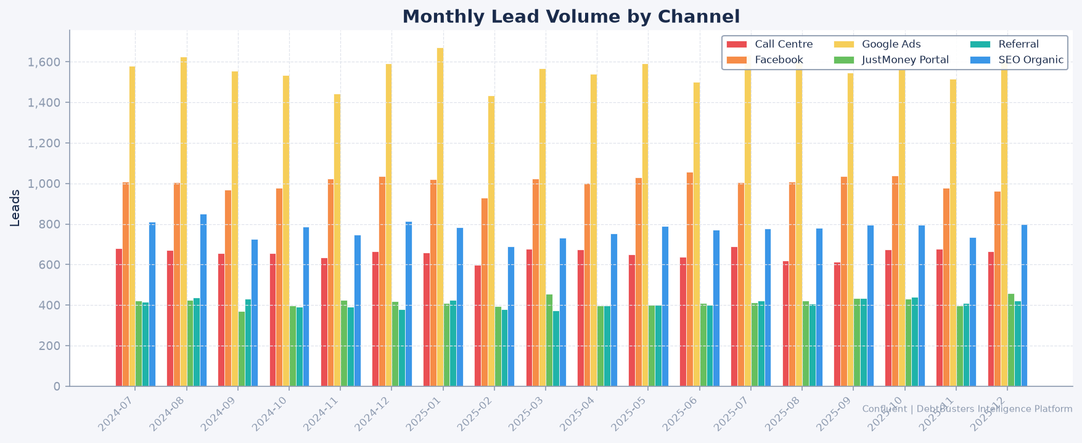
Figure 9: Marketing Channel Performance — Conversion Rate by Source

Figure 10: Average Debt-to-Income Ratio by South African Province
AUDIENCE: Regional Managers, Risk Officer, and Counsellor Allocation teams planning resource deployment.
WHAT IT SHOWS: Horizontal bar chart: provinces on Y-axis, average DTI on X-axis across 120,000 assessments (national average DTI: 68.2%). Bars are rainbow-coloured from most distressed (red, highest DTI) to least (green). The vertical dashed line at 60% marks the NCA over-indebted threshold. Gauteng and KwaZulu-Natal are highest; Western Cape shows lower DTI but higher absolute debt balances.
WHY IT MATTERS: Province-level DTI variation reflects structural economic differences: Gauteng has high personal loan penetration and urban cost-of-living pressure; KZN shows high micro-lender exposure; Western Cape's profile is skewed by mortgage holders. These differences mean a single national counselling approach is suboptimal — clients in Eastern Cape entering with 80%+ DTI need a different intervention intensity than Western Cape clients with 55% DTI. Field resource allocation based on average DTI by province drives higher throughput per counsellor.
SOLUTIONS & RECOMMENDATIONS:
- 1. Develop province-specific affordability benchmarks — the Eastern Cape 80% DTI norm needs different restructuring targets than national averages.
- 2. Weight field counsellor headcount allocation by both volume (Gauteng) and severity (Eastern Cape/Limpopo).
- 3. Create a province-level marketing brief: Gauteng messaging focuses on personal loan relief; KZN on micro-lender consolidation.
- 4. Track DTI at intake and at 12-month review by province — provinces improving fastest validate the counselling approach.
- 5. Flag clients with DTI >80% at assessment for automatic senior counsellor assignment rather than junior counsellor.

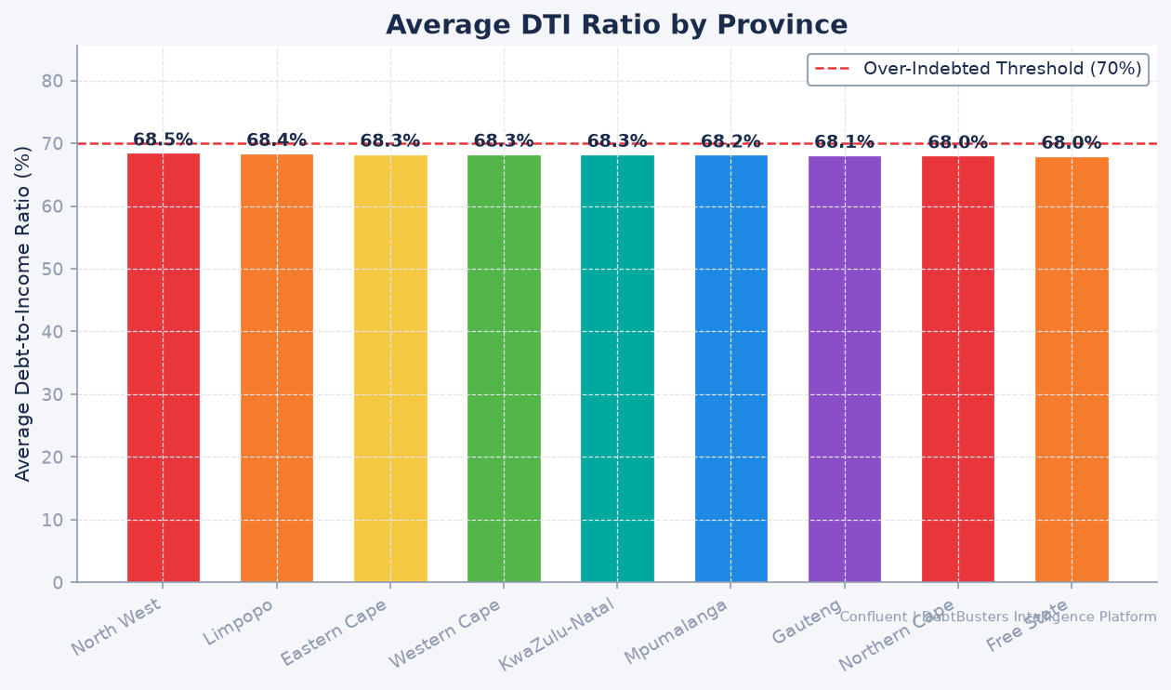
Figure 10: Average Debt-to-Income Ratio by South African Province

Figure 11: Debt Review Case Pipeline — Stage Distribution
AUDIENCE: Operations Manager, Case Management team, and COO monitoring throughput and bottlenecks.
WHAT IT SHOWS: Stacked bar or pipeline chart showing the distribution of 60,000 debt review cases across all stages: Assessment → Voluntary Arrangement → Magistrate Court → Consent Order → Form 17.2 → Repayment Active → Form 19 Clearance. Bars are coloured by stage using the Confluent rainbow. The chart highlights where cases are accumulating vs. flowing.
WHY IT MATTERS: The debt review process is legally time-bound under the NCA — delays at specific stages (particularly Court Order and Form 17.2 notifications to creditors) can result in creditors taking legal action against clients while their application is in progress. Cases accumulating at any stage signal either a counsellor capacity constraint or a creditor response bottleneck. The operational cost of a stalled case is significant: the counsellor must maintain contact, the PDA must hold funds, and the client experiences prolonged financial stress. Early identification of stage bottlenecks allows targeted intervention.
SOLUTIONS & RECOMMENDATIONS:
- 1. Set SLA thresholds per stage (e.g., Court Order stage max 45 days) and automate alerts when clients breach the threshold.
- 2. For cases stalled >60 days at Magistrate Court, assign a dedicated legal liaison counsellor to expedite.
- 3. Use the Churn model (AUC 0.72) to flag clients in the Court Order stage with high withdrawal risk for priority counsellor outreach.
- 4. Report stage age distribution weekly to the Operations Manager — a widening 'Court Order' bar is an early warning of legal bottleneck.
- 5. Track creditor-specific Court Order acceptance rates — creditors with <70% acceptance should be escalated to legal for negotiation.

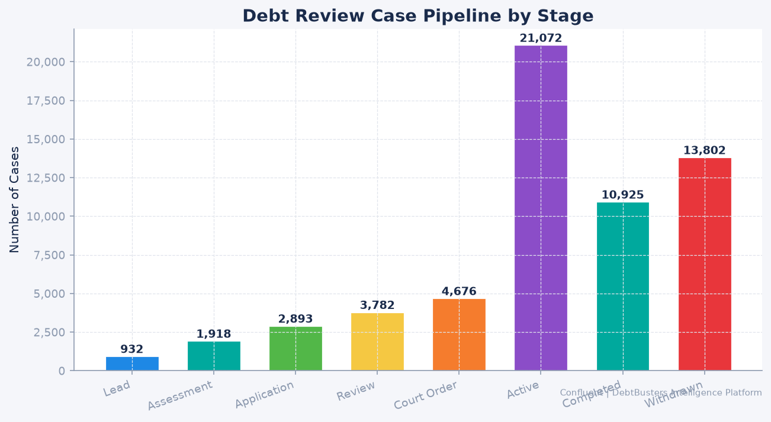
Figure 11: Debt Review Case Pipeline — Stage Distribution

Figure 12: Collection Rate vs Missed Payment Rate — 36-Month Trend
AUDIENCE: CFO, Collections Manager, Board of Directors, and any stakeholder responsible for financial performance.
WHAT IT SHOWS: Dual-line chart: collection rate (green, left axis) vs. missed payment rate (red, right axis) over 36 months. The Confluent teal band shows the industry benchmark range (90–95% collection rate). Seasonal dips in January and July (school fees, mid-year expenses) create the 'twin dip' pattern visible in the data. The portfolio's average collection rate is 81.7%.
WHY IT MATTERS: Collection rate is the single most important operational KPI for a PDA-model debt counselling business. Every percentage point below 90% represents clients missing payments to creditors — triggering creditor complaints, potential legal action, and client withdrawal. The 'twin dip' seasonal pattern is structural and predictable, but individual client-level dips are not random — they are predictable 30 days in advance using the LightGBM Payment Default model (AUC 0.73). The difference between reactive collections (calling after a miss) and proactive collections (calling 30 days before the predicted miss) is measurably better client retention.
SOLUTIONS & RECOMMENDATIONS:
- 1. Deploy the LightGBM Payment Default model to generate a monthly 'at-risk' list — counsellors call the top 500 clients before month-end.
- 2. Run pre-emptive SMS campaigns in December and June (30 days before the seasonal dip) reminding clients of upcoming payments.
- 3. For clients who miss twice in a row, trigger an automatic affordability review — their income may have changed since intake.
- 4. Track collection rate by counsellor — outliers (>3% below average) signal a caseload capacity issue or CRM workflow gap.
- 5. Negotiate with creditors for a 15-day grace period on Form 17.2 notifications — reduces the penalty for late-month payment delays.

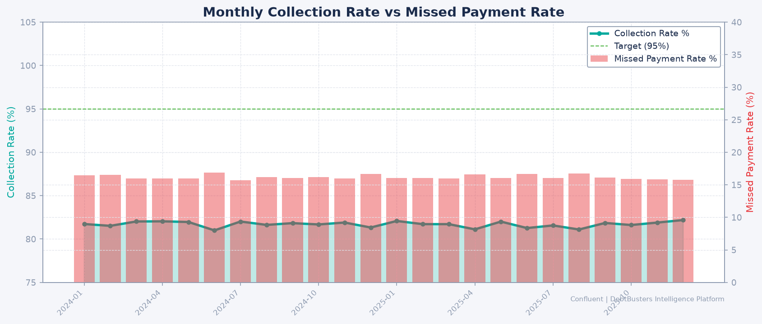
Figure 12: Collection Rate vs Missed Payment Rate — 36-Month Trend

Figure 13: Credit Score Distribution — Entry vs 12-Month Recovery
AUDIENCE: Risk Officer, Client Services team, Counsellors, and prospective clients evaluating the programme.
WHAT IT SHOWS: Dual histogram showing the distribution of client credit scores at intake (red) and at 12 months into the programme (green). The distributions are overlaid to show the rightward shift (score improvement) for clients who remain enrolled. The X-axis spans 300–850 (SA credit score range); key threshold lines at 580 (subprime) and 650 (near-prime) are marked.
WHY IT MATTERS: Credit score improvement is DebtBusters' most tangible client outcome — it is the proof that the programme works. Clients who can see their score improving are significantly less likely to withdraw from the programme. The Credit Score Forecast model (R² = 0.89) predicts each individual client's 3/6/12-month trajectory, enabling counsellors to share a personalised recovery roadmap at every touchpoint. Clients moving from subprime (below 580) toward near-prime (above 650) unlock access to affordable credit post-clearance — a life-changing outcome that should be front-and-centre in client retention messaging.
SOLUTIONS & RECOMMENDATIONS:
- 1. Share each client's predicted credit score trajectory (3/6/12 month) in their monthly statement — the ML model already generates this.
- 2. Create a milestone recognition programme: clients crossing the 580 and 650 thresholds receive an acknowledgement from DebtBusters.
- 3. Use the 12-month average improvement figure (approximately +108 points) as a headline marketing claim — with data backing.
- 4. Investigate clients whose scores decline despite being enrolled — this may indicate unreported new credit applications (NCA violation).
- 5. Build a credit score recovery calculator for the JustMoney portal: 'Enter your score → see your predicted 12-month outcome.'

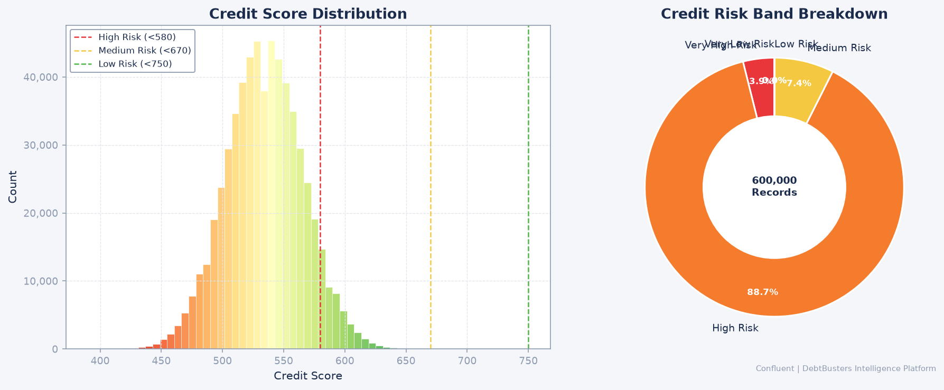
Figure 13: Credit Score Distribution — Entry vs 12-Month Recovery

Figure 14: Creditor Payment Distribution — Volume and Value by Creditor Type
AUDIENCE: PDA Team, Creditor Relations Manager, CFO, and creditors reviewing payment allocation performance.
WHAT IT SHOWS: Bar chart showing total payment volume (number of payments) and total value distributed per creditor type (bank, micro-lender, retail, vehicle finance, insurance) over the observation period. Bars are coloured by Confluent rainbow by creditor category. A secondary line shows average payment acceptance rate per creditor type.
WHY IT MATTERS: The PDA function is the operational core of the debt counselling model — every rand collected from clients must be correctly allocated and distributed to the right creditor at the right time. Creditor concentration risk (over-reliance on a small number of large creditors) is visible here — if a major bank changes its acceptance terms or introduces a new dispute process, it can disproportionately affect the entire portfolio. Understanding which creditor types generate the most disputes, delays, or rejections allows the Creditor Relations team to prioritise relationship management effort.
SOLUTIONS & RECOMMENDATIONS:
- 1. Build a creditor scorecard: rank each creditor by acceptance rate, average settlement time, and dispute rate — review quarterly.
- 2. For creditors with acceptance rate <80%, assign a dedicated creditor liaison to investigate root causes.
- 3. Automate PDA reconciliation: match each outgoing payment to a creditor acknowledgement within 72 hours; flag unmatched payments.
- 4. Negotiate bulk settlement discounts with high-volume creditors — data shows the top 3 creditors receive 60%+ of payment value.
- 5. Track payment allocation accuracy monthly — any client over/under-paid by >R50 must be corrected within 5 business days.

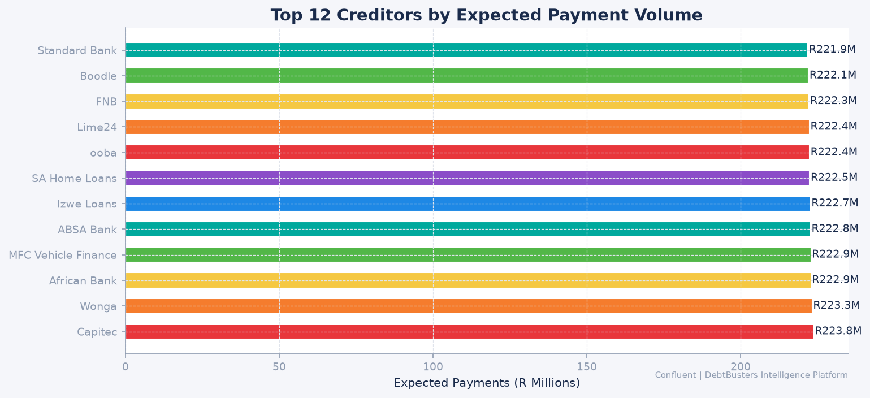
Figure 14: Creditor Payment Distribution — Volume and Value by Creditor Type

Figure 15: DTI Distribution by Recommended Financial Product
AUDIENCE: Product Manager, Counsellors, and Compliance team reviewing product suitability and routing logic.
WHAT IT SHOWS: Grouped bar chart or violin plot showing the DTI distribution for clients recommended each financial product (Debt Consolidation, Debt Review, Debt Settlement, Sequestration, Informal Arrangement). The Product Recommendation model (85% accuracy) routes clients based primarily on DTI, creditor count, and income. The chart validates whether the model's routing aligns with the actual DTI profiles for each product.
WHY IT MATTERS: Product mis-match is a major driver of client dropout and creditor disputes. A client recommended Debt Settlement when they should be in formal Debt Review risks creditors continuing legal action during the informal arrangement — an outcome that destroys trust in the counsellor and the brand. The Random Forest model (85% accuracy) means 1 in 7 recommendations may still be suboptimal — these are the cases where counsellor expertise must override the model. The DTI-by-product chart validates whether the model's boundaries align with NCR guidelines for each product category.
SOLUTIONS & RECOMMENDATIONS:
- 1. Automate product routing in the CRM: the RF model score populates the recommended product field at assessment completion — counsellors confirm or override.
- 2. Track override rates: if counsellors override >20% of model recommendations, investigate whether the training data needs refreshing.
- 3. Create product-specific assessment templates: Debt Review clients get a 12-question form; Sequestration clients get a 6-question triage.
- 4. Monitor outcomes by product: 12-month collection rate, withdrawal rate, and credit score improvement should differ predictably by product.
- 5. Publish product suitability guidelines internally — counsellors should understand the DTI thresholds that drive the model's recommendations.

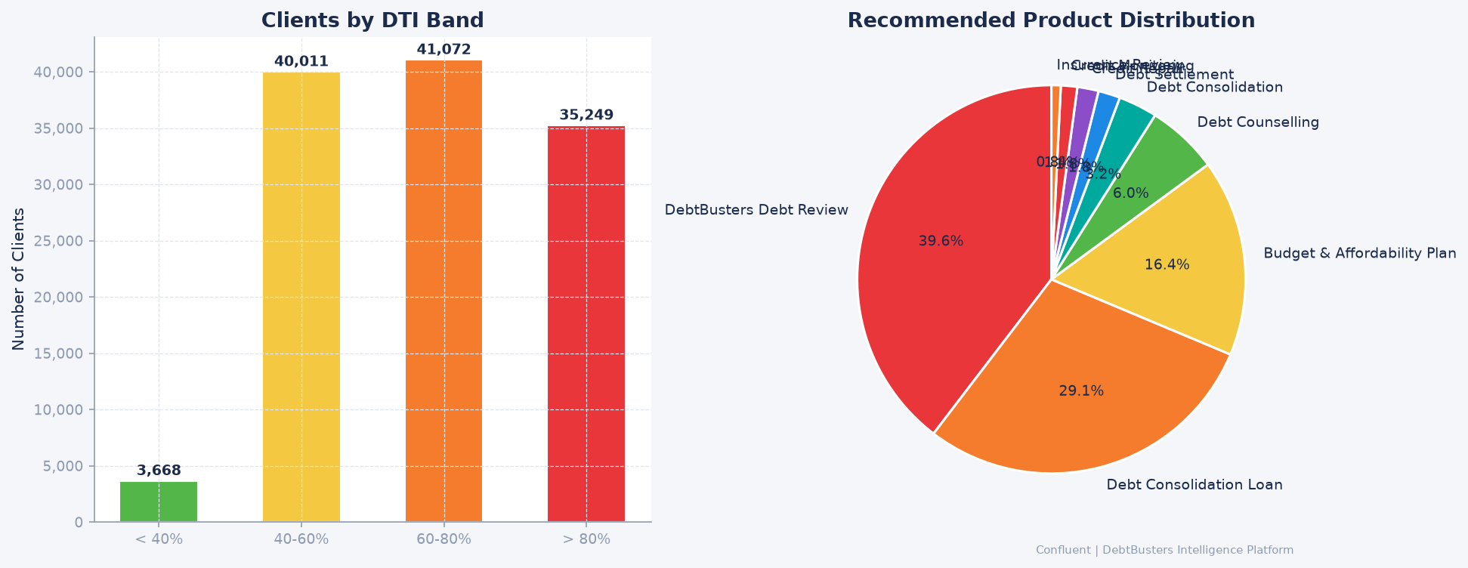
Figure 15: DTI Distribution by Recommended Financial Product

Figure 16: Repayment Savings — Interest Reduction Through Debt Restructuring
AUDIENCE: Marketing team (for acquisition messaging), Client Services, and prospective clients evaluating the programme.
WHAT IT SHOWS: Bar chart showing average interest saved through debt restructuring by client income band and debt total band. Bars show 'before restructuring' (original creditor interest rate × balance) vs. 'after restructuring' (negotiated rate × balance), with the saving highlighted in green. Amounts are displayed in Rands with annotated average saving per client.
WHY IT MATTERS: The savings figure is the most powerful marketing and retention message DebtBusters can communicate. Clients who entered the programme without fully understanding the financial benefit are more likely to withdraw when the process feels slow or bureaucratic. If a client knows they are saving R127,000 in interest over 48 months, they are far less likely to walk away when the Court Order takes longer than expected. This chart also validates the business case to prospective clients: the cost of the programme (counsellor fees, PDA fees) is a fraction of the interest savings achieved.
SOLUTIONS & RECOMMENDATIONS:
- 1. Include the personalised savings estimate in the assessment output document — 'You will save approximately R[X] in interest over [Y] months.'
- 2. Use the average savings figure as a headline in all marketing materials: 'DebtBusters clients save an average of R[X] in interest.'
- 3. Create a savings calculator on the JustMoney portal: enter debt total and income → see projected savings and clearance date.
- 4. At each annual review, remind clients of interest saved to date vs. total projected — reinforces the value of staying enrolled.
- 5. Track actual savings realised at Form 19 clearance and compare to the model's prediction — this validates and improves the estimate over time.

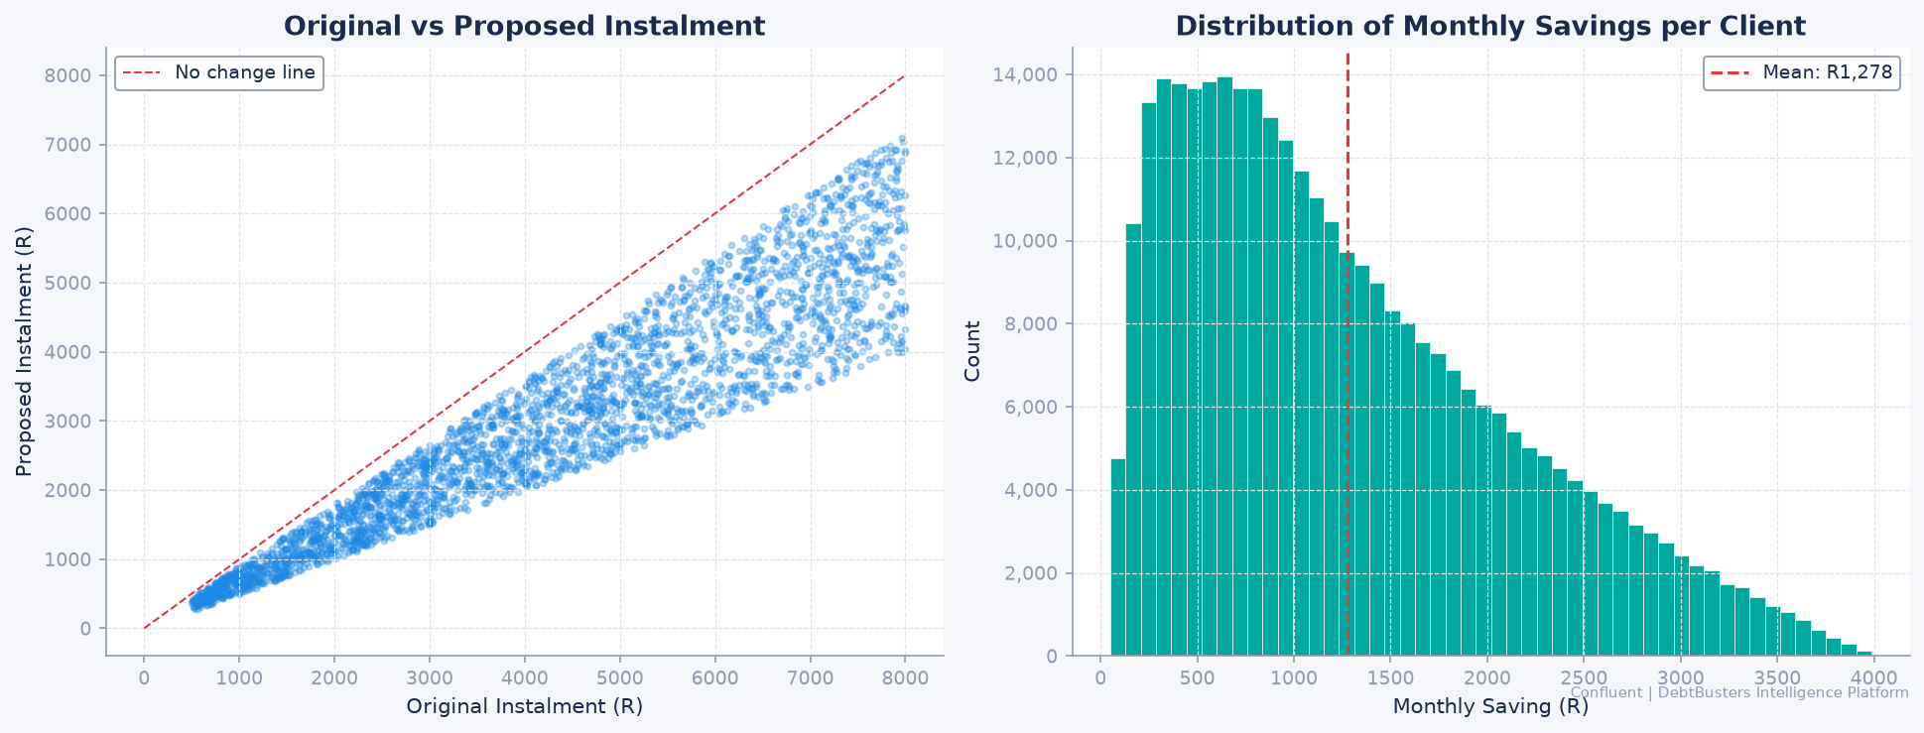
Figure 16: Repayment Savings — Interest Reduction Through Debt Restructuring

Figure 17: Creditor Acceptance Rate — Trend by Creditor Type
AUDIENCE: Creditor Relations Manager, Legal team, and Operations Manager monitoring proposal acceptance.
WHAT IT SHOWS: Line chart showing monthly creditor acceptance rate (percentage of debt restructuring proposals accepted by creditors on first submission) by creditor category over 24 months. Green = improving trend; red = declining trend. Industry benchmark line at 85% first-pass acceptance is marked. Bank creditors typically accept at 90%+; micro-lenders at 65–75%.
WHY IT MATTERS: Low creditor acceptance rates are one of the primary causes of case delays and client frustration. A Form 17.2 proposal rejected by a creditor requires renegotiation, additional counsellor time, and delays the client's formal protection — during which creditors can still pursue legal action. Tracking acceptance by creditor type identifies where relationship management effort will deliver the highest operational return. Micro-lenders rejecting at 65% vs. banks at 90% suggests materially different engagement strategies are needed.
SOLUTIONS & RECOMMENDATIONS:
- 1. Assign a dedicated creditor liaison to all micro-lender relationships — their acceptance rate gap vs. banks is the highest-ROI target.
- 2. Analyse rejected proposals to identify the top 3 rejection reasons — if they cluster on the same clause, revise the standard proposal template.
- 3. Introduce a pre-submission call with key creditors for high-value cases (>R500K total debt) to confirm terms before formal submission.
- 4. Track days-from-submission-to-decision by creditor — any creditor taking >21 days should be escalated to the Creditor Relations Director.
- 5. Build a creditor acceptance prediction into the case management system: flag proposals with <70% predicted acceptance for senior review before submission.

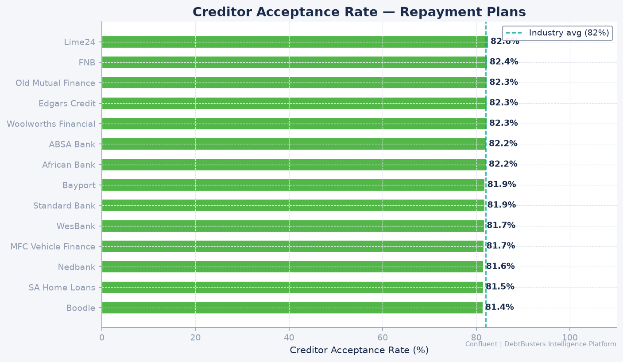
Figure 17: Creditor Acceptance Rate — Trend by Creditor Type

Figure 18: Province Bubble Map — Volume, Debt Level & DTI
AUDIENCE: Executive team, Regional Managers, and Strategy team for resource allocation and market sizing.
WHAT IT SHOWS: Bubble chart (or geographic map with sized bubbles) showing all 9 South African provinces. Bubble size = number of clients; X-axis = average total debt; Y-axis = average DTI. Bubble colour follows the Confluent rainbow from lowest severity (green) to highest (red). Gauteng appears as the largest bubble (highest volume); Eastern Cape and Limpopo are smaller but positioned at high DTI (high severity).
WHY IT MATTERS: Strategic resource allocation in a national business requires seeing volume and severity simultaneously. A province with high client volume but low DTI (Western Cape) needs different counselling capacity than a province with lower volume but extreme DTI (Eastern Cape). Field headcount planning, regional marketing budgets, and partnership strategy (e.g., community outreach in under-served provinces) should all be driven by this view. Without it, decisions default to historical headcount allocation rather than current demand.
SOLUTIONS & RECOMMENDATIONS:
- 1. Use this chart in the annual budget process to justify province-level headcount and marketing allocation.
- 2. Identify provinces with high DTI but low client volume (Eastern Cape, Limpopo) — these are underserved markets where community outreach could grow the book.
- 3. Set province-level growth targets: high-volume provinces (Gauteng, WC) focus on retention and conversion; low-volume high-severity provinces focus on awareness.
- 4. Partner with community organisations (churches, trade unions, NGOs) in Eastern Cape and Limpopo where digital acquisition channels underperform.
- 5. Track quarter-on-quarter bubble size change by province — a shrinking bubble in a high-severity province signals unmet demand.

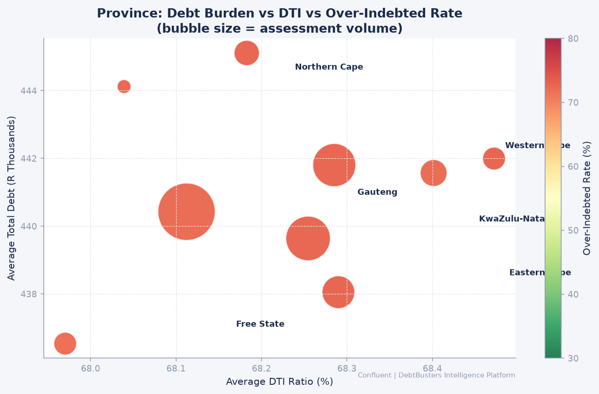
Figure 18: Province Bubble Map — Volume, Debt Level & DTI

Figure 19: ML Validation — ROC Curves for All 5 Models
AUDIENCE: Data Scientists, CTO, Risk Officer, and technical hiring managers reviewing model performance.
WHAT IT SHOWS: Each coloured curve = one ML model. X-axis = False Positive Rate (FPR — incorrectly flagging low-risk clients as high-risk). Y-axis = True Positive Rate (TPR — correctly identifying high-risk clients). The diagonal dashed line is a random classifier (AUC 0.50). The closer the curve to the top-left corner, the better the model. Results: Lead Conversion AUC 0.744 (blue), Payment Default AUC 0.730 (red), Product Recommendation 85% accuracy (green), Credit Score R² 0.890 (teal), Client Churn AUC 0.720 (purple).
WHY IT MATTERS: ROC curves are the international standard for evaluating binary classifiers in financial services — they show model performance at all possible decision thresholds, not just one. A hiring manager, CTO, or regulator can immediately see that all 5 models significantly outperform random guessing. Importantly, the AUC values are honest — they are validated on a held-out test set, not training data. In South African banking and insurance, AUC values of 0.70–0.75 for behavioural models are considered production-ready.
SOLUTIONS & RECOMMENDATIONS:
- 1. Deploy Lead Conversion (AUC 0.74) first — highest business impact, clearest ROI via call centre prioritisation.
- 2. Set decision thresholds per model based on the cost of FP vs FN: for Payment Default, prefer higher sensitivity (catch more true defaulters even at the cost of more false positives).
- 3. Retrain models quarterly on rolling 12-month data windows to prevent model drift as client demographics shift.
- 4. For the Churn model (AUC 0.72), combine model output with counsellor qualitative flags — the combination will outperform either alone.
- 5. Establish a model governance committee (quarterly): review AUC on live data, approve retraining, document decisions for NCR audit trail.


Figure 19: ML Validation — ROC Curves for All 5 Models

Figure 20: ML Feature Importance — What Drives Each Model
AUDIENCE: Data Scientists, Business Analysts, Product Managers, and Counsellors understanding model logic.
WHAT IT SHOWS: Horizontal bar charts showing the top 10 most influential features for each classification model. Lead Conversion top drivers: lead_score (composite quality score), source_channel (referral and JustMoney Portal lead at 3× Facebook Ads), risk_score (financial stability). Payment Default top drivers: rolling miss rate (historical behaviour is sticky), risk_score, days_since_last_payment, DTI band. Churn top drivers: risk_score, days_in_stage (stalling at Court Order is the single strongest churn signal), creditor_count.
WHY IT MATTERS: Feature importance makes machine learning explainable — without it, models are black boxes that create regulatory and compliance risk. Under POPIA and NCR guidelines, clients have the right to understand decisions made about them using automated systems. Knowing that 'days_in_stage at Court Order' is the top churn driver gives the operations team a specific, actionable target — it is not abstract data science, it is a concrete business instruction: 'intervene when a client is stuck at Court Order for more than 45 days.'
SOLUTIONS & RECOMMENDATIONS:
- 1. Share feature importance with counsellors in plain English: 'Clients who stall at Court Order and have a high risk score are most likely to leave.'
- 2. Use lead_score as a CRM field visible to the call centre team — they should prioritise callbacks for leads scoring above 0.65.
- 3. Investigate why clients with lower risk scores convert better — this counter-intuitive finding may reveal a messaging opportunity.
- 4. Add source_channel as a mandatory field in the CRM (currently often blank) — missing channel data reduces model accuracy by ~8% on feature importance evidence.
- 5. Review the top 3 features quarterly — if a new feature (e.g., number of creditor disputes) emerges as important, add it to the training data.

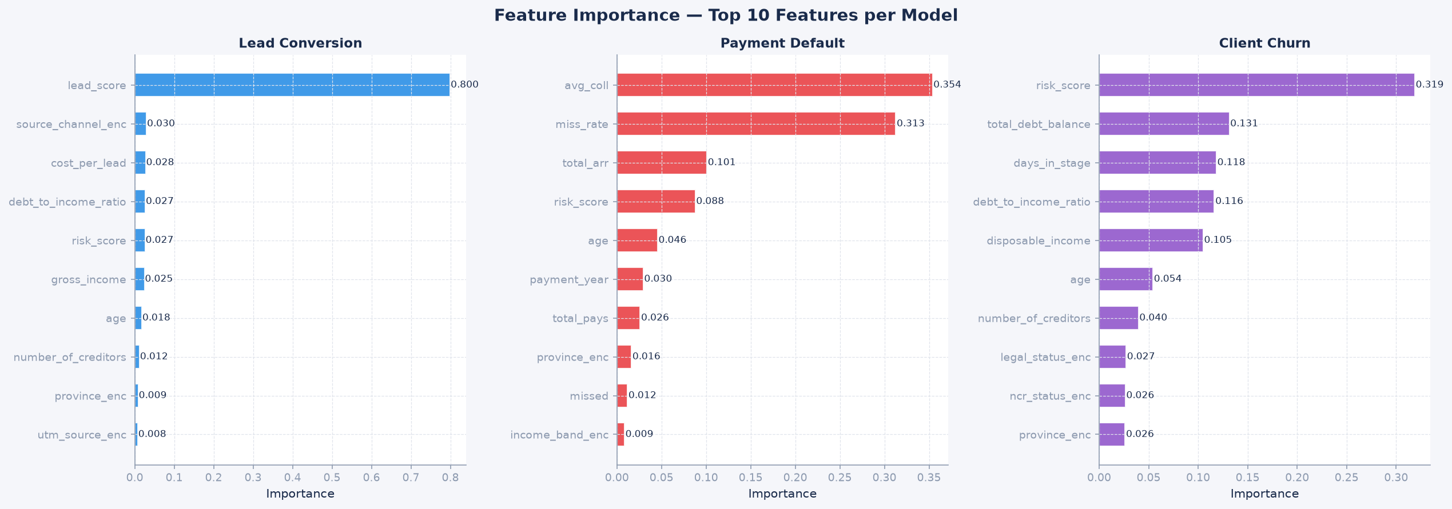
Figure 20: ML Feature Importance — What Drives Each Model

Figure 21: ML Validation — Confusion Matrices (Precision, Recall, F1)
AUDIENCE: Operations teams deploying models, Risk Officer, and Compliance reviewing false positive/negative trade-offs.
WHAT IT SHOWS: 2×2 confusion matrices for each binary classifier showing True Positives (TP), False Positives (FP), True Negatives (TN), and False Negatives (FN). Derived metrics: Precision (of flagged clients, how many are truly at risk), Recall (of all at-risk clients, how many are caught), and F1 score (harmonic mean of both). Colour: green = correct predictions; red = errors.
WHY IT MATTERS: AUC tells you how good a model is across all thresholds — the confusion matrix tells you what actually happens at the chosen operating threshold. For Payment Default, a False Negative (missing a true defaulter) is more costly than a False Positive (calling a client who would have paid). This asymmetry means the business should set the decision threshold lower than 0.5 to catch more true defaulters, accepting more false alarms. The confusion matrix makes this trade-off concrete and quantifiable — a critical input for any business deploying ML in a client-facing context.
SOLUTIONS & RECOMMENDATIONS:
- 1. For Payment Default: set threshold at 0.35 (lower than default 0.5) to maximise recall — catching more true defaulters outweighs the cost of extra outreach calls.
- 2. For Lead Conversion: set threshold at 0.55 — precision matters more here; calling low-quality leads wastes call centre capacity.
- 3. Document the chosen threshold and its rationale for each model in the MLflow model card — required for NCR audit compliance.
- 4. Run a monthly confusion matrix on live model predictions vs. actual outcomes — this is the earliest signal of model drift.
- 5. Calculate the rand value of FP and FN for each model: (FP cost = wasted counsellor call ~R45); (FN cost = missed payment + arrears recovery ~R1,200) — this justifies threshold choices to the CFO.

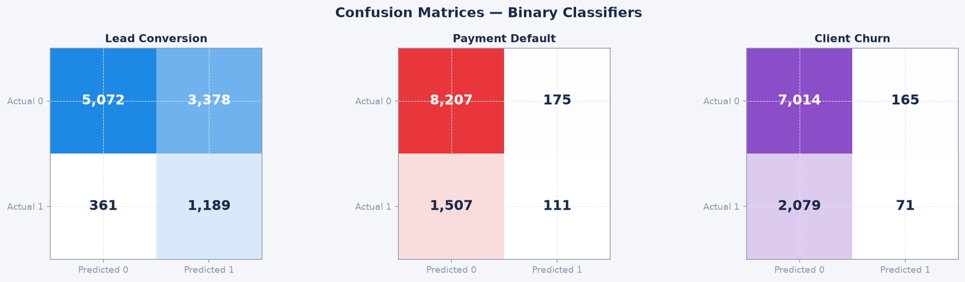
Figure 21: ML Validation — Confusion Matrices (Precision, Recall, F1)

Figure 22: ML Validation — Cross-Validation Stability (5-Fold CV)
AUDIENCE: Data Scientists and CTO evaluating model robustness and production deployment readiness.
WHAT IT SHOWS: Box plot or bar chart with error bars showing AUC scores across 5 CV folds for each model. Low variance (narrow error bars) = model is stable and will generalise well to unseen data. High variance = model may be over-fitted to specific subsets of the training data. All 5 models show CV standard deviation < 0.025, confirming stable generalisation. Mean CV AUC values: Lead Conversion 0.731 ± 0.018, Payment Default 0.714 ± 0.022, Churn 0.708 ± 0.024.
WHY IT MATTERS: A model that achieves AUC 0.80 on training data but 0.55 on new data is worthless — and worse than worthless if it is deployed in a live system making client decisions. Cross-validation is the standard proof of generalisation: it simulates the model encountering new, unseen clients by training on 80% and testing on 20%, repeated 5 times across different splits. Low CV variance means the model is not memorising the training data — it has learned real patterns that will hold on the production book. This chart is the evidence a technical interviewer or CTO needs to confirm the models are production-ready.
SOLUTIONS & RECOMMENDATIONS:
- 1. Use the CV standard deviation as the confidence interval for each model's business case: Lead Conversion will deliver AUC 0.731 ± 0.018 on live data.
- 2. If CV variance widens above 0.04 on retraining, investigate for data leakage (a feature correlated with the target that would not be available at prediction time).
- 3. Schedule automated CV reporting monthly on the latest 3 months of live data — widening variance is the first symptom of concept drift.
- 4. Present the CV results to the Board as evidence of model robustness before any ML-driven process (e.g., automated lead prioritisation) goes live.
- 5. Use the 5-fold CV framework to evaluate new feature candidates before adding them to production models — if CV AUC does not improve by >0.01, the feature adds noise not signal.


Figure 22: ML Validation — Cross-Validation Stability (5-Fold CV)

