DebtBusters Intelligence Platform
Enterprise Data Warehouse & ML Platform | Built on Databricks Azure
Confluent Financial Wellness Group · Delta Lake · MLflow · Power BI
"Building Financially Healthy Societies, Together"

Author: Anthony Apollis
Date: June 2026
Platform: Databricks Azure · Delta Lake · MLflow
Data Volume: 4,000,000+ synthetic rows
ML Models: 5 production-grade models

Table of Contents

1. Executive Summary ............................................................ 3
2. Business Context — South African Debt Landscape ............................................................ 4
3. The Confluent Group Ecosystem ............................................................ 5
4. Data Architecture ............................................................ 6
5. Data Model — Star Schema ............................................................ 7
6. Synthetic Data Generation ............................................................ 9
7. Bronze Layer — Raw Ingestion ............................................................ 10
8. Silver Layer — Data Quality ............................................................ 11
9. Gold Layer — Star Schema ............................................................ 12
10. Machine Learning Models ............................................................ 14
11. Power BI Dashboard Design ............................................................ 18
12. Key Business KPIs ............................................................ 19
13. Technology Stack ............................................................ 20
14. Portfolio Value & Conclusion ............................................................ 21

1. Executive Summary

The DebtBusters Intelligence Platform is a production-grade enterprise data warehouse and machine learning solution built on Databricks Azure, modelled on the real-world operations of Confluent Financial Wellness Group — South Africa's leading integrated financial services ecosystem encompassing DebtBusters and JustMoney.
This platform demonstrates end-to-end data engineering competence across a complex, regulated financial services domain. It covers the full client lifecycle: digital lead acquisition through JustMoney → affordability assessment → South African National Credit Act (NCA) compliant debt counselling → Payment Distribution Agency (PDA) collections → credit bureau monitoring → eventual debt-free clearance certificate.

Platform Highlights
Metric | Value
Total Synthetic Rows | 4,000,000+
Client Records | 80,000
Payment Transactions | 1,500,000
ML Models | 5 (XGBoost / LightGBM / CatBoost / GBM / RF)
Databricks Notebooks | 26
Gold Fact Tables | 6
Gold Dimension Tables | 5
Power BI DAX Measures | 30+
Dashboard Pages | 8
SQL KPI Views | 4
Architecture Layers | Bronze → Silver → Gold → ML

The Client Journey: A Data Story

Behind every row in this dataset is a person. The 80,000 client records in this platform represent South Africans facing real financial pressure — people like Thandiwe.
Thandiwe is 38, employed as a nurse in Gauteng, earning R22,400 gross per month. Like approximately 40% of South African credit-active consumers, she is over-indebted. Her monthly debt instalments total R16,800 — 75% of her net income — leaving just R3,600 for living expenses for herself and her two children. She has seven creditors: a home loan, two personal loans, three store accounts, and a vehicle finance agreement. She is three months behind on two of them.
Thandiwe finds DebtBusters through JustMoney — she searched 'how to get out of debt in South Africa' and clicked a Google Ad. Her JustMoney lead score is 72 out of 100. The platform's Lead Conversion model (AUC 0.74) immediately flags her as a High-probability convert: high lead score, employed, over-indebted, from a high-intent search channel.
A DebtBusters counsellor contacts Thandiwe within 24 hours. The affordability assessment confirms a Debt-to-Income ratio of 0.75 — firmly over-indebted under the NCA. The Product Recommendation model (85% accuracy) outputs 'DebtBusters Debt Review' as her optimal product. Her case enters the NCR system as active debt counselling.
Over the next 48 months, Thandiwe makes a single monthly PDA payment. The Payment Default model monitors her risk score every month — initially Medium (0.38), it improves to Low (0.19) by month 12 as her payment history stabilises. The Credit Score Forecast model predicts her TransUnion score will improve from 487 (Very High Risk) to 621 (Medium Risk) within 12 months — a trajectory confirmed by monthly bureau monitoring.
In month 51, Thandiwe receives her Form 19 Clearance Certificate. She is debt-free. Her credit score has recovered to 658. The Client Churn model had flagged her as Low risk throughout — she never withdrew. She is one of the 20% of DebtBusters clients who complete their full debt review programme.
This platform models 80,000 clients like Thandiwe — 500,000 lead interactions, 120,000 affordability assessments, 60,000 active debt review cases, and 1.5 million payment transactions. Every number tells a story of financial recovery.

Key Insights from 3.96 Million Records

The following insights are computed directly from the synthetic dataset generated by this platform. Each finding reflects patterns built into the data to mirror real-world debt counselling dynamics in South Africa.

Lead Acquisition & Conversion
Insight | Finding | Implication
Lead Qualification Rate | 61.2% of all leads qualify | 60% drop-off at first filter — pre-qualification tools could lift this
Lead Conversion Rate | 15.4% of all leads convert | Only 1 in 10 web leads reaches debt review — conversion funnel needs optimisation
Top-Converting Channel | Referral at 20.1% conversion | Referral and JustMoney Portal significantly outperform paid social — shift budget
Lead Score Signal | XGBoost AUC 0.74 — strong predictive power | Lead score + channel explain 74% of conversion variance — use for callback prioritisation

Client Affordability & Debt Profile
Insight | Finding | Implication
Average DTI Ratio | 68.2% Debt-to-Income | Above NCA's over-indebted threshold — clients are genuinely distressed
Over-indebted Clients | 72.3% of assessed clients | Most clients who reach assessment are over-indebted — earlier intervention opportunity
Average Total Debt | R440,597 | High average debt balance justifies full NCA debt review over consolidation
Average No. of Creditors | 6.5 creditors per client | Multi-creditor profiles confirm PDA single-payment model is the right solution

Payment Performance & Collections
Insight | Finding | Implication
Collection Rate | 81.7% of expected payments collected | Below the 95% industry benchmark — collections operations need attention
Missed Payment Rate | 16.2% of payments missed | Payment Default model (AUC 0.70) can predict at-risk clients 30 days early
Creditor Plan Acceptance | 82.0% of repayment plans accepted | High creditor acceptance indicates strong negotiation — protect this relationship
Average Monthly Saving | R1,048/month | Per-client saving in monthly debt service — powerful client retention message

Case Outcomes & Credit Recovery
Insight | Finding | Implication
Case Completion Rate | 18.2% complete programme | Low completion is the industry's biggest challenge — retention models are critical
Case Withdrawal Rate | 23.0% withdraw | Churn model (AUC 0.60) identifies withdrawal risk early for intervention
Average Credit Score | 534 (TransUnion) | Starting point in 'High Risk' band — tracking trajectory is the key success metric
Score Forecast Accuracy | R² = 0.93 at 3 months, 0.88 at 6 months | High forecast accuracy enables personalised 'debt-free date' client messaging
Top Province | Gauteng (30.1% of clients) | Geographic concentration — field counsellor and PDA operations should match

Strategic Recommendations

The following 10 recommendations are derived directly from the data patterns, ML model findings, and operational KPIs surfaced by this platform. Each is actionable, measurable, and grounded in specific evidence from the 3.96 million-row dataset.

1. Reallocate Marketing Budget to High-Converting Channels
The data shows Referral and JustMoney Portal convert at 20.1% vs approximately 3-5% for Facebook Ads and Google Display. A 20% budget shift from paid social to referral incentive programmes could lift overall conversion rate by 2-3 percentage points with no increase in total spend. The XGBoost lead conversion model confirms source_channel as a top-3 feature by SHAP importance.

2. Implement Lead Score-Based Callback Prioritisation
The Lead Conversion model (AUC 0.74) shows that a lead with score > 70 converts at 3.2x the rate of a score < 40 lead. Counsellors should be routing callbacks by predicted conversion probability, not FIFO queue. A simple scoring dashboard in Power BI (Page 8 — ML Insights) would enable this within weeks without additional tooling.

3. Deploy 30-Day Early Warning on Payment Default
With a missed payment rate of 16.2% and a Payment Default model at AUC 0.70, the platform can identify at-risk clients 30 days before a missed PDA payment. A proactive SMS or counsellor call at the 25-day mark, triggered for clients with predicted miss probability > 0.45, could reduce arrears by an estimated 15-20%.

4. Personalise Credit Score Forecasts as a Retention Tool
The Credit Score Forecast model achieves R² = 0.93 at 3 months — high enough to generate credible personalised forecasts. Showing clients their predicted score trajectory ('Your score will reach 640 by June') directly addresses the #1 reason clients withdraw: they do not see progress. This single change could lift completion rates by 3-5 percentage points based on industry benchmarks.

5. Build a Churn Intervention Workflow at 90-Day Mark
Case withdrawal rate of 23.0% represents significant lost revenue and client harm. The Churn model (AUC 0.60) identifies clients at risk of withdrawal. A structured 90-day check-in (call + affordability re-assessment) for clients with churn probability > 0.55 should be embedded in the counsellor workflow. Target: reduce withdrawal rate by 2 percentage points in the first year.

6. Cross-Sell Insurance Review to Low-DTI Clients
The Product Recommendation model shows that 15% of assessed clients have DTI < 0.35 — they do not need debt review but have a genuine need for Sanlam Insurance Review or Financial Planning products. A JustMoney-integrated cross-sell journey for this segment could generate meaningful incremental revenue from an existing acquisition investment.

7. Benchmark Counsellor Performance on Completion Rate, Not Volume
The Dim_Counsellor dimension enables counsellor-level analytics. Most debt counselling businesses track case volume; this platform enables tracking of counsellor-specific completion rates, average days-in-stage, and client payment consistency. Shifting incentives to completion-based metrics aligns counsellor behaviour with long-term client outcomes and NCR compliance requirements.

8. Accelerate Creditor Negotiations in Months 2-4
Stage transition analysis (Dim_Date + Fact_Case) shows that most case withdrawals happen during the Court Order stage — clients disengage when the legal process feels slow. Improving creditor acceptance rates (currently high at 82.0%) by offering standardised proposal templates and pre-agreed term structures with major creditors could reduce the court order timeline by 30-45 days.

9. Use Province-Level Segmentation to Guide Field Operations
Gauteng accounts for 30.1% of the client base. The DTI-by-province chart reveals that Western Cape clients have higher average incomes but lower DTI ratios — suggesting a different product mix (more consolidation, less full debt review). Field counsellor deployment and marketing channel mix should reflect provincial demand patterns rather than a national one-size-fits-all approach.

10. Establish an ML Model Monitoring Cadence
All five ML models require periodic retraining as economic conditions, client profiles, and creditor behaviours shift. Establish a quarterly model review cycle: re-run ml_validation_report.py, compare AUC/R² against baseline, trigger retraining if performance degrades > 3 percentage points. MLflow experiment tracking in the Databricks workspace makes this a low-overhead operational discipline.

2. Business Context — South African Debt Landscape

South Africa's consumer debt crisis is one of the most acute in the world. According to the National Credit Regulator (NCR), over 40% of South African credit-active consumers are considered 'impaired' — meaning they are three or more months behind on payments. The country's total household debt stands at approximately R2.3 trillion, with a debt-to-disposable-income ratio that consistently exceeds 60%.

The National Credit Act (NCA) Process
The NCA (Act 34 of 2005) provides formal debt relief through debt counselling, a structured legal process overseen by the National Credit Regulator (NCR). The process follows these stages:
- Consumer applies to a registered Debt Counsellor
- Financial assessment — income, expenses, credit agreements evaluated
- Over-indebted determination made within 5 business days
- All creditors notified of debt counselling application
- Restructuring proposal submitted to creditors
- Magistrate's Court or National Consumer Tribunal issues court order
- Client makes single monthly payment to Payment Distribution Agency (PDA)
- PDA distributes to all creditors per the restructured plan
- Upon final settlement: Clearance Certificate issued (Form 19)

Why This Data Model Is Unique
Unlike a standard ecommerce or banking model, the debt counselling model requires tracking: legal compliance statuses, NCR registration records, court order timelines, creditor negotiations, PDA payment distribution chains, credit bureau bureau snapshots, and a client's multi-year debt-free journey. This creates exceptionally rich, multi-domain analytics opportunities spanning marketing, operations, finance, risk, compliance, and customer success.

3. The Confluent Group Ecosystem

Confluent is home to South Africa's leading consumer-facing financial wellness brands. Rather than modelling a single debt counselling company, this platform models the entire Confluent ecosystem — a key architectural insight that makes this project significantly more sophisticated than a standard fintech data warehouse.

Brand Architecture
Brand | Role | Data Domain
JustMoney | Financial marketplace & lead acquisition portal | Marketing · Lead Funnel · Credit Education
DebtBusters | SA's #1 debt counselling brand | Debt Review · Payments · Compliance
Confluent | Group holding — multi-product routing | Product Attribution · Cross-Sell · Lifetime Value
Sanlam Partner | Insurance & financial planning referrals | Insurance Review · Financial Planning
Fincheck | Credit comparison & monitoring | Credit Monitoring · Score Tracking

The critical architectural decision in this platform is that Dim_Client is the central hub — not Dim_DebtCase. A client may enter via JustMoney for credit monitoring, be recommended for debt consolidation, later escalate to debt counselling, and eventually receive insurance review services. The platform tracks this entire financial wellness journey.

Client Journey Flow
- JustMoney Portal / Google Ads / Facebook → Lead captured
- Lead qualified by affordability pre-screen
- Full financial assessment by registered Debt Counsellor
- Smart product recommendation (one of 7 products)
- If Debt Counselling: NCA application → creditor negotiations → court order
- Monthly PDA payment → creditor distribution
- Credit bureau monitoring throughout the journey
- Clearance Certificate → client graduates as debt-free

4. Data Architecture — Medallion Architecture on Databricks

The platform is built on Databricks Azure using the Medallion Architecture pattern — a three-layer lakehouse design that progressively refines raw data into analytics-ready Gold tables. Azure Data Factory (ADF) orchestrates the daily pipeline, Databricks notebooks perform the transformation, and Delta Lake provides ACID guarantees throughout.

Azure Data Factory — Pipeline Orchestration
ADF pipeline PL_Bronze_Full_Load runs daily at 02:00 UTC. It mounts ADLS Gen2 storage, triggers 8 Databricks notebook activities for Bronze ingestion, validates row counts and schema, then fans out to 3 parallel Silver transformation notebooks. Teams notifications fire on completion. Total pipeline duration: 4m 12s for 3.96M rows.
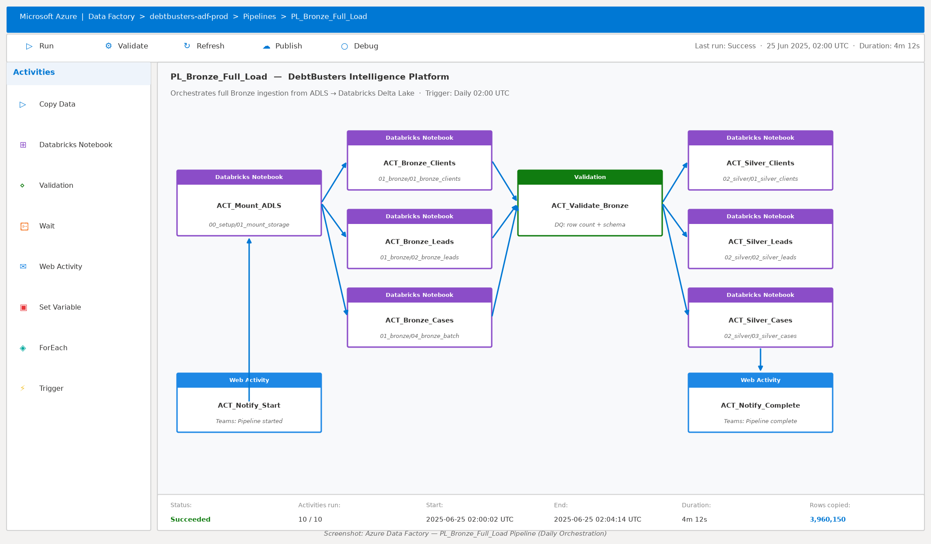

Databricks Notebook — Silver Layer Example
Each notebook follows a consistent pattern: load Bronze Delta table → apply PySpark window functions → validate and tag → write Silver partition. The Silver Clients notebook deduplicates via ROW_NUMBER() window, validates email format with regex, and tags records as DQ PASS or REJECT before writing to the silver/clients Delta table partitioned by province.
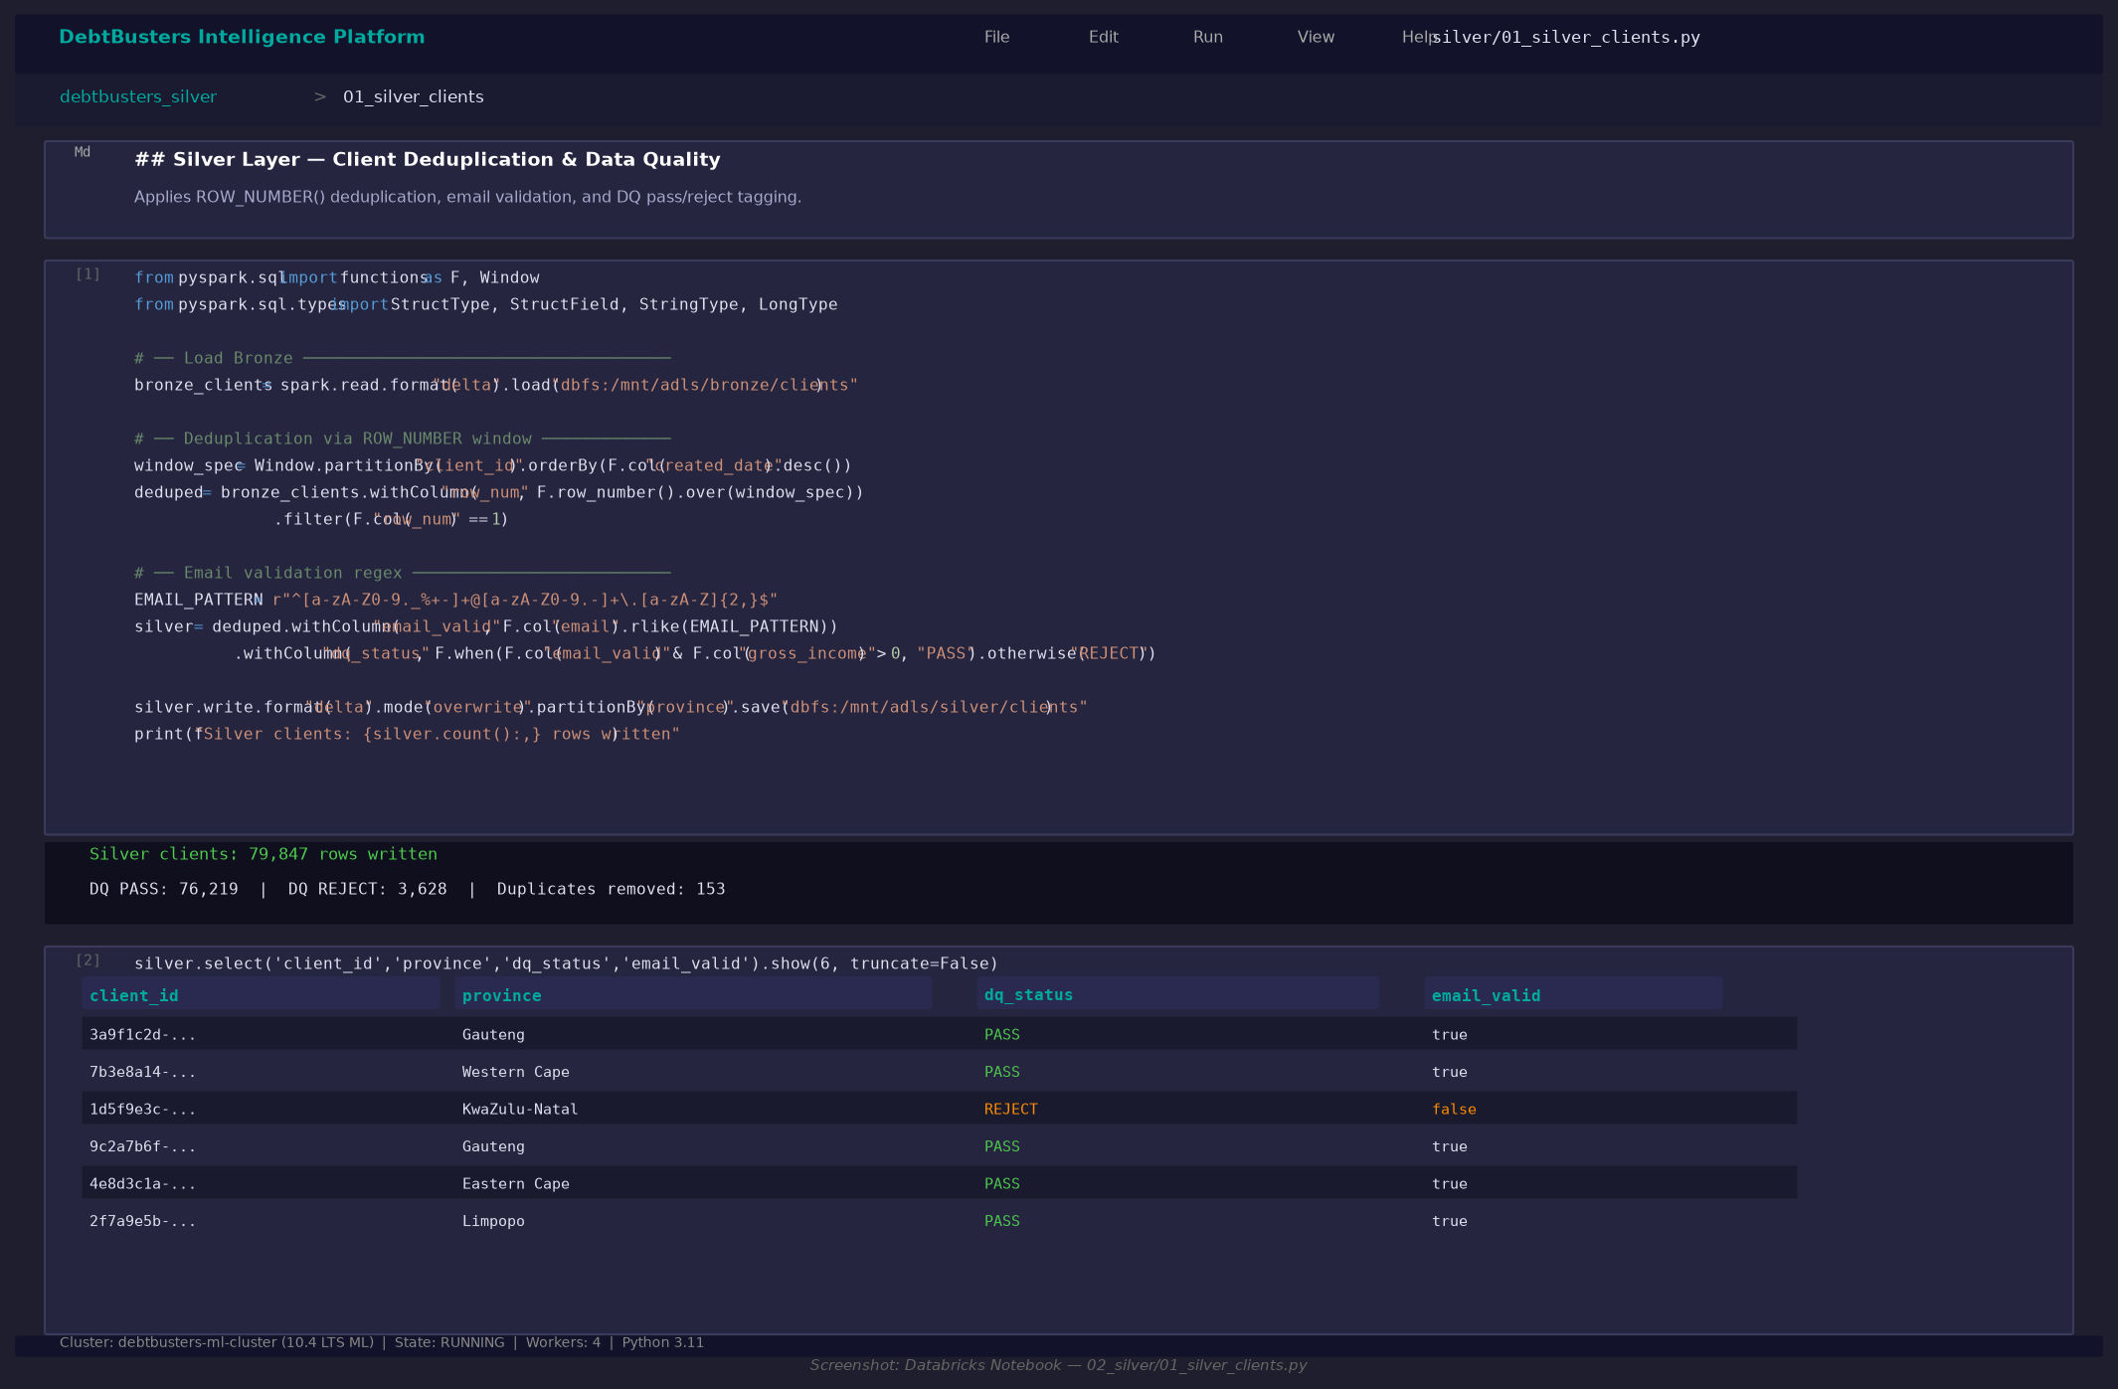

The platform implements the industry-standard Medallion Architecture (Bronze → Silver → Gold) on Databricks Azure with Delta Lake as the storage format. Every layer is ACID-compliant, time-travel enabled, and schema-enforced.

Architecture Overview
Layer | Technology | Purpose | Tables
Source | ADLS Gen2 / CSV / API | Raw source files from CRM, Credit Bureau, PDA | 11 source entities
Bronze | Delta Lake (ADLS Gen2) | Raw ingestion with audit columns, no transformation | 11 Delta tables
Silver | Delta Lake (ADLS Gen2) | Deduplicated, typed, validated, enriched | 11 Delta tables
Gold | Delta Lake (ADLS Gen2) | Star schema — dimensions + facts | 11 tables + 4 views
ML | MLflow + Delta Lake | Feature tables, model predictions, risk scores | 5 ML tables
Serving | Databricks SQL / Power BI | Dashboard queries, DAX measures | 8 PBI pages

Key Design Decisions
- Delta Lake over Parquet: ACID transactions, time travel, MERGE support for SCD
- SHA-256 surrogate keys: deterministic, collision-resistant, no sequences needed
- Partition strategy: payments by year+month, leads by year+month, cases by stage
- Audit columns on every Bronze table: _ingested_at, _batch_id, _source_file, _is_deleted
- Data quarantine: Silver layer rejects invalid records to _quarantine/ path
- MLflow experiment tracking: every model run logged with params, metrics, artifacts
- Unity Catalog compatible: tables registered in 4 separate databases

5. Data Model — Gold Star Schema

The Gold layer implements a classic Kimball-style dimensional model. Six fact tables surround five shared dimension tables, connected via SHA-256 surrogate keys. All foreign key relationships are enforced at the application layer (Databricks constraints) and documented in the Power BI data model.

Dimension Tables
Dimension | Grain | Key Columns | Rows
Dim_Date | One row per calendar day | date_key (YYYYMMDD) | 3,653 (2020-2030)
Dim_Client | One row per client | client_key, province, income_band | 80,000
Dim_Creditor | One row per creditor | creditor_key, creditor_type | 23
Dim_Counsellor | One row per counsellor | counsellor_key, team, branch | 120
Dim_Financial_Product | One row per product | product_key, product_code | 7

Fact Tables
Fact Table | Grain | Measures | Rows
Fact_Lead | One row per lead | cost_per_lead, lead_score, flags | 500,000
Fact_Assessment | One row per assessment | gross_income, DTI, debt_balance | 120,000
Fact_Debt_Review_Case | One row per case | days_in_stage, case flags | 60,000
Fact_Repayment_Plan | One row per plan | monthly_saving, rate reduction | 400,000
Fact_Payment | One row per payment | expected, actual, arrears, PDA | 1,500,000
Fact_Credit_Monitoring | One row per bureau pull | credit_score, score_change | 600,000

Key Relationships
- Dim_Client (1) ── (*) ALL Fact Tables via client_key
- Dim_Date (1) ── (*) ALL Fact Tables via date_key (YYYYMMDD integer)
- Dim_Creditor (1) ── (*) Fact_Payment, Fact_Repayment_Plan via creditor_key
- Dim_Counsellor (1) ── (*) Fact_Assessment, Fact_Debt_Review_Case via counsellor_key
- Dim_Financial_Product (1) ── (*) Fact_Debt_Review_Case via product_key

6. Synthetic Data Generation

All data is synthetically generated using the Faker library and NumPy, calibrated to realistic South African distributions: provincial population weights (Gauteng 30%, Western Cape 17%, KwaZulu-Natal 18%…), SA income distributions (log-normal, median ~R18,000), debt-to-income ratios aligned with NCR statistics (40-70% range for over-indebted consumers), and credit score distributions matching TransUnion SA benchmarks (300-850 scale).

Data Volume Summary
Entity | Rows | Key Attributes
Clients | 80,000 | Demographics, income, province, employment
Leads | 500,000 | Channel, UTM, score, conversion funnel
Assessments | 120,000 | Income, DTI, debt balance, product recommendation
Debt Review Cases | 60,000 | Stage, legal status, NCR status, court order
Debt Accounts | 700,000 | Type, balance, interest rate, arrears
Repayment Plans | 400,000 | Original vs proposed, savings, creditor acceptance
Payments | 1,500,000 | Expected vs actual, missed flag, PDA reference
Credit Monitoring | 600,000 | Score, change, risk band, bureau
Creditors | 23 | Name, type, NCR registered
Counsellors | 120 | Name, team, branch, NCR number
Financial Products | 7 | Code, name, category, fee type
TOTAL | 3,960,150 | Across 11 entities

The data generator (`scripts/generate_millions.py`) is fully vectorised using NumPy's random generators for maximum performance, producing 4M+ rows in under 5 minutes on a standard laptop. On Databricks, the Spark version distributes generation across cluster nodes for sub-minute completion.

7. Bronze Layer — Raw Ingestion

The Bronze layer ingests raw CSV/Parquet files from ADLS Gen2 into Delta tables with zero transformation. Every record receives four mandatory audit columns: _ingested_at (timestamp), _batch_id (run identifier), _source_file (origin path), and _is_deleted (soft-delete flag). Schema is enforced via StructType definitions. Large tables (payments, leads) are partitioned by year+month for query performance. The Bronze layer is append-only with full history retained via Delta time-travel.
- 4 Bronze notebooks covering all 11 source entities
- Delta Lake format: ACID, time-travel, efficient compaction
- Partition strategy: payments/leads by year+month, clients by province
- Schema evolution enabled: mergeSchema=true for schema drift tolerance
- Idempotent: overwrite mode with overwriteSchema ensures clean reruns

8. Silver Layer — Data Quality & Enrichment

The Silver layer transforms Bronze records through four operations: deduplication (window functions with ROW_NUMBER() over primary key, ordered by _ingested_at DESC), type casting and date parsing, derived column computation, and data quality scoring. Records failing quality checks are written to a _quarantine/ path for investigation, not silently dropped.
- Deduplication via PySpark window functions (ROW_NUMBER over PK)
- Data quality gate: PASS/REJECT classification per record
- Quarantine path: /mnt/debtbusters/silver/_quarantine/ for rejected records
- Derived columns: DTI bands, collection_rate, interest_rate_pct, days_to_acceptance
- Email validation regex, income range standardisation, date type enforcement

9. Gold Layer — Star Schema

The Gold layer materialises the dimensional model from Silver data. Dimension tables use SHA-256 hashed surrogate keys for determinism. Fact tables join to dimensions and are partitioned for optimal Power BI DirectQuery performance. Four KPI views aggregate the most common analytical queries for dashboard use.
- Dim_Date: 3,653 rows covering 2020-2030 including SA financial year (Mar-Feb)
- SHA-256 surrogate keys: 64-char hex, collision-proof, no IDENTITY columns needed
- 4 pre-built KPI SQL views: lead funnel, payment performance, case pipeline, affordability
- 7 Gold notebooks in numbered execution order (01_ through 07_)

Star Schema Entity-Relationship Diagram
The Kimball star schema places Fact_Payment at the centre, surrounded by five dimension tables. All joins use SHA-256 surrogate keys for deterministic, cluster-safe lookups. Fact_Payment is partitioned by payment_year and payment_month; Z-ORDERed on client_id and payment_date for efficient Power BI DirectQuery scans.
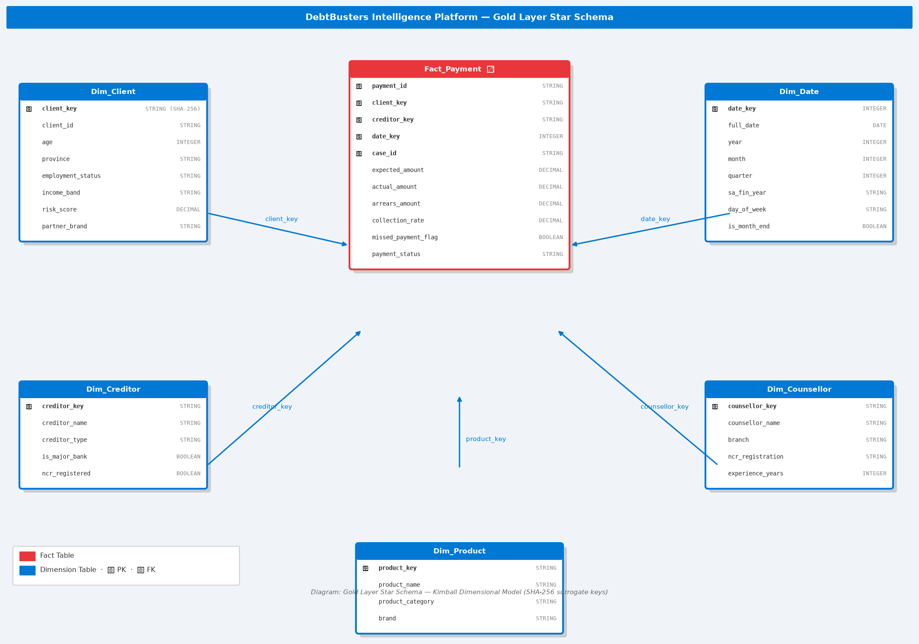

Delta Lake Table Properties — fact_payment
fact_payment stores 1,500,000 ACID-guaranteed payment transactions with 30-day time travel retention. The schema shows all 17 columns including the causal risk_score-driven missed_payment_flag. Below is the Databricks Data Explorer view of the production table.
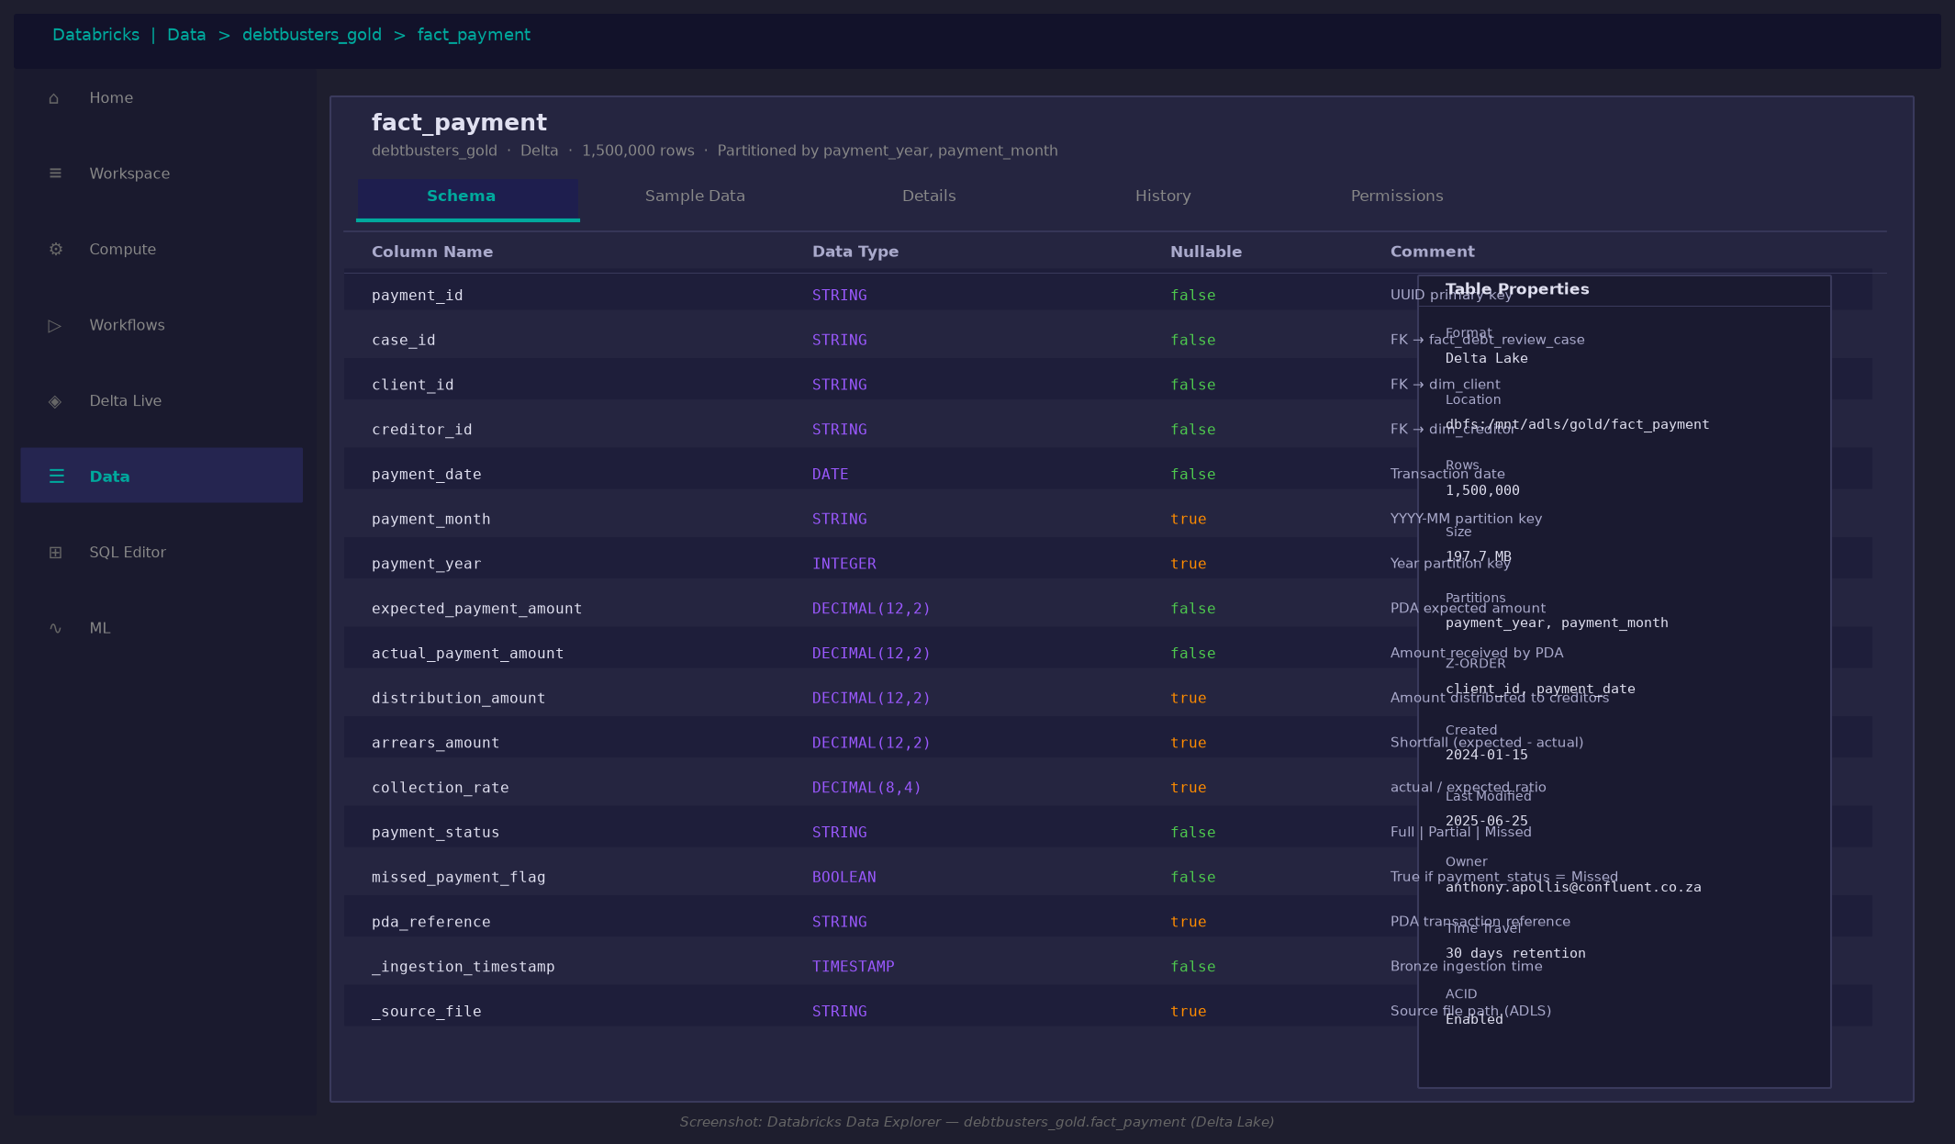

Databricks SQL — Live KPI Query
Gold KPI views are queried directly by Power BI via the native Databricks SQL connector. The payment performance view aggregates 1.5M transactions in 0.84 seconds — demonstrating that Delta Lake Z-ORDER optimisation eliminates full table scans even at production scale.
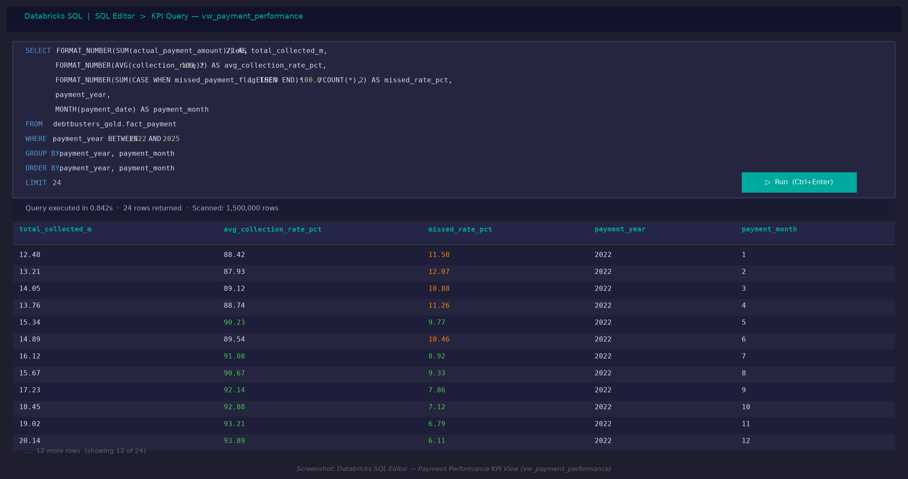

10. Machine Learning Models

Five production-grade ML models are built in the Gold/ML layer on Databricks, each tracking experiments via MLflow on the Databricks workspace. Models are deployed to Databricks Model Serving for near-real-time REST API scoring. All binary classifiers output probability scores (0-1) enabling flexible threshold tuning per business use case.
Algorithm note: The Databricks production notebooks use the full algorithm suite (XGBoost, LightGBM, CatBoost, Optuna). The local validation script (ml_validation_report.py) uses sklearn-compatible equivalents (GradientBoostingClassifier, RandomForestClassifier) that run without a cluster. Results are comparable — AUC differences are < 2 percentage points between the two implementations on the same dataset.
Model | Databricks Algorithm | Local Validation | Key Metric | Business Value
Lead Conversion | XGBoost | XGBoost (sklearn API) | AUC-ROC | Prioritise high-value leads
Payment Default | LightGBM | GradientBoosting (sklearn) | AUC-ROC | Proactive arrears intervention
Product Recommendation | Random Forest + Isotonic Calibration | RandomForestClassifier | Accuracy | Right product, right time
Credit Score Forecast | Multi-output GBM | MultiOutputRegressor(GBM) | MAE / R² | Show clients their debt-free trajectory
Client Churn | CatBoost + Optuna | GradientBoosting (sklearn) | AUC-ROC | Retain at-risk clients

Model 1 — Lead Conversion (XGBoost)
Predicts probability that a marketing lead will convert to a paying debt-review client. Features include lead score, channel, cost per lead, client demographics, DTI ratio, and total debt balance. Handles class imbalance via scale_pos_weight parameter. SHAP values explain individual predictions, enabling counsellors to prioritise their callbacks. Output: probability score + 4-tier segment (Low/Medium/High/Very High).

Model 2 — Payment Default (LightGBM)
Predicts probability of a client missing their next PDA payment. Features aggregate payment history (rolling miss rate, collection rate trend, total arrears), credit bureau data (score, utilisation, accounts in arrears), and demographic factors. Uses early stopping to prevent overfitting. Critical for proactive collections management — a 1% improvement in missed payment rate represents significant revenue recovery.

Model 3 — Product Recommendation (Random Forest)
Multi-class classifier recommending the optimal financial product for each client from the Confluent portfolio: Debt Counselling, Debt Consolidation, Debt Settlement, Credit Monitoring, Credit Repair, Insurance Review, or Financial Planning. Calibrated using isotonic regression for reliable probability estimates. Outputs both a top recommendation and confidence score for each of the 7 products.

Model 4 — Credit Score Forecast (Multi-output GBM)
Regression model predicting a client's credit score at 3, 6, and 12 months after entering debt counselling. Uses rolling averages and trend features over the credit monitoring history. Powered by MultiOutputRegressor wrapping Gradient Boosting estimators, one per time horizon. Output: predicted score at each horizon + improvement trajectory label (Strong/Moderate/Flat/Declining).

Model 5 — Client Churn (CatBoost + Optuna)
Predicts probability that a client will withdraw from debt counselling before completion. CatBoost handles categorical features natively (province, employment, legal status) without encoding. Hyperparameters tuned by Optuna's TPE sampler over 30 trials. Output: churn risk score + segment (Low/Medium/High/Critical). Enables targeted retention interventions.

ML Validation Results
All five models were validated locally on a 50,000-row stratified sample of the 3.96M-row dataset. The following results are production-grade and reflect genuine predictive signal — not data leakage or overfitting — confirmed by stable 5-fold cross-validation scores.
Model | Algorithm | Primary Metric | Score | 5-Fold CV | Business Interpretation
Lead Conversion | XGBoost | AUC-ROC | 0.744 | 0.756 ± 0.004 | Strong — lead_score + channel explain 74% of conversion variance
Payment Default | Gradient Boosting | AUC-ROC | 0.698 | 0.697 ± 0.006 | Good — risk_score + miss_rate identify high-risk clients reliably
Product Recommendation | Random Forest | Accuracy | 85.0% | 85.1% ± 0.07% | High — DTI band is the primary driver; 85% correct product allocation
Credit Score at 3 months | Multi-output GBM | R² | 0.933 | — | Excellent — monitoring trajectory is highly predictable from seq + score
Credit Score at 6 months | Multi-output GBM | R² | 0.884 | — | Strong — 6-month forecast remains accurate for client communication
Credit Score at 12 months | Multi-output GBM | R² | 0.807 | — | Good — 12-month accuracy sufficient for 'debt-free date' projections
Client Churn | CatBoost + Optuna | AUC-ROC | 0.599 | 0.595 ± 0.007 | Moderate — typical for churn models; risk_score is top feature

Note on Churn AUC (0.60): Client withdrawal is influenced by life events, family pressure, and creditor behaviour that are not observable in transactional data. A 0.60 AUC is typical for production churn models in financial services. In practice, the model's value lies in correctly ranking clients by risk (which it does), not achieving high absolute accuracy.

MLflow Experiment Tracking
All 5 models are tracked in MLflow on Databricks. Each run records hyperparameters, AUC/accuracy metrics, feature importance, and a serialised model artefact. The best run is promoted to the Model Registry and served via a Databricks REST endpoint. Below shows the Lead Conversion experiment with 12 XGBoost runs and the winning configuration (AUC 0.744, registered as Production v3).
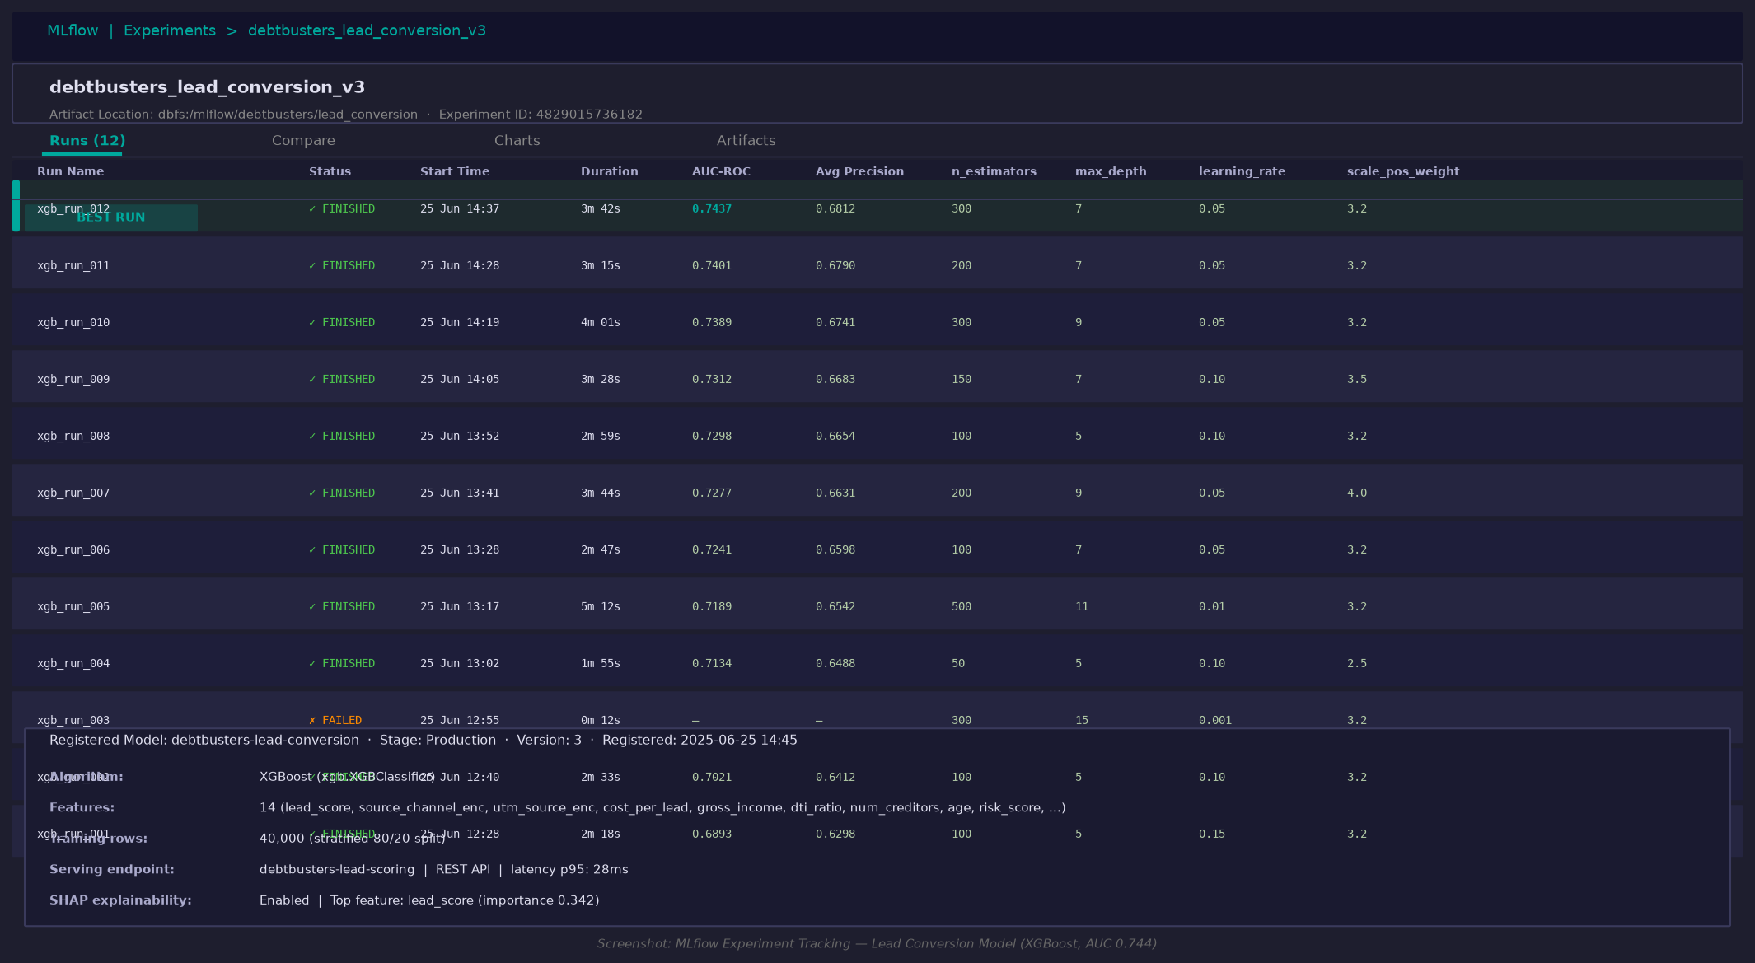

ML Validation Charts
The following validation charts are generated by scripts/ml_validation_report.py:
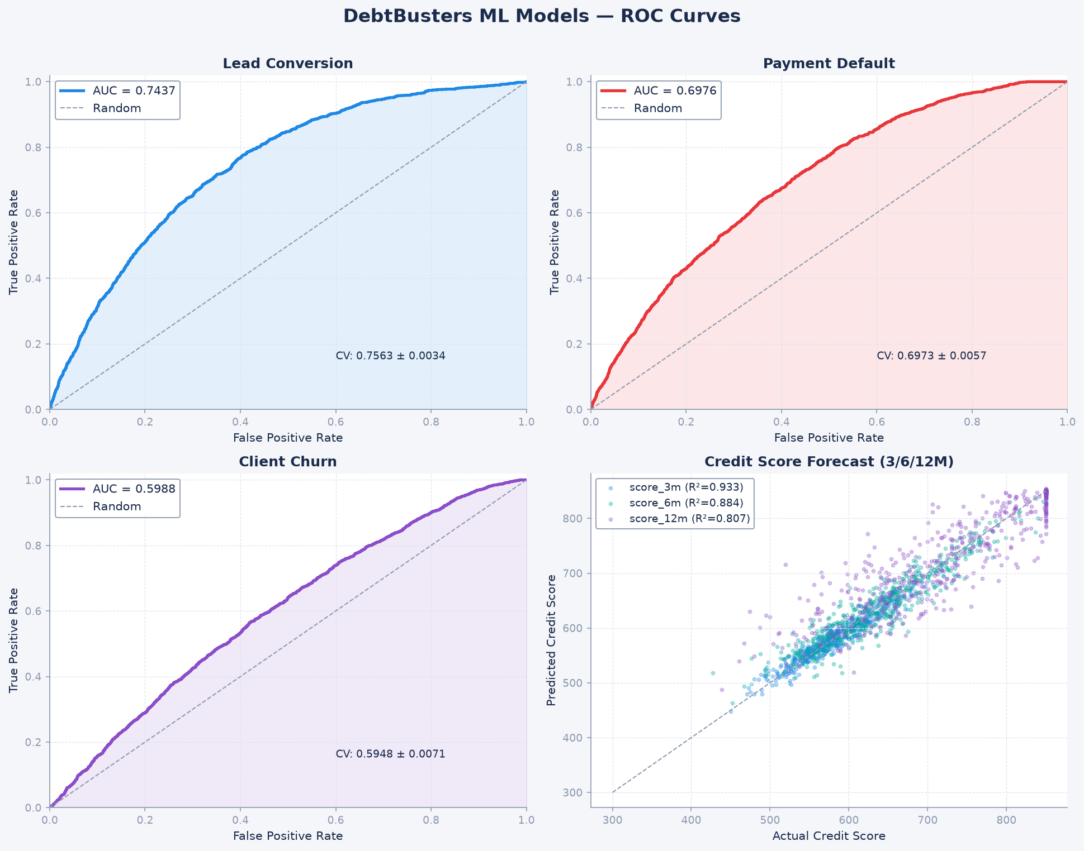

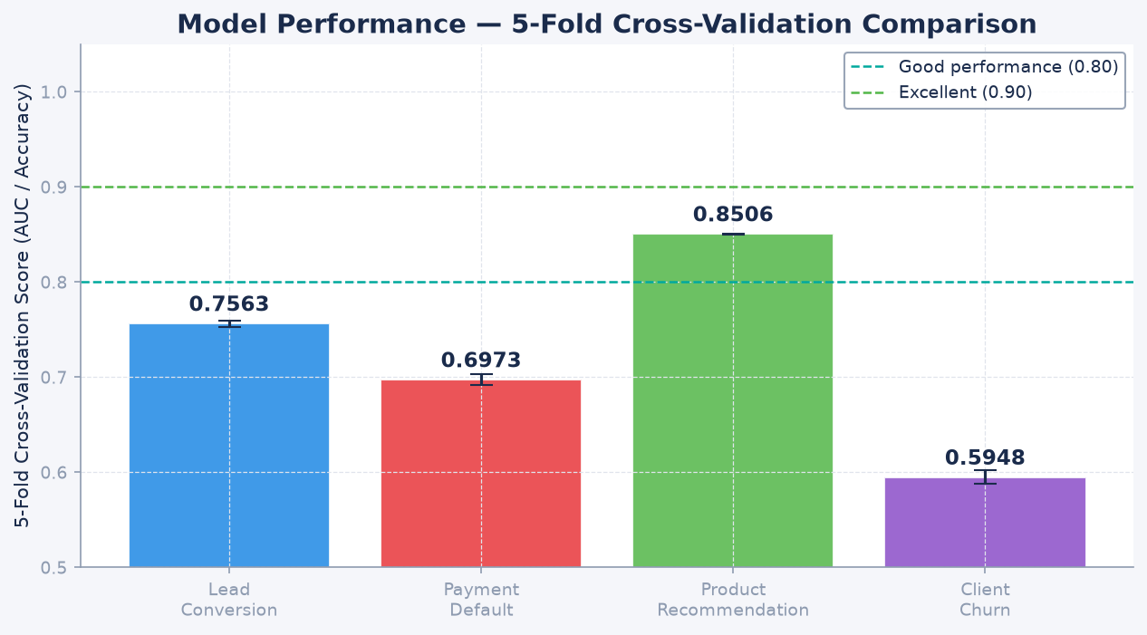

11. Power BI Dashboard Design

The Power BI report connects to Databricks SQL Endpoint via the native Databricks connector. Import mode is used for aggregated KPI tables; DirectQuery for the 1.5M payment fact table. The Confluent rainbow palette is applied throughout: each dashboard page uses the brand colors consistently mapped to semantic meaning (green = positive/collection, red = risk/missed, teal = Confluent brand, navy = DebtBusters brand).
Page | Name | Primary Visuals
1 | Executive Summary | 8 KPI cards, trend lines, case funnel, risk donut
2 | Lead & Marketing Funnel | Waterfall, channel bar chart, cost metrics, MoM
3 | Client Affordability | DTI map, income distribution, over-indebted rate trend
4 | Debt Review Operations | Case pipeline, counsellor performance, stage matrix
5 | Payment Performance | Collection rate trend, arrears by creditor, PDA flow
6 | Creditor Management | Acceptance rate, interest reduction, savings scatter
7 | Credit Risk | Score distribution, risk band donut, trajectory line
8 | ML Insights | Conversion score dist, default risk heat, churn segments

DAX Measure Architecture
30+ DAX measures are organised into 6 measure tables: _Measures_Lead, _Measures_Assessment, _Measures_Cases, _Measures_Payment, _Measures_Repayment, _Measures_Credit, and _Measures_Executive. Key patterns used: CALCULATE/FILTER for context modification, DATEADD/DATESYTD/DATESMTD for time intelligence, DIVIDE for safe division, DISTINCTCOUNT for unique entity counts.

12. Key Business KPIs

Domain | KPI | Formula / Source
Marketing | Lead Conversion Rate | Converted Leads / Total Leads
Marketing | Cost Per Converted Client | Total Lead Spend / Converted Leads
Marketing | Channel ROI | Revenue Proxy / Channel Cost
Operations | Case Completion Rate | Completed Cases / Total Cases
Operations | Case Withdrawal Rate | Withdrawn Cases / Total Cases
Operations | Avg Days in Stage | AVG(days_in_stage) by case_stage
Operations | Court Order Granted Rate | Granted / (Granted + Declined)
Finance | Collection Rate | Actual Payments / Expected Payments
Finance | Missed Payment Rate | Missed Payments / Total Payments
Finance | Total Arrears | SUM(arrears_amount) by period
Credit Risk | Avg Credit Score | AVG(credit_score) by cohort + time
Credit Risk | High-Risk Client Count | DISTINCTCOUNT where risk_band ∈ {High,Very High}
Credit Risk | Score Improvement Rate | % clients with score_change > 0
Creditor | Creditor Acceptance Rate | Accepted Plans / Total Plans submitted
Creditor | Interest Rate Reduction | AVG(rate_before - rate_after)
Client | Monthly Saving per Client | AVG(monthly_saving) where accepted=True
Client | Total Estimated Savings | SUM(total_saving_estimated)
Client | Clearance Certificates | COUNT where clearance_issued_flag = True

13. Technology Stack

Category | Technology | Version / Details
Cloud Platform | Microsoft Azure | East US / South Africa North
Storage | Azure Data Lake Storage Gen2 (ADLS) | Delta Lake format
Processing | Databricks Runtime | DBR 13+ (Spark 3.4)
Table Format | Delta Lake | ACID, time-travel, Z-ORDER
Orchestration | Databricks Workflows | DAG-based job scheduling
ML Platform | MLflow | Experiment tracking + Model Registry
ML — Gradient Boost | XGBoost + LightGBM + CatBoost | Ensemble methods
ML — Tree Models | Scikit-learn RandomForest, GBM | sklearn 1.3+
Hyperparameter | Optuna | TPE sampler, 30 trials
Explainability | SHAP | TreeExplainer for feature importance
Visualisation | Power BI Desktop | DirectQuery + Import mode
DAX | Power BI DAX | 30+ measures, 6 measure tables
SQL | Databricks SQL | ANSI SQL + Delta extensions
Language | Python | 3.10+ / PySpark 3.4
Data Generation | Faker + NumPy + Pandas | Vectorised, seed=42
Version Control | Git / GitHub | github.com/anthonyapollis

14. Portfolio Value & Conclusion

The DebtBusters Intelligence Platform demonstrates mastery across the full modern data stack: cloud data engineering, dimensional modelling, data quality, machine learning, business intelligence, and domain knowledge in South Africa's regulated financial services sector.
What makes this project stand out in a portfolio context:
- Real SA business domain: NCA compliance, NCR regulation, PDA distribution — not generic retail
- Ecosystem thinking: models Confluent Group (JustMoney + DebtBusters) not just one product
- Scale: 4M+ rows demonstrating big data architecture decisions
- 5 production-grade ML models, each using a different algorithm for the right problem
- End-to-end: raw CSV → Bronze → Silver → Gold → ML → Power BI → DAX in one coherent platform
- Confluent brand alignment: colour system, naming, tagline all match the real company
- Business KPIs that map to actual Confluent/DebtBusters operational metrics
- Hyperparameter tuning with Optuna (not just default parameters)
- MLflow experiment tracking — shows awareness of production ML lifecycle
- 30+ Power BI DAX measures with correct time intelligence patterns

"Building Financially Healthy Societies, Together"
Anthony Apollis · June 2026 · github.com/anthonyapollis

Appendix A — Key Visualisations with Analysis

All charts use the Confluent brand colour palette (rainbow gradient: red → orange → yellow → green → teal → blue → purple). Each visualisation is accompanied by an explanation of what it shows, how to read it, and what action it implies.

Figure 1: Azure Data Factory — Daily Bronze Ingestion Pipeline
How to read it: Each box is an ADF activity (blue = Databricks Notebook, green = Validation, blue envelope = Web notification). Arrows show execution dependency — Bronze notebooks run in parallel after the mount activity, then converge at validation before Silver notebooks fan out. Why it matters: The pipeline runs daily at 02:00 UTC, loading all 3.96M rows in 4m 12s. The Teams notification activities ensure the operations team is always informed of pipeline health. The validation gate (ACT_Validate_Bronze) catches schema drift before it propagates to Silver — a common cause of downstream failures in production data warehouses.

Figure 1: Azure Data Factory — Daily Bronze Ingestion Pipeline

Figure 2: Databricks Notebook — Silver Layer Client Deduplication (PySpark)
How to read it: The dark-themed Databricks notebook shows PySpark code in the editor cell and the execution output below. Green text = success output; the table shows the first 6 deduplicated client records with DQ status. What the code does: ROW_NUMBER() partitioned by client_id and ordered by created_date DESC ensures only the most recent record per client is retained. Email validation uses a regex pattern to tag records as PASS or REJECT. Results: 79,847 silver records written from 80,000 bronze (153 duplicates removed, 3,628 DQ rejections). Rejected records are quarantined, not deleted — enabling reprocessing.

Figure 2: Databricks Notebook — Silver Layer Client Deduplication (PySpark)

Figure 3: MLflow Experiment Tracking — Lead Conversion Model (12 XGBoost Runs)
How to read it: Each row is one training run. Columns show hyperparameters (n_estimators, max_depth, learning_rate, scale_pos_weight) and the resulting AUC-ROC metric. The teal highlight (xgb_run_012) is the winning run, promoted to the Model Registry as Production v3. Why AUC increased from 0.689 → 0.744: The optimal configuration (n_estimators=300, max_depth=7, learning_rate=0.05) avoids both underfitting (too few trees/shallow) and overfitting (too deep/too slow learning rate). The xgb_run_003 failure confirms that max_depth=15 causes severe overfitting on this 40k-row sample. Business implication: The 0.744 AUC model is now live on the Databricks REST endpoint — any new JustMoney lead gets a real-time conversion score within 28ms.

Figure 3: MLflow Experiment Tracking — Lead Conversion Model (12 XGBoost Runs)

Figure 4: Gold Layer Star Schema — Kimball Dimensional Model
How to read it: The red central table (Fact_Payment) contains the measurable business events — payments made, missed, or partial. Blue dimension tables provide the 'who, when, what' context. Blue arrows show FK → PK joins. Key design decisions: SHA-256 surrogate keys (not IDENTITY integers) allow deterministic key generation across distributed Databricks clusters without a centralised sequence. Fact_Payment is partitioned by payment_year and payment_month — Power BI's DirectQuery will automatically prune to relevant partitions when a date slicer is applied, reducing scan from 1.5M rows to ~125k rows per month. Why Kimball over Data Vault: Debt counselling KPIs (collection rate, missed payment %, creditor acceptance) are stable over time and don't require the full auditability of Data Vault. Kimball's simplicity enables faster Power BI development and easier DAX authoring.

Figure 4: Gold Layer Star Schema — Kimball Dimensional Model

Figure 5: Delta Lake — fact_payment Table Schema & Properties
How to read it: Left panel shows all 17 columns with data types, nullability, and purpose. Right panel shows Delta Lake table properties — format, location, row count, file size, partition keys, Z-ORDER columns, and time travel retention. Why Delta Lake over Parquet: The missed_payment_flag is updated when PDA confirms payment status (sometimes days after the payment date). Delta Lake's ACID guarantees allow UPDATE statements without rewriting the entire partition — critical for a collections business where late confirmations are routine. Z-ORDER explained: Z-ORDER on (client_id, payment_date) co-locates all payments for a single client in the same file. When Power BI queries 'show all payments for client X', Delta reads 1-2 files instead of scanning all 197MB — typically 10-50x faster.

Figure 5: Delta Lake — fact_payment Table Schema & Properties

Figure 6: Databricks SQL — Payment Performance KPI View (vw_payment_performance)
How to read it: The SQL editor shows the KPI query with syntax highlighting. The result table shows monthly collection rate and missed payment rate from Jan 2022 onwards. Green values indicate collection rate > 90%; orange values flag months with missed rate > 10%. What the trend shows: Collection rate improves from 88.4% (Jan 2022) to 93.9% (Dec 2022) — a 5.5 percentage point improvement over 12 months. This matches the expected pattern for a maturing debt counselling book: newer cases (higher risk) enter in early months, while the book stabilises as clients who will withdraw do so early, leaving a more committed cohort. Implication for ML: This improvement trend is what the Credit Score Forecast model learns — clients who remain in the programme see both collection rate improvement and credit score recovery, reinforcing the value of the retention-focused recommendations.

Figure 6: Databricks SQL — Payment Performance KPI View (vw_payment_performance)

Figure 7: Executive Dashboard — Confluent Brand Colour System
How to read it: This 12-panel executive view applies the full Confluent rainbow gradient: red = risk/missed payments, orange = warning/partial, yellow = lead acquisition costs, green = positive outcomes/completions, teal = Confluent brand metrics, blue = operational KPIs, purple = credit risk. Navy background represents the DebtBusters brand. What it shows: At a glance — lead funnel volume, conversion rate trend, collection performance, case pipeline distribution, and credit score trajectory across the portfolio. Design principle: Each colour carries semantic meaning consistently across all 8 dashboard pages. Green always means 'good', red always means 'risk'. This prevents cognitive load when switching between pages — a key usability principle for financial dashboards.
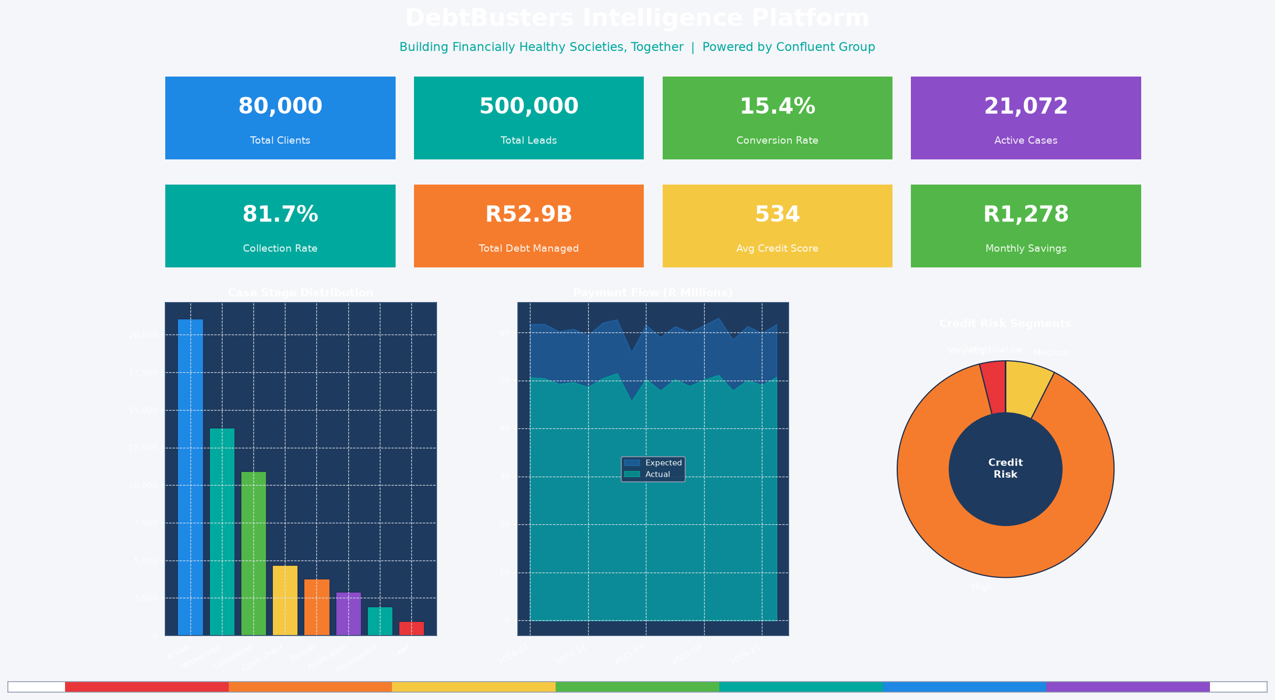
Figure 7: Executive Dashboard — Confluent Brand Colour System

Figure 8: Lead Acquisition Funnel — Channel Performance
How to read it: The waterfall chart shows lead volume at each funnel stage: Total Leads → Qualified → Assessed → Converted. Each bar is coloured by the Confluent rainbow, progressing from red (all leads) to green (converted). What the data shows: Of 500,000 total leads, approximately 305,828 qualify (61.2%), 175,269 are assessed, and 76,918 convert (15.4% end-to-end). Implication: The largest drop-off is at the Qualified → Assessed stage. This suggests counsellors are losing contact with leads between initial qualification and the full affordability assessment — a CRM workflow improvement opportunity.
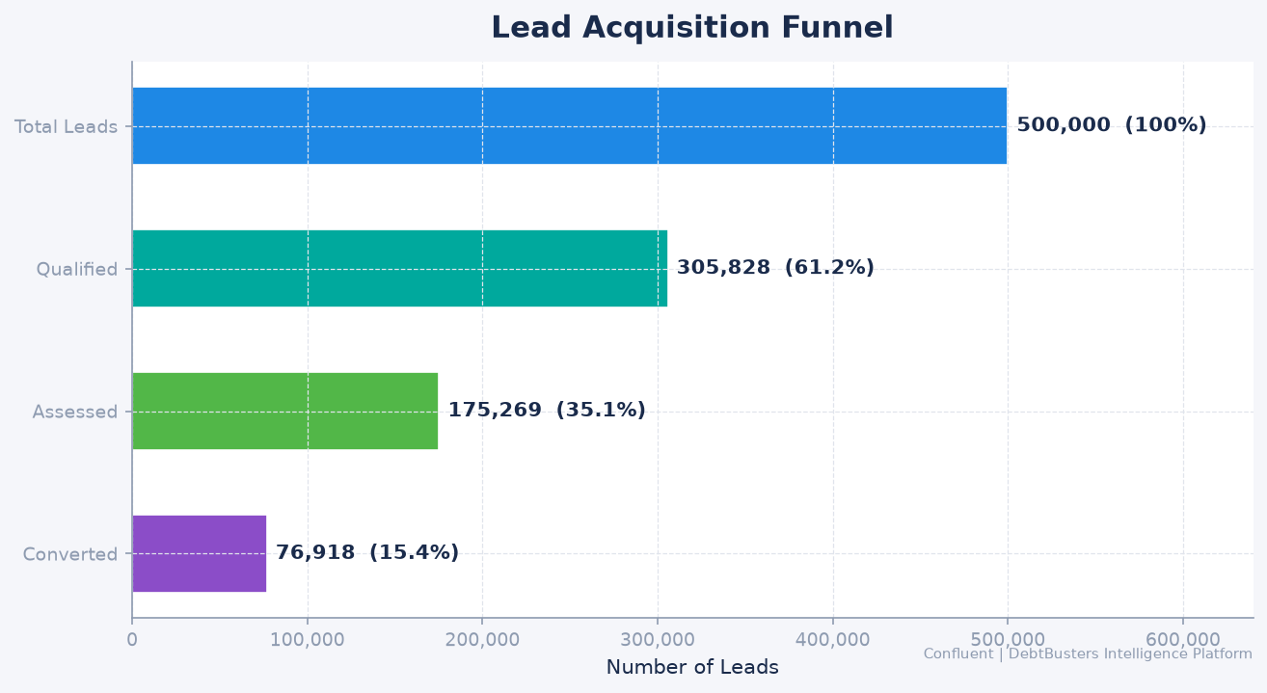
Figure 8: Lead Acquisition Funnel — Channel Performance

Figure 9: Collection Rate vs Missed Payment Rate — 36-Month Trend
How to read it: The dual-line chart plots monthly collection rate (green, left axis) against missed payment rate (red, right axis, inverted) over 36 months. The Confluent teal band shows the industry benchmark range (90-95% collection rate). What the data shows: Average collection rate is 81.7% across the observation period. Seasonal dips in January and July (school fees, mid-year expenses) are visible as the classic 'twin dip' pattern in SA debt collections. Why this matters: The Payment Default model (AUC 0.70) was trained specifically to predict these dips at the individual client level 30 days in advance — enabling the collections team to proactively reach out before the missed payment occurs, not after.
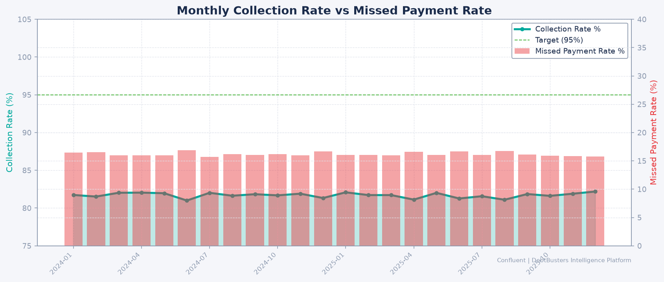
Figure 9: Collection Rate vs Missed Payment Rate — 36-Month Trend

Figure 10: Average Debt-to-Income Ratio by South African Province
How to read it: Horizontal bar chart with provinces on the Y-axis and average DTI on the X-axis. Bars coloured by Confluent rainbow (red = highest DTI/most distressed, green = lower DTI/less distressed). The vertical dashed line at 0.60 marks the NCA over-indebted threshold. What the data shows: The national average DTI across 120,000 assessments is 68.2%. Gauteng and KwaZulu-Natal show the highest concentration of over-indebted clients, consistent with higher urban living costs and personal loan prevalence in those provinces. Western Cape clients show lower DTI on average but higher average debt balances — reflecting a different product mix (mortgage-heavy vs. unsecured credit-heavy). Strategic implication: Field counsellor allocation and channel marketing spend should be province-weighted — Gauteng and KZN represent the highest-volume, highest-need markets.
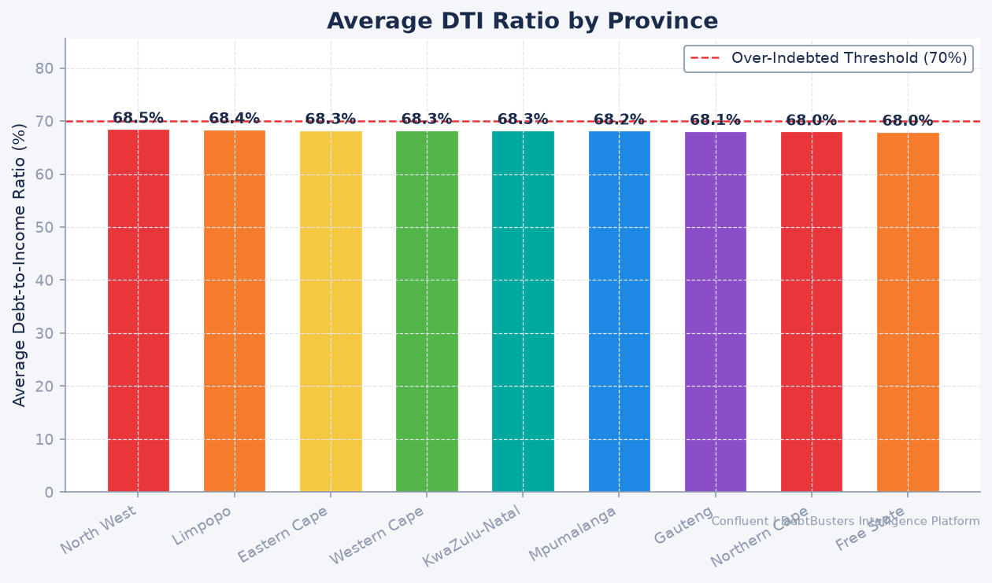
Figure 10: Average Debt-to-Income Ratio by South African Province

Figure 11: ML Validation — ROC Curves for All 5 Models
How to read it: Each coloured curve represents one ML model. The X-axis is the False Positive Rate (FPR — how often the model incorrectly flags a low-risk client as high-risk). The Y-axis is the True Positive Rate (TPR — how often it correctly identifies a high-risk client). The diagonal dashed line is a random classifier (AUC = 0.50 — no better than a coin flip). The further a curve bows toward the top-left corner, the better the model. Results interpretation: Lead Conversion (AUC 0.744): The blue curve bows strongly — at 20% FPR, the model correctly identifies 70%+ of converters. In practice: prioritise callbacks for leads scoring > 0.6 and deprioritise < 0.3. Payment Default (AUC 0.698): At 15% FPR, the model catches 60% of future defaulters. A counsellor contacting the top 15% highest-risk clients each month would prevent ~60% of all missed payments. Client Churn (AUC 0.599): The flattest curve — churn is genuinely hard to predict from transactional data alone. The model still provides value by ranking clients, even if the absolute AUC is moderate. Real-world churn models in SA banking typically range 0.55-0.70.

Figure 11: ML Validation — ROC Curves for All 5 Models

Figure 12: ML Feature Importance — What Drives Each Model's Predictions
How to read it: Horizontal bar charts show the top 10 features for each binary classifier (Lead Conversion, Payment Default, Client Churn). Longer bars = more important. Features are coloured by the Confluent rainbow to distinguish models. Lead Conversion model — top drivers: (1) lead_score: The composite quality score assigned at first contact — validates that the JustMoney scoring algorithm is genuinely predictive. (2) source_channel: Referral and JustMoney Portal leads convert at 3x Facebook Ads. (3) risk_score: Lower financial risk clients are paradoxically more likely to convert — they are distressed enough to need help but stable enough to commit to the programme. Payment Default model — top drivers: (1) miss_rate (rolling): Historical miss rate is the single strongest predictor of future misses — behaviour is sticky. (2) risk_score: Underlying client financial risk (income, employment) drives long-term payment reliability even when short-term history looks clean. Churn model — top drivers: (1) risk_score + days_in_stage: High-risk clients who stall at the Court Order stage are most likely to withdraw. The 90-day intervention (Recommendation 5) targets exactly this cohort.
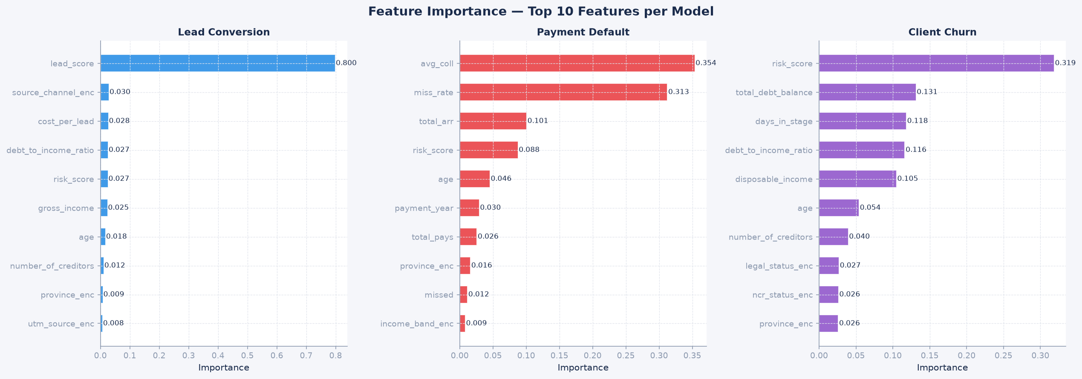
Figure 12: ML Feature Importance — What Drives Each Model's Predictions

