Inside the Libstar Catalog
A data story from five million product records
Azure Data Factory · Synapse serverless · Qlik Sense · Python ML
Anthony Apollis — July 2026
Synthetic portfolio dataset built on Libstar's public brand and category model (libstar.co.za). Not affiliated with Libstar Holdings.

1. The story in one page
We started with 5,014,409 raw catalog rows — deliberately messy, the way real operational exports arrive: prices captured as "R 1,234.56" in one system and "ZAR1234" in another, dates in three formats, weights sometimes in grams, brands typed by hand. After an Azure Data Factory cleaning pass, 4,284,971 unique, trustworthy products remained; 729,438 rows were quarantined with an explicit reject reason.
The cleaned catalog represents R1,170.3 billion in trailing 12-month revenue. Spreads is the biggest category (R160.4 billion); ambient products contribute 77% of revenue. Retailer Brands is the highest-grossing brand, Gauteng the strongest province, and Retail and wholesale the dominant channel.
A gradient-boosted pricing model reconstructs shelf price from catalog attributes with R² = 0.71 (MAE R12.71 on a mean price of R71.69), an IsolationForest flags 2,000 pricing anomalies for review, and KMeans splits the range into 4 actionable product segments.

2. From dirty to trusted: the pipeline
Architecture: gzipped CSVs land in an Azure Data Lake (ADLS Gen2) raw zone. An Azure Data Factory mapping data flow normalises prices, dates, booleans, units and geography; resolves brands against a reference dimension (fixing legacy business-unit category names like "Groceries" via brand lookup); deduplicates product IDs keeping the latest record; and writes snappy parquet to a curated zone. Synapse serverless SQL exposes the parquet through reporting views — no cluster, no idle cost — and Qlik Sense, this ebook and the Excel report all read the same views.
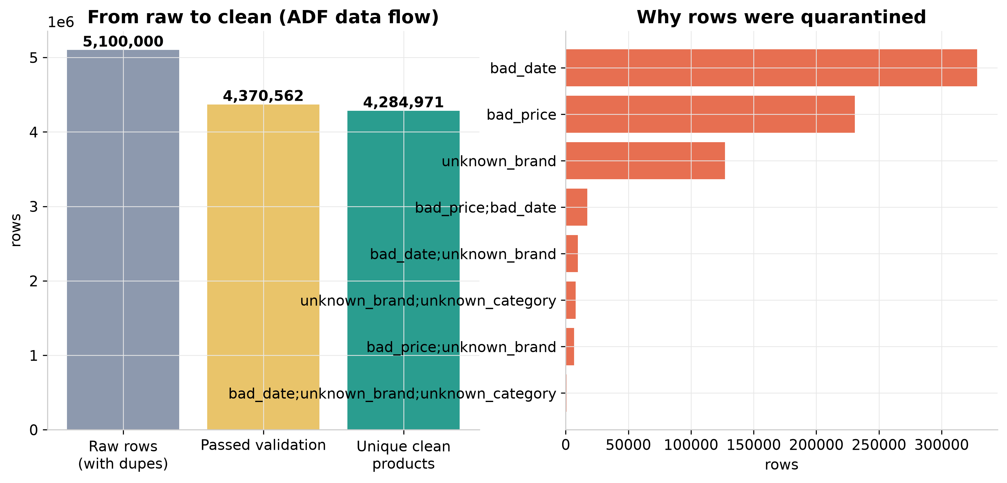
Figure 1 — 5,014,409 raw rows in, 4,284,971 clean products out. Dates and prices are the biggest offenders.
Every quarantined row carries its reject reasons, so data quality is a reportable metric, not a silent filter: bad_date (328,279), bad_price (230,750), unknown_brand (127,137) lead the list.

3. What the shelf looks like
Libstar's simplified operating model has two product groups. In this catalog the ambient group carries 77% of revenue across 7 categories, while perishables — dairy, convenience meals, value-added meats, baby and fresh mushrooms — hold the rest.
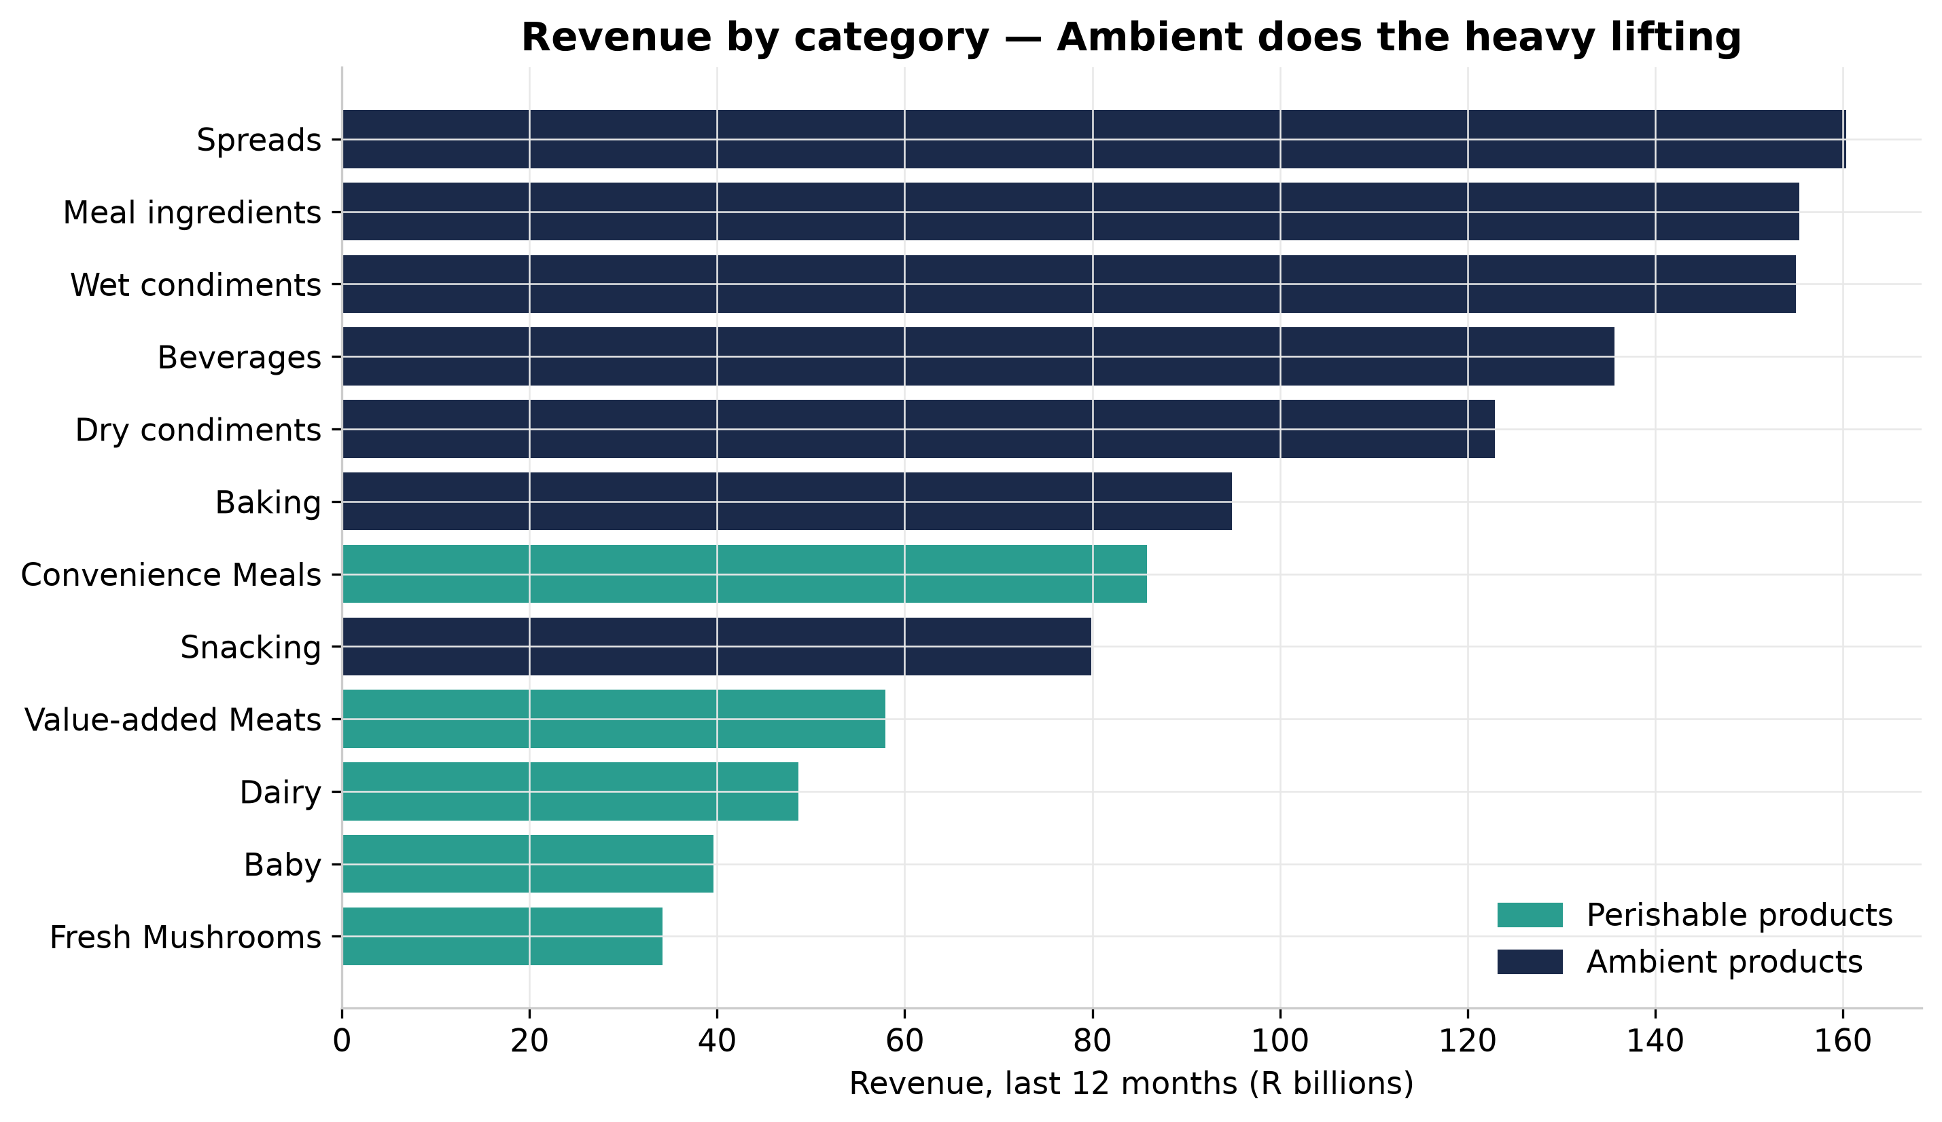
Figure 2 — Revenue by category, coloured by product group.
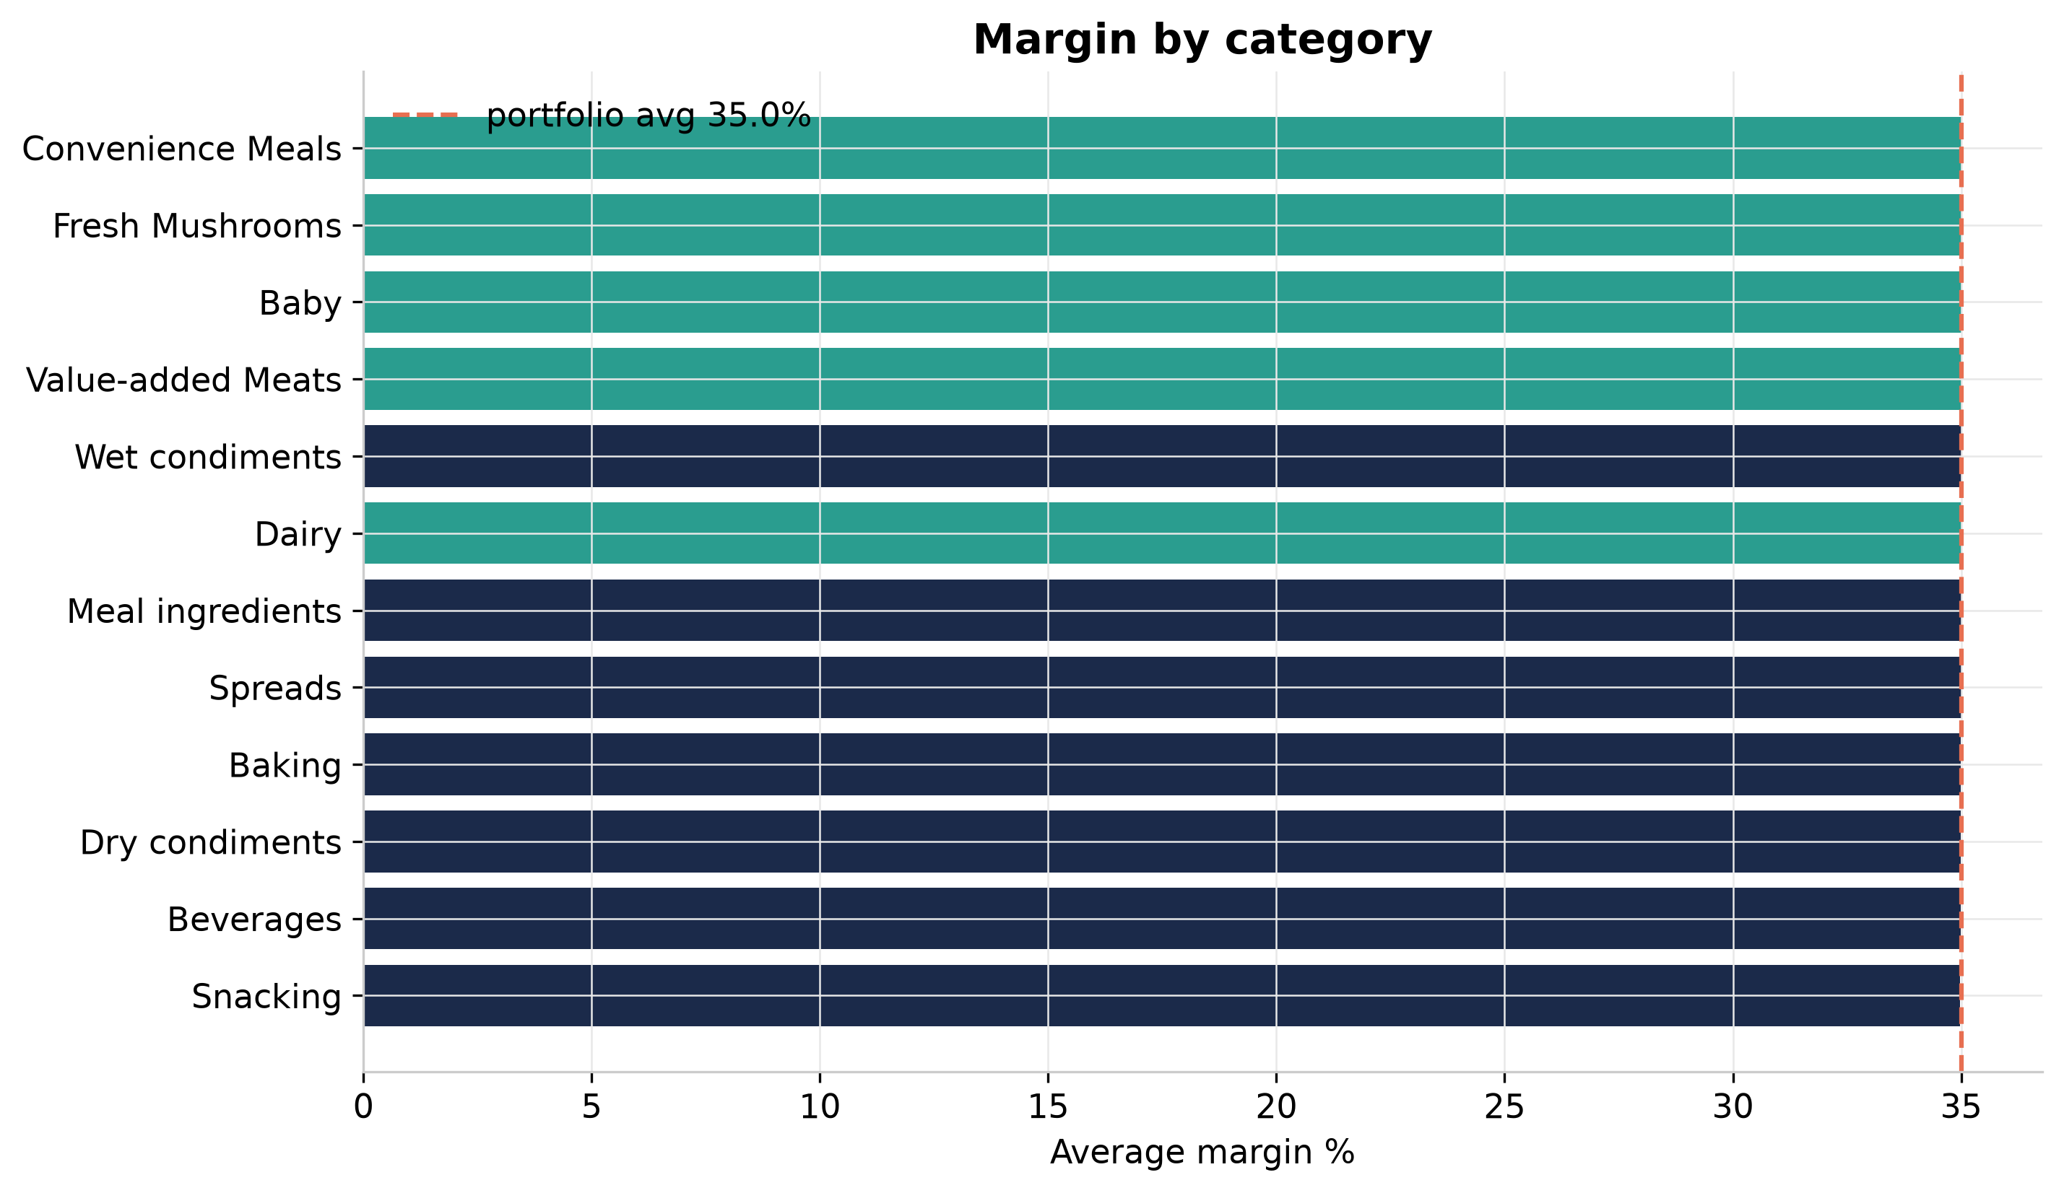
Figure 3 — Margins cluster tightly; the dashed line is the portfolio average.
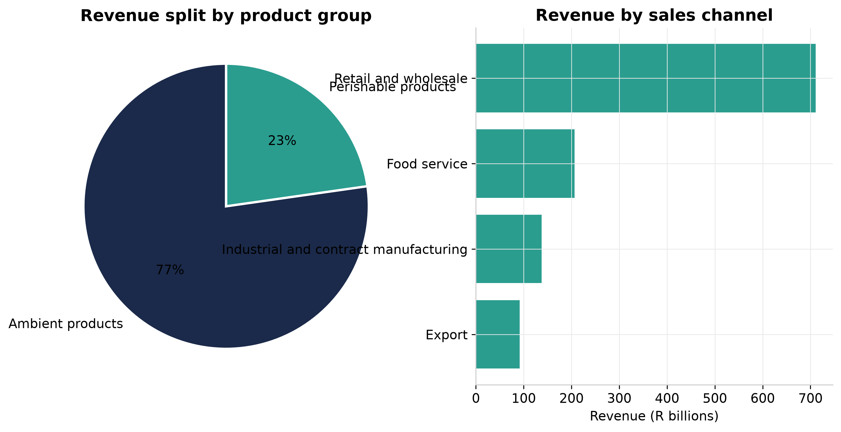
Figure 4 — Product-group split and the four routes to market.

4. Brand power: three ways to win
Libstar runs three brand solutions: its own Libstar Brands (Lancewood, Denny Mushrooms, Cape Herb & Spice…), Principal Brands it represents in South Africa (Bonne Maman, Kikkoman, Tabasco, Maille) and private label for retailers. Principal brands price ~35% above comparable own-brand products in this dataset; private label sits ~20% below.
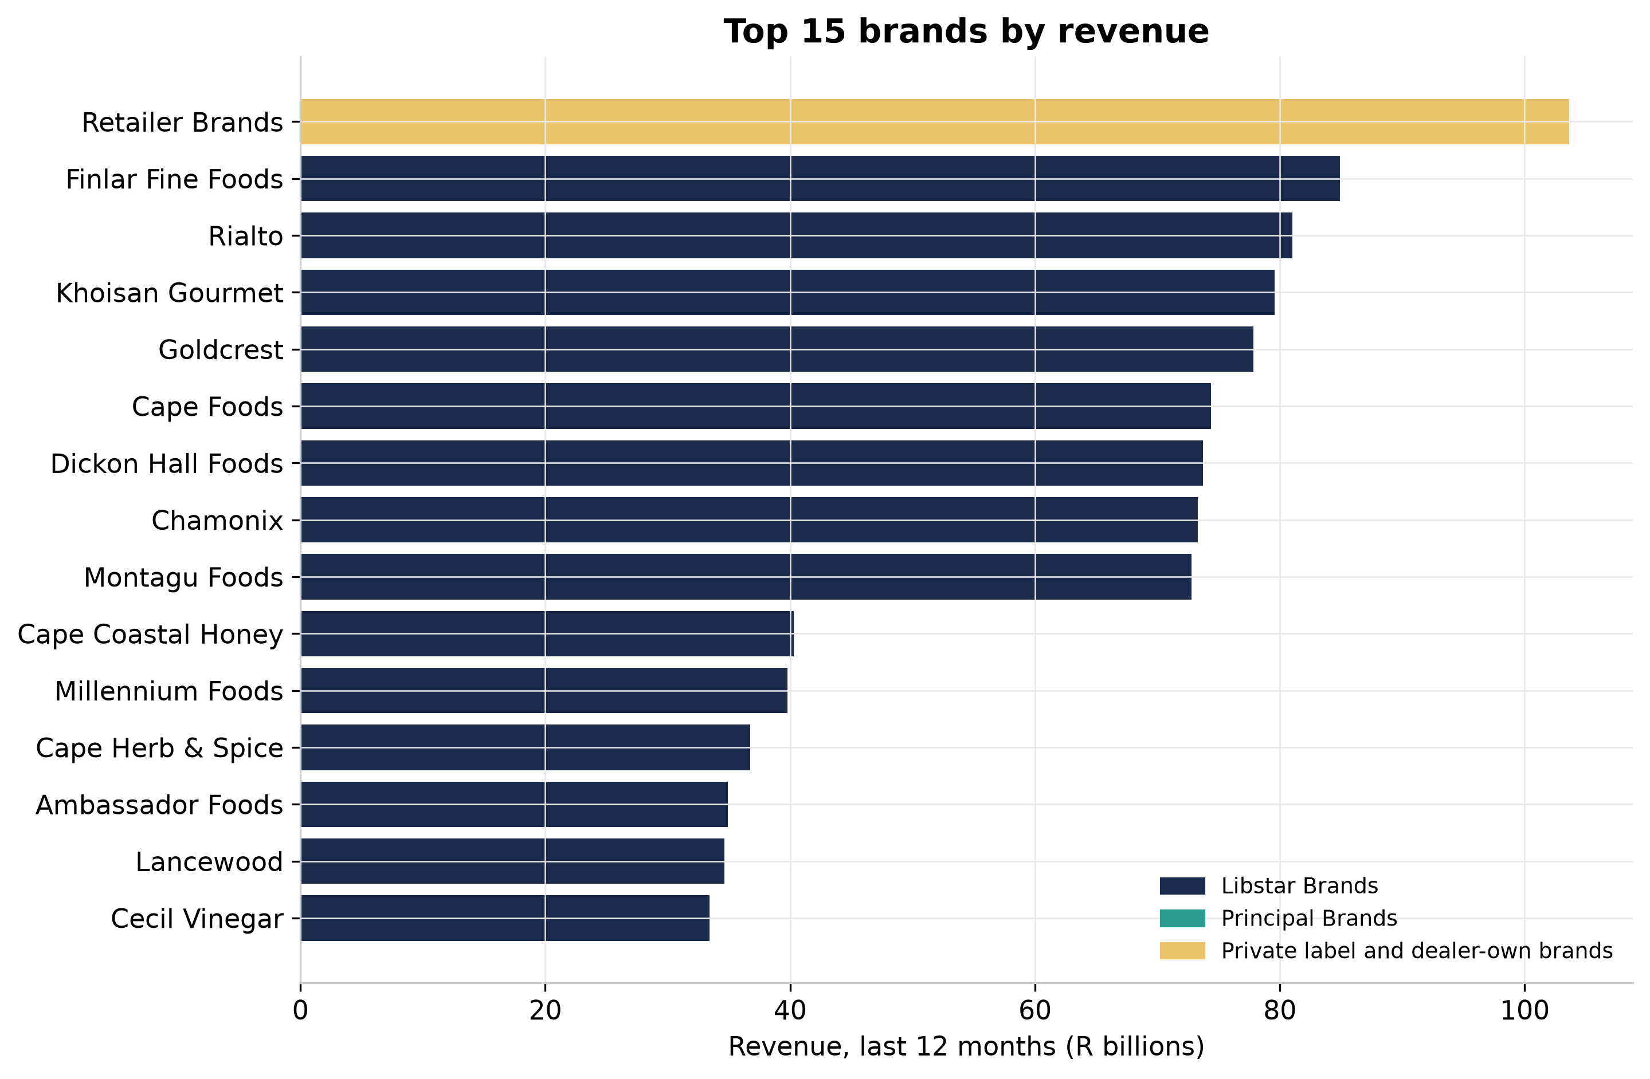
Figure 5 — Retailer Brands leads with R103.7 billion.

5. Where South Africa buys
Sales concentrate where Libstar operates: Gauteng leads with R343.8 billion, and the five provinces with production or distribution footprints (Western Cape, Gauteng, KwaZulu-Natal, Eastern Cape, Mpumalanga) account for the bulk of revenue.
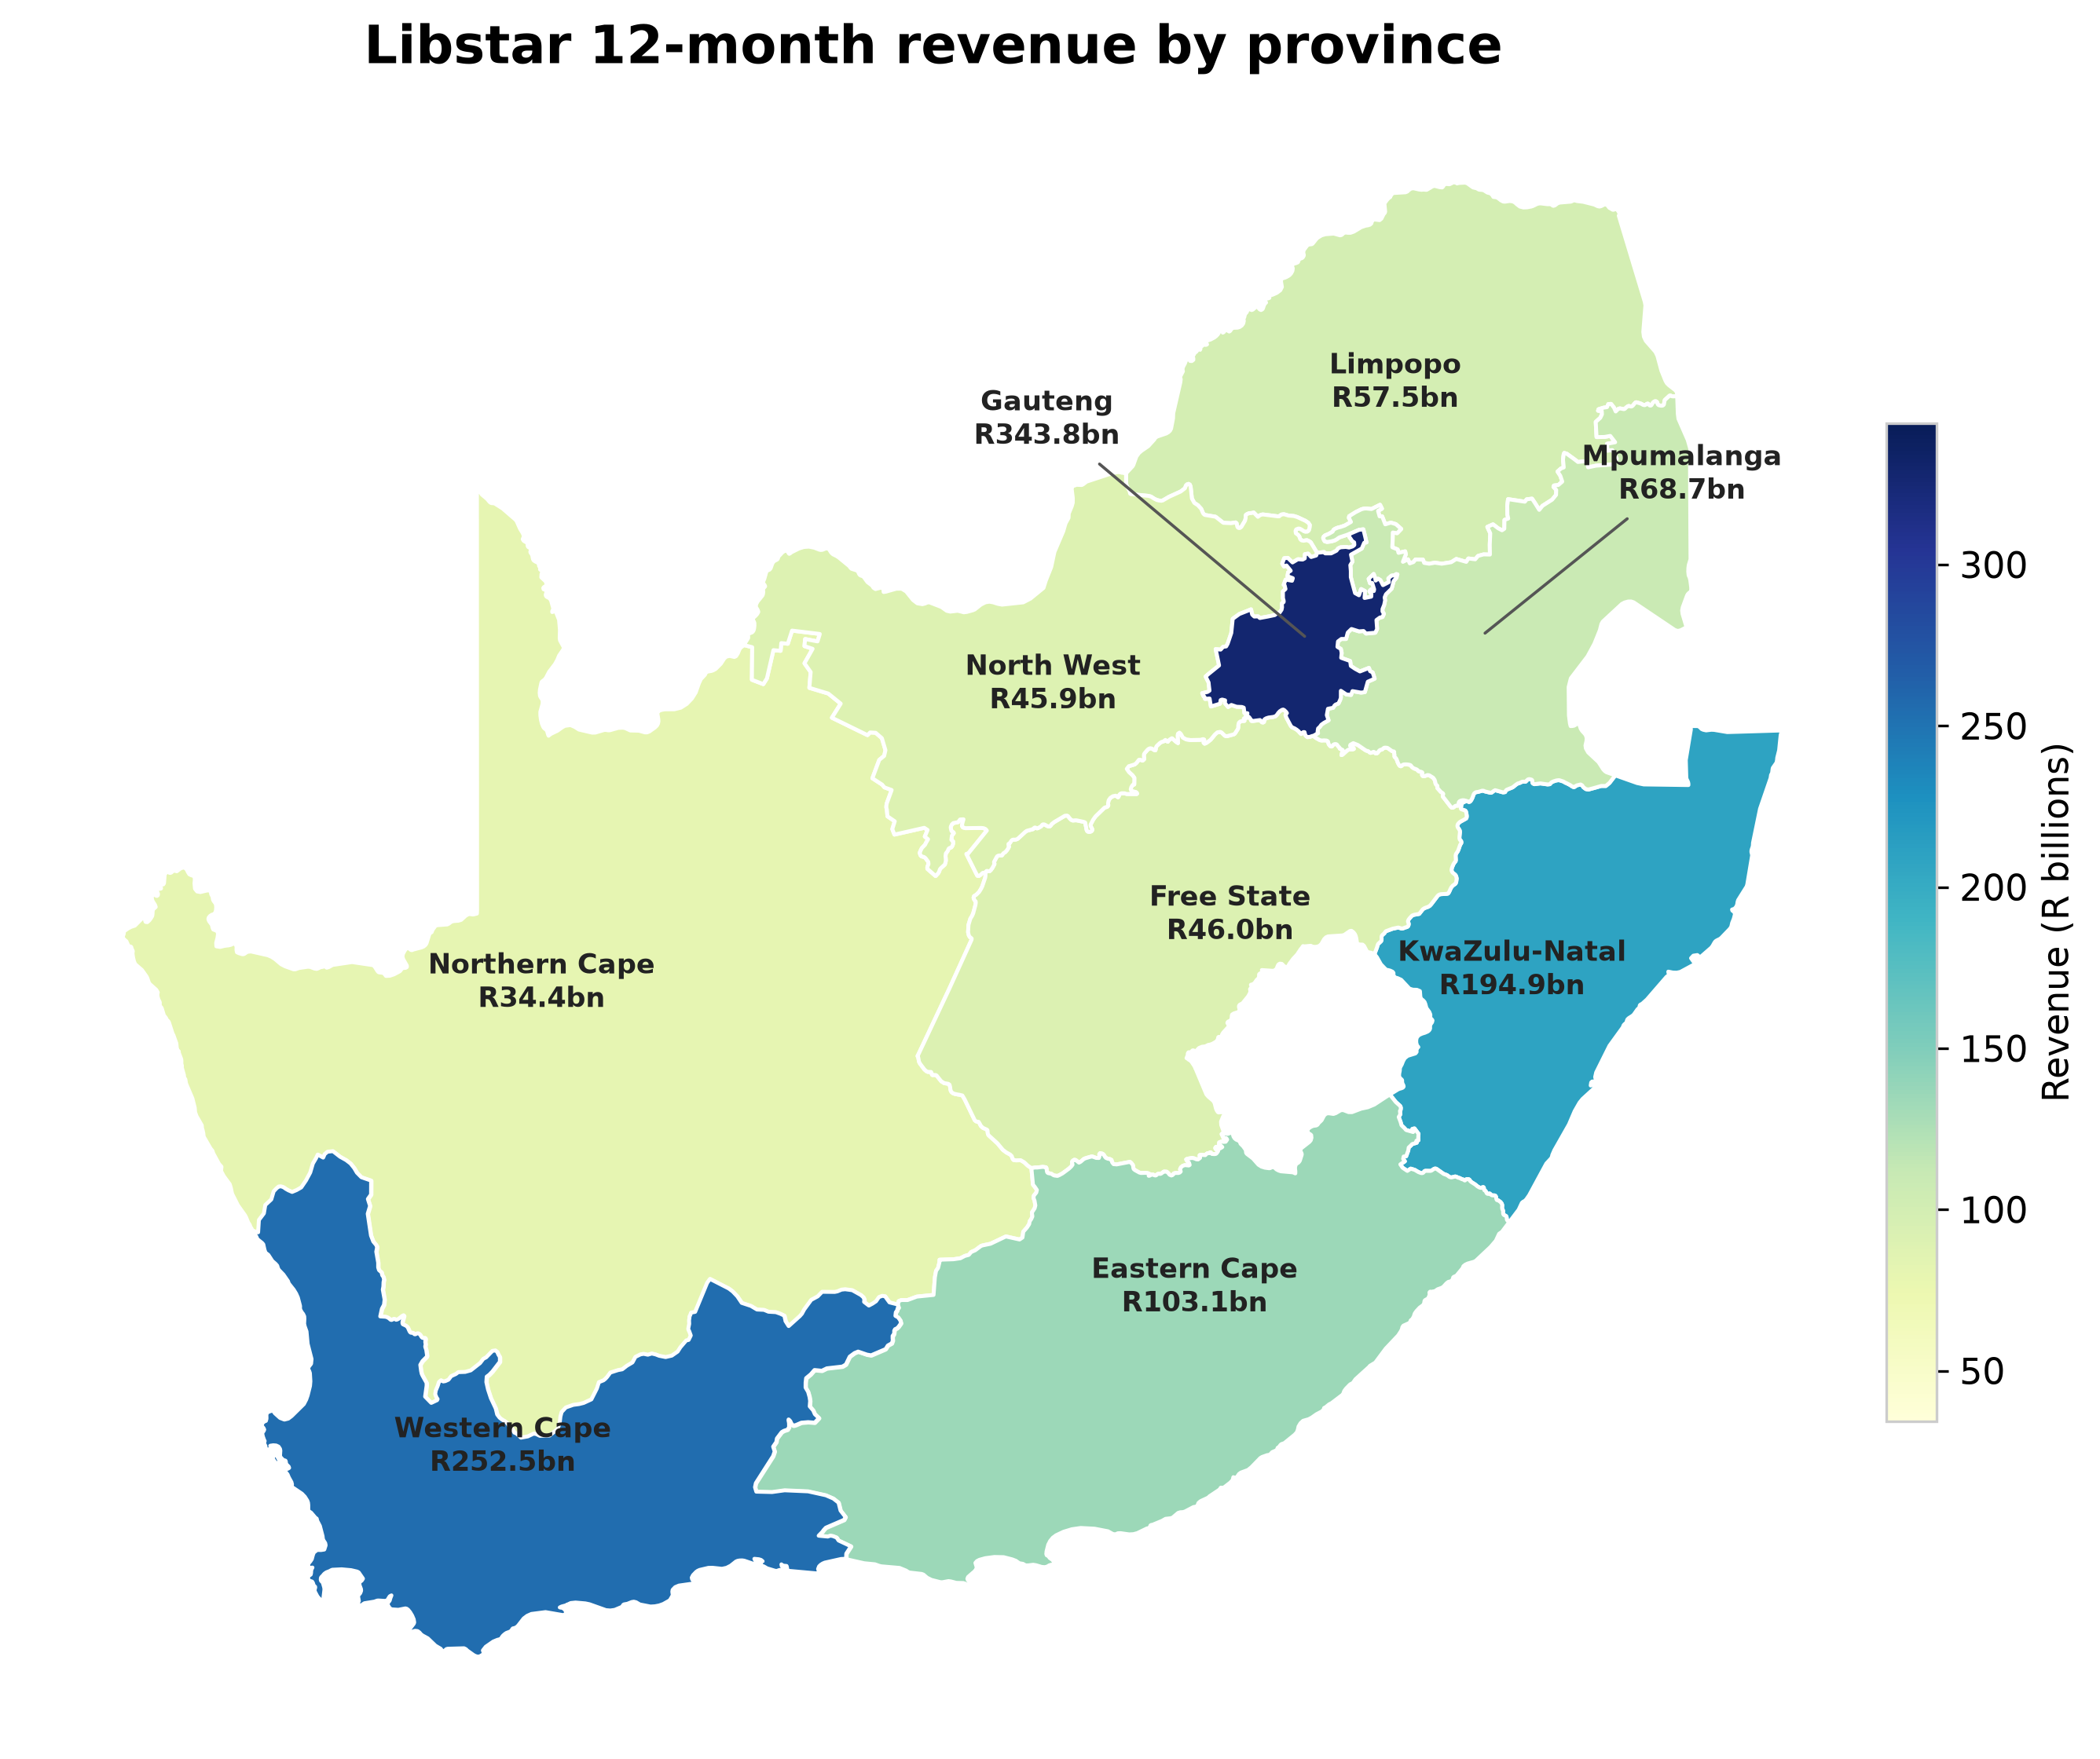
Figure 6 — 12-month revenue by province.

6. Catalog momentum
Product introductions run steadily across the observation window — the assortment machine keeps feeding the shelf.
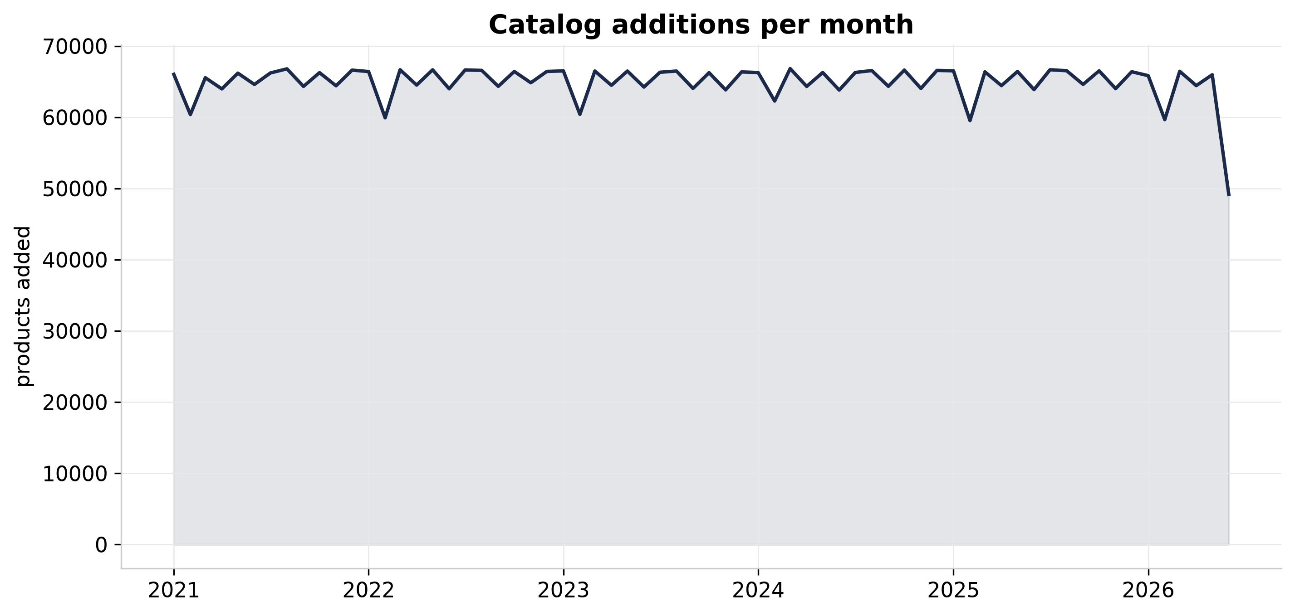
Figure 7 — Products added per month.

7. What the machines found

Pricing has learnable structure
A HistGradientBoosting regressor trained on 480,000 products predicts price from category, brand, brand solution, channel, weight and rating with R² = 0.71 and a mean absolute error of R12.71. Category and brand solution carry most of the signal — pricing follows the portfolio's architecture, which is exactly what a well-governed catalog should show.

Anomalies worth a second look
An IsolationForest scored one million products on price, cost, margin and weight and flagged 2,000 outliers — gram-priced heavyweights, negative-margin outliers, luxury-priced commodity items. The top 50 ship in the Excel report for review.
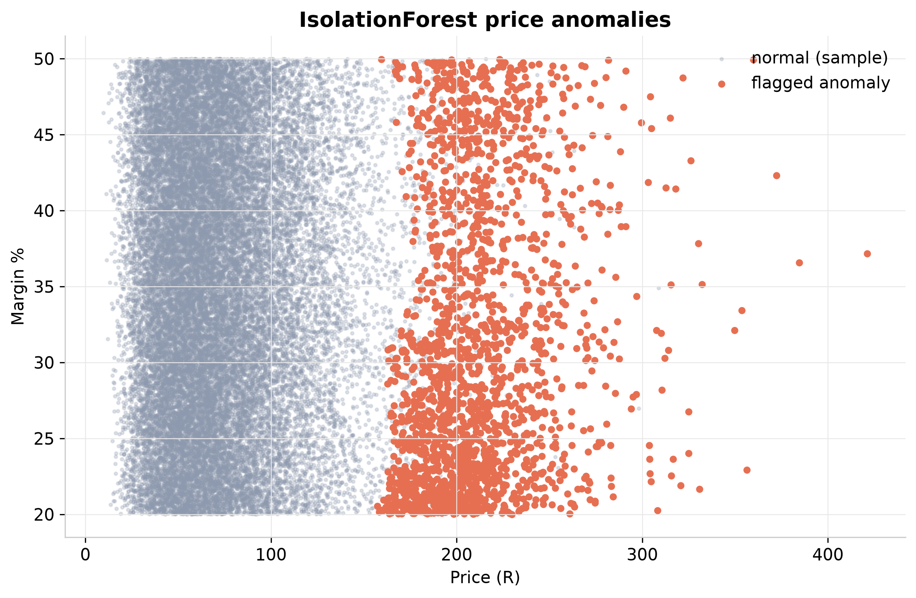
Figure 8 — Flagged anomalies against the normal price–margin cloud.

Four product segments
KMeans on price, margin, volume and rating yields four segments: volume movers (high units, mid price), premium niche (top price, average volume), and two mainstream clusters split by customer rating — a ready-made lens for range reviews.
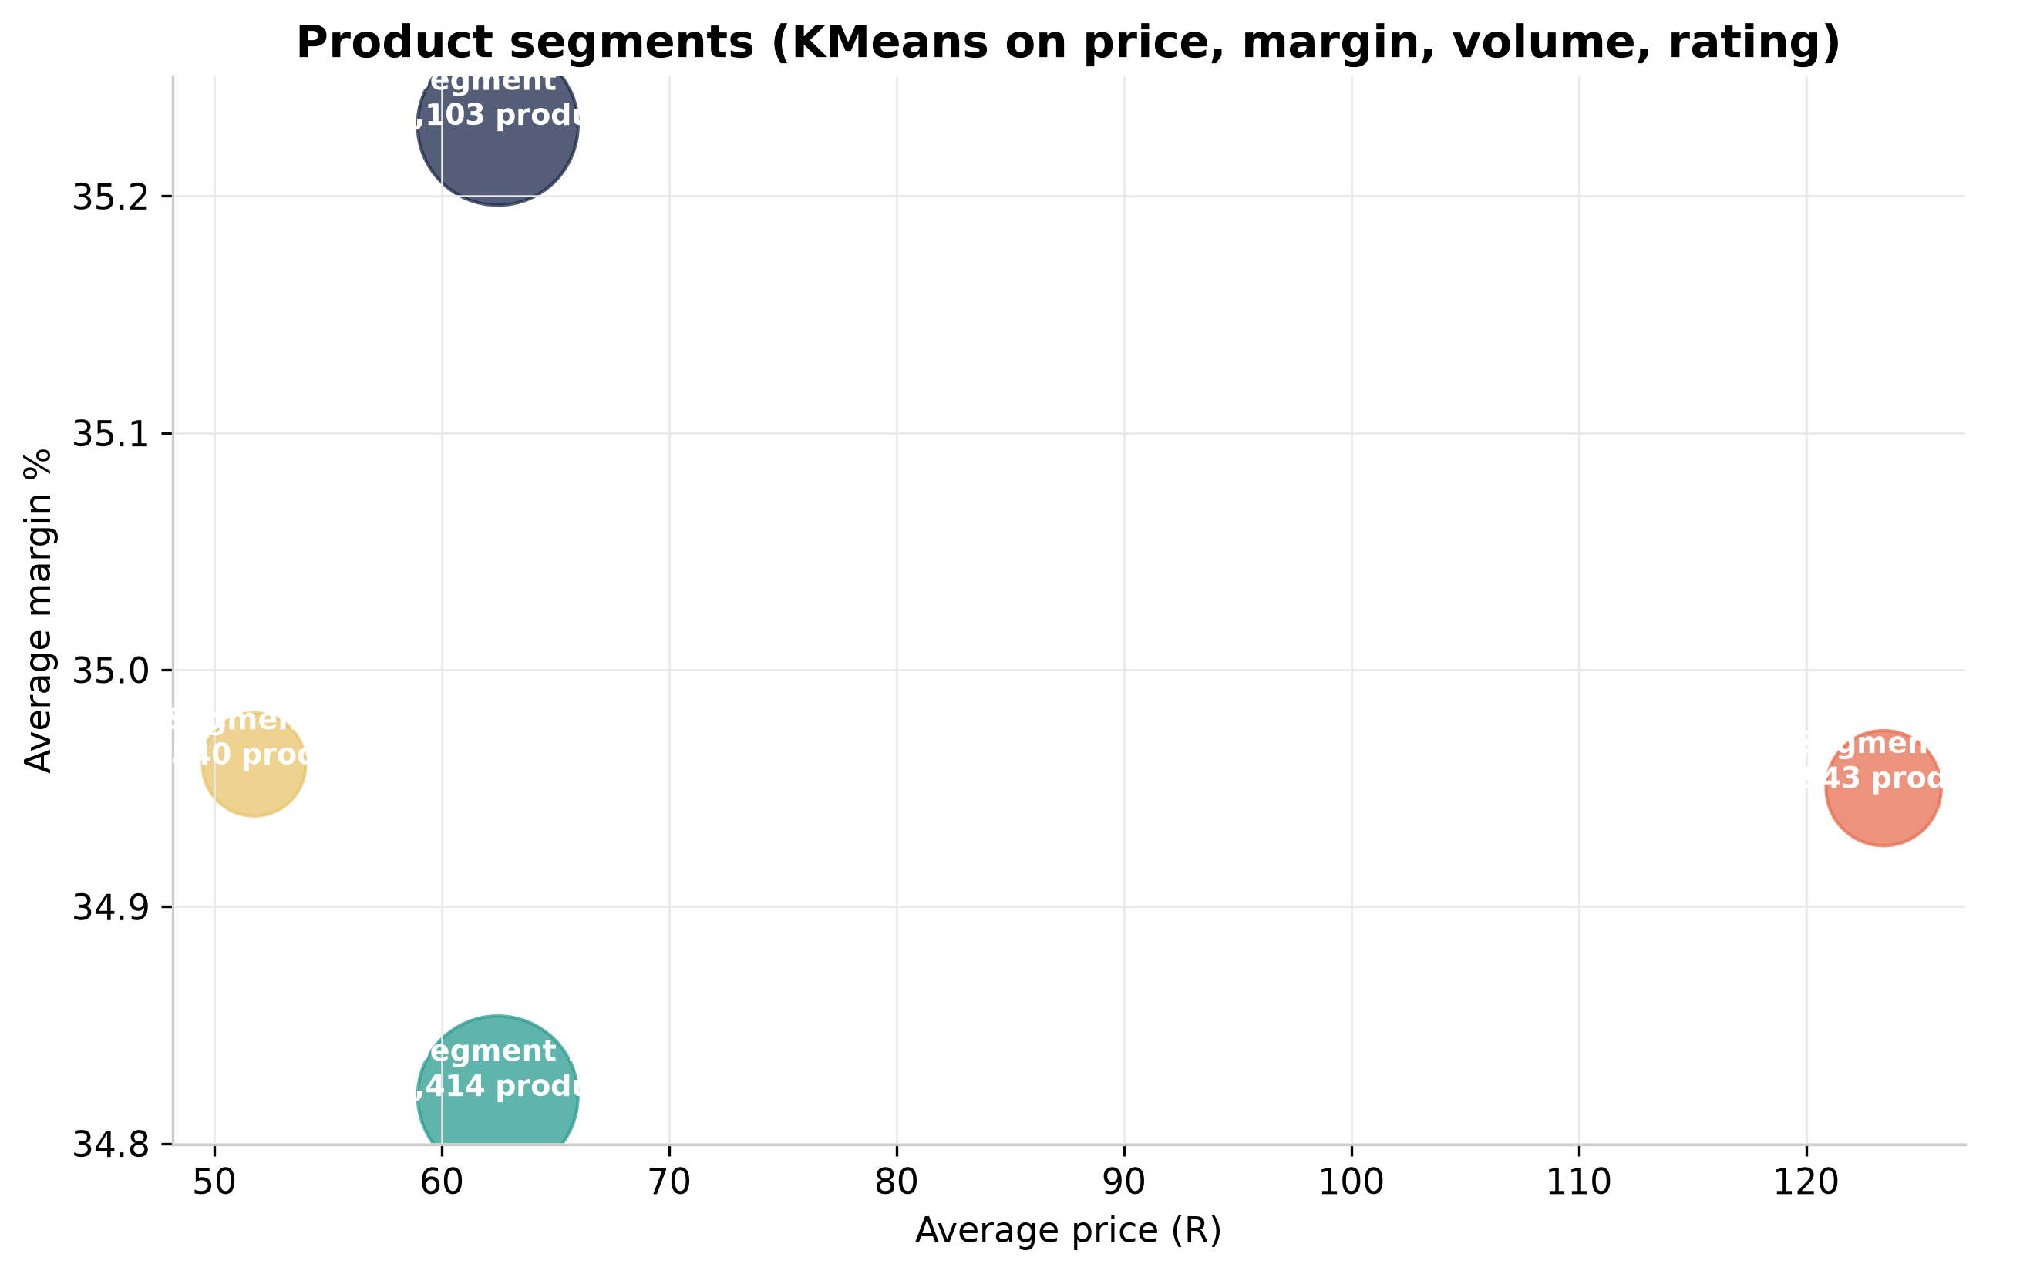
Figure 9 — Segment centroids sized by product count.

8. The business behind the data
Libstar (JSE-listed, founded 2005, HQ Cape Town) produces, distributes and markets consumer packaged goods for South Africa and export markets. The operating model in this dataset mirrors its public structure:
- 2 product groups — Perishable products and Ambient products
- 12 categories — from Dairy and Fresh Mushrooms to Spreads and Beverages
- 3 brand solutions — Libstar Brands, Principal Brands, Private label and dealer-own
- 4 sales channels — Retail and wholesale, Food service, Industrial and contract manufacturing, Export (50+ countries)
- Operations in 5 provinces — Western Cape, Gauteng, KwaZulu-Natal, Eastern Cape, Mpumalanga

9. Methodology, cost and reproducibility
Data is synthetic (seeded, reproducible) and generated on Libstar's public brand/category model. Stack: Python generator → ADLS Gen2 → ADF mapping data flow (8 vCores, ~6 min per run) → parquet → Synapse serverless views → Qlik Sense / Excel / this ebook. Everything reads one aggregate layer, so the numbers here reconcile with the Qlik app and the Excel report by construction.
Cloud cost discipline: the design has no always-on compute. A full pipeline run costs well under R20 in ADF data-flow time; Synapse serverless queries on this volume cost fractions of a cent ($5/TB scanned); an Azure budget alerts at 50/75/90% of the $200 trial credit.
Code, pipeline JSON and SQL: PargoParcels portfolio repository.

