Data Quality Assurance · Technical Challenge
Employee 360
What is wrong, why it matters, and how to stop it recurring
Profiling · six data-quality checks · reconciliation · root cause · monitoring · Bronze/Silver/Gold · Azure Databricks and DevOps
Tools
Spark SQL · PySpark 4.0 · Delta Lake · Databricks (serverless) · Python · Mermaid · Azure DevOps (pipeline definition)
AI coding assistants (Claude Code and Codex) were used during development and review; every result was executed and checked independently (Chapter 9).
Every number in this book is read from the output of running the code shown. All data is synthetic. Amounts in ZAR.

Contents
No. | Title | Page
1 | Profile: what the three files look like | 5
1.1 | Rows, keys and duplicates | 5
1.2 | Blanks, freshness and unexpected patterns | 5
1.3 | Not every difference is an error | 5
1.4 | Top three findings and why they matter | 6
2 | Executable data-quality checks | 7
2.1 | PySpark: field-level reconciliation | 7
2.2 | How the checks were verified | 7
3 | Reconciliation: sources to Employee 360 | 8
3.1 | Summary | 8
3.2 | Why agreeing totals prove nothing | 8
4 | Root cause: E1099 appears, E1027 disappears | 10
5 | Monitoring output and release decision | 11
6 | Pipeline: Bronze, Silver, Gold, incremental | 12
6.1 | Layers | 12
6.2 | Incremental runs and the issue lifecycle | 12
7 | Running it in Azure Databricks and Azure DevOps | 14
8 | Proof on Databricks | 15
8.1 | Bronze, Silver, Gold on Databricks | 15
8.2 | Dashboard: Employee 360 Data Quality | 17
9 | AI use | 20
App. A | Files, how to run, assumptions, limitations | 21
App. B | Evidence index | 22

Executive summary
The decision: BLOCK this Employee 360 release
- All 10 rules fail; 5 of them (DQ01, DQ05, RC01, RC02, RC03) block publication.
- Employee 360 is missing a real employee (E1027) and contains an invented one (E1099, a copy of E1028); it shows a terminated employee as active and carries salaries that cannot be traced or verified.

Five things worth knowing
1. Counts and totals lie. 48 rows in every file, yet the key sets differ; the salary gap nets to R64,600 but is R225,200 gross across four employees.
2. The wrong people are listed. E1099 matches E1028 on 8 of 8 attributes and was written by the current build; E1027 vanished. The likely failure point is the identity or crosswalk step (hypothesis).
3. A leaver may be overpaid. E1029 left on 2 October and is still payable at R84,200 a month, while later leavers are stopped. Payroll should confirm before the October cut-off.
4. Some salaries cannot be verified. Payroll holds two salaries for E1015 and a USD amount for E1037. The checks say “cannot verify” instead of guessing.
5. Correct is buildable. The Gold layer rebuilt from the sources by ownership rules has 45 active employees (as HR), the right people, and 40 of 48 fully trusted records.
How to read this book. Chapters 1–5 answer tasks 1–5 of the brief in order; chapters 6–7 answer task 6; chapter 9 answers the AI questions. Each section opens with an “Answers” tag naming the part of the brief it covers. Every figure is labelled with its kind: rendered log (real run output drawn as an image, excerpt kept beside it), chart from data, generated diagram or Databricks run export. Appendix B lists every image with its source and SHA-256.

Requirements index: where each part of the brief is answered
Task | Brief requirement | Answered in | Page
1 | Profile with SQL: counts, distinct keys, null rates, duplicates | §1.1, §1.2 | 5, 5
1 | At least one unexpected pattern or freshness concern | §1.2 | 5
1 | Top three findings and their business significance | §1.4, Executive summary | 6, 4
2 | 4–6 automated checks across at least three dimensions | Ch. 2 | 7
2 | Advanced SQL (joins, CTEs, window functions) | Ch. 2 | 7
2 | PySpark for a substantive validation or reconciliation | §2.1 | 7
2 | Return affected employee IDs, not only pass/fail counts | Ch. 2, Ch. 5 | 7, 11
2 | Disclose limitations if Spark cannot run | §2.2, App. A | 7, 21
3 | Employees missing downstream, unexpected downstream records | §3.1 | 8
3 | Field-level mismatches for business-critical fields | §3.1 | 8
3 | Prove why agreeing totals do not establish correctness | §3.2 | 8
3 | Short reconciliation summary | §3.1 | 8
4 | Evidence, point of failure, impact, confirming information, owner | Ch. 4 | 10
4 | Distinguish proven facts from hypotheses | Ch. 4 | 10
5 | Monitoring output: rule, pass/fail, count, severity, IDs | Ch. 5, §8.2 | 11, 17
5 | An alert threshold; what blocks a release vs is monitored | Ch. 5 | 11
6 | How checks run in Azure Databricks and Azure DevOps CI/CD | Ch. 7, §8.1 | 14, 15
6 | Before deployment, on a schedule, who receives alerts | Ch. 7 | 14
6 | Minimise compute, full-table scans, noisy alerts, paid tools | §6.2, Ch. 7 | 12, 14
6 | One check not to run on every execution, and why | Ch. 7 | 14
AI | Tools used and what they accelerated | Ch. 9 | 20
AI | One AI suggestion corrected, simplified, challenged or rejected | Ch. 9 | 20
AI | How it was verified; was it commercially justified | Ch. 9 | 20
Submit | SQL, PySpark and scripts in Git; README with run, assumptions, limitations | App. A | 21
Submit | Profiling, validation, reconciliation, monitoring outputs, root-cause note | Ch. 1, Ch. 2, Ch. 3, Ch. 4, Ch. 5 | 5, 7, 8, 10, 11
The 5–10 minute video is recorded separately; its script is docs/walkthrough_script.md.

1. Profile: what the three files look like
Answers Task 1 · inspect with SQL: counts, distinct keys, null rates, duplicates, an unexpected pattern or freshness concern
Three CSV extracts for the October 2026 snapshot: HR (system of record for who works here, status, manager, department, location), payroll (salary, payroll status) and the delivered Employee 360 view under test. The SQL is sql/01_profile.sql; it runs unchanged on Databricks and on local Spark.

1.1 Rows, keys and duplicates
Source | Rows | Distinct IDs | Duplicate rows
HR | 48 | 48 | 0
Payroll | 48 | 47 | 1
Employee_360 | 48 | 48 | 0

Insight: the counts agree, the contents do not
- All three files have exactly 48 rows. A row-count check, the usual first control, passes.
- Yet payroll has 47 distinct employees (E1015 appears twice with different salaries), and only 47 of Employee 360's IDs exist in HR.

1.2 Blanks, freshness and unexpected patterns
Source | Column | Blank | %
Employee_360 | manager_id | 5 | 10.4
HR | department | 1 | 2.1
HR | email | 1 | 2.1
HR | manager_id | 5 | 10.4

Pattern | Rows | Examples
HR dates use yyyy/MM/dd; the other files use ISO yyyy-MM-dd | 48 | –
HR effective_date after the reporting month (future-dated change) | 1 | E1042
HR last_updated earlier than effective_date (change keyed in before it takes effect) | 23 | –
Location alias (CPT for Cape Town) | 1 | E1040
Payroll currency other than ZAR in a ZAR salary column | 1 | E1037
Payroll pay_period is not the reporting month | 48 | –

- Freshness: payroll's pay period is 2026-09 for an October snapshot, so salaries are a month behind (acceptable, but it matters for leavers). E1030 has not been touched for 99 days.
- Format: HR writes dates as yyyy/MM/dd, the other files as ISO. A loader that assumes ISO turns every HR date into NULL, silently.

1.3 Not every difference is an error
Observation | Verdict | Why
E1040 location “CPT” vs “Cape Town” | Not an error | Same place; compared on the standard name
E1042 HR effective date 19 Nov | Legitimate exception | Future-dated change: the October snapshot should still show the October value
E1001–E1005 have no manager | Allowed | They head departments (they manage others)
23 HR rows updated before their effective date | Normal | Changes keyed in ahead of time
E1029 terminated in HR, payable in payroll | Inconsistent: confirm | September pay may be due, but the two later leavers are already stopped

1.4 Top three findings and why they matter
Answers Task 1 · identify your top three findings and explain their business significance
1 · Employee 360 lists the wrong people and wrong values. Release must be blocked
- E1027 (active, paid R80,300) is missing; E1099 “Unknown Legacy Employee” is present instead and is a field-for-field copy of E1028.
- E1012 is shown Active although HR terminated them; E1018's salary is R6,500 too high; E1037's USD amount is relabelled ZAR; E1044 has a salary with no payroll record.
- Significance: reported headcount is 46 active against HR's 45, and the salary total is off by a net R64,600 that hides R225,200 of gross error.

2 · A leaver is still payable (E1029). Alert payroll before the October cut-off
- HR terminated E1029 on 2026-10-02; payroll still says Payable (R84,200 a month). E1012 and E1041, who left later, are already Stopped.
- E1044 is the mirror case: active in HR with no payroll record at all (possibly unpaid).
- Significance: an overpayment that must later be recovered, or an employee not paid. Both are people and compliance risks, not just data risks.

3 · Payroll, the salary system of record, cannot be trusted for two employees
- E1015 has two payroll rows (R57,100 and R58,600). Employee 360 shows the first, but nobody can say which is right.
- E1037's salary is in USD in a column that should only hold ZAR.
- Significance: until payroll is fixed, salary for these employees is reported as “cannot verify”. Guessing would hide the problem.

2. Executable data-quality checks
Answers Task 2 · 4–6 automated checks across at least three dimensions; advanced SQL; PySpark; return affected employee IDs
Six checks in sql/02_checks.sql, one per dimension. Each is a view that returns one row per affected employee (rule, employee_id, source, detail), so an empty view means pass and a failure always names who is affected.
Rule | Dimension | What it checks | Technique
DQ01 | Uniqueness | employee_id unique in every source | window count over a union of sources
DQ02 | Completeness | mandatory HR fields; blank manager only for heads | self-join (who manages others), filter(array)
DQ03 | Referential integrity | manager_id exists in HR | LEFT ANTI JOIN
DQ04 | Consistency | HR status agrees with payroll status | CTE + LEFT JOIN, missing payroll counted
DQ05 | Validity | salary is a positive ZAR amount; pay period well formed | RLIKE, CASE
DQ06 | Freshness | updated within 30 days of the extract | datediff over a union of sources
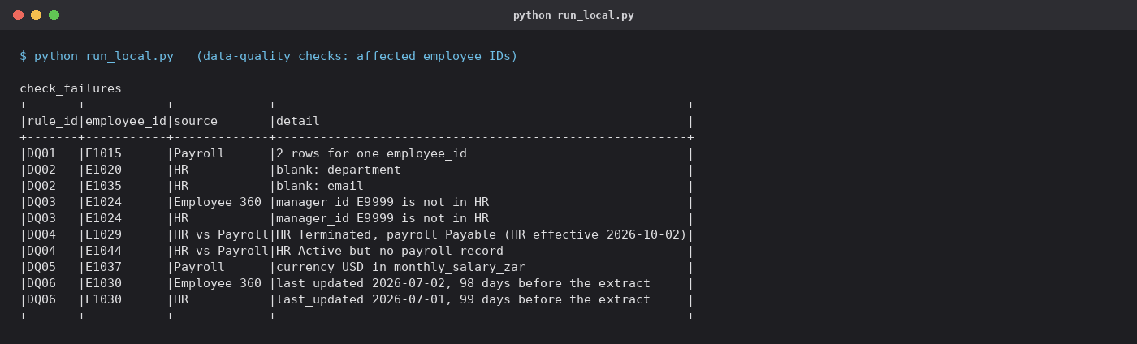
Figure 1. Output of the six checks: every failure names the employee. [Rendered log]

2.1 PySpark: field-level reconciliation
reconcile_fields() in the notebook compares every business-critical field of Employee 360 with the system that owns it (HR or payroll), using null-safe equality, and classifies each difference as an Error, a Legitimate exception or Cannot verify, with the reason. It is the PySpark task the brief asks for, and it feeds rules RC03 and RC04.

2.2 How the checks were verified
tests/check_expected.py recomputes every rule's affected IDs from the raw CSVs in plain Python, with separately written logic and no Spark, and compares them with the Spark output. It runs in seconds, so it can run on every pull request.
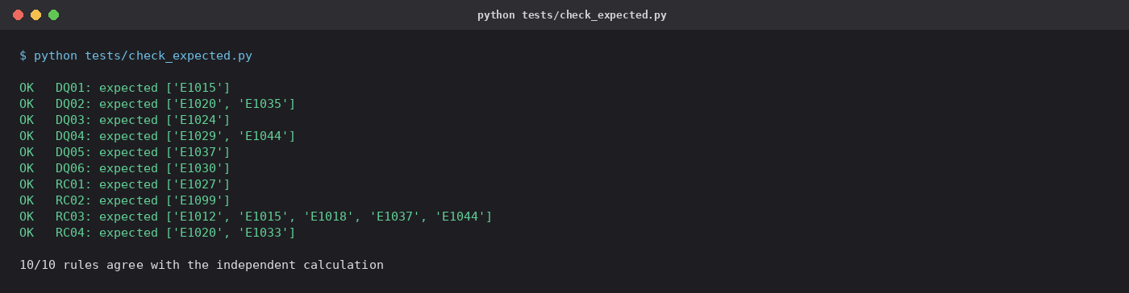
Figure 2. Independent recomputation: all 10 rules agree with the Spark output. [Rendered log]

3. Reconciliation: sources to Employee 360
Answers Task 3 · missing downstream, unexpected downstream, field mismatches; why agreeing totals do not prove correctness; a short summary

3.1 Summary
Measure | Value
Employees in HR (system of record) | 48
Rows in Employee 360 | 48
Matched on employee_id | 47
Missing downstream (in HR, not in Employee 360) | 1
Unexpected downstream (in Employee 360, not in HR) | 1
Matched employees with at least one field error | 6
Matched employees whose value cannot be verified (conflicting source) | 1
Field differences that are legitimate exceptions | 1

Employee | Field | Source | Employee 360 | Classification
E1015 | monthly_salary | 57100.00 | 57100.00 | Cannot verify
E1012 | employment_status | Terminated | Active | Error
E1018 | monthly_salary | 62900.00 | 69400.00 | Error
E1037 | currency | USD | ZAR | Error
E1044 | monthly_salary | blank | 56200.00 | Error
E1044 | currency | blank | ZAR | Error
E1020 | department | blank | Finance | Error
E1033 | department | People | Sales | Error
E1042 | effective_date | 2026-11-19 | 2026-10-01 | Legitimate exception

3.2 Why agreeing totals prove nothing
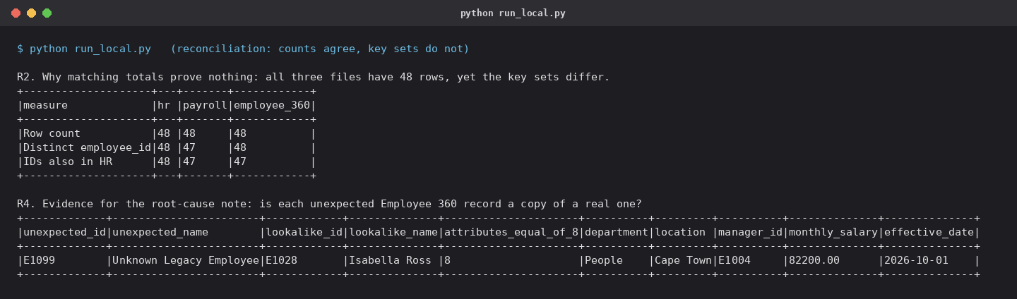
Figure 3. Row counts agree (48/48/48) while the key sets differ; E1099 matches E1028 on 8 of 8 attributes. [Rendered log]
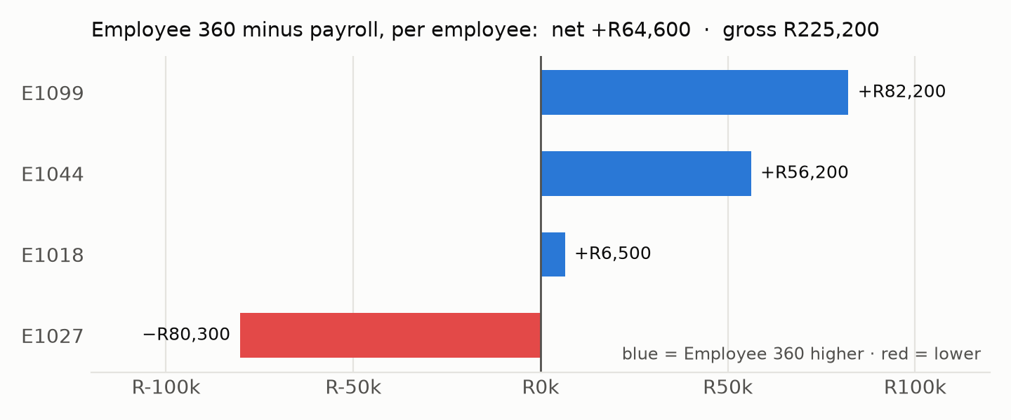
Figure 4. One net figure (R64,600) hides four errors worth R225,200 gross. [Chart from data]
Insight: reconcile keys and fields, not totals
- A missing employee and an invented one cancel exactly in a headcount.
- Salary errors in both directions cancel in a total: +R82,200, −R80,300, +R56,200, +R6,500.
- Only a key-level and field-level comparison against the system of record finds them.

4. Root cause: E1099 appears, E1027 disappears
Answers Task 4 · evidence, likely point of failure, business impact, what would confirm it, who should fix it; facts kept apart from hypotheses
Proven facts (evidence in outputs/) | Hypothesis (not proven)
E1027 is in HR (Active) and payroll (Payable, R80,300) but not in Employee 360 (recon_keys.csv). E1099 exists only in Employee 360. E1099 equals E1028 (Isabella Ross) on 8 of 8 attributes (recon_lookalike.csv). E1099's last_updated (2026-10-08) is the build date stamped on all current rows, so this build wrote it. The 48-row count did not change. | The identity-resolution step that assigns employee_id in the Employee 360 build (for example a legacy-ID crosswalk) produced a second record carrying E1028's attributes under the legacy key E1099, and the same step may be why the neighbouring ID E1027 was dropped. Alternative: a manual legacy insert copied an existing row while a separate filter excluded E1027.

- Related pattern (hypothesis): Employee 360 carries values the current extracts do not contain (E1020's department, E1044's salary, E1012's pre-termination status). The build may keep the previous value when the source is blank or missing.
- What would confirm it: the crosswalk or MDM entries for E1027, E1028 and E1099; the Employee 360 table's Delta history (DESCRIBE HISTORY, VERSION AS OF) to see when E1099 appeared and E1027 went; the 2026-10-08 job logs and merge logic; HR confirming that no E1099 exists.
- Business impact: people reporting lists the wrong people while headcount and cost look plausible; anything fed by Employee 360 (access, org charts) inherits the error.
- Who should fix it: the Employee 360 data engineering team (owner of the build and the crosswalk) with the MDM or HR data steward. Release stays blocked by RC01 and RC02 until it is fixed.

5. Monitoring output and release decision
Answers Task 5 · rule, pass/fail, affected count, severity, affected IDs; an alert threshold; what blocks a release and what is monitored
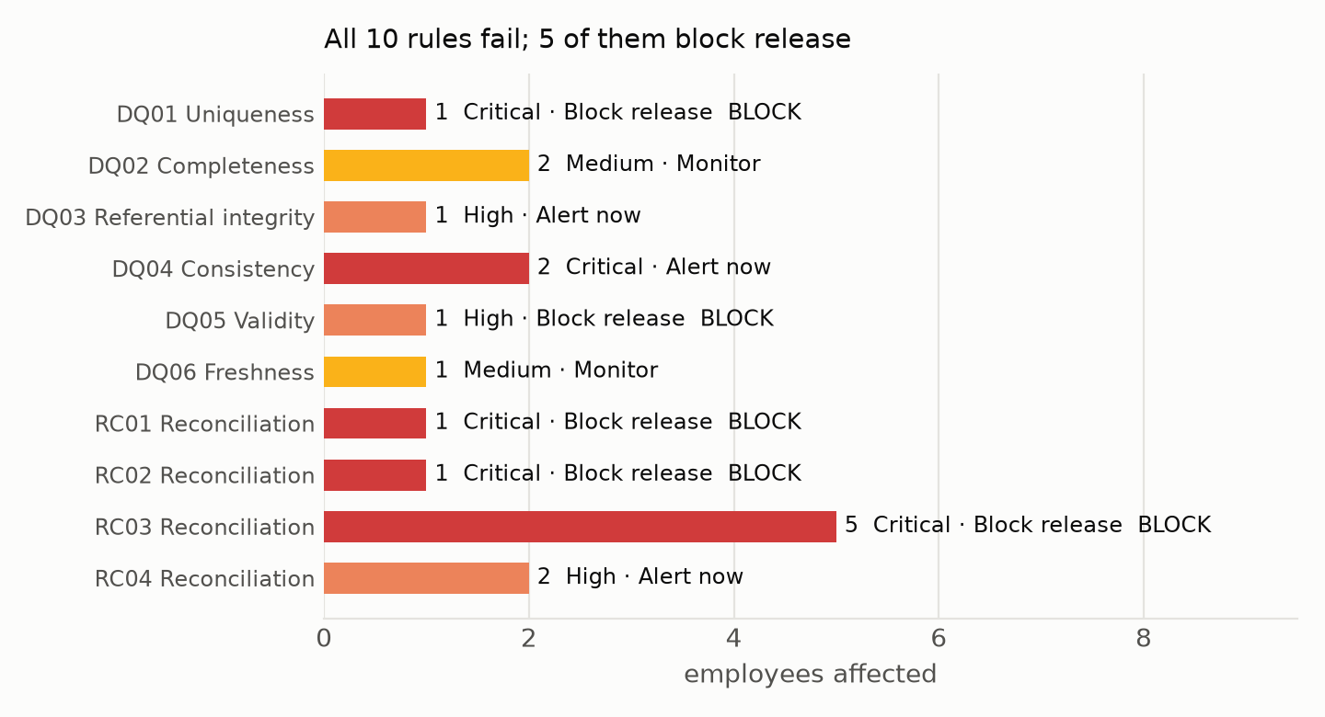
Figure 5. All 10 rules fail; 5 block release. [Chart from data]
Rule | Status | Count | Severity | Action | Alert when > | Affected IDs
DQ01 | FAIL | 1 | Critical | Block release | 0 | E1015
DQ02 | FAIL | 2 | Medium | Monitor | 1 | E1020, E1035
DQ03 | FAIL | 1 | High | Alert now | 0 | E1024
DQ04 | FAIL | 2 | Critical | Alert now | 0 | E1029, E1044
DQ05 | FAIL | 1 | High | Block release | 0 | E1037
DQ06 | FAIL | 1 | Medium | Monitor | 2 | E1030
RC01 | FAIL | 1 | Critical | Block release | 0 | E1027
RC02 | FAIL | 1 | Critical | Block release | 0 | E1099
RC03 | FAIL | 5 | Critical | Block release | 0 | E1012, E1015, E1018, E1037, E1044
RC04 | FAIL | 2 | High | Alert now | 0 | E1020, E1033

- Block release (any failure stops this Employee 360 build being published): wrong people, wrong or unverifiable pay, invalid currency, duplicate keys.
- Alert now (owner told the same day; publishing may continue): the fix is in a source system. DQ04, a leaver still payable, goes to payroll before the pay-run cut-off.
- Monitor (trend, alert only above a threshold): e.g. alert when more than 1 employee (2% of 48) has a blank mandatory field; freshness alerts when more than 2 records are stale.
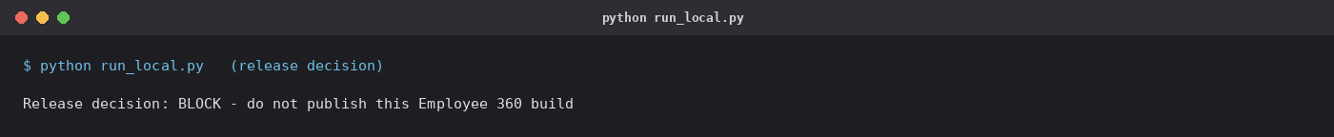
Figure 6. The gate's decision for this delivery. [Rendered log]

6. Pipeline: Bronze, Silver, Gold, incremental
Answers Task 6 · minimise repeated full-table scans and noisy alerts; how the checks sit in a Databricks pipeline
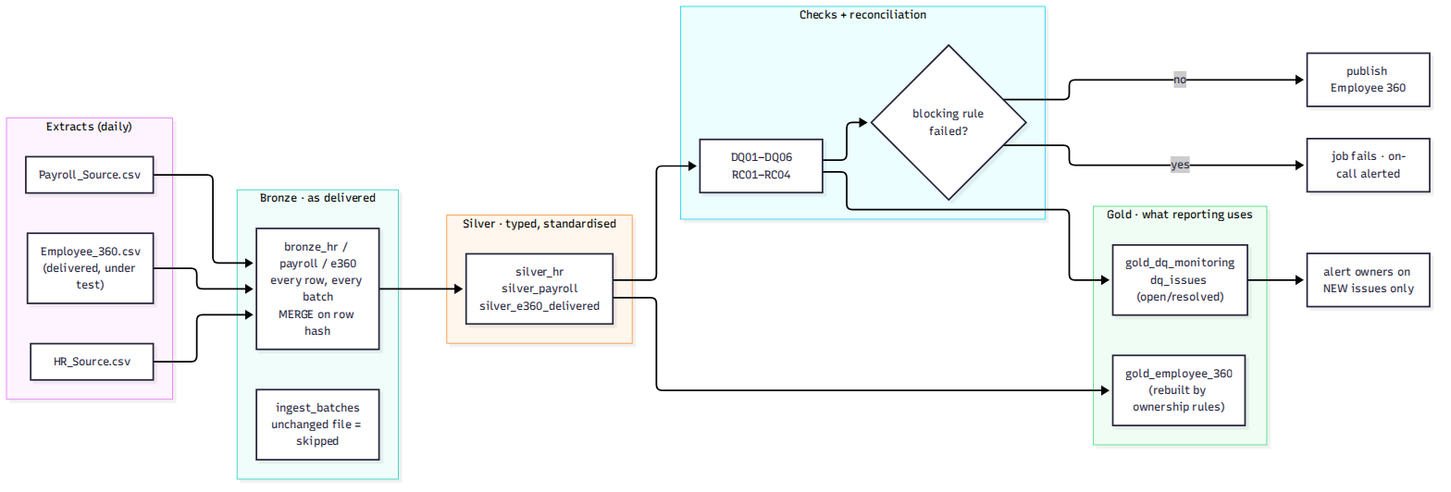
Figure 7. How the checks sit in the pipeline: a blocking failure stops publication; owners hear about new issues only. [Generated diagram]

6.1 Layers
Layer | Table | Rows
Bronze | bronze_hr | 48
Bronze | bronze_payroll | 48
Bronze | bronze_e360 | 48
Silver | silver_hr | 48
Silver | silver_payroll | 48
Silver | silver_e360_delivered | 48
Gold | gold_employee_360 | 48
Gold | gold_dq_monitoring | 10
Gold | dq_issues | 17

Measure | Gold | Delivered Employee 360
Employees | 48 | 48
Active employees | 45 | 46
Employees with a verified ZAR salary | 45 | 48
Trusted records (no open source-quality rule, salary verified) | 40 | –

Insight: Gold shows what correct looks like
- Gold is rebuilt from Silver by the ownership rules: HR decides who exists and their status; payroll supplies salary only when it holds exactly one valid ZAR value.
- It has E1027 and not E1099, shows E1012 as Terminated and gives E1018's salary as R62,900. 45 active employees, the same as HR.
- Salaries for E1015, E1037 and E1044 are left empty and flagged, not guessed. 40 of 48 records are fully trusted.

6.2 Incremental runs and the issue lifecycle
Each delivery is MERGEd into Bronze on a row hash. An extract whose file hash matches the last one is not read at all. Failures are MERGEd into dq_issues (open, resolved), and alerts go out only for issues that are new in a run. Run 3 uses a labelled, simulated delivery (data/simulated_run3) with three fixes and one new problem.
Run | Delivery | Employees changed | Checks | New (alerted) | Resolved | Open
1 | data | 49 | ran | 17 | 0 | 17
2 | data | 0 | skipped | 0 | 0 | 17
3 | data/simulated_run3 | 7 | ran | 2 | 8 | 11
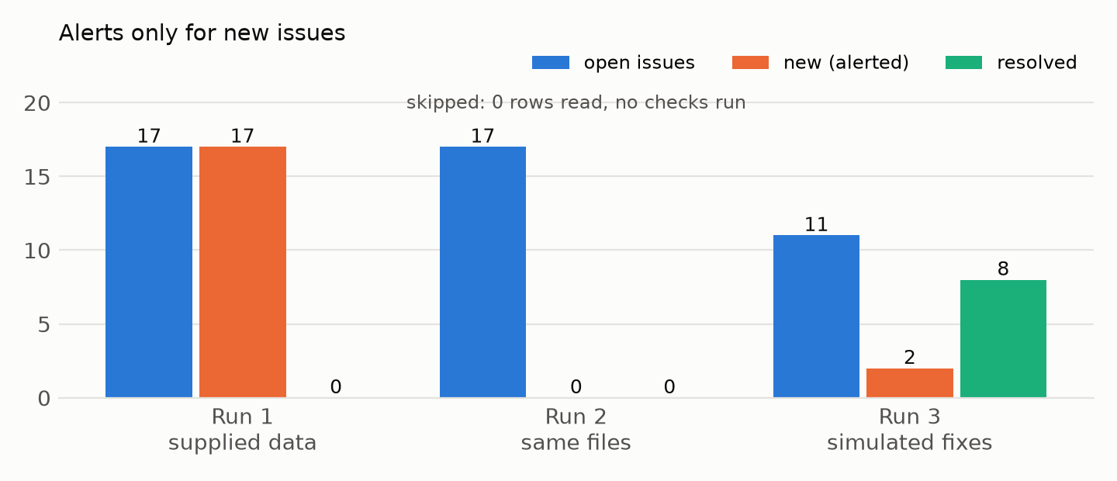
Figure 8. Run 2 reads nothing; run 3 alerts on 2 new issues, not on the 11 still open. [Chart from data]
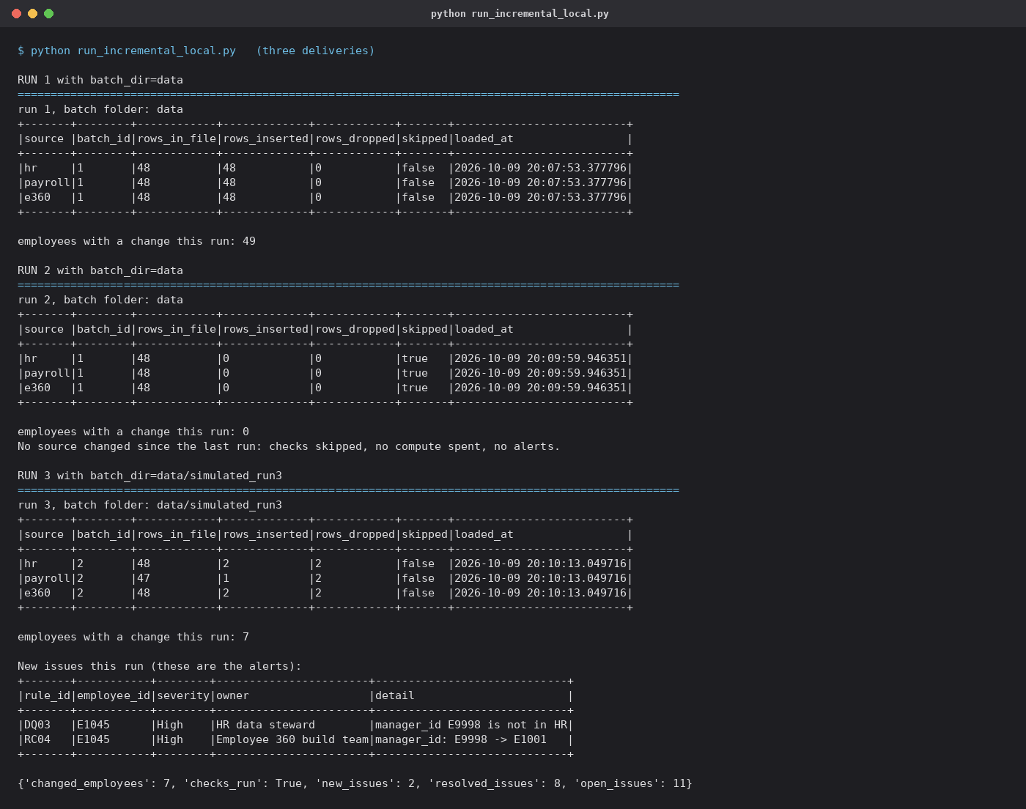
Figure 9. The three runs: batches loaded or skipped, changed employees, and the only two alerts. [Rendered log]

7. Running it in Azure Databricks and Azure DevOps
Answers Task 6 · what runs before deployment, on a schedule, who is alerted; compute cost, scans, noisy alerts, paid tools; one check not run every time
When | What runs | Databricks cost
Every pull request | run_local.py on the fixture CSVs and tests/check_expected.py (must be 10/10), on the build agent with local PySpark | none
Merge to main | databricks bundle validate and deploy -t test, then one smoke run on the fixtures | one short run
Release | databricks bundle deploy -t prod behind an approval gate | none
Daily 06:00 (prod) | The medallion job: Bronze load, checks with fail_on_block=true, Silver and Gold; publish runs only if the checks task succeeds | minutes, serverless

- Alerts: DQ04 (leaver still payable) to payroll and HR operations the same day, re-checked three working days before the pay run; a blocking failure to the Employee 360 on-call through the job's failure notification; High rules to the HR data steward for new issues only; Medium rules in a weekly digest.
- Compute: serverless jobs compute (nothing billed between runs); unchanged extracts skipped by file hash; only new or changed rows written; at scale the row-level checks filter to the changed keys the notebook already lists.
- Noise: one issue per rule and employee; alert once when it opens, close it when it stops failing.
- Tools: plain SQL and PySpark in the same job, history in Delta tables; no separate data-quality or observability licence. The same SQL runs on open-source Spark, so CI needs no workspace.
A check I would not run on every execution
- The full profile (every column of every table) and the look-alike search (a self-join that grows with the square of the table).
- They give diagnostic insight, not a pass/fail gate, and their answers change slowly: run them weekly and during an investigation.

8. Proof on Databricks
Answers Tasks 2 and 6 · the same notebooks on Databricks serverless, results compared with the local run
The notebooks and SQL files were imported into the workspace unchanged and run as one-time serverless jobs. Results were read back with the SQL Statement API and compared line by line with the local outputs (evidence/databricks_run.md, raw data in evidence/databricks_*.csv).
# | Notebook | Run ID | Result | Duration
0 | employee360_dq | 898819557289071 | FAILED | 126 s
1 | employee360_dq | 515886583443770 | SUCCESS | 136 s
2 | employee360_incremental | 981987682878372 | SUCCESS | 225 s
3 | employee360_incremental | 94742837183686 | SUCCESS | 37 s
4 | employee360_incremental | 68446115877254 | SUCCESS | 196 s

Comparison with the local run | Result
Monitoring: rules with identical status and affected IDs | 10 of 10
Incremental runs: changed / checks / new / resolved / open | 3 of 3 runs identical
Issue lifecycle rows (status, first/last seen, resolved, detail) | 19 of 19 identical

Insight: one engine is not enough evidence
- The first Databricks run failed: a correlated scalar subquery that open-source Spark accepts is rejected by Databricks serverless (MUST_AGGREGATE_CORRELATED_SCALAR_SUBQUERY).
- The fix carries the value through the existing join (same result) and both engines now pass. CI runs the open-source engine, so the deploy smoke run on Databricks stays in the pipeline for exactly this reason.

8.1 Bronze, Silver, Gold on Databricks
Three runs of the medallion notebook, each named for its purpose so the Runs list explains itself. All succeeded on the first attempt with no code change; Gold after run 1 matches the local output in all 576 cells, and the run log, all 19 issue rows and all 10 monitoring rules match too.
Run name | Result | Duration
Medallion run 1 of 3 | supplied data, full load | SUCCESS | 780 s
Medallion run 2 of 3 | same files again, should skip | SUCCESS | 34 s
Medallion run 3 of 3 | simulated fixes + 1 new issue | SUCCESS | 293 s
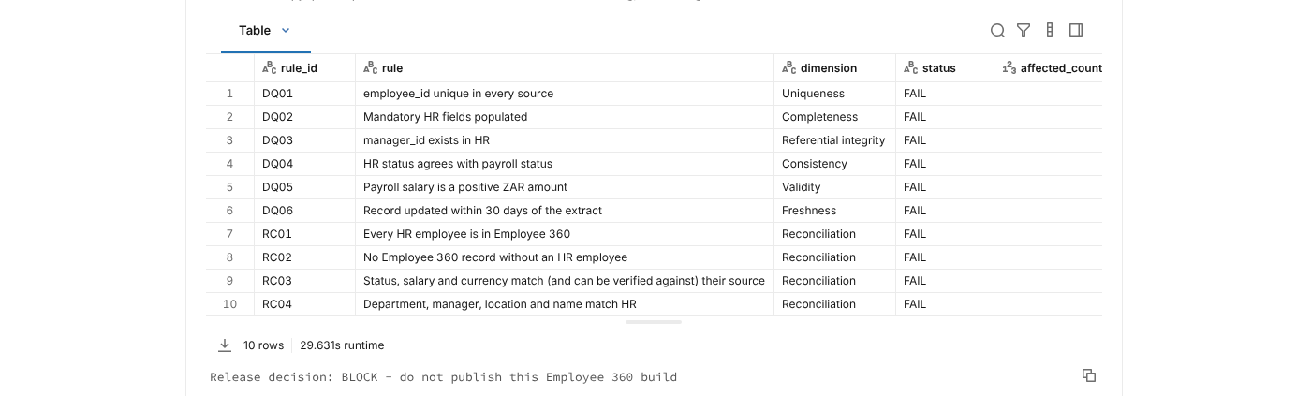
Figure 10. Run 1 on Databricks: the monitoring table (10 rules, all FAIL) and the release decision BLOCK. [Databricks run export (rendered, not a browser screenshot)]
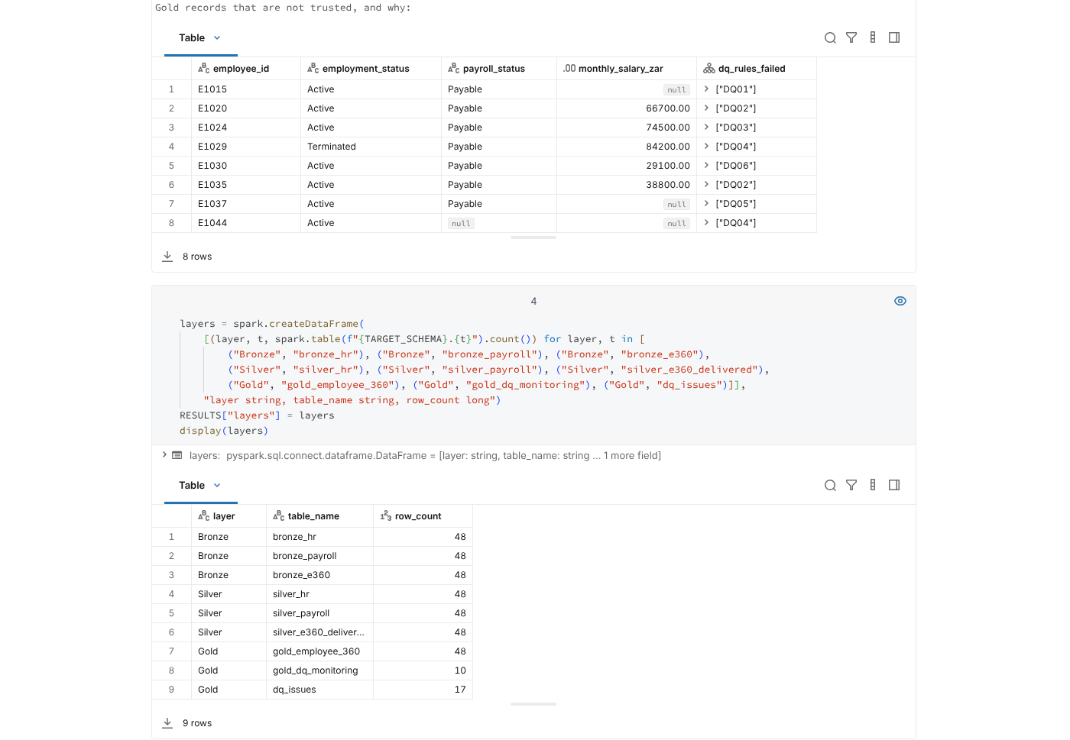
Figure 11. Run 1 on Databricks: Gold records that are not trusted, and why; row counts per layer. [Databricks run export (rendered, not a browser screenshot)]
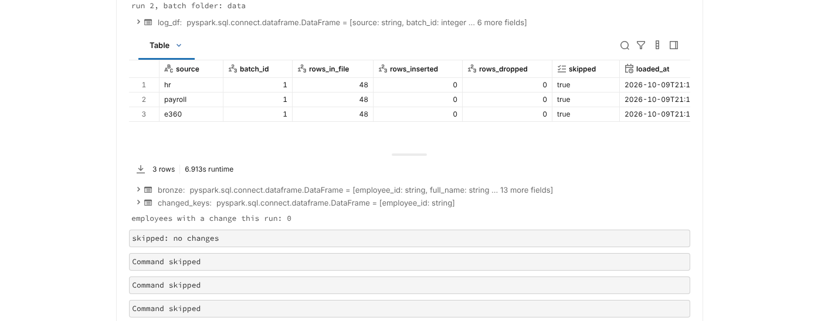
Figure 12. Run 2 on Databricks: same files again, 0 rows inserted, checks skipped. [Databricks run export (rendered, not a browser screenshot)]
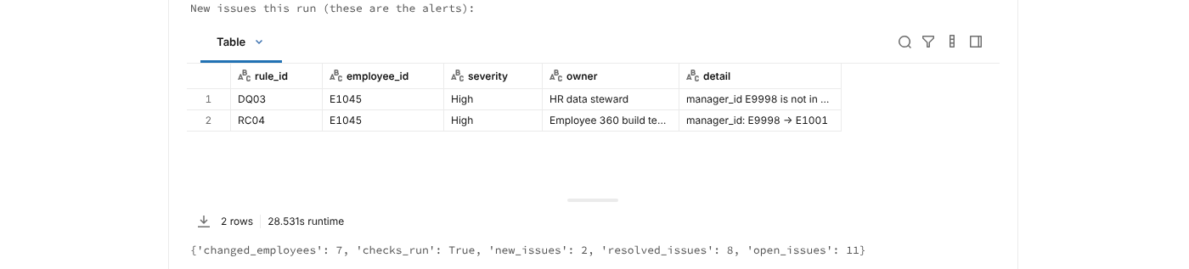
Figure 13. Run 3 on Databricks (simulated delivery): the only two alerts, and the run summary. [Databricks run export (rendered, not a browser screenshot)]

8.2 Dashboard: Employee 360 Data Quality
Answers Task 5 · a usable monitoring output, live in Databricks AI/BI
A Databricks AI/BI dashboard on the Gold and monitoring tables, deployed from dashboards/employee360_dq.lvdash.json. Headline numbers come from the supplied data (run 1, kept with Delta time travel); anything from run 3 is labelled as the simulated delivery.
Page | What it shows
1 · Release gate (supplied data) | Decision BLOCK, 10 of 10 rules failing, 5 blocking, affected employees by rule and severity, the full rule table with owners
2 · Reconciliation and Gold | Reconciliation categories (below), Gold against the delivered Employee 360, untrusted Gold records, failure detail by rule
3 · Pipeline runs and issue lifecycle | New, resolved and open issues per run; the issue table by status; the load log per source

Reconciliation category | Employees | Counts as failure | Meaning
Missing downstream | E1027 | yes | In HR and payroll but missing from Employee 360 (RC01)
Unexpected downstream | E1099 | yes | In Employee 360 with no HR or payroll record (RC02)
Field error | E1012, E1018, E1020, E1033, E1037, E1044 | yes | Employee 360 differs from, or cannot be traced to, the system of record (RC03, RC04)
Cannot verify | E1015 | yes | The system of record is ambiguous, so the Employee 360 value cannot be verified (RC03)
Legitimate exception | E1042 | no | A difference that is correct (e.g. a future-dated HR change); shown for transparency, does not count as a failure or block release

Access: private to the owner
- Owner-only (plus the workspace admins group, which on this workspace is the same person); no shares, no public or embed links, no schedules or subscriptions.
- Published with embedded credentials off, so anyone ever given access would still need their own grant on the tables. Evidence: evidence/databricks_dashboard.md.
Screenshots taken by the candidate in their own signed-in browser, cropped only to remove the browser bar and taskbar (evidence/dashboard_screenshots.md has the crop boxes and the SHA-256 of each original).
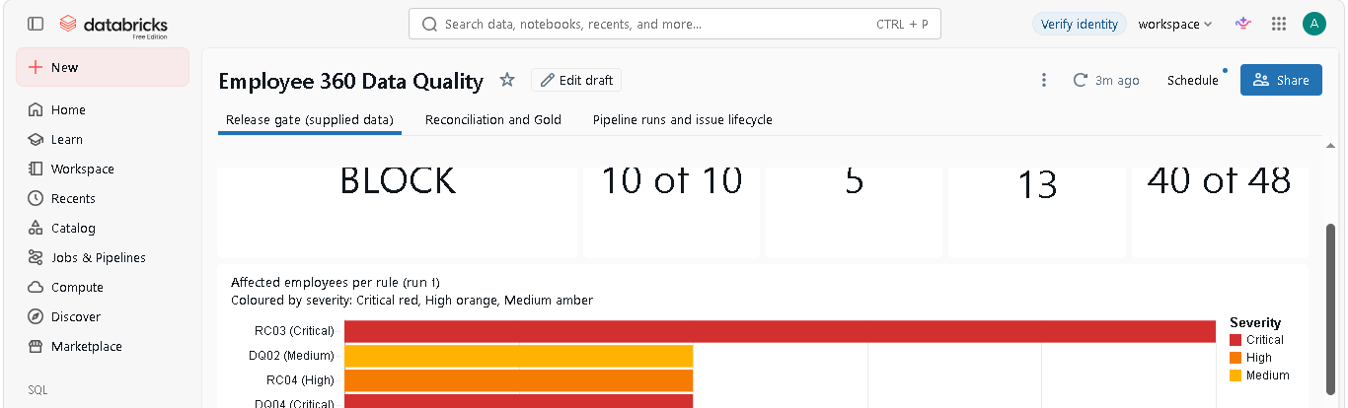
Figure 14. Dashboard page 1, Release gate: BLOCK, 10 of 10 rules failing, 5 blocking, 13 employees affected, 40 of 48 Gold records trusted; affected employees per rule by severity (cropped above a desktop notification that covered the lower chart). [Screen capture (candidate's browser)]
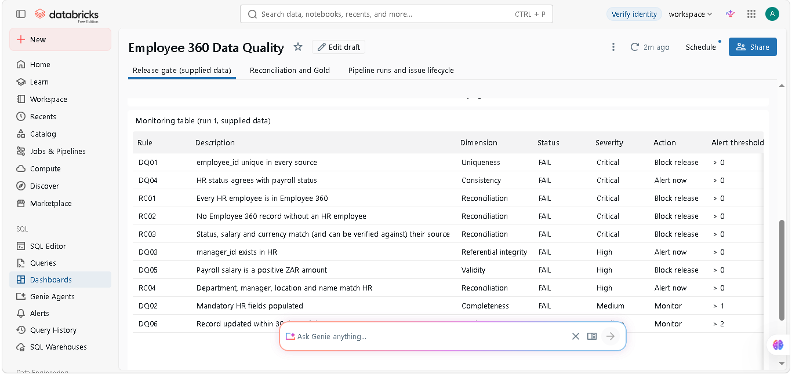
Figure 15. Dashboard page 1: the monitoring table for run 1 (supplied data), with severity, action and alert threshold. [Screen capture (candidate's browser)]
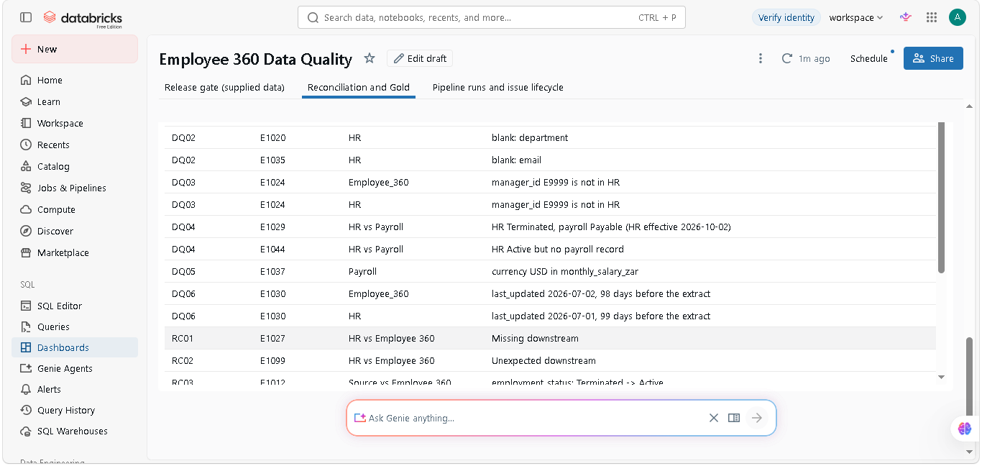
Figure 16. Dashboard page 2: failure detail by rule and employee. [Screen capture (candidate's browser)]
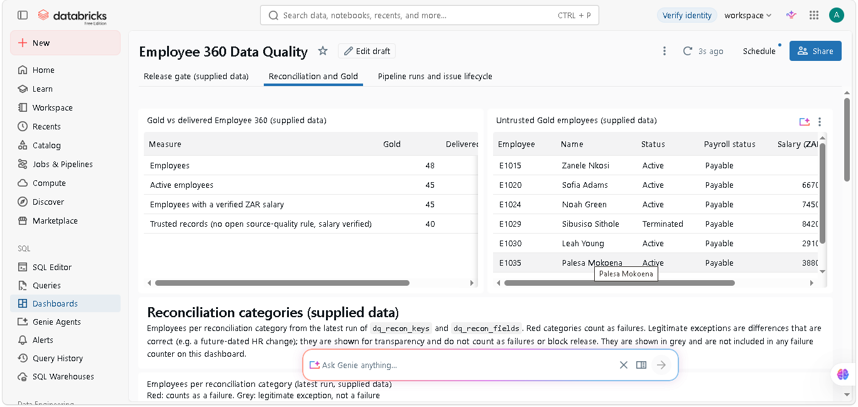
Figure 17. Dashboard page 2: Gold against the delivered Employee 360 (45 vs 46 active), and the untrusted Gold employees. [Screen capture (candidate's browser)]
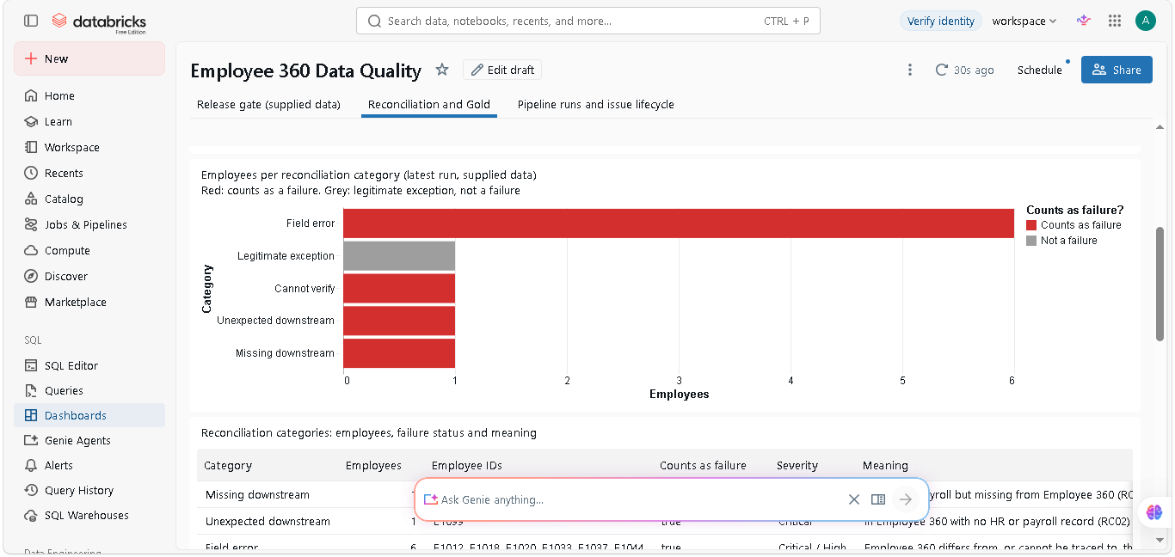
Figure 18. Dashboard page 2: employees per reconciliation category. The legitimate exception is grey and not counted as a failure. [Screen capture (candidate's browser)]

9. AI use
Answers AI use · tools and what they sped up; one suggestion corrected or rejected; how it was verified; commercial value
- Tools: Claude Code (Anthropic) drafted and ran the SQL, PySpark, runners and these notes; Codex (OpenAI) reviewed the branch independently. Judgement calls (what is an error, severity, ownership) were not delegated.
- Corrected: the first PySpark reconciliation used groupBy().agg(F.first()), which is non-deterministic in Spark and let E1015 pass silently because Employee 360 matched one of two conflicting salaries. The independent profile caught it; the fix takes values in file order and adds a Cannot verify class.
- Also corrected: a draft claim that the salary gap was under 0.3% (it is 2.6%, and the real story is net against gross); a QUALIFY clause that runs on Databricks but not on open-source Spark, rewritten so one SQL file runs in both.
- Verification: the independent plain-Python recomputation (10/10), the same code on Databricks and locally, and every finding traceable to an output file and employee ID.
- Commercial value: worth it for mechanical, checkable work (scaffolding, harness, drafts); no time saved on judgement, and some spent on verification, which the silent-pass example shows is necessary. With real client data, only a client-approved assistant inside the client's tenancy, or schemas and synthetic samples only.

Appendix A. Files, how to run, assumptions, limitations
Answers What to submit · SQL, PySpark and scripts in Git; outputs; README with run instructions, assumptions and limitations
Path | What it is
sql/00_staging.sql … 03_reconciliation.sql | Typed staging, profile, six checks, key and totals reconciliation
sql/10_silver_gold.sql | Silver and Gold layers
notebooks/employee360_dq.py | Databricks notebook: runs the SQL, PySpark reconcile_fields, monitoring, release gate
notebooks/employee360_incremental.py, employee360_medallion.py | Incremental Bronze load, issue lifecycle, Silver and Gold
run_local.py, run_incremental_local.py | Run the notebooks on local PySpark (+ Delta) and save outputs/
tests/check_expected.py | Independent plain-Python recomputation of every rule
outputs/*.csv, outputs/logs/ | Every result in this book, and the run logs
databricks.yml, azure-pipelines.yml | Bundle job and CI/CD pipeline (not executed: no Azure project available)
docs/, README.md | Notes, assumptions, limitations, video script

Run locally: pip install "pyspark==4.0.*" "delta-spark==4.0.*"; python run_local.py; python tests/check_expected.py; python run_incremental_local.py
- Assumptions: employee_id is the join key; HR owns status, manager, department, location; payroll owns salary, currency and payroll status; extract date 2026-10-08; stale = not updated in 30 days; future-dated = HR effective date after 31 October; CPT = Cape Town; payroll period 2026-09 is the latest for the October snapshot.
- Limitations: databricks.yml and azure-pipelines.yml were not executed; run 3 of the incremental demo uses a labelled simulated delivery; the root cause is a hypothesis until the crosswalk, Delta history and job logs are seen; at this size the row-level checks re-run on the full snapshot when anything changes.

Appendix B. Evidence index
Every image in this book, what kind it is and where it came from. Check any file with sha256sum <path>.
Fig. | File | Kind | Source | SHA-256 (first 16)
1 | term_checks.png | Rendered log | outputs/logs/run_local.log → ebook/captures/term_checks.txt | 66c3de0e6277c27f
2 | term_independent.png | Rendered log | outputs/logs/check_expected.log → ebook/captures/term_independent.txt | 04f926781b7db1b9
3 | term_counts.png | Rendered log | outputs/logs/run_local.log → ebook/captures/term_counts.txt | 6d2a8dfb6ad1f616
4 | chart_net_vs_gross.png | Chart from data | outputs/recon_salary_totals.csv | d0cb99d3f7de9695
5 | chart_monitoring.png | Chart from data | outputs/monitoring.csv | 5db3620a8b4b6ddc
6 | term_release.png | Rendered log | outputs/logs/run_local.log → ebook/captures/term_release.txt | 55f8010f10c23b0b
7 | diagram_pipeline.png | Generated diagram | ebook/pipeline.mmd | 74f2a7c92b02c2bf
8 | chart_issue_lifecycle.png | Chart from data | outputs/incremental_runs.csv | c07c3b8bc1084df0
9 | term_incremental.png | Rendered log | outputs/logs/run_incremental_local.log → ebook/captures/term_incremental.txt | 6d9d54ac51da5bf6
10 | databricks_run1_monitoring.png | Databricks run export (rendered, not a browser screenshot) | evidence/databricks_exports/ | 2d221abca7ae49fb
11 | databricks_run1_gold.png | Databricks run export (rendered, not a browser screenshot) | evidence/databricks_exports/ | 3732076c0519fe07
12 | databricks_run2_skipped.png | Databricks run export (rendered, not a browser screenshot) | evidence/databricks_exports/ | ff8036048942d98c
13 | databricks_run3_new_issues.png | Databricks run export (rendered, not a browser screenshot) | evidence/databricks_exports/ | f30e927f352ca320
14 | genuine_dashboard_1_counters_chart.png | Screen capture (candidate's browser) | evidence/dashboard_screenshots.md | a1a9709d7f57f7bd
15 | genuine_dashboard_1_rule_table.png | Screen capture (candidate's browser) | evidence/dashboard_screenshots.md | de3bf6a4978fe1d4
16 | genuine_dashboard_2_failure_detail.png | Screen capture (candidate's browser) | evidence/dashboard_screenshots.md | ab22abc5739663d4
17 | genuine_dashboard_2_gold.png | Screen capture (candidate's browser) | evidence/dashboard_screenshots.md | 6343696869d9ec59
18 | genuine_dashboard_2_recon_categories.png | Screen capture (candidate's browser) | evidence/dashboard_screenshots.md | f9ca9f27b6873532

