JSB Data Engineer
Practical Exercises — Candidate Submission
Payment reconciliation · Incremental API ingestion · Database design & reporting model
Tools used, end to end
MySQL 8.0 · MariaDB 10.11 (cross-verified) · Python 3.11 · dbt-core 1.7 (dbt-mysql) · Postman / Newman · Mermaid · Power BI (data model)
Every number in this document was produced by actually running the code and queries shown — not hand-typed. Evidence for each figure lives in the accompanying repository.

How to read this document
This document is the write-up for all three practical exercises. Each section states the scenario briefly, the approach taken, the tools used, and the evidence that it actually works — screenshots are captures of real runs, not mock-ups. Full source code, SQL, and raw evidence files accompany this document in the submitted repository (folder: candidate-assessment/).
A short note on assumptions: per the brief's instruction not to stop on ambiguity, every assumption made is written down at the point it's used, not buried — for example the definition of NGR used in Exercise 3, and the fee-rounding tolerance used in Exercise 1.

Contents
- Exercise 1 — Payment Gateway Reconciliation
- Exercise 2 — Incremental, Restartable API Ingestion
- Exercise 3 — Database Design: Players, Wallets, Bets, Bonuses
- Power BI — Reporting Data Model and Report

Exercise 1 — Payment Gateway Reconciliation
Finance Manager summary
Week 1–7 September 2026 (UTC) · NAD · internal_deposits (326 rows) vs gateway_settlement (306 rows)
274 of 306 gateway settlements (90%) match exactly on reference, gross, fee and net. The 49 differences are 34 genuine breaks, 6 timing differences and 9 that are not a problem (exceptions.csv). The bridge from our R218,280.00 to the gateway's R217,979.97 leaves R0.00 unexplained; its two timing lines are provisional (see assumptions).
Bridge on gross amounts: internal total → gateway total
Line | NAD
Internal SUCCESS deposits, total | 218,280.00
− Duplicate internal deposit rows (same settlement counted twice) | (1,300.00)
− Reversals / chargebacks (not in the gateway's SETTLED total) | (850.00)
− Deposits with no settlement yet (mid-week) | (2,700.00)
− Created in the last 15 min, not yet settled (provisional) | (3,650.00)
+ Settled in the first 15 min, no deposit this week (provisional) | 2,600.00
+ Settlements with no internal record | 2,900.00
+ Settled by the gateway but marked FAILED by us | 250.00
+ Duplicate gateway settlement rows | 1,550.00
+/− Gross amount differences with the gateway (net) | 900.00
+/− Rounding (exactly 1 cent on 3 rows) | (0.03)
= Gateway SETTLED total | 217,979.97
Residual (unexplained) | 0.00
Priority actions
When | Action | Owner | NAD
Today | Re-credit 2 players: marked FAILED by us, settled by the gateway | Payments | 250.00
Today | Get gateway detail for 4 unrecognised settlements (GW-000301 to 304) | Payments | 2,900.00
Week | Dispute 4 gross differences (3 players under-credited R950, 1 over R50) | Finance | 900.00 net
Week | Claim fee overcharges (4) and short-paid nets (2) | Finance | 7.75
Week | Did 2 duplicate settlements pay twice? Audit 3 duplicate deposits | Payments | 1,550 / 1,300
Week | Confirm the wallet debit for each of 3 reversals | Finance | 850.00
3 days | 5 deposits with no settlement: re-check next file, then escalate | Finance | 2,700.00
Material assumptions
- Timing lines are provisional: this week's files can't prove them. R3,650 (3 deposits created 23:54–23:55 on 7 Sep) should appear in the 8–14 Sep gateway file; R2,600 (3 settlements at 00:04–00:06 on 1 Sep, GW-000331 to 333) should match the 25–31 Aug internal file. Finance keeps all six open until matched; any unmatched item becomes a break.
- Fee = 2% of gross + R1.00, to the cent; any fee or net difference of 1 cent or more is flagged. Gross differences of exactly 1 cent (3 rows, R0.03) are treated as rounding, a materiality choice for Finance to confirm. Fee and net errors don't move gross, so they are actions, not bridge lines.

Supporting detail
Tools used: MySQL 8.0 for the schema, load and categorisation SQL; Python/pandas for the load script, CSV export and an independent cross-check of the bridge arithmetic.

Approach
Both source files were loaded as-is into MySQL. Matching between internal_deposits.gateway_ref and gateway_settlement.merchant_ref uses a normalised reference (upper-case, letters and digits only), because the gateway returns six of our references with different punctuation, case or spacing ("GW_000020", "GW000102", "gw-000196 ", " GW-000267 " and others). An exact-match join would misclassify those six clean matches as breaks.
Every internal SUCCESS deposit and every gateway settlement row is either a clean match or one of twelve exception types: a genuine break, a timing difference, a business event (reversal), or not a problem at all. The rules live in exercise1-reconciliation/sql/03_reconciliation.sql and are ported into a dbt model (fct_recon_exceptions) so they run on a schedule with tests attached. The checks follow the brief's contract exactly: fee = 2% of gross + R1.00 to the cent, and net = gross − fee. Boundary tests at 1, 2 and 3 cents (sql/06_threshold_fixtures.py) confirm that every fee or net difference of a cent or more is flagged.
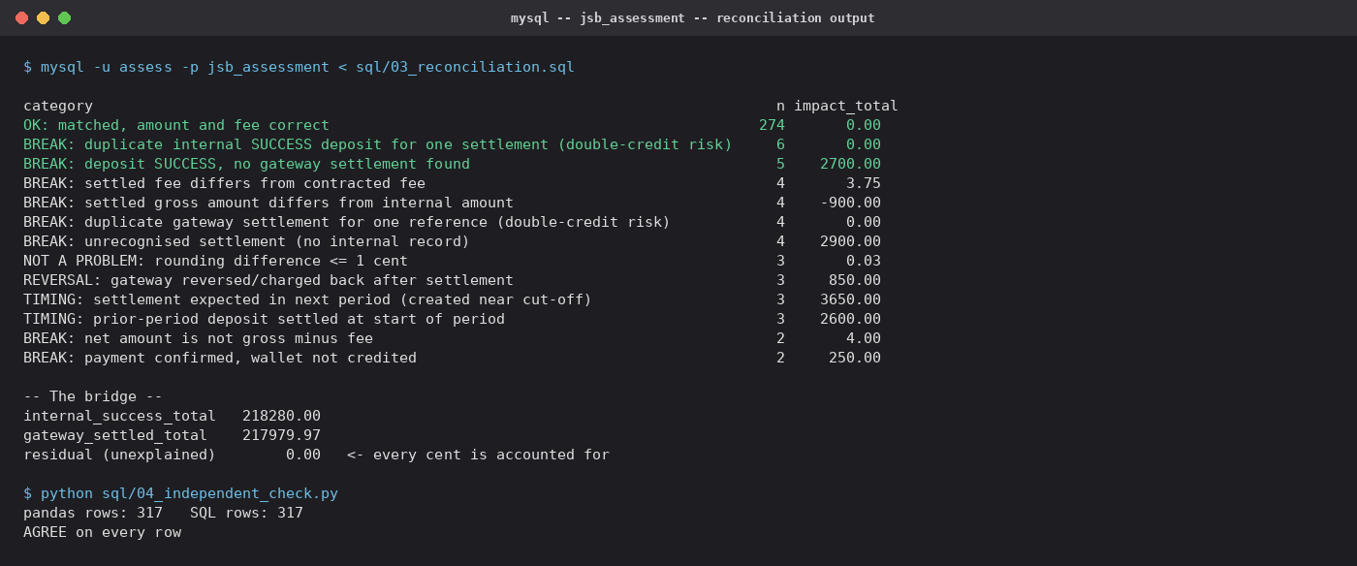
Actual output of sql/03_reconciliation.sql against MySQL 8.0, and of the independent row-by-row check.

Exceptions by category
Every one of the 49 rows in exceptions.csv carries exactly one classification, as the brief asks: genuine break (34), timing difference (6) or not a problem (9), plus a row-specific explanation, next step and owner. Reconciliation_Workbook.xlsx holds the same rows and the two raw files, with the bridge and category totals as live SUMIFS/COUNTIFS formulas that recalculate to a 0.00 residual.
Category | Classification | Rows | Impact (NAD)
Payment confirmed, wallet not credited | Genuine break — act today | 2 | 250.00 owed
Unrecognised settlement (no internal record) | Genuine break — act today | 4 | 2,900.00
Net amount is not gross minus fee | Genuine break — dispute | 2 | 4.00 short-paid
Settled fee differs from contract | Genuine break — dispute | 4 | 3.75 overcharged
Settled amount differs from internal amount | Genuine break — dispute | 4 | -900.00 (net)
Duplicate gateway settlement | Genuine break — dispute | 4 | 1,550.00*
Duplicate internal deposit | Genuine break — reverse credit | 6 | 1,300.00*
Reversal / chargeback | Genuine break — claw back | 3 | 850.00
Deposit SUCCESS, no settlement found | Genuine break — chase | 5 | 2,700.00
Created in the last 15 min (expected next week) | Timing difference | 3 | 3,650.00
Settled in the first 15 min (likely last week's) | Timing difference | 3 | 2,600.00
Rounding, exactly 1 cent | Not a problem | 3 | 0.03
Reference formatting differs (matched) | Not a problem | 6 | 0.00
* Amount carried by the duplicate row only; the original row in each pair is 0. Only SUCCESS deposits credit a wallet, so each duplicate internal deposit credited the player twice for one payment. A dbt test (assert_recon_bridge_reconciles) fails the build if the bridge residual is ever not exactly zero.

Assumptions
- Period 2026-09-01 00:00:00 to 2026-09-07 23:59:59 UTC inclusive; all times UTC; both files NAD only. Internal total = SUCCESS deposits; gateway total = SETTLED rows.
- References match after upper-casing and keeping only letters and digits. Fee = ROUND(2% × gross + 1.00, 2); any fee or net difference of 1 cent or more is a break; a gross difference of exactly 1 cent is rounding (Finance to confirm).
- Cut-off window of 15 minutes at each end. Settlements arrive 28 min after the deposit on median, 50 min at most, and the nearest unexplained items are 2 hours or more from either boundary, so the result doesn't depend on the window. The six timing items stay provisional until matched.
- Reversals are genuine breaks until the wallet debit is confirmed. For duplicates, the later row is the duplicate. The bridge is on gross, so fee and net errors are actions, not bridge lines. FAILED deposits with no settlement agree on both sides and aren't listed.

How the figures were checked
The categorisation was implemented three times: the MySQL script, the dbt model, and separately written pandas code (sql/04_independent_check.py) that works per deposit and per settlement instead of through a join. All three agree on all 317 rows individually, and on every category's count and rand total.
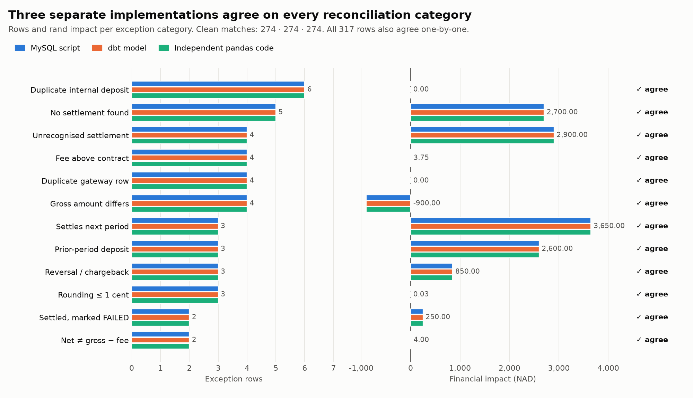
Three implementations, identical results in every category (sql/05_agreement_chart.py).
That check was added after an audit of an earlier draft found real problems, all now fixed. The draft had no test for net = gross − fee, which the brief requires, so it missed two short-paid settlements. It didn't quantify the fee overcharge. It counted four reference-formatting variants instead of six, because a case-insensitive database comparison hid three. It filed three start-of-week settlements as unrecognised money rather than timing. A later review by Codex found the fee check tolerated differences of up to 2 cents and a 2-cent gross difference could be labelled rounding; the rules are now exact, with boundary tests, and no figure changed. The bridge balanced throughout. The errors were in how the differences were labelled and summarised, which is why the categories are now cross-checked independently.

Automating this daily
- Land both feeds daily as-is, never overwriting, and log control totals (row count, sum) per source before matching. A source-declared-vs-received mismatch is itself an alert.
- Run the categorisation as a scheduled dbt model; persist history, never overwrite yesterday's result.
- Alert tiers: page immediately on "wallet not credited" or "unrecognised settlement"; same-day on new duplicates or disputes above a materiality threshold; daily digest for reversals and timing items still within the cut-off window.
- Ageing: unresolved after 3 days escalates to Finance management; unresolved after 7 days requires a signed-off write-off or credit note.

Exercise 2 — Incremental, Restartable API Ingestion
Tools used: Python 3 (standard library HTTP, plus pymysql), MySQL 8 / MariaDB for the target and control tables (the brief allows any database; this one also holds the other exercises and dbt), Postman/Newman for the API contract.

Design
- Progress: a checkpoint table holds the last (updated_at, id) fully committed. Each run resumes with updated_since = that time (inclusive, per the API doc) and pages with the server's cursor. The API moves updated_at forward when a record changes, so one position covers new and changed records.
- No duplicates: id is the primary key and every write is an upsert on it. Repeated rows within a page are collapsed; a record is written only if it is new or its updated_at moved forward, so an older version never overwrites a newer one. A page's rows, its rejects, the checkpoint and the run counters commit in one transaction, so a kill loses at most the uncommitted page, which the next run re-reads.
- Failures: 429 waits for Retry-After; 500 and network errors retry with 2, 4, 8… s backoff, then the run ends FAILED with exit code 1 and the checkpoint unchanged. A database lock stops two scheduled runs overlapping; a run killed mid-way is marked ABANDONED by the next.
- Unclean data: numbers sent as strings are coerced; records with a missing player_id, an unparseable amount or time, or a negative amount go to ingest_rejects with the reason and raw JSON, once per distinct payload. The run carries on.
- Monitoring: ingest_runs records, per run, pages, new / changed / unchanged / rejected rows, 429 and 500 counts, start and end time, status and any error; the checkpoint is the last successful position. checks.sql holds the monitoring and alert queries.

Evidence: kill, restart, new activity
demo.py reproduces the whole sequence on any machine, with the mock API's faults switched on. Run 1 uses 50-record pages and a pause before each commit, and is hard-killed while page 2 is uncommitted. Only page 1 (50 rows) is in the table; the restart marks run 1 ABANDONED, resumes from the checkpoint and loads the rest.
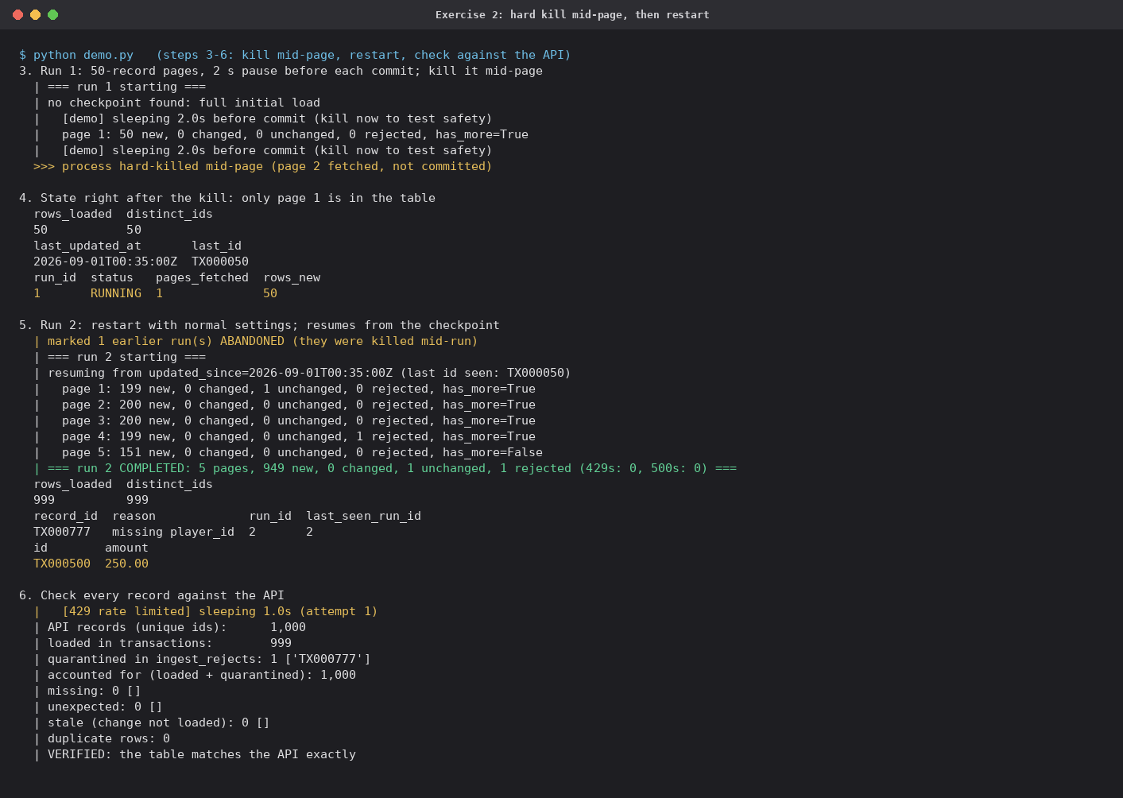
demo.py, steps 3–6: hard kill mid-page, restart from the checkpoint, check every id against the API.
Run 3, straight after, finds nothing new or changed. After the interviewer's step (POST /admin/advance), run 4 loads exactly the 25 new and 40 changed records. verify_against_api.py then reads the whole API and compares id by id: 1,025 ids = 1,024 loaded + 1 quarantined (TX000777, missing player_id), with 0 missing, 0 stale versions and 0 duplicates. A live 500 and a 429 were retried along the way.
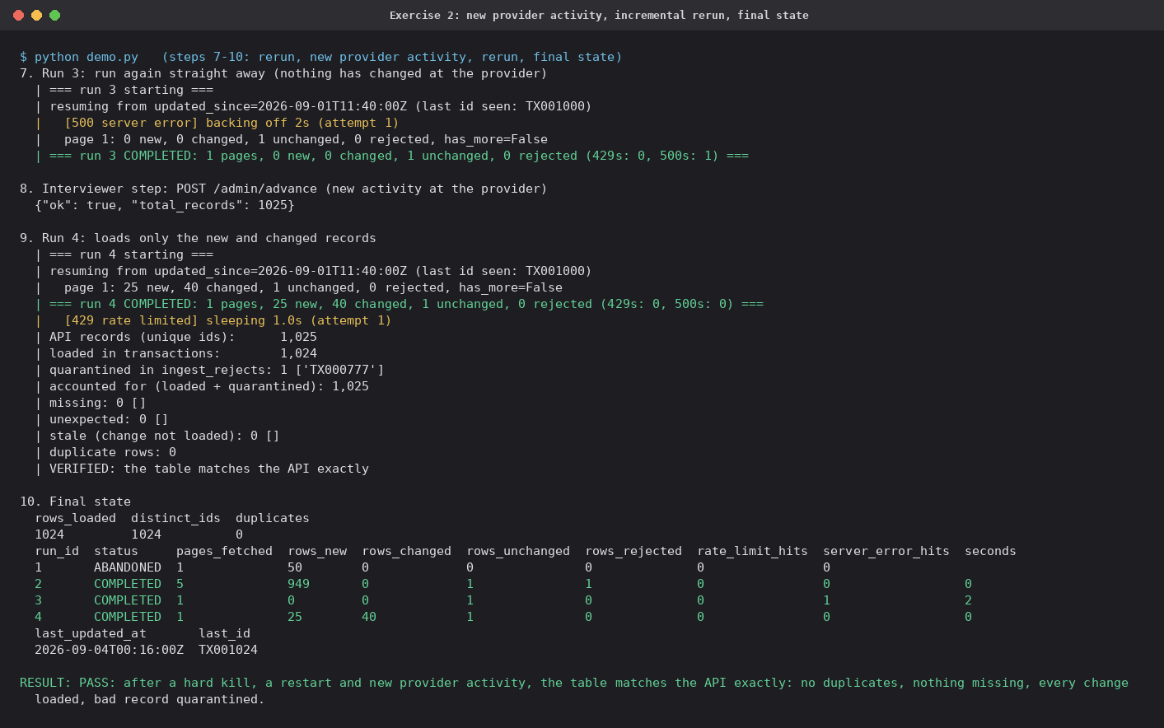
demo.py, steps 7–10: rerun, new provider activity, incremental rerun, final state.
The load continues incrementally into the reporting layer: the dbt model fct_api_transactions picks up only rows the ingestion stamped since its last run. incremental_demo.py shows 999 rows on the first build, 0 on a rerun, and exactly the 65 new and changed rows after the new activity, with the mart then equal to the source.

Checks and tests
- checks.sql: duplicates, reject accounting, run history, stale or failed runs, and the last successful position.
- verify_against_api.py: every id in the table against the API (missing, unexpected, stale, duplicates); exits 1 on any mismatch.
- 9 unit tests with no network or database: exit codes (401, exhausted 429 and 500 retries, success), the run lock, validation of unclean records, and the new / changed / unchanged classification.

API contract — Postman
A Postman collection documents the API's pagination, filtering, auth and admin-simulation behaviour, and includes a self-paginating request that walks every page and reports the total record count.
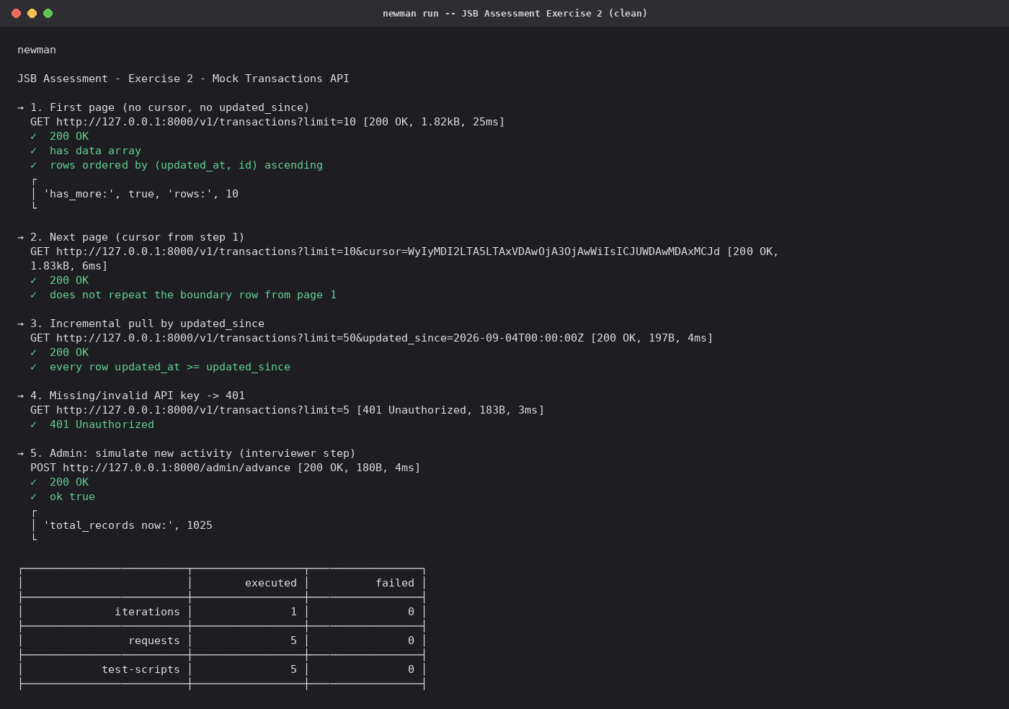
Newman run of the Exercise 2 collection.

Live run — Postman Desktop against the local mock API
The same collection was run in Postman Desktop on a Windows workstation against mock_api.py started from PyCharm, an independent environment from the one the code was built in.
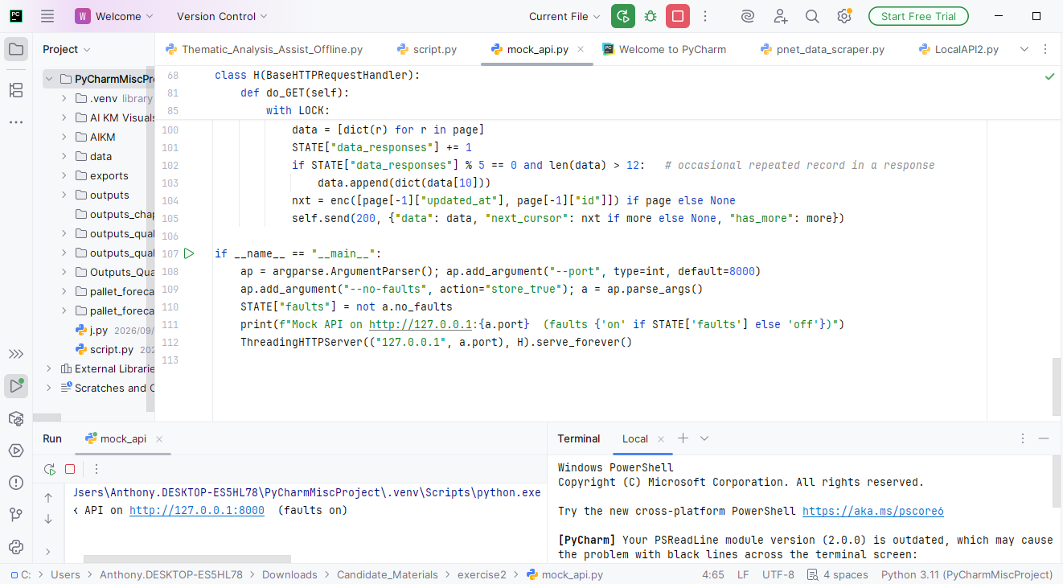
mock_api.py running in PyCharm: "Mock API on http://127.0.0.1:8000 (faults on)".
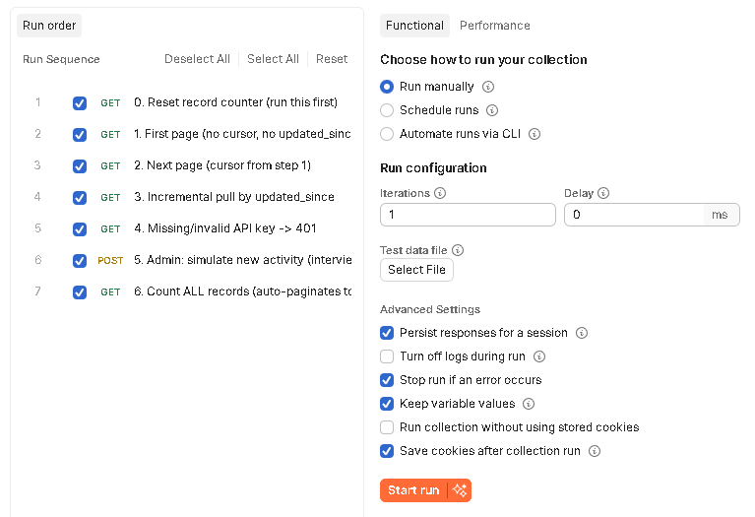
Collection Runner configuration: all seven requests, one iteration.
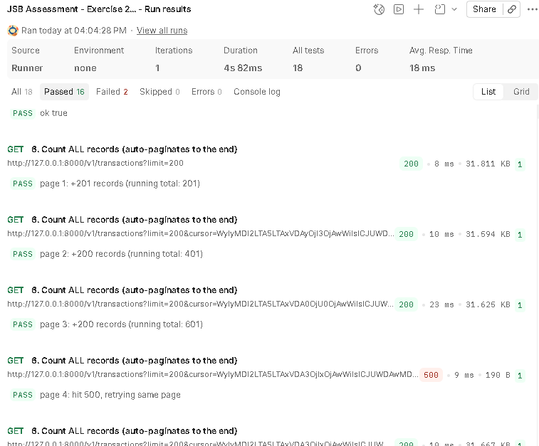
Runner results, pages 1–4 of the self-paginating count. Page 1 returns 201 rows for limit=200 (an in-page repeated row); page 4 hits a live 500 and retries the same page.
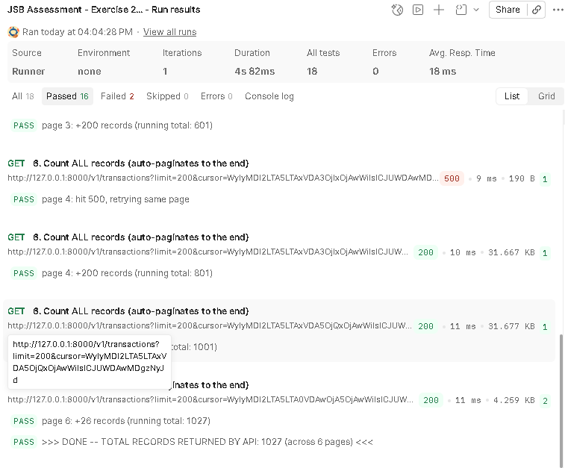
Runner results, pages 4–6: DONE — total rows returned by the API: 1,027 across 6 pages.
Two assertions fail on request 2 ("Next page"), a one-shot documentation request with no retry logic that happened to land on an injected 429; only the counting request retries. 1,027 rather than 1,025 because the raw count includes the API's in-page repeated rows, which ingest.py collapses.

What I'd change for production
- Scheduling: Airflow or cron every few minutes; the lock already makes overlapping runs harmless.
- Alerting: page on a non-zero exit code, a run stuck RUNNING past one interval, a rising reject rate, or checkpoint lag.
- Secrets: the API key and database password come from environment variables today; in production, from a secrets manager.
- Scale: bulk-load each page into a staging table and MERGE; partition by date; split id ranges across workers if the rate limit becomes the bottleneck.

Exercise 3 — Database Design: Players, Wallets, Bets, Bonuses
Tools used: MySQL 8.0 for the schema (cross-verified against MariaDB 10.11), Mermaid for the ERD, dbt for the reporting-model mapping.

Entity-relationship diagram
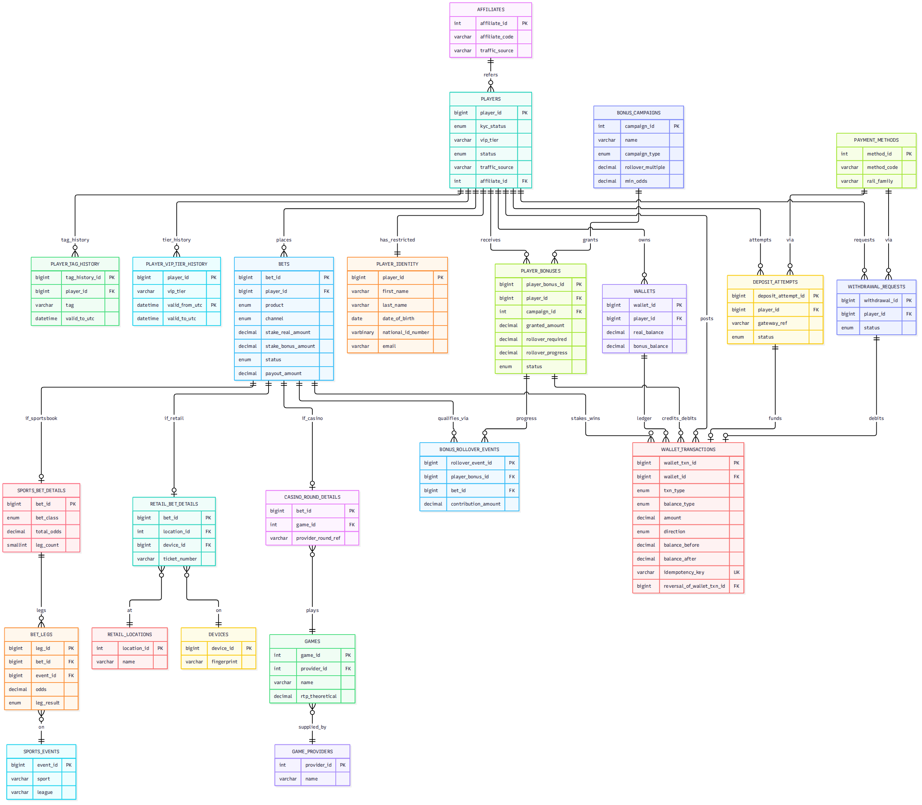
23-table operational schema — full DDL in exercise3-schema-design/ddl.sql, verified to run clean on both MySQL 8.0 and MariaDB 10.11.

Design principles

Money and time
DECIMAL(18,4) everywhere a balance or amount is stored — never FLOAT/DOUBLE. DATETIME(6), always UTC, columns suffixed _at_utc; MySQL's TIMESTAMP is deliberately avoided because it silently converts using the session/server time zone.

Balance correctness
wallets.real_balance / bonus_balance are a materialised cache, not the source of truth — wallet_transactions (an append-only ledger) is. A balance at any point in time is SUM(credit) − SUM(debit) up to that moment, proven directly by example query (c) below. Corrections and reversals are new rows referencing the original (reversal_of_wallet_txn_id), never edits; every row carries a deterministic idempotency_key so replaying an event can never double-post it. A dbt test (assert_wallet_cache_matches_ledger) fails the build if the cache ever disagrees with the ledger.

History over time
player_vip_tier_history and player_tag_history are SCD Type 2 (a new row per change, valid_from/valid_to), so "what tier was this player on 3 September" is answerable, not just "what tier are they now".

Protecting personal information
player_identity is a separate table, joined only by player_id — every other table (bets, wallet transactions, bonuses) never sees a name or ID number. In production: application-layer encryption on sensitive fields, a dedicated low-privilege DB role, and every read of the identity table logged.

The four required queries — verified output
Run against the seed data in exercise3-schema-design/seed.sql; identical results on MySQL 8.0 and MariaDB 10.11.
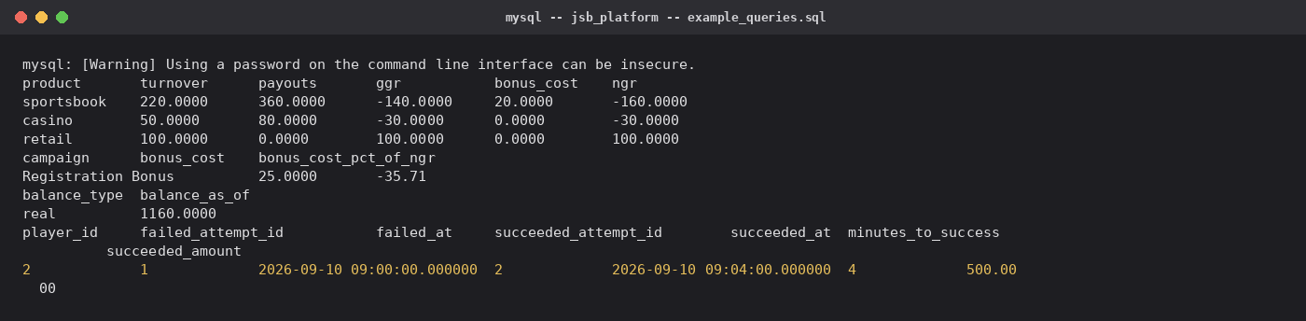
mysql -- jsb_platform -- example_queries.sql
Query | Result
(a) NGR by product for a month | sportsbook -160.00 · casino -30.00 · retail 100.00 (NAD)
(b) Bonus cost as % of NGR, by campaign | Registration Bonus: -27.78% (matches the dbt mart's independently-computed figure exactly)
(c) A player's balance at a given date/time | Reconstructed purely from the ledger (SUM), not a stored column — proves the design
(d) Deposits that failed, then later succeeded | Self-join on deposit_attempts finds the failed→success pair, 4 minutes apart

Operational design → reporting model
A dbt project (dbt_jsb_assessment/) builds a star schema on top of this operational design: conformed dimensions (dim_player, dim_date, dim_campaign — dim_player_vip_tier_scd carries the same Type-2 history pattern through to the reporting layer) surrounding grain-specific facts (fact_bet, fact_wallet_transaction, fact_bonus_transaction). Two reusable marts answer queries (a) and (b) directly, and — extended during this review — the project now also covers Exercise 1's reconciliation as a scheduled, tested model.
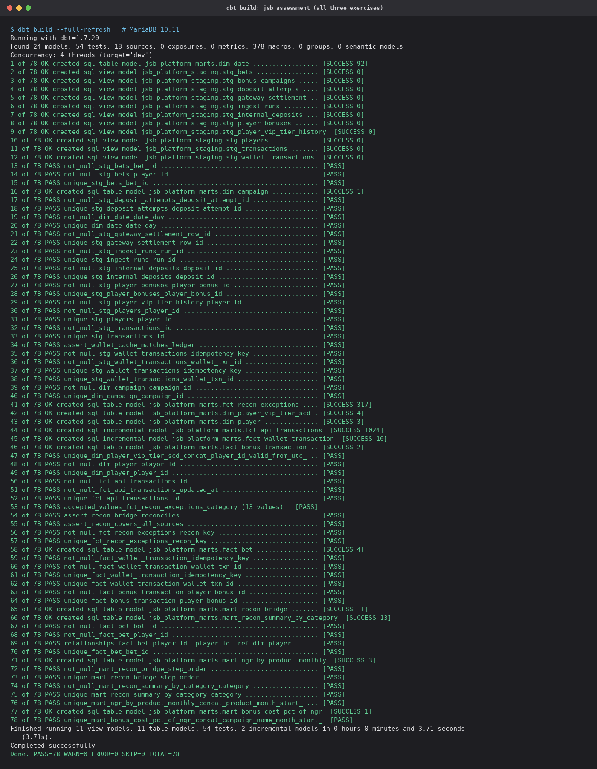
dbt build across all three exercises: 78/78 pass (24 models, 54 tests), 0 errors. Every mart has a primary key; two models load incrementally.

Power BI — Reporting Data Model and Report
Tools used: Power BI project format (.pbip), generated by a Python script from one set of definitions, with the dbt marts embedded as data.
The dbt marts become a Power BI project, JSB_Assessment.pbip, covering all three exercises. The semantic model has 11 tables, 7 relationships and 28 DAX measures (22 calculations and 6 colour rules for the KPI tiles), and the report has four pages. The data is embedded in the project, so it opens and refreshes on any machine with no folder path or database connection to set up. The same script writes the model, the report pages, the readable DAX file and a list of expected values, then validates them, so the four cannot drift apart.
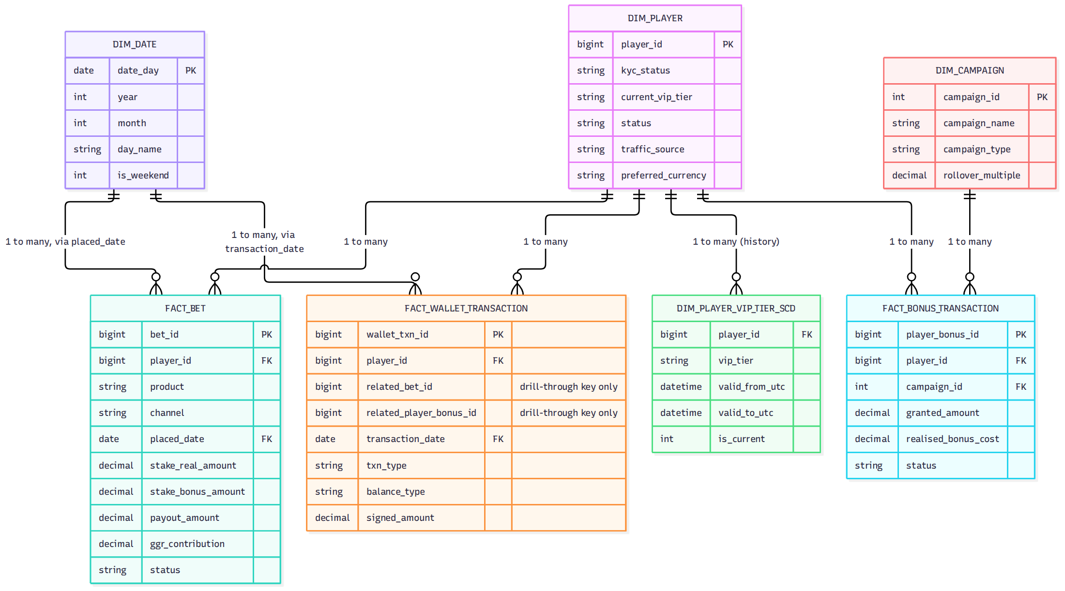
Power BI model view for Exercise 3: three dimensions filter three facts. Facts are not joined to each other.

Modelling decisions worth calling out
- Facts are not joined to facts. fact_wallet_transaction keeps related_bet_id and related_player_bonus_id as drill-through keys only. Relating them would give dim_player two filter paths to the wallet table. Power BI rejects that as an ambiguous model, and in any tool it is a source of silently wrong numbers. The build script checks every pair of tables and refuses to build if any pair has more than one path.
- Money is fixed decimal (Currency.Type, 4 dp, matching DECIMAL(18,4)), and the CSVs are parsed with en-US culture. A South African regional setting, which uses a comma as the decimal separator, therefore can't misread 200.0000.
- The Exercise 1 and 2 tables (fct_recon_exceptions, mart_recon_bridge, ingest_runs, transactions) stand alone. They share no keys with the player model, so they have no relationships to it, and a filter on one page can't leak into another.

Measures
Measure | Definition
GGR | Stakes − payouts on settled (won/lost) bets
Bonus Cost (realised) | Bonus money staked on bets that lost
NGR | GGR − Bonus Cost (realised) — query (a)
Campaign Bonus Cost / % of NGR | Granted amount of resolved bonuses, ÷ total NGR — query (b)
Bonus Liability Outstanding | Granted amount of bonuses still active: owed, not yet a cost
Balance as of selected date | Sum of the ledger up to the last date in the date filter — query (c)
Settlements Matched Exactly / Exceptions | Counts of OK rows and of every other category in fct_recon_exceptions
Act Now Value | Impact of the two act-now categories: settled but marked FAILED, and unrecognised settlements
Bridge Amount / Bridge Residual | Sum of the bridge steps; residual = gateway total − steps, which must be 0.00
Transactions Loaded / Runs / Rows Rejected / Retries | Exercise 2's loaded rows and run log

Report pages and expected values
- NGR overview (Ex. 3): GGR, realised bonus cost, NGR and bonus liability cards; GGR vs NGR by product; bonus cost as a percentage of NGR by campaign.
- Player balances (Ex. 3): a date slicer, deposits, and each player's balance rebuilt from the ledger as of the slicer's end date.
- Reconciliation (Ex. 1): headline cards, the bridge as a waterfall from the internal total to the gateway total, exceptions by category, and a detail table.
- Ingestion monitoring (Ex. 2): loaded rows, runs, rejected rows and rate-limit retries; the run history, including the run killed mid-page; transactions by status.
Each value below was computed from the CSVs with pandas, independently of the DAX, and matches the MySQL, MariaDB and dbt results. The full list is in powerbi/expected_values.md.
Visual | Expected value
GGR / Bonus Cost (realised) / NGR | -70.00 / 20.00 / -90.00
NGR by product | sportsbook -160.00 · casino -30.00 · retail 100.00
Registration Bonus: cost / % of NGR | 25.00 / -27.78%
Player 1 balance, slicer ending 2026-09-06 | 1,160.00 (real)
Balances, full date range | Player 1: 1,190.00 · Player 2: 400.00 · Player 3: 100.00 real + 30.00 bonus
Settlements matched exactly / exceptions | 274 / 43
Act Now Value / Bridge Residual | 3,150.00 / 0.00
Waterfall | 218,280.00 → 217,979.97 in 10 adjustment steps
Transactions loaded / runs / rows rejected / API retries | 1,024 / 4 / 1 / 1
Transactions by status | completed 587 · failed 214 · pending 207 · reversed 16

How it was verified
Power BI Desktop doesn't run in the Linux environment this was built in. Instead, the build script checks that every visual field, sort and DAX reference resolves to the model, that every CSV's columns match the model, that every relationship column exists, and that no filter path is ambiguous. A negative test confirmed it rejects an ambiguous relationship and a misspelled measure. The report layout follows the supplied Demo.pbix (Power BI Desktop 2.130, CY24SU06 theme).
Power BI Desktop has since opened an earlier version of this project on a Windows machine: the pages and visuals loaded. The one failure was that the data folder path didn't exist on that machine, and embedding the data removes that step. If Desktop objects to the project for any other reason, powerbi/README.md gives a five-minute manual route to build the same model in Demo.pbix.
Building this layer also caught a real defect upstream. The seed data's wallet balance cache didn't match its own ledger, breaking the rule that the ledger is the truth. The seed was fixed, and a dbt test (assert_wallet_cache_matches_ledger) now fails the build if the two ever diverge. The test failed on the old data and passes on the corrected data.

