FILE / IT & DATA MANAGER / TSHIAMISO TRUST / PARKTOWN, JHB
A Claimant-Intelligence Platform
for Tshiamiso Trust
A solution proposal for the IT & Data Manager role. Turning silicosis and TB compensation data into found claimants, defensible payments, and a governed system trustees can run with confidence.

PREPARED BY Anthony Apollis
CURRENT ROLE Data Engineer & Analyst, On the Spot
REPORTS TO (PROPOSED) Chief Executive Officer
CONTACT anthony.apollis@gmail.com
DATE July 2026

Executive Summary
Tshiamiso Trust's mandate is compensating ex-gold mineworkers and dependants affected by silicosis and occupational TB. It is not blocked by medicine or funding. It is blocked by findability. Thousands of eligible people are hard to locate because employment, medical and identity records live in disconnected systems, and outreach without matching wastes field time chasing people already paid, already deceased with no traced dependant, or duplicated across source systems.
This proposal sets out how the IT & Data Manager role closes that gap through an insight-driven operating model: executive dashboard first, then claimant tracing, compensation logic, spatial intelligence, zero-trust controls, vendor governance and delivery sequencing. It is written so the reader always knows what the data says, why it matters, when to act and what decision it supports.
It closes with how this maps against the role's five Key Performance Areas, the candidate's track record building comparable systems, and a fourteen-year data career applied directly to the Trust's hardest operational problem.

01 THE CHALLENGE

The hardest claim isn't the one filed. It's the one nobody filed.
Many eligible ex-mineworkers or their families are hard to find because they moved to rural former labour-sending areas or neighbouring countries, changed contact numbers, or passed away without their families knowing a claim exists.

Why they go missing
Mine employment records, TEBA archives, ID data and medical files sit in different systems with inconsistent name spellings, mine numbers and dates. A person who worked under three different mine numbers across two provinces doesn't look like one claimant. They look like three partial ones.

Why it is a data problem before it is an outreach problem
Outreach without matching wastes field time. The Trust needs to know where to look before it decides how to reach, which means resolving identity across sources is the first engineering problem, not a side task.

02 CLAIMANT PIPELINE: CURRENT STATE

What the Trust's own public figures already show
All 8 stages of the Trust's own Progress Report, tshiamisotrust.com, 15 July 2026.
Stage | Cumulative total | Latest-day change
Contact Made | 53,945 | +21
Registrations | 414,885 | +127
Appointments | 191,592 | +35
Lodgements | 162,541 | +116
BMEs | 81,903 | +6
MCPs | 119,555 | +278
Final TCCs | 28,655 | +36
Claims Paid | 28,060 | +12

This isn't one straight pipeline. Registrations (414,885) run far ahead of Contact Made (53,945), and Appointments exceed Lodgements. These are 8 process counters with different denominators. The MCP-vs-BME question has a real answer: the Trust's own medical eligibility breakdown shows 119,555 MCP decisions splitting into 31,375 eligible, 78,144 ineligible and 9,401 deferred. MCP counts decisions, including historical-TB cases that skip a fresh BME.
Total paid to date: R2.73 billion. The homepage banner still reads 'over R2.5 billion,' a stale hardcoded figure beside a live one, exactly the kind of inconsistency a monthly data QA pass is built to catch. Only 26% of MCP decisions come back medically eligible. Screening yield is its own KPI. Certified-but-unpaid backlog: 595 cases, and Section 06 shows it's growing, not shrinking.
Source: tshiamisotrust.com/information/progress-report/, 15 July 2026. Full interactive version: companion Excel workbook, 'KPI Dashboard' tab.

03 WHY THIS TRUST EXISTS

The 500,000-strong workforce this Trust was built to compensate
The claimant-location problem in Section 01 isn't a data accident. It's the direct legacy of how the gold industry recruited and housed its labour for most of a century.

How the labour system worked
Gold was discovered on the Witwatersrand in 1886. To staff it, the mines built two recruiting networks: the Witwatersrand Native Labour Association (WNLA, 'Wenela,' est. 1900) drawing from Mozambique and further afield, and the Native Recruiting Corporation (NRC) drawing from Basutoland (Lesotho), Bechuanaland (Botswana), Swaziland (Eswatini) and South Africa itself. The two merged in 1977 into TEBA, The Employment Bureau of Africa, the same archive this proposal's matching pipeline depends on.
Workers signed annual contracts and lived in single-sex hostel compounds. Over 97% of a roughly 500,000-strong workforce were cut off from family for the length of each contract, then rotated home before the next one. By the 1970s, about 70% of gold-mine labour was foreign-born. That oscillation between mine hostel and rural homestead is precisely why claimants and their descendants are hardest to find in exactly the regions that supplied the labour. The regional rankings in Section 06 aren't arbitrary, they're the recruitment map, inverted.

Why the disease burden is what it is
Autopsy studies of South African gold miners found silicosis prevalence rising from roughly 3% (Black miners) and 18% (white miners) in 1975 to 32% and 22% respectively by 2007, and in miners with around 40 years of dust exposure, silicosis was found in up to 52% at autopsy.
Tuberculosis followed the same exposure. South African gold-mine TB incidence has run at roughly 3,000 to 7,000 cases per 100,000 workers a year, against a South African national average of 981 and a global average of 128 per 100,000, more than ten times the World Health Organization's emergency threshold of 250 per 100,000. Rates peaked above 4,000 per 100,000 in 1999, compounded by HIV co-infection running near 29% in the mine workforce by 2001. Silica dust independently raises TB risk, which is exactly why the Trust compensates the two diseases under one scheme rather than two.
Metric | Figure
Silicosis at autopsy, 1975 to 2007 | 3% to 32% (Black); 18% to 22% (white)
Silicosis at ~40 yrs dust exposure | Up to 52% at autopsy
SA gold-mine TB incidence | 3,000-7,000 / 100,000 / year
SA national vs. global TB | 981 / 100,000 vs. 128 / 100,000
WHO emergency threshold | 250 / 100,000, mines run 10x+ this
Peak SA gold-mine TB rate | >4,000 / 100,000 (1999), ~29% HIV co-infection by 2001

The settlement itself: on 26 July 2019 the High Court approved a R5 billion class-action settlement across six major mining groups (African Rainbow Minerals, Anglo American SA, AngloGold Ashanti, Gold Fields, Harmony, Sibanye-Stillwater), covering mine service between 12 March 1965 and 10 December 2019, disbursed over 12 years through the Trust, whose name, Tshiamiso, means 'to make good' in Setswana. The 2026 schedule in Section 04 is that same benefit, escalated for inflation since the original 2019 base amounts (Class 2 silicosis opened at R150,000; it is R180,059.28 now).
Sources: Nelson et al., 'Three Decades of Silicosis: Disease Trends at Autopsy in South African Gold Miners' (Environmental Health Perspectives, via PMC); Stuckler et al. and World Bank/Results UK reporting on TB in Southern African mining; Oxford Human Rights Hub and GroundUp reporting on the 2019 Tshiamiso settlement; South African History Online and Heritage Portal on WNLA/NRC/TEBA and the compound system.

04 COMPENSATION SCHEDULE: 1 FEB 2026 TO 31 JAN 2027

Disease classes and maximum benefit
Every downstream system depends on this schedule. The certified class sets both the payment ceiling and which data fields matter for verification.
Class | Certification meaning | Maximum (gross)
Silicosis Class 1 | Early silicosis, lung impairment up to 10% | R84,027.66
Silicosis Class 2 | Equivalent to 1st degree silicosis | R180,059.28
Silicosis Class 3 | Equivalent to 2nd degree silicosis | R300,098.80
Silicosis Special Award | Extraordinary, severe disease conditions | R600,197.60
Dependant Silicosis A | Deceased worker, silicosis primary cause of death | R84,027.66
Dependant Silicosis B | Deceased worker had a Class 2 or 3 condition | R120,039.52
TB 1st Degree | Qualifying underground work + 1st degree TB | R60,019.76
TB 2nd Degree | Qualifying underground work + 2nd degree TB | R120,039.52
Historical TB | Older certificate, usually 1965-1994 | R12,003.95+
Dependant TB | Deceased worker, TB primary cause of death | R120,039.52

Source: Tshiamiso Trust published compensation classes, 2026 schedule.

Calculation logic
final payment = gross benefit - (gross benefit x work-history reduction %) - tax
Reductions apply for risk work at qualifying mines outside the qualifying period, at non-qualifying gold mines, or for TB, at non-qualifying mines such as coal or platinum. Example: Silicosis Class 2 (R180,059.28) with 3 of 10 risk-work years outside the qualifying period gives a 30% reduction, approximately R126,041.50 before tax.
Exception the platform must encode as a rule, not a manual override: 30+ years of risk work at qualifying gold mines during qualifying periods waives the reduction entirely. The full class amount is paid.

05 PROPOSED BUILD

A claimant intelligence layer, sitting above the claims system
Not a replacement for case management. A governed data layer turning scattered mine, medical, call-centre and geographic records into a ranked list of who to find next.
Stage | Function | Detail
Ingest | Legacy & source data | Mine employment history, TEBA archives, medical exam status, call-centre logs, death registrations.
Match & clean | Identity resolution | ID number, mine number, surname variants, DOB and employer fuzzy-matched. Uncertain matches flagged for human review, never auto-merged.
Locate | GIS mapping | Uncontacted claimants plotted by province, district and former labour-sending village to target field teams.
Engage | Outreach automation | SMS/WhatsApp/call-centre workflows with every attempt and failure reason logged, routed through chiefs, clinics, churches, pension pay-points.
Report | Executive dashboards | Claims registered vs. paid, bottlenecks, regional outreach yield, unresolved-document exceptions, for the CEO and Board.

Questions it must answer on demand
- Who is eligible but not yet contacted?
- Which regions carry the highest unresolved caseload?
- Which claimants are stuck on missing documents or missed medical exams?
- Where should the next outreach trip go?

Geo intelligence: the travel-distance layer behind the map
Beyond ranking which region to prioritise, the platform answers the field team's next question: how far is that outreach trip, actually. Great-circle (haversine) distance is computed from real coordinates for historical gold-mining hubs, labour-sending centres and Trust/service sites. In the HTML proposal, this is now a multi-purpose bounded map: one layer shows worker migration from home areas to mine hubs, another shows return/family tracing back to communities, another shows outreach distance corridors, and the user can toggle hubs, labour centres and Trust/service sites while switching between street and satellite imagery.
Labour-sending centre | Nearest gold-mining hub | Great-circle distance
Mbabane, Eswatini | Barberton | 58 km
Maseru, Lesotho | Welkom (Free State Goldfields) | 166 km
Maputo, Mozambique | Barberton | 154 km
Polokwane, Limpopo | Barberton | 263 km
Mthatha, Eastern Cape | Welkom (Free State Goldfields) | 448 km
Durban, KwaZulu-Natal | Barberton | 452 km

Reading it operationally: the map separates three decisions that often get confused. Migration routes explain how workers reached the mines; return-tracing routes explain where sick workers, retired workers or dependants may now be located; outreach corridors turn that history into field-team travel priorities. An Mbabane-based tracing/outreach trip sits under an hour from Barberton by straight-line distance, while Mthatha or Durban requires a multi-day field plan.

06 REGIONAL INTELLIGENCE, GIS & MACHINE LEARNING

The Trust already publishes the data this needs. Nobody has run the numbers.
Everything below runs on the Trust's own published Progress Report (15 July 2026). A real regional table, real correlation, real clustering, a real spatial nearest-neighbor test on 17 named Trust sites, and a real trend projection.
Region | Lodgements | Payments | Conversion | ML Cluster
Eastern Cape | 36,503 | 6,405 | 17.5% | Anchor (high volume)
Lesotho | 57,565 | 10,633 | 18.5% | Anchor (high volume)
Free State | 17,195 | 2,651 | 15.4% | Emerging (mid volume)
Mozambique | 11,739 | 1,833 | 15.6% | Emerging (mid volume)
North West | 9,270 | 1,395 | 15.0% | Emerging (mid volume)
Gauteng | 7,095 | 739 | 10.4% | Emerging (mid volume)
eSwatini | 6,681 | 1,426 | 21.3% | Emerging (mid volume)
KwaZulu-Natal | 6,283 | 558 | 8.9% | Emerging (mid volume)
Botswana | 5,961 | 1,975 | 33.1% | Small / early-stage
Zimbabwe | 834 | 0 | 0.0% | Stalled: needs intervention
Malawi | 0 | 0 | n/a | Stalled: needs intervention

Source: tshiamisotrust.com/information/progress-report/, 15 July 2026. Full 16-region table: companion Excel workbook, 'Regional Data (Real)' tab. Interactive multi-purpose map views: companion HTML proposal, with static fallbacks retained for offline review.
Real validation, not coincidence: this analysis independently ranks Lesotho and Eastern Cape as the two anchor regions, and the Trust's own newsroom currently features a 'historic R1 billion in compensation for Basotho ex-mineworkers' announcement from Maseru, plus an 'expanded outreach campaign for KZN ex-gold miners,' matching this model flagging KwaZulu-Natal's 8.9% conversion rate as one of the weakest of any mid-volume region.

Correlation: what actually moves with what
Lodgements, BMEs, payments and Rand value are almost perfectly correlated (r of 0.96 to 1.00). Unsurprising, bigger regions have more of everything. The useful signal: conversion rate barely correlates with volume (r of 0.25 to 0.33). Being a large region doesn't make it efficient.
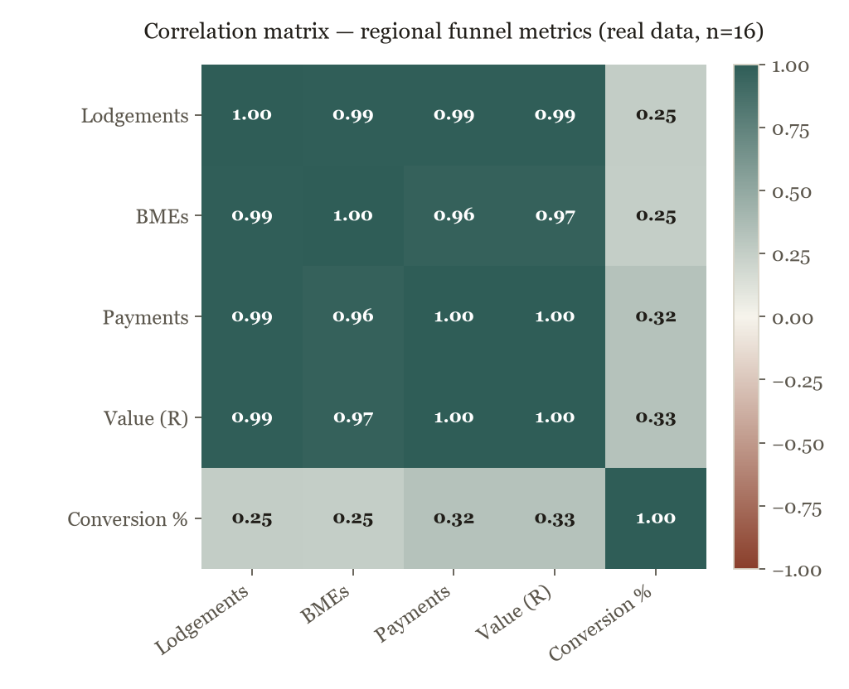

Clustering: four groups, one k-means model
K-means on standardised lodgement volume, conversion rate and value-per-payment splits 15 regions into four operational groups. Botswana is the highest-conversion region at any real volume (33.1%), worth studying as a best-practice site. Zimbabwe is the clearest red flag: 834 real lodgements, zero payments to date.
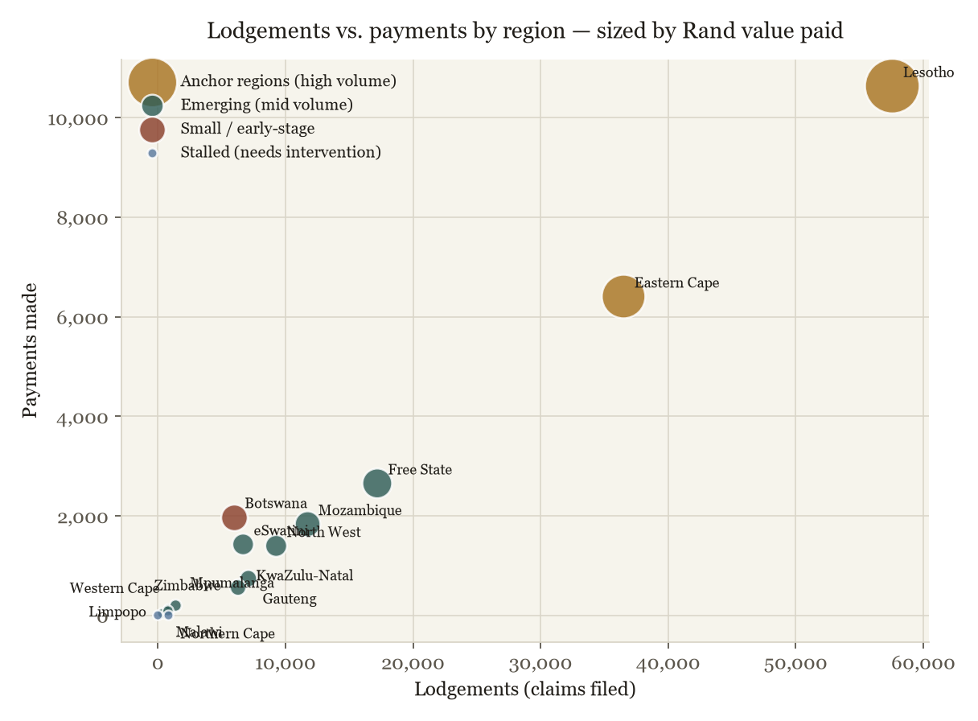

Prediction: where the backlog goes if nothing changes
Final certifications (TCCs) are growing at +36/day. Payments are growing at only +12/day. That net +24/day gap is a straight-line trend from the site's own live counters, no assumptions. At the current rate, a 595-case backlog becomes roughly 2,755 within 90 days.
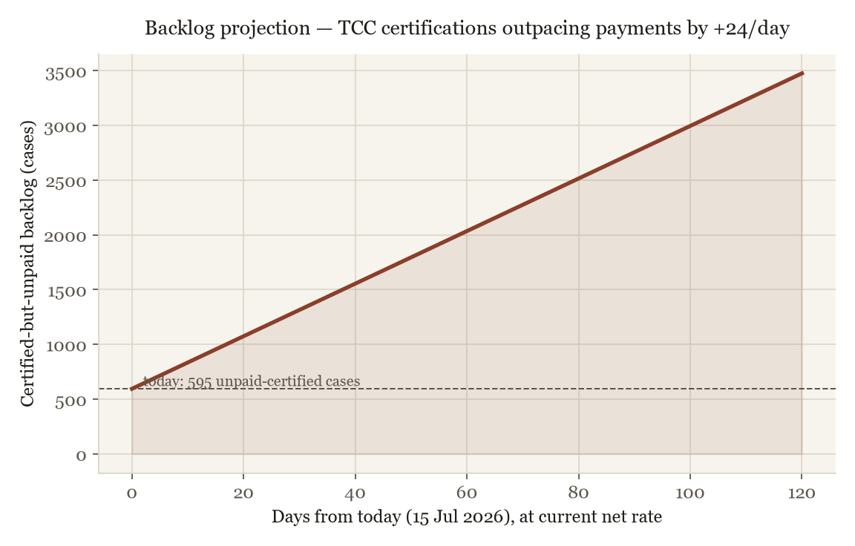

Spatial intelligence: Nearest Neighbor Analysis on real sites
The Trust's Progress Report names its top lodgement, appointment and BME sites with real activity counts. Average Nearest Neighbor Analysis (ANN), the standard GIS test for whether points cluster, spread randomly, or sit uniformly, was run on all 17 of those real, named sites.
Metric | Result
Sites tested (n) | 17
Observed mean spacing | 69.9 km
Expected mean spacing (random) | 94.7 km
ANN ratio (R) | 0.738 (clustered)
z-score | -2.07 (statistically significant)

The Trust's real site network is not randomly distributed. It clusters, concentrated in Lesotho and the Eastern Cape / Free State corridor. The Lesotho cluster (Maseru, Teyateyaneng, Hlotse, Mafeteng, Mohale's Hoek) sits 30-45 km apart, tightly packed. Mbabane and Maputo sit 148 km apart despite both being cross-border sites, a real coverage gap in that eastern corridor worth a midpoint office.
Method: haversine pairwise distance, expected mean distance under complete spatial randomness (CSR) over the sites' bounding-box area, z-test per the standard ANN formula (as used in ArcGIS's Average Nearest Neighbor tool). Full site table: companion Excel, 'NNA & k-NN (Real)' tab. The HTML proposal now renders the 17-site ANN layer as an interactive bounded map with zoom controls, street/satellite selection, clickable weighted site markers, nearest-neighbor lines, a side legend and toggleable service-site/link layers.

Why nearest-neighbor thinking solves the missing-claimant problem
Section 01 named the real blocker: fragmented records make one person look like three. Nearest Neighbor Analysis has two forms, and both apply. Spatial clustering (GIS) finds hotspot villages for mobile-clinic targeting. Social network linkage (k-NN) fixes spelling and ID anomalies, and links deceased miners to families.
Fixing broken records with k-NN: exact database joins fail on a misspelled name or a partial ID. k-NN treats each record as a point in feature space (birth year, name, mine number, region) and merges whichever records sit closest together, not just the ones that match exactly.
Finding dependants through kinship proximity: dependant Silicosis and TB claims exist because a worker died and the family never knew. Proximity here means shared surname, shared rural local authority, or the same TEBA recruitment batch. When a deceased, uncompensated miner's record surfaces, the same nearest-neighbor logic scans current identity and mobile registries for the closest social matches, giving field teams an algorithmic starting point instead of a cold call to an entire village.
Record | Source | Name as recorded | Nearest neighbor
R1 | TEBA archive | Sipho Mokoena | R2 (d=0.021)
R2 | Mine payroll | S. Mokwena | R1 (d=0.021)
R3 | Call-centre intake | Sipho Mokoena Snr | R1 (d=0.041)
R4 | Death registration | S Mokoena | R2 (d=0.526)
R5 | TEBA archive | Thabo Ramaboea | R6 (d=0.247)
R6 | Mine payroll | T. Ramabowa | R5 (d=0.247)
R7 | Call-centre intake | Petrus Nkosi | R8 (d=0.330)
R8 | Mine payroll | P. Nkozi | R7 (d=0.330)

Run on 8 synthetic demonstration records built to mirror Section 01's example, the model correctly clustered the three-partial-record case at distance 0.02 to 0.05, tight. R4 shows why naive tokenization still needs fuzzy name-matching in production: a shortened first name ('S' vs 'Sipho') pushed one true match out to distance 0.53. That's the argument for edit-distance matching, not simplistic hashing, in the real build.
Synthetic demonstration data (8 fabricated records), not real claimants. scikit-learn NearestNeighbors, Euclidean distance on 4 encoded features. Method (all techniques on this page): Python (pandas, scikit-learn, matplotlib). Full dataset and reproducible script: companion Excel workbook, 'NNA & k-NN (Real)' and 'Regional Data (Real)' tabs.
What this becomes as automation: a nightly job flags any region whose conversion drops more than one standard deviation below its cluster average, which would have caught KZN and Zimbabwe automatically. The backlog trend recalculates daily and alerts the CEO if the net rate turns positive for more than a week. The cluster model re-runs monthly as new lodgements land.

07 ICT MANAGEMENT & GOVERNANCE

Five ICT problems this role inherits, and how each gets solved
Not abstractions: these map directly to the role description's ICT Management KPA and to gaps a first-round interview would surface fast.
Problem | Solution | User support experience
Remote access has no defined support path | Single intake channel, triaged in under 30 min against four failure classes (credential/MFA, device, network, application), each with a written runbook. | Every ticket logged with a plain-language note; monthly rollup to the CEO shows recurring failure types.
Invoices approved without checking the contract | Vendor register (terms, SLAs, renewal dates); every invoice reconciled against it before approval. | Trustees see one vendor scorecard per quarter.
No single owner of the case-management data model | Direct ownership, using the same audited, UAT-gated migration method already run at On the Spot. | Every system change ships with a short release note in plain language.
Non-technical users, low adoption, repeat questions | Role-specific one-page quick guides plus a standing weekly office-hours slot. | The same recurring questions get answered once, in writing, for everyone.
Governance has no regular view of ICT risk | Monthly ICT dashboard: uptime, tickets, cybersecurity posture, open risks, same BI stack as the claimant dashboards. | The Board sees ICT health in the same report format it trusts for claims data.

Access model: zero trust applied to five people who touch the same record
Zero trust means nobody is trusted by default, including staff already inside the network. Every access is verified, scoped, and logged.
Role | Access scope
Call-centre agent | Contact details and claim status only. No medical record, no payment approval, no bulk export.
Medical partner | Medical certification fields for assigned cases. No financial data, no other partner's caseload.
Finance user | Payment and banking data. Read-only on medical outcome. Cannot edit the class that drives the payment.
Trustee / executive | Aggregate dashboards and reports. Bulk personal-data export requires a logged, approved request.
IT & Data Manager | Full system visibility for administration, under MFA, conditional access and continuous audit logging.

Controls stack
MFA on every account, role-based access mapped to the table above, conditional access by device and location, encryption at rest and in transit, and audit trails on every read of medical or identity data, because POPIA treats health and biometric data as special personal information requiring explicit safeguards.

Disaster recovery
Automated, geographically separated backups of claimant, medical and payment data, a defined recovery-time and recovery-point objective, and a tested restore, not just a scheduled job nobody has verified.

08 ROLE FIT

Mapped against the five Key Performance Areas

Technology Governance & ICT Management
IT strategy tied to the claimant-location outcome; cloud platform reliability, security and cost ownership; ICT policy and governance-committee input.
Evidence: Azure, AWS, Google Cloud, Data Factory, Databricks

Business Systems & Vendor Management
Ownership of the custom claims system as business custodian; UAT coordination and vendor SLA/contract review; legacy-to-cloud migration without service interruption.
Evidence: SAP ERP, SAP HANA, Snowflake, legacy migration

Data Management
Data governance framework and quality assurance on claimant records; warehousing and BI strategy built for the tracing use case; POPIA compliance embedded in access design.
Evidence: Power BI, Tableau, Python, GIS, Snowflake ML

Strategic Planning & Team Leadership
Multi-year technology roadmap and budget ownership; mentoring an IT/data team; change adoption led by user needs first.
Evidence: Stakeholder management, phased rollout, training programs

Reporting & Compliance
Monthly/quarterly ICT and data reports to CEO and Board; cybersecurity posture and incident reporting; audit-ready contract and asset records.
Evidence: Executive dashboards, audit trails

09 TRACK RECORD

Fourteen years, one throughline: messy data into decisions people can act on
Period | Organisation | Role & relevance
2012-2014 | MultiChoice Internet Holdings (Kalahari) | Foundation in commercial data operations.
2014-2015 | Bytes Universal Systems | BI Analyst/Developer, business intelligence development and reporting.
2015-2016 | Shoprite | SAP Master Data across SAP ERP and SAP HANA modules.
2016-2018 | Macro Plan Town & Regional Planners | GIS Analyst, mine-area planning and 3D spatial drawing, the direct precedent for claimant-location mapping.
2020-2023 | TMI | Digital Marketing BI Analyst / Data Lead, freelance analytics through the Corporate Renaissance transition and COVID period.
2023-2024 | CHEP | Data operations inside a multinational logistics environment.
2024-Present | On the Spot | Data Engineer & Analyst, most senior data resource in the company: legacy-to-Snowflake migration, Azure/Databricks pipelines, Power BI reporting.

10 DELIVERY SEQUENCE

This is buildable, not theoretical: here's the 90-day sequence
Everything in this document, the schedule logic, the access matrix, the distance model, is already runnable against real data. This is the order it goes into production.
Phase | Focus | Delivered
Days 1-30 | Access & identity foundation | MFA/RBAC live for the five roles in Section 07. First-pass ID/mine-number matching running against existing case data. First data-quality exception report to the CEO.
Days 31-60 | Outreach goes live | Region-level model in Section 06 extended to claimant level: outreach automation targets actual uncontacted individuals within each region, not just the aggregate. Call-centre and WhatsApp outreach logged against a single claimant ID.
Days 61-90 | Governance closed out | Disaster-recovery restore tested end to end. POPIA access audit signed off. First executive dashboard cycle delivered to the Board.

Anthony Apollis, Data Engineer & Analyst
anthony.apollis@gmail.com
Executive dashboard: what management needs to know first
This report is insight-led: every chart, table and map answers a management question. The reader should not have to infer the point. Each section states the data used, the finding, why it matters, and the action it supports.
Registrations: 414,885. Action: split registered claimants by contactability, documents and medical status.
Contact made: 53,945. Action: rank uncontacted records by probability of successful tracing.
Medical eligibility yield: 31,375 of 119,555 MCP decisions, or 26%. Action: track screening yield as a Board KPI.
Certified but unpaid backlog: 595 cases. Action: create a daily certified-unpaid exception queue.
Backlog growth signal: +24 net cases per day. Action: intervene before the 90-day projection reaches about 2,755 cases.
KZN conversion: 8.9%. Action: run a targeted document and medical follow-up campaign.
Zimbabwe: 834 lodgements and zero payments in the public table. Action: investigate cross-border documentation, BME and payment blockers.
Spatial clustering: ANN ratio 0.738. Action: use GIS clustering to plan mobile outreach and midpoint service coverage.
Reader approach: What = claimant intelligence layer above existing systems. Why = finding and verifying claimants is a data, spatial, medical and governance problem. When = first 90 days. How = ingest, match, score, map, engage, report and govern. Decision = use evidence to prioritise regions, vendors, ICT controls, field trips and payment bottlenecks.
Detailed Key Points and Recommendations
The Claimant-Intelligence Platform addresses a specific operational problem: finding and compensating former gold mineworkers and dependants affected by silicosis and occupational TB. The issue is not only whether funds exist. The issue is whether the Trust can locate the right people, prove the right claim, protect sensitive data, and make compensation decisions that are accurate and defensible.
Core problem: claimants are difficult to trace because employment, medical and identity records sit across fragmented sources such as old mining archives, TEBA records, medical files and call-centre histories.
Proposed response: build a governed data layer above the existing claims system so the Trust can clean, match, enrich and prioritise claimant records without replacing the operational case-management platform.
Intelligence value: cloud warehousing, identity matching, GIS targeting and executive dashboards turn scattered records into ranked outreach lists, regional priorities and payment-bottleneck exceptions.
Operational focus: outreach should be guided by evidence from high-priority regions such as Lesotho and the Eastern Cape, weak-conversion regions such as KwaZulu-Natal, and stalled cross-border records such as Zimbabwe.
Management result: the Trust gets a defensible view of who is likely eligible, what evidence is missing, where the person or dependant may now be located, and which team action should happen next.
Recommendations for improvement
Enhanced data governance: implement formal ownership for data quality, privacy, retention, consent, audit trails and exception handling. Old archive data should be useful, traceable, explainable and POPIA-compliant.
Automated outreach and feedback loops: use SMS, WhatsApp and call-centre workflows once likely claimants are identified. Feed every failed call, wrong number, missed appointment and successful contact back into the scoring model.
Role-based access controls: separate trustee, call-centre, medical, finance, ICT and executive access. Sensitive identity, medical and banking data should be visible only to users with a clear business need.
Continuous improvement with dashboards: treat dashboards as living management tools, not static reports. When a region lags, a BME queue stalls, or certified unpaid claims rise, the dashboard should trigger a management response.
Reader takeaway: this proposal is not a technology wish list. It is an operating model for using data and intelligence to find claimants, protect their information, target outreach, and move valid claims toward defensible payment.

