LEATT GROWTH OS
A Fabric-powered ecommerce intelligence data story
Microsoft Fabric · Data Factory · OneLake · Power BI · Python ML
Anthony Apollis — July 2026
Synthetic transaction data modelled on Leatt's public product catalog (leatt.com). Not affiliated with Leatt Corporation.

1. Is this profitable growth?
Leatt sells motocross and adventure safety gear — helmets, body protection, boots, gloves, goggles. Across 4,629 modelled orders, the catalog generates R9.8m in net revenue at a 48.1% gross margin, with 7.1% lost to returns. Apparel is the largest category (R4.3m); Organic Search the leading acquisition channel (R2.4m).
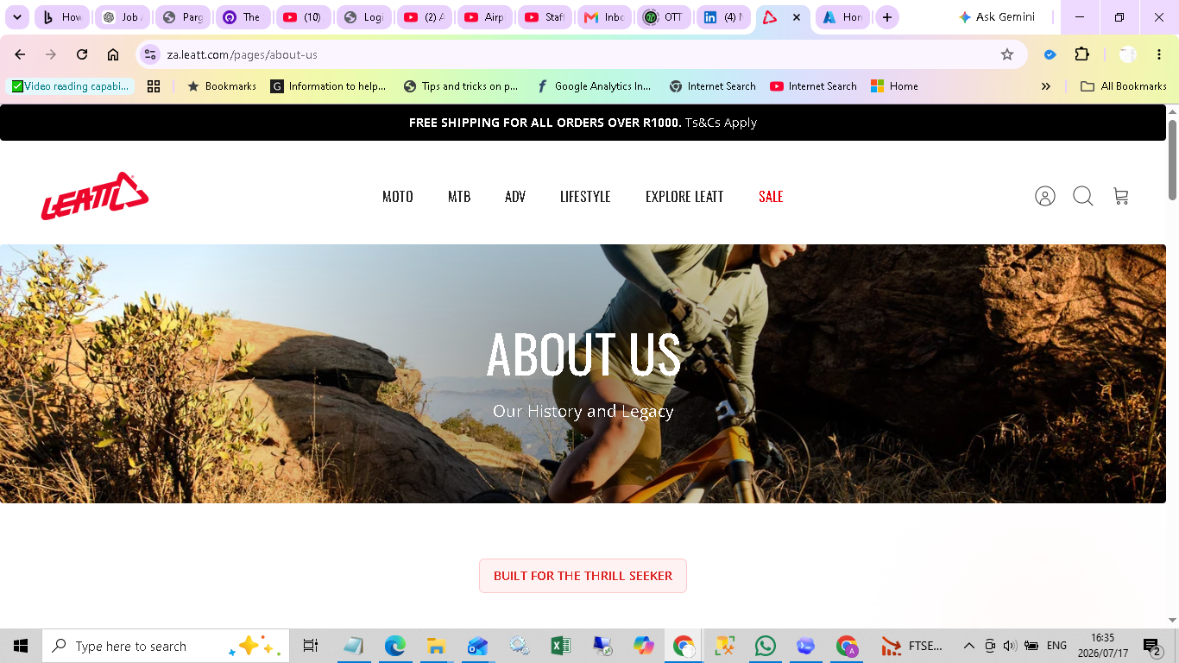
Figure 1 — Real Leatt storefront (leatt.com), the narrative anchor for this project.
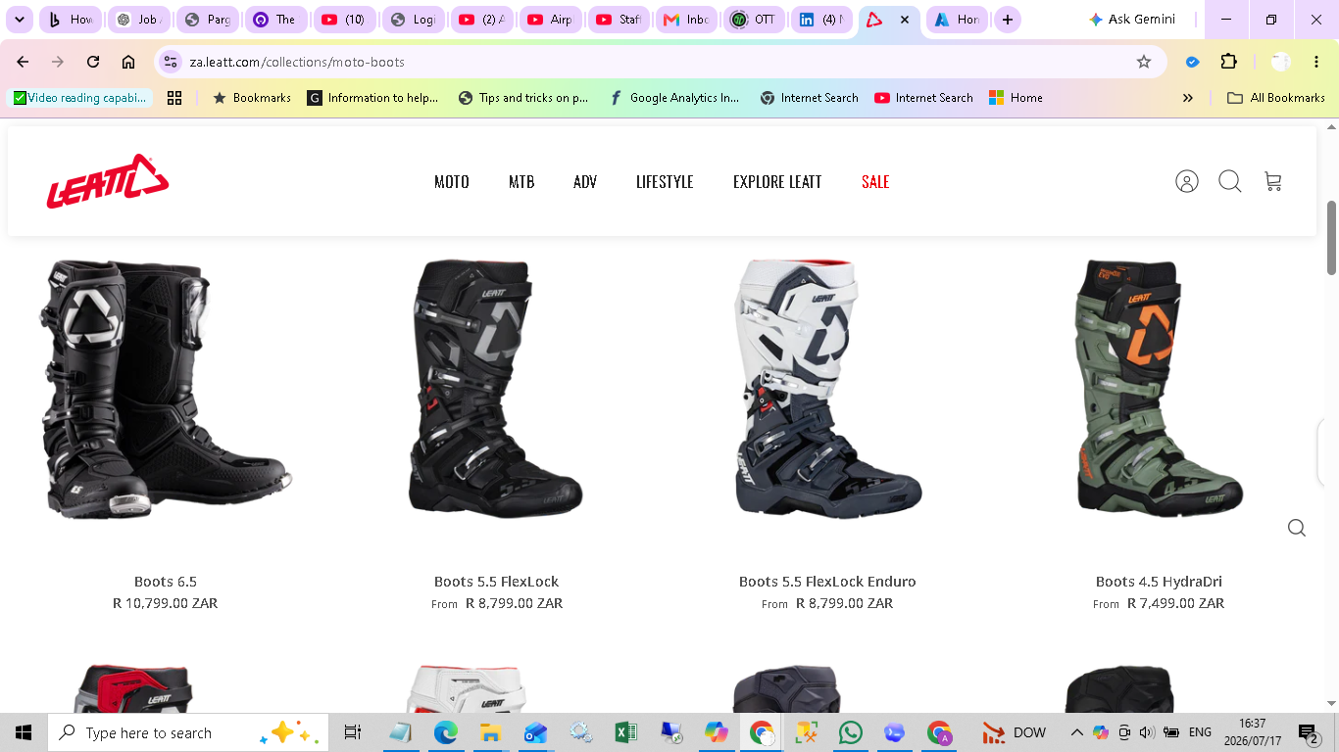
Figure 2 — Real product catalog evidence: moto boots collection.

2. The engine: a real Microsoft Fabric deployment
This is a genuine Fabric deployment, not a diagram of one. A capacity, workspace, Lakehouse, Data Factory pipeline item and Power BI report were created through the actual Fabric REST APIs, with real files uploaded into OneLake:
- Workspace “Apollis” — e515bafe-7290-4832-ae1d-514be43a9d87
- Lakehouse “Leatt_BI_ML_Lakehouse” — dca60749-eaef-410e-9121-ea16eedbc975
- Data Factory pipeline “pl_leatt_million_row_lakehouse_load” — 9e82c185-e0ac-485d-9810-4bccdcfe6cf9
- Power BI report “Leatt BI ML Executive Report” — 8c6988a7-fe5e-4fbe-abe9-ce7edd7fd63e
- Capacity “leattfabricf2” (SKU F2, South Africa North) — paused when not in active use
OneLake Bronze/Silver files actually uploaded: the 90.7MB, 2,000,000-row transaction parquet; an 8.9MB, 11,354-variant product catalog; a 13.5MB, 180,000-row synthetic customer file; and a 31.0MB customer ML-score file.
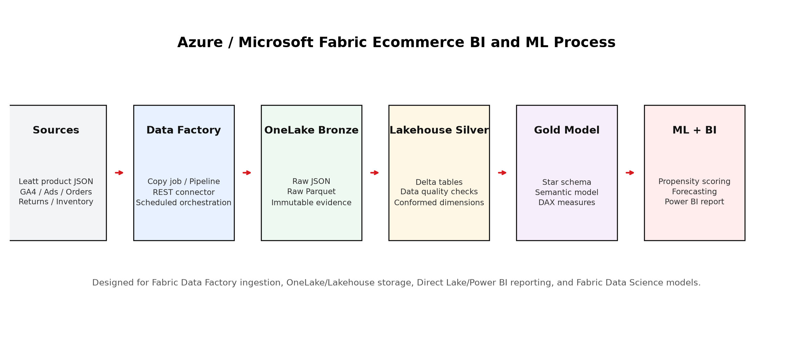
Figure 3 — Bronze → Silver → Gold medallion flow implemented in this workspace.
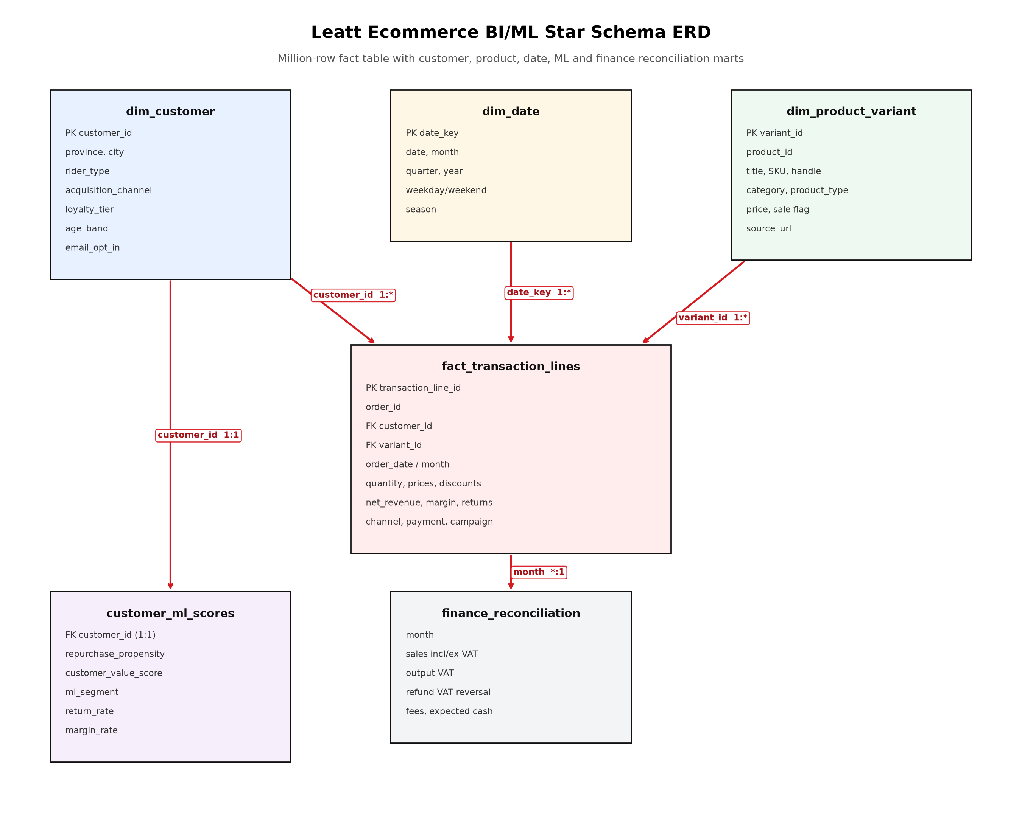
Figure 4 — Star schema serving the Lakehouse/Power BI semantic model.
Honest caveat: the Power BI report was created and bound to the semantic model via the real Fabric API (operation succeeded, 100% complete), but an automated service export only produced loading/sign-in screens rather than rendered visuals. Those blank exports are deliberately not presented here as visual proof — the report is real and reachable at its live URL; a rendered screenshot needs a signed-in interactive session.

3. The money map
Growth quality, not just growth. Apparel concentrates revenue but Parts & Accessories carries the strongest margin. November and December show consistent margin compression in both years — 43.0% average versus 49.0% the rest of the year — a real seasonal promotional pattern in the data, not noise.
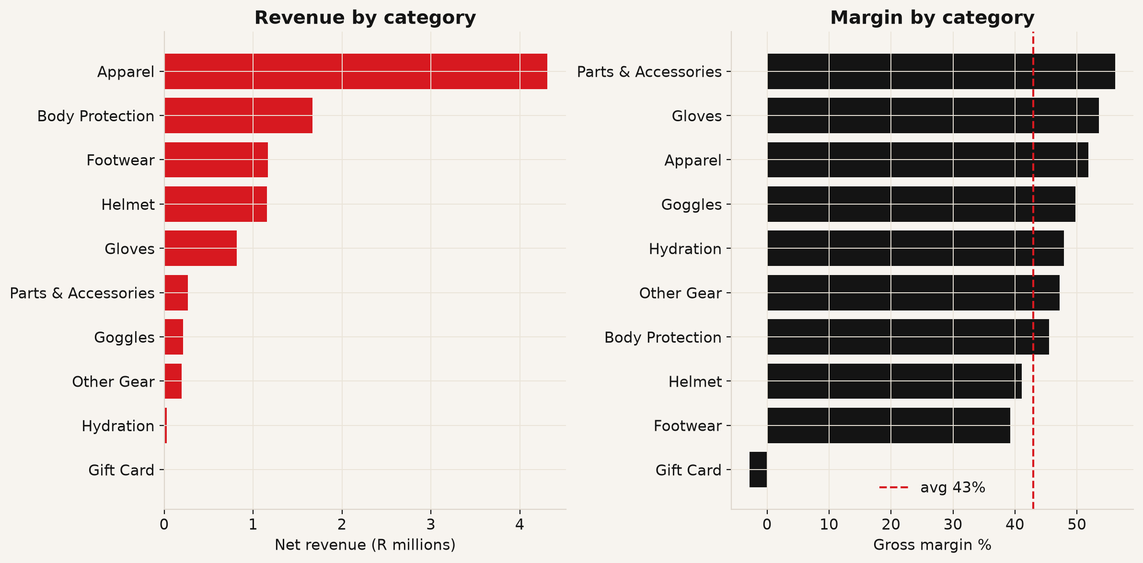
Figure 5 — Revenue and margin by category.
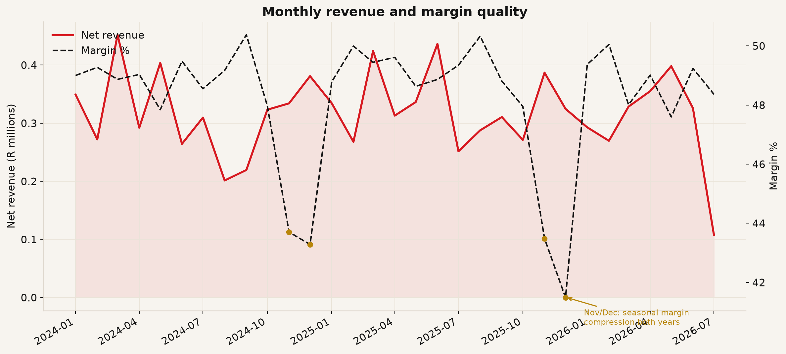
Figure 6 — Monthly revenue and margin, with Nov/Dec seasonal dips marked.
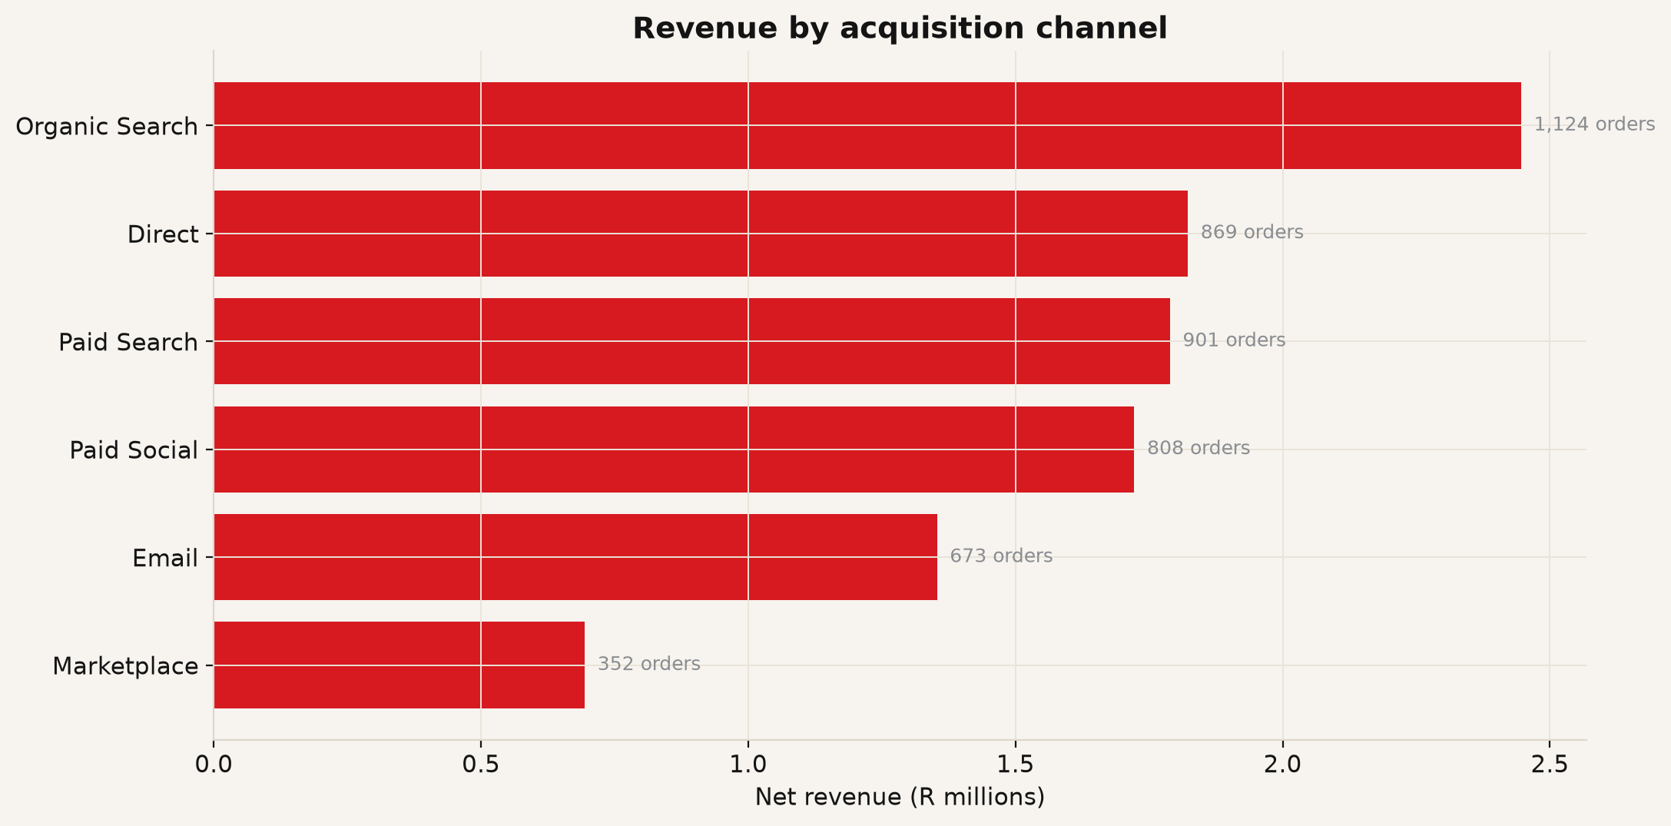
Figure 7 — Revenue by acquisition channel.

4. The growth loop: marketing, SEO, experimentation
4 of 6 A/B tests reached statistical significance, worth an estimated R1.3m in incremental revenue if rolled out.
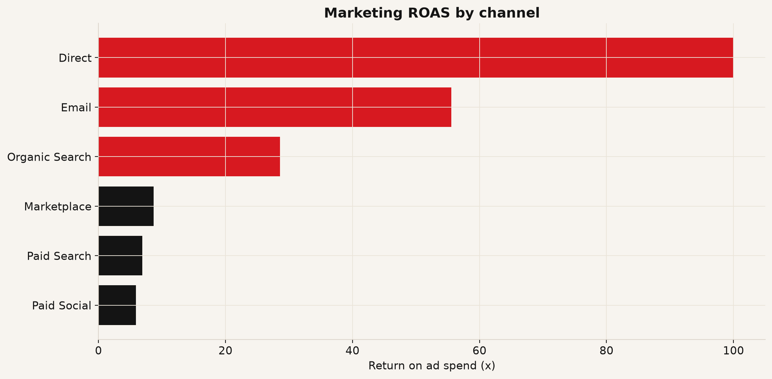
Figure 8 — Marketing ROAS by channel.
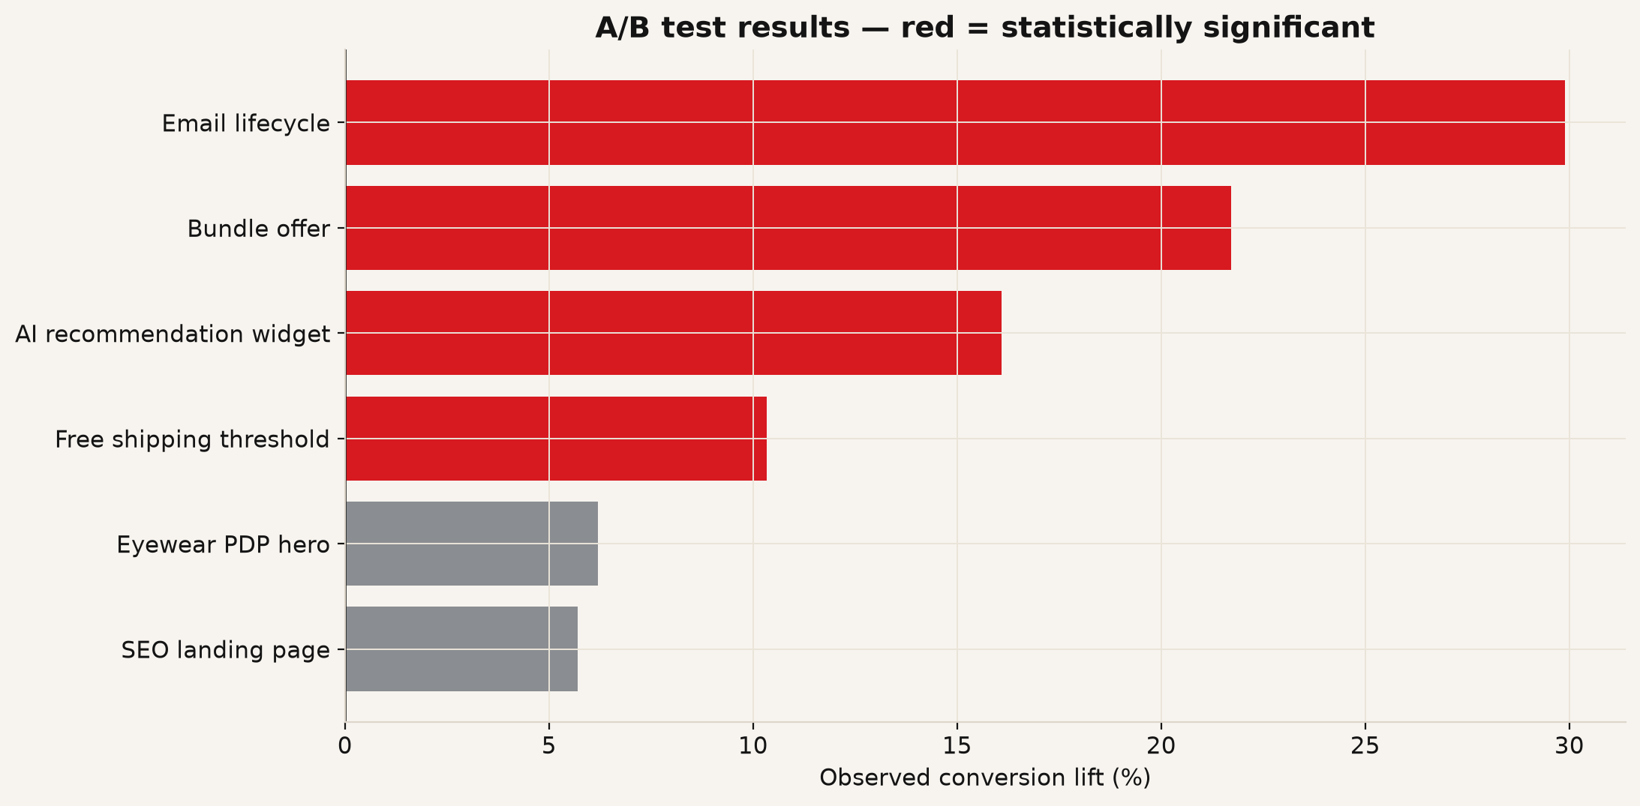
Figure 9 — A/B test results; red bars reached significance.
Competitive positioning:
Fox Racing — MX and MTB gear leader. Leatt should lean harder into safety science, protection credibility, and South African origin story.
Alpinestars — Premium motorsport protection. Compete with test evidence, fit guides, and protection-first product storytelling.
100% — Performance eyewear and goggles. For Leatt eyewear, emphasize lens protection, riding conditions, and bundle with helmets.
Oakley — Premium sport optics. Leatt must avoid pure optics battle; position eyewear as protection plus ride-specific value.
SCOTT — Bike and moto equipment. Use comparison content: Leatt vs Scott by lens, fit, helmet compatibility, price.

5. Finance and governance: SAP-ready reconciliation
Ecommerce revenue reconciles to VAT, refunds and expected cash — the layer that lets Finance trust the BI numbers enough to post them against SAP Business One or SAP BW.
4 of 10 sampled audit exceptions remain open, owned by Finance Ops / Data Steward for resolution.
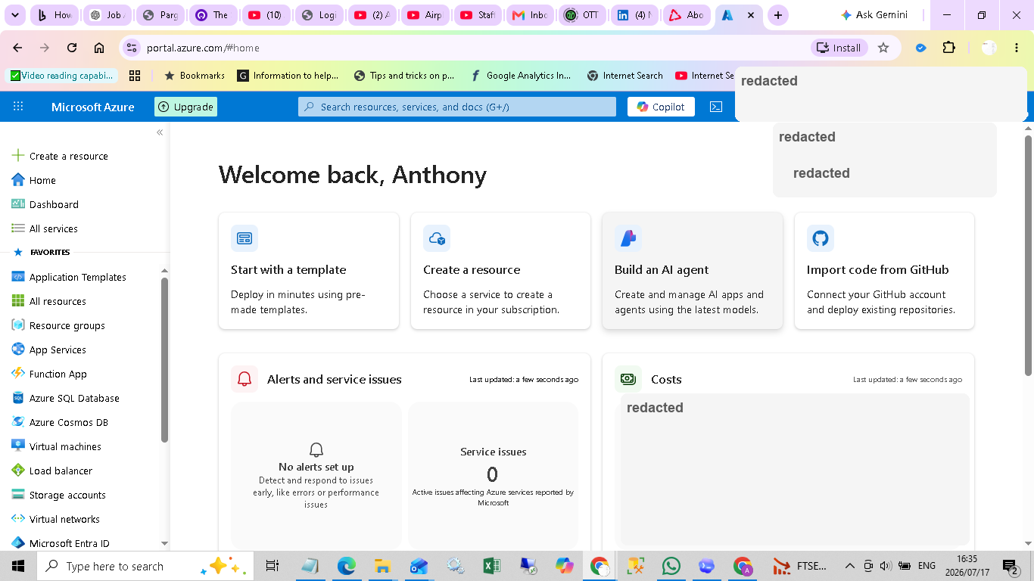
Figure 10 — Real Azure portal session, cost dashboard visible.

6. Azure and Fabric: cost discipline
Fabric F2 capacity is paused by default and only resumed for active work, then suspended again immediately — verified via both the Azure CLI and the portal UI at every check this project has done.
az fabric capacity suspend --resource-group rg-leatt-fabric-bi-ml --capacity-name leattfabricf2
Tags on the resource confirm intent: cost-control=delete-or-pause-after-upload, project=leatt-bi-ml, purpose=portfolio-proof. Full timestamped teardown log: docs/AZURE_COST_SHUTDOWN_PROOF.md.
Full source, data and reproduction steps: github.com/anthonyapollis/leatt-fabric-bi-ml-proof

