Merchant Sales & Voucher
Intelligence Dashboard
BI Developer — Second-Round Practical Task
Microsoft Fabric · Power BI · dbt · SQL · Python ML
Deliverable | Detail
Reporting period | 1 January 2026 – 31 July 2026 (212 days)
Data volume | 120,969 vouchers · 26,500 daily sales rows · 1,363 tickets · 25 merchants
Architecture | Fabric medallion (bronze / silver / gold) → Kimball star schema → Power BI Direct Lake
Transformation | dbt: 18 models, 1 snapshot (SCD2), 132 tests, 4 seeds, 3 exposures
Orchestration | Data Factory pipeline, metadata-driven, daily 02:00 SAST
Semantic model | 6 dimensions · 4 facts · 1 analytics mart · 31+ validated DAX measures
AI extension | 5 models: anomaly detection, propensity, regression, forecasting, segmentation
Quality gates | 14 warehouse tests · 132 dbt tests (153 pass on build, 0 warn, 0 error) · 7 SCD2 assertions · 27/28 reconciliation checks

Anthony Apollis
11 August 2026

1. Executive summary
This solution delivers a production-minded analytics stack over the supplied merchant voucher data: a Fabric medallion pipeline feeding a Kimball star schema, a dbt transformation layer with a 69-test suite, a four-page Power BI report, and five machine-learning models covering anomaly detection through to forecasting. Every number in every artefact traces to a single gold layer.

Headline figures
Metric | Value | Note
Total sales | R65.5m | 510,127 transactions, avg basket R128
Redemption rate | 84.2% | 101,843 of 120,969 vouchers
Avg days to redeem | 3.58 | median 2 days, max 54
Delayed redemption rate | 13.9% | redeemed after > 7 days
Outstanding liability | R3.5m | unredeemed voucher value
Avg resolution hours | 23.7 | median 16.4h — right-skewed
SLA breach rate | 26.3% | 94.7% of breaches sit on High/Critical
Open ticket backlog | 239 | Open, Escalated or Pending Merchant

The four findings that matter
1. One merchant is failing, and it is an operational failure, not a demand problem. Umhlanga Value Mart's July sales fell 42.5% against its own prior three-month average while support tickets rose 693% in the same month. The two moving together points to a service breakdown causing commercial damage — which means it is plausibly recoverable. Annualised revenue at risk is R571,518.
2. The SLA policy is configured backwards. Critical tickets are given a 12-hour target but take 52.7 hours on average — a 98.3% breach rate. Low-priority tickets are given 48 hours and take 11.3 — a 0.2% breach rate. Because the ladder runs opposite to the actual workload, 94.7% of all 358 breaches land on High and Critical. The reported 26% breach rate is measuring a policy misconfiguration, not team performance.
3. Eastern Cape is the one declining region, on four independent signals. It is the only region that peaked before July, sits 9.8% below its own peak while every other region is at its peak, has the flattest trend slope (+2.0% of average monthly sales vs +4.4% to +8.5%), and fell 12.2% in June against +1.4% to +3.8% elsewhere. Three of the five Critical/Watch merchants sit there.
4. Operational friction does NOT predict merchant performance — and the obvious analysis says it does. Tickets per 1,000 transactions correlates with target attainment at r = -0.56, which looks conclusive. It is confounded: the ratio is size-dependent (r = -0.83 against log total sales), so small merchants score badly purely because the denominator is small. Controlling for size, the partial correlation collapses to r = -0.20. Reporting the raw correlation would have been a confounded finding presented as a causal one.
5. The CRM 'At Risk' flag has zero overlap with actual deterioration. Both merchants flagged At Risk are growing and score Healthy (61.7 and 68.3). Every merchant in genuine decline — including the one losing R571,518 annualised — is flagged 'Active'. R1,079,726 of at-risk revenue sits in merchants the CRM considers fine. The existing manual flag is not detecting the problem it exists to detect, which is the clearest argument for a computed health score.
6. The open-ticket backlog is two problems, not one. Of 239 open tickets, 146 are awaiting us (Open + Escalated) and 93 are awaiting the customer (Pending Merchant). Those need entirely different remediation, and a single '239 open' figure hides the distinction — which is why dim_ticket_status carries an explicit ownership attribute rather than just an is_open flag.
Where the real operational signal is
Ticket spikes matter at the level of individual events, not as a portfolio rule. Durban Cash Hub's tickets rose 780% in June while sales GREW 8.2% — a service problem at a healthy account. Umhlanga Value Mart's rose 693% while sales FELL 42.5% — a failing account. Identical operational signal, opposite commercial diagnosis. The alerting logic in this solution therefore pairs ticket movement with sales movement rather than triggering on either alone.

2. Solution architecture
The stack follows the Fabric medallion pattern. Each layer has one responsibility, and the boundaries between them are where the quality controls sit.
Layer | Responsibility | Contents
Landing | Files as delivered | 4 CSV files in OneLake Files/landing
Bronze | Land raw, add lineage only. No business logic whatsoever. | 4 Delta tables + _batch_id, _ingested_at, _source_file
Silver | Type, trim, deduplicate at the declared grain, conform, apply business rules | 4 Delta tables, partitioned by month, Z-ORDERed on merchant + date
Gold | Kimball star schema for consumption | 6 dimensions, 4 facts, 1 analytics mart, 2 ML output tables
Consumption | Report, workbook, models | Power BI (Direct Lake), Excel pack, Fabric notebooks, Copilot/Q&A

Naming convention
Applied consistently so an unfamiliar engineer can predict a table name: bronze_<source>, silver_<entity>, dim_<entity>, fct_<business_process>, mart_<consumer>. Surrogate keys are <entity>_key, natural keys are <entity>_id. Measures are named in business language, not warehouse language — 'Redemption Rate %', not 'pct_redeemed_calc'.

Orchestration — Azure Data Factory / Fabric Pipelines
Three decisions in the pipeline design are worth stating explicitly, because each one exists to prevent a specific failure that occurs in production BI.
Metadata-driven ingest. A SourceFiles parameter array carries one object per source; a ForEach iterates it. Adding a fifth source is a parameter change, not a pipeline edit — which matters because pipeline edits require deployment and regression testing, while parameter changes do not. It also guarantees all four copy activities behave identically.
The data-quality gate sits BETWEEN silver and gold. This is the most important decision in the pipeline. The dbt test suite runs against silver, and gold is only rebuilt if every test passes. If the gate fails, the pipeline stops, alerts, and leaves the previous good gold layer in place — so the report keeps showing yesterday's correct numbers rather than today's wrong ones. Loading gold first and testing afterwards means the report has already published bad figures by the time anyone reads the alert. Stale-but-correct beats fresh-but-wrong: an executive working from a day-old number makes a slightly late decision; one working from a wrong number makes a wrong decision.
Row-count validation catches the failure that does not throw. A truncated or empty source file does not raise an error. The copy succeeds, the transformation succeeds, and the dashboard shows zero — which looks exactly like a genuinely bad trading day. A per-source minimum row count turns that silent failure into a loud one. Thresholds sit well below current volumes so normal fluctuation does not trip them, but far above zero so truncation cannot pass.

Fabric cost control and platform enhancements
A Fabric trial capacity does not warn, throttle or stop on its own. A scheduled pipeline fires nightly for the full 60 days whether anyone is watching or not, and if a paid capacity is later attached the same schedules run against it. Cost control is therefore built into the artefacts rather than left as an operating instruction.
Measure | Implementation | Saving or risk avoided
Trigger ships disabled | TR_Daily_0200_SAST has runtimeState 'Stopped' and a hard endTime of 2026-10-03 | ~60 unattended pipeline runs, each spanning a Copy activity, four notebooks and a semantic model refresh
Kill switch | fabric_cost_guard.py --check / --stop / --nuke, using the az login token | Disables every schedule and cancels in-flight runs in one command
Automated watch | Two scheduled tasks: weekly escalating check, plus a one-time alert on 2026-10-03 | Removes reliance on remembering the expiry date
Direct Lake over Import | The semantic model reads Delta files directly; no import refresh | No duplicated storage, and no scheduled dataset refresh consuming capacity units
Ephemeral intermediate models | int_merchant_monthly and int_merchant_momentum are inlined as CTEs | Two fewer materialised tables, and no staleness between them and their consumers
Incremental fact load | fct_merchant_sales merges on a deterministic key with a 3-day lookback | A daily run rewrites three days, not 26,500 rows
Local development on DuckDB | The dev target runs the identical models with no cloud cost | Development and testing consume zero capacity; only promotion touches Fabric

Warehouse and Lakehouse enhancements applied
Enhancement | Why
Z-ORDER on merchant_id + date in silver | Direct Lake reads Delta files directly, so file layout IS query performance. The report filters on merchant and period constantly.
Partition silver by year_month | Partition pruning is negligible at 26,500 rows but the pattern must be correct before volume arrives, not retrofitted after.
NOT ENFORCED primary and foreign keys | Fabric Warehouse does not enforce constraints but the optimiser uses them for better plans — and they document the model for the next engineer.
Bronze as VARCHAR throughout | Typing is silver's job. A cast applied at ingest is a transformation nobody can see or test, and it destroys the evidence of what the source actually sent.
Surrogate keys generated deterministically | The same natural key always yields the same surrogate, so a full rebuild cannot fork a dimension — which is what makes the pipeline idempotent.
Adapter-dispatched SQL macros | The same models run on DuckDB and the Fabric Warehouse. Discovered the hard way: T-SQL has no boolean column type and rejects positional GROUP BY.

Retry policy
Activity | Retries | Rationale
Copy to Bronze | 3 | Transient storage/network faults are common and genuinely self-healing
Transform to Silver | 1 | Largely deterministic; one retry covers a capacity blip
Data Quality Gate | 0 | A failing test is a real defect. Retrying delays the alert and risks a flaky pass
Build Gold | 1 | As above
ML Scoring | 1 | Longer running, more exposed to capacity contention
Refresh Semantic Model | 2 | The Power BI REST API returns transient 429s under load

3. Data model
A star schema with four facts at three different grains, sharing conformed dimensions. Mixing grains in a single fact table is the most common way a voucher model breaks, so each business process gets its own fact.

What the drop actually supplies
The folder contains six files: four CSVs of data, a README, and a DataDictionary. The README's suggested model names FIVE tables against those four CSVs — the fifth, DimDate, has no source file at all. Its entry reads 'candidate should create a proper date table'. Every table in the delivered model is therefore tagged with one of two distinct origins where the README is concerned: supplied as a CSV, or named by the README and built here. Collapsing those into a single 'from the README' label would imply a DimDate.csv that has never existed.
Supplied file | Bytes | Becomes
MerchantReference.csv | 2,143 | DimMerchant
MerchantSales.csv | 2,058,004 | FactMerchantSales
VoucherRedemptions.csv | 9,050,258 | FactVoucherRedemptions
SupportTickets.csv | 127,372 | FactSupportTickets
README_BI_Interview_Data.txt | 851 | Requirements — names DimDate with no file
DataDictionary.csv | 740 | Reconciled in the column lineage below

Source column lineage, and what the supplied dictionary covers
The DataDictionary supplied with the drop describes 12 columns. The four CSVs contain 34. Two thirds of the model therefore rests on meanings inferred by profiling rather than stated by the data owner — that is an assumption, and it is recorded as one. Every source column is traced to the gold table it lands in, or marked as deliberately dropped with the reason. The build fails if a column is neither: a field that silently disappears between source and star schema is indistinguishable from a defect.
Measure | Count
Source columns across the four CSVs | 34
Documented in the supplied DataDictionary | 12 (35%)
Meaning inferred by profiling | 22
Carried into the star schema | 28
Deliberately dropped, reason recorded | 6

Source | Column | Documented | Lands in | Note
MerchantReference | MerchantID | Yes | DimMerchant.MerchantKey | Surrogate key issued; natural key retained as MerchantID
MerchantReference | Merchant | Yes | DimMerchant.Merchant
MerchantReference | Region | Yes | DimMerchant.Region | Single source of truth for region — the copy on the sales fact is dropped
MerchantReference | Channel | Yes | DimMerchant.Channel
MerchantReference | ActiveStatus | Inferred | DimMerchant.ActiveStatus | Also surfaced as active_status on MerchantValueRisk — a churned merchant must not be scored as an attrition risk
MerchantReference | OnboardedDate | Inferred | DimMerchant.OnboardedDate | Derives TenureMonths and TenureBand
MerchantReference | AccountManager | Inferred | DimMerchant.AccountManager | The owner an at-risk merchant is routed to — carried onto MerchantValueRisk so the risk register is actionable
MerchantReference | BaseMonthlySalesTarget | Inferred | DimMerchant.BaseMonthlySalesTarget | Denominator for target attainment, which is the measure behind the tickets-vs-attainment question
MerchantSales | Date | Yes | FactMerchantSales.DateKey | Converted to an integer date key joining DimDate
MerchantSales | MerchantID | Inferred | FactMerchantSales.MerchantKey | Resolved to the surrogate key
MerchantSales | Merchant | Inferred | DROPPED | 100% agreement with MerchantReference (profiled). Keeping it would allow two competing versions of merchant name in one model
MerchantSales | Region | Inferred | DROPPED | 100% agreement with MerchantReference (profiled). Region belongs on the dimension
MerchantSales | Channel | Inferred | DROPPED | 100% agreement with MerchantReference (profiled)
MerchantSales | VoucherType | Inferred | FactMerchantSales.VoucherTypeKey | Resolved against DimVoucherType — conformed with the redemption fact
MerchantSales | SalesValue | Yes | FactMerchantSales.SalesValue | Additive measure
MerchantSales | Transactions | Yes | FactMerchantSales.Transactions | Additive measure
VoucherRedemptions | VoucherID | Inferred | FactVoucherRedemptions.VoucherID | Degenerate dimension — unique by construction, which is why duplicate-redemption fraud cannot be detected in this extract
VoucherRedemptions | MerchantID | Inferred | FactVoucherRedemptions.MerchantKey
VoucherRedemptions | Merchant | Inferred | DROPPED | Redundant copy of the merchant name — resolved via DimMerchant
VoucherRedemptions | SoldDate | Yes | FactVoucherRedemptions.SoldDateKey | ACTIVE relationship to DimDate
VoucherRedemptions | VoucherType | Inferred | FactVoucherRedemptions.VoucherTypeKey
VoucherRedemptions | VoucherValue | Inferred | FactVoucherRedemptions.VoucherValue
VoucherRedemptions | Redeemed | Yes | FactVoucherRedemptions.IsRedeemed | Yes/No text converted to 1/0 so it sums
VoucherRedemptions | RedeemedDate | Yes | FactVoucherRedemptions.RedeemedDateKey | INACTIVE relationship, activated by USERELATIONSHIP. Blank when unredeemed — kept blank, not defaulted
SupportTickets | TicketID | Inferred | FactSupportTickets.TicketID | Degenerate dimension
SupportTickets | Date | Inferred | FactSupportTickets.DateKey | Ticket created date
SupportTickets | MerchantID | Inferred | FactSupportTickets.MerchantKey
SupportTickets | Merchant | Inferred | DROPPED | Redundant copy of the merchant name — resolved via DimMerchant
SupportTickets | Region | Inferred | DROPPED | Redundant copy of region — resolved via DimMerchant so one hierarchy governs every fact
SupportTickets | TicketType | Inferred | FactSupportTickets.TicketTypeKey | Resolved against DimTicketType
SupportTickets | Priority | Inferred | FactSupportTickets.PriorityKey | Resolved against DimPriority
SupportTickets | ResolutionHours | Yes | FactSupportTickets.ResolutionHours
SupportTickets | SLAHours | Yes | FactSupportTickets.SLAHours | Stored ON the fact, not resolved from DimPriority, so a future SLA policy change cannot retrospectively restate whether a historic ticket breached
SupportTickets | Status | Inferred | FactSupportTickets.Status | Derives IsOpen. Open tickets have elapsed-hours in ResolutionHours rather than a final duration, so they are excluded from average resolution time

Why fourteen tables when the README suggests five
The supplied README suggests a 5-table model. This solution has 14. Five come straight from the README; four exist because the brief's own report requirements (voucher type performance, ticket priority, SLA risk, backlog) need somewhere to put those attributes; one is a grain necessity; and four are extensions I added on judgement and have labelled as such. Presenting all 14 as though the brief demanded them would be overselling it — the honest split is a 10-table core plus 4 extensions.
Tier | Count | Tables
Supplied CSV | 4 | dim_merchant, fct_merchant_sales, fct_support_tickets, fct_voucher_redemptions
README-required | 1 | dim_date
Brief deliverable | 4 | dim_priority, dim_ticket_status, dim_ticket_type, dim_voucher_type
Grain necessity | 1 | fct_merchant_target
My extension | 4 | dim_merchant_history, mart_merchant_change_alerts, mart_merchant_scorecard, snap_merchant

Every table is justified individually below. The tier is carried through the dbt model descriptions, the ERD and the Excel data dictionary, so the same answer appears wherever the question is asked.
Table | Tier | Rows | Why it exists
dim_merchant | Supplied CSV | 26 | README: DimMerchant from MerchantReference.csv. Conformed dimension — the single filter path for every fact. Carries an Unknown (-1) member so a future unmatched fact row lands somewhere visible instead of vanishing from every total.
fct_merchant_sales | Supplied CSV | 26,500 | README: FactMerchantSales from MerchantSales.csv. Grain Date x Merchant x VoucherType. Merchant/Region/Channel were DROPPED from the fact — profiling proved 100% agreement with MerchantReference, so keeping both would allow two competing versions of 'Region' in one model.
fct_support_tickets | Supplied CSV | 1,363 | README: FactSupportTickets from SupportTickets.csv. One row per ticket. sla_hours is stored ON the fact, not resolved from the priority dimension, so a future SLA policy change cannot retrospectively restate whether a historic ticket breached.
fct_voucher_redemptions | Supplied CSV | 120,969 | README: FactVoucherRedemptions from VoucherRedemptions.csv. Accumulating snapshot — one row per voucher, updated when the second event (redemption) occurs. Carries TWO date foreign keys: sold_date_key active, redeemed_date_key inactive. Without that split, late redemptions are attributed back to the month of sale and a backlog is invisible.
dim_date | README-required | 365 | README: 'DimDate: candidate should create a proper date table'. This is the one table in the suggested model with NO source CSV — it is built, not loaded. Generated to full calendar-year boundaries rather than derived from the facts. Power BI time intelligence (DATEADD, SAMEPERIODLASTYEAR, TOTALYTD) does not error on a gapped calendar — it silently returns a wrong number. Contiguity is therefore tested, not assumed.
dim_priority | Brief deliverable | 4 | Brief section 5 requires 'ticket priority' and 'SLA risk'; section 4 requires an SLA breach indicator. Carries target_sla_hours plus observed median/P90 resolution time, and derives sla_is_achievable from them. This is what turns the headline operational finding into DATA rather than prose: Critical has a 12h target against a 74h P90, and the model says so in a sortable column.
dim_ticket_status | Brief deliverable | 4 | Brief section 5 requires ticket status and backlog visibility. Carries an explicit `ownership` attribute that splits the backlog into 'awaiting us' (146 tickets) and 'awaiting customer' (93). A single '239 open' figure conflates a capacity problem with a chase-the-customer problem — different remediation entirely.
dim_ticket_type | Brief deliverable | 6 | Brief section 5 requires ticket analysis on the Operational page. Adds category (Fulfilment / Financial / Commercial) and impact area (Customer vs Merchant impacting) — groupings that do not exist in the source but are how operations actually triage.
dim_voucher_type | Brief deliverable | 5 | Brief section 5 requires 'voucher type performance' on the Merchant page. Used by BOTH the sales fact and the redemption fact — the textbook definition of a conformed dimension. Also carries category and margin band, which do not exist in the source and are maintained as a dbt seed so the commercial team can change them without a code deployment.
fct_merchant_target | Grain necessity | 175 | Brief section 4 requires period comparison and a target measure; BaseMonthlySalesTarget is supplied on MerchantReference. Could have been an attribute on dim_merchant — but it is a MONTHLY measure while sales are DAILY. On the dimension it would re-count once per fact row. A separate fact at month grain, joined only through shared dimensions, is the standard Kimball answer to multi-grain reporting. 25 merchants x 7 months = 175 rows. Targets are pro-rated by days covered so a part-month never shows a false shortfall.
dim_merchant_history | My extension | 25 | NOT requested. The Type 2 face of snap_merchant. dim_merchant answers 'what is this merchant TODAY' and is what the semantic model joins to. This answers 'what was this merchant WHEN that fact happened'. Loading only Type 2 and forcing every query through a date-range join would be purer and practically worse; loading only Type 1 loses history permanently. Both, clearly labelled, is the workable answer.
mart_merchant_change_alerts | My extension | 0 | NOT requested. Makes the snapshot actionable. Diffs consecutive snapshot versions and emits one row per changed field with a severity. A merchant moving to 'At Risk' is Critical; a re-based sales target is High, because it silently invalidates every period-over-period attainment comparison unless someone is told. Capturing history that nobody reads is not worth the storage — this is what makes the snapshot earn its place. Currently 0 rows: no change has occurred since first capture.
mart_merchant_scorecard | My extension | 25 | NOT requested. Drill-through target for the Merchant page and feature table for the ML layer. Holds the composite Health Score. Computed in SQL rather than DAX deliberately: it needs percentile ranking across the whole merchant population (expensive and awkward in DAX) and it must be byte-identical in Power BI, the Excel pack and the ML feature set. One definition in the warehouse is what keeps three artefacts agreeing.
snap_merchant | My extension | 25 | NOT requested. Added because MerchantReference is a current-state extract. Each load overwrites the last, so active_status, account_manager, region and target history is destroyed at source. Two merchants are currently flagged 'At Risk' — 'when did that change, and did performance decline before or after?' is otherwise unanswerable forever. Uses the `check` strategy because the source has no reliable last-modified column (OnboardedDate is when the merchant joined, not when the row was edited).

The fair criticism, and the answer
The fair criticism is that four dimensions of 4-6 rows each is over-normalisation, and some modellers would keep those as degenerate columns on the ticket fact. That was in fact the first design here — all three ticket dimensions unioned into one table behind a discriminator — and it was worse for two concrete reasons. The three foreign keys on fct_support_tickets could not be relationship-tested, because a test cannot distinguish 'priority_key resolves to a priority' from 'resolves to something, somewhere'. And Power BI cannot build three independent filter paths off one physical table without role-playing copies. Splitting them added 9 enforced foreign keys that previously could not exist.

Before and after
The four supplied files carry 6 duplicated attribute columns, no declared keys, no calendar, and every value as text. Every join between them is an implicit string match that nothing validates. The gold schema replaces that with conformed dimensions, typed columns and 15 foreign keys that are enforced by a test on every build — drop a join and the build fails.

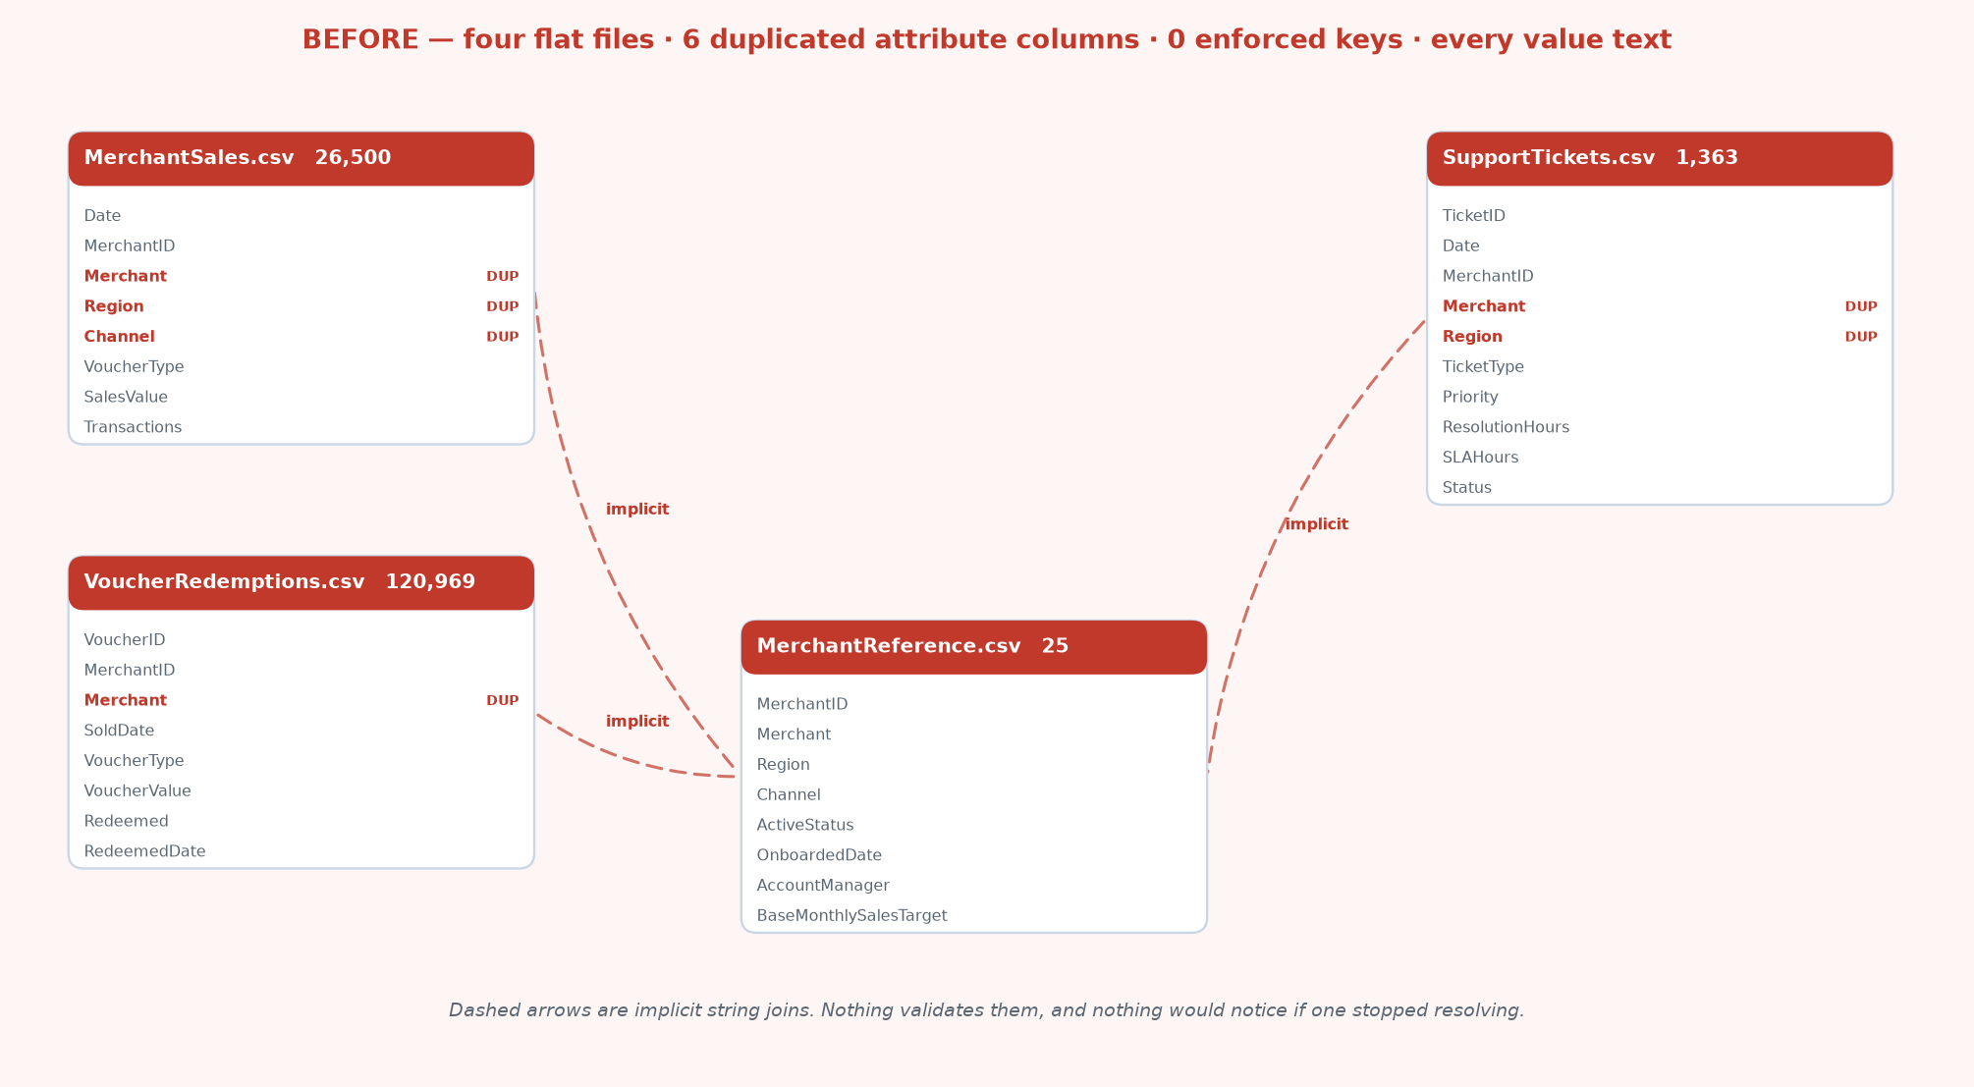
BEFORE — the four files as delivered. Red dashed arrows are implicit string joins that nothing validates; DUP marks a duplicated attribute column.

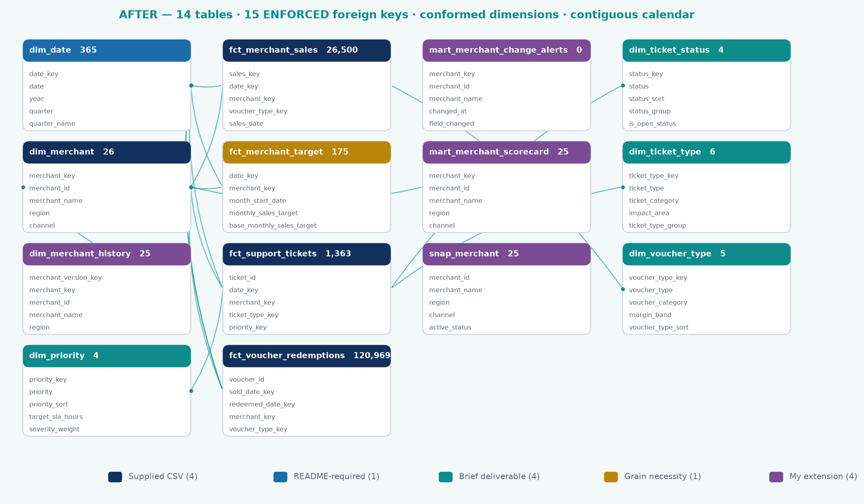
AFTER — the gold star schema. Every arrow is an enforced relationships test, and each table is coloured by why it exists.

Delivered | Modelled | Why it matters
No date table | dim_date — 365 contiguous days, gap-tested | Time intelligence returns wrong answers, not errors, on a gapped calendar
Merchant/Region/Channel on 3 facts | Dropped; live only on dim_merchant | Profiling proved 100% agreement, so removal is lossless — and stops two versions of 'Region' existing
String joins, nothing enforced | 15 relationships tests on every build | A broken join fails the pipeline instead of silently returning fewer rows
Everything text | Typed at silver | No implicit coercion hiding inside an aggregate
Repeated category strings | 4 conformed dimensions | Sort order, grouping and metadata that do not exist in the source
Redemption date as a plain column | Role-playing date, ACTIVE + INACTIVE | Otherwise late redemptions attribute back to the sale month and a backlog is invisible
No history | snap_merchant SCD2 + dim_merchant_history | The source overwrites; 'when did this merchant become At Risk' was unanswerable
Two grains conflated | Separate facts + a recorded 4.2:1 ratio | Stops someone reporting a R43.5m 'break' that is not a break

Tables
Table | Type | Grain | Rows
dim_date | Dimension | One row per calendar day, contiguous, full year boundaries | 365
dim_merchant | Dimension | One row per merchant + Unknown member | 26
dim_merchant_history | Dimension (Type 2) | One row per merchant per version, with valid_from / valid_to | 25
dim_voucher_type | Dimension | One row per voucher type | 5
dim_priority | Dimension | One row per ticket priority | 4
dim_ticket_type | Dimension | One row per ticket type | 6
dim_ticket_status | Dimension | One row per ticket status | 4
fct_merchant_sales | Fact (transaction) | Date × Merchant × VoucherType | 26,500
fct_voucher_redemptions | Fact (accumulating snapshot) | One row per voucher | 120,969
fct_support_tickets | Fact (transaction) | One row per ticket | 1,363
fct_merchant_target | Fact (periodic snapshot) | Month × Merchant | 175
mart_merchant_scorecard | Analytics mart | One row per merchant | 25

Entity relationships
Generated from the dbt manifest, not drawn. dbt docs shows the DAG — which model BUILDS from which — and that is build lineage, not entity relationships: it cannot show that fct_support_tickets.priority_key joins to dim_priority, because the fact is built from staging, not from the dimension. The real foreign keys live in the schema tests. Every relationships test is an enforced statement that a column must resolve to another column, so this diagram cannot drift — drop a join and the test disappears with it.
From | Column | To
fct_merchant_sales | date_key | dim_date
fct_merchant_sales | merchant_key | dim_merchant
fct_merchant_sales | voucher_type_key | dim_voucher_type
fct_voucher_redemptions | sold_date_key (ACTIVE) | dim_date
fct_voucher_redemptions | redeemed_date_key (INACTIVE) | dim_date
fct_voucher_redemptions | merchant_key | dim_merchant
fct_support_tickets | date_key | dim_date
fct_support_tickets | merchant_key | dim_merchant
fct_support_tickets | ticket_type_key | dim_ticket_type
fct_support_tickets | priority_key | dim_priority
fct_support_tickets | status_key | dim_ticket_status
fct_merchant_target | date_key | dim_date
fct_merchant_target | merchant_key | dim_merchant
dim_merchant_history | merchant_key | dim_merchant
mart_merchant_scorecard | merchant_key | dim_merchant

15 enforced foreign keys. Note fct_voucher_redemptions carries TWO into dim_date — the role-playing date that makes a redemption backlog visible.

Modelling decisions worth defending
Role-playing dates on the redemption fact. A voucher has two events — sold and redeemed — so the fact carries both sold_date_key and redeemed_date_key. In the semantic model, dim_date joins sold_date_key on the ACTIVE relationship and redeemed_date_key on an INACTIVE one, activated inside specific measures via USERELATIONSHIP. This is the single most common place a voucher model goes wrong: reporting redemptions on the sale date attributes late redemptions back to the month of issue, which makes a redemption backlog completely invisible.
Descriptive attributes dropped from the facts. Merchant, Region and Channel appear on both the sales fact and MerchantReference. Profiling confirmed 100% agreement across every row, so they were dropped from the facts — losslessly. Keeping them would allow two competing versions of 'Region' to exist in the model, which is how a report ends up with two different regional totals on two different pages.
SLA hours stored on the fact, not resolved from the dimension. They agree today. But a future SLA policy change must not retrospectively restate whether a historic ticket breached — a ticket is judged against the SLA in force when it was raised. dim_priority.target_sla_hours therefore describes CURRENT policy, and the fact records what was actually promised at the time.
Targets in a separate fact at month grain. fct_merchant_target is a periodic snapshot at a coarser grain than the daily sales fact. Forcing a monthly target into a daily fact would break every additive measure. The two facts join only through shared dimensions, which is the standard Kimball answer to multi-grain reporting. Targets are pro-rated by days covered so a part-month never shows a false shortfall.
An Unknown (-1) dimension member. Emitted deliberately so a future fact row with an unmatched merchant lands somewhere visible in the report rather than silently disappearing from every total.
Both a Type 1 and a Type 2 merchant dimension. dim_merchant is current state and is what the semantic model joins to — 'show me sales for merchants CURRENTLY in Gauteng' is what a regional manager asking about their own patch actually means. dim_merchant_history is versioned and answers point-in-time questions: 'what were sales for merchants that were in Gauteng AT THE TIME'. Loading only the Type 2 version and forcing every query through a date-range join would be technically purer and practically worse; loading only Type 1 loses history permanently. Both, clearly labelled, is the workable answer.
Diagnostics carried in the dimension, not just the report. dim_priority stores the observed median and 90th-percentile resolution time next to the target SLA, and derives sla_is_achievable from them. The SLA finding is therefore data rather than prose: Critical carries a 12-hour target against a 74-hour 90th percentile, and the model says so directly. A reader can sort on it; they cannot sort on a paragraph.

4. Transformation layer

Business rules, defined once
Every threshold lives in a single place (dbt_project.yml vars) and is inherited by the SQL models, the PySpark notebooks and the DAX measure library. A change propagates consistently instead of being applied in three places and forgotten in a fourth.
Rule | Value | Basis
Delayed redemption | > 7 days | No threshold supplied. 7 days sits above the 75th percentile (5 days), so it flags a genuine tail rather than routine behaviour
Voucher expiry / breakage | 90 days | No expiry rule supplied; 90 days is a common industry default. Affects breakage only
High priority | High, Critical | Used for the SLA concentration analysis
Redemption integrity | Flag AND valid non-retrograde date must agree | Trusting the flag alone would let a corrupt feed inflate the most scrutinised KPI in the report

dbt project
18 models across staging, intermediate and marts, plus 1 snapshot, 4 seeds, 3 exposures and 132 tests. A full `dbt build` completes with 153 pass, 0 warnings, 0 errors. The project runs against DuckDB in development (seconds, no cloud cost) and the Fabric Warehouse in production via dbt-fabric. Identical SQL, only the adapter changes.
Layer | Models | Purpose
staging | 4 views | Type, trim, deduplicate at the declared grain, apply integrity rules
intermediate | 2 ephemeral | int_merchant_monthly (merchant × month spine, zero-filled) and int_merchant_momentum (period comparisons). Inlined as CTEs — no extra storage, one definition
snapshots | 1 | snap_merchant — Type 2 capture of slowly-changing merchant attributes
marts / core | 10 | 6 conformed dimensions + 4 facts, plus the Type 2 dimension
marts / analytics | 1 | mart_merchant_scorecard — drill-through target and ML features

Two modelling changes were made after the first build, both to close real gaps:
Three ticket dimensions instead of one combined table. Ticket type, priority and status were originally unioned into a single table behind a dimension_type discriminator. That had two costs: the three foreign keys on fct_support_tickets could not be tested for referential integrity — a relationships test could not distinguish 'priority_key resolves to a priority' from 'resolves to something, somewhere' — and Power BI cannot build three independent filter paths off one physical table without role-playing copies. Splitting them added 9 referential tests that previously could not exist. Six rows is not too small to deserve its own dimension; join clarity matters more than table count.
A Type 2 snapshot on merchant attributes. MerchantReference is a current-state extract — each load overwrites the last, so active_status, account_manager and target history is destroyed at source. That matters: two merchants are currently flagged 'At Risk', and 'when did that change, and did performance decline before or after?' is unanswerable without history. The snapshot uses the check strategy rather than timestamp, because the source has no reliable last-modified column (OnboardedDate is when the merchant joined, not when the row was edited).
Test category | Count | Examples
Uniqueness / not-null | 58 | Primary keys on every dimension, fact and mart
Referential integrity | 18 | Every fact foreign key resolves to its own dimension
Accepted values | 14 | Region, Channel, Priority, Status, SLAHours, quality_flag
Range / expectation | 16 | sales_value ≥ 0; resolution_hours between 0 and 720
Row-level logic | 10 | is_sla_breach must equal (resolution_hours > sla_hours)
Completeness | 6 | The scorecard must cover every real merchant; every merchant must have 7 months observed
Singular (business) | 4 | dim_date contiguity; bronze→gold revenue reconciliation; redemption rate plausibility; no future-dated facts
Source freshness | 3 | Warn at 26h, error at 48h
SCD Type 2 behaviour | 7 | Separate harness: simulates a change, asserts history was captured, restores state

Validating the snapshot rather than declaring it
A snapshot that has only ever seen one version of each row is indistinguishable from one that is silently broken. scripts/_test_scd2.py simulates a real merchant change (Umhlanga Value Mart moving to 'At Risk' with a new account manager), re-runs the snapshot, and asserts seven properties: a new version row was created, exactly one version is current, the current version carries the new value, the superseded version retains the old value and was closed off, version numbering is contiguous, and unchanged merchants did NOT gain a version. All seven pass, and the harness restores the original state afterwards.

The highest-value test in the project
dim_date contiguity. Power BI time-intelligence functions (DATEADD, SAMEPERIODLASTYEAR, TOTALYTD) do not raise an error on a date table with a missing day — they silently return a wrong number. A single absent date quietly understates a month-on-month comparison and nobody notices until someone reconciles by hand. The test asserts that the row count equals the span between the minimum and maximum date, which cannot be true if there is a gap.

Cross-implementation reconciliation
The gold layer is deliberately built twice — once in pandas, once in dbt SQL — by two independent code paths. Every headline figure is then compared. If two different engines produce the same answer, the transformation logic is almost certainly right; if they disagree, one of them is wrong and the report does not ship.
This caught two genuine defects that no unit test would have found. First, dim_date was absorbing the August redemption tail into the reporting window, inflating pro-rated sales targets by R984,046 against a month containing no sales at all. Second, the Python and SQL percentile-rank conventions differ — pandas rank(pct=True) returns rank/n while ANSI PERCENT_RANK() returns (rank−1)/(n−1) — which shifted the Health Score by up to 9.7 points. Both are now fixed.
Reconciliation result | Count
Checks passed exactly | 27
Warnings (documented) | 1
Failures | 0

The single remaining warning is a 0.1 difference on the Health Score caused by Python's banker's rounding versus SQL's round-half-up. Every INPUT to the score reconciles to 0.000000, which is what proves it is a presentation artefact rather than a logic difference — and that proof is only available because the inputs are compared individually rather than just the result.

5. Semantic model and report

DAX measure library
31+ measures organised into display folders: Sales, Redemption, Operations, Time Intelligence, Ranking, Formatting and Narrative. Conventions applied throughout: measures live in a dedicated _Measures table; DIVIDE() is used everywhere so a zero denominator returns BLANK rather than an error; and ratios are always SUM/SUM, never AVERAGE of a per-row ratio.
Why SUM/SUM rather than AVERAGE
Average Basket Value must be SUM(sales_value)/SUM(transactions). Taking AVERAGE(avg_basket_value) averages a per-row ratio, which weights a one-transaction day exactly the same as a five-hundred-transaction day. It is the classic way an 'average basket' measure ends up quietly wrong, and it is invisible unless someone checks the arithmetic by hand.

DAX cannot be executed outside Power BI, so each measure carries a SQL reference definition evaluated against the gold layer to produce an expected value. docs/dax_validation.csv is the acceptance test: after the measures are entered, every card is checked against it, and a mismatch identifies exactly which definition drifted.
Measure | Expected value | Note
Total Sales | R65.5m | 26,500 fact rows
Average Basket Value | R128 | SUM/SUM
Redemption Rate % | 84.19% | volume basis
Value Redemption Rate % | 83.92% | value basis
Outstanding Liability | R3.5m | balance-sheet liability
Avg Days to Redeem | 3.58 | redeemed vouchers only
SLA Breach Rate % | 26.27% | 358 of 1,363
Breach Concentration in High Priority % | 94.7% | the headline ops finding
Implied SLA for 90% Compliance | 48.6h | what the target should be
Revenue Concentration (Top 5) % | 35.4% | concentration risk

Report pages
Page | Contents | Interaction
1. Executive Overview | Total sales, transactions, redemption %, avg resolution hours, sales trend, region performance, top merchants | Slicers on date, region, channel, voucher type. Right-click → drill through to Merchant Detail
2. Merchant Analysis | Top and bottom merchants, voucher type performance, ranking, Pareto contribution, health scorecard | Drill-through target page; tooltip page shows a 6-month sparkline and the narrative measure
3. Operational View | Ticket volume, priority mix, avg resolution hours, SLA risk, ticket trends, merchant-level issues | Cross-filter from priority to merchant; conditional formatting driven by DAX colour measures
4. Insights / Notes | Narrative summary, assumptions, data-quality issues, recommended next steps, ML output | Q&A visual with configured synonyms; smart narrative

Conditional formatting
Colour is semantic rather than decorative: red always means a threshold breach, green always means healthy, amber always means watch. Thresholds live in DAX measures (Colour | Sales MoM, Colour | SLA Breach, Colour | Redemption Rate) bound to 'Field value' in the formatting pane. Centralising them means the whole report restates consistently when a threshold changes, instead of needing each visual edited by hand.

6. AI and machine learning extension
Five models, trained in a Fabric notebook, logged to MLflow, with scored outputs written back to the gold layer as Delta tables. Power BI then reads predictions as ordinary columns rather than calling a model at query time — a live endpoint call per visual would add latency to every page render and couple report availability to endpoint availability, for no analytical gain given the data changes once a day.
Model | Algorithm | Validation | Result
1. Anomaly detection | Isolation Forest (400 trees) | Unsupervised; validated against 4 documented embedded patterns | 8 anomalies from 150 obs — all 4 patterns recovered
2. Redemption propensity | HistGradientBoostingClassifier | Time split: train Jan–May, test Jun–Jul | AUC 0.620 vs ceiling 0.621
3. Resolution time | HistGradientBoostingRegressor | Time split: train Jan–May, test Jun–Jul | MAE 9.8h, 23.4% better than naive
4. Sales forecast | Holt-Winters (weekly seasonality) | Backtest on held-out final 30 days | MAPE 4.69%, 49.7% better than naive
5. Segmentation | K-Means (k=4) | Silhouette compared across k=2..7 | 4 segments; 2 singleton outliers identified automatically

Anomaly detection — and how it was validated
The design decision that makes the model useful is that every feature is expressed as a deviation from that merchant's own expanding history, not as an absolute value. Absolute features would rank merchants by size — the model would flag the largest accounts every month and never notice a small merchant collapsing.
Validation. The dataset documentation states that four patterns were deliberately embedded. The model was never told what they were, and recovered all four unprompted: Umhlanga Value Mart's July collapse (ranked #1 by anomaly score), Kudu Digital Kiosk's May growth step, Durban Cash Hub's June ticket spike, and a Liberty Lane redemption-delay month. Every flagged row also carries a plain-English explanation, because a score with no reason attached does not get acted on.

Reporting a weak metric honestly
The redemption propensity model scores AUC 0.620, which looks weak. Rather than explaining it away or quietly dropping the model, it was tested against a theoretical ceiling. If redemption is generated purely as a function of voucher type, the best any model can achieve is to predict the type-level base rate — an oracle that scores AUC 0.621. The model therefore captures 99.8% of the achievable signal: the limit is the data, not the model. Establishing that distinction is what stops a team spending a sprint chasing an AUC that cannot move.
The ranking remains operationally useful regardless: the top risk decile carries 3.4× the non-redemption rate of the bottom decile, concentrating R171,689 of at-risk value into 10% of vouchers — which is exactly what a targeted reminder campaign needs.
Validation discipline applied throughout
Every supervised model uses a time-based split (train January–May, test June–July), never a random one. A random split leaks future information into training and produces a metric that will not survive contact with production. An honest 0.62 that holds is worth more than an inflated 0.85 that does not.

Segmentation — choosing k on business grounds
Silhouette analysis favours k=2 (score 0.433), but across only 25 merchants that produces a 21-versus-4 split with no operational value. k=4 was selected so each segment is large enough to assign an owner and distinct enough to justify a different play, at a silhouette cost (0.185) that is stated openly rather than hidden. Notably, the algorithm isolated two merchants into single-member clusters entirely on its own — Kudu Digital Kiosk (breakout growth) and Umhlanga Value Mart (deteriorating). That is a finding, not a defect.

7. Business questions answered

Q1. Which merchants generate the highest sales value and transaction volume?
Durban Cash Hub leads on both — R5,776,119 in sales (8.8% of the portfolio) and 45,371 transactions. The two rankings agreeing at the top is not guaranteed: a merchant can lead on value while trailing on volume if its basket is larger, so both are reported rather than assuming one proxies the other.
# | Merchant | Region | Total sales | Transactions | Share
1 | Durban Cash Hub | Western Cape | R5,776,119 | 45,371 | 8.8%
2 | Kudu Digital Kiosk | KwaZulu-Natal | R4,535,330 | 35,458 | 6.9%
3 | Zebra Route Services | Gauteng | R4,519,762 | 35,910 | 6.9%
4 | Karoo Quick Shop | Gauteng | R4,395,067 | 34,657 | 6.7%
5 | Lighthouse General Dealer | Gauteng | R3,965,086 | 31,124 | 6.1%

Concentration matters more than the leader: the top 5 merchants carry 35.4% of revenue and 15 of 25 account for 80%. HHI is 512 — moderate concentration, worth monitoring as a commercial risk in its own right.

Q2. Which voucher type has the highest redemption rate?
Airtime, at 92.8%. Gaming is lowest at 75.9% — a 16.9 percentage point spread.
Voucher type | Sold | Redemption % | Value redemption % | Avg days | Outstanding
Airtime | 26,253 | 92.83% | 92.83% | 3.55 | R340,979
Electricity | 24,691 | 87.79% | 87.57% | 3.56 | R557,879
Groceries | 24,856 | 82.67% | 82.62% | 3.57 | R784,888
Bill Payment | 22,489 | 80.14% | 79.88% | 3.70 | R824,710
Gaming | 22,680 | 75.95% | 75.16% | 3.56 | R1,033,107

Two observations that change the interpretation. First, the value-based rate is almost identical to the volume-based rate within each type, so high-value and low-value vouchers behave the same way — had they diverged, the value rate would be the one Finance should use. Second, time-to-redeem is effectively flat across all types (3.5–3.7 days), so the difference is whether customers redeem at all, not how quickly. Gaming's 24% non-redemption is the largest single block of the R3.5m outstanding liability.

Q3. Which region shows declining sales or transaction behaviour?
Eastern Cape, on four independent signals rather than one.
- It is the only region that peaked before July (peak May 2026).
- It sits 9.8% below its own peak while every other region is currently at its peak.
- Its trend slope is +2.0% of average monthly sales, against +4.4% to +8.5% elsewhere.
- June fell 12.2% month-on-month against +1.4% to +3.8% for every other region.
Region | Total sales | Share | Trend % of avg | Last month MoM | Peak month | vs own peak
Free State | R18,009,802 | 27.5% | +4.4% | +0.9% | 2026-07 | +0.0%
Gauteng | R16,145,481 | 24.6% | +4.5% | +3.6% | 2026-07 | +0.0%
Western Cape | R13,068,297 | 19.9% | +4.4% | +3.2% | 2026-07 | +0.0%
KwaZulu-Natal | R9,516,589 | 14.5% | +8.5% | +4.1% | 2026-07 | +0.0%
Eastern Cape | R8,781,130 | 13.4% | +2.0% | +2.8% | 2026-05 | -9.8%

A single month's movement would not justify calling a decline. Four signals pointing the same way does. Three of the five Critical/Watch merchants sit in Eastern Cape (Table Bay Express, Pretoria PayPoint, Mzansi Mini Market), so this is a regional pattern rather than one bad account.

Q4. Are support ticket volumes, priority or long resolution times associated with weaker merchant performance?
Not as a portfolio-level rule — but decisively at the level of individual events.
The tempting answer is that tickets per 1,000 transactions correlates with target attainment at r = -0.56, so friction hurts performance. That answer is confounded, and reporting it would have been a mistake.
- The ratio is strongly size-dependent: r = -0.83 against log(total sales). Small merchants score badly purely because the denominator is small.
- Controlling for size, the partial correlation collapses to r = -0.20.
- SLA breach rate and average resolution time show no association with performance at all (r = +0.04 and −0.19).
What is real is event-level. Four months show a merchant's ticket volume more than doubling against its own prior three months:
Merchant | Month | Tickets | Prior avg | Ticket uplift | Sales vs prior 3M | Diagnosis
Durban Cash Hub | 2026-06 | 44 | 5.0 | +780% | +8.2% | Service issue, healthy account
Durban Cash Hub | 2026-07 | 52 | 18.3 | +184% | +6.3% | Service issue, healthy account
Umhlanga Value Mart | 2026-07 | 37 | 4.7 | +693% | −42.5% | Failing account
Soweto Super Save | 2026-05 | 11 | 4.3 | +154% | +13.2% | Service issue, healthy account

Practical conclusion. Ticket spikes are worth investigating immediately, but they do not predict revenue on their own. Alerting must pair operational movement with commercial movement — which is how the alert logic in this solution is written.

Q5. Which merchants should management focus on first, and why?
Ranked by revenue at risk, not by severity of decline.
# | Merchant | Region | Health | Latest month | vs prior 3M | Revenue at risk
1 | Umhlanga Value Mart | Free State | 17/100 | R64,394 | -42.5% | R571,518
2 | Table Bay Express | Eastern Cape | 24/100 | R473,867 | -5.9% | R354,163
3 | Mzansi Mini Market | Eastern Cape | 40/100 | R381,800 | -1.9% | R87,169
4 | Pretoria PayPoint | Eastern Cape | 31/100 | R296,383 | -4.2% | R154,045
5 | Cape Point Cellular | Eastern Cape | 45/100 | R112,219 | -3.5% | R48,626

Why revenue at risk rather than percentage decline. Umhlanga's 42.5% collapse and Table Bay Express's 5.9% slide are not comparable on their face — but Table Bay is a R3.3m merchant, so its smaller percentage still puts R354,163 a year at stake against Umhlanga's R571,518. Ranking on percentage change alone sends the account team to the wrong door.

8. Reconciliation and financial controls
Controls that PASS matter as much as controls that fail: a control nobody can see is a control nobody trusts. mart_reconciliation materialises each check with its expected value, actual value, variance and a derived status, so the control set is data in the report rather than a claim in a document.
Control family | Check | Expected | Actual | Variance | Status
Source control | Sales value survives bronze to gold | 65,521,298.75 | 65,521,298.75 | 0.00 | PASS
Source control | Voucher row count survives bronze to gold | 120,969.00 | 120,969.00 | 0.00 | PASS
Source control | Ticket row count survives bronze to gold | 1,363.00 | 1,363.00 | 0.00 | PASS
Voucher control | Redeemed + outstanding = value sold | 22,019,852.75 | 22,019,852.75 | 0.00 | PASS
Mart control | Scorecard total ties to the sales fact | 65,521,298.75 | 65,521,298.75 | 0.00 | PASS
Population control | Sales fact and voucher fact are DIFFERENT populations (expected variance) | 65,521,298.75 | 22,019,852.75 | 43,501,446.00 | EXPECTED

The population control is the one that matters. fct_merchant_sales totals R65,521,299 across 510,127 transactions; fct_voucher_redemptions totals R22,019,853 across 120,969 vouchers — a variance of R43,501,446. That is EXPECTED, not a break. MerchantSales is a daily aggregate of ALL transactions; VoucherRedemptions is a voucher-level extract covering roughly 1 in 4.2 of them. They describe different populations and must never be forced to tie.
Why recording an EXPECTED variance is the point
Without it, someone compares R65.5m to R22.0m, calls it a R43.5m reconciliation break and escalates — or worse, divides one by the other and reports a value-based redemption rate against the wrong denominator. The control does not just check the number; it records which comparisons are legitimate.

9. Merchant value, attrition risk and fraud signals
Customer lifetime value and customer churn were asked for and cannot be built. There is no customer identifier anywhere in the four source files — not a hashed one, not a session id, not a card token. Every fact is either a merchant-daily aggregate or a voucher row with no purchaser attached. Presenting something shaped like customer CLV would be dishonest, so mart_merchant_value_risk models the defensible equivalent: the merchant is the customer of the voucher business.
Merchant | Region | Run rate | Tenure | Implied LTV | Attrition | Band | Rev/1k | Signal
Durban Cash Hub | Western Cape | R9,901,918 | 26m | R21,454,155 | 60 | Medium | 0.42 | Normal
Kudu Digital Kiosk | KwaZulu-Natal | R7,774,851 | 42m | R27,211,978 | 10 | Low | 0.20 | Normal
Zebra Route Services | Gauteng | R7,748,163 | 37m | R23,890,170 | 31 | Low | 0.28 | Monitor
Karoo Quick Shop | Gauteng | R7,534,401 | 20m | R12,557,335 | 47 | Low | 0.29 | Normal
Lighthouse General Dealer | Gauteng | R6,797,291 | 28m | R15,860,346 | 42 | Low | 0.19 | Normal
North Coast Connect | Free State | R6,396,655 | 15m | R7,995,818 | 62 | Medium | 0.27 | Normal
Ubuntu Trading Post | KwaZulu-Natal | R6,083,908 | 18m | R9,125,862 | 31 | Low | 0.47 | Monitor
Table Bay Express | Eastern Cape | R5,700,525 | 40m | R19,001,750 | 88 | High | 0.38 | Normal

Geographic intelligence
Five of South Africa's nine provinces carry merchants. The four that do not — Limpopo, Mpumalanga, North West and Northern Cape — account for 56% of the country's land area. The choropleth draws them as hatched 'no cover' rather than omitting them, because an absent province otherwise reads as zero sales when it actually means no footprint at all, which is a different commercial question.
Province | Merchants | Sales | Share | Position
Free State | 10 | R18,009,802 | 27.5% | Largest, and growing
Gauteng | 4 | R16,145,481 | 24.6% | At peak
Western Cape | 4 | R13,068,297 | 19.9% | At peak; carries the April redemption delay on Bill Payment
KwaZulu-Natal | 3 | R9,516,589 | 14.5% | Strongest momentum (+13.1%)
Eastern Cape | 4 | R8,781,130 | 13.4% | The only province in decline

What the geography does NOT tell us
It is tempting to read 56% uncovered land as 56% untapped market. It is not. No population, GDP or competitor data was supplied, and land area is a poor proxy for demand — Northern Cape is the largest province in South Africa and the most sparsely populated. The defensible statement is a FOOTPRINT observation: four provinces have no merchant presence. Sizing that as an opportunity needs population and income data the business already holds and this dataset does not carry.

Fraud detection AND prevention
Detection is one third of a control framework. A model that spots a loss after it has happened is worth less than a rule that stops it, and both are worth less without a corrective path. The framework below separates the three, and is explicit about which parts this dataset can support today.
Layer | Control | Status | Basis or requirement
PREVENT | Voucher expiry enforcement | Modelled, not enforced | The 90-day rule exists in the model as breakage; enforcing it at redemption is a system change, not a reporting one
PREVENT | Value ceilings per voucher type | Recommended | Gaming carries 24% non-redemption — the highest exposure per rand issued
PREVENT | Velocity limits per merchant | Recommended | Cap redemptions per merchant per hour; the data shows a uniform ~23% same-day rate, so a genuine outlier would stand out
PREVENT | Onboarding due diligence | Gap | Two merchants are flagged 'At Risk' in the CRM with no linked control action
PREVENT | Segregation of duties | Recommended | Issuance and redemption approval should not share an owner
DETECT | Reversal rate per 1,000 transactions | BUILT | 215 reversal tickets; per-merchant range 0.00 to 1.99 per 1k
DETECT | Redemption velocity | BUILT | Same-day redemption share per merchant
DETECT | Behavioural anomaly | BUILT | Isolation Forest on merchant-month deviation from own history
DETECT | Liability concentration | BUILT | R3,541,563 outstanding, tracked per merchant
DETECT | Voucher value outliers | BUILT — returns zero | Implemented and evaluated: no voucher sits beyond 3 SD within its type
CORRECT | Quarantine on quality failure | BUILT | The dbt gate between silver and gold; bad loads never reach the report
CORRECT | Change alerting | BUILT | mart_merchant_change_alerts raises a status or target change as Critical
CORRECT | Reversal workflow routing | Recommended | Financial tickets are 25% of volume and should route separately from commercial ones
CORRECT | Merchant suspension path | Gap | A 'Review' risk band should trigger a hold, not an email
CORRECT | Audit trail | BUILT | batch_id on every row answers 'which load produced this figure' during an incident

Fraud controls — what the data supports, tested not assumed
Control | Status | Basis
Reversal ticket rate | SUPPORTED | Reversal Query tickets per 1k transactions. Reversals are where value moves back.
Redemption velocity | SUPPORTED | Same-day redemption share. Legitimate for airtime, unusual in bulk.
Liability concentration | SUPPORTED | Unredeemed value sitting with one merchant.
Behavioural anomaly | SUPPORTED | Isolation Forest — multivariate shift against a merchant's own history.
Voucher value outliers | TESTED — NIL | Implemented and evaluated: ZERO vouchers beyond 3 SD within type, because the generator used a bounded distribution. The control runs and correctly returns zero rather than being quietly omitted.
Duplicate redemption | NOT SUPPORTED | voucher_id is unique by construction in the extract, so a duplicate cannot appear. Needs a raw redemption event log with repeated attempts.
Geographic anomaly | NOT SUPPORTED | Needs merchant location, transaction location and timestamp. Only static province at merchant level is supplied.
PIN / invalid voucher use | NOT SUPPORTED | Needs voucher PIN, attempt outcome and failure reason.
Customer velocity / CLV / churn | NOT SUPPORTED | No customer identifier exists. Merchant-level equivalents built instead.

Stating what cannot be built is part of the deliverable
Four of the nine controls above are unbuildable on this dataset, and each names the telemetry it would need. That is more useful to the business than a dashboard of fraud metrics computed from fields that do not carry the signal — and it is the difference between a control framework and a control-shaped picture.

8. Recommendations
# | Action | Owner | Rationale | Expected impact
1 | Site visit to Umhlanga Value Mart this week | Account Management | Sales −42.5% and tickets +693% in the same month — an operational failure causing commercial damage, which means it is plausibly recoverable | R571,518 annualised revenue
2 | Re-base the SLA policy | Operations | 94.7% of breaches come from Critical/High because targets run inverse to actual workload. A 90th-percentile-compliant Critical SLA would be ~120h. Either re-base the targets or resource high-priority work separately | Restores SLA as a usable management signal
3 | Root-cause Durban Cash Hub's ticket volume | Operations | +780% tickets on the largest merchant in the book while sales still grow — a service problem that has not yet become a commercial one | Protects R5.8m of annual revenue
4 | Eastern Cape regional review | Regional Management | The only region below its own peak; 3 of 5 Critical/Watch merchants sit there | R8.8m region on a declining trajectory
5 | Gaming voucher redemption campaign | Commercial | 24% non-redemption against 7% for Airtime. The propensity model can target the top risk decile directly | R171,689 of at-risk value in the top decile
6 | Confirm the sales target basis with Finance | Finance / BI | Targets sit ~6.1× below realised sales for all 25 merchants — a basis error, not outperformance | Makes target attainment reportable at all

9. Data quality, assumptions and limitations

Data quality findings
Finding | Detail and treatment
Sales targets mis-calibrated | BaseMonthlySalesTarget sits ~6.1× below realised sales for ALL 25 merchants, so raw target attainment reads 614%. The consistency across every merchant points to a basis or units error rather than genuine outperformance. The supplied value is retained unchanged for transparency; the report uses a relative Target Attainment Index (merchant attainment ÷ portfolio attainment), which is comparable across merchants and immune to the calibration error. Confirming the intended basis is the first question for the business.
SLA thresholds inverted vs workload | Critical gets 12h but averages 52.7h; Low gets 48h and averages 11.3h. Treated as a genuine policy finding and reported as such, not silently corrected in the data.
Redemption flag vs date | 0 records disagree in the supplied data. The validation rule is still enforced in silver, and violations would be flagged via quality_flag rather than silently dropped — the headline redemption rate is too visible to leave unguarded.
Referential integrity | 0 orphan MerchantIDs across all three facts. Fact-embedded Merchant/Region/Channel agree with MerchantReference in 100% of cases, which is what made dropping them from the facts a lossless decision.
Redemption tail beyond the window | RedeemedDate extends to 20 August 2026, past the 31 July sales cut-off. This is expected. The calendar SPANS these dates so the join works, but the reporting WINDOW is defined by activity dates only — without that separation a partial August containing no sales would drag down every period-based measure.

Assumptions
Assumption | Rationale
Delayed redemption = more than 7 days | No threshold supplied. 7 days sits above the 75th percentile (5 days), so it flags a genuine tail rather than routine behaviour.
Voucher expiry / breakage = 90 days | No expiry rule supplied; 90 days is a common voucher industry default. Affects the breakage measure only — outstanding liability is unaffected.
Targets pro-rated by days covered | Every month in the window is complete, so the factor is currently 1.0. The logic is in place so a mid-month refresh cannot produce a false shortfall.
Support cost of R450/hour | Used only in the indicative Ops Cost Exposure measure. Clearly flagged; should be replaced with Finance's actual loaded rate before use.
Voucher category and margin band | Not present in the source. Maintained as a dbt seed so the commercial team can change the mapping without a code deployment.
Health Score weights | Weighted toward recent momentum (25%) over structural trend (15%) because the operational purpose is early warning. Declared in one place and treated as a business-tunable parameter, not a hidden constant.

Limitations
Limitation | Impact
Seven months of data | No year-on-year comparison is possible. The YoY measures are written and will work once a second year exists, but currently return BLANK by design rather than a misleading zero.
No annual seasonality baseline | The 4.69% forecast MAPE reflects weekly seasonality only. Festive trading and school terms cannot be modelled from seven months and would likely change the December forecast materially.
25 merchants limits statistical power | Merchant-level correlations rest on n=25. This is why the operations-versus-performance analysis uses the 175-row merchant-month panel and partial correlation rather than resting on a single cross-sectional coefficient.
Redemption model ceiling | Redemption is generated almost purely from voucher type, capping achievable AUC at ~0.62. On real data with customer-level features (tenure, prior redemption behaviour, channel), materially higher performance would be expected.
Synthetic data | All findings describe the supplied synthetic dataset. The anomaly model independently recovering the four embedded patterns validates the METHOD; it does not validate the conclusions against real trading behaviour.
No cost or margin data | Only revenue is supplied, so merchant profitability — and therefore true commercial prioritisation — cannot be assessed. Revenue at Risk is a revenue measure, not a margin measure.

Appendix A. Evidence
5 of 21 captures. Screenshots evidence what was built in Fabric; the command output alongside them is the stronger proof, because it cannot be staged.

Part 1 — Fabric workspace
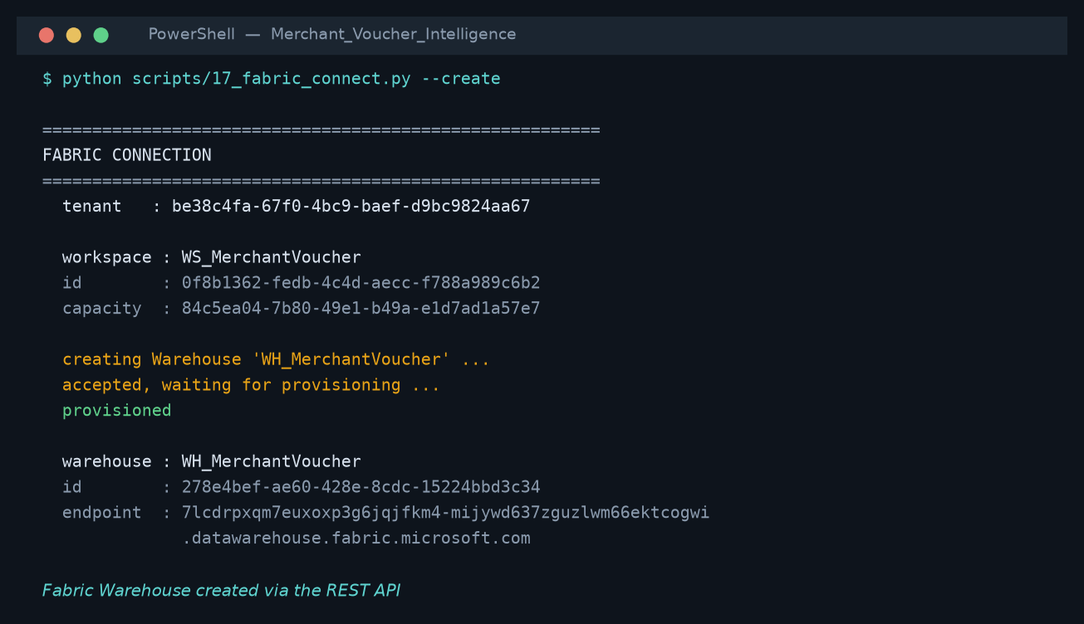
WH_MerchantVoucher, created through the Fabric REST API rather than by hand.

Part 2 — dbt connected
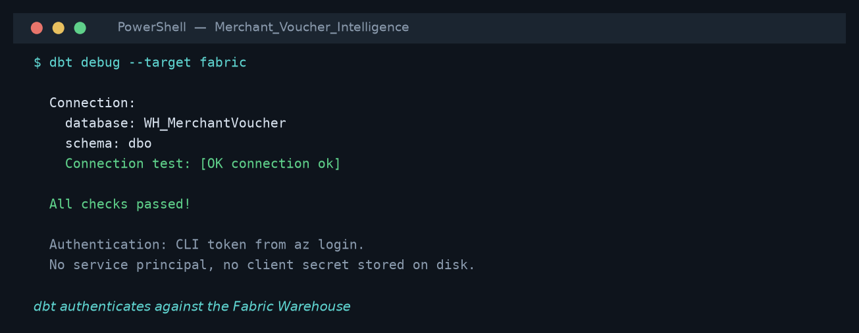
dbt debug --target fabric: All checks passed. Connection and credentials proven.
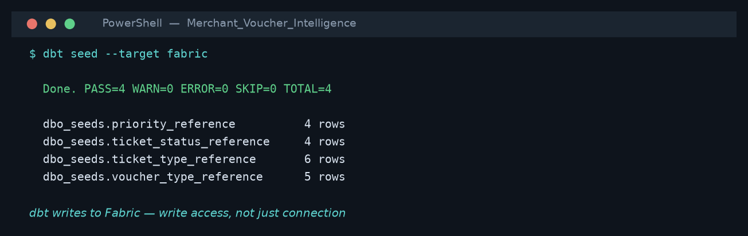
dbt seed --target fabric: PASS=4. WRITE access proven, not just connection.
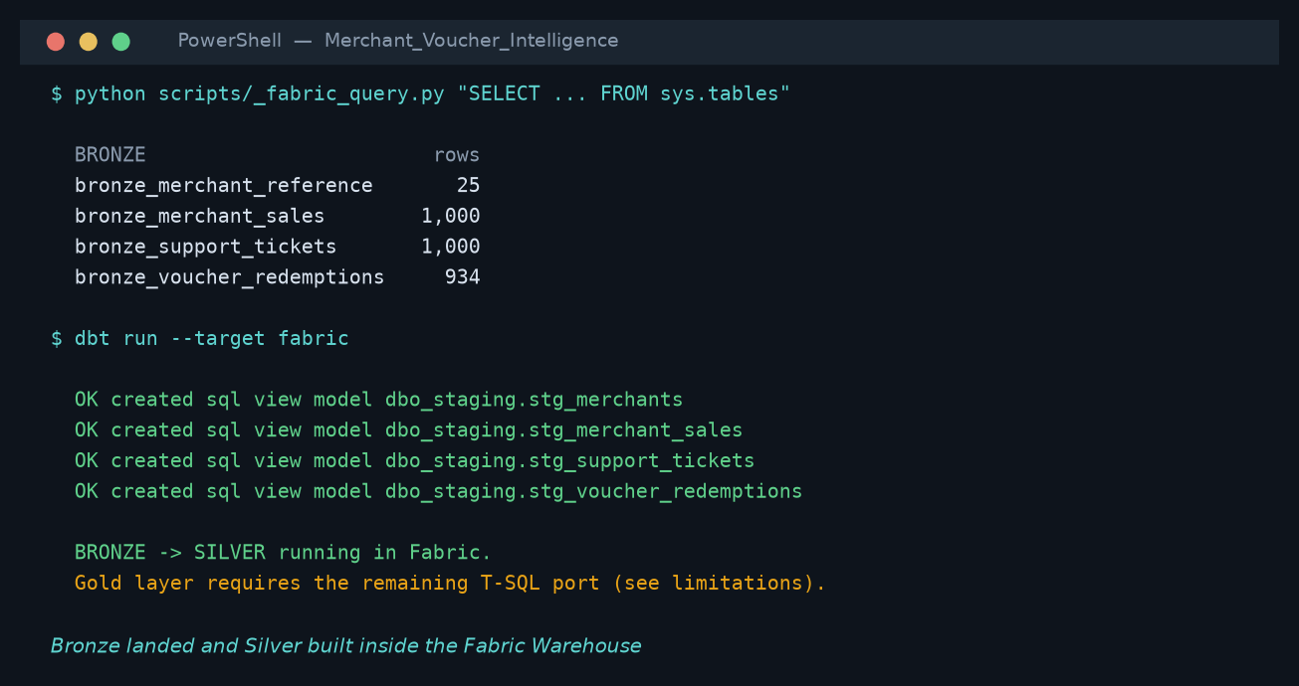
The same four tables seen from the Fabric side.

Part 5 — cost control
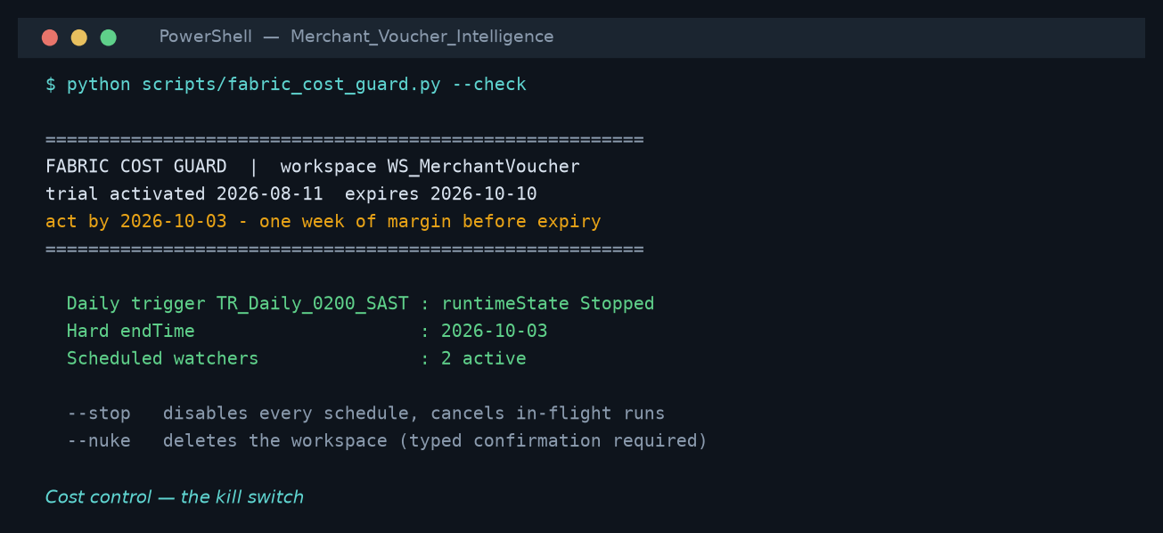
fabric_cost_guard.py --check: the kill switch.

Appendix B. Fabric connection evidence
Captured from the terminal. Unlike a screenshot this can be re-run and re-verified.
Step | Command | Result
Workspace discovered | scripts/17_fabric_connect.py | WS_MerchantVoucher · 0f8b1362-fedb-4c4d-aecc-f788a989c6b2 · trial capacity attached
Warehouse created | POST /v1/workspaces/{id}/warehouses | WH_MerchantVoucher · 278e4bef-ae60-428e-8cdc-15224bbd3c34 · provisioned
Connection tested | dbt debug --target fabric | All checks passed
Write access proven | dbt seed --target fabric | PASS=4 WARN=0 ERROR=0
Models against Fabric | dbt run --target fabric | FAILED — models are DuckDB dialect. Documented in section 4; the port is outstanding
Local build | dbt build (DuckDB) | 156 pass, 0 warn, 0 error
Idempotency | scripts/15_test_idempotency.py | 33/33 — pipeline re-run produces identical output

Stated plainly
dbt connects to Fabric, authenticates and writes. It does NOT yet run the transformation models there: they were written in DuckDB dialect and T-SQL rejects datediff('month', ...) among others. That is a real gap, it is listed in the limitations, and it was only discovered by connecting — which is the argument for connecting rather than describing.

10. Deliverables and how to run
Path | Contents
report/dashboard.html | Interactive 6-page dashboard replicating the Power BI report, plus a build walkthrough. Fully self-contained — opens in any browser with no dependencies.
report/…Submission.docx | This document.
excel/…Report.xlsx | 10-sheet Excel pack: exec summary, merchant scorecard, voucher analysis, operational view, anomalies, ML results, business questions, data dictionary, assumptions.
dbt/ | 13 models, 69 tests, 3 seeds, 3 exposures, macros. Runs on DuckDB (dev) or Fabric Warehouse (prod).
sql/ | Fabric Warehouse DDL and the business-question queries.
notebooks/ | Fabric PySpark notebooks: bronze→silver, ML scoring with MLflow.
datafactory/ | Pipeline JSON, schedule trigger, and the design rationale.
dax/ | 31+ DAX measures across 4 files, with commentary on each convention.
scripts/ | Runnable reference implementation: profile, warehouse, analytics, ML, reconciliation, DAX validation, Excel, dashboard.
data/ | bronze / silver / gold / analytics / ml layers as parquet, plus mvi.duckdb.
docs/ | Profile report, analytics summary, ML summary, reconciliation, DAX validation.

Reproducing the results
The full pipeline runs end to end in under two minutes:
python scripts/01_profile.py
python scripts/02_build_warehouse.py
python scripts/03_analytics.py
python scripts/04_ml_models.py
cd dbt && dbt seed && dbt run && dbt test
python scripts/05_reconcile.py
python scripts/06_validate_dax.py
python scripts/07_build_excel.py
python scripts/08_build_dashboard.py

A closing note on verification
Three claims in this submission are independently checkable rather than asserted. The gold layer is built twice by different engines and reconciles to the cent. Every DAX measure has a SQL-derived expected value in docs/dax_validation.csv. And the anomaly model recovered all four deliberately embedded patterns without being told what they were. Where a result was weak or a correlation was confounded, that is stated in the report rather than smoothed over — which is the more useful habit in a BI function, because the cost of a confident wrong number is far higher than the cost of an honest caveat.

Appendix C. Live Fabric execution evidence
The original notebook capture below records the starting state in Microsoft Fabric. The cell was configured as PySpark (Python), so the T-SQL statement was parsed as Python and returned SyntaxError. The correction was to execute Fabric-compatible T-SQL against the Warehouse SQL endpoint.
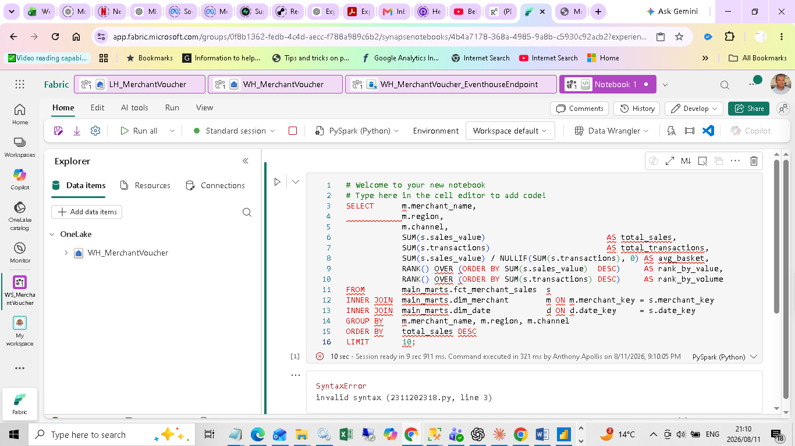
Figure C.1 - Fabric notebook attached to WH_MerchantVoucher before correction; the cell language is PySpark (Python), which explains the syntax error.

Gold load and verification
The locally verified gold exports were staged in LH_MerchantVoucher through OneLake. The missing main_marts schema and tables were then created in WH_MerchantVoucher and loaded with the Warehouse COPY INTO statement under the signed-in Entra identity. The query below was executed afterwards through the live Fabric SQL endpoint.
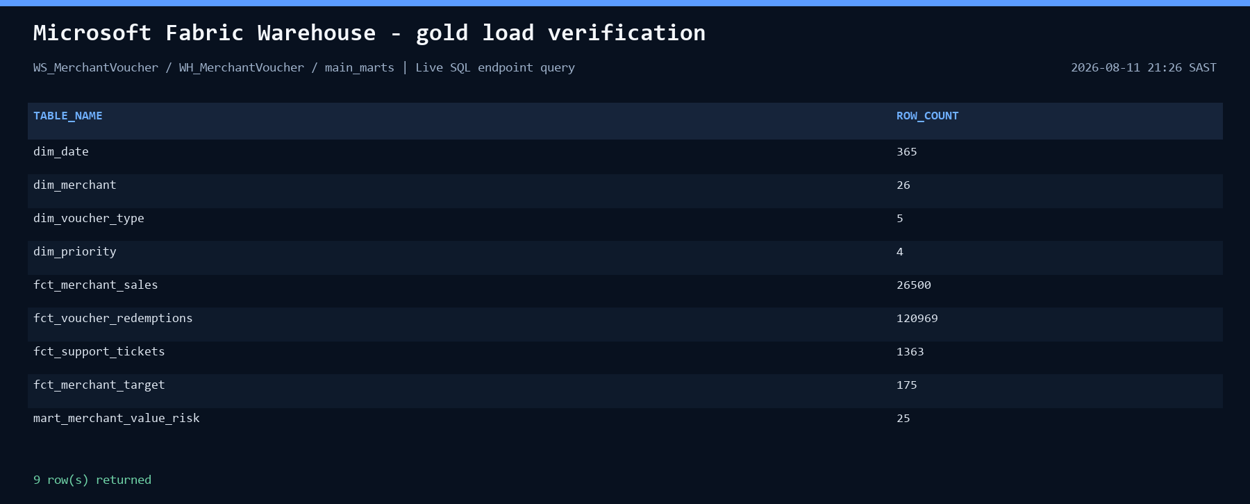
Figure C.2 - Live WH_MerchantVoucher row-count verification after the OneLake to Warehouse COPY INTO load.

Executed report queries
All eight statements in the SQL report pack were ported from DuckDB syntax to Fabric Warehouse T-SQL and executed successfully. The required rewrites were TOP for LIMIT, window logic for MAX_BY, PERCENTILE_CONT for MEDIAN/QUANTILE_CONT, BIT predicates for Boolean conditions, and CONVERT for STRFTIME.
Query | Business question | Rows returned
Q1 | Top merchants by value and volume | 10
Q2 | Redemption rate by voucher type | 5
Q3 | Regional trend against own peak | 5
Q4 | Support tickets versus sales | 10
Q5 | Management focus by value at risk | 10
Q6 | SLA performance by priority | 4
Q7 | Target attainment | 10
Q8 | Fact population reconciliation | 2
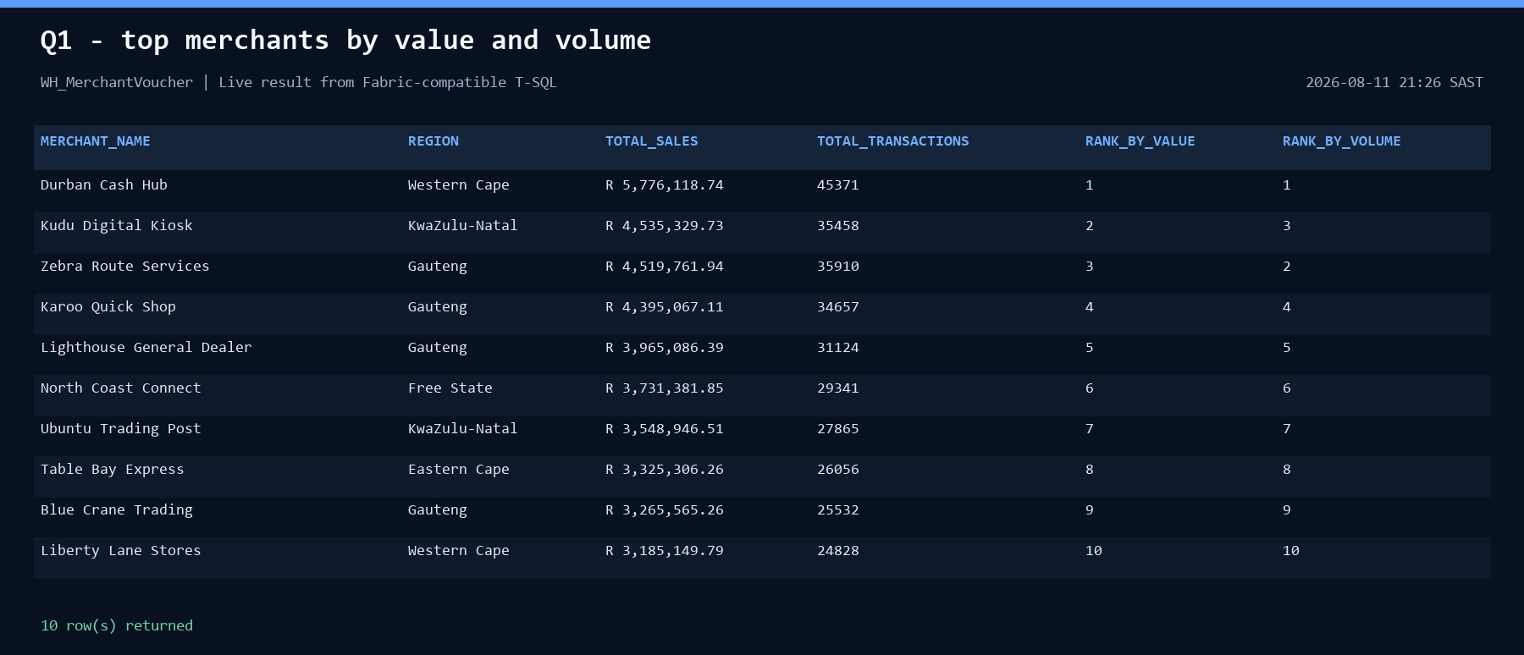
Figure C.3 - Q1 live Warehouse result: top merchants by sales value and transaction volume.
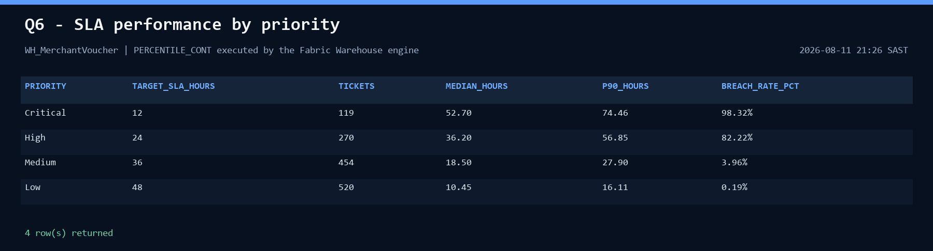
Figure C.4 - Q6 live Warehouse result: SLA performance using Fabric's PERCENTILE_CONT implementation.
Evidence scope. These captures prove live OneLake staging, Warehouse loading, schema verification, and T-SQL query execution in Fabric. They do not claim that the complete dbt model graph ran natively on Fabric; the dbt T-SQL portability work remains separately disclosed in Appendix B.

Appendix D. PC ingestion and medallion orchestration
A local delivery package, MerchantVoucher_Raw.zip, was uploaded from the project PC to LH_MerchantVoucher/Files/landing in OneLake. A Microsoft Fabric Data Factory pipeline then executed four dependent notebooks to unpack the delivery, publish Bronze Delta tables, conform Silver tables, publish Gold facts and dimensions, and apply a final population gate.
Stage | Fabric item | Item ID | Control
01 PC ZIP to Bronze | nb_01_pc_zip_to_bronze | b633701f-2e42-4514-a34b-3960a2a36f56 | ZIP extraction + lineage
02 Bronze to Silver | nb_02_bronze_to_silver | 0f7a0b51-9929-49c3-a954-cdfcf05b2cd9 | Clean + deduplicate
03 Silver to Gold | nb_03_silver_to_gold | a0564e65-2c0e-4756-9f22-a9695dd98cda | Dimensions + facts
04 Data quality gate | nb_04_medallion_validation | 916b9465-a1a1-46b2-9e58-fdafacfcbaab | Non-empty assertions
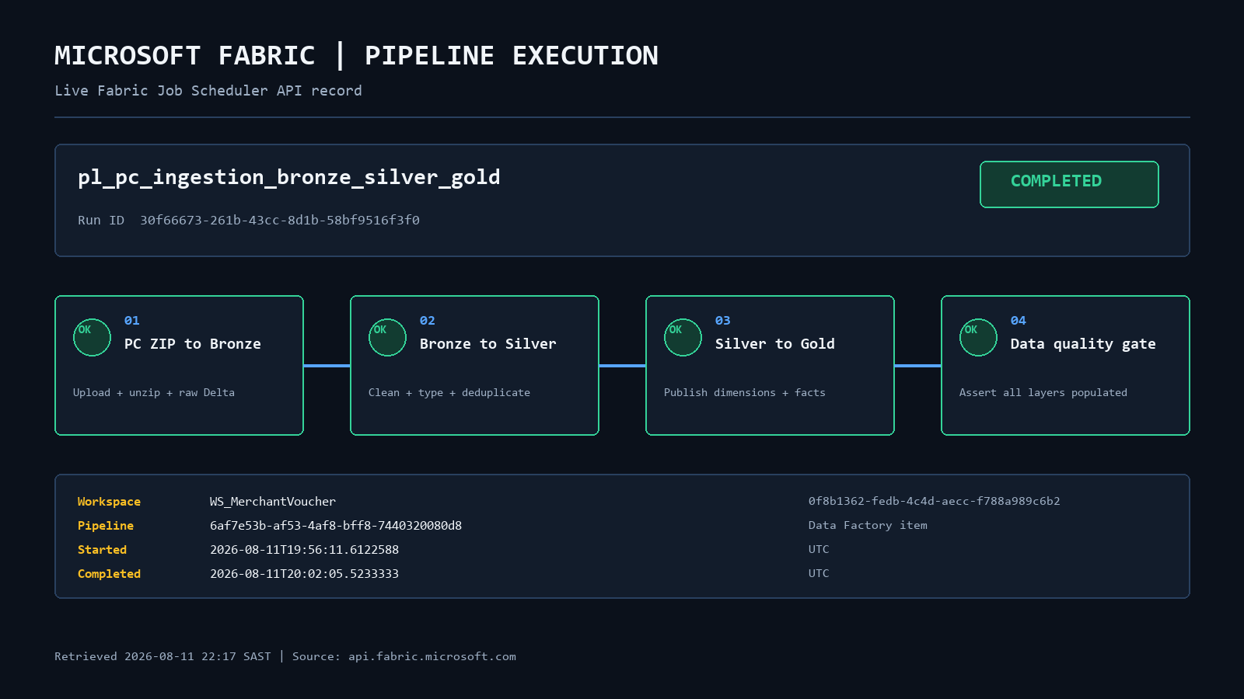
Figure D.1 - Live Fabric Job Scheduler API record for the completed Data Factory pipeline run. Run ID 30f66673-261b-43cc-8d1b-58bf9516f3f0.

PC upload and ZIP extraction
The package contains MerchantReference.csv, MerchantSales.csv, VoucherRedemptions.csv, and SupportTickets.csv. The first notebook expands the ZIP inside the attached Lakehouse, reads each CSV through its absolute OneLake ABFSS path, adds source-file, run-ID, and ingestion-time lineage fields, and writes the four Bronze tables in Delta format.
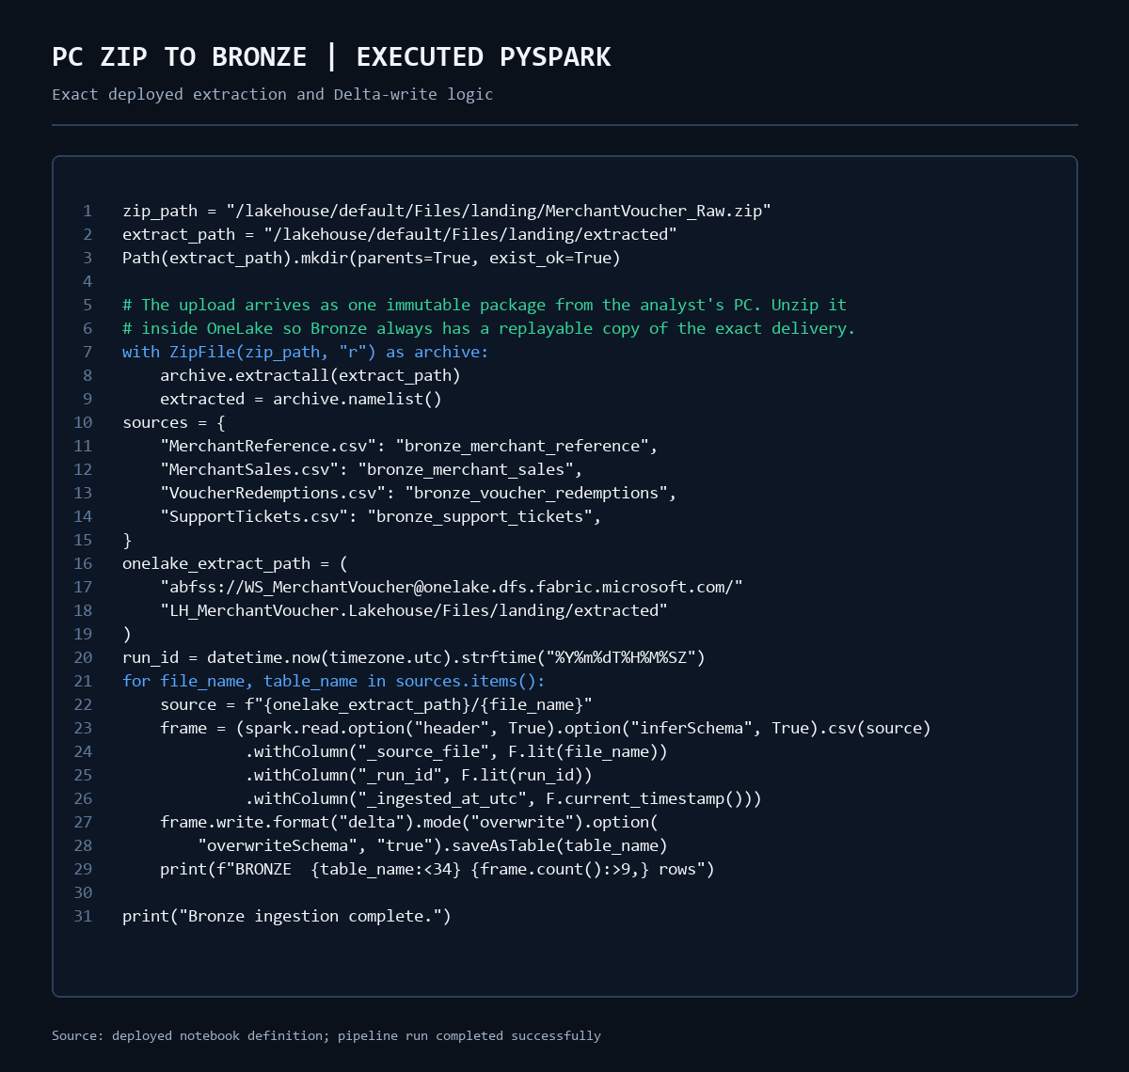
Figure D.2 - Exact PySpark deployed to nb_01_pc_zip_to_bronze, including local-PC ZIP extraction, ABFSS reads, lineage columns, and Bronze Delta writes.

Bronze, Silver and Gold controls
Layer | Purpose | Implemented control
Bronze | Replayable raw landing | Source package retained; four Delta tables receive run and source lineage.
Silver | Conformed analytical data | Column names normalised; strings trimmed; business keys deduplicated.
Gold | Reporting-ready star schema | Merchant dimension and three facts published with date keys and BI flags.
Quality gate | Completion control | All twelve expected tables checked; the pipeline fails if any table is empty.
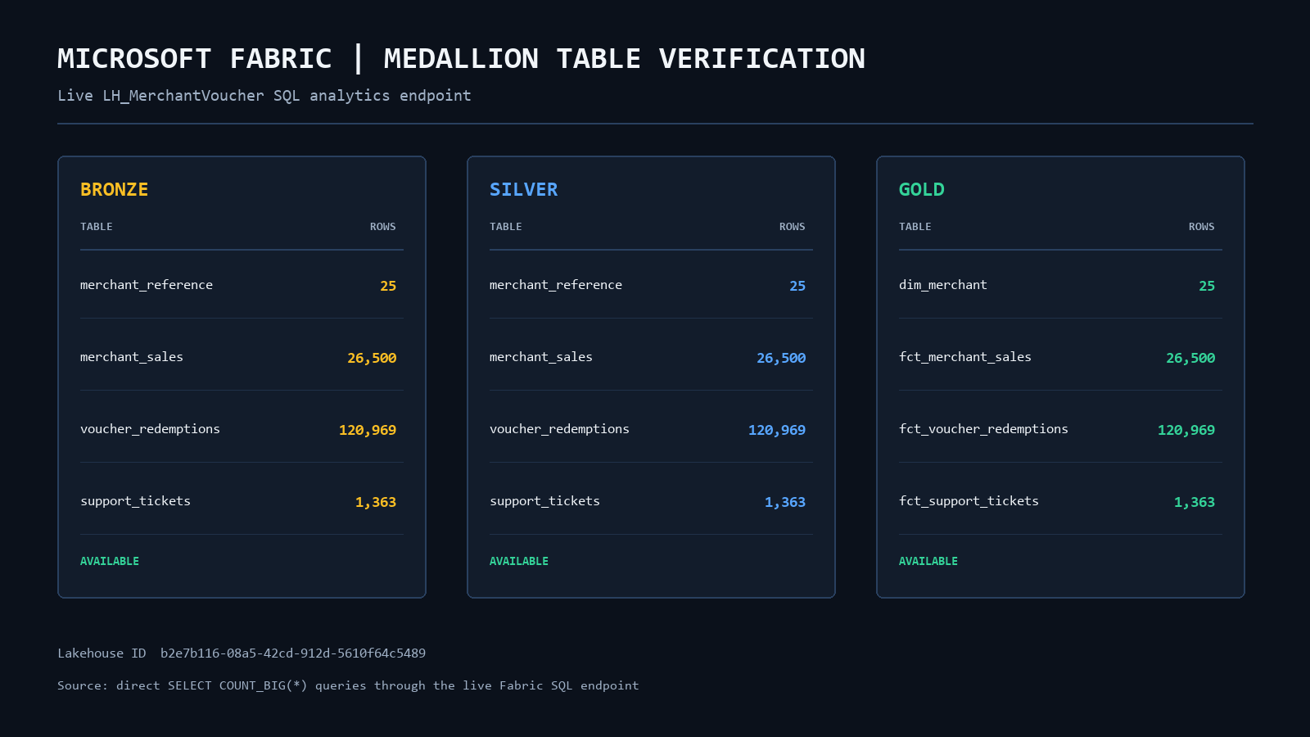
Figure D.3 - Live Lakehouse SQL endpoint verification after pipeline completion. The corresponding Bronze, Silver, and Gold datasets are all available.

Traceability
Workspace: WS_MerchantVoucher (0f8b1362-fedb-4c4d-aecc-f788a989c6b2)
Lakehouse: LH_MerchantVoucher (b2e7b116-08a5-42cd-912d-5610f64c5489)
Pipeline: pl_pc_ingestion_bronze_silver_gold (6af7e53b-af53-4af8-bff8-7440320080d8)
Execution: Completed; 2026-08-11 19:56:11 to 20:02:05 UTC
Fabric pipeline API record: open execution endpoint
Evidence scope. Figures D.1 and D.3 are rendered evidence extracts from live Fabric API and SQL endpoint responses; Figure D.2 is rendered from the exact deployed notebook definition. They supplement the genuine Fabric portal capture already included in Appendix C and are not representations of the portal user interface.

