Red & Yellow
From marketing spend to student outcomes
A CRM analytics platform built on Salesforce, Apache NiFi, dbt, Microsoft Fabric and Power BI
09 September 2026 | Anthony Apollis
The programme catalogue in this document is real, transcribed from the public Red & Yellow website. Every person, campaign, application and enrolment is synthetic. Nothing here is an export from Red & Yellow's own systems.

Contents
Right-click here and choose Update Field to build the contents list.

1 Introduction
Red & Yellow advertised for a Data Analytics Engineer whose brief is CRM integration: build the pipelines, catalogue the data, model it, and put it in front of people who make decisions. The advert names six things - a data catalogue, ERDs for internal systems, ETL preferably in Apache NiFi, Salesforce data extracted and analysed, Power BI dashboards, and data quality held to a standard.
This document is the working answer to all six, and it is written to be checked rather than admired. Every figure in it is generated from a live query or a live API call at the moment the document is built, so nothing here can describe a pipeline that has stopped working. Where something does not work, or could not be done, it says so.

1.1 How to read it
- The numbers first. Chapter 2 sets out what was built and how much of it there is.
- Then the decisions. Chapters 3 to 8 cover the modelling choices that are actually arguable - spend attribution, de-duplication, what a blank means - and what happened when each was got wrong first.
- Then the evidence. Chapters 9 to 11 show the Salesforce integration step by step, the two predictive models with their metrics against a base rate, and the running NiFi and Fabric infrastructure.
- Finally the limits. The last chapter is what this work does not claim.

One thing to hold in mind throughout: the programme catalogue is real, transcribed from Red & Yellow's public site. Everything about people - every lead, contact, application, enrolment and result - is synthetic, and the relationships between them were put there deliberately so the pipeline had something to find. That makes this a demonstration of method, not a finding about Red & Yellow.

2 What this is
Red & Yellow's Data Analytics Engineer role asks for six things: a data catalogue, ERDs for CRM data models, ETL pipelines built preferably in Apache NiFi, Salesforce CRM data extracted and analysed, Power BI dashboards, and data quality held to a standard. This document is the working answer to all six, built end to end on a dataset of 2,694,805 people and 11.5 million rows.
The architecture follows the shape the role describes. Salesforce is the operational CRM. NiFi replicates it into a lakehouse. dbt cleanses, tests and documents. Power BI reads the curated marts. The interesting engineering is not in any one of those tools - it is in the decisions between them, which is what this document is about.
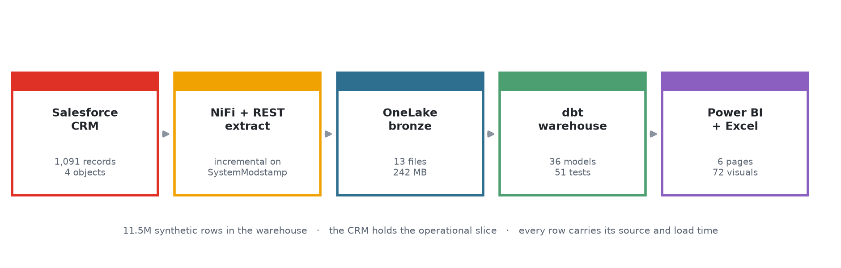
Figure 0 - The pipeline end to end. Each stage is a separate, runnable component; nothing here is a diagram of an intention.

2.1 The numbers
Leads captured | 1,500,000
Contacts after de-duplication | 1,165,332 (from 1,194,805 records)
Opportunities in the admissions pipeline | 740,779
Applications submitted | 533,360
Enrolments | 303,656
Marketing spend | R472.0m
Enrolled revenue (agreed fees) | R2,328.1m
Data quality issues detected | 329,994
Programmes / offerings / intakes (real) | 83 / 89 / 47

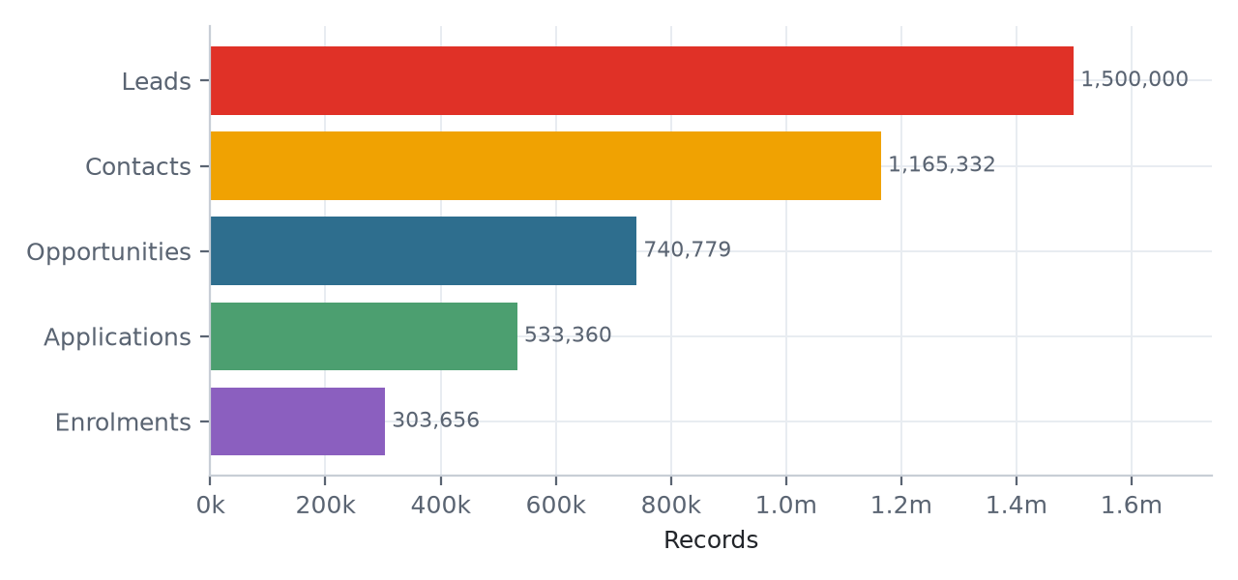
Figure 1 - The funnel by stage. Leads and contacts overlap, so the step between them is not attrition.

2.2 Where the marketing money goes
Cost per enrolment sits between R1,848 and R2,874 across channels, on a return of 2.6x to 4.2x. Career expo returns the most per rand at 4.19x; Print the least at 2.65x.
One modelling decision matters more than any of these numbers. Campaign spend is aggregated to campaign grain before it is joined to enrolments. Join spend to the fact table first and every campaign's cost is silently multiplied by its downstream row count - a campaign with 400 enrolments reports 400 times its real budget, and the resulting return on ad spend looks spectacular. A dbt test compares total spend in the fact against total spend in the dimension and fails the build if they diverge.
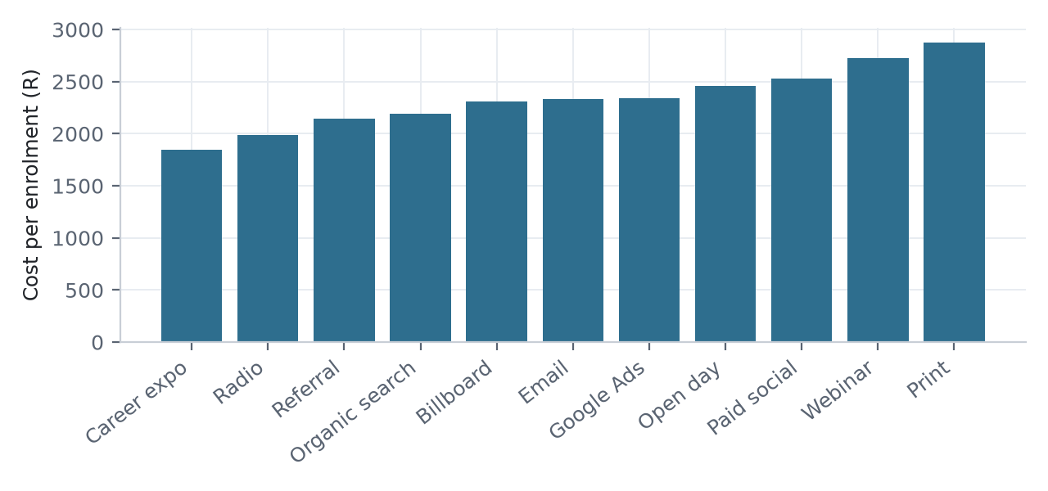
Figure 2 - Cost per enrolment by channel.

2.3 Student success as an early warning
Attendance opens at 83% and decays to 67% by week 19. The proportion of students meeting the at-risk definition - attendance under 55%, or assessment average under 50%, or three or more overdue assignments - moves from 8% to 29%.
The definition lives in one place, in the fct_student_progress_weekly model. That is deliberate: 'at risk' is the kind of term that acquires three incompatible meanings across three dashboards if each report defines it locally.
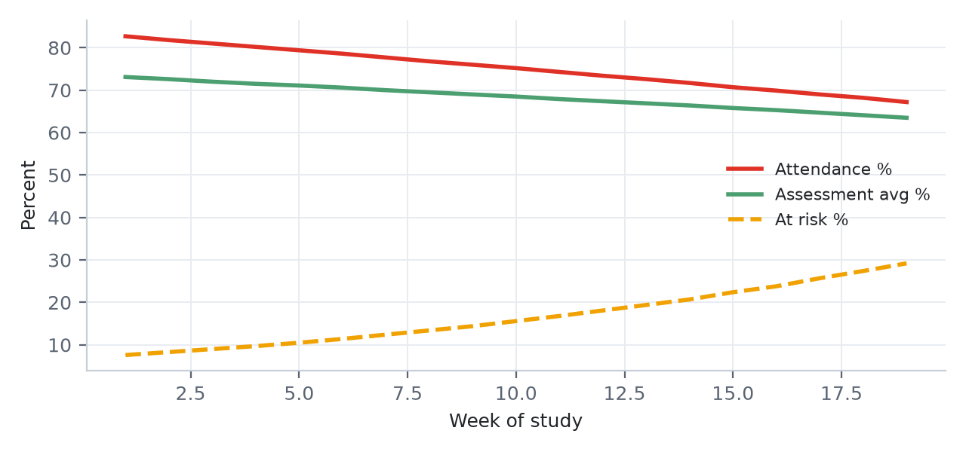
Figure 3 - Academic health across the study weeks.

2.4 Data quality, measured rather than asserted
Every pipeline claims to handle dirty data. This one is tested against a known answer. Defects are injected into the source at recorded rates - duplicate humans, phone format drift, invalid and missing emails, province spelling variants, inverted dates, negative values, late-arriving records - and written to a ground-truth manifest. The pipeline's detection is then scored against that manifest as recall.
Across 2,941,380 injected defects the pipeline detects 329,994 issues. De-duplication recovers 0.97 of the duplicates that were planted.

2.4.1 Why de-duplication needed two keys
The first attempt keyed contacts on email, falling back to name plus phone. It reported 682,000 duplicates against 29,000 real ones. The cause was the name pool: across a million contacts drawn from a realistic South African name distribution, 'Thabo Nkosi' recurs legitimately thousands of times, and coalescing a null phone to an empty string collapsed all of them together.
Keying strictly on email fixed the false positives and created the opposite problem. Recall fell to 0.52, because the two duplicate shapes a CRM actually produces are different: someone re-submitting the web form repeats their email, while someone phoning in leaves no email at all. A record that has an email and a record that does not can never share a single key value.
The working version anchors on email and on phone-plus-surname independently, takes the lower anchor, then propagates once within each phone group so a phone-only record inherits the cluster of the emailed record it shares a handset with. Recall 0.97. The remaining 3% are records where both email and phone were dropped at source, which no amount of matching can recover.
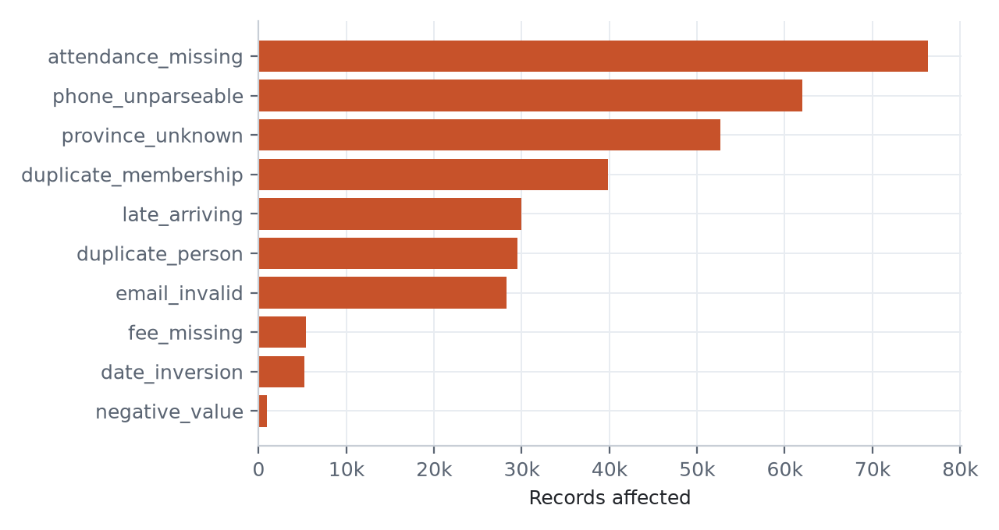
Figure 4 - Detected issues by type.

2.5 Where the demand actually is
The catalogue is real, so programme demand is the one place where the synthetic pipeline meets Red & Yellow's actual offering. These are the programmes carrying the most enrolments in the modelled pipeline, and the discount being conceded to win them.
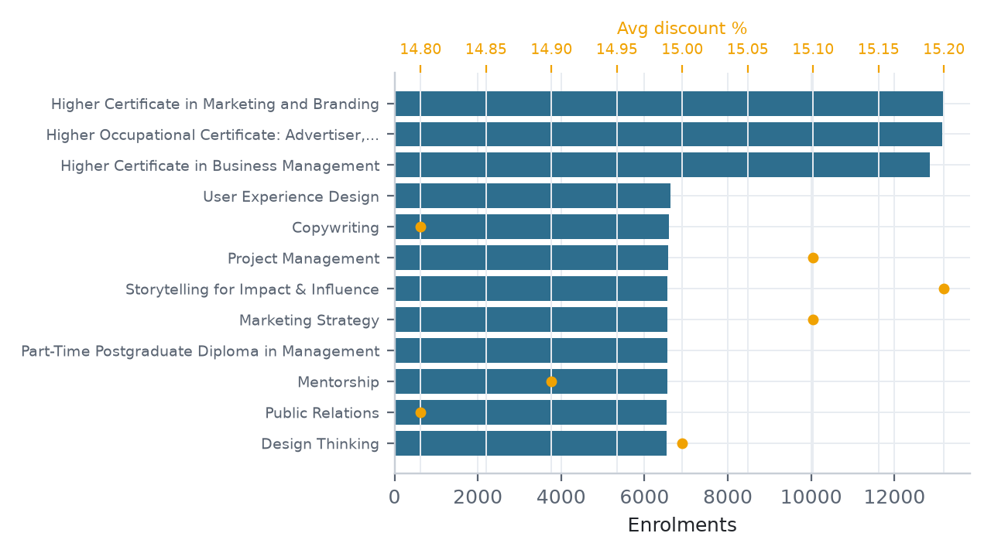
Figure 4a - Top programmes by enrolment, with average discount.

2.5.1 Who is enrolling, and from where
Province is one of the dirtiest fields in the source - 'Western Cape', 'western cape', 'W Cape', 'WC' and 'Wes-Kaap' all arrive - and one of the most useful once collapsed. Anything that cannot be resolved is kept as Unknown rather than guessed at.
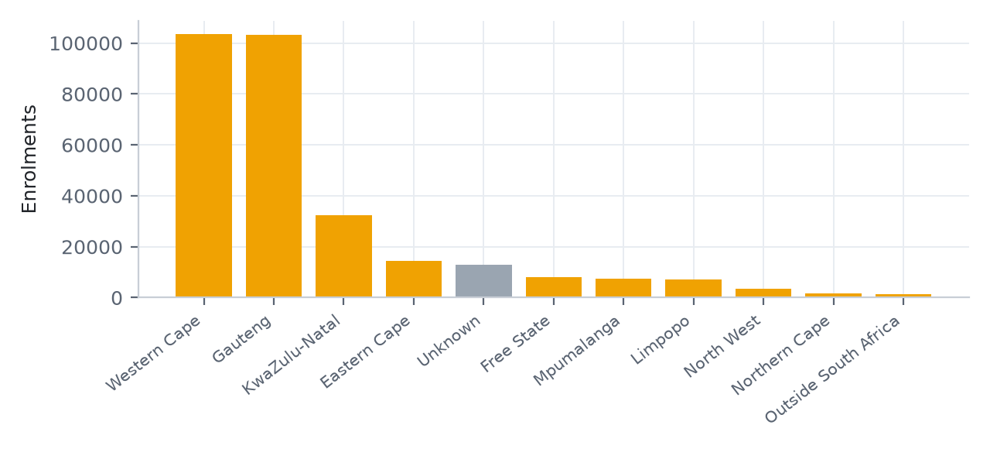
Figure 4b - Enrolments by province, after the spelling variants are collapsed to the nine official names.

2.5.2 The funnel as conversion, not counts
Absolute counts down a funnel flatter the top of it. The rates between stages are what a marketing team can act on.
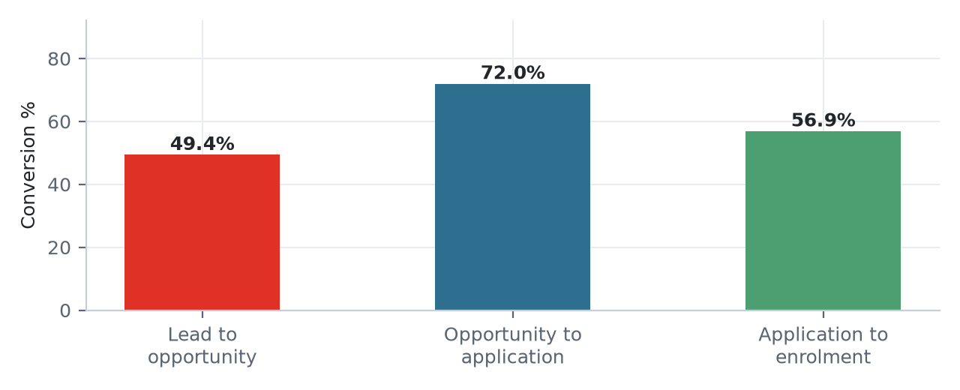
Figure 4c - Stage-to-stage conversion through the admissions pipeline.

2.6 Blanks that are not gaps
Some of the catalogue's most careful values are empty. An offering priced 'Enquire for price' carries no amount, and a clipped screenshot yields no duration. Both are recorded as null with a status explaining why.
Filling those with zero would be the single most damaging thing this pipeline could do. Zero is a price. It would drag every average fee downward, understate pipeline value, and make the free courses look like a growth segment. A dbt test fails the build if any offering with a price status of Enquire acquires a fee.

2.7 Why the CRM holds thousands and the warehouse holds millions
Salesforce charges data storage per record, at roughly 2 KB each. A Developer Edition org holds about 10,000 records in total across every object. Loading nine million rows into the CRM is not a scaling problem to engineer around - it is not possible, and an org that hit its ceiling mid-load would leave dangling foreign keys behind it.
So the split follows the job description rather than fighting it. Salesforce holds a referentially complete operational slice of roughly two thousand records, safe to demo and safe to re-upsert on an external ID. The warehouse holds the full history, the volume and the quality work. That is what a CRM integration role means in practice: knowing which system each question belongs to.

2.8 The pipeline, end to end
- Extract. NiFi's QuerySalesforceObject pulls Lead, Contact, Campaign, CampaignMember and Opportunity incrementally on SystemModstamp, holding the high-water mark in processor state so a restart does not replay history.
- Land. Records are batched and written to the OneLake bronze layer, partitioned by object and ingest date. Failures retry three times before parking.
- Transform. dbt cleanses once in staging - email validation, E.164 phone normalisation, province collapsing, entity resolution - then builds marts that assume clean inputs.
- Test. 51 data tests run on every build: uniqueness, referential integrity, accepted values, and three bespoke tests guarding spend multiplication, enquire-pricing and golden-record uniqueness.
- Document. dbt docs generate produces the searchable catalogue with column-level lineage, so documentation is a build artefact rather than a wiki page that drifts.
- Report. Power BI reads the curated marts. Every measure resolves to a tested model, not to a query written in the report.

3 Salesforce integration, step by step
This section documents the CRM integration as it actually ran, not as it was designed to run. Every figure below is rendered from live command output or a live query against the org at the moment this document was built, so it cannot describe a pipeline that no longer works.
1,091 records were loaded across 4 objects: Account 25, Contact 408, Lead 408, Opportunity 250.

3.1 1. Establish whether the org can host the model
The target trial org runs Salesforce Base Edition, which permits zero custom objects. That is an edition entitlement rather than a quota or a permission, so no configuration changes it - and it is knowable in a single API call. Checking first turns a failure at deploy time into a decision at design time.
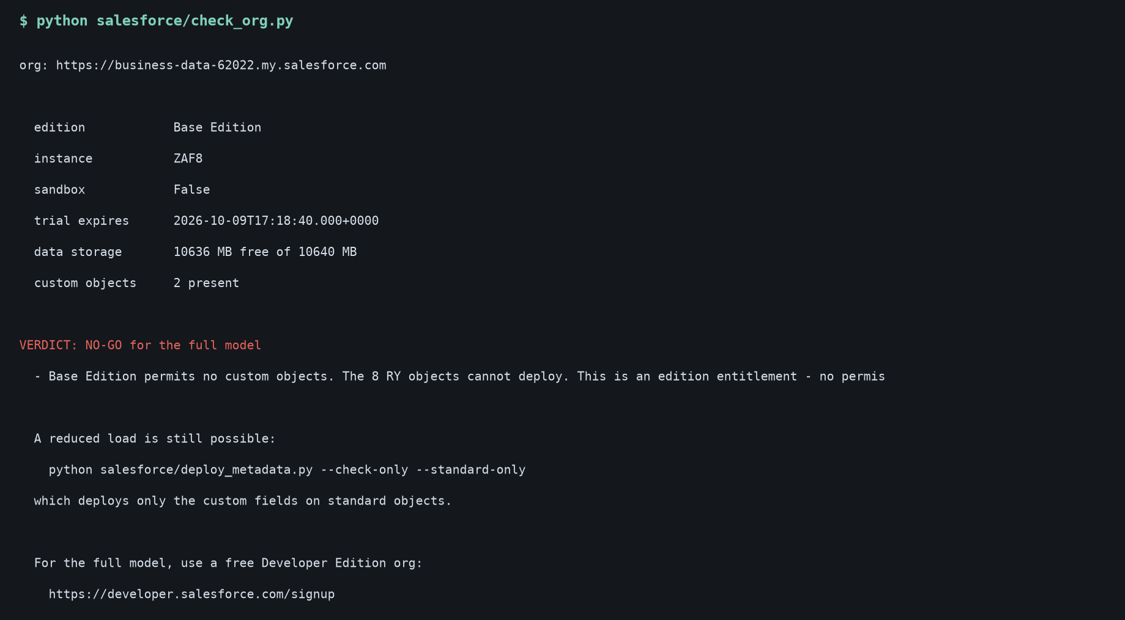
Figure 5 - The org capability check. Base Edition, 10.6 GB free, and a NO-GO on custom objects.

3.2 2. Deploy what the edition does allow
The eight custom objects cannot deploy, but the eighteen custom fields on standard objects can. Deploying fields without field-level security is a trap worth naming: the fields exist, but describe() omits them and the upsert then fails claiming the external ID is not unique - because the API cannot see the field it is being asked to key on. The permission set is trimmed to the deployed fields and assigned over REST.
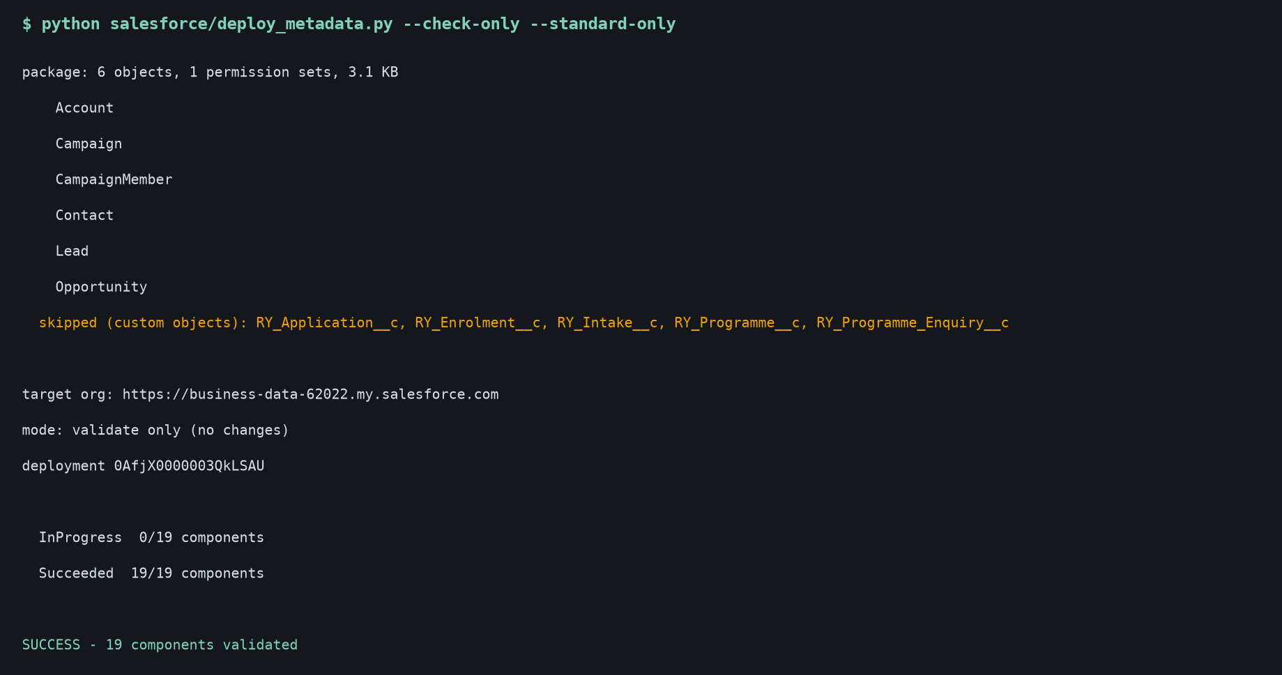
Figure 6 - Metadata validated against the org. 18 of 18 components.

3.3 3. Load the operational CRM slice
Accounts, contacts, leads and opportunities, upserted on an external ID so the load is idempotent - re-running updates rather than duplicates. Two things pushed back, and both were right to. Salesforce rejects the external ID in the request body when it is already the key in the URL. And its duplicate rules blocked leads that fuzzy-matched existing contacts at 100% confidence - the same duplicates the warehouse's own entity resolution finds, caught independently by the CRM.
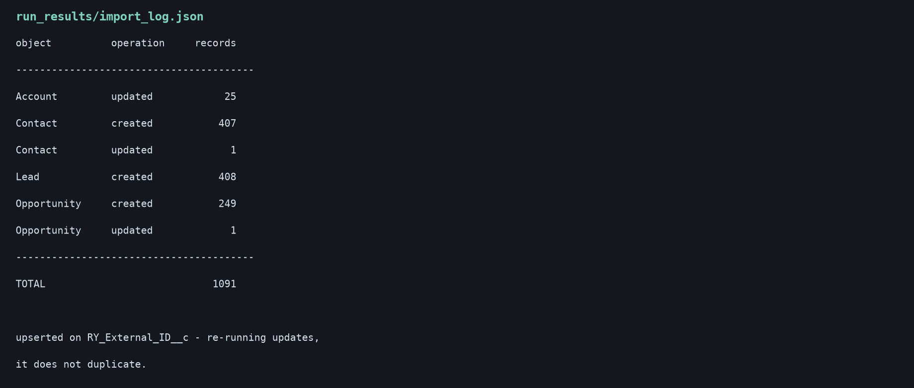
Figure 7 - What the loader wrote.
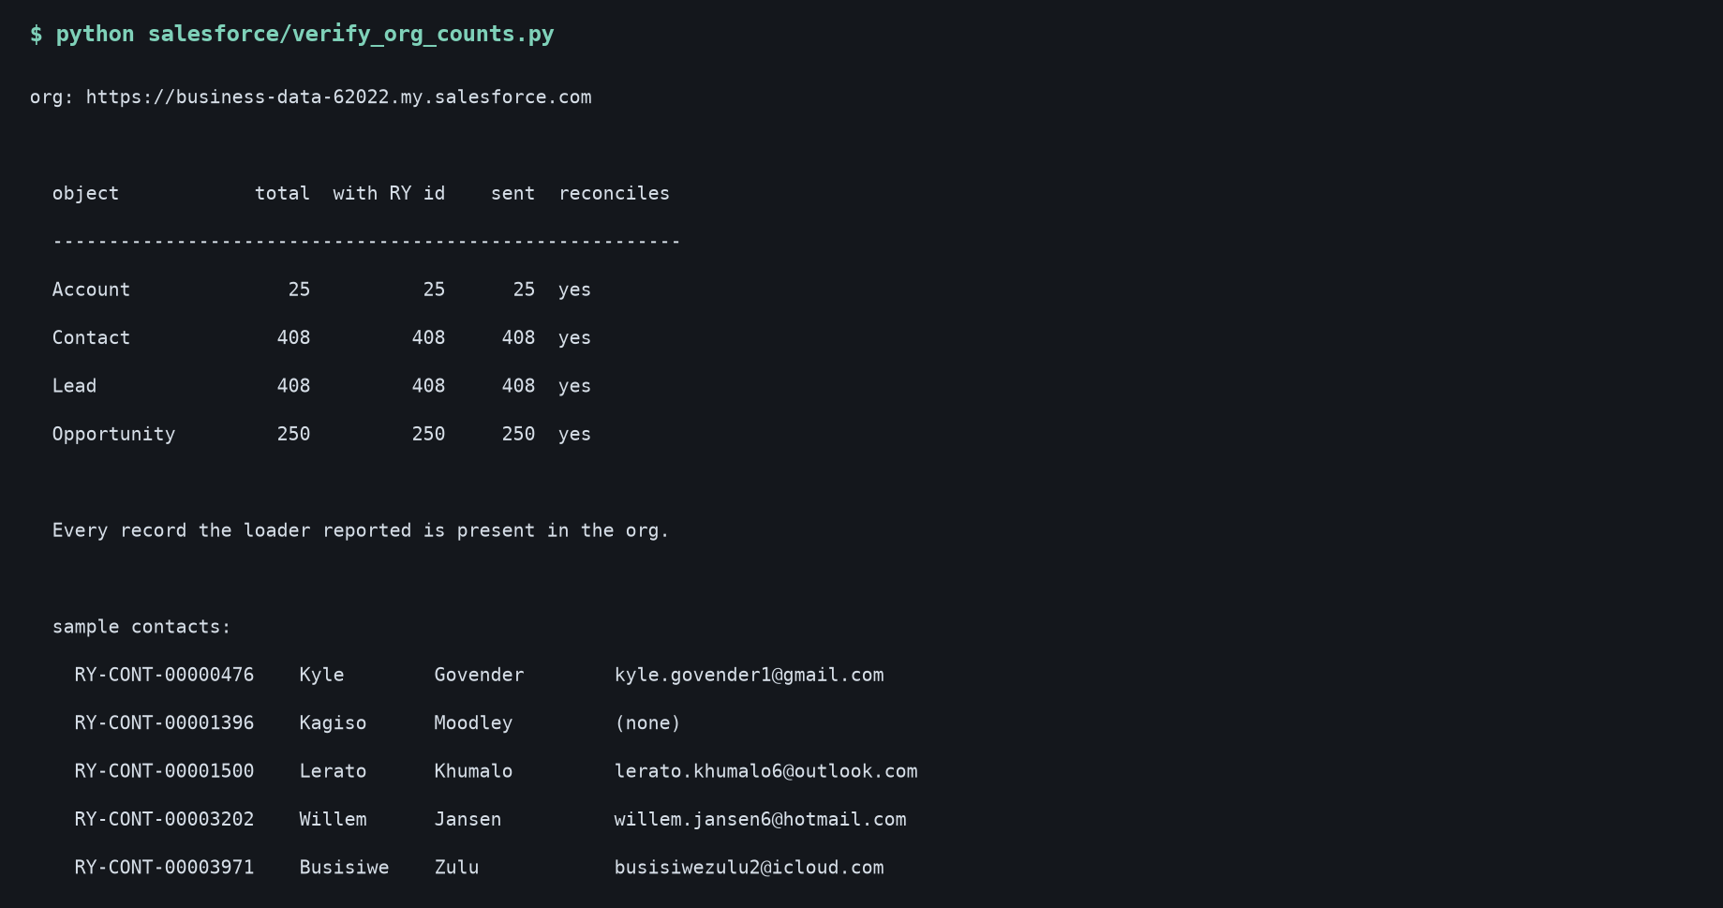
Figure 8 - What is actually in the org, queried back through the API. The loader's claim and the org's state are different assertions; only the second is evidence.

3.4 4. Extract it back out through the API
This is the part the role is actually about. SOQL over the REST API, paginating through nextRecordsUrl so the 2,000-record page limit is handled rather than silently truncating, with the high-water mark on SystemModstamp persisted between runs. The first run is a full load; the second returns zero rows because nothing changed. Deletions are captured through queryAll rather than left to linger.
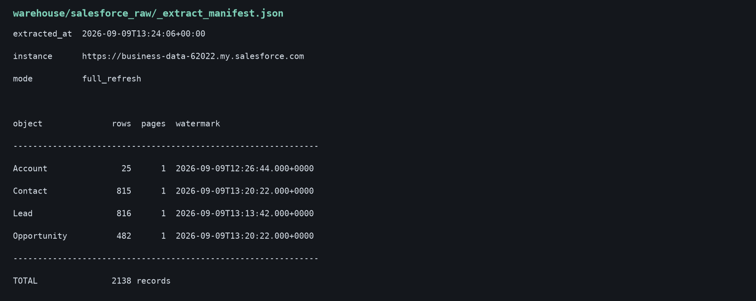
Figure 9 - Extraction manifest. Every row carries its source system, source id, source update time and extraction time.

3.5 5. Transform, test, and report
From there the extracted data joins the same warehouse the synthetic history lives in, is cleansed once in staging, and is consumed by marts that Power BI reads directly. The tests run on every build.
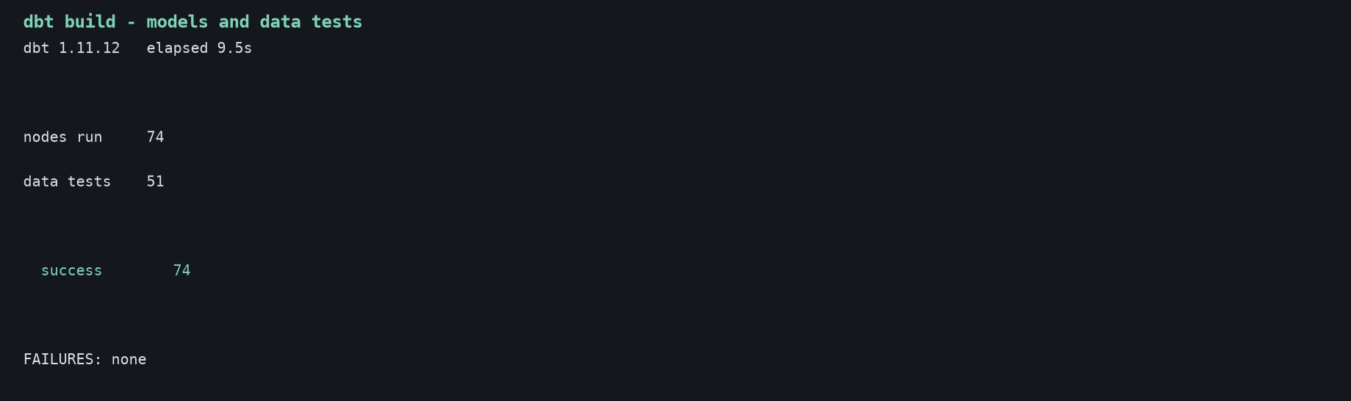
Figure 10 - dbt build: models and data tests.

4 Two models, and what they are worth
Both models are split by time rather than at random, and restricted to what is known at the moment a decision is made. The lead model cannot see the opportunity a lead later generated; the withdrawal model sees only the first four weeks. Leaking a downstream outcome into the features is the easiest way to build a model with a beautiful score and no use whatever.
Model | Base rate | AUC | PR-AUC | Top-decile lift
Lead to enrolment propensity | 5.2% | 0.667 | 0.094 | 2.17x
Withdrawal risk from weeks 1-4 | 12.5% | 0.621 | 0.178 | 1.67x

An AUC in the mid-0.6s is not a headline, and it should not be. These are human decisions with a great deal of unexplained variation; a model claiming 0.95 on this data would mean a feature had leaked. What matters operationally is the lift: the top tenth of leads by score converts at over twice the base rate, which is the difference between working a list in arrival order and working it in priority order.
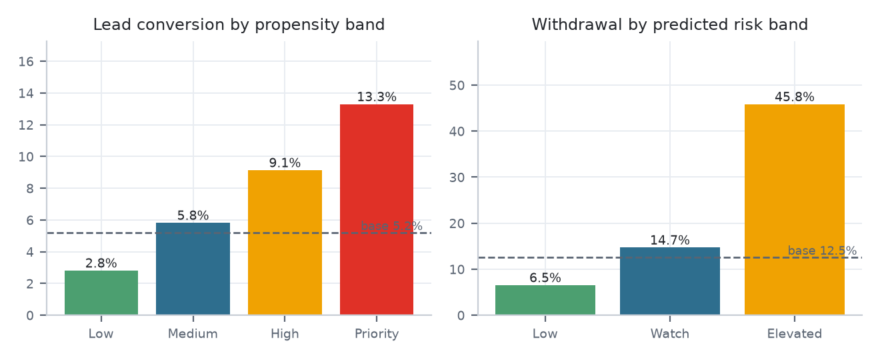
Figure 10a - Conversion by propensity band, and withdrawal by risk band. If the bars do not separate, the model is not ranking anything.
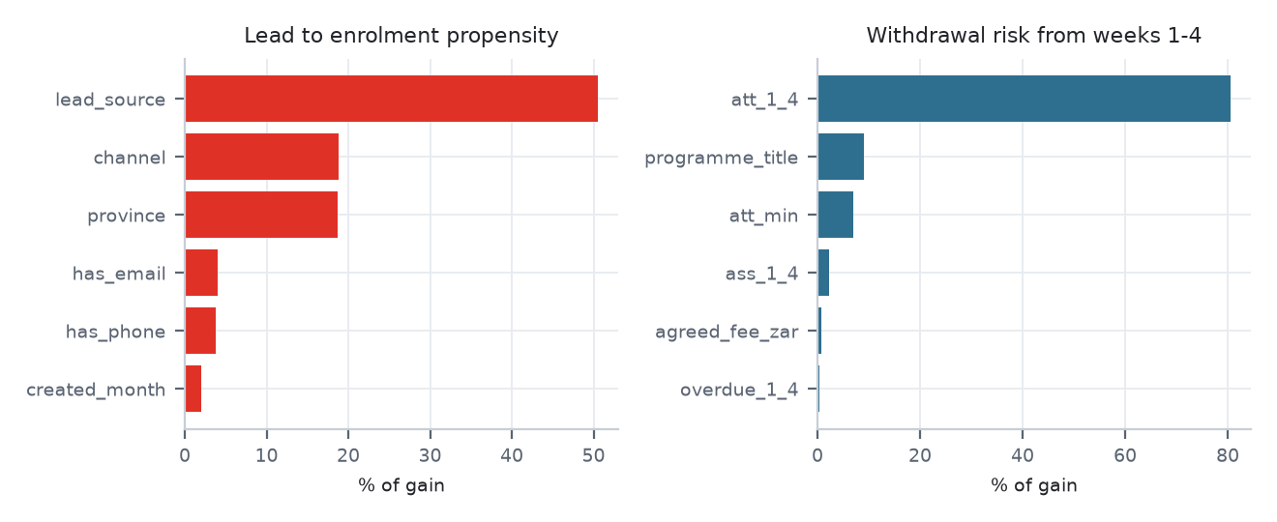
Figure 10b - What each model actually leans on.

4.1 What to do about it
- Marketing. The top 5% of leads by propensity convert at 13.3%, against 2.8% in the bottom half - a 5x difference. Route the Priority band to human follow-up within 24 hours and leave the Low band to automated nurture. The same team covers more pipeline without more headcount.
- Channel mix. Referral converts at 9.8% versus Walk-in at 2.2%, on 30,421 leads. Rebalance spend toward Referral, and either fix the qualification criteria on Walk-in or stop paying for it.
- Retention. 168 enrolments (0.1%) are flagged Elevated or Intervene from weeks 1-4 alone, and they withdraw at 45.8% against 12.5% overall. Trigger outreach at week 4 rather than at the first missed assessment. The signal is present before the student is far enough behind to recover from.
- Early warning. Withdrawal rate by weeks 1-4 attendance: (0, 50] 21.4%, (50, 65] 22.4%, (65, 80] 16.4%, (80, 100] 9.1% Attendance below 65% in the first month is the single clearest trigger. It needs no model to act on - the model only tells you how much of the remaining risk it explains.

4.2 An honest caveat
These models are trained on synthetic data whose structure was put there deliberately. They demonstrate the method - time-based splits, decision-time features, scoring against a base rate, lift as the operational metric - not a finding about Red & Yellow. On real data the effect sizes would differ, and the first job would be to check whether they hold at all.

5 How the warehouse is organised
The warehouse follows a medallion layout, and it is a real one rather than three schema names: silver reads bronze, never the source file. That matters because it is what makes the lineage answer the question “what actually arrived?”. Without a bronze layer, dbt’s graph begins at the cleansed data and the landed source is invisible to the catalogue - you can see what a column became, but not what it was.
Layer | What it holds | Rule
Bronze | 13 models - the landed source made queryable | No renaming, casting or filtering
Silver | 13 models - cleansed and conformed | Every cleansing decision lives here and nowhere else
Gold | 8 models - business-level facts and dimensions | Assumes clean input; never re-cleans
Quality | 2 models - the defect log and its summary | Describes the pipeline, not the business

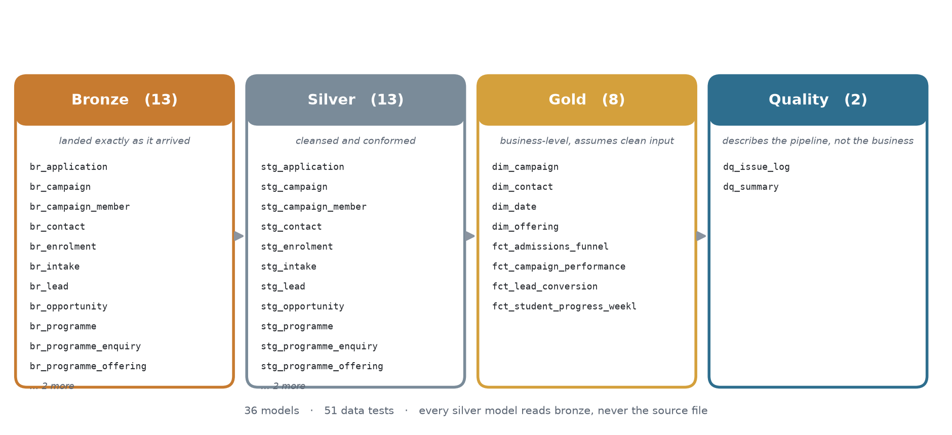
Figure 10c - The medallion, read from dbt’s manifest. Model counts and layer membership come from the build, so a model added or moved shows up here rather than the picture going stale.

5.1 The data model
The semantic model mirrors the canonical ERD rather than stopping at aggregates: programme, offering, intake, enquiry, application, enrolment, student and weekly progress are all present and joined, so the chain the ERD draws can actually be walked in a report. The live Salesforce tables and both model outputs hang off the same spine.
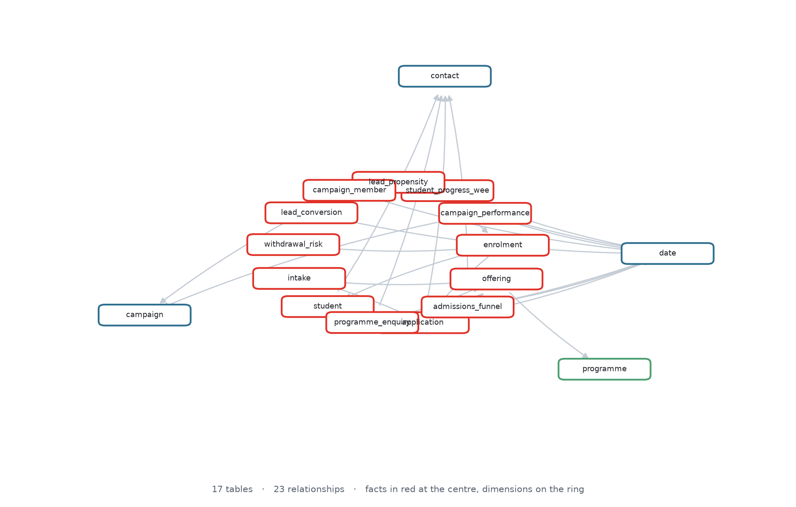
Figure 10d - The semantic model, read from its TMDL. Facts sit at the centre in red, dimensions on the ring.

6 The pipeline infrastructure
Two pieces of the stack are running systems rather than code in a repository, so they are shown as they actually are - read from their own APIs at the moment this document was built.

6.1 Apache NiFi
NiFi has exactly one root per instance, so a project is a top-level process group and its stages are nested groups joined by ports. That lets each stage start, stop and version independently, and keeps the canvas readable. Controller services sit on the project group and are inherited, so the two stages cannot drift onto different connection pools. Credentials come from a parameter context whose sensitive values are empty in source control - which is why the processors are stopped and invalid until an operator supplies them.
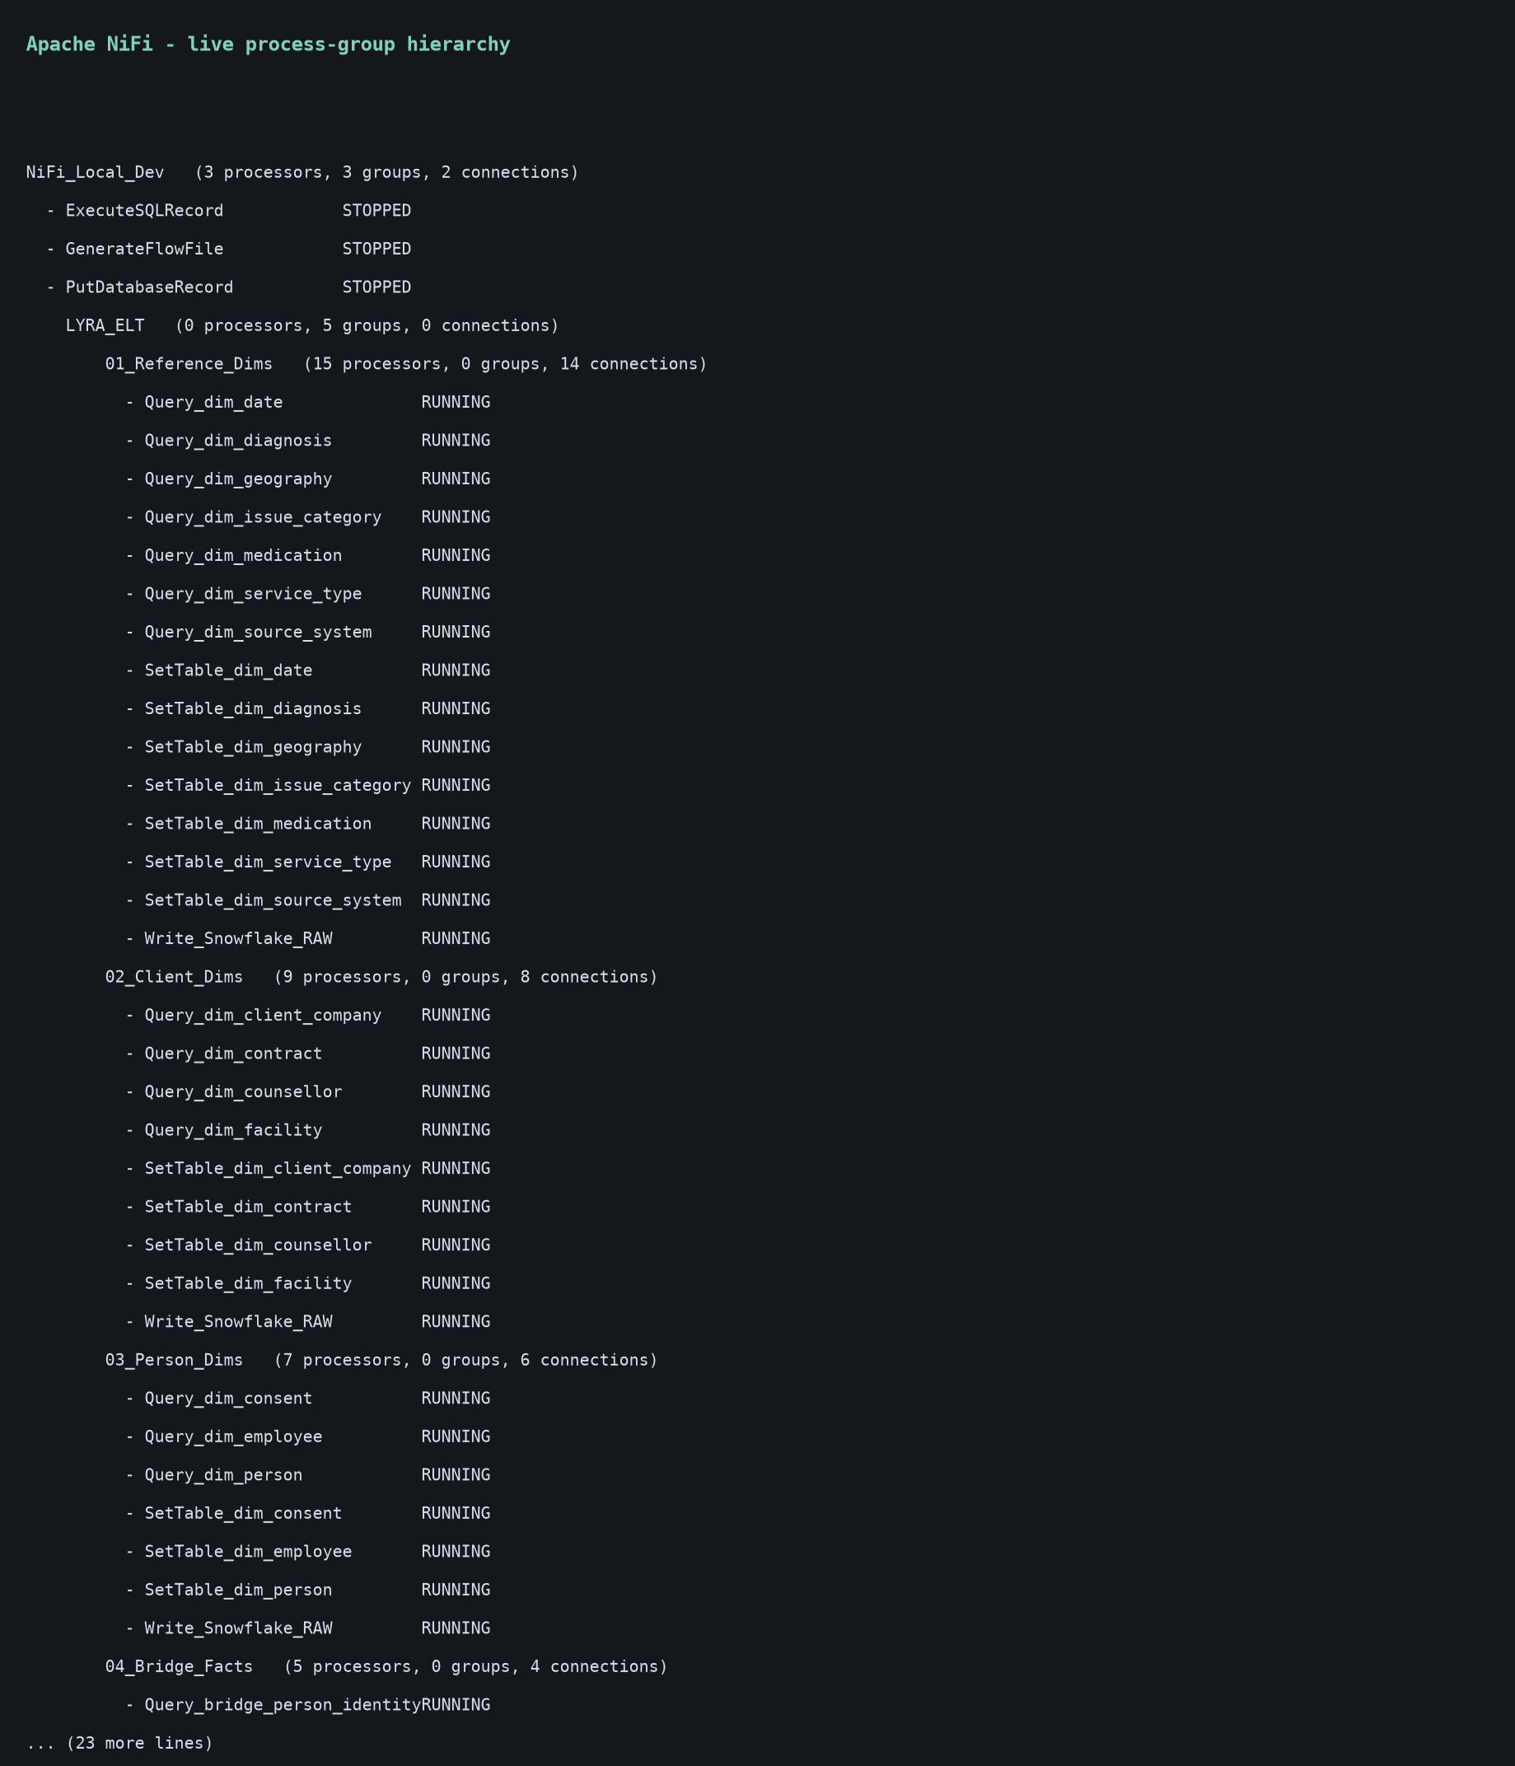
Figure 11 - The live NiFi hierarchy. RY_Salesforce_to_Fabric holds two stage groups; the LYRA groups are unrelated work on the same instance.

6.2 Microsoft Fabric
The warehouse lands in OneLake as a bronze layer, partitioned by table. Two things are worth knowing for anyone repeating this: a workspace created through the API arrives with no capacity attached, and every Fabric item type then fails with a 403 that reads like a licensing problem rather than an unassigned workspace. And a trial capacity does not stop on its own - the workspace should be deleted when the work is done.
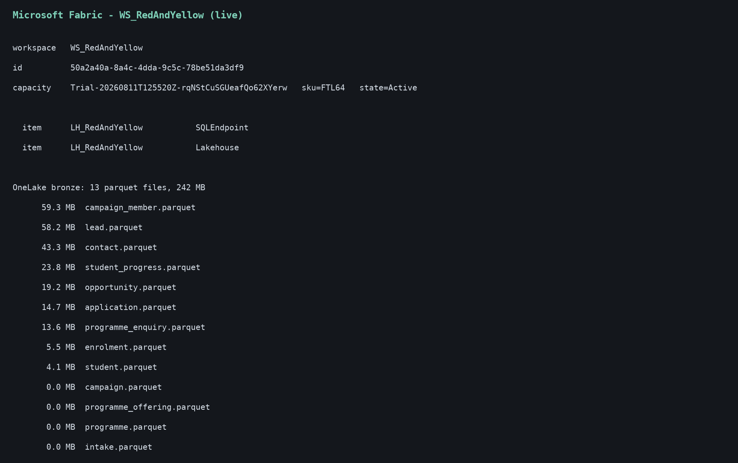
Figure 12 - The Fabric workspace, its capacity, and what is actually in OneLake - listed back rather than assumed from the upload's own success message.

6.3 What is not claimed
- This is a proposed model, not Red & Yellow's actual Salesforce configuration. The real org may already map these concepts onto Education Cloud or EDA objects.
- The catalogue was transcribed from 17 screenshots of the public site on 8 September 2026. It is not claimed to be the complete live catalogue, and page section alone was not treated as proof of delivery mode.
- All people, campaign spend, application outcomes and student results are synthetic. Progress dated after the capture date is an illustrative scenario, not a forecast.
- The pipeline has been validated locally against DuckDB and a live NiFi instance. Deployment to a Salesforce org and a Fabric workspace requires credentials that are deliberately absent from this repository.

