RED-GREEN-REFACTOR CYCLE FOR TEST 1, SeatNumber Validation
RED- the test fails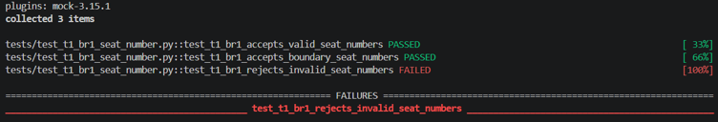
GREEN- Write the code to solve make the test pass
