LearnLoop A Stateful Agentic Platform for Adaptive Learning

1 Group Members
Name | Student ID
Fong Chi Ching | 3035299466
Ching Nok Yee | 3035283572
Lai Hok Lam Justin | 3036657081
Zhou Yuxin | 3036791693

2 Project Objective
LearnLoop is an iterative learning platform designed for undergraduate and postgraduate students. It allows learners to upload their own course materials and define their own learning goals. Through the iterative agent-learner interaction, the platform continuously assesses learner’s understanding, generates appropriate learning activities and adjusts the learning plan. LearnLoop supports course material re-organizing to sustain a persistent learning journey.
The core of LearnLoop is a source-grounded agent–environment loop. Within this loop, an LLM proposes an educational action, the runtime validates and executes it, and the resulting observation informs the next decision. The environment comprises learner responses, uploaded course resources, activity records, and the learning-plan database. Effective operation therefore requires interventions that are pedagogically appropriate and state changes that can be verified. This action–observation feedback mechanism is informed by ReAct [1].
To ground the agent's decisions in course content, LearnLoop will derive learning items and prerequisite relationships from the uploaded materials, calibrating the number of learning items and depth to each document's length, page count, structure and topic coverage. The platform will maintain both topic state and learner state, and will deliver explanations, diagnostic questions, and practice tasks through reusable mission templates. The initial implementation will prioritize uploaded materials, with broader topic exploration planned as a later extension.

3 Motivation and Challenges
Students often receive course outlines, slides, and readings but are unsure where to start, which ideas matter most, or what they need to understand first. They may spend time reviewing familiar topics while overlooking gaps in their knowledge. Occasionally, student like to ask a chatbot to explain a topic, but the quality of response highly depends on how they ask the chatbot.
Meanwhile, it is also hard to keep track of their own learning progress. Conversely, LearnLoop is designed to organize their uploaded materials into a learning path, check what they understand, and offer practice or explanations where they need help. By remembering earlier attempts, it can revisit difficult topics and adjust the plan over time. Research on intelligent tutoring systems supports investigating this approach [2]. We will evaluate whether LearnLoop selects useful activities and helps students navigate their materials more confidently.
The main challenges of this project are recognizing a lasting misunderstanding rather than a temporary mistake, finding reliable support in the uploaded materials, and keeping an accurate record of progress. We will check assessment evidence before updating the learner’s state, allow the system to express uncertainty, and limit repeated attempts when tools fail. Missions and rewards will support the learning tasks, while progress will depend on demonstrated understanding. We will assess learning and motivation separately, as suggested by research on gamification [3].

4 Potential Solutions

4.1 Agent Roles and Execution Architecture
LearnLoop will use three specialized roles within one shared LangGraph execution graph. The Teaching Agent identifies learning needs and chooses the next activity. The Assessment Agent checks responses against rubrics and returns evidence, misconceptions, and uncertainty. The Gamification Agent presents approved activities as missions while preserving their objectives and assessment criteria. Figure 1 shows the architecture. Figures 2–4 in Appendix B show each agent’s design.
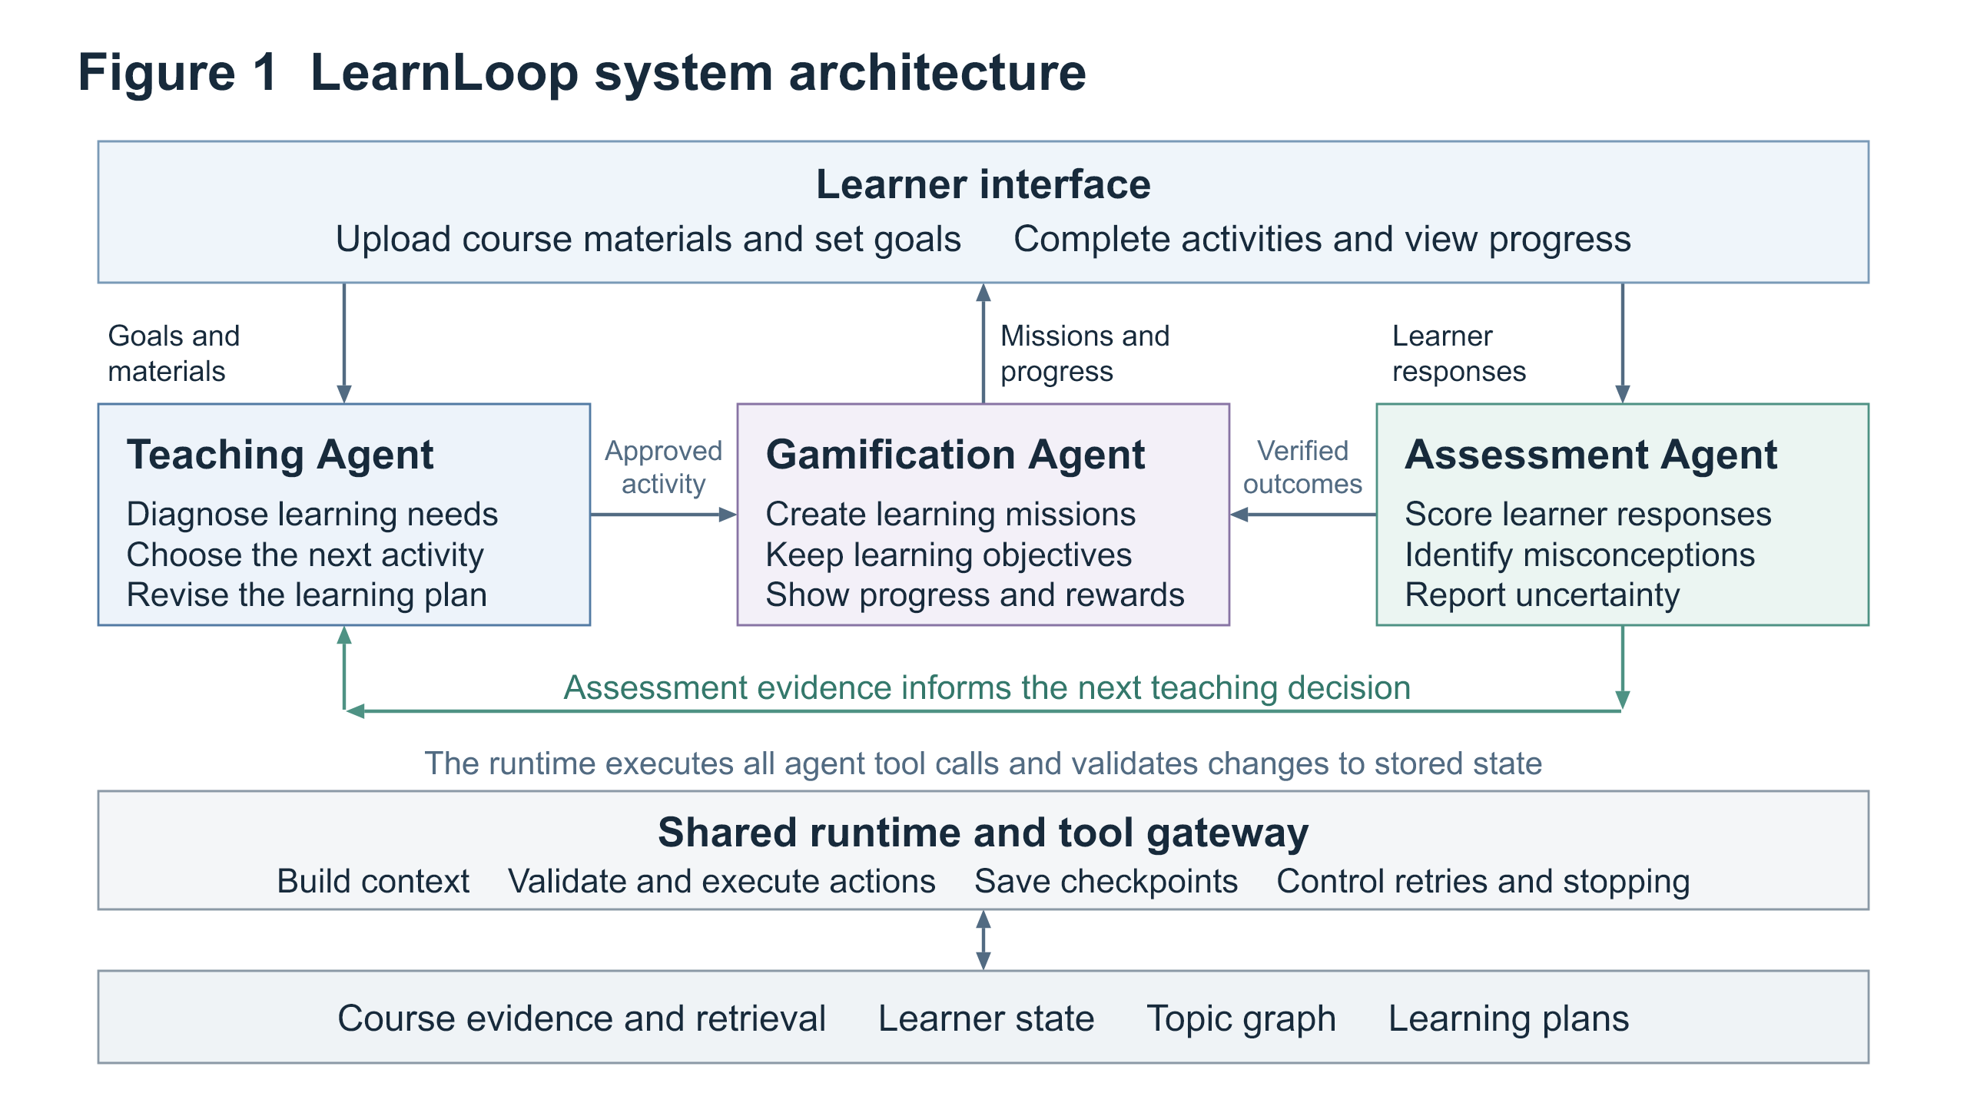
Figure 1 LearnLoop agent roles and shared execution infrastructure
Before each model call, the context builder selects the current objective, relevant learner history, source passages and tool schemas. Retrieval supplies course evidence for generated explanations [4]. The builder preserves source references, limits irrelevant history, and refreshes changed records.

4.2 Observation Decision Execution and Verification
In each learning cycle, LearnLoop observes the learner’s response, selects an action, validates and executes a tool, and checks the result. New evidence can change the next decision. The runtime then continues, pauses for the learner, or stops within its execution limits. Appendix A gives the detailed workflow.

4.3 Example Adaptive Episode
Now we consider a learner who claims that retrieval updates a language model’s weights in his learning. The system will flag this as a possible misconception and select a diagnostic question grounded in the course materials. The runtime will present the question and wait for the learner’s response. A correct answer with hints will leave the learner’s status as developing, while two distinct, independent successes may justify advancement. However, any conflicting evidence will prompt further diagnosis. If the materials do not support the question, the system will report the gap, or find information from reliable sources online.
This example illustrates the system’s agentic capability: choosing and executing actions as new evidence emerges and the learner’s state changes. Appendix A details the tools and runtime checks.

4.4 Memory and Learner State
The system tracks both what is happening during a learning activity and what it needs to remember across sessions. Its working state includes the current activity, evidence, next action, tool results, and execution counters. LangGraph checkpoints preserve this state so interrupted activities can resume. PostgreSQL stores long-term learner data, such as assessment history, preferences, plans, concept relationships, and source records. Qdrant indexes course passages for retrieval, while PostgreSQL remains the authoritative record for learner information.
For each concept, the system records its status, related assessments, possible misconceptions, hint use, and review dates. As learners answer questions, the system updates its estimate of their understanding—a principle drawn from knowledge tracing [5]. However, the prototype uses explicit evidence rules rather than a probabilistic model. A concept can be unassessed, developing, demonstrated, or review_due. To advance, a learner must provide two distinct answers that meet the rubric without hints. The answers must have adequate support from course sources, and there must be no unresolved conflicting evidence. Scheduled review changes a demonstrated concept to review_due. If the learner struggles during review, the concept returns to developing, while the earlier evidence is retained.
Assessment results are treated as candidate evidence until the runtime checks the activity ID, source references, required fields, and whether the proposed status change follows the rules. Each record includes its owner, course, source, timestamp, and rubric version. The system filters records by scope and freshness, and preserves an audit history when records are corrected. Reusing feedback in later decisions is inspired by Reflexion [6], but learner evidence is kept separate from the agent’s own self-reflection. The system loads versioned procedures, rubrics, and templates for diagnosis, remediation, and source-grounded assessment. These procedures guide which actions to take; tools carry them out.

4.5 Runtime Control and Recovery
Pydantic schemas and an allowlisted tool gateway will check syntax, field types, ownership, resource existence, and operation preconditions. Semantic assessment will be evaluated separately because schema-valid output may still be wrong. Uploaded passages and learner responses will be treated as task data, with their provenance preserved, rather than as runtime instructions.
Each cycle will initially allow at most eight model calls, two attempts per transient read failure, and a 60-second execution deadline, excluding time awaiting the learner. These configurable limits will be recorded and tuned using development cases. A malformed proposal permits one repair within the same budget. Missing learner input causes a checkpointed pause; unsupported evidence or exhausted limits produces a clear fallback and a resumable progress record.
Mutating operations will use stable operation IDs, database transactions, and expected state versions. After a timeout or restart, the runtime will check whether a write committed before retrying, preventing duplicate activities or mastery updates. Traces will record selected context IDs, concise decision summaries, proposed and executed actions, tool observations, state differences, time, and cost. They will support failure localization without requiring hidden model reasoning.

4.6 Implementation and Trade offs
A Next.js/React interface will display activities and progress; a FastAPI backend will run the shared LangGraph workflow. OpenRouter will provide hosted model access, with model identifiers and generation settings pinned for each experiment. BAAI/bge-m3 embeddings and Qdrant will support retrieval, while PostgreSQL and Docker Compose will provide persistent storage and reproducible deployment. We will first implement and test one complete learning cycle, then persistence and recovery, and finally template-based gamification and experiments. Retrieved support does not guarantee correctness, and additional assessment calls may increase latency; both limitations will be measured.

5 Experimental Dataset Description and Evaluation Plan

5.1 Data and Scenario Construction
We will make use of COMP7608B materials as a sample uploaded course, while LearnLoop will support students’ own courses. Learning items and prerequisite links will be reviewed, with document and page references preserved. If needed, we will use an approved or openly licensed corpus.
Interactive agent evaluation motivates our trajectory tests [7]. We plan 60 multi-step scenarios: 20 development cases and 40 held-out test trajectories, each spanning three to five responses. Development cases will tune prompts and policies; test cases will remain fixed. Each case will specify initial state, objective, evidence, acceptable interventions, and state constraints. Response scripts will branch by objective and activity type, with shared probes across variants. Held-out questions and reference answers will be excluded from retrieval.
The 40 test trajectories will comprise eight cases each for persistent misconceptions, hint-dependent or ambiguous answers, conflicting evidence, later-session review, and execution failures. Responses will be authored and reviewed for conceptual accuracy; any model-assisted drafts will be checked before inclusion. Alternative valid interventions will be allowed by the rubric. Scripted trajectories will test system behavior and will not be interpreted as human learning gains.

5.2 Baselines and Experimental Controls
We will compare LearnLoop with (a) a fixed-sequence tutor and (b) a tutor that adapts using only the current exchange, without cross-session learner memory. To make the comparison fair, all systems will use the same course materials, questions, assessment rules, model settings, instructions, and time limits for each interaction. We will run each of the 40 test scenarios three times with each system, giving 120 runs per system. If resources allow, we will also run a smaller comparison with a single-agent version of LearnLoop. A comparison that includes gamification may be explored as a separate experiment.

5.3 Measures and Review Protocol
Measure | Definition or assessment
Adaptive decision quality | Human rating from 1–4 for instructional alignment, evidence use, and appropriateness of the next intervention.
Assessment quality | Mean absolute score error against reviewed rubrics; precision and recall for labeled misconception detection.
State reliability | Invalid transitions / attempted transitions; premature demonstration / demonstration updates; duplicate committed effects.
Workflow robustness | Successful recoveries / injected recoverable faults; supported completion / eligible trajectories; schema-valid proposals / proposals.
Operational performance | p50 and p95 cycle latency, timeout rate, and all model/tool attempts and token costs per completed cycle; cold and warm runs separated.

Two reviewers will independently assess 15 test scenarios for each system, using the first run of each scenario. They will compare their ratings and resolve disagreements. The remaining runs will receive one human review and an automated check. We will report how consistent the results are across repeated runs and group failures by cause—for example, whether they came from the scenario, the system’s decision, a tool, or a record update. Feedback from users may be sought to inform actual performance of LearnLoop.

Appendix A Tool Contracts and Verification Cases
The following planned interfaces make the model–runtime boundary explicit. Every result will include status and evidence or a structured error. Identifiers must refer to authorized course, learner, or activity records.

A1 Learning Cycle
Stage | LearnLoop behavior
Observe | Load the learning goal, current response, relevant history, and available course evidence.
Decide | Select diagnosis, prerequisite review, explanation, practice, advancement, or a request for clarification. Return a typed proposal with objective and evidence IDs.
Execute | Validate the proposal, authorize the operation, and dispatch a permitted tool that retrieves evidence, assigns an activity, or revises the plan.
Verify | Check tool outcomes, source support, and update preconditions; commit validated changes and retain the observation.
Continue or stop | Rebuild context after an observation; pause for the learner, finish the cycle, or report a blocked action when evidence or execution budgets are exhausted.

A2 Tool Contracts
Tool | Input contract | Result and runtime checks
retrieve_evidence | course_id, concept_id, query | Source passages and page IDs; course scope and retrieval limits enforced. Empty results preserve the evidence gap.
load_learner_state | learner_id, concept_ids | Current records and versions; ownership checked before selected records enter context.
assess_response | activity_id, response, hint_used | Rubric score, evidence IDs, misconception candidates, uncertainty; activity and source references validated.
assign_activity | operation_id, objective_id, activity_type, evidence_ids | Persisted activity ID and status; supported objective, template and evidence required. Duplicate operation IDs return the original outcome.
revise_plan | operation_id, expected_version, activity_ids, review_dates | New plan version; learner ownership, prerequisite constraints and prior commit checked transactionally.
record_assessment | operation_id, expected_version, assessment_id, candidate_update | Committed evidence and concept status; transition preconditions enforced. The model cannot directly overwrite mastery.

A3 Executable Acceptance Cases
Hint-dependent success: a correct hinted answer is recorded but cannot independently support demonstrated status. Contradictory evidence: a later wrong answer preserves the earlier record and requests diagnosis rather than silently discarding it. Missing evidence: retrieval returns no suitable source and the cycle reports insufficient support. Resume: an answer to a pending question restores the activity and counters from a durable checkpoint. Retry safety: a timed-out plan write that already committed returns its original result after restart, with no duplicate activity. Budget exhaustion: the runtime stops and retains a progress record instead of continuing indefinitely.

A4 Limits of the Initial Study
A reviewed concept graph reduces extraction risk but does not test autonomous curriculum discovery. Authored trajectories provide controlled coverage but simplify real learner behavior. Source-grounded LLM assessment can still misgrade responses; persistent errors and uncertain cases will therefore be reported explicitly. Gamification is a supporting interface feature whose educational benefit remains an exploratory question.

Appendix B Agent Design Figures
Figures 2–4 show each agent’s tools, decision branches and handoffs. Agents propose actions and evidence; the shared runtime validates tool execution and commits permitted state changes. Retries remain within the cycle’s execution limits.
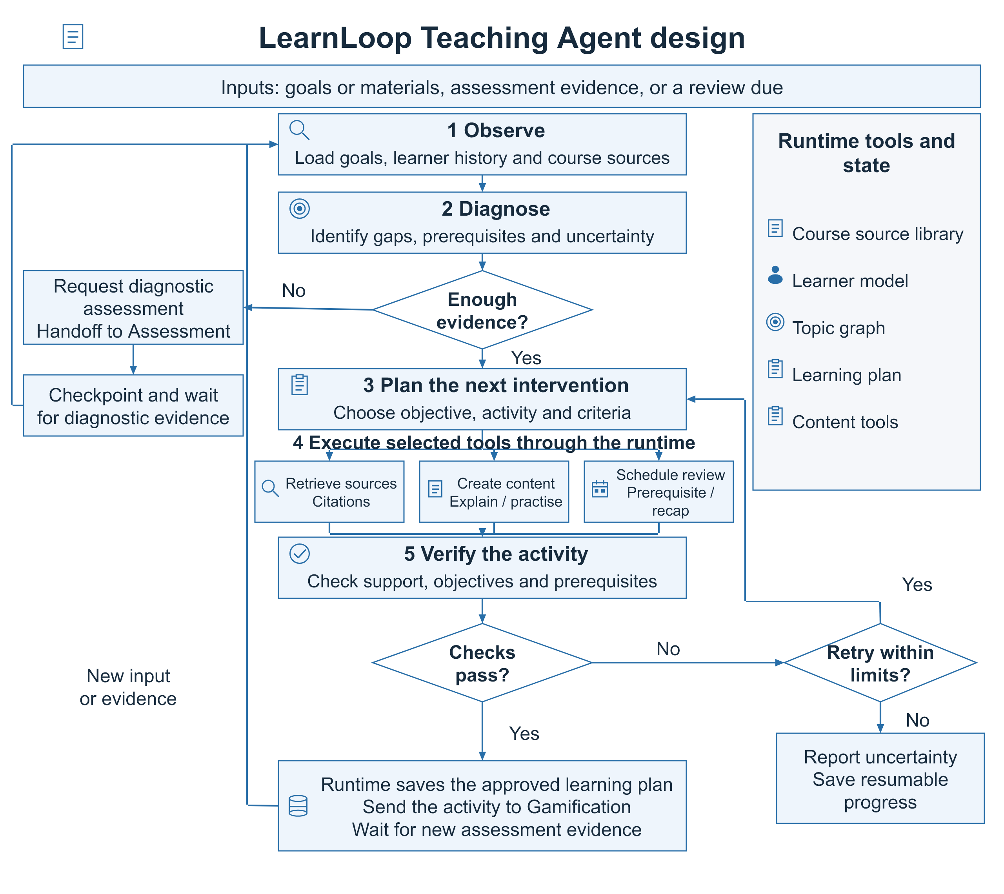
Figure 2 Teaching Agent design. Diagnostic evidence guides intervention selection; the runtime saves the verified plan and hands approved activities to Gamification.
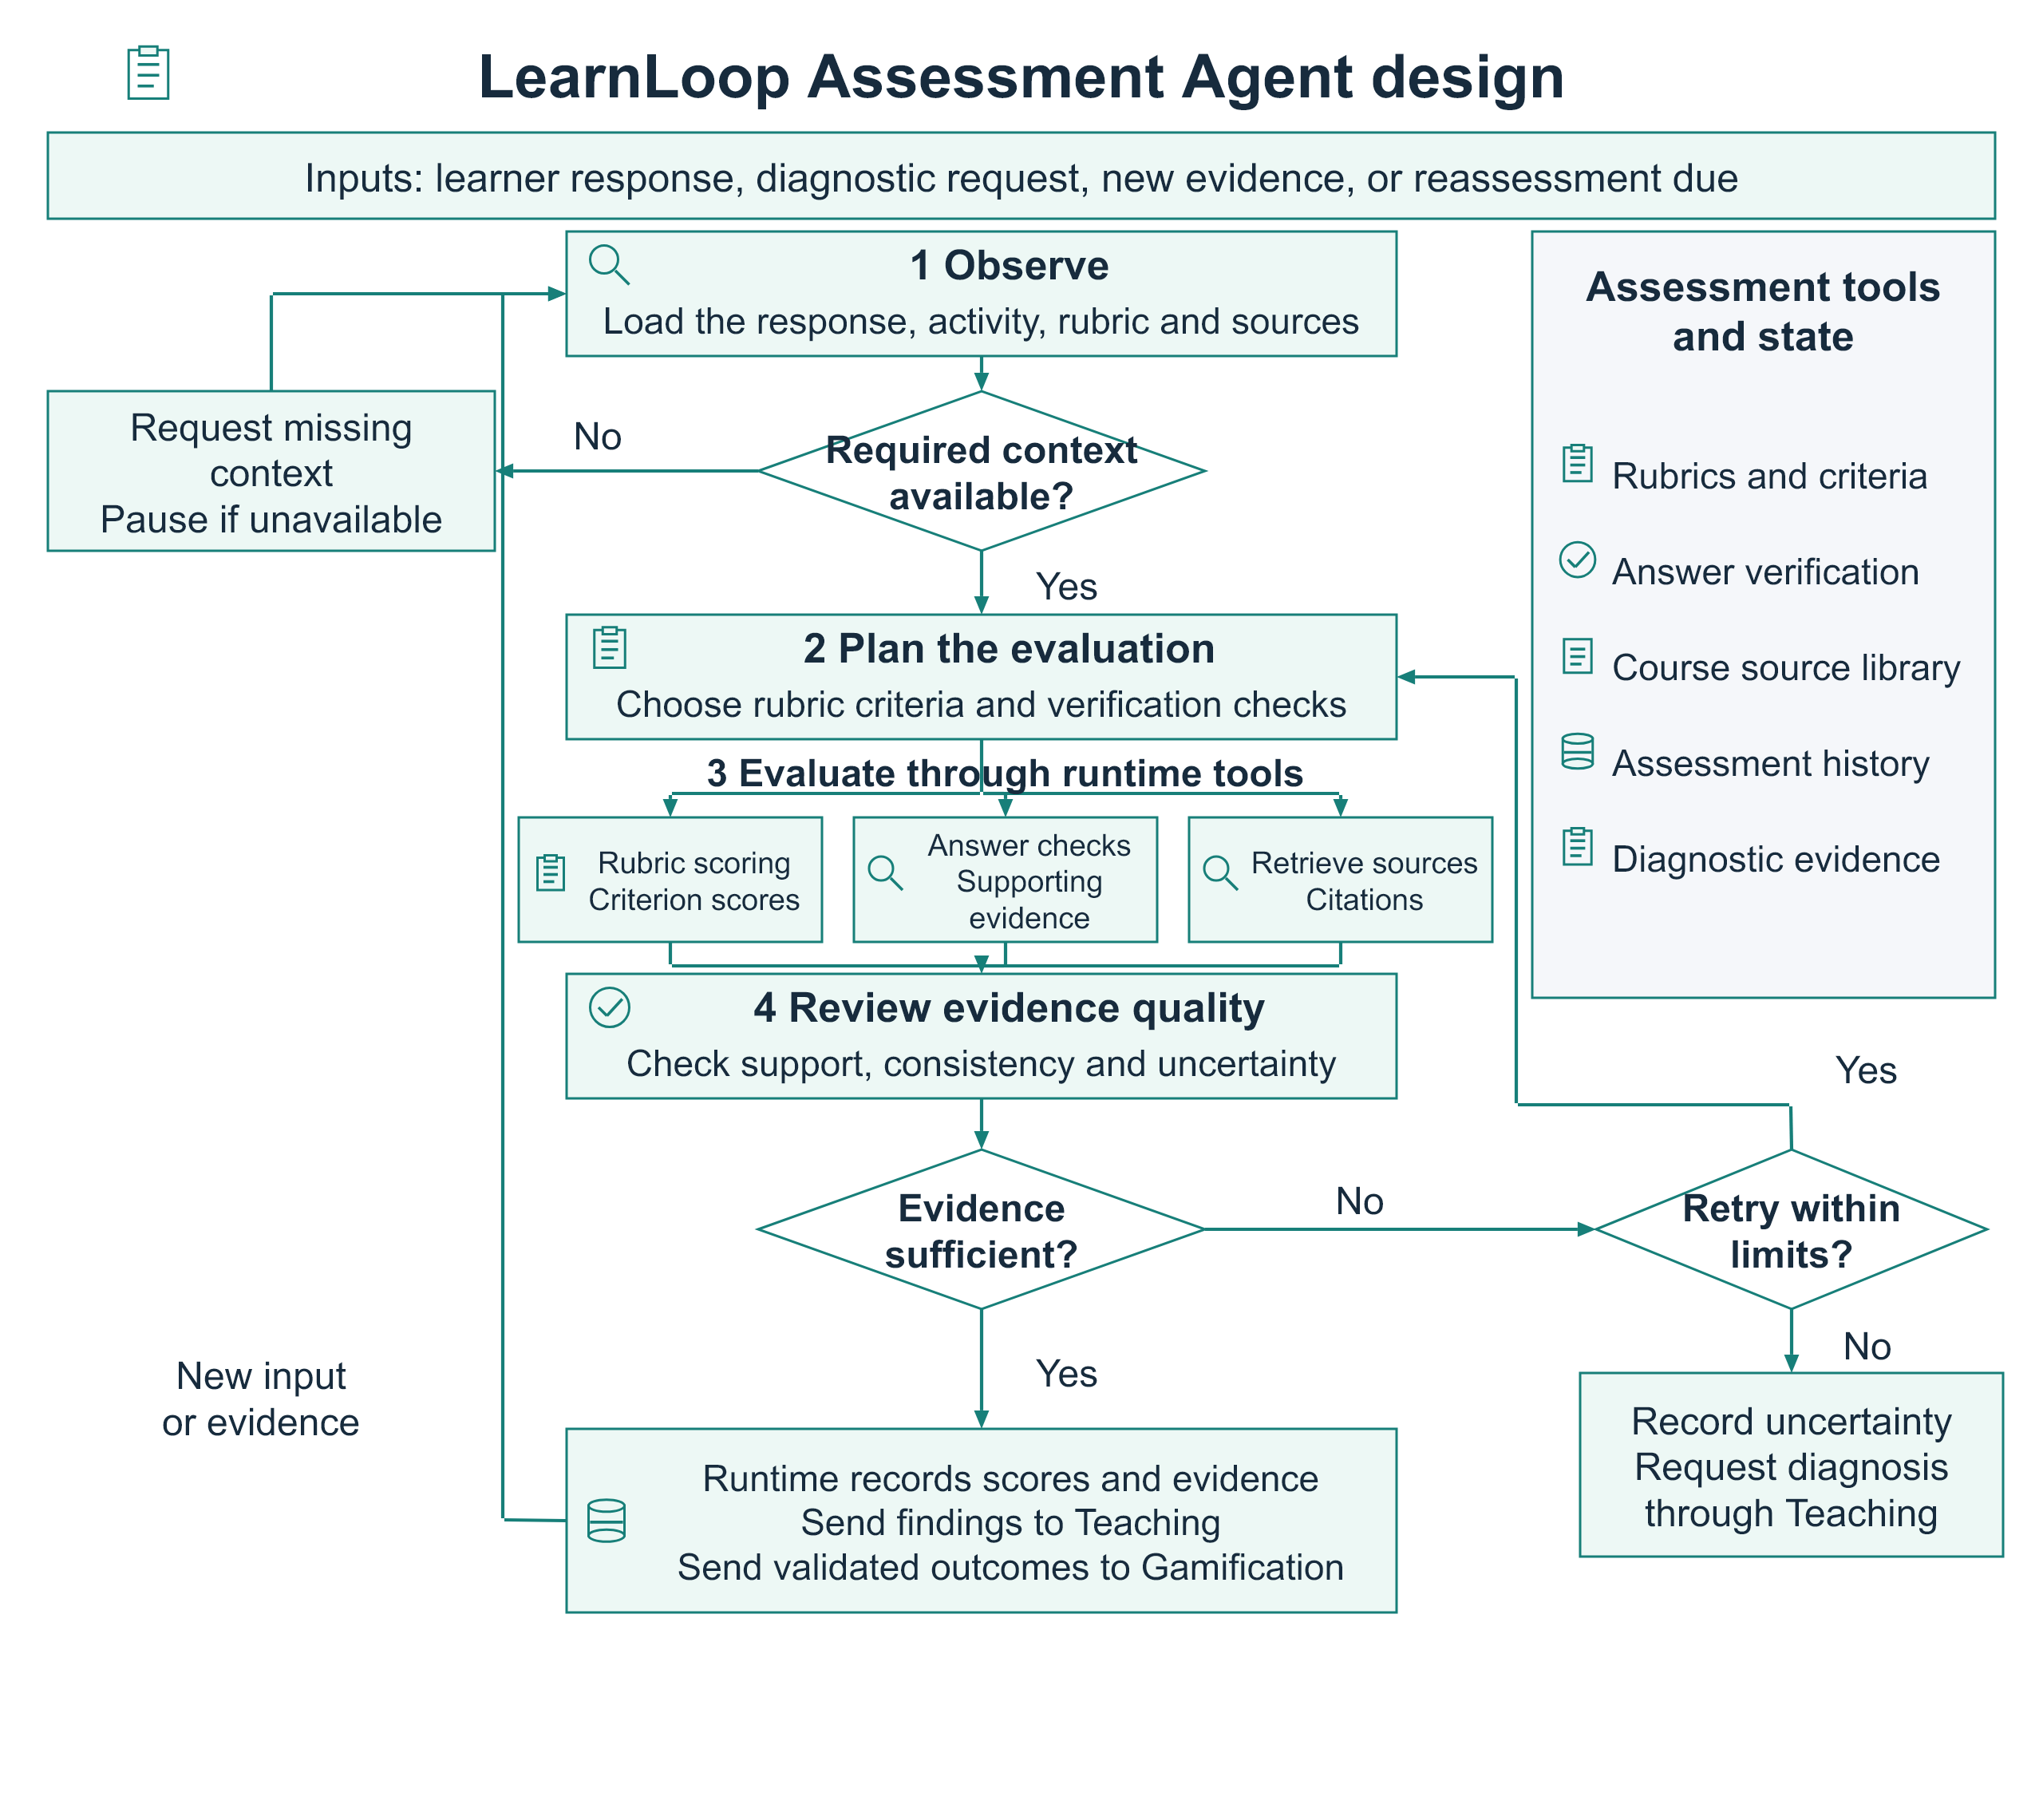
Figure 3 Assessment Agent design. Rubric scores, answer checks and source evidence inform teaching decisions. Insufficient evidence triggers bounded checks or further diagnosis.
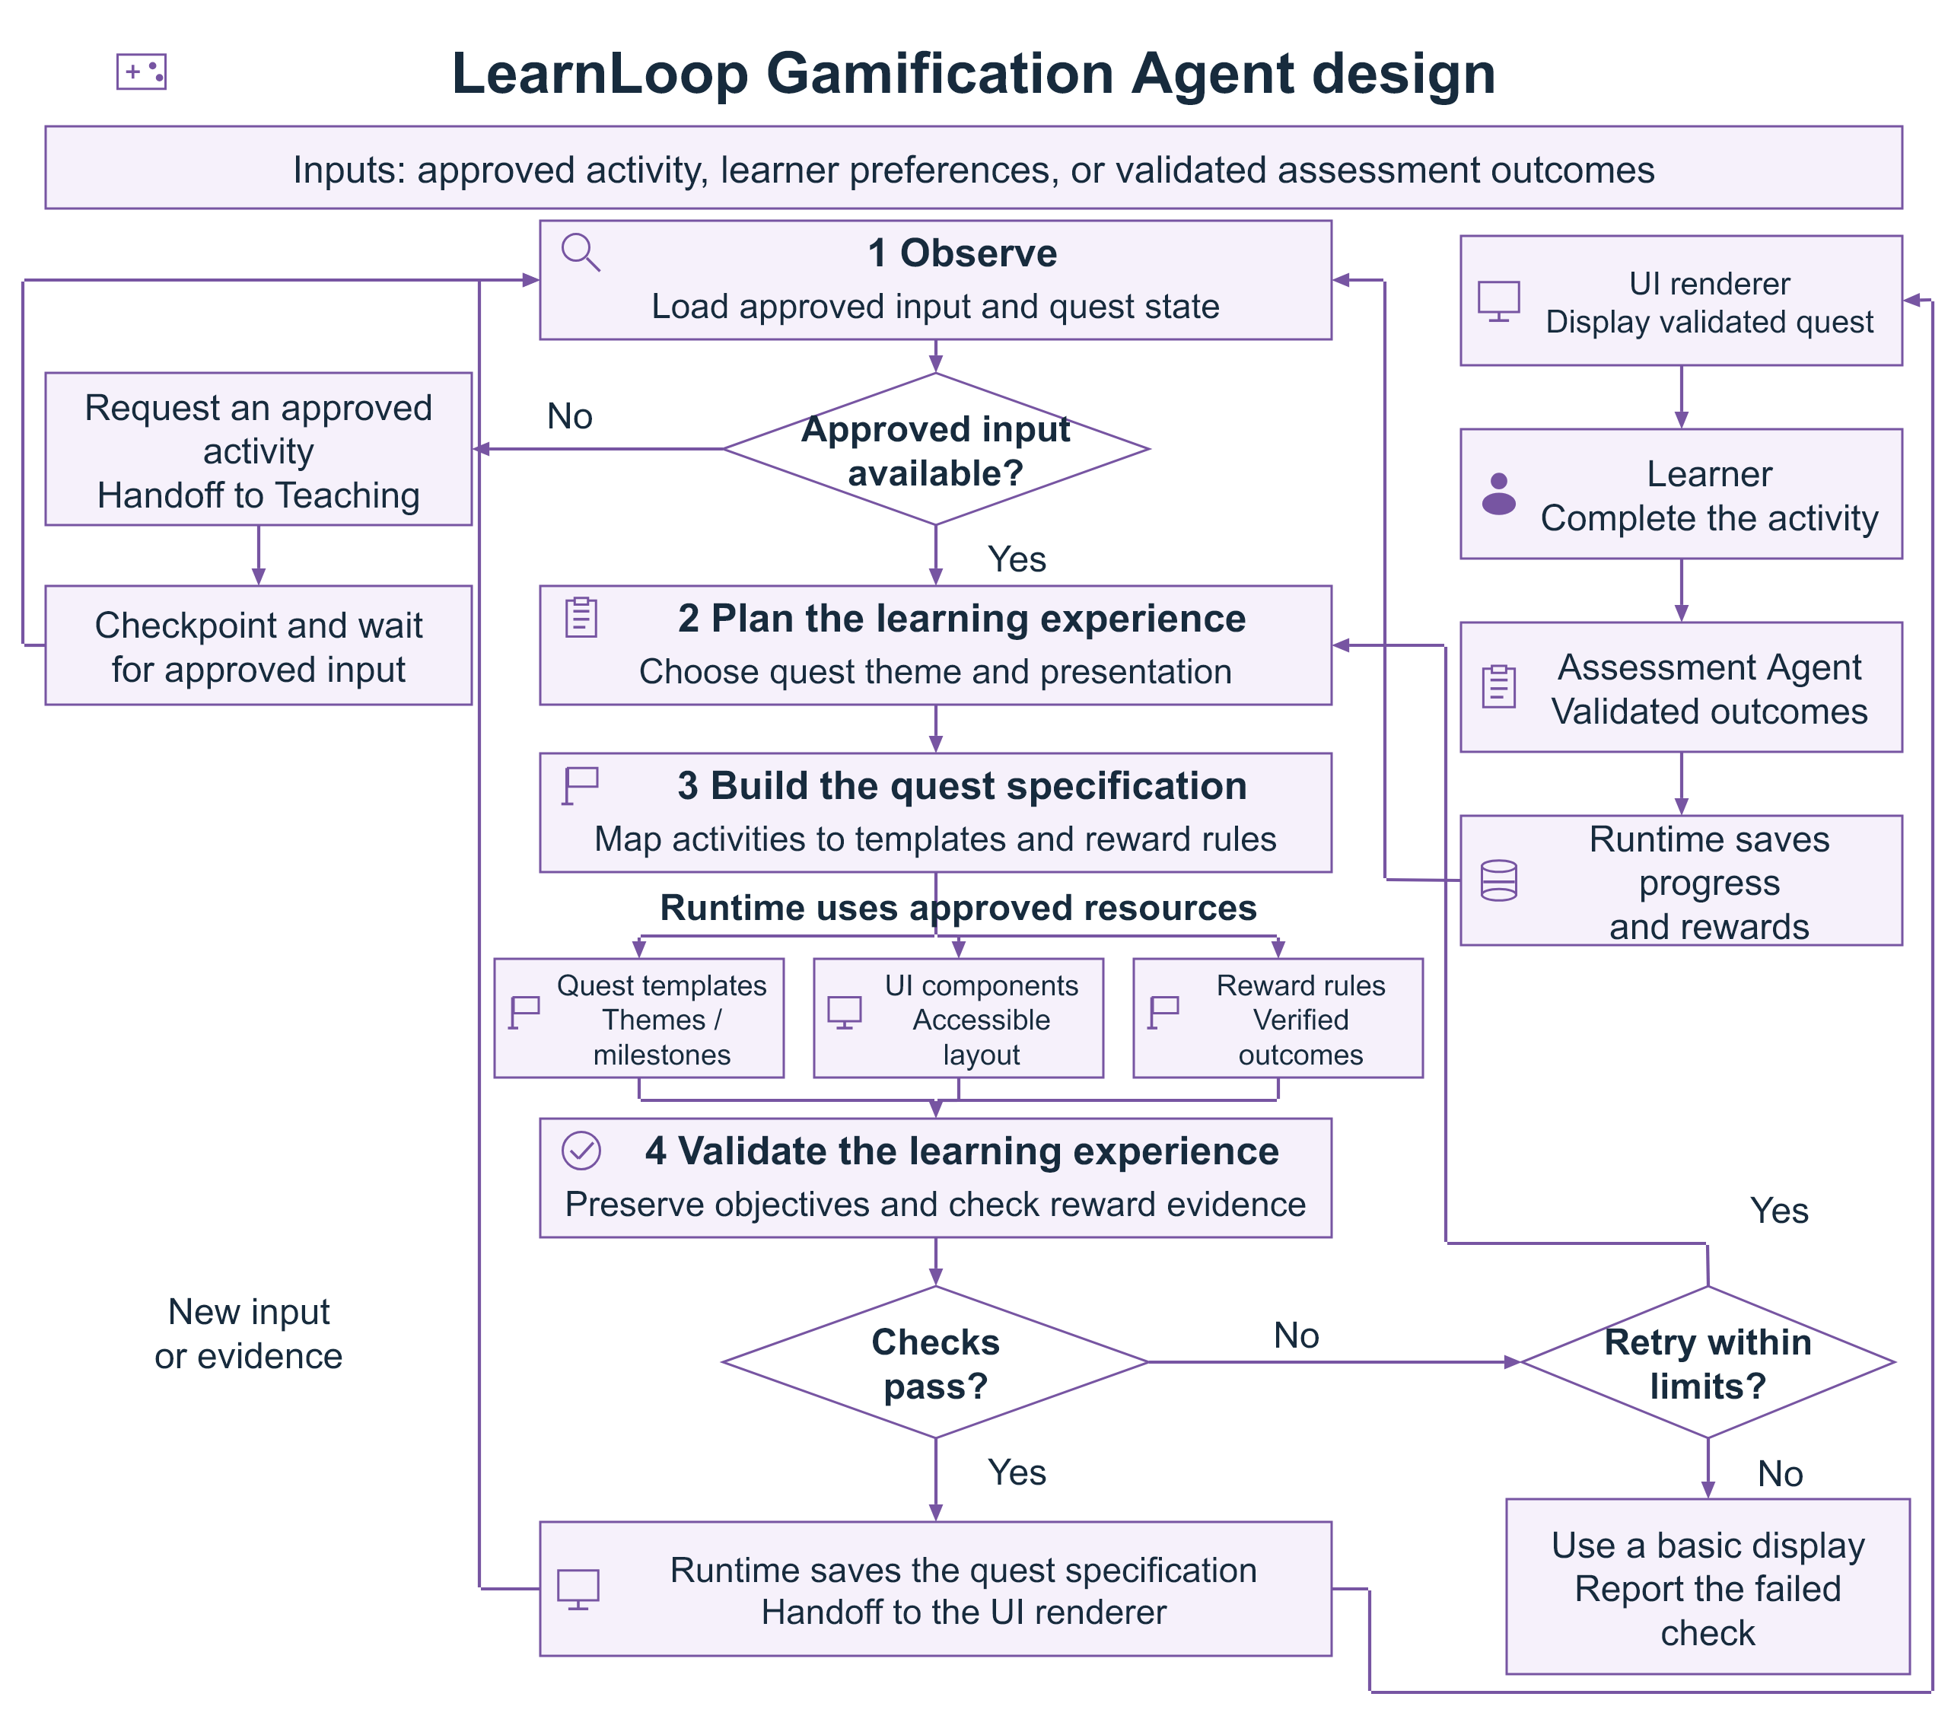
Figure 4 Gamification Agent design. Approved templates preserve learning objectives. The runtime records progress and rewards after validated assessment outcomes.

References
[1] Yao, S., Zhao, J., Yu, D., Du, N., Shafran, I., Narasimhan, K., and Cao, Y. (2023). ReAct: Synergizing Reasoning and Acting in Language Models. International Conference on Learning Representations (ICLR). Source
[2] Ma, W., Adesope, O. O., Nesbit, J. C., and Liu, Q. (2014). Intelligent tutoring systems and learning outcomes: A meta-analysis. Journal of Educational Psychology, 106(4), 901–918. Source
[3] Sailer, M., and Homner, L. (2020). The Gamification of Learning: A Meta-analysis. Educational Psychology Review, 32, 77–112. Source
[4] Lewis, P., et al. (2020). Retrieval-Augmented Generation for Knowledge-Intensive NLP Tasks. Advances in Neural Information Processing Systems, 33, 9459–9474. Source
[5] Corbett, A. T., and Anderson, J. R. (1994). Knowledge tracing: Modeling the acquisition of procedural knowledge. User Modeling and User-Adapted Interaction, 4, 253–278. Source
[6] Shinn, N., Cassano, F., Gopinath, A., Narasimhan, K., and Yao, S. (2023). Reflexion: Language Agents with Verbal Reinforcement Learning. Advances in Neural Information Processing Systems, 36. Source
[7] Liu, X., et al. (2024). AgentBench: Evaluating LLMs as Agents. International Conference on Learning Representations (ICLR). Source

