**Question 1 (20 points)**

Consider the following 2 scenarios

* A circuit-switching scenario in which *Ncs* users, each requiring a bandwidth of 25 Mbps, must share a link of capacity 200 Mbps.
* A packet-switching scenario with *Nps* users sharing a 200 Mbps link, where each user again requires 25 Mbps when transmitting, but only needs to transmit 20 percent of the time.

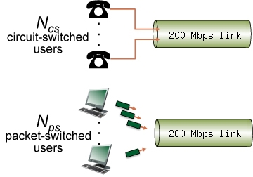

Answer the following questions:

1. When circuit switching is used, what is the maximum number of circuit-switched users that can be supported? Explain your answer.

8 users can be supported at once with circuit switching, because 200Mbps needs to be divided into sections of 25 Mbps, hence 200/25=8.

1. For the remainder of this problem, suppose packet switching is used. Suppose there are 15 packet-switching users (i.e., *Nps* = 15). Can this many users be supported under circuit-switching? Explain.

No, 15 users cannot be supported under circuit switching, as the link must be shared constantly by all users at once, and 8 is the most that can be supported.

1. What is the probability that a given (*specific*) user is transmitting, and the remaining users are not transmitting?

P=(0.2)(0.8)^14 = 0.008796

1. What is the probability that one user (*any* one among the 15 users) is transmitting, and the remaining users are not transmitting? When one user is transmitting, what fraction of the link capacity will be used by this user?

P=15C1*(0.2)(0.8)^14 = 0.1319, the user will be using 1/8 of the link capacity.

1. What is the probability that any 8 users (of the total 15 users) are transmitting and the remaining users are not transmitting?

P=15C8*(0.2)^8*(0.8)^7 = 0.003455

1. What is the probability that *more*than 8 users are transmitting?

P=Sum(i=9-15, (15Ci*(0.2)^i*(0.8)^15-i)) = 0.0007850

**Question 2 (10 points)**

Consider the figure below, in which a single router is transmitting packets, each of length *L* bits, over a single link with transmission rate *R*Mbps to another router at the other end of the link.

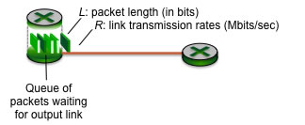

Suppose that the packet length is *L*= 4000 bits, and that the link transmission rate along the link to router on the right is *R* = 1 Mbps.

1. What is the transmission delay (the time needed to transmit all of a single packet's bits into the link)?

Dtrans = L/R = 4000bits/1Mbps * 1Mb/1024kb * 1kb/1024b = 0.00381 s

1. what is the maximum number of packets per second that can be transmitted by the link?

(0.00381 s/packet)^-1 = 262.144 packets

**Question 3 (20 points)**

Consider the figure below, with three links, each with the specified transmission rate and link length.

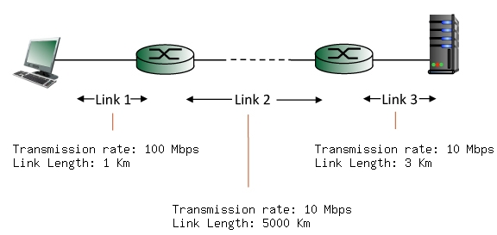

Find the end-to-end delay (including the transmission delays and propagation delays on each of the three links, but ignoring queueing delays and processing delays) from when the left host begins transmitting the first bit of a packet to the time when the last bit of that packet is received at the server at the right. The speed of light propagation delay on each link is 3x10**8 m/sec. Note that the transmission rates are in Mbps and the link distances are in Km. Assume a packet length of **4000**bits. Give your answer in milliseconds.

      Link 1 transmission delay = L/R = 4000 bits / 100 Mbps / 1024 kb/Mb / 1024 b/kb = 3.815*10-5 s  
      Link 1 propagation delay = m/s = 1Km / 3*10^8 m / sec *1000m/Km = 3.333*10^-6 s  
      Link 2 transmission delay = L/R = 4000 bits / 10 Mbps / 1024 kb/Mb / 1024 b/kb = 3.8*10^-4 s  
      Link 2 propagation delay = m/s = 5000 Km / 3*10^8 m / sec * 1000 m/Km = 1.666*10^-2 s  
      Link 3 transmission delay = L/R = 4000 bits / 10 Mbps / 1024 kb/Mb / 1024 b / kb = 3.8*10^-4 s  
      Link 3 propagation delay = m/s = 3 Km / 3*10^8 m / sec * 1000m/Km = 1.0*10^-5 s  
  
  End-to-end Delay: 0.017473 s

**Question 4 (20 points)**

Consider the scenario shown below, with four different servers connected to four different clients over four three-hop paths. The four pairs share a common middle hop with a transmission capacity of R = 400 Mbps. The four links from the servers to the shared link have a transmission capacity of RS = 50 Mbps. Each of the four links from the shared middle link to a client has a transmission capacity of RC = 80 Mbps per second. You might want to review Figure 1.20 in the text before answering the following questions:

1. What is the maximum achievable end-end throughput (in Mbps) for each of four client-to-server pairs, assuming that the middle link is fair-shared (i.e., divides its transmission rate equally among the four pairs)?

50 Mbps

1. Which link is the bottleneck link for each session?

The first link on each path from the server is the bottleneck link for all 4.

1. Assuming that the senders are sending at the maximum rate possible, what are the link utilizations for the sender links (RS), client links (RC), and the middle link (R)?

Going from server to client:

Part 1 = 50Mb/s / 50Mb/s = 100%

Part 2 = 50Mb/s / (400Mb/s / 4) = 50%

Part 3 = 50Mb/s / 80Mb/s = 62.5%

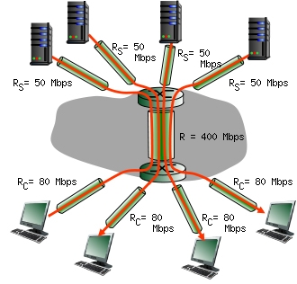

**Question 5 (30 ponints)**

Before doing this question, you might want to review sections 2.2.1 and 2.2.2 on HTTP (in particular the text surrounding Figure 2.7) and the operation of the DNS (in particular the text surrounding Figure 2.19).

Suppose within your Web browser you click on a link to obtain a Web page. The IP address for the associated URL is not cached in your local host, so a DNS lookup is necessary to obtain the IP address. Suppose that three DNS servers are visited before your host receives the IP address from DNS. The first DNS server visited is the local DNS cache, with an RTT delay of RTT0 = 5 msecs. The second and third DNS servers contacted have RTTs of 11 and 47 msecs, respectively. Initially, let's suppose that the Web page associated with the link contains exactly one object, consisting of a small amount of HTML text. Suppose the RTT between the local host and the Web server containing the object is RTTHTTP = 62 msecs.

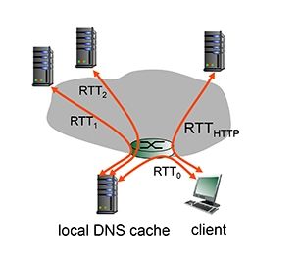

1. Assuming zero transmission time for the HTML object, how much time elapses from when the client clicks on the link until the client receives the object?
2. Now suppose the HTML object references 9 very small objects on the same web server. Neglecting transmission times, how much time elapses from when the client clicks on the link until the base object and all 9 additional objects are received from web server at the client, assuming non-persistent HTTP and no parallel TCP connections?
3. Repeat 2. above but assume that the client is configured to support a maximum of 5 parallel TCP connections, with non-persistent HTTP.
4. Repeat 2. above but assume that the client is configured to support a maximum of 5 parallel TCP connections, with persistent HTTP.
5. What do you notice about the overall delays (taking into account both DNS and HTTP delays) that you computed in cases 2., 3. and 4. above?

**Answer on the next page.**

**Solution for Q5**

**Part 1:**

RTT0 + RTT1 + RTT2 + RTThttp + RTThttp

5ms + 11 ms + 47 ms +2*62ms = 187 ms

**Part 2:**

RTT0 + RTT1 + RTT2 + RTThttp + 9*(RTThttp)

5ms + 11ms + 47 ms + 10(62 ms) = 683 ms

**Part 3:**

RTT0 + RTT1 + RTT2 + RTThttp + RTThttp (1-5) + RTThttp + RTThttp(6-9)

5ms + 11ms + 47ms + 4(62ms) = 311 ms

**Part 4:**

RTT0 + RTT1 + RTT2 + RTThttp + RTThttp(1-5) + RTThttp(6-9)

5ms + 11ms + 47ms + 3(62ms) = 249 ms

**Part 5:**

I notice that establishing a persistent connection as well as maintaining multiple connections can greatly reduce the amount of transmission time necessary for files.