I pledge my honor that I have abided by the Stevens Honor System. aciccone

Anthony Ciccone

9-17-20

Assignment 02

Questions

1. 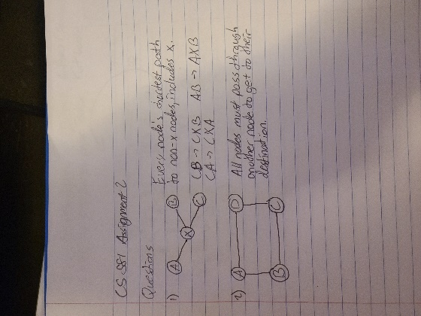
2. E and B are gatekeepers. E is keeping the other nodes from reaching C and G without passing through itself, and B is keeping the other nodes from reaching A without passing through itself.
3. C and G are NOT local gatekeepers because they are both connected to each other and another node, therefore creating a triangle. Also A is not a local gatekeeper because it is only connected to one other node.
4. E is pivotal for any node pairs from any node other than C or G, to the nodes C or G. B is pivotal for any node pairs starting at any node that is not A to A.
5. The network was designed this way so that if X, a gatekeeper node, went down, any nodes on one side of X would no longer have access to the nodes on the other side of X. It is possible that both MIT and BBN could go down but the likelihood of that happening at the same time is most likely very low.
6. STAN and UCSB are not pivotal because SRI can reach UCLA, or vice-versa, without going through either of them, and they are not connected to any other nodes.
7. Considering a situation where two people are connected in a social network, and one of those people is connected to another, third, person. A triadic closure is when the first person, who is not connected to the third, gets connected and forms an edge between each other. Having their mutual edge increased the likelihood of them creating said edge. This is a big part of the formation of social networks because it is a huge process of forming new connections between many different people. The easiest way to meet someone is through someone else.
   1. Weak
   2. If b and c had a strong connection then the graph would violate the Strong Triadic Closure Property because e is already strongly connected to b, and c and e have no direct connection.
   3. AE & BE
   4. The links I would expect to form over time would be AE and BE, because both A and B have a strong connection with C, who is also strongly connected with E. Nothing else would be formed because D is weakly connected to B and E, while everything else is already strongly connected with the AE and BE ties we already believe will form.
   5. Someone’s friend’s friends are often a better source of job leads for that someone, than one of their closer friends. It could be that the friend’s friend is a weak connection to our specific job-searching person. Weak connections usually indicate a difference in what is known, and a different in who those people are connected with. If someone that you had a strong tie with had a job opportunity, you would most likely already know about that opening and in some cases that knowledge could have caused you to quit / lose the previous job. In the case of a weak tie, the person on the other end of the edge has many different connections than you or someone that you have a strong connection to do. These people can almost be like local bridges to these other connections that could be everyone at the company, or anyone involved in the job in question.
   6. I personally have given a lot of my very close friends jobs. I work at a restaurant in Hoboken, and a lot of the workers used to be high schoolers and graduated, so as they left I would have a lot of people willing to fill those positions because of my connections at Stevens. When it came to finding jobs for myself, I found my current job by creating new connections; specifically, by asking around Hoboken, at potential workplaces, if they were hiring.
   7. 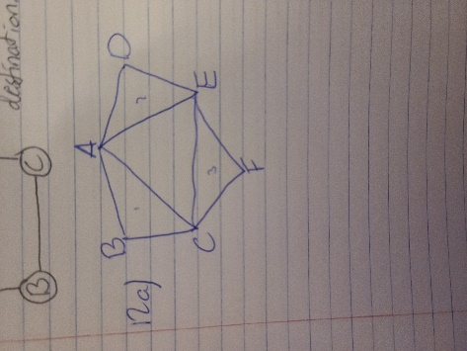
   8. Triangle ACE shows a connection between all of the three groups, while the smaller triangles are the individual groups. It could be possible to be in more than one group as well.
8. A
   1. This network is not balanced.
   2. The network is not balanced because the villages are all enemies. The triangle between the three villages will have negative signs, and it violates the principle of a balanced network because the villages have incentive to work together against the third.
   3. The network is weakly balanced.
   4. The definition in Figure 5.6 proves that this network is weakly balanced because if you break the three villages up into three groups. Those three groups are all enemies with each other which is a form of complete mutual antagonism.
   5. My answer would remain the same.
   6. The triangles formed after using A as the center node do not satisfy the two positive and one negative edge case for the Weak Structural Balance property.
   7. ABX and ACX are unbalanced, and XBC and ABC are balanced.
   8. The entire graph is unbalanced.
   9. The entire graph is unbalanced because ABX and ACX are unbalanced, which means violates the Structural Balance Property.