I pledge my honor that I have abided by the Stevens Honor System. aciccone

Anthony Ciccone

10-14-20

Assignment 04

|  |  |  |
| --- | --- | --- |
|  | Fish | Hunt |
| Fish | 6,6 | 4,0 |
| Hunt | 0,4 | 10,10 |

* 1. No because cooperation is key for this scenario. If they are aware of the other players actions, then it would be better to do what they do for a better payoff. Hunting alone is bad, while fishing or hunting together is good.
  2. Yes, if they both fish and if they both hunt are situations that could be considered a Nash equilibrium. Fishing is the best response to other person fishing because if they do not fish, they will get a 0 payout. Hunting is also the best response to hunting because if they do not hunt, they will only get a payout of 4 instead of the 10 they’d have chosen for hunting.

|  |  |  |
| --- | --- | --- |
|  | Swerve | Straight |
| Swerve | -5,-5 | -5,10 |
| Straight | 10,-5 | -50,-50 |

* 1. Neither player has a strictly dominant strategy. In a situation where player 1 is swerving it would be best for player 2 to go straight because the payout from swerving would be -5, while the payout from going straight would be +10. Vice-versa if player 1 is going straight, then it would be best for player 2 to swerve because the payout from swerving would be -5, while the payout from going straight would be -50.
  2. Yes, the situations where they select opposite choices. As shown in b, it is always better to choose the opposite of what your opponent chooses to minimize pay loss.

1. A

|  |  |  |
| --- | --- | --- |
|  | Low | High |
| Low | 3.6,3.6 | 3,4 |
| High | 4,3 | 3.2,3.2 |

* 1. The strictly dominant strategy here is high production. If p1 chooses high, then it would be best for p2 to match that for a 3.2 payout as opposed to 3 if p2 chose low. If p1 chose low, then it would be best for p2 to go high for a payout of 4, as opposed to 3.6 if p2 also chose low.
  2. Both p1 and p2 choosing high would be the Nash equilibrium in this case, considering high is the strictly dominant strategy for both p1 and p2.

1. 80 cars
   1. 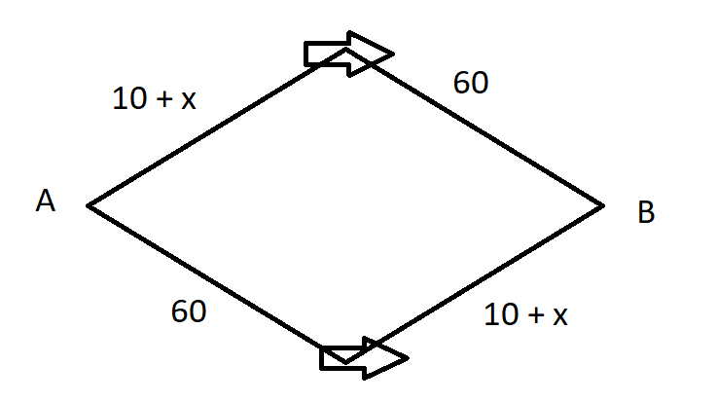(sorry about my really bad arrows for direction)
   2. If all the cars chose route 1, then total travel time would be: 10 + x(80) + 60 = 150 min
   3. X = 40. Each car would take 110 minutes, and the total travel time would be 880.
   4. The Nash equilibrium value for x would be 40, half the total cars, because each route would then only take 110 minutes for each car, rather than 150. Reducing each cars travel time by 40 minutes, and the total travel time by 320.
   5. The travel time if all cars chose route 4 would be 120 minutes.
   6. The travel time if all cars chose route 3 would be 180 minutes.
   7. If all cars were to choose the same route, this new road would reduce the total travel time because the two highways are a much faster option.
   8. Route 1: 10 cars, 80 minutes  
      Route 2: 10 cars, 80 minutes

Route 3: 10 cars, 40 minutes

Route 4: 50 cars, 120 minutes

and the total travel time is 8000 minutes

1. In Milwaukee, Wisconsin there was a road called the Park East Freeway. It was planned to “extend east towards Lake Michigan and then run south along the shore” (CNU) This plan fell through, as it was met with a lot of opposition from locals and govt officials. Because of this, it is now just an elevated 0.8-mile freeway. Maintaining a road, specifically a elevated freeway, is a very costly task for any city in possession of one. The road itself also restricted access to some parts of the city and was confusing when looking at the bigger street grid picture. The removal of this road cost 45 million dollars, but only took one year to remove. It was replaced with McKinley Boulevard, which was a much better alternative to a badly designed, raised road. This was more of local-loving road. It was designed to fix the confusions that the Park East Freeway created in the street grid, and also create a more livable area in the middle of the city. The land that was formally occupied “raised in value by more than 180 percent, and the average assessed land values of the TIF district grew by 45 percent.” (LincolnInst)
   1. Your firm should bid 5000, that way if you do not win then your payoff is 0, where if you do win than your payoff will be more than 0. If you bid 5000 and win, in a second-price auction, then you will be paying less than the 5000 that you valued the item at. Therefore, getting a 5000 value item for less than 5000, unless there is a tie.
   2. The number of other bidders does not matter, unless you are the only bidder, because   
      the bids of the other people involved are kept hidden until the winner is announced.
2. 1. ¼ *1 + ½*1 + ¼*3 = 1.5 = 6/4
   2. 1*1/8 + 1*1/8 + 1*1/8 + 1*1/8 (1/2) + 3*1/8 + 3*1/8 + 3*1/8 + 3*1/8 (3/2) = 4/2 = 2
   3. The number of bidders going up, increases the chances of there being a tie. Before there was only a ¼ chance, while now there is a ½ chance. This means that there is a twice as likely chance that the seller is going to get 3 from the item they are selling.

Sources?

CNU article: <https://www.cnu.org/what-we-do/build-great-places/park-east-freeway>

LincolnInst article: <https://www.lincolninst.edu/publications/articles/2020-03-deconstruction-ahead-urban-highway-removal-changing-cities>