UNIVERSIDAD DE DAGUPAN
School of Information Technology Education
ITP10 | Event-Driven Programming | Midterm Laboratory Activity 2
Secure Dynamic Task Manager: Explanation and Test Results
Name: Louis Anthony L. De Vera
Year, Course & Block: 3rd Year, BSIT - Block 8
Subject: ITP10 - Event-Driven Programming
Date: October 2, 2026

1. What the application does
The Secure Dynamic Task Manager lets a user add, complete, edit, and remove tasks without reloading the page. The task list is empty when the page loads, and every task is created by JavaScript. The summary shows Total Tasks, Pending, and Completed, and these counts are always calculated from the tasks currently in the page.

2. Project structure
secure-task-manager/
├── index.html
├── css/
│ └── style.css
└── js/
├── app.js
├── data.js
├── utils.js
└── display.js
The JavaScript is divided into four modules, and each one has a single responsibility:
- data.js: keeps the constants (the "Task cannot be empty" message, the task states, and the three sample tasks), generates unique task IDs such as task-1, and calculates the total, pending, and completed counts from an array of states.
- utils.js: small reusable helpers, normalizeText() and isBlank(), used to trim and validate text.
- display.js: stores the references to the page elements and handles what the user sees: showing or clearing the message, clearing the input, and showing the counts.
- app.js: the main module. It contains the nine required functions, attaches the event listeners, and connects the other three modules using import statements.

3. How the required functions work
- createTaskElement(taskText, taskId): uses document.createElement() to build an li with class task-item, its data-task-id and data-state="pending", the task-text span, and the Complete, Edit, and Remove buttons. It returns the item and does not attach it to #taskList.
- addTask(taskText): checks for blank text first. If it is blank, it shows "Task cannot be empty" and stops. Otherwise it creates a unique ID, calls createTaskElement(), appends the item to #taskList, clears the input and message, and updates the counts.
- toggleTaskComplete(taskItem): uses classList.toggle("completed") and then sets dataset.state to "completed" or "pending" to match.
- beginTaskEdit(taskItem): replaces the task-text span with an input.edit-input that holds the current text, and changes the Edit button to Save.
- saveTaskEdit(taskItem): validates the edit input. If it is valid, it creates a new task-text span using textContent, replaces the input with it, and changes Save back to Edit. If it is blank, it shows the error message and keeps the input open.
- removeTask(taskItem): calls taskItem.remove() on only the selected task and updates the counts.
- updateTaskCounts(): reads the data-state of every .task-item currently in the DOM, passes those values to calculateCounts(), and displays the result. No count is hard-coded.
- handleTaskListClick(event): the single delegated click handler (explained in Section 5).
- loadSampleTasks(): builds the three sample tasks inside a DocumentFragment and appends the fragment to #taskList once (explained in Section 6).

4. Security: safe handling of user text
If task text is placed into the page as HTML, a user could type something like <img src=x onerror=alert(1)> and run a script in the page. To prevent this, the application never uses innerHTML, insertAdjacentHTML(), document.write(), or inline onclick attributes. Every element is created with document.createElement(), and every user-entered or edited task value is assigned with textContent. The browser then treats the text as plain characters, so the example above is displayed literally and no img element is created. This was tested and is shown in Screenshot 3.

5. Event delegation and traversal
Tasks are created after the page loads, so adding a listener to each button would be repetitive and the buttons of new tasks would not be covered. Instead, exactly one click listener is attached to #taskList. When any button inside the list is clicked, the event reaches the list and handleTaskListClick() runs:
const taskItem = event.target.closest(".task-item");
if (event.target.matches(".complete-btn")) { ... }
else if (event.target.matches(".edit-btn")) { ... }
else if (event.target.matches(".remove-btn")) { ... }
event.target.matches() identifies which button was clicked, and event.target.closest(".task-item") travels up the DOM to find the task that owns the button. Because of this, Complete, Edit/Save, and Remove work for any task, including tasks added later and the sample tasks.

6. Performance: DocumentFragment
loadSampleTasks() creates the three sample tasks (Review DOM selectors, Practice createElement, Study event delegation) and puts them into a DocumentFragment first. The fragment is then appended to #taskList one time. This means the live page is changed once instead of three times, which is more efficient.

7. JavaScript concepts used
- Functions and modules: the code is split into functions, and the modules share them using export and import.
- Arrays and array methods: SAMPLE_TASKS is an array, forEach() builds the sample tasks, and Array.from(), map(), and filter() are used to read and count the task states.
- Objects: the TASK_STATES constant, the elements object, and the counts object returned by calculateCounts().
- Callbacks: arrow functions are passed to forEach(), map(), filter(), the ID checker, and the event listeners.
- Destructuring: const { taskInput, addTaskBtn, loadSamplesBtn, taskList } = elements; and renderCounts({ total, pending, completed }).

8. Test results
The project was tested in a browser using each item in the Testing Requirements. The browser console showed no JavaScript errors.
Test | Expected result | Result
Initial page load | Zero .task-item elements; Total 0, Pending 0, Completed 0 | Passed
Add "Finish Module 4" | One pending task is created; Total 1, Pending 1 | Passed
Add a blank task | No task is created; "Task cannot be empty" is displayed | Passed
Add <img src=x onerror=alert(1)> | Shown as text; no img element; no alert | Passed
Click Complete | Class completed added; data-state is completed; counts update | Passed
Click Complete again | Task returns to pending; counts restored | Passed
Click Edit, change text, click Save | Edit input shows current text; only that task is updated safely | Passed
Click Remove | Only the selected task is deleted; counts update | Passed
Click Load Sample Tasks | Exactly the three required sample tasks are added | Passed
Buttons on tasks created later | Complete, Edit/Save, and Remove all work through delegation | Passed

9. Screenshots
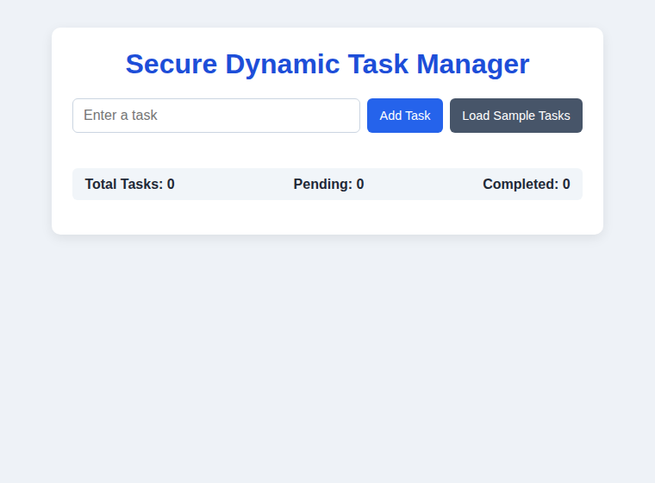
Screenshot 1: Initial state, empty list and counts at 0
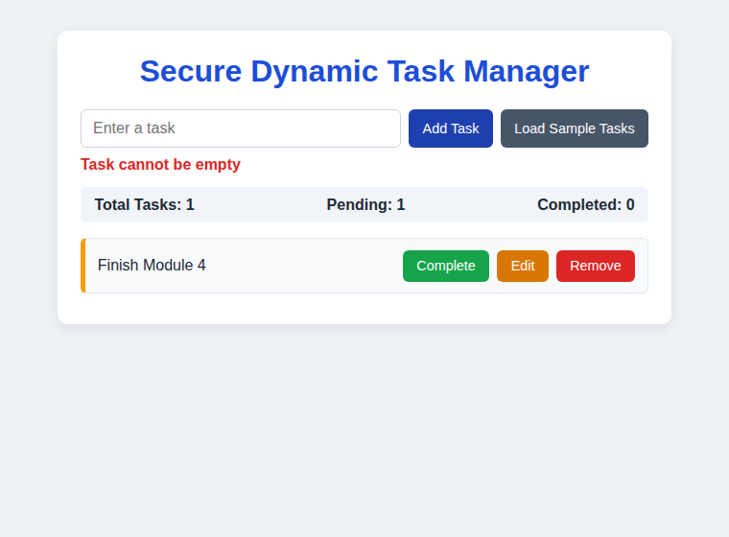
Screenshot 2: A task added, and the error shown for a blank task
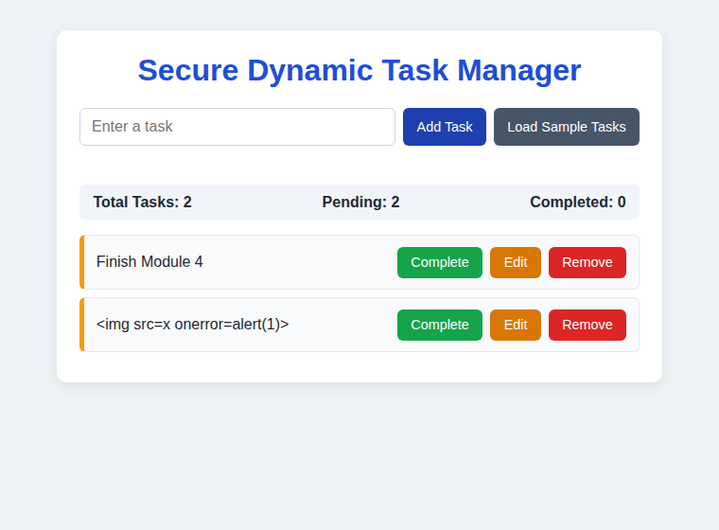
Screenshot 3: HTML-like text displayed literally (no img element created)
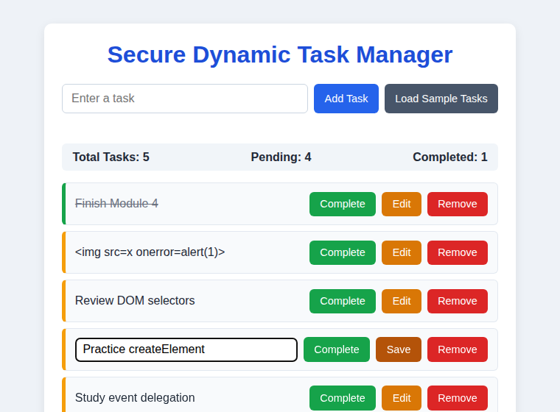
Screenshot 4: Completed task, sample tasks loaded, and a task in edit mode
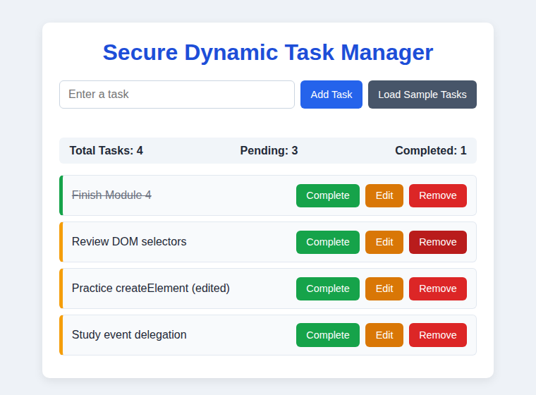
Screenshot 5: After saving an edit and removing a task

10. How to run the project
The project uses JavaScript modules, so the browser must load it through a local server and not by double-clicking index.html. Open the secure-task-manager folder in VS Code and use the Live Server extension (Open with Live Server), or publish it with GitHub Pages.

