Predicting NFL Third-Down Conversions | 1
Predicting NFL Third-Down Conversions
Anthony Feaster II and Nathaniel Sabbara
University of San Diego
AAI 500: Applied Probability and Statistics for AI
Professor Leonid Shpaner
October 19, 2026

Predicting NFL Third-Down Conversions | 2
Introduction
In football, third downs are one of the most important situations because it is often the offense’s last opportunity to keep the drive going. A successful conversion allows the offense to continue the drive; however, a failed conversion means the team has to punt, attempt a field goal, or go for it on fourth down. This makes third down a useful situation for examining which factors are associated with offensive success.
For our project we used the NFLverse play-by-play data from the 2023-2026 NFL seasons (Carl & Baldwin, 2026a, 2026b). We examined information available before each play to include yards to go, play type, field position, quarter, and score differential. Our objectives for this project were to identify which pre-play factors were associated with a successful NFL third down conversion and to evaluate their accuracy in predicting the probability of success.
The dataset includes detailed play-by-play information from the 2023-2026 seasons. The 2023, 2024, and 2025 files contain complete seasons, while the 2026 dataset only includes plays from week 1-3. The first part of this paper explains how the data was prepared and summarizes the exploratory analysis. The second part describes the model, evaluates its results, and discusses the conclusions and limitations of the analysis.
Data Preparation
During the data preparation phase, we combined the 2023-2026 datasets into one DataFrame before filtering the data. The combined dataset contained 156,084 plays and 372 variables. Each row in the dataset represented one play from the 2023 through 2026 NFL

Predicting NFL Third-Down Conversions | 3
seasons. Our initial check found no duplicated rows.
Because this project focuses on third-down conversions, we filtered the data to only include third-down plays. This reduced the dataset to 25,422 third-down plays. We then examined the third_down_converted column, which served as the target variable, and found 41 missing values (NaN). All 41 records were classified as no-play events associated with penalties.
Because these plays did not have a valid conversion outcome, they were removed from the analysis.
We also separated regular-season and postseason games. Of the third-down plays, 24,344 occurred during the regular season and 1,078 occurred during the postseason. We limited the project to regular-season plays because they provided a larger and more consistent sample across the four seasons. The data were then restricted to run and pass attempts with a recorded third-down outcome. After applying these filters, the final exploratory analysis dataset contained 21,948 plays.
The original dataset contained many variables that described what happened after the play began, including yards gained and other results of the play. Those variables were not included because the objective was to estimate conversion success using information available before or at the beginning of the play. Including information that became known after the play would give the analysis information that would not be available when the play was called.
Sixteen variables were selected for the exploratory analysis. These included the game and play identifiers, season, week, offensive and defensive teams, quarter, time remaining, field

Predicting NFL Third-Down Conversions | 4
position, yards to go, play type, third-down outcome, remaining timeouts, score differential, and shotgun formation. After selecting these variables, we found no missing values and no duplicate plays in the final dataset.
NFLverse classifies quarterback scrambles as run plays (Carl & Baldwin, 2026a). We kept that original classification for the exploratory analysis. For the modeling analysis, scrambles were classified as passes because a scramble begins as a designed passing play before the quarterback leaves the pocket. Therefore, a run in the model represents a called running play rather than every play labeled as a run in the original data.
Exploratory Data Analysis (EDA)
The exploratory analysis included 21,948 regular-season third-down run and pass plays. Out of those plays, 8,712 resulted in a successful conversion and 13,236 were unsuccessful. This produced an overall third-down conversion rate of 39.69%, which means that the majority of third-down plays in the dataset were not converted.
Third-down conversion rates were fairly consistent across the four seasons. As shown in Table 1, the rates for the three completed seasons ranged from 39.05% in 2023 to 39.95% in 2024. The partial 2026 season had a conversion rate of 41.22%. Because 2026 does not represent a complete season, comparisons with the earlier seasons should be interpreted cautiously.
Table 1

Predicting NFL Third-Down Conversions | 5
Third-Down Conversion Rate by Season
Season | Conversion rate
2023 | 39.05%
2024 | 39.95%
2025 | 39.85%
2026 | 41.22%
Note. The 2026 season file only contains Weeks 1 through 3.
Run plays had a higher conversion rate than pass plays. Runs converted 53.34% of the time, compared to 35.14% for passes. This difference does not necessarily mean that calling a running play causes a higher chance of success. Teams are more likely to run the ball when they need a few yards and more likely to pass when facing longer distances. Therefore, the difference in conversion rates may be partly related to the number of yards needed rather than play type alone.
Yards to go had the clearest relationship with conversion success. Plays needing one or two yards converted 63.38% of the time. The rate decreased to 47.21% for plays needing three to five yards and 33.69% for plays needing six to ten yards. When the offense needed 11 or more yards, the conversion rate fell to 15.07%. As shown in Figure 1, conversion success became less likely as the required distance increased.

Predicting NFL Third-Down Conversions | 6
Figure 1
Third-Down Conversion Rate by Yards to Go
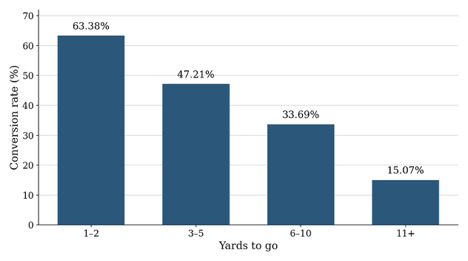
Figure 2 compares the overall conversion rates for run and pass plays. The higher rate for runs should be interpreted together with yards to go because run plays are more common in short-yardage situations. This comparison describes the pattern in the dataset, but it does not prove that selecting a run causes a higher probability of conversion.

Predicting NFL Third-Down Conversions | 7
Figure 2
Third-Down Conversion Rate: Run vs Pass
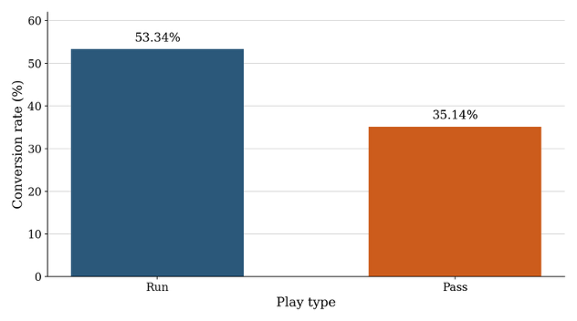
Note. Run and pass categories use the NFLverse play-type labels. Quarterback scrambles are included in the run category for this exploratory comparison.
Quarter, field position, and score differential showed less variation in conversion rates than yards to go. Conversion rates by field position ranged from 30.93% to 41.16%, while the rates across the score situations ranged from 38.36% to 41.13%. The conversion rate more noticeably changed based on the yards needed for a first down and whether the play was a run or pass.
Overall, yards to go had the strongest relationship with conversion success. Play type also

Predicting NFL Third-Down Conversions | 8
mattered, but its relationship with conversion success depended on the number of yards required
for a first down. Season, quarter, field position, and score situation showed smaller differences.
These findings guided the variable selection used in the modeling analysis.
Model Selection
The outcome on each play is a conversion or failure. The exploratory analysis showed that the conversion rate falls with yards to go, that the run-versus-pass comparison changes with that distance, but everything else does not move the rate. We therefore compared three models that can return a probability from the same three predictors (Agresti & Kateri, 2022): yards to go, called run versus pass, and goal-to-go. One caveat, a quarterback scramble is stored in the file as a run. Because a scramble is a dropback on which the quarterback left the pocket, we coded those 1,037 plays as passes, since our goal is to give the most accurate prediction prior to the play. A run in the model is a called run. Considering the results at each yard in Figure 3, we tested linear regression, Identity-link, and logistic regression.

Predicting NFL Third-Down Conversions | 9
Figure 3
Observed Conversion Rate
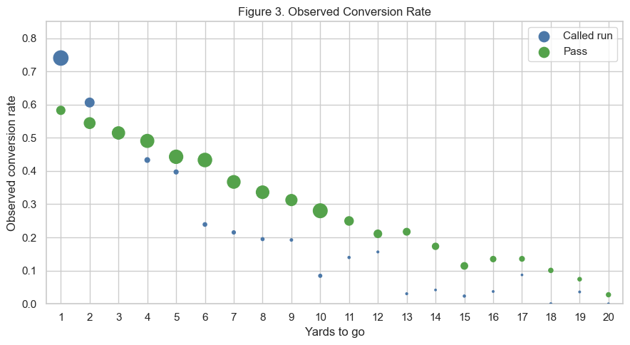
The linear model applies least squares directly to the 0/1 outcome, so a coefficient is a change in the conversion probability. While it is easy to analyze, a binary result is not a normal measurement and its variance is not constant. The straight line in the probability can also be outside the interval from 0 to 1. On the 20,769 plays from 2023 through 2025, this model assigned a probability outside 0 to 1 on 501 plays. When looking inside that interval, the highest fitted probability was 0.66, below the 0.74 observed for an open-field called run on 3rd-and-1. Even worse, at 20 yards the called-run line was negative.
The identity-link binomial model uses the same straight line for the mean and the binomial variance, which matches a yes-or-no outcome. It correctly stayed inside 0 and 1 for nearly every play, but the line still missed the shape of the rates. At 1 yard it gave 0.61 for a called run and 0.45 for a pass, against observed rates of 0.74 and 0.58, while at 20 yards it

Predicting NFL Third-Down Conversions | 10
remained quite high, 0.23 to 0.28, against observed rates of 0.00 and 0.03. The exploratory rates fall quickly at short distances and then level off, and a linear model struggles to replicate this.
The identity-link fit also did not return a usable AIC, because some fitted values reached the boundary.
We did not use AIC to rank the linear model against the logistic model, because those models do not share a likelihood. We chose logistic regression because every fitted probability on the estimation sample stayed between 0 and 1, the curve follows the decline in the observed rates, and the tail was reasonable. At 1 yard the logistic probabilities were 0.71 and 0.60. At 20 yards they were 0.00 and 0.08.
Logistic Regression
Logistic regression writes the line on the log-odds, where R = 1 for a called run and R = 0 for a pass, including scrambles, and G = 1 when the first down is the goal line. The coefficients were estimated by maximum likelihood in statsmodels (Seabold & Perktold, 2010) on the 20,769 regular-season plays from 2023, 2024, and 2025. We held out the 2026 file because it contained only Weeks 1 through 3.
For a run the fitted line is

Predicting NFL Third-Down Conversions | 11
For a pass, the fitted line is
Each additional yard multiplies a pass's odds of converting by 0.86 (95% confidence interval 0.85 to 0.87). The called-run line has an intercept 1.222 and slope −0.333. The two lines cross at 3.7 yards when the play is not goal-to-go. Goal-to-go leaves the slopes unchanged and multiplies the odds by 0.635 (95% confidence interval 0.56 to 0.72).
Model Analysis
Substituting a distance into the fitted line converts the log-odds into a chance the down converts. On 3rd-and-1 in the open field that chance is 0.71 for a called run and 0.60 for a pass.
On 3rd-and-10 the same lines give 0.11 and 0.28. The called-run advantage is therefore a short-yardage advantage. It is gone by about 4 yards, which is where the two open-field curves cross, and past that point the pass is the higher fitted chance. The goal line does not change either slope.
It multiplies the odds by 0.635, so both calls convert less often at the same distance: the 3rd-and-1 called run falls from 0.71 to 0.61, and the pass falls from 0.60 to 0.48. Table 2 is that comparison at the distances where the call actually changes.

Predicting NFL Third-Down Conversions | 12
Table 2
Fitted Conversion Probabilities by Distance, Play Call, and Goal Line
Yards | Open-field run | Open-field pass | Goal-line run | Goal-line pass
1 | 0.709 | 0.596 | 0.607 | 0.483
3 | 0.556 | 0.522 | 0.442 | 0.409
4 | 0.473 | 0.484 | 0.363 | 0.373
10 | 0.109 | 0.276 | 0.072 | 0.195
15 | 0.023 | 0.152 | 0.014 | 0.102
Note. Probabilities are from the logistic model fit on the 2023–2025 regular season. A run is a called run. Scrambles are included with passes.
Figure 4 is the check that those open-field numbers follow the plays. The curves fall roughly with the observed rates, the called-run curve falls faster, and they meet at 3.7 yards. The size of the marker is the number of observed plays, so 3rd-and-1 is drawn from a large sample and a long-yardage called run is rare.

Predicting NFL Third-Down Conversions | 13
Figure 4
Open-Field Rate and the Logistic Fit
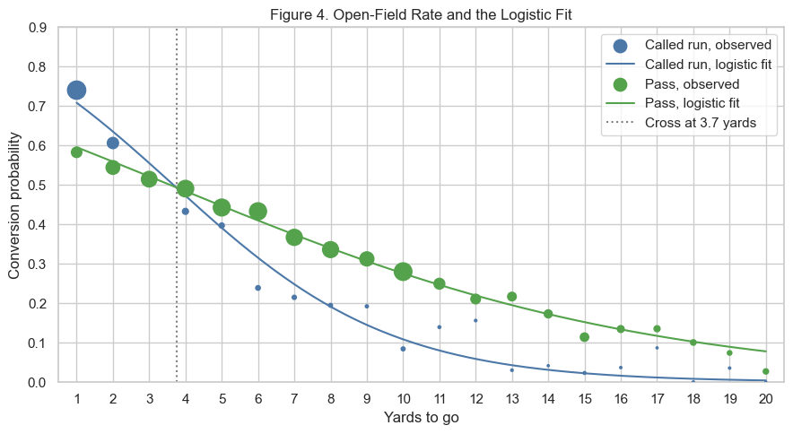
Figure 5 applies the same curves after the goal-line shift. The markers there are thinner and more scattered, especially for called runs past short yardage, so that figure supports the shift.
It does not support a separate goal-line slope, although future work could be done for that.

Predicting NFL Third-Down Conversions | 14
Figure 5
Goal line Rate and the Logistic Fit
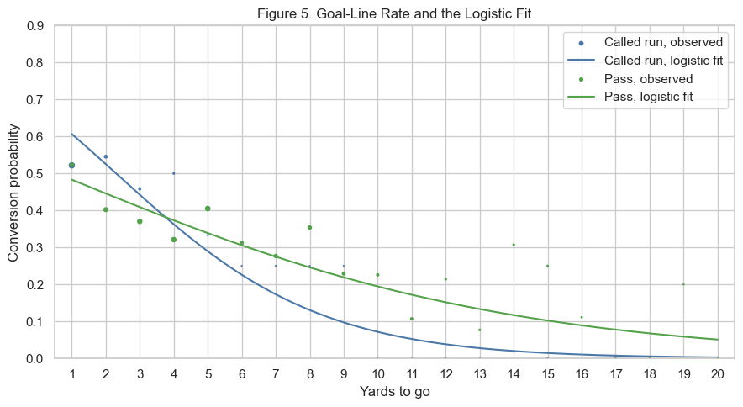
On 1,179 plays in 2026, the model expects a conversion rate of 0.393 and the observed rate is 0.412. That is a check on the overall level after three new weeks. It is too small a sample, and too thin once it is split by distance and call, to refit the line or to rank teams.
Some caveats and issues with the model. The offense chose the call, so 0.71 against 0.60 is the difference between the called runs that were used on 3rd-and-1 and the passes that were used there. It is not an estimate of what would happen if the other call were required. Oftentimes these plays are called due to the formation and performance in that game of the defense. Plays from the same game are also dependent, and the reported standard errors treat them as
independent, so those standard errors are somewhat too small. That being said, the comparison between different play choices at yardage markers show some resilience to this, so long as the difference between the conversion rates are large.

Predicting NFL Third-Down Conversions | 15
Conclusion and Recommendations
Distance is what separates third downs that convert from third downs that do not. Season, quarter, and score move the rate by only a few points. Yards to go moves it from 63.38% at 1–2 yards to 15.07% at 11 or more. For each model the distance is a line rather than a bucket, and it gives the called run and the pass different slopes. The called run is the higher chance inside about 4 yards. Past that point the pass is higher. On the goal line both chances fall: goal-to-go
multiplies the odds by 0.635, and the slopes stay the same.
That is the reading we would use for a call made before the snap. On open-field 3rd-and-1 the fitted chances are 0.71 for a called run and 0.60 for a pass. On 3rd-and-10 they are 0.11 and 0.28. On the goal line that 3rd-and-1 called run is 0.61. A scramble is not evidence for the run, because those plays are coded as passes. Two limits stay on that reading. In making a decision on what to call, the offense factors in the defensive substitutions and formation, as well as their performance throughout the game. Due to this, plays from the same game are dependent, while the reported standard errors treat them as independent. The gaps at 1 yard and at 10 yards are wide enough that a slightly larger error would leave them in place. Near 4 yards, where the two chances are close, the same change would not.
Three things would make the next version of this model stronger. A full or even partial 2026 season would replace the three-week sample we had. On those 1,179 plays the model expected a conversion rate of 0.393 and the observed rate was 0.412, which is close, and it is too small a sample to refit the line or to rank teams. Standard errors computed by game would show

Predicting NFL Third-Down Conversions | 16
whether the gaps at 1 yard and at 10 yards still hold once plays that share a game are allowed to be dependent. Adding the formation, which we already have data on, and how that defense had been playing, which is not in this model, would speak to the call the offense actually chose.

Predicting NFL Third-Down Conversions | 17
References
Agresti, A., & Kateri, M. (2022). Foundations of statistics for data scientists: With R and Python.
Chapman & Hall/CRC. https://doi.org/10.1201/9781003159834
Carl, S., & Baldwin, B. (2026a). nflfastR: Functions to efficiently access NFL play by play data (Version 6.0.0) [Computer software]. https://nflfastr.com/
Carl, S., & Baldwin, B. (2026b). NFL play-by-play data (2023–2026 seasons) [Data set].
nflverse. https://github.com/nflverse/nflverse-data/releases/tag/pbp
Seabold, S., & Perktold, J. (2010). Statsmodels: Econometric and statistical modeling with Python. In S. van der Walt & J. Millman (Eds.), Proceedings of the 9th Python in Science Conference (pp. 92–96). https://doi.org/10.25080/Majora-92bf1922-011

Appendix
Team 2: Nathan Sabbara and Anthony Feaster II
This notebook is the code appendix for the report. The exploratory section is the initial EDA notebook. The later
cells estimate the logistic model. An AI assistant drafted portions of the fitting and plotting code. We checked the
sample and the fitted values against the output.
Initial Exploratory Data Analysis
Project: Predicting Successful NFL Third Down Conversions
This project examines NFLverse play-by-play data from the 2023-2026 seasons. The goal is to identify pre-play factors associated with successful third down conversions, including yards to go, field position, quarter, score
differential, play type, formation and time remaining.
Data Source: [NFLverse Play-by-Play Data](https://github.com/nflverse/nflverse-data/releases/tag/pbp)
1. Data Loading and Initial Review
# Importing Libraries
from pathlib import Path
import pandas as pd
import numpy as np
import matplotlib.pyplot as plt
import seaborn as sns
# Locating and setting the data folder
project_root = Path.cwd()
if project_root.name == "notebooks":
project_root = project_root.parent
data_dir = project_root / "data" / "raw"
# Loading the data and creating the combined DataFrame
pbp_2023 = pd.read_csv(data_dir / "play_by_play_2023.csv", low_memory=False) pbp_2024 = pd.read_csv(data_dir / "play_by_play_2024.csv", low_memory=False) pbp_2025 = pd.read_csv(data_dir / "play_by_play_2025.csv", low_memory=False) pbp_2026 = pd.read_csv(data_dir / "play_by_play_2026.csv", low_memory=False)
pbp = pd.concat([pbp_2023, pbp_2024, pbp_2025, pbp_2026], ignore_index=True)
#Commented out to avoid html submission issue
pbp.head(5)
play_id game_id old_game_id home_team away_team season_type \ 0 1 2023_01_ARI_WAS 2023091007 WAS ARI REG 1 39 2023_01_ARI_WAS 2023091007 WAS ARI REG 2 55 2023_01_ARI_WAS 2023091007 WAS ARI REG 3 77 2023_01_ARI_WAS 2023091007 WAS ARI REG 4 102 2023_01_ARI_WAS 2023091007 WAS ARI REG
week posteam posteam_type defteam ... out_of_bounds home_opening_kickoff \ 0 1 NaN NaN NaN ... 0 1 1 1 WAS home ARI ... 0 1 2 1 WAS home ARI ... 0 1 3 1 WAS home ARI ... 0 1 4 1 WAS home ARI ... 0 1
qb_epa xyac_epa xyac_mean_yardage xyac_median_yardage xyac_success \ 0 0.000000 NaN NaN NaN NaN

1 0.000000 NaN NaN NaN NaN 2 -0.336103 NaN NaN NaN NaN 3 0.703308 0.340652 3.328642 1.0 0.996628 4 0.469799 NaN NaN NaN NaN
xyac_fd xpass pass_oe
0 NaN NaN NaN
1 NaN NaN NaN
2 NaN 0.515058 -51.505846
3 0.583928 0.661106 33.889407
4 NaN 0.196065 -19.606467
[5 rows x 372 columns]
print(f"Total: {pbp.shape[0]:,} rows, {pbp.shape[1]:,} columns\n")

print(f"Dataset: {pbp.shape[0]:,} plays from 2023-2026 seasons\n")

pbp["season"].value_counts().sort_index()
Total: 156,084 rows, 372 columns
Dataset: 156,084 plays from 2023-2026 seasons
season
2023 49665
2024 49492
2025 48771
2026 8156
Name: count, dtype: int64
2. Reviewing the Complete Dataset
pbp.info()
<class 'pandas.core.frame.DataFrame'>
RangeIndex: 156084 entries, 0 to 156083
Columns: 372 entries, play_id to pass_oe
dtypes: float64(181), int64(39), object(152)
memory usage: 443.0+ MB
pbp.describe()
play_id old_game_id week yardline_100 \ count 156084.000000 1.560840e+05 156084.000000 144945.000000 mean 2186.581008 2.024291e+09 9.537070 47.756487 std 1274.076580 9.383605e+05 5.736511 23.932132 min 1.000000 2.023091e+09 1.000000 1.000000 25% 1092.000000 2.023122e+09 4.000000 30.000000 50% 2166.000000 2.024112e+09 9.000000 49.000000 75% 3263.000000 2.025102e+09 15.000000 68.000000 max 5519.000000 2.026093e+09 22.000000 99.000000
quarter_seconds_remaining half_seconds_remaining \ count 156067.000000 156067.000000 mean 408.920278 803.135583 std 282.995402 560.986725 min 0.000000 0.000000 25% 143.000000 273.000000 50% 388.000000 784.000000 75% 654.000000 1285.000000 max 900.000000 1800.000000
game_seconds_remaining quarter_end drive sp \ count 156067.000000 156084.000000 154292.000000 156084.000000 mean 1704.052497 0.017651 11.318098 0.075447 std 1058.225076 0.131679 6.591909 0.264111 min 0.000000 0.000000 1.000000 0.000000 25% 781.000000 0.000000 6.000000 0.000000 50% 1800.000000 0.000000 11.000000 0.000000

75% 2590.000000 0.000000 17.000000 0.000000 max 3600.000000 1.000000 34.000000 1.000000
... out_of_bounds home_opening_kickoff qb_epa xyac_epa \ count ... 156084.000000 156084.000000 154280.000000 52770.000000 mean ... 0.085922 0.507547 0.006451 0.733447 std ... 0.280249 0.499945 1.249021 0.528333 min ... 0.000000 0.000000 -12.689102 -3.181688 25% ... 0.000000 0.000000 -0.557776 0.325437 50% ... 0.000000 1.000000 0.000000 0.608888 75% ... 0.000000 1.000000 0.531366 1.007500 max ... 1.000000 1.000000 8.882384 9.585749
xyac_mean_yardage xyac_median_yardage xyac_success xyac_fd \ count 52770.000000 52770.000000 52770.000000 52770.000000 mean 5.527103 3.702274 0.775842 0.578875 std 2.564078 2.630531 0.254090 0.356944 min 0.442673 0.000000 0.026981 0.004220 25% 3.756694 2.000000 0.555827 0.242725 50% 4.621278 3.000000 0.983180 0.474688 75% 6.920977 5.000000 1.000000 0.999328 max 23.952005 36.000000 1.000000 1.000000
xpass pass_oe
count 118896.000000 115501.000000
mean 0.628758 -1.418037
std 0.240985 42.391991
min 0.013008 -99.538189
25% 0.456023 -42.579734
50% 0.601380 3.849697
75% 0.859060 32.931900
max 0.997794 97.848164
[8 rows x 220 columns]
pbp.columns
Index(['play_id', 'game_id', 'old_game_id', 'home_team', 'away_team', 'season_type', 'week', 'posteam', 'posteam_type', 'defteam', ...
'out_of_bounds', 'home_opening_kickoff', 'qb_epa', 'xyac_epa',
'xyac_mean_yardage', 'xyac_median_yardage', 'xyac_success', 'xyac_fd', 'xpass', 'pass_oe'],
dtype='object', length=372)
3. Initial Data Quality Review
#Looking for Missing Values

pbp.isnull().sum()
play_id 0
game_id 0
old_game_id 0
home_team 0
away_team 0
...
xyac_median_yardage 103314
xyac_success 103314
xyac_fd 103314
xpass 37188
pass_oe 40583
Length: 372, dtype: int64
# Checking for Duplicate Values

print(f"Number of Duplicate Values: {pbp.duplicated().sum()}")
Number of Duplicate Values: 0

4. Defining the Plays Included in the Analysis
# Creating a new dataframe of only 3rd Down Plays

third_down = pbp[pbp["down"] == 3].copy()

print(f"Dataset: {third_down.shape[0]:,} third down plays from 2023-2026 seasons\n")
Dataset: 25,422 third down plays from 2023-2026 seasons
# Reviewing the types of third down plays

third_down['play_type'].value_counts(dropna=False)
play_type
pass 17180
run 5765
no_play 2162
qb_kneel 190
field_goal 100
qb_spike 25
Name: count, dtype: int64
# Reviewing the target variable

third_down["third_down_converted"].value_counts(dropna=False).rename(index={0: "Failed", 1:

"Successful"})
third_down_converted
Failed 16257
Successful 9124
NaN 41
Name: count, dtype: int64
# Identifying third-down records with missing conversion outcomes

missing_outcomes = third_down[third_down["third_down_converted"].isna()]

# Checking which play types have missing outcomes

missing_outcomes["play_type"].value_counts(dropna=False)
play_type
no_play 41
Name: count, dtype: int64
41 third down plays had missing conversion outcomes NaN. All 41 records were classified as no_play and
described penalty events. Only regular-season run and pass plays were retained for analysis, so these records were
not included. No missing conversion outcomes remained among the selected plays.
# Reviewing regular season vs playoffs

third_down['season_type'].value_counts(dropna=False)
season_type
REG 24344
POST 1078
Name: count, dtype: int64
# Keeping regular-season third-down run and pass attempts with a recorded conversion outcome

third_down_analysis = third_down[

(third_down['season_type'] == 'REG') &

(third_down['play_type'].isin (['run','pass'])) &

(third_down['third_down_converted'].notna())

].copy()

print(f"Dataset: {third_down_analysis.shape[0]:,} third down plays from 2023-2026 seasons\n")
Dataset: 21,948 third down plays from 2023-2026 seasons

5. Selecting the Analysis Variables
analysis_columns = [
"game_id",
"play_id",
"season",
"week",
"posteam",
"defteam",
"qtr",
"game_seconds_remaining",
"yardline_100",
"ydstogo",
"play_type",
"third_down_converted",
"posteam_timeouts_remaining",
"defteam_timeouts_remaining",
"score_differential",
"shotgun"
]
third_down_plays = third_down_analysis[analysis_columns].copy() third_down_plays.shape
(21948, 16)
# Looking for missing values in the selected analysis variables

missing_values = pd.DataFrame({

"missing_count": third_down_plays.isna().sum(),

"missing_percentage": third_down_plays.isna().mean() * 100

})

missing_values = missing_values.sort_values(by="missing_percentage", ascending=False)

missing_values
missing_count missing_percentage game_id 0 0.0 play_id 0 0.0 season 0 0.0 week 0 0.0 posteam 0 0.0 defteam 0 0.0 qtr 0 0.0 game_seconds_remaining 0 0.0 yardline_100 0 0.0 ydstogo 0 0.0 play_type 0 0.0 third_down_converted 0 0.0 posteam_timeouts_remaining 0 0.0 defteam_timeouts_remaining 0 0.0 score_differential 0 0.0 shotgun 0 0.0
print("Complete Duplicate Rows:", third_down_plays.duplicated().sum())

print("Duplicate Rows by Play ID:", third_down_plays.duplicated(subset=["game_id",

"play_id"]).sum())
Complete Duplicate Rows: 0
Duplicate Rows by Play ID: 0
There are 21,948 plays in the dataset after filtering down to regular season third-down run and pass attempts with a
recorded conversion outcome. 16 selected variables (columns) describe the game situation, play type, field position, time remaining, and conversion outcome. There were no missing values and no duplicate plays found.

6. Third-Down Conversion Analysis
Conversion Summary Function
def summarize_conversions(data, group_column):
summary = (
data.groupby(group_column, as_index=False).agg( number_of_plays=(
"third_down_converted", "count"
),
successful_conversions=(
"third_down_converted", "sum"
),
conversion_rate=(
"third_down_converted", "mean"
)
)
)
summary["conversion_rate"] = (summary["conversion_rate"] * 100).round(2)

return summary
6.1 Overall Conversion Results
conversion_summary = (third_down_plays["third_down_converted"].value_counts().reindex([0, 1], fill_value=0).rename_axis("conversion").reset_index(name="count"))
# Adding Descriptive Labels
conversion_summary["outcome"] = conversion_summary["conversion"].map({0: "Failed", 1: "Successful"})
# Calculating the proportion and percentage of third down plays
conversion_summary["rate"] = (conversion_summary["count"] / conversion_summary["count"].sum())
conversion_summary["rate_percentage"] = (conversion_summary["rate"] * 100).round(2).map(" {:.2f}%".format)
# Renaming Column Names to be more descriptive
conversion_summary = conversion_summary[["outcome", "count", "rate_percentage"]].rename(columns={
"outcome": "Conversion Outcome",
"count": "Number of Plays",
"rate_percentage": "Percentage of Plays"
})
conversion_summary.style.format({
"Number of Plays": "{:,.0f}",
})

 | Conversion Outcome | Number of Plays | Percentage of Plays
0 | Failed | 13,236 | 60.31%
1 | Successful | 8,712 | 39.69%
Out of the 21,948 third down plays, 8,712 were successful which resulted in a conversion rate of 39.69%, while
13,236 were unsuccessful which resulted in a failed rate of 60.31%. This means that the majority of third down plays were unsuccessful, highlighting the challenges teams face when converting on third down situations.
6.2 Conversion Rate by Season

# Comparing Conversion Rates by Seasons
conversion_by_season = (third_down_plays.groupby("season", as_index=False) .agg(
number_of_plays = ("third_down_converted", "count"),
successful_conversions = ("third_down_converted", "sum"),
conversion_rate = ("third_down_converted", "mean")
))
# Converting Rate to Percentage
conversion_by_season["conversion_rate"] = (conversion_by_season["conversion_rate"] * 100).round(2).map("{:.2f}%".format)
# Renaming Columns
conversion_by_season = conversion_by_season.rename(columns={ "season": "Season",
"number_of_plays": "Number of Plays",
"successful_conversions": "Successful Conversions", "conversion_rate": "Conversion Rate (%)"
})
conversion_by_season.style.format({
"Number of Plays": "{:,.0f}",
"Successful Conversions": "{:,.0f}",
})

 | Season | Number of Plays | Successful Conversions | Conversion Rate (%)
0 | 2023 | 7,140 | 2,788 | 39.05%
1 | 2024 | 6,828 | 2,728 | 39.95%
2 | 2025 | 6,801 | 2,710 | 39.85%
3 | 2026 | 1,179 | 486 | 41.22%

season_plot = (third_down_plays.groupby("season", as_index=False) ["third_down_converted"].mean())
sns.barplot(
data=season_plot,
x="season",
y="conversion_rate",
hue="season",
palette="Set2",
dodge=False,
legend=False,
ax=ax
)
for container in ax.containers:
ax.bar_label(container, fmt="%.2f%%", padding=3)
ax.set_title("Third Down Conversion Rate by Season") ax.set_xlabel("Season")
ax.set_ylabel("Conversion Rate (%)")
ax.set_ylim(0, 50)
ax.grid(axis="x", visible=False)

sns.set_theme(style="whitegrid")

season_plot["conversion_rate"] = season_plot["third_down_converted"] * 100

fig, ax = plt.subplots(figsize=(9, 5))

plt.tight_layout()

plt.show()
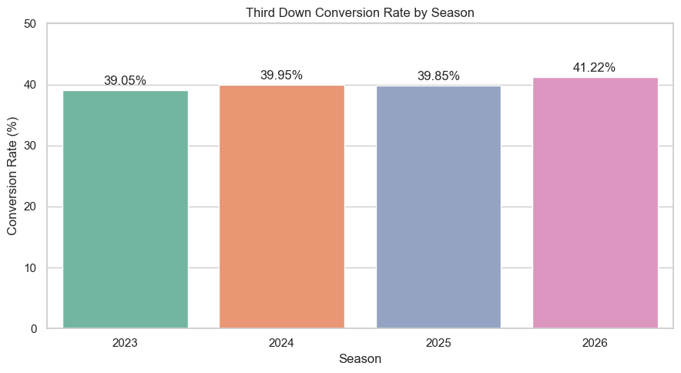
Third down conversion rates remained relatively consistent across the four seasons, ranging from 39.05% to
41.22%. The partial 2026 season had the highest conversion rate, but it contained fewer plays than the completed
seasons. Therefore, comparisons with previous years should be interpreted cautiously.
6.3 Conversion Rate by Play Type
conversion_by_play_type = summarize_conversions(third_down_plays, "play_type")

conversion_by_play_type_display = conversion_by_play_type.rename(
columns={
"play_type": "Play Type",
"number_of_plays": "Number of Plays",
"successful_conversions": "Successful Conversions", "conversion_rate": "Conversion Rate (%)"
}
).copy()

conversion_by_play_type_display['Play Type'] = (conversion_by_play_type_display['Play
Type'].str.title())
conversion_by_play_type_display['Conversion Rate (%)'] =
(conversion_by_play_type_display['Conversion Rate (%)'].map("{:.2f}%".format))

conversion_by_play_type_display.style.format({
"Number of Plays": "{:,.0f}",
"Successful Conversions": "{:,.0f}"
})
 | Play Type | Number of Plays | Successful Conversions | Conversion Rate (%)
0 | Pass | 16,455 | 5,782 | 35.14%
1 | Run | 5,493 | 2,930 | 53.34%

plt.figure(figsize=(9, 5))

ax = sns.barplot(
data=conversion_by_play_type,
x = conversion_by_play_type["play_type"].str.title(),
y = "conversion_rate",
order = ["Run", "Pass"],
color = "steelblue"
)

plt.title("Third Down Conversion Rate: Run vs Pass")
plt.xlabel("Play Type")
plt.ylabel("Conversion Rate (%)")
plt.ylim(0, conversion_by_play_type["conversion_rate"].max() + 10)
for container in ax.containers:
ax.bar_label(container, fmt="%.2f%%", padding=3)
plt.show()
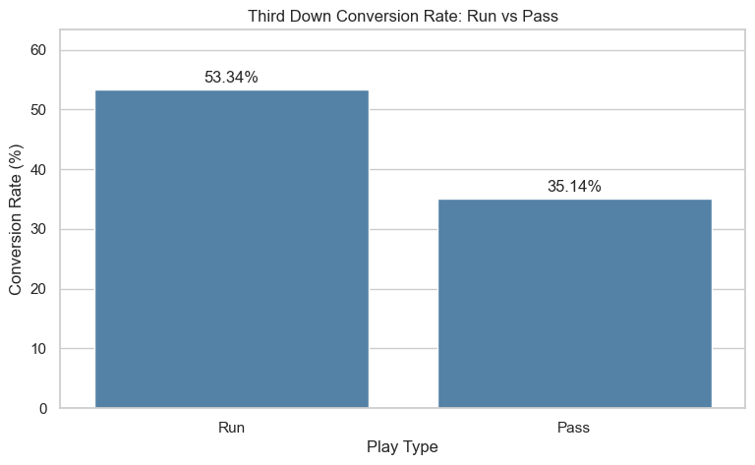
The data reveals that running plays had a higher third-down conversion rate than passing plays. Running plays
were converted 53.34% of the time compared to 35.14% for passing plays. This doesn't mean that running caused
a higher degree of conversions; teams may be more likely to run when fewer yards are needed for a first down.
6.4 Conversion Rate by Yards to Go
third_down_plays["yards_to_go_group"] = pd.cut(third_down_plays["ydstogo"],

bins=[0, 2, 5, 10, np.inf],

labels=[

"1-2 Yards",

"3-5 Yards",

"6-10 Yards",

"11+ Yards"

]

)
conversion_by_distance = summarize_conversions(third_down_plays, "yards_to_go_group")
conversion_by_distance_display = conversion_by_distance.rename( columns={
"yards_to_go_group": "Yards to Go",
"number_of_plays": "Number of Plays",
"successful_conversions": "Successful Conversions", "conversion_rate": "Conversion Rate (%)"
}
)
# Display successful conversion counts as whole numbers
conversion_by_distance_display["Successful Conversions"] = (
conversion_by_distance_display["Successful Conversions"].astype(int) )
conversion_by_distance_display['Conversion Rate (%)'] =
(conversion_by_distance_display['Conversion Rate (%)'].map("{:.2f}%".format))

conversion_by_distance_display.style.format({
"Number of Plays": "{:,.0f}",
"Successful Conversions": "{:,.0f}"
})
/var/folders/7j/tm7h019108s7yxqq8_pr_8z00000gn/T/ipykernel_54391/2302337863.py:3: FutureWarning: The default of observed=False is deprecated and will be changed to True in a future version of pandas. Pass observed=False to retain current behavior or observed=True to adopt the future default and silence this warning.
data.groupby(group_column, as_index=False).agg(
 | Yards to Go | Number of Plays | Successful Conversions | Conversion Rate (%)
0 | 1-2 Yards | 4,498 | 2,851 | 63.38%
1 | 3-5 Yards | 5,497 | 2,595 | 47.21%
2 | 6-10 Yards | 7,866 | 2,650 | 33.69%
3 | 11+ Yards | 4,087 | 616 | 15.07%

plt.figure(figsize=(9, 5))

plt.show()

)

plt.title("Distribution of Yards to Go on Third Down")

plt.xlabel("Yards to Go")

plt.ylabel("Number of Plays")

plt.tight_layout()

color="steelblue",

alpha=0.7

sns.histplot(

data=third_down_plays,

x="ydstogo",

discrete=True,

kde=True,

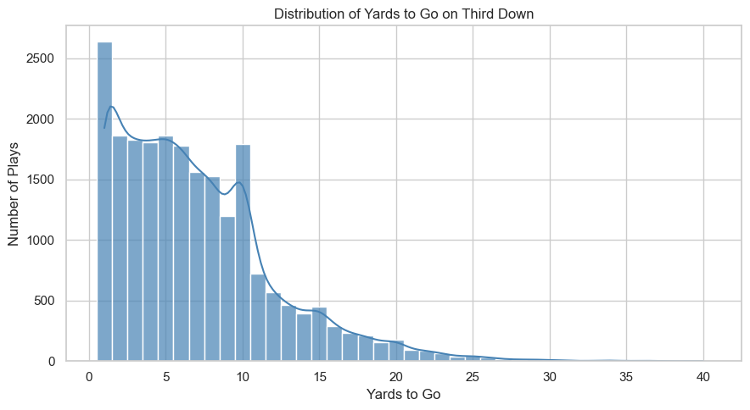
This histogram shows the distribution of yards to go on third downs. Each bar represents the number of plays at a
particular distance. The histogram illustrates that majority of third down plays were 10 yards or less.
plt.figure(figsize=(9, 5))

sns.barplot(
data = conversion_by_distance,
x = conversion_by_distance["yards_to_go_group"].str.title(), y = "conversion_rate",
color = "seagreen"
)

plt.title("Third Down Conversion Rate by Yards to Go")
plt.xlabel("Yards to Go")
plt.ylabel("Conversion Rate (%)")
plt.tight_layout()
plt.show()

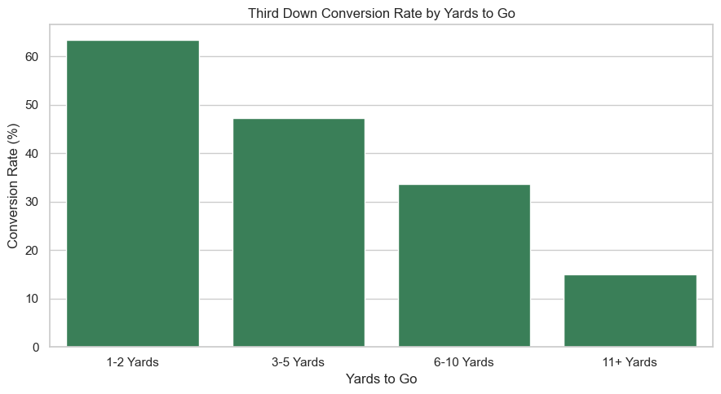
As the distance for a first down increased, the successful conversion rate decreased. Plays needing 1–2 yards for a
first down were converted 63.38% of the time. However, plays needing 11+ yards only converted 15.07% of the
time. This suggests that yards to go has a strong relationship with successful third down conversions.
6.5 Distance and Play Type
conversion_heatmap = third_down_plays.pivot_table( values="third_down_converted",
index="yards_to_go_group",
columns="play_type",
aggfunc="mean",
observed=False
) * 100
conversion_heatmap = conversion_heatmap.reindex(columns=["run", "pass"])
conversion_heatmap = conversion_heatmap.rename(columns={"run": "Run", "pass": "Pass"})
plt.figure(figsize=(8, 5))
sns.heatmap(
conversion_heatmap,
annot=True,
fmt=".2f",
cmap="Blues",
vmin=0,
vmax=100,
cbar_kws={"label": "Conversion Rate (%)"}
)
plt.title("Third Down Conversion Rate (%) by Distance and Play Type") plt.xlabel("Play Type")
plt.ylabel("Yards to Go")
plt.yticks(rotation=0)
plt.tight_layout()
plt.show()

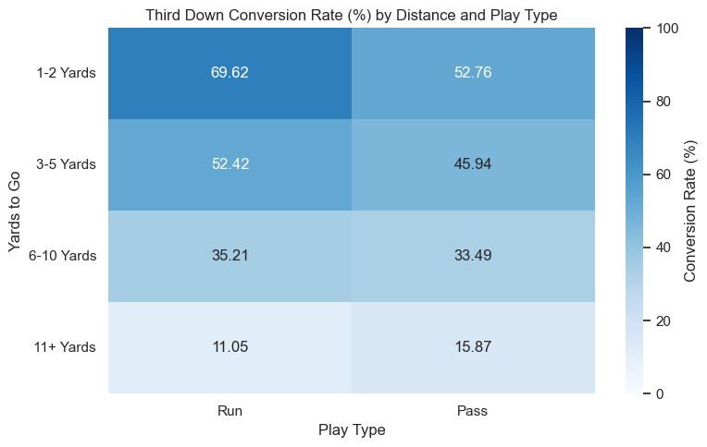
This heatmap compares run and pass conversion rates within the same yards to go categories. It shows how teams
were more successful at converting third downs with running plays when the yards to go were 5 and under. When
first downs required 11+ yards, teams were more successful with passing plays.
6.6 Conversion Rate by Quarter
conversion_by_quarter = summarize_conversions(third_down_plays, "qtr")
conversion_by_quarter_display = conversion_by_quarter.rename( columns={
"qtr": "Quarter",
"number_of_plays": "Number of Plays",
"successful_conversions": "Successful Conversions", "conversion_rate": "Conversion Rate (%)"
}
)
# Display successful conversion counts as whole numbers
conversion_by_quarter_display["Successful Conversions"] = (
conversion_by_quarter_display["Successful Conversions"].astype(int) )
# Display quarters as whole numbers
conversion_by_quarter_display["Quarter"] = (
conversion_by_quarter_display["Quarter"].astype(int) )
# Display conversion rate with a percentage sign
conversion_by_quarter_display['Conversion Rate (%)'] =
(conversion_by_quarter_display['Conversion Rate (%)'].map("{:.2f}%".format))
# Display quarter 5 as Overtime

conversion_by_quarter_display["Quarter"] = (
conversion_by_quarter_display["Quarter"].replace({ 1: "1st",
2: "2nd",
3: "3rd",
4: "4th",
5: "Overtime"
})
)

conversion_by_quarter_display.style.format({
"Number of Plays": "{:,.0f}",
"Successful Conversions": "{:,.0f}"
})

 | Quarter | Number of Plays | Successful Conversions | Conversion Rate (%)
0 | 1st | 4,890 | 2,027 | 41.45%
1 | 2nd | 6,054 | 2,403 | 39.69%
2 | 3rd | 4,797 | 1,925 | 40.13%
3 | 4th | 6,101 | 2,314 | 37.93%
4 | Overtime | 106 | 43 | 40.57%

fig, ax = plt.subplots(figsize=(9, 5))

sns.lineplot(
data=conversion_by_quarter, x="qtr",
y="conversion_rate",
marker="o",
linewidth=2,
color="steelblue",
sort=False,
ax=ax
ax.set_xlabel("Quarter")
ax.set_xticks(
[1, 2, 3, 4, 5],
labels=["1st", "2nd", "3rd", "4th", "Overtime"] )
ax.set_ylabel("Conversion Rate (%)")
ax.set_ylim(0, 50)
ax.grid(axis="x", visible=False)
plt.tight_layout()
plt.show()

ax.set_title("Third Down Conversion Rate by Quarter")

)

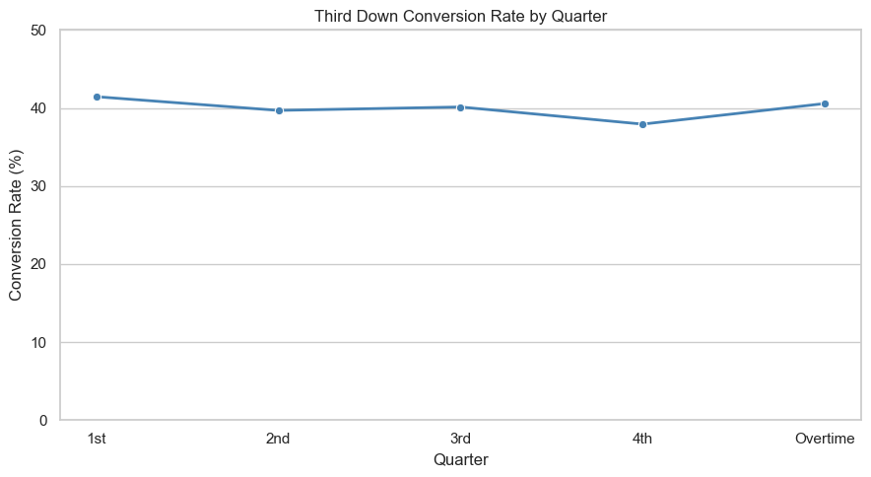
Conversion rates were relatively similar across the four regulation quarters. The first quarter had the highest
conversion rate at 41.45%, compared with 37.93% in the fourth quarter. Overtime had a conversion rate of
40.57%, but contained only 106 plays.
6.7 Conversion Rate by Field Position
third_down_plays["field_position_group"] = pd.cut( third_down_plays["yardline_100"],
bins=[0, 20, 50, 79, 100],
labels=[
"Opponent 1-20",
"Opponent 21-50",
"Own 21-50",
"Own 1-20"
],
include_lowest=True
)
conversion_by_field_position = summarize_conversions(third_down_plays, "field_position_group")
conversion_by_field_position_display = conversion_by_field_position.rename( columns={
"field_position_group": "Field Position",
"number_of_plays": "Number of Plays",
"successful_conversions": "Successful Conversions",
"conversion_rate": "Conversion Rate (%)"
}
)
conversion_by_field_position_display['Conversion Rate (%)'] =
(conversion_by_field_position_display['Conversion Rate (%)'].map("{:.2f}%".format))
conversion_by_field_position_display.style.format({
"Number of Plays": "{:,.0f}",

"Successful Conversions": "{:,.0f}"

})
/var/folders/7j/tm7h019108s7yxqq8_pr_8z00000gn/T/ipykernel_54391/2302337863.py:3: FutureWarning: The default of observed=False is deprecated and will be changed to True in a future version of pandas. Pass observed=False to retain current behavior or observed=True to adopt the future default and silence this warning.
data.groupby(group_column, as_index=False).agg(
 | Field Position | Number of Plays | Successful Conversions | Conversion Rate (%)
0 | Opponent 1-20 | 3,678 | 1,470 | 39.97%
1 | Opponent 21-50 | 7,006 | 2,884 | 41.16%
2 | Own 21-50 | 9,431 | 3,791 | 40.20%
3 | Own 1-20 | 1,833 | 567 | 30.93%

fig, ax = plt.subplots(figsize=(9, 5))

sns.barplot(
data=conversion_by_field_position, y="field_position_group",
x="conversion_rate",
color="darkorange",
ax=ax
)
for container in ax.containers: ax.bar_label(
container,
fmt="%.2f%%",
padding=3
)
ax.set_title("Third Down Conversion Rate by Field Position") ax.set_xlabel("Conversion Rate (%)")
ax.set_ylabel("Field Position")
ax.set_xlim(0, 50)
ax.grid(axis="y", visible=False)
plt.tight_layout()
plt.show()

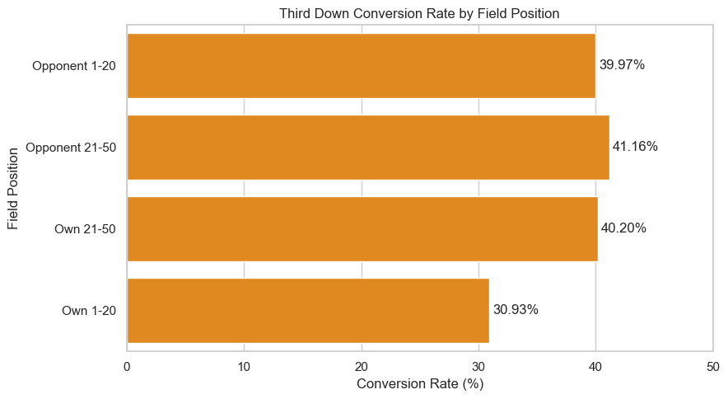
Conversion rates were highest between the opponent's 21–50 yard lines (41.16%) and lowest between the offense's
own 1–20 yard lines (30.93%).
6.8 Conversion Rate by Score Situation
third_down_plays["score_situation"] = pd.cut(
third_down_plays["score_differential"],
bins = [-np.inf, -9, -1, 0, 8, np.inf],
labels = [
"Trailing by 9+",
"Trailing by 1-8",
"Tied",
"Leading by 1-8",
"Leading by 9+"
]
)
conversion_by_score = summarize_conversions(third_down_plays, "score_situation")
conversion_by_score_display = conversion_by_score.rename( columns={
"score_situation": "Score Situation",
"number_of_plays": "Number of Plays",
"successful_conversions": "Successful Conversions", "conversion_rate": "Conversion Rate (%)"
}
)
conversion_by_score_display['Conversion Rate (%)'] = (conversion_by_score_display['Conversion Rate (%)'].map("{:.2f}%".format))
conversion_by_score_display.style.format({
"Number of Plays": "{:,.0f}",
"Successful Conversions": "{:,.0f}"
})

/var/folders/7j/tm7h019108s7yxqq8_pr_8z00000gn/T/ipykernel_54391/2302337863.py:3: FutureWarning: The default of observed=False is deprecated and will be changed to True in a future version of pandas. Pass observed=False to retain current behavior or observed=True to adopt the future default and silence this warning.
data.groupby(group_column, as_index=False).agg(
 | Score Situation | Number of Plays | Successful Conversions | Conversion Rate (%)
0 | Trailing by 9+ | 4,228 | 1,622 | 38.36%
1 | Trailing by 1-8 | 5,919 | 2,346 | 39.64%
2 | Tied | 4,333 | 1,782 | 41.13%
3 | Leading by 1-8 | 4,571 | 1,795 | 39.27%
4 | Leading by 9+ | 2,897 | 1,167 | 40.28%
The conversion rate is pretty consistent across the five score situations. The rates ranged from 38.36% when a team is trailing by 9+ to 41.13% when the game is tied. This suggests that score differential by itself may not
predict whether a team would successfully convert on third down.
7. Model Selection
7.1 Preparing the Plays for the Model
import statsmodels.api as sm #GLMs
import warnings
warnings.filterwarnings('ignore') #identity link warning
# drop a row if yards or goal-to-go is missing
third = third_down_analysis[
(third_down_analysis['ydstogo'] >= 1)
& (third_down_analysis['goal_to_go'].notna())
].copy()
third['yards'] = third['ydstogo'].astype(int)
third['converted'] = third['third_down_converted'].astype(int) #1 = converted third['goal'] = (third['goal_to_go'] == 1).astype(int) #1 = goal-to-go
# scramble is stored as a run, code it as a pass
third['play'] = third['play_type']
third.loc[third['qb_scramble'].fillna(0) == 1, 'play'] = 'pass' third['run'] = (third['play'] == 'run').astype(int) #1 = called run third['yards_run'] = third['yards'] * third['run'] #interaction
# 2026 is only weeks 1-3
fit = third[third['season'].isin([2023, 2024, 2025])].copy() holdout = third[third['season'] == 2026].copy()
n_scramble = int((third['qb_scramble'].fillna(0) == 1).sum())
n_file_runs = int((third['play_type'] == 'run').sum())
print(f'2023-2025 plays: {len(fit):,}')
print(f'Scrambles moved to the pass: {n_scramble:,} (out of {n_file_runs:,} plays the file called runs)')
display(fit.groupby('play')['converted'].agg(['mean', 'count']))
print(f'2026 left out: {len(holdout):,} plays')
2023-2025 plays: 20,769
Scrambles moved to the pass: 1,096 (out of 5,493 plays the file called runs)
 | mean | count
play
pass | 0.361884 | 16602

 | mean | count
play
run | 0.532277 | 4167
2026 left out: 1,179 plays
The model is fit on 20,769 plays from the 2023–2025 seasons. Out of 5,493 plays the file called runs, 1,096 were
scrambles and were coded as passes. On the plays used in the fit, called runs converted 53.23% of the time
compared with 36.19% for passes. The 1,179 plays from the first three weeks of 2026 were left out of the fit.
7.2 Linear Model
# OLS on the 0/1 outcome

X = sm.add_constant(fit[['yards', 'run', 'yards_run', 'goal']])

linear_model = sm.OLS(fit['converted'], X).fit()

display(linear_model.summary())
<class 'statsmodels.iolib.summary.Summary'>
"""
OLS Regression Results ============================================================================== Dep. Variable: converted R-squared: 0.115 Model: OLS Adj. R-squared: 0.115 Method: Least Squares F-statistic: 676.0 Date: Mon, 19 Oct 2026 Prob (F-statistic): 0.00 Time: 22:11:59 Log-Likelihood: -13344. No. Observations: 20769 AIC: 2.670e+04 Df Residuals: 20764 BIC: 2.674e+04 Df Model: 4
Covariance Type: nonrobust
============================================================================== coef std err t P>|t| [0.025 0.975]------------------------------------------------------------------------------const 0.5819 0.007 83.948 0.000 0.568 0.595 yards -0.0279 0.001 -36.830 0.000 -0.029 -0.026 run 0.1192 0.011 10.558 0.000 0.097 0.141 yards_run -0.0127 0.002 -8.159 0.000 -0.016 -0.010 goal -0.0908 0.014 -6.473 0.000 -0.118 -0.063 ============================================================================== Omnibus: 116201.644 Durbin-Watson: 1.977 Prob(Omnibus): 0.000 Jarque-Bera (JB): 2364.899 Skew: 0.309 Prob(JB): 0.00 Kurtosis: 1.467 Cond. No. 38.5 ==============================================================================
Notes:
[1] Standard Errors assume that the covariance matrix of the errors is correctly specified.
"""
This fits a straight line to a 0 or 1 outcome. The R-squared is 0.115, so yards to go, play type, and goal-to-go leave
most of the play-to-play result unexplained. A straight line can also fall below 0 or rise above 1, which is not a
usable chance.
7.3 Identity-Link Model
# binomial GLM, identity link

identity_model = sm.GLM(

fit['converted'],

X,

family=sm.families.Binomial(link=sm.families.links.Identity()),

).fit()

display(identity_model.summary())
<class 'statsmodels.iolib.summary.Summary'>
"""

Generalized Linear Model Regression Results ============================================================================== Dep. Variable: converted No. Observations: 20769 Model: GLM Df Residuals: 20764 Model Family: Binomial Df Model: 4 Link Function: Identity Scale: 1.0000 Method: IRLS Log-Likelihood: nan Date: Mon, 19 Oct 2026 Deviance: 26126. Time: 22:11:59 Pearson chi2: 1.95e+04 No. Iterations: 10 Pseudo R-squ. (CS): nan Covariance Type: nonrobust
============================================================================== coef std err z P>|z| [0.025 0.975]------------------------------------------------------------------------------const 0.4611 0.005 97.970 0.000 0.452 0.470 yards -0.0115 0.000 -97.970 0.000 -0.012 -0.011 run 0.1662 0.010 17.298 0.000 0.147 0.185 yards_run -0.0059 0.000 -22.591 0.000 -0.006 -0.005 goal -0.0754 0.014 -5.303 0.000 -0.103 -0.048 ============================================================================== """
The identity-link model is still a straight line, but it is fit as a binomial model. It stays closer to 0 and 1 than the
linear fit. It still misses the observed rates at short distances and at 20 yards, so it is not the model used for the rest
of the notebook.
7.4 Logistic Model
# binomial GLM, logit link

logit_model = sm.GLM(fit['converted'], X, family=sm.families.Binomial()).fit()

display(logit_model.summary())
<class 'statsmodels.iolib.summary.Summary'>
"""
Generalized Linear Model Regression Results ============================================================================== Dep. Variable: converted No. Observations: 20769 Model: GLM Df Residuals: 20764 Model Family: Binomial Df Model: 4 Link Function: Logit Scale: 1.0000 Method: IRLS Log-Likelihood: -12522. Date: Mon, 19 Oct 2026 Deviance: 25045. Time: 22:11:59 Pearson chi2: 2.11e+04 No. Iterations: 6 Pseudo R-squ. (CS): 0.1279 Covariance Type: nonrobust
============================================================================== coef std err z P>|z| [0.025 0.975]------------------------------------------------------------------------------const 0.5384 0.035 15.550 0.000 0.471 0.606 yards -0.1504 0.004 -33.854 0.000 -0.159 -0.142 run 0.6831 0.062 11.004 0.000 0.561 0.805 yards_run -0.1823 0.016 -11.366 0.000 -0.214 -0.151 goal -0.4548 0.067 -6.811 0.000 -0.586 -0.324 ============================================================================== """
The logistic model keeps every fitted chance between 0 and 1. A longer distance lowers the log-odds, and a goal-
to-go situation lowers them as well. This is the model used from here on.
7.5 Comparing the Models at 1, 10, and 20 Yards
# const, yards, run, yards_run, goal

def fitted_chance(model, yards, play_name, goal_flag):

run = 1 if play_name == 'run' else 0

return float(model.predict([[1, yards, run, yards * run, goal_flag]])[0])

rows = []
for yards in [1, 10, 20]:
for play_name in ['run', 'pass']:
these = fit[(fit['yards'] == yards) & (fit['play'] == play_name) & (fit['goal'] == 0)] rows.append({
'yards': yards,
'play': play_name,
'n': len(these),
'observed': these['converted'].mean(),
'linear': fitted_chance(linear_model, yards, play_name, 0),
'identity': fitted_chance(identity_model, yards, play_name, 0),
'logit': fitted_chance(logit_model, yards, play_name, 0),
})
comparison = pd.DataFrame(rows)
display(comparison.round(3))
# fitted values outside 0 to 1
for name, model in [('linear', linear_model), ('identity', identity_model), ('logit', logit_model)]:
fitted = model.predict(X)
n_outside = int(((fitted < 0) | (fitted > 1)).sum())
print(f'{name}: {n_outside:,} outside 0 to 1, range {fitted.min():.3f} to {fitted.max():.3f}')
display(round(linear_model.rsquared, 3))
display(round(logit_model.aic, 1))
display(identity_model.aic) #nan if a fit hits 0 or 1
yards play n observed linear identity logit 0 1 run 1715 0.741 0.660 0.610 0.709 1 1 pass 561 0.583 0.554 0.450 0.596 2 10 run 83 0.084 0.295 0.453 0.109 3 10 pass 1591 0.280 0.303 0.346 0.276 4 20 run 23 0.000 -0.111 0.279 0.004 5 20 pass 147 0.027 0.024 0.231 0.078
linear: 501 outside 0 to 1, range -0.761 to 0.660
identity: 1 outside 0 to 1, range -0.000 to 0.610
logit: 0 outside 0 to 1, range 0.000 to 0.709
np.float64(0.115)
np.float64(25055.0)
np.float64(nan)
At 1 yard the logistic chances, 0.709 for a called run and 0.596 for a pass, are the closest to the observed rates of 0.741 and 0.583. The linear fit falls outside 0 to 1 on 501 plays, and at 20 yards a called run is fit at −0.111. The
identity fit is still about 0.279 and 0.231 at 20 yards, where the observed rates are 0.000 and 0.027. The logistic
model follows the observed rates and stays inside 0 to 1, so it is the one that is kept.
8. Logistic Regression
8.1 Odds Ratios
# odds ratio

display(logit_model.params.round(4))

display(np.exp(logit_model.params).round(4))

display(np.exp(logit_model.conf_int()).round(4))
const 0.5384
yards -0.1504
run 0.6831
yards_run -0.1823
goal -0.4548
dtype: float64

const 1.7132
yards 0.8604
run 1.9800
yards_run 0.8333
goal 0.6346
dtype: float64
 | 0 | 1
const | 1.6008 | 1.8335
yards | 0.8529 | 0.8679
run | 1.7532 | 2.2362
yards_run | 0.8075 | 0.8600
goal | 0.5567 | 0.7233
Each additional yard multiplies the odds of a conversion by 0.8604, with a 95% confidence interval from 0.8529 to
0.8679. Goal-to-go multiplies the odds by 0.6346, with an interval from 0.5567 to 0.7233. Both intervals sit below
1, so both lower the odds of converting.
8.2 Pass Line and Called-Run Line
For a pass, the log-odds start at 0.538 and fall by 0.150 for each extra yard. A called run starts higher, at 1.222, and
falls faster, by 0.333 per yard. The two lines meet at 3.7 yards when it is not goal-to-go, and past that point the pass
rows = []

pass_slope = b_yards
run_intercept = b0 + b_run
run_slope = b_yards + b_int
print('Called-run intercept:', round(run_intercept, 3))
print('Called-run slope:', round(run_slope, 3))
print('Lines cross at', round(crossover, 1), 'yards when it is not goal-to-go')
Pass line: 0.538 + -0.15 * yards
Called-run intercept: 1.222
Called-run slope: -0.333
Lines cross at 3.7 yards when it is not goal-to-go Goal-to-go multiplies the odds by 0.635
has the higher chance. Goal-to-go multiplies the odds by 0.635 and does not change either slope.
9. Model Analysis
9.1 Fitted Conversion Probabilities
situation,

for yards in [1, 2, 3, 4, 6, 8, 10, 15]:

for play_name in ['run', 'pass']:

for goal_flag, situation in [(0, 'open field'), (1, 'goal line')]:

rows.append([

yards,

# pass line is intercept + yards slope

# called-run line adds the run term and the interaction

b0 = logit_model.params['const']

b_yards = logit_model.params['yards']

b_run = logit_model.params['run']

b_int = logit_model.params['yards_run']

pass_intercept = b0

crossover = -b_run / b_int #yards where the lines meet

print('Pass line:', round(pass_intercept, 3), '+', round(pass_slope, 3), '* yards')

print('Goal-to-go multiplies the odds by', round(np.exp(logit_model.params['goal']), 3))

play_name,
fitted_chance(logit_model, yards, play_name, goal_flag), ])
use_table = pd.DataFrame(rows, columns=['yards_to_go', 'situation', 'play', 'fitted_chance'])

display(
use_table.pivot_table(
index=['situation', 'yards_to_go'],
columns='play',
values='fitted_chance',
).round(3)
)
play pass run
situation yards_to_go
goal line 1 0.483 0.607
2 0.446 0.525
3 0.409 0.442
4 0.373 0.363
6 0.306 0.226
8 0.246 0.131
10 0.195 0.072
15 0.102 0.014
open field 1 0.596 0.709
2 0.559 0.636
3 0.522 0.556
4 0.484 0.473
6 0.410 0.315
8 0.340 0.192
10 0.276 0.109
15 0.152 0.023
At 1 yard a called run has the higher fitted chance, 0.709 compared with 0.596 for a pass. By 4 yards the pass is
already slightly higher, 0.484 against 0.473, and at 10 yards the gap is 0.276 for a pass against 0.109 for a called
run. On the goal line both chances fall, and a 3rd-and-1 called run drops from 0.709 to 0.607. This doesn't mean a
team would convert at these rates if the other call were required. These are the chances for the calls that were
actually used.
9.2 Observed Open-Field Rates
# figure 3, open field, yards 1 to 20
open_field = fit[fit['goal'] == 0]
observed_rows = []
for (yards, play_name), group in open_field.groupby(['yards', 'play']): observed_rows.append({
'yards': int(yards),
'play': play_name,
'n': len(group),
'rate': float(group['converted'].mean()),
})
observed = pd.DataFrame(observed_rows)
observed = observed[observed['yards'] <= 20]
plt.figure(figsize=(9, 5))
for play_name, color, label in [('run', '#4c78a8', 'Called run'), ('pass', '#54a24b', 'Pass')]: group = observed[observed['play'] == play_name]
plt.scatter(group['yards'], group['rate'], s=group['n'] / 8, color=color, label=label) #dot size follows n
plt.xticks(range(1, 21, 1))
plt.xlim(0.5, 20.5)
plt.ylim(0, 0.85)
plt.xlabel('Yards to go')
plt.ylabel('Observed conversion rate')
plt.title('Figure 3. Observed Conversion Rate')
plt.legend()

plt.tight_layout()

plt.show()
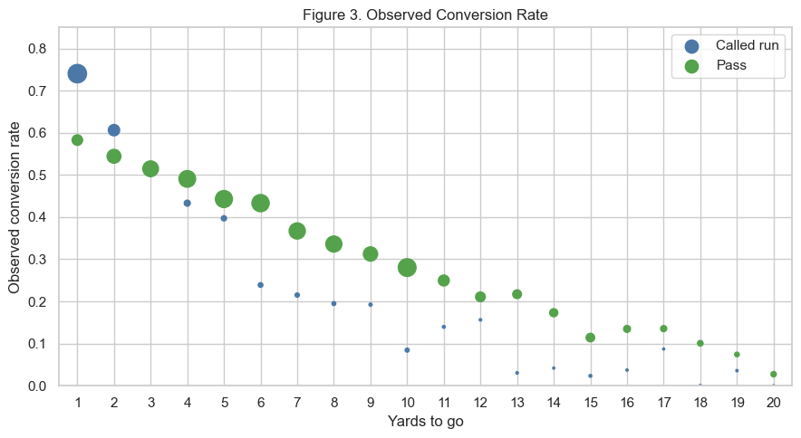
This plot shows the observed open-field conversion rate from 1 to 20 yards. Called runs convert more often when
few yards are needed, and passes convert more often once the distance gets longer. The larger dots are the
distances with more plays.
9.3 Open-Field Rate and the Logistic Fit
# figure 4, open field with the logit
yard_grid = np.linspace(1, 20, 191)
plt.figure(figsize=(9, 5))
for play_name, color, label in [('run', '#4c78a8', 'Called run'), ('pass', '#54a24b', 'Pass')]: group = observed[observed['play'] == play_name]
plt.scatter(group['yards'], group['rate'], s=group['n'] / 8, color=color, label=f'{label}, observed')
curve = [fitted_chance(logit_model, float(yard), play_name, 0) for yard in yard_grid] #goal = 0
plt.plot(yard_grid, curve, color=color, label=f'{label}, logistic fit')
plt.axvline(crossover, color='gray', linestyle=':', label=f'Cross at {crossover:.1f} yards') plt.xticks(range(1, 21, 1))
plt.xlim(0.5, 20.5)
plt.ylim(0, 0.9)
plt.xlabel('Yards to go')
plt.ylabel('Conversion probability')
plt.title('Figure 4. Open-Field Rate and the Logistic Fit')
plt.legend()
plt.tight_layout()
plt.show()

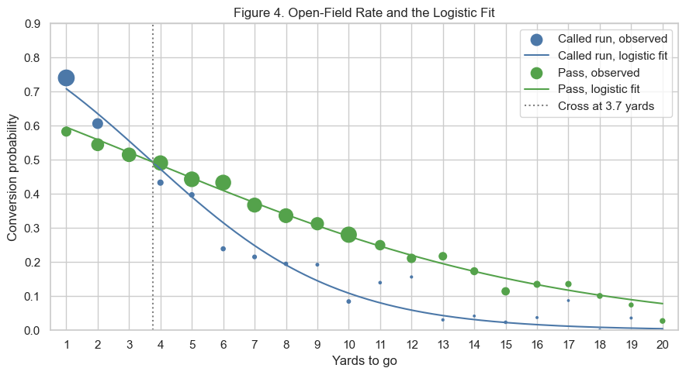
The curves are the logistic fit on the same open-field plays. They cross at 3.7 yards, which is where the pass
chance overtakes the called-run chance. The short called-run points sit a little above the curve, while the pass
points stay close to it.
9.4 Goal-Line Rate and the Logistic Fit
# figure 5, goal line
goal_line = fit[fit['goal'] == 1]
goal_rows = []
for (yards, play_name), group in goal_line.groupby(['yards', 'play']): goal_rows.append({
'yards': int(yards),
'play': play_name,
'n': len(group),
'rate': float(group['converted'].mean()),
})
goal_observed = pd.DataFrame(goal_rows)
goal_observed = goal_observed[goal_observed['yards'] <= 20]
plt.figure(figsize=(9, 5))
for play_name, color, label in [('run', '#4c78a8', 'Called run'), ('pass', '#54a24b', 'Pass')]: group = goal_observed[goal_observed['play'] == play_name]
plt.scatter(group['yards'], group['rate'], s=group['n'] / 8, color=color, label=f'{label}, observed')
curve = [fitted_chance(logit_model, float(yard), play_name, 1) for yard in yard_grid] #goal = 1
plt.plot(yard_grid, curve, color=color, label=f'{label}, logistic fit')
plt.xticks(range(1, 21, 1))
plt.xlim(0.5, 20.5)
plt.ylim(0, 0.9)
plt.xlabel('Yards to go')
plt.ylabel('Conversion probability')
plt.title('Figure 5. Goal-Line Rate and the Logistic Fit')
plt.legend()

plt.tight_layout()

plt.show()
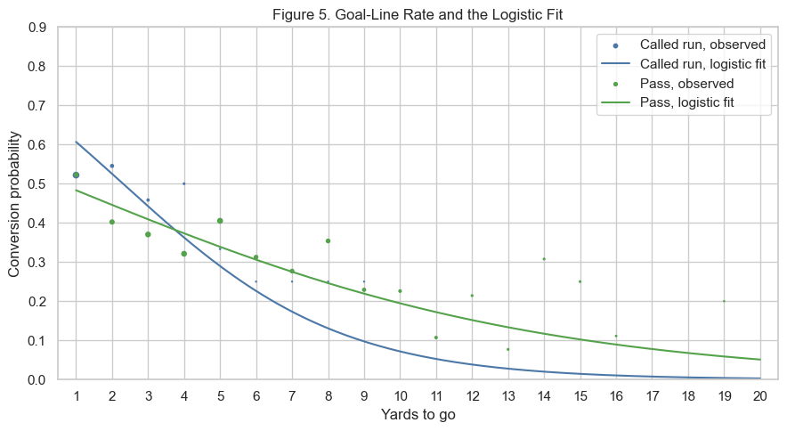
Goal-to-go shifts both curves down. A called run is still higher at 1 yard, and a pass is higher once the distance gets
past about 4 yards. There are fewer goal-line plays, so the points jump around more than they do in the open field.
9.5 2026 Plays Left Out of the Fit
# 2026 plays not used in the fit

Xh = sm.add_constant(holdout[['yards', 'run', 'yards_run', 'goal']])

holdout = holdout.copy()

holdout['predicted'] = logit_model.predict(Xh)

print(

f"2026 left out of the fit: actual {holdout['converted'].mean():.3f}, "

f"model says {holdout['predicted'].mean():.3f}, n = {len(holdout):,}"

)
2026 left out of the fit: actual 0.412, model says 0.393, n = 1,179
These 1,179 plays from the first three weeks of 2026 were not used to fit the line. The model expected a
conversion rate of 0.393, and the plays converted at 0.412. The sample is only three weeks, so the difference
should be interpreted cautiously and the line was not refit.

