Predicting NFL Third-Down Conversions
Anthony Feaster II and Nathaniel Sabbara
University of San Diego
AAI 500: Applied Probability and Statistics for AI
Professor Leonid Shpaner
October 19, 2026

Introduction
In football, third downs are one of the most important situations because it is often the offense’s last opportunity to keep the drive going. A successful conversion allows the offense to continue the drive; however, a failed conversion means the team has to punt, attempt a field goal, or go for it on fourth down. This makes third down a useful situation for examining which factors are associated with offensive success.
For our project we used the NFLverse play-by-play data from the 2023-2026 NFL seasons (Carl & Baldwin, 2026a, 2026b). We examined information available before each play to include yards to go, play type, field position, quarter, and score differential. Our objectives for this project were to identify which pre-play factors were associated with a successful NFL third down conversion and to evaluate their accuracy in predicting the probability of success.
The dataset includes detailed play-by-play information from the 2023-2026 seasons. The 2023, 2024, and 2025 files contain complete seasons, while the 2026 dataset only includes plays from week 1-3. The first part of this paper explains how the data was prepared and summarizes the exploratory analysis. The second part describes the model, evaluates its results, and discusses the conclusions and limitations of the analysis.

Data Preparation
During the data preparation phase, we combined the 2023-2026 datasets into one DataFrame before filtering the data. The combined dataset contained 156,084 plays and 372 variables. Each row in the dataset represented one play from the 2023 through 2026 NFL seasons. Our initial check found no duplicated rows.
Because this project focuses on third-down conversions, we filtered the data to only include third-down plays. This reduced the dataset to 25,422 third-down plays. We then examined the third_down_converted column, which served as the target variable, and found 41 missing values (NaN). All 41 records were classified as no-play events associated with penalties. Because these plays did not have a valid conversion outcome, they were removed from the analysis.
We also separated regular-season and postseason games. Of the third-down plays, 24,344 occurred during the regular season and 1,078 occurred during the postseason. We limited the project to regular-season plays because they provided a larger and more consistent sample across the four seasons. The data were then restricted to run and pass attempts with a recorded third-down outcome. After applying these filters, the final exploratory analysis dataset contained 21,948 plays.
The original dataset contained many variables that described what happened after the play began, including yards gained and other results of the play. Those variables were not included because the objective was to estimate conversion success using information available before or at the beginning of the play. Including information that became known after the play would give the analysis information that would not be available when the play was called.
Sixteen variables were selected for the exploratory analysis. These included the game and play identifiers, season, week, offensive and defensive teams, quarter, time remaining, field position, yards to go, play type, third-down outcome, remaining timeouts, score differential, and shotgun formation. After selecting these variables, we found no missing values and no duplicate plays in the final dataset.
NFLverse classifies quarterback scrambles as run plays (Carl & Baldwin, 2026a). We kept that original classification for the exploratory analysis. For the modeling analysis, scrambles were classified as passes because a scramble begins as a designed passing play before the quarterback leaves the pocket. Therefore, a run in the model represents a called running play rather than every play labeled as a run in the original data.

Exploratory Data Analysis (EDA)
The exploratory analysis included 21,948 regular-season third-down run and pass plays. Out of those plays, 8,712 resulted in a successful conversion and 13,236 were unsuccessful. This produced an overall third-down conversion rate of 39.69%, which means that the majority of third-down plays in the dataset were not converted.
Third-down conversion rates were fairly consistent across the four seasons. As shown in Table 1, the rates for the three completed seasons ranged from 39.05% in 2023 to 39.95% in 2024. The partial 2026 season had a conversion rate of 41.22%. Because 2026 does not represent a complete season, comparisons with the earlier seasons should be interpreted cautiously.

Table 1
Third-Down Conversion Rate by Season
Season | Conversion rate
2023 | 39.05%
2024 | 39.95%
2025 | 39.85%
2026 | 41.22%
Note. The 2026 season file only contains Weeks 1 through 3.

Run plays had a higher conversion rate than pass plays. Runs converted 53.34% of the time, compared to 35.14% for passes. This difference does not necessarily mean that calling a running play causes a higher chance of success. Teams are more likely to run the ball when they need a few yards and more likely to pass when facing longer distances. Therefore, the difference in conversion rates may be partly related to the number of yards needed rather than play type alone.
Yards to go had the clearest relationship with conversion success. Plays needing one or two yards converted 63.38% of the time. The rate decreased to 47.21% for plays needing three to five yards and 33.69% for plays needing six to ten yards. When the offense needed 11 or more yards, the conversion rate fell to 15.07%. As shown in Figure 1, conversion success became less likely as the required distance increased.

Figure 1
Third-Down Conversion Rate by Yards to Go
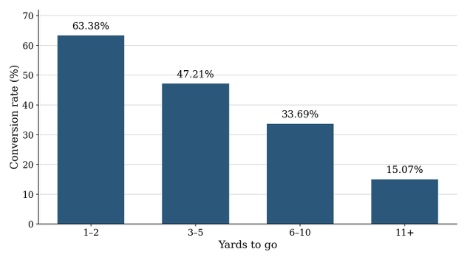

Figure 2 compares the overall conversion rates for run and pass plays. The higher rate for runs should be interpreted together with yards to go because run plays are more common in short-yardage situations. This comparison describes the pattern in the dataset, but it does not prove that selecting a run causes a higher probability of conversion.

Figure 2
Third-Down Conversion Rate: Run vs Pass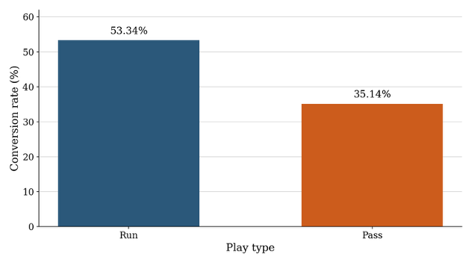
Note. Run and pass categories use the NFLverse play-type labels. Quarterback scrambles are included in the run category for this exploratory comparison.

Quarter, field position, and score differential showed less variation in conversion rates than yards to go. Conversion rates by field position ranged from 30.93% to 41.16%, while the rates across the score situations ranged from 38.36% to 41.13%. The conversion rate more noticeably changed based on the yards needed for a first down and whether the play was a run or pass.
Overall, yards to go had the strongest relationship with conversion success. Play type also mattered, but its relationship with conversion success depended on the number of yards required for a first down. Season, quarter, field position, and score situation showed smaller differences. These findings guided the variable selection used in the modeling analysis.

Model Selection
The outcome on each play is a conversion or failure. The exploratory analysis showed that the conversion rate falls with yards to go, that the run-versus-pass comparison changes with that distance, but everything else does not move the rate. We therefore compared three models that can return a probability from the same three predictors (Agresti & Kateri, 2022): yards to go, called run versus pass, and goal-to-go. One caveat, a quarterback scramble is stored in the file as a run. Because a scramble is a dropback on which the quarterback left the pocket, we coded those 1,037 plays as passes, since our goal is to give the most accurate prediction prior to the play. A run in the model is a called run. Considering the results at each yard in Figure 3, we tested linear regression, Identity-link, and logistic regression.

Figure 3
Observed Conversion Rate
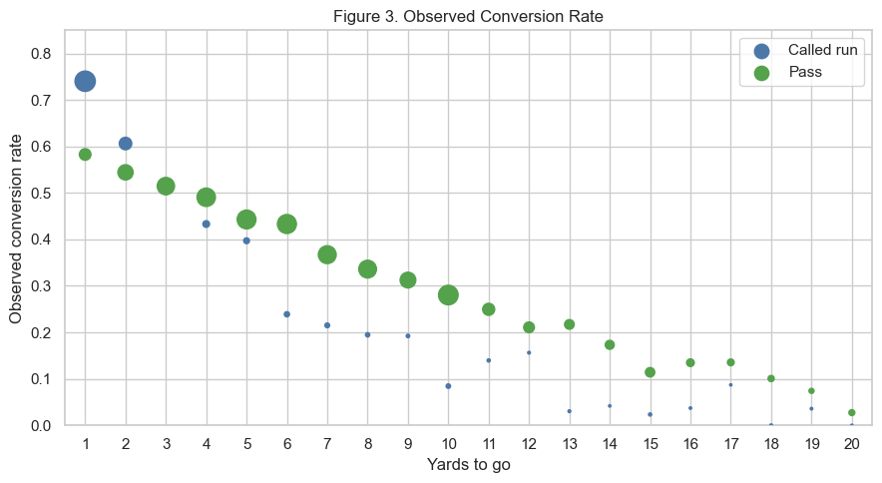
The linear model applies least squares directly to the 0/1 outcome, so a coefficient is a change in the conversion probability. While it is easy to analyze, a binary result is not a normal measurement and its variance is not constant. The straight line in the probability can also be outside the interval from 0 to 1. On the 20,769 plays from 2023 through 2025, this model assigned a probability outside 0 to 1 on 501 plays. When looking inside that interval, the highest fitted probability was 0.66, below the 0.74 observed for an open-field called run on 3rd-and-1. Even worse, at 20 yards the called-run line was negative.
The identity-link binomial model uses the same straight line for the mean and the binomial variance, which matches a yes-or-no outcome. It correctly stayed inside 0 and 1 for nearly every play, but the line still missed the shape of the rates. At 1 yard it gave 0.61 for a called run and 0.45 for a pass, against observed rates of 0.74 and 0.58, while at 20 yards it remained quite high, 0.23 to 0.28, against observed rates of 0.00 and 0.03. The exploratory rates fall quickly at short distances and then level off, and a linear model struggles to replicate this. The identity-link fit also did not return a usable AIC, because some fitted values reached the boundary.
We did not use AIC to rank the linear model against the logistic model, because those models do not share a likelihood. We chose logistic regression because every fitted probability on the estimation sample stayed between 0 and 1, the curve follows the decline in the observed rates, and the tail was reasonable. At 1 yard the logistic probabilities were 0.71 and 0.60. At 20 yards they were 0.00 and 0.08.

Logistic Regression
Logistic regression writes the line on the log-odds, where R = 1 for a called run and R = 0 for a pass, including scrambles, and G = 1 when the first down is the goal line. The coefficients were estimated by maximum likelihood in statsmodels (Seabold & Perktold, 2010) on the 20,769 regular-season plays from 2023, 2024, and 2025. We held out the 2026 file because it contained only Weeks 1 through 3.
For a run the fitted line is

For a pass, the fitted line is
Each additional yard multiplies a pass's odds of converting by 0.86 (95% confidence interval 0.85 to 0.87). The called-run line has an intercept 1.222 and slope −0.333. The two lines cross at 3.7 yards when the play is not goal-to-go. Goal-to-go leaves the slopes unchanged and multiplies the odds by 0.635 (95% confidence interval 0.56 to 0.72).

Model Analysis
Substituting a distance into the fitted line converts the log-odds into a chance the down converts. On 3rd-and-1 in the open field that chance is 0.71 for a called run and 0.60 for a pass. On 3rd-and-10 the same lines give 0.11 and 0.28. The called-run advantage is therefore a short-yardage advantage. It is gone by about 4 yards, which is where the two open-field curves cross, and past that point the pass is the higher fitted chance. The goal line does not change either slope. It multiplies the odds by 0.635, so both calls convert less often at the same distance: the 3rd-and-1 called run falls from 0.71 to 0.61, and the pass falls from 0.60 to 0.48. Table 2 is that comparison at the distances where the call actually changes.

Table 2
Fitted Conversion Probabilities by Distance, Play Call, and Goal Line
Yards | Open-field run | Open-field pass | Goal-line run | Goal-line pass
1 | 0.709 | 0.596 | 0.607 | 0.483
3 | 0.556 | 0.522 | 0.442 | 0.409
4 | 0.473 | 0.484 | 0.363 | 0.373
10 | 0.109 | 0.276 | 0.072 | 0.195
15 | 0.023 | 0.152 | 0.014 | 0.102
Note. Probabilities are from the logistic model fit on the 2023–2025 regular season. A run is a called run. Scrambles are included with passes.
Figure 4 is the check that those open-field numbers follow the plays. The curves fall roughly with the observed rates, the called-run curve falls faster, and they meet at 3.7 yards. The size of the marker is the number of observed plays, so 3rd-and-1 is drawn from a large sample and a long-yardage called run is rare.

Figure 4
Open-Field Rate and the Logistic Fit
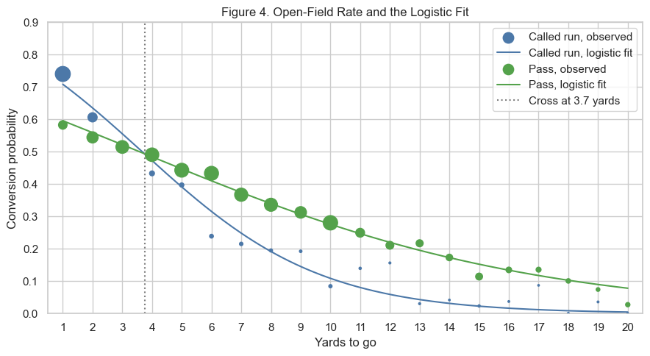
Figure 5 applies the same curves after the goal-line shift. The markers there are thinner and more scattered, especially for called runs past short yardage, so that figure supports the shift. It does not support a separate goal-line slope, although future work could be done for that.

Figure 5
Goal line Rate and the Logistic Fit
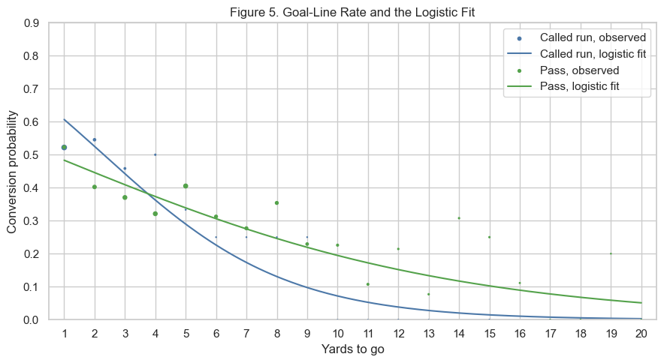
On 1,179 plays in 2026, the model expects a conversion rate of 0.393 and the observed rate is 0.412. That is a check on the overall level after three new weeks. It is too small a sample, and too thin once it is split by distance and call, to refit the line or to rank teams.
Some caveats and issues with the model. The offense chose the call, so 0.71 against 0.60 is the difference between the called runs that were used on 3rd-and-1 and the passes that were used there. It is not an estimate of what would happen if the other call were required. Oftentimes these plays are called due to the formation and performance in that game of the defense. Plays from the same game are also dependent, and the reported standard errors treat them as independent, so those standard errors are somewhat too small. That being said, the comparison between different play choices at yardage markers show some resilience to this, so long as the difference between the conversion rates are large.

Conclusion and Recommendations
Distance is what separates third downs that convert from third downs that do not. Season, quarter, and score move the rate by only a few points. Yards to go moves it from 63.38% at 1–2 yards to 15.07% at 11 or more. For each model the distance is a line rather than a bucket, and it gives the called run and the pass different slopes. The called run is the higher chance inside about 4 yards. Past that point the pass is higher. On the goal line both chances fall: goal-to-go multiplies the odds by 0.635, and the slopes stay the same.
That is the reading we would use for a call made before the snap. On open-field 3rd-and-1 the fitted chances are 0.71 for a called run and 0.60 for a pass. On 3rd-and-10 they are 0.11 and 0.28. On the goal line that 3rd-and-1 called run is 0.61. A scramble is not evidence for the run, because those plays are coded as passes. Two limits stay on that reading. In making a decision on what to call, the offense factors in the defensive substitutions and formation, as well as their performance throughout the game. Due to this, plays from the same game are dependent, while the reported standard errors treat them as independent. The gaps at 1 yard and at 10 yards are wide enough that a slightly larger error would leave them in place. Near 4 yards, where the two chances are close, the same change would not.
Three things would make the next version of this model stronger. A full or even partial 2026 season would replace the three-week sample we had. On those 1,179 plays the model expected a conversion rate of 0.393 and the observed rate was 0.412, which is close, and it is too small a sample to refit the line or to rank teams. Standard errors computed by game would show whether the gaps at 1 yard and at 10 yards still hold once plays that share a game are allowed to be dependent. Adding the formation, which we already have data on, and how that defense had been playing, which is not in this model, would speak to the call the offense actually chose.

References
Agresti, A., & Kateri, M. (2022). Foundations of statistics for data scientists: With R and Python. Chapman & Hall/CRC. https://doi.org/10.1201/9781003159834
Carl, S., & Baldwin, B. (2026a). nflfastR: Functions to efficiently access NFL play by play data (Version 6.0.0) [Computer software]. https://nflfastr.com/
Carl, S., & Baldwin, B. (2026b). NFL play-by-play data (2023–2026 seasons) [Data set]. nflverse. https://github.com/nflverse/nflverse-data/releases/tag/pbp
Seabold, S., & Perktold, J. (2010). Statsmodels: Econometric and statistical modeling with Python. In S. van der Walt & J. Millman (Eds.), Proceedings of the 9th Python in Science Conference (pp. 92–96). https://doi.org/10.25080/Majora-92bf1922-011

