**Jesus Anthony Gutierrez**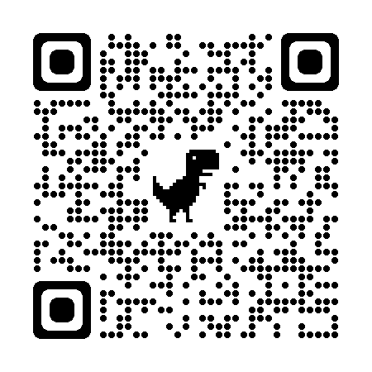

Portfolio: [anthonygutierrez94.github.io/portfolio](https://anthonygutierrez94.github.io/portfolio)

Email: [jesusagutierrez94@gmail.com](mailto:jesusagutierrez94@gmail.com)

Phone: 805-953-5360



### EXPERIENCE

### 

### 2022-Present Software Developer / Computer Scientist, NAWCWD (Naval Air Warfare Center Weapons Division)

* Designed and implemented clean code solutions to software issues
* Facilitated code reviews of the work of other developers
* Utilized Team Foundations Server for Agile version control
* Wrote up concise software anomaly reports to be validated by SMEs
* Lead products through a whole development life cycle

### 

### 2021-2022 Web Services Assistant, California State University Channel Islands

* Created new pages for the CSUCI website in OMNI CMS using HTML and CSS
* Communicated with clients and responded to tickets to make edits to existing pages
* Performed proper web accessibility following WCAG and ADA standards
* Photoshopped images for optimization
* Created forms and surveys using Qualtrics

### 2022 Volunteer, Robotics Lab, California State University Channel Islands

* Researched and built robotics
* Assisted in the Lab

### 2019-2020 President, Enthusiastic Programmers Club

* Organized events, such as tours of tech jobs
* Led weekly club meetings
* Helped students with their programming, math, and physics assignments

### 2012-2020 Additional Experience Includes Positions At:

* Uber, Grubhub, Doordash, Red Robin, Denny’s, Baskin Robbins, Subway, Jack in the Box, Huege’s Land Surveying

### EDUCATION

B.S. - Computer Science, Minor- Robotics Engineering, *California State University Channel Islands*

A.S. - Computer Science, *Moorpark College*

#### Skills:

**Programming Languages** - C# / C++ / C / Python / Java / HTML / CSS / PHP / Javascript / SQL

**Physics** - Mechanics of Fluids & Solids / Thermodynamics & Electromagnetism / Electronics / Embedded Systems / Image Processing & Pattern Recognition

**Math** - Trigonometry / Calculus I & II / Linear Algebra / Probability and Statistics / Discrete Math