Advance Networking Case Study

Anthony Habib – 100662176

Quintyn Walcott – 100670867

Advanced Networking I

Josh Lowe

December 2nd, 2018

Table of Contents

Task 1: Logical Setup…………………………………………………….5-9

Task 2: Addressing ……………………………………………………….4,9-15

Task 3: Configure Ospf …………………………………………………...15-18

Task 4: Configure EIGRP ………………………………………………...18-20

Task 5: Configure Redistribution and Summarization ………………...20-23

Task 6: Configure MP – BGP ……………………………………………..23-25

Task 7: Configure NAT ……………………………………………………..25-27

Task 8: Connecting Pods ………………………………………………...27-28

Task 9: Testing …………………………………………………………….28-38

Additional Task ……………………………………………………………...38-41

Final show run ……………………………………………………………...42-84

References ………………………………………………………………..85-86

**Routing Protocol Topology:**

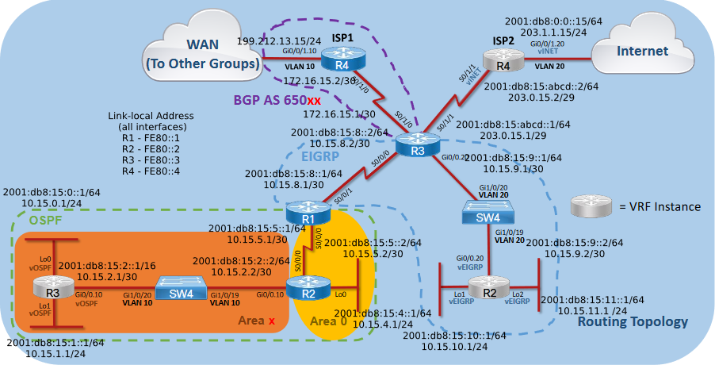

**Physical Topology:**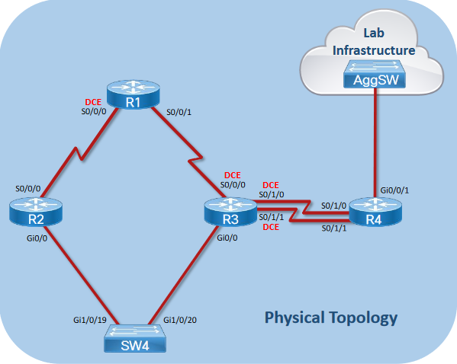

**Logical Topology:**

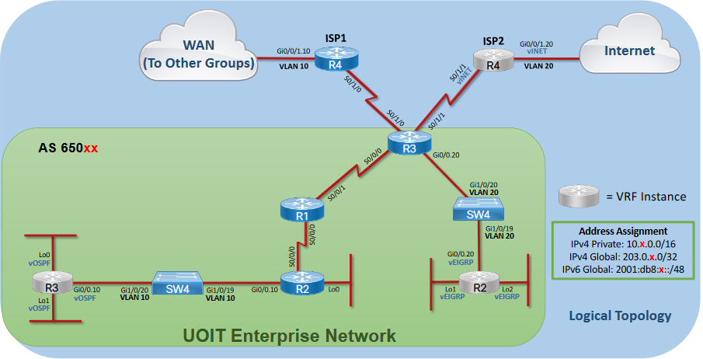

Task 1:

|  |  |  |  |  |  |
| --- | --- | --- | --- | --- | --- |
| **Router** | **IPv4** | **Subnet mask** | **Ipv6** | **IPv6 Subnet Mask** | **Loop back** |
| R3 vrf  (lo0) | 10.15.0.1 | 255.255.255.0 | 2001:db8:15:0::1  Link-local Fe80::3 | /64 | Loopback 0 |
| R3 vrf  (lo1) | 10.15.1.1 | 255.255.255.0 | 2001:db8:15:1::1  Link-local Fe80::3 | /64 | Loopback 1 |
| R3 vrf  (g0/0.10) | 10.15.2.1 | 255.255.255.252 | 2001:db8:15:2::1  Link-local Fe80::3 | /64 |  |
| R2  (g0/0.10) | 10.15.2.2 | 255.255.255.252 | 2001:db8:15:2::2  Link-local Fe80::2 | /64 |  |
| R2  (lo0) | 10.15.4.1 | 255.255.255.0 | 2001:db8:15:4::1  Link-local fe80::2 | /64 | Loopback 0 |
| R2  (s0/0/0) | 10.15.5.2 | 255.255.255.252 | 2001:db8:15:5::2  Link-local Fe80::2 | /64 |  |
| R1  (s0/0/0) | 10.15.5.1 | 255.255.255.252 | 2001:db8:15:5::1  Link-local Fe80::1 | /64 |  |
| R1  (s0/0/1) | 10.15.8.1 | 255.255.255.252 | 2001:db8:15:8::1  Link-local Fe80::1 | /64 |  |
| R3  (s0/0/0) | 10.15.8.2 | 255.255.255.252 | 2001:db8:15:8::2  Link-local Fe80::3 | /64 |  |
| R3  (g0/0.20) | 10.15.9.1 | 255.255.255.252 | 2001:db8:15:9::1  Link-local Fe80::3 | /64 |  |
| R2 vrf  (g0/0.20) | 10.15.9.2 | 255.255.255.252 | 2001:db8:15:9::2  Link-local Fe80::2 | /64 |  |
| R2 vrf  (lo1) | 10.15.10.1 | 255.255.255.0 | 2001:db8:15:10::1  Link-local Fe80::2 | /64 | Loopback 1 |
| R2 vrf  (lo2) | 10.15.11.1 | 255.255.255.0 | 2001:db8:15:11::1  Link-local Fe80::2 | /64 | Loopback 2 |

1. Name all devices according to the topology diagram (R1-R4, SW4)
   * On each device, we go in to configuration mode and use the hostname command to set the name of the device.
   * Command:

** **







1. Be sure to shut down any unused ports on the routers and switches. Failure to do so will result in unexpected route selections.
   * For each device, we identify the interfaces not used. We then configure into these interfaces and issue the shutdown command.
   * Command:
     + **Show ip int br**
     + **Int FastEthernet 0**
     + **Shutdown**
     + **Int range g1/0/1 – 28**
     + **Shutdown**
2. Turn on ipv6 unicast-routing on all routers.
   * For IPv6 routing to be ran on routers, we configure into the routers and issue the IPV6 unicast routing command.
   * Command:
     + **Ipv6 unicast-routing**
     + 
3. Make a VRF called vOSPF on R3, a VRF called vEIGRP on R2, and a VRF called vINET on R4. Make sure you use the vrf definition command and not the ip vrf command.
   * For virtual instances to be created, we enter configuration terminal mode and issue the vrf definition command which creates the vrf by defining the name of the vrf.
   * Command:
     + R3: vrf definition vOSPF
     + R2: vrf definition vEIGRP
     + R4: vrf definition vINET
4. Assign route distinguishers 650xx:y where x is your 2-digit group number (e.g. 01, 02, 3...10, 11, etc.) and yis the router number (e.g. on R2 y= 2)to your VRFs.
   * To assign route distinguishers, we enter vrf created configuration mode and issue the route distinguisher command.
   * Command:
     + vrf definition vOSPF
       - rd 65015:3



* + - vrf definition vINET
      * rd 65015:4



* + - vrf definition vEIGRP
      * rd 65015:2

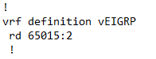

1. Add both the IPv4 and IPv6 address families to each VRF
   * To add Ipv4 and Ipv6 address families, we enter vrf configuration mode and define the address-family command and specify unicast.
   * Command:
     + R3 vrf: vrf definition vOSPF
     + R3 vrf: address-family ipv4 unicast
     + R3 vrf: vrf definition vOSPF
     + R3 vrf: address-family ipv6 unicast
     + R4 vrf: vrf definition vINET
     + R4 vrf: address-family ipv4 unicast
     + R4 vrf: vrf definition vINET
     + R4 vrf: address-family ipv6 unicast
     + R2 vrf: vrf definition vEIGRP
     + R2 vrf: address-family ipv4 unicast
     + R2 vrf: vrf definition vEIGRP
     + R2 vrf: address-family ipv6 unicast
   * 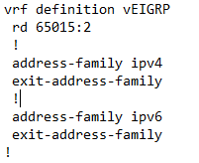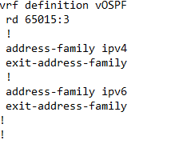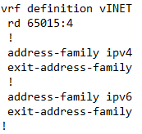
2. Assign interfaces to the VRFs as shown in the topology diagram
   * We identify the interfaces which are part of the vrf created and enter these interface configuration mode, as issue the vrf forwarding command to identify which vrf the interface is in.
   * Command:
     + R3: int lo0
     + R3: vrf forwarding vOSPF
     + R3: int lo1
     + R3: ip vrf forwarding vOSPF
     + R3: int g0/0.10
     + R3: ip vrf forwarding vOSPF
     + R4: int s0/1/1
     + R4: vrf forwarding vINET
     + R4: int g0/0/1.20
     + R4: vrf forwarding vINET
     + R2: int lo1
     + R2: vrf forwarding vEIGRP
     + R2: int lo2
     + R2: ip vrf forwarding vEIGRP
     + R2: int g0/0.20
     + R2: ip vrf forwarding vEIGRP







1. Create the VLANs on the switch as indicated in the topology diagram. Gi1/0/19 & Gi1/0/20 should both be set as static trunk links. Set VTP to Transparent mode.
   * To create the vlans, we entered configuration mode and enetered the vlan command which specified number of vlan. We then entered interface configuration mode and issued the switchport mode trunk command and then specified which vlans are allowed on the interface. Zzzzzthen issued the vtp mode command in config mode to set the mode of vtp.
   * Command:
     + SW4: vlan 10
     + SW4: vlan 20
     + SW4: int g1/0/19
     + SW4: switchport mode trunk
     + SW4: switchport trunk allowed vlan 10,20
     + SW4: int g1/0/20
     + SW4: switchport mode trunk
     + SW4: switchport trunk allowed vlan 10,20
     + SW4: vtp mode transparent

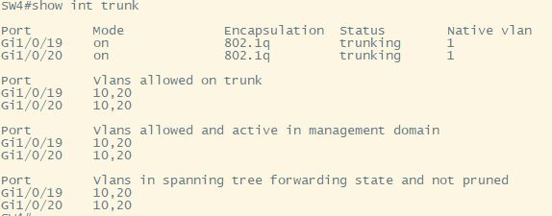



1. Set the clock rate of each serial link to 64,000 bps on all DCE interfaces.
   * We identified the DCE interfaces and entered these interfaces configuration modes and issued the clock rate command to the desired value.
   * Command:
     + R1: int s0/0/0
     + R1: clock rate 64000
     + R3: int s0/0/0
     + R3: clock rate 64000
     + R3: int s0/1/0
     + R3: clock rate 64000
     + R3: int s0/1/1
     + R3: clock rate 64000



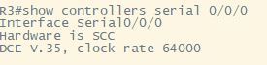

**Task 2:**

* Assign R3 s0/1/1 the IPv4 address 203.0.x.1/29 and R4 s0/1/1 the IPv4 address 203.0.x.2/29.
  + We entered these interfaces configuration mode and issued the ipv4 add command to assign the address as well as the subnet they are in mentioned.
  + Command:
    - R3: int s0/1/1
    - R3: ip add 203.0.15.1 255.255.255.248
    - R4: int s0/1/1
    - R4: ip add 203.0.15.2 255.255.255.248









* Assign R3 s0/1/0 the IPv4 address 172.16.x.1/30 and R4 s0/1/0 the IPv4 address 172.16.x.2/30.
  + We entered these interfaces configuration mode and issued the ipv4 add command to assign the address as well as the subnet they are in mentioned.
  + Command:
    - R3: int s0/1/0
    - R3: ip add 172.16.15.1 255.255.255.252
    - R4: int s0/1/0
    - R4: ip add 172.16.15.2 255.255.255.252









* Assign R3 s0/1/1 the IPv6 address 2001:DB8:x:ABCD::1/64 and R4 s0/1/1 the IPv6 address 2001:DB8:x:ABCD::2/64
  + We entered these interfaces configuration mode and issued the ipv6 add command to assign the address as well as the subnet they are in mentioned.
  + Command:
    - R3: int s0/1/1
    - R3: ipv6 add 2001:DB8:15:ABCD::1/64
    - R4: int s0/1/1
    - R4: ipv6 add 2001:DB8:15:ABCD::2/64









* Assign R4 Gi0/0/1.10 (VLAN 10) the IPv4 address 199.212.32.x/24
  + We entered this interfaces configuration mode and since it’s a sub interface, we issued the encapsulation command to allow inter-vlan routing. We then issued the ipv4 add command to assign the address as well as the subnet that is mentioned.
  + Command:
    - R4: int g0/0/1.10
    - R4: encapsulation dot1q 10
    - R4: ip add 199.212.32.15 255.255.255.0





* Assign R4 Gi0/0/1.20 (VLAN 20) the IPv4 address 203.1.1.x/24 and the IPv6 address 2001:DB8:0:0::x/64.
  + We entered this interfaces configuration mode and since it’s a sub interface, we issued the encapsulation command to allow inter-vlan routing. We then issued the ipv4 and ipv6 add command to assign the address as well as the subnet that is mentioned.
  + Command:
    - R4: int g0/0/1.20
    - R4: encapsulation dot1q 20
    - R4: ip add 203.1.1.15 255.255.255.0
    - R4: ipv6 add 2001:DB8:0:0::15/65





* Assign a /24 IPv4 subnet and a /64 IPv6 subnet to each Loopback interface. Use the pools shown in the diagram. Assign the first address in the range to the router interface.
  + We entered each loopback interface configuration mode and issued the ipv4 and ipv6 add command to assign the address as well as the subnet they are in mentioned from our addressing scheme..
  + Command:
    - R3 vrf: vrf definition vOSPF
    - R3 vrf: int lo0
    - R3 vrf: ip add 10.15.0.1 255.255.255.0
    - R3 vrf: ipv6 add 2001:DB8:15:0::1/64
    - R3 vrf: ipv6 add fe80::3 link local
    - R3 vrf: vrf definition vOSPF
    - R3 vrf: int lo1
    - R3 vrf: ip add 10.15.1.1 255.255.255.0
    - R3 vrf: ipv6 add 2001:DB8:15:1::1/64
    - R3 vrf: ipv6 add fe80::3 link local
    - R2 vrf: vrf definition vEIGRP
    - R2 vrf: int lo1
    - R2 vrf: ip add 10.15.10.1 255.255.255.0
    - R2 vrf: ipv6 add 2001:DB8:15:10::1/64
    - R2 vrf: ipv6 add fe80::2 link local
    - R2 vrf: vrf definition vEIGRP
    - R2 vrf: int lo2
    - R2 vrf: ip add 10.15.11.1 255.255.255.0
    - R2 vrf: ipv6 add 2001:DB8:15:11::1/64
    - R2 vrf: ipv6 add fe80::2 link local
    - R2: int lo0
    - R2: ip add 10.15.4.1 255.255.255.0
    - R2: ipv6 add 2001:DB8:15:4::1/64
    - R2: ipv6 add fe80::2 link local

































* Assign a /30 IPv4 subnet and a /64 IPv6 subnet to each point-to-point link between routers. Use the pools shown in the diagram. Give the lower numbered router the first address in each range, and the other router the second address.
  + We identified the point-to-point interfaces and entered it’s configuration mode and issued the ipv4 and ipv6 add command to assign the address as well as the subnet they are in mentioned.
  + Command:
    - int serial #
      * ip add X.X.X.X 255.255.255.252
      * ipv6 add X.X.X.X.X.X.X.X /64















* Statically configure link-local addresses on each router interface to be FE80::y, where y is the router number (e.g. R3 would have FE80::3on all of its interfaces).
  + We identified all interfaces on a router being used, and entered the interface configuration mode and issued the ipv6 add fe8o command.
  + Command:
    - R3 vrf: vrf definition vOSPF
    - R3 vrf: int lo0
    - R3 vrf: Fe80::3 link-local
    - R3 vrf: vrf definition vOSPF
    - R3 vrf: int lo1
    - R3 vrf: Fe80::3 link-local
    - R3 vrf: vrf definition vOSPF
    - R3 vrf: int g0/0.10
    - R3 vrf: Fe80::3 link-local
    - R2: int g0/0.20
    - R2: Fe80::2 link-local
    - R2: int s0/0/0
    - R2: Fe80::2 link-local
    - R2: int lo0
    - R2: fe80::2 link-local
    - R1: int s0/0/0
    - R1: fe80::1 link-local
    - R1: int s0/0/1
    - R1: fe80::1 link-local
    - R3: int s0/0/0
    - R3: Fe80::3 link-local
    - R3: int s0/1/0
    - R3: Fe80::3 link-local
    - R3: int s0/1/1
    - R3: Fe80::3 link-local
    - R3: int g0/0.20
    - R3: Fe80::3 link-local
    - R2 vrf: vrf definition vEIGRP
    - R2 vrf: int lo1
    - R2 vrf: Fe80::2 link-local
    - R2 vrf: vrf definition vEIGRP
    - R2 vrf: int lo2
    - R2 vrf: Fe80::2 link-local
    - R2 vrf: vrf definition vEIGRP
    - R2 vrf: int g0/0.20
    - R2 vrf: fe80::2 link-local
    - R4: int s0/1/0
    - R4: fe80::4 link-local
    - R4: int g0/0/1.10
    - R4: fe80::4 link-local
    - R4: vrf definition vINET
    - R4: int s0/1/1
    - R4: fe80::4 link-local
    - R4: vrf definition vINET
    - R4: int g0/0/1.20
    - R4: fe80::4 link-local















































Task 3:

* Use a process number equal to your group number.
  + For OSPF, we use our group number 15 as process number.
  + Command:
    - Router ospfv3 15
* Set the bandwidth of all interfaces appropriately.
  + For all Point to Point link in OSPF, we entered interface configuration mode and issued the bandwidth command to set the bandwidth.
  + Command:
    - R1/R2/R3/R4(config)# int serial #
    - Bandwidth 64

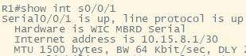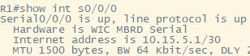

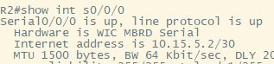

* Change the OSPF reference bandwidth to 100Gbps
  + We issued the Router Ospf configuration mode and issued the auto-cost reference-bandwidth command to set the reference bandwidth.
  + Command:
    - R1/R2/R3(Config)# router ospfv3 15
      * auto-cost reference-bandwidth 100000

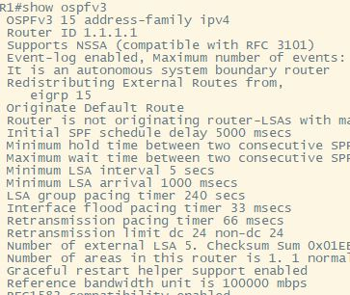

* Enable OSPFv3 on R1, R2, and R3 for both IPv4 and IPv6 address families, on the interfaces indicated in the diagram. (Note that the commands all start with "ospfv3", not the older "ipv6 router ospf" or "ip ospf" commands).
  + We Identified the interfaces on the routers that are participating in the OSPF process. We then entered these interface configuration modes and issued the ipv6 enabling command. We then issued the commands to specify the process as well as area these interfaces are in for ipv4 and ipv6 families
  + Commands:
    - Ipv6 enable
    - R1: ospfv3 15 ipv4 area 0 b
    - R1: ospfv3 15 ipv6 area 0
    - R2: ospfv3 15 ipv4 area 0
    - R2: ospfv3 15 ipv6 area 0
    - R3 vrf: definition vOSPF
    - R3 vrf: ospfv3 15 ipv4 area 15
    - R3 vrf: ospfv3 15 ipv6 area 15

* Use the router number as the router ID (e.g., on R1 use 1.1.1.1). Use this router ID for IPv4, IPv6, and the VRF address families as applicable.
  + We entered router ospf configuration mode and issued the router-id command relative to the router.
  + Commands:
    - R1/R2/R3: router ospfv3 15
    - R1: router-id 1.1.1.1
    - R2: router-id 2.2.2.2
    - R3 vrf: router-id 3.3.3.3





* Change the network type on the loopback interfaces so that the routes are advertised with the correct subnet mask rather than /32 or /128
  + We entered the loopback interfaces configuration mode and issued the ip ospf command to specify the network as point-to-point for routes to be advertised with correct subnet mask.
  + Commands:
    - R3 vrf: int lo0
    - R3 : ip ospf network point-to-point
    - R3 vrf: int lo1
    - R3 : ip ospf network point-to-point

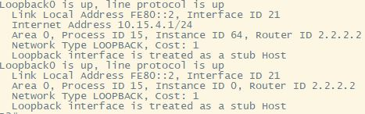

* Configure all Loopback interfaces as passive
  + We entered router ospf configuration mode and then entered both ipv4 and ipv6 address-family configuration mode and issued the passive interface command for the relative loopbacks.
  + Commands:
    - router ospfv3
    - address-family ipv4/ipv6 unicast
    - passive-interface loopback#
* Configure area x as a totally stubby area for both IPv4 and IPv6
  + We entered router ospf configuration mode and then entered both ipv4 and ipv6 address-family configuration mode and issued the stub command to identify which area is totally stubby.
  + Commands:
    - router ospf 15
    - address-family ipv4/ipv6 unicast
    - address-family ipv4/ipv6 unicast vrf vOSPF
      * area 15 stub
* Note that on R3 in the VRF address family (IPv4 and IPv6) you must include the following command for your routes to show up in the routing table: capability vrf-lite
  + We entered router ospf configuration mode and then entered both ipv4 and ipv6 address-family configuration mode and issued the capability vrf-lite command so routes would show up in tables.

Command : address-family ipv4/ipv6 unicast vrf vOSPF



Task 4: Configure EIGRP

* Use an AS number equal to your group number
  + For EIGRP, we use our group number 15 as our AS number



* Set the bandwidth of all interfaces appropriately.
  + For all Point to Point link in EIGRP, we entered interface configuration mode and issued the bandwidth command to set the bandwidth.

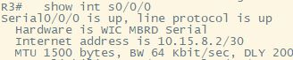

* Enable EIGRP Named Mode on R1, R2, and R3, for both IPv4 and IPv6, as indicated in the diagram. Name your EIGRP process CASE2018
  + We issued the router EIGRP command and specified the name as CASE2018 on all routers mentioned. We then entered the address-family command and specified the ipv4 and ipv6 as well as the autonomous system for the address family for the relative routers.





* Use /32 wildcard masks for each interface in your network commands
  + We entered the relative address-family configuration mode and advertised the /32 networks by using the network command and setting the net mask to 0.0.0.0 to specify the address must match.
* Use the router number as the router ID (e.g., on R1 use 1.1.1.1). Use this router ID for IPv4, IPv6, and the VRF address families as applicable
  + We entered the relative address-family configuration mode for both ipv4 and ipv6 address families and issued the eigrp router-id command for the relative router to set the router id. For the vrf, we did the same but we identified the vrf when entering address-family modes.



* By default, all IPv6 interfaces participate in EIGRP Named Mode. Remove EIGRP from interfaces where it is not required (check show ipv6 eigrp interface).
  + We checked showed EIGRP ipv6 Interface and identified which interfaces are not part of the process. We then entered address-family interface configuration mode and issued the shutdown command so they don’t participate in process.

Command :

* Address-family ipv6 unicast autonomous-system 15
* Af-interface s0/1/0
* Shutdown
* Af-interface s0/1/1
* Shutdown

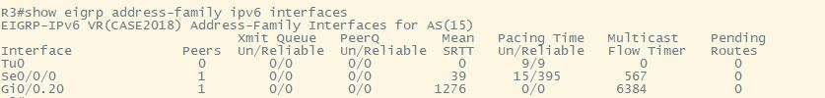



* Configure all Loopback interfaces as passive.
  + We entered router eigrp configuration mode and then entered both ipv4 and ipv6 address-family configuration modes and issued the passive interface command for the relative loopbacks.

Command :

Address-family ipv4/ipv6 unicast vrf vEIGRP autonomous-system 15

Af-interface lo1

Passive-interface

Af-interface lo2

Passive-interface

* Configure R2 vEIGRP as a stub router in both IPv4 and IPv6, advertising only connected routes.
  + We entered the relative address-family configuration mode for both ipv4 and ipv6 vrf address families and issued the eigrp stub connected command to advertise only connected routes.
  + COmmand:

Address-family ipv4 unicast vrf vEIGRP autonomous-system 15

* Eigrp stub connected static



Task 5

* Perform mutual redistribution between EIGRP and OSPF on R1 for both IPv4 and IPv6. For EIGRP metrics use the following values:

Bandwidth: 1 Gbps Delay: 300 µsec Reliability: 255/255 Load: 1/255 MTU: 1500

* In router EIGRP named mode configuration mode, we enter both IPV4 and IPV6 address-family topology bases configuration and enter the redistribute ospf command. With this command, we listed the metric values given above as the parameters.
  + - R1(config)# router eigrp CASE2018
    - R1(config)# address-family ipv4 unicast autonomous-system 15
    - R1(config-router-af)# topology base
    - R1(config-router-af)# redistribute ospfv3 1 metric 1000000 300 255 1 1500
    - R1(config-router)# exit
    - R1(config-router)# exit
    - R1(config)# router eigrp CASE2018
    - R1(config)#address-family IPV6 unicast autonomous 15
    - R1(config-router-af)#topology base
    - R1(config-router-af)# redistribute ospfv3 1 metric 1000000 300 255 1 1500
    - R1(config-router)# exit
    - R1(config)# ROUTER ospfV3 15
    - R1(config)# address-family ipv4 unicast
    - R1(config-router)# redistribute eigrp 15 subnets
    - R1(config-router)# exit
    - R1(config)# ROUTER OSPFV3 15
    - R1(config-router)# address-family ipv6 unicast
    - R1(config-router-af)# redistribute eigrp 15
    - R1(config-router-af)# exit
    - R1(config-router)# exit
    - R1(config)# router eigrp CASE2018
    - R1(config)# address-family IPV6 unicast as 15
    - R1(config)# topology base
    - R1(config-rtr)# redistribute ospfV3 15 metric 1000000 300 255 1 1500
    - R1(config-rtr)# exit















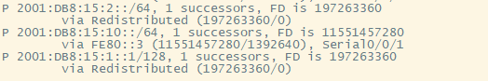

* Create a static default route on R3 pointing to the IPv4 address of ISP2 (R4). Do the same for IPv6.
  + We entered configuration mode and issued the IPV4 and IPV6 route command to create a default static route to any network by using the next hop and interface to point to IPV4 address of ISP2. (R4)
    - R3(config)# ip route 0.0.0.0 0.0.0.0 203.0.15.2
    - R3(config)# ipv6 route ::/0 S0/1/1 2001:db8:15:ABCD::2









* Create a static default route on R4 pointing to 203.1.1.254 (a gateway on the Internet)
  + We entered configuration mode and issued the IPV4 route vrf command to create a default static route to any network by using the next hop and interface to point to a gateway on the internet.
    - R4(config)# ip route vrf vINET 0.0.0.0 0.0.0.0 203.1.1.254





* Distribute the default route for IPv4 and IPv6 via redistribution into EIGRP, using the metrics given previously for R1.
  + IN router EIGRP named mode configuration mode, we enter both IPV4 and IPV6 address-family topology bases configuration and enter the redistribute static command. With this command, we listed the metric values given above as the parameters.
    - R3(config)# router eigrp CASE2018
    - R3(config)# Address-family ipv4 unicast as 15
    - R3(config)# Topology base
    - R3(config-rtr)# redistribute static metric 1000000 300 255 1 1500
    - R3(config-rtr)# Address-family ipv6 unicast as 15
    - R3(config-rtr)# Topology base
    - R3(config-rtr)# redistribute static metric 1000000 300 255 1 1500





* On R1, originate a default route into OSPFv3, but only when there is a default route already in R1’s routing table.
  + After using show IP route to ensure static route is installed, we issued the default information originate command in both ospfv3 address-families to originate the route in OSPFv3.
    - R1(config)# router ospfv3 15
    - R1(config)# address-family ipv4 unicast
    - R1(config-router-af)# default-information originate
    - R1(config-router-af)# exit
    - R1(config)# address-family ipv6 unicast
    - R1(config-router-af)# default-information originate









* Create a static route on R4 to the 2001:db8:x::/48 subnet. Be sure this route is created in the vINET VRF.
  + We issued the IPV6 route vrf command in configuration mode to create a static route to the ipv6 address mentioned above by specifying the next-hop interface.
    - R4(config)# ipv6 route vrf VINET 2001:db8:15::/48 s0/1/1





* Summarize the IPv4 routes in OSPF Area x to the most efficient summary address and advertise it into Area 0
  + After manually summarizing the routes in area 15 efficiently, we issued the area number range command to advertise the summary route in router ospfv3 ipv4 address-family configuration mode.
    - R2(config)# router ospfv3 15
    - R2(config-router)# address-family ipv4 unicast
    - R2(config-router-af)# area 15 range 10.15.0.0 255.255.252.0





* Create a single EIGRP summary route on the R1 interface to R3, summarizing all of the IPv6 routes in the OSPF network as efficiently as possible.
  + After manually summarizing the ipv6 routes efficiently, we enter router eigrp name mode ipv6 address-family mode and then issue the summary address command in an af-interface mode to advertise the routes.
    - R1(config)# int s0/0/1
    - R1(config-int)# ipv6 summary-address eigrp CASE2018 2001:db8:15::0/61





Task 6 – Configure MP-BGP

* The BGP AS number is 650xx, where xx is your 2-digit group number (e.g. 01, 02, 03…10, 11, etc.).
  + For router BGP configurations, we specified the AS number as 65015.
    - R3/R4(config)# router bgp 65015
* Use router ID x.y.y.y, where x is your group number and y is the router number (e.g. Group 5 would use 5.3.3.3 on R3)
  + We entered bgp configuration mode and entered the bgp router-id command to set the id of the router.
    - R3(config) router bgp 65015
    - R3(config-router)# bgp router-id 15.3.3.3
    - R4(config) router bgp 65015
    - R4(config-router)# bgp router-id 15.4.4.4





* Configure iBGP neighbor relationships between R3 and ISP1 (R4) as shown in the topology diagram.
  + To establish the relationships, we entered router BGP configuration mode and entered the neighbor command and specified which AS the neighbor was in. We then proceeded to the address-families to activate these neighbors.
    - Router BGP 65007
    - R4(config-router)# neighbour 172.16.15.1 remote-as 65015
    - R4(config-router-af)# neighbour 172.16.15.1 activate
    - R3(config-router)# neighbour 172.16.15.2 remote-as 65015
    - R3(config-router)#address-family ipv4/ipv6 unicast
    - R3(config-router-af)# neighbour 172.16.15.2 activate
    - R3(config-router-af)# neighbour 172.16.15.2 activate

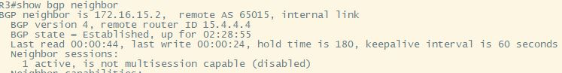

* Configure R3 and R4 to advertise themselves as the next hop for all IPv4 routes they exchange with each other.
  + We entered router BGP configuration mode and entered the neighbor command + the parameter next-hop-self on both routers to advertise themselves as the next hop.
    - R3(config)# neighbor 172.16.15.2 next-hop-self
    - R4(config)# neighbor 172.16.15.1 next-hop-self
    - 
* The configuration should use MP-BGP to carry both IPv4 and IPv6 routes (IPv6 will be configured in Task 8).
* Advertise all subnets of the 10.x.0.0/16 networks, except any /32 routes, from R3 to R4. Do not add any static or summary routes to accomplish this.
  + We issue the network command in IPV4 address-family multiple times in router bgp configuration mode to advertise all the subnets.
    - R3(config-router-af)# network 172.16.15.0 mask 255.255.255.252
    - R3(config-router-af)# network 10.15.8.0 mask 255.255.255.252
    - R3(config-router-af)# network 10.15.9.0 mask 255.255.255.252



* Also advertise the 172.16.x.0/30 subnet.
  + We issue the network command in IPV4 address-family multiple times in router bgp configuration mode to advertise the subnets.
    - R4(config-router-af)# network 172.16.15.0 mask 255.255.255.252



* Configure R3 to set a Local Preference of 500 on all routes received from R4
  + In router BGP configuration mode, we issue the bgp default local preference command which accepts a metric value to set the relative metric.
    - R3(config)#: bgp default local-preference 500
  + 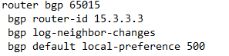

**Task 7 :**

* Configure NAT on R3 for all IPv4 connections to the Internet. Specifically, use NAT Overload (PAT) so that all outbound connections from 10.x.0.0/16 will be translated to the IP address assigned to the s0/1/1 interface of R3.
  + We entered the related interface configuration mode and issued the ip nat command to specify direction of translations. In addition, we created an access list to permit the outbound connections and then issued the ip nat inside command to overload the serial and identify the source list.
  + Command:
  + interface type#
  + ip nat inside/outside
  + ip nat inside source list 150 interface Serial0/1/1 overload
  + 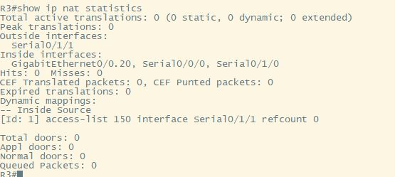
* Create a static NAT mapping for the IPv4 address of R2's Loopback0 interface to the global address 203.0.x.3
  + We issued the IP nat inside source command to specify static mapping for the IPV4 address of R2’s Loopback0 interface.
  + ip nat inside source static 10.15.4.1 203.0.15.3

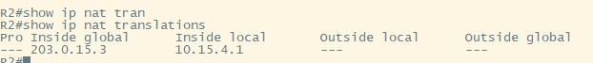

Task 8

* Create a tunnel interface on R3 running GRE over IPv4.The tunnel source should be s0/1/0 andthe destination should be the address of the other pods R3 s0/1/0 interface. Give the tunnel interface the IPv6 address FEC0:1::x/64. The tunnel should not have any IPv4 address.
  + We first enter in the tunnel interface 0, from there we assign our ipv6 addressing scheme, add our gre tunneling mode and finally set our ipv4 tunnel destination as well as source.
  + Command:
  + 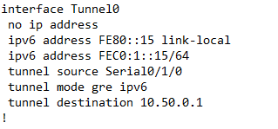
* Configure MP-BGP on both R3 routers and form eBGP neighbor relationships between them using their FEC0:1::/64 addresses. These BGP routers should exchange only IPv6 routes.
  + To form our tunneling relationship we must enter the same tunnel destination and configure through the same interface.
  + 
* Advertise all subnets of the 2001:db8:x::/48 from R3 to the other pod, except any /128 route you may have in your routing table
  + 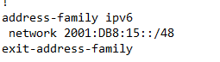
* Form an eBGP neighbor relationship between R4 on your pod an R4 on the

other pod. This relationship should be made using the IPv4 addresses on your Gi0/0/1.10 interfaces.

* To establish our relationship between R4 and the other R4 we must advertise our neighboring route as 192.212.32.xx, xx is the pod number and remote to their as number. Then we must use activate when entering in the ip address to establish the connection.





* Advertise all IPv4 routes available on R4 to the other group via MP-BGP
  + We must first go into the ipv4 address family and advertise the following routes 172.16.15.0 and 203.0.15.0 with the following subnet mask.
  + 
* Configure R4 to set the MED to 50 on all IPv4 routes sent to the other pod
  + First we must enter the route map and permit any number, then we must match the ip address of our area and set the metric to 50. Finally we then use route map med value and permit any number.
  + 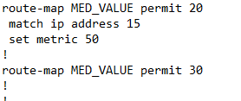

Task 9:

Tclash for Pings:

foreach address {  
10.15.5.1   
172.16.15.1  
203.0.15.1  
2001:db8:15:abcd::1  
203.0.15.2  
172.16.15.2  
2001:DB8:15:ABCD::2  
199.212.32.15  
203.1.1.15   
2001:DB8:0:0::15  
10.15.8.1  
2001:db8:15:8::1  
10.15.5.2  
2001:db8:15:5::2  
10.15.10.1  
2001:db8:15:10::1  
10.15.11.1  
2001:db8:15:11::1  
10.15.9.2  
2001:db8:15:9::2  
10.15.4.1  
2001:db8:15:4::1  
10.15.5.1  
2001:db8:15:5::1  
10.15.2.2  
2001:db8:15:2::2  
10.15.0.1  
2001:db8:15:0::1  
10.15.1.1  
2001:db8:15:1::1  
10.15.2.1  
2001:db8:15:2::1  
10.15.8.2  
2001:db8:15:8::2  
10.15.9.1  
2001:db8:15:9::1  
} { ping $address }

R1:

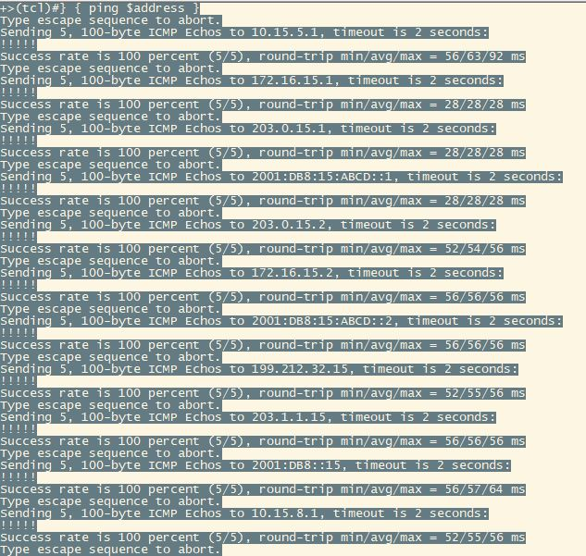

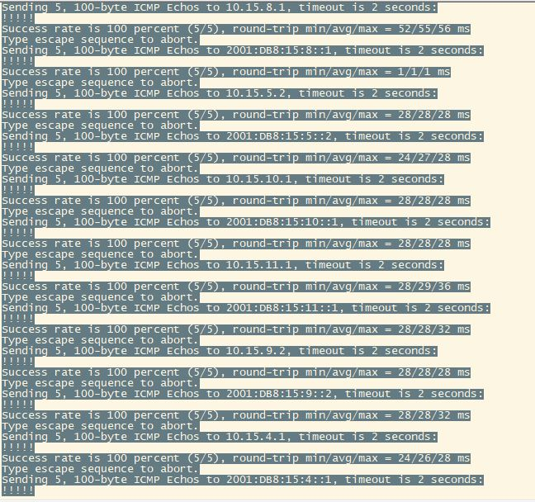

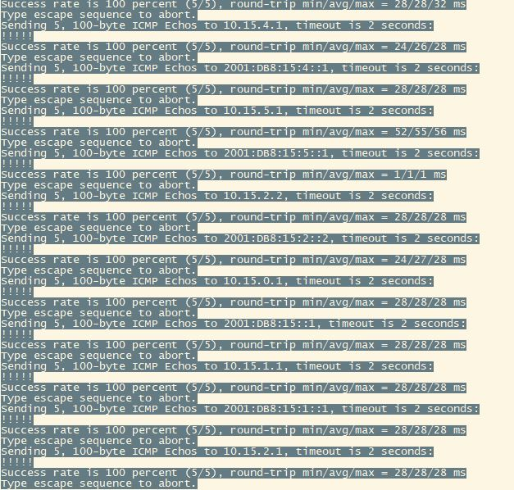

R2: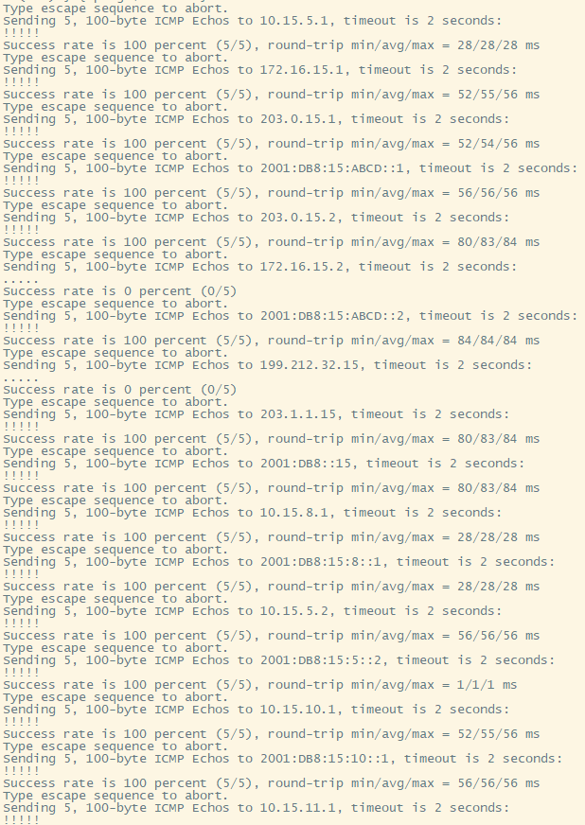

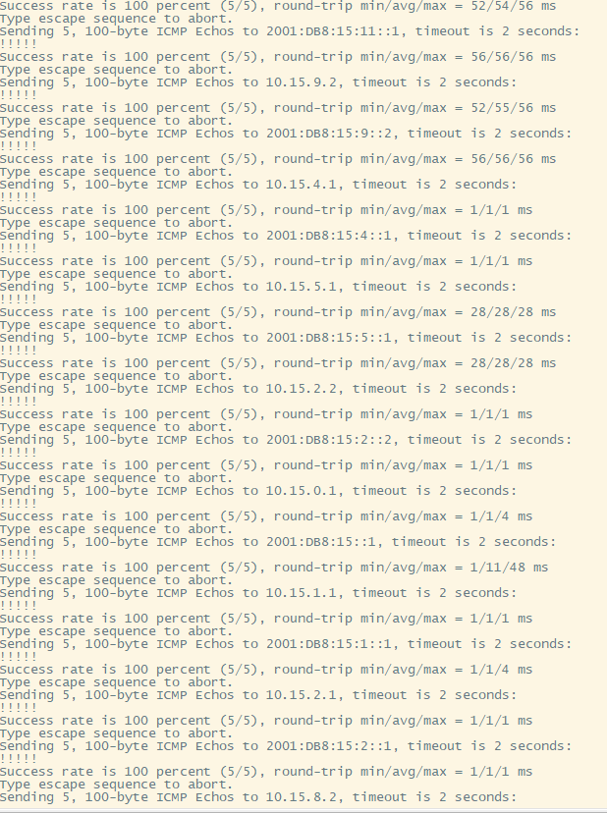

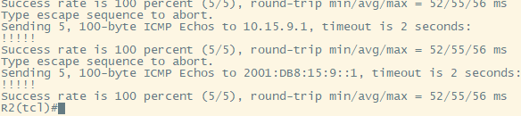

R3:

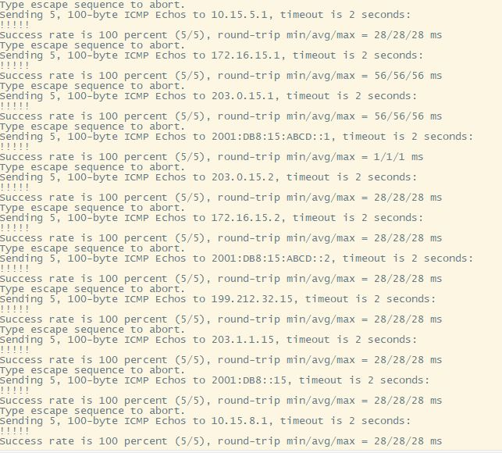

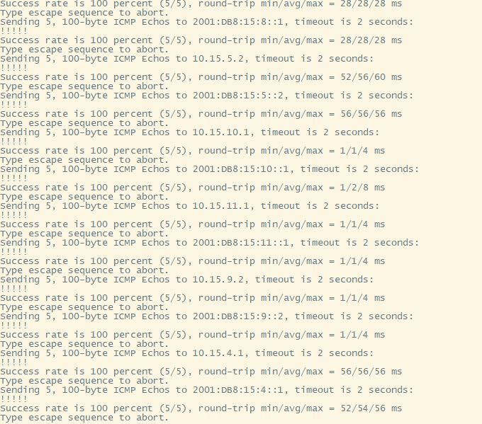

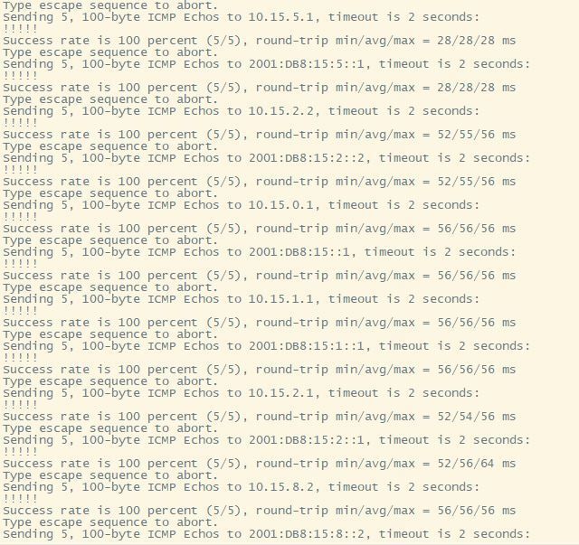

R4:

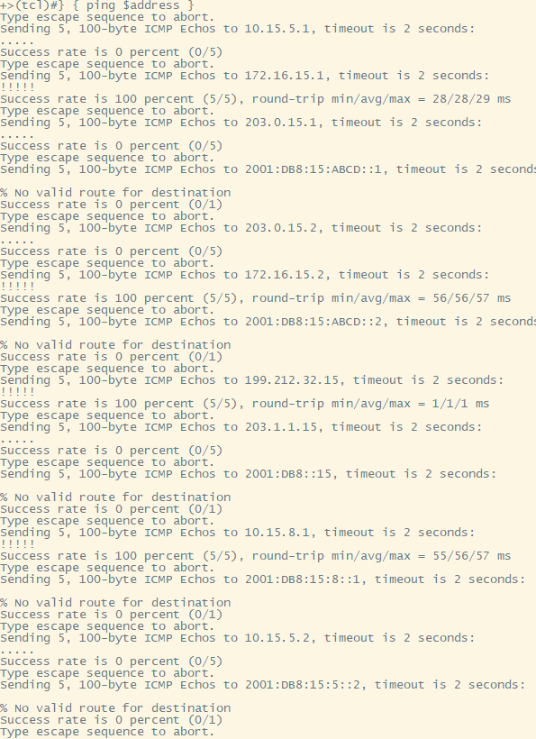

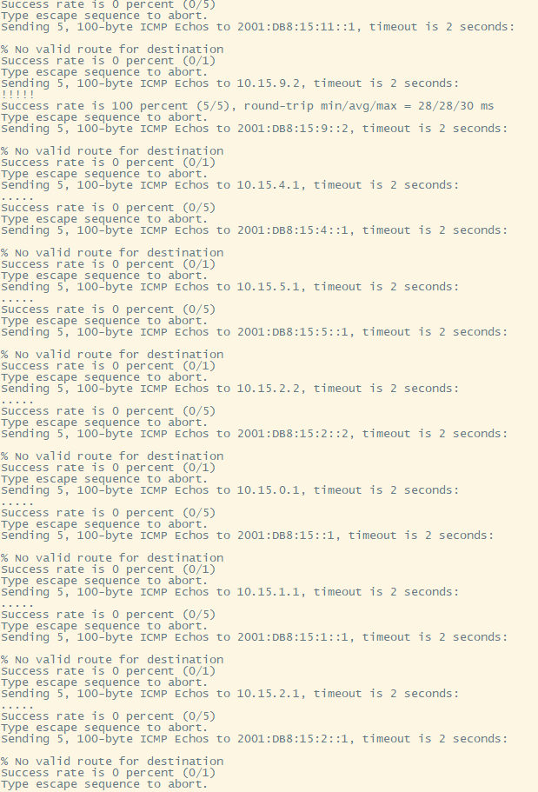

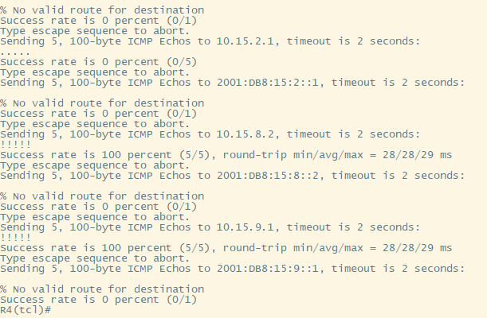

**Additional Task**

**OSPF Security Feature:**

**1. MD5 Authentication:**

1. MD5 authentication is an algorithm for encrypting passwords. This can be implemented when applying a password on a router or switch to prevent attackers from modifying your router or switch configurations.
2. We chose to implement MD5 authentication for OSPF because using this security practice will prepare you for real world authentication. Attackers can attempt to telnet into your routers or switches. Adding this simple MD5 command can help encrypt your passwords and prevent these attackers.
3. When configuring MD5 authentication, it must be implemented in the entire area. So, for our case study since R2, R1 and R3 vrf is in the ospf area we will apply it on each interface, R3: g0/0.10, R2: g0/0.10, R2: s0/0/0 and R1: s0/0/0.
4. To configure MD5 authentication:
   * 1. Interface (s0/0/0, g0/0/0, etc.)
     2. Ip ospf message-digest-key 1 md5 (password)
     3. Router ospf (process-id)
     4. Area (as number) authentication message-digest

**2. Additional Security: OSPF Time to Live:**

1. A time to live configuration can be set to a maximum value of 255 and when a packet is forwarded, the time to live value is decreased by 1 every time.
2. We decided to choose this feature to be implemented in our network since there are many switches and routers that may cause routing loops. A time to live would be extremely helpful to prevent this issue if our configuration does happen to have an error.
3. This feature would be implemented on virtual links due to this feature only working on virtual links. This feature can be implemented on R3 vrf subinterface g0/0.10, R2 vrf sub interface gi0/0.20 and R4 subinterface g0/1.20.
4. To configure TTL this must be configured on our virtual links:
   * 1. Ospfv3 (process-id) area (as number) ipv6
     2. Address-family ipv6 unicast vrf (vrf name)
     3. Area (as number) virtual-link (router-id) ttl-security hops (hop count)

**EIGRP Security Feature:**

**1. Route Filtering**

1. For our network we are going to implement route map filtering. We decided to use this feature because it allows further permitting and denying that allows the topology to read specific attributes like filtering by subnet masks.
2. We chose to use this feature because it adds additional security and efficiency to our network. In our topology, if we wanted to deny a specific route going from R3 vrf to R4 BGP, we would first create an ACL name, deny the specific ip, permit the other routes to be distributed, go into the OSPF configuration and filter out BGP.
3. Route filter is best to filter routes from the distributing router. So in our case to deny R3 vrf loopback 0’s address we would use the deny 10.15.0.1 0.0.0.255.
4. The route map filtering feature can be complex and specific so you must be careful when configuring this on your network. The configurations used to implement this feature:
   * 1. Ip access-list standard (ACL name)
     2. Deny (ip address) (wildcard mask)
     3. Permit (any or specific ip address)
     4. Router (ospf, bgp, eigrp) (process-id)
     5. Distribute-list (ACL name) (out or in) (ospf, bgp, eigrp) 1

**2.**  **Additional Security: Unicast Reverse Path Forwarding**

1. Unicast reverse path forwarding helps detect suspicious traffic on your network. This can help prevent source addresses from being forwarded. If the source address is not in the routing table, this packet will be discarded.
2. We thought this could be a great feature to use on your network since this could be a good command to practice and remember for future use
3. This command is required to be set on every interface since packets can be forwarded through your whole network.
4. To implement this command:
   * 1. Interface (the interface you want to enable it on, s0/0/0 or lo0)
     2. Ip verify reverse-path interface (the interface, s0/0/0 or lo0)

**BGP Security Feature:**

**1. BGP maxas-limit**

1. This feature is a border gateway protocol that is configured to discord routes when the as number exceeds your set value.
2. We decided to implement this BGP security feature because if we didn’t want routes coming from another area like 0 or 15, we can use this feature to achieve this.
3. We could implement this feature on R4 to prevent incoming routes from area 0 which would be ospf.
4. The command would be configured as:
   * 1. Router bgp (as number)
     2. Bgp maxas-limit (the area you want to block)

**2. Additional Security: Firewall Intrusion Detection System**

1. The intrusion detection system is configured to monitor your network and create alarms with abnormal traffic. IDS’s configuration can be used to send you messages when malicious or abnormal traffic is being forwarded, drop the packet or reset the TCP connection.
2. We would like to use this feature as an additional security property because attackers could forward abnormally large packets to attempt to DDOS your network. Using this will help the DDOS attack and be used to drop these packets.
3. This configuration is used on per interface to each router can be notified of forwarding malicious packets.
4. IDS can be configured to set an alarm, drop the packet or reset the tcp connection, to configure this command we do:
   * 1. Interface (interface s0/0/0, lo0, etc.)
     2. Ip audit (audit name) (int or out) (action [alarm] [drop] [reset])

What UOIT Should Implement in your Network

1. Redundancy – Adding another router:
   1. Our additional feature that we plan to add to our network is adding an additional router to be connected to R3. Since we see that R3 is the central unit of connecting the network to EIGRP and BGP area. This would be beneficial to the network topology since we think adding a 5th router to be the backbone of R3 would help with the networking redundancy and prevent our networking from failing if R3 decides to fail.

Final Show Running Configs

Router 1:

------------------------------------------------------------------------------------

hostname R1

!

boot-start-marker

boot-end-marker

!

!

!

no aaa new-model

memory-size iomem 10

!

!

!

!

!

!

!

!

!

!

!

!

!

!

!

!

!

!

ip cef

ipv6 unicast-routing

ipv6 cef

!

multilink bundle-name authenticated

!

!

!

!

!

!

cts logging verbose

!

!

voice-card 0

!

!

!

!

!

!

!

!

license udi pid CISCO2901/K9 sn FJC1928A153

license boot module c2900 technology-package securityk9

license boot module c2900 technology-package uck9

license boot module c2900 technology-package datak9

license boot module c2900 technology-package CollabProSuitek9

!

!

!

redundancy

!

!

!

!

!

!

!

!

!

!

!

!

!

!

!

interface Embedded-Service-Engine0/0

no ip address

shutdown

!

interface GigabitEthernet0/0

no ip address

shutdown

duplex auto

speed auto

!

interface GigabitEthernet0/1

no ip address

shutdown

duplex auto

speed auto

!

interface Serial0/0/0

bandwidth 64

ip address 10.15.5.1 255.255.255.252

ipv6 address FE80::1 link-local

ipv6 address 2001:DB8:15:5::1/64

ipv6 enable

ospfv3 15 ipv4 area 0

ospfv3 15 ipv6 area 0

clock rate 64000

!

interface Serial0/0/1

bandwidth 64

ip address 10.15.8.1 255.255.255.252

ipv6 address FE80::1 link-local

ipv6 address 2001:DB8:15:8::1/64

!

!

!

router eigrp CASE2018

!

address-family ipv4 unicast autonomous-system 15

!

topology base

redistribute ospfv3 15 metric 1000000 300 255 1 1500

exit-af-topology

network 10.15.8.1 0.0.0.0

eigrp router-id 1.1.1.1

exit-address-family

!

address-family ipv6 unicast autonomous-system 15

!

af-interface Serial0/0/0

shutdown

exit-af-interface

!

af-interface Serial0/0/1

summary-address 2001:DB8:15::/61

exit-af-interface

!

topology base

redistribute ospf 15 metric 1000000 300 255 1 1500

exit-af-topology

eigrp router-id 1.1.1.1

exit-address-family

!

router ospfv3 15

router-id 1.1.1.1

auto-cost reference-bandwidth 100000

!

address-family ipv4 unicast

redistribute eigrp 15

default-information originate

exit-address-family

!

address-family ipv6 unicast

default-information originate

redistribute eigrp 15 include-connected

exit-address-family

!

ip forward-protocol nd

!

no ip http server

no ip http secure-server

!

!

!

!

!

control-plane

!

!

!

!

!

!

mgcp behavior rsip-range tgcp-only

mgcp behavior comedia-role none

mgcp behavior comedia-check-media-src disable

mgcp behavior comedia-sdp-force disable

!

mgcp profile default

!

!

!

!

!

!

!

gatekeeper

shutdown

!

!

!

line con 0

line aux 0

line 2

no activation-character

no exec

transport preferred none

transport output lat pad telnet rlogin lapb-ta mop udptn v120 ssh

stopbits 1

line vty 0 4

login

transport input none

!

scheduler allocate 20000 1000

!

end

Router 2:

------------------------------------------------------------------------------------

hostname R2

!

boot-start-marker

boot-end-marker

!

!

vrf definition vEIGRP

rd 65015:2

!

address-family ipv4

exit-address-family

!

address-family ipv6

exit-address-family

!

! card type command needed for slot/vwic-slot 0/1

!

no aaa new-model

memory-size iomem 10

!

!

!

!

!

!

!

!

!

!

!

!

!

!

!

!

!

!

ip cef

ipv6 unicast-routing

ipv6 cef

!

multilink bundle-name authenticated

!

!

!

!

!

!

cts logging verbose

!

!

voice-card 0

!

!

!

!

!

!

!

!

license udi pid CISCO2901/K9 sn FCZ171970TR

license boot module c2900 technology-package securityk9

license boot module c2900 technology-package uck9

license boot module c2900 technology-package datak9

license boot module c2900 technology-package CollabProSuitek9

hw-module pvdm 0/0

!

!

!

vtp mode transparent

!

redundancy

!

!

!

!

!

!

!

!

!

!

!

!

!

!

!

interface Loopback0

ip address 10.15.4.1 255.255.255.0

ip ospf network point-to-point

ipv6 address FE80::2 link-local

ipv6 address 2001:DB8:15:4::1/64

ipv6 enable

ospfv3 15 ipv4 area 0

ospfv3 15 ipv6 area 0

!

interface Loopback1

vrf forwarding vEIGRP

ip address 10.15.10.1 255.255.255.0

ipv6 address FE80::2 link-local

ipv6 address 2001:DB8:15:10::1/64

!

interface Loopback2

vrf forwarding vEIGRP

ip address 10.15.11.1 255.255.255.0

ipv6 address FE80::2 link-local

ipv6 address 2001:DB8:15:11::1/64

!

interface Embedded-Service-Engine0/0

no ip address

shutdown

!

interface GigabitEthernet0/0

no ip address

duplex auto

speed auto

!

interface GigabitEthernet0/0.10

encapsulation dot1Q 10

ip address 10.15.2.2 255.255.255.252

ipv6 address FE80::2 link-local

ipv6 address 2001:DB8:15:2::2/64

ipv6 enable

ospfv3 15 ipv6 area 15

ospfv3 15 ipv4 area 15

!

interface GigabitEthernet0/0.20

encapsulation dot1Q 20

vrf forwarding vEIGRP

ip address 10.15.9.2 255.255.255.252

ipv6 address FE80::2 link-local

ipv6 address 2001:DB8:15:9::2/64

!

interface GigabitEthernet0/1

no ip address

shutdown

duplex auto

speed auto

!

interface Serial0/0/0

bandwidth 64

ip address 10.15.5.2 255.255.255.252

ipv6 address FE80::2 link-local

ipv6 address 2001:DB8:15:5::2/64

ipv6 enable

ospfv3 15 ipv4 area 0

ospfv3 15 ipv6 area 0

!

interface Serial0/0/1

no ip address

shutdown

clock rate 2000000

!

!

!

router eigrp CASE2018

!

address-family ipv4 unicast vrf vEIGRP autonomous-system 15

!

af-interface Loopback1

passive-interface

exit-af-interface

!

af-interface Loopback2

passive-interface

exit-af-interface

!

topology base

exit-af-topology

network 10.15.9.2 0.0.0.0

network 10.15.10.1 0.0.0.0

network 10.15.11.1 0.0.0.0

eigrp router-id 2.2.2.2

eigrp stub connected static

exit-address-family

!

address-family ipv6 unicast vrf vEIGRP autonomous-system 15

!

af-interface Loopback1

passive-interface

exit-af-interface

!

af-interface Loopback2

passive-interface

exit-af-interface

!

topology base

exit-af-topology

eigrp router-id 2.2.2.2

eigrp stub connected static

exit-address-family

!

router ospfv3 15

router-id 2.2.2.2

auto-cost reference-bandwidth 100000

!

address-family ipv4 unicast

passive-interface Loopback0

area 15 stub

area 15 range 10.15.0.0 255.255.252.0

exit-address-family

!

address-family ipv6 unicast

passive-interface Loopback0

area 15 stub

exit-address-family

!

ip forward-protocol nd

!

no ip http server

no ip http secure-server

!

ip nat inside source static 10.15.4.1 203.0.15.3

!

!

!

!

control-plane

!

!

voice-port 0/2/0

!

voice-port 0/2/1

!

voice-port 0/3/0

!

voice-port 0/3/1

!

!

!

!

!

mgcp behavior rsip-range tgcp-only

mgcp behavior comedia-role none

mgcp behavior comedia-check-media-src disable

mgcp behavior comedia-sdp-force disable

!

mgcp profile default

!

!

!

!

!

!

!

gatekeeper

shutdown

!

!

!

line con 0

line aux 0

line 2

no activation-character

no exec

transport preferred none

transport output lat pad telnet rlogin lapb-ta mop udptn v120 ssh

stopbits 1

line vty 0 4

login

transport input none

!

scheduler allocate 20000 1000

!

end

Router 3:

------------------------------------------------------------------------------------

hostname R3

!

boot-start-marker

boot-end-marker

!

!

vrf definition vOSPF

rd 65015:3

!

address-family ipv4

exit-address-family

!

address-family ipv6

exit-address-family

!

!

no aaa new-model

memory-size iomem 10

!

!

!

!

!

!

!

!

!

!

!

!

!

!

!

!

!

!

ip cef

ipv6 unicast-routing

ipv6 cef

!

multilink bundle-name authenticated

!

!

!

!

!

!

cts logging verbose

!

!

voice-card 0

!

!

!

!

!

!

!

!

license udi pid CISCO2901/K9 sn FJC1928A155

license boot module c2900 technology-package securityk9

license boot module c2900 technology-package uck9

license boot module c2900 technology-package datak9

license boot module c2900 technology-package CollabProSuitek9

hw-module pvdm 0/0

!

!

!

!

redundancy

!

!

!

!

!

!

!

!

!

!

!

!

!

!

!

interface Loopback0

vrf forwarding vOSPF

ip address 10.15.0.1 255.255.255.0

ip ospf network point-to-point

ipv6 address FE80::3 link-local

ipv6 address 2001:DB8:15::1/64

ipv6 enable

ospfv3 15 ipv4 area 15

ospfv3 15 ipv6 area 15

!

interface Loopback1

vrf forwarding vOSPF

ip address 10.15.1.1 255.255.255.0

ip ospf network point-to-point

ipv6 address FE80::3 link-local

ipv6 address 2001:DB8:15:1::1/64

ipv6 enable

ospfv3 15 ipv4 area 15

ospfv3 15 ipv6 area 15

!

interface Tunnel0

no ip address

ipv6 address FE80::15 link-local

ipv6 address FEC0:1::15/64

tunnel source Serial0/1/0

tunnel mode gre ipv6

tunnel destination 10.50.0.1

!

interface Embedded-Service-Engine0/0

no ip address

shutdown

!

interface GigabitEthernet0/0

no ip address

duplex auto

speed auto

!

interface GigabitEthernet0/0.10

encapsulation dot1Q 10

vrf forwarding vOSPF

ip address 10.15.2.1 255.255.255.252

ipv6 address FE80::3 link-local

ipv6 address 2001:DB8:15:2::1/64

ipv6 enable

ospfv3 15 ipv4 area 15

ospfv3 15 ipv6 area 15

!

interface GigabitEthernet0/0.20

encapsulation dot1Q 20

ip address 10.15.9.1 255.255.255.252

ip nat inside

ip virtual-reassembly in

ipv6 address FE80::3 link-local

ipv6 address 2001:DB8:15:9::1/64

!

interface GigabitEthernet0/1

no ip address

shutdown

duplex auto

speed auto

!

interface Serial0/0/0

bandwidth 64

ip address 10.15.8.2 255.255.255.252

ip nat inside

ip virtual-reassembly in

ipv6 address FE80::3 link-local

ipv6 address 2001:DB8:15:8::2/64

clock rate 64000

!

interface Serial0/0/1

no ip address

shutdown

!

interface Serial0/1/0

ip address 172.16.15.1 255.255.255.252

ip nat inside

ip virtual-reassembly in

clock rate 64000

!

interface Serial0/1/1

ip address 203.0.15.1 255.255.255.248

ip nat outside

ip virtual-reassembly in

ipv6 address FE80::3 link-local

ipv6 address 2001:DB8:15:ABCD::1/64

clock rate 64000

!

!

!

router eigrp CASE2018

!

address-family ipv4 unicast autonomous-system 15

!

topology base

redistribute static metric 1000000 300 255 1 1500

exit-af-topology

network 10.15.8.2 0.0.0.0

network 10.15.9.1 0.0.0.0

eigrp router-id 3.3.3.3

exit-address-family

!

address-family ipv6 unicast autonomous-system 15

!

af-interface Serial0/1/1

shutdown

exit-af-interface

!

topology base

redistribute static metric 1000000 300 255 1 1500

exit-af-topology

eigrp router-id 3.3.3.3

exit-address-family

!

router ospfv3 15

router-id 3.3.3.3

auto-cost reference-bandwidth 100000

!

address-family ipv4 unicast vrf vOSPF

passive-interface Loopback0

passive-interface Loopback1

capability vrf-lite

area 15 stub

exit-address-family

!

address-family ipv6 unicast vrf vOSPF

passive-interface Loopback0

passive-interface Loopback1

capability vrf-lite

area 15 stub

exit-address-family

!

router bgp 65015

bgp router-id 15.3.3.3

bgp log-neighbor-changes

bgp default local-preference 500

neighbor 172.16.15.2 remote-as 65015

neighbor FEC0:1::50 remote-as 65050

!

address-family ipv4

network 10.15.8.0 mask 255.255.255.252

network 10.15.9.0 mask 255.255.255.252

network 172.16.15.0 mask 255.255.255.252

neighbor 172.16.15.2 activate

no neighbor FEC0:1::50 activate

exit-address-family

!

address-family ipv6

network 2001:DB8:15::/48

exit-address-family

!

ip forward-protocol nd

!

no ip http server

no ip http secure-server

!

ip nat inside source list 150 interface Serial0/1/1 overload

ip route 0.0.0.0 0.0.0.0 203.0.15.2

!

ipv6 route ::/0 Serial0/1/1 2001:DB8:15:ABCD::2

!

!

access-list 15 permit any

access-list 150 permit ip 10.15.0.0 0.0.255.255 any

!

control-plane

!

!

voice-port 0/2/0

!

voice-port 0/2/1

!

voice-port 0/3/0

!

voice-port 0/3/1

!

!

!

!

!

mgcp behavior rsip-range tgcp-only

mgcp behavior comedia-role none

mgcp behavior comedia-check-media-src disable

mgcp behavior comedia-sdp-force disable

!

mgcp profile default

!

!

!

!

!

!

!

gatekeeper

shutdown

!

!

!

line con 0

line aux 0

line 2

no activation-character

no exec

transport preferred none

transport output lat pad telnet rlogin lapb-ta mop udptn v120 ssh

stopbits 1

line vty 0 4

login

transport input none

!

scheduler allocate 20000 1000

!

end

Router 4:

------------------------------------------------------------------------------------

hostname R4

!

boot-start-marker

boot-end-marker

!

!

vrf definition Mgmt-intf

!

address-family ipv4

exit-address-family

!

address-family ipv6

exit-address-family

!

vrf definition vINET

rd 65015:4

!

address-family ipv4

exit-address-family

!

address-family ipv6

exit-address-family

!

!

no aaa new-model

!

!

!

!

!

!

!

!

!

!

!

!

ipv6 unicast-routing

!

!

!

!

!

!

!

subscriber templating

multilink bundle-name authenticated

!

!

!

!

license udi pid ISR4331/K9 sn FDO205021FD

!

!

redundancy

mode none

!

!

!

!

!

!

!

interface GigabitEthernet0/0/0

no ip address

negotiation auto

!

interface GigabitEthernet0/0/0.10

!

interface GigabitEthernet0/0/1

no ip address

negotiation auto

!

interface GigabitEthernet0/0/1.10

encapsulation dot1Q 10

ip address 199.212.32.15 255.255.255.0

!

interface GigabitEthernet0/0/1.20

encapsulation dot1Q 20

vrf forwarding vINET

ip address 203.1.1.15 255.255.255.0

ipv6 address FE80::4 link-local

ipv6 address 2001:DB8::15/64

!

interface GigabitEthernet0/0/2

no ip address

shutdown

negotiation auto

!

interface Serial0/1/0

ip address 172.16.15.2 255.255.255.252

!

interface Serial0/1/1

vrf forwarding vINET

ip address 203.0.15.2 255.255.255.248

ipv6 address FE80::4 link-local

ipv6 address 2001:DB8:15:ABCD::2/64

!

interface GigabitEthernet0

vrf forwarding Mgmt-intf

no ip address

shutdown

negotiation auto

!

router bgp 65015

bgp router-id 15.4.4.4

bgp log-neighbor-changes

neighbor 172.16.15.1 remote-as 65015

neighbor 199.212.32.50 remote-as 65050

neighbor 199.212.32.50 route-map MED_VALUE out

!

address-family ipv4

network 172.16.15.0 mask 255.255.255.252

network 203.0.15.0 mask 255.255.255.248

neighbor 172.16.15.1 activate

neighbor 172.16.15.1 next-hop-self

neighbor 199.212.32.50 activate

exit-address-family

!

address-family ipv6

neighbor 172.16.15.1 activate

neighbor 199.212.32.50 activate

exit-address-family

!

ip forward-protocol nd

no ip http server

no ip http secure-server

ip tftp source-interface GigabitEthernet0

ip route vrf vINET 0.0.0.0 0.0.0.0 203.1.1.254

!

!

access-list 15 permit any

ipv6 route vrf vINET 2001:DB8:15::/48 Serial0/1/1

!

route-map MED_VALUE permit 20

match ip address 15

set metric 50

!

route-map MED_VALUE permit 30

!

!

!

control-plane

!

!

line con 0

stopbits 1

line aux 0

stopbits 1

line vty 0 4

login

!

!

end

Switch 4:

------------------------------------------------------------------------------------

hostname SW4

!

boot-start-marker

boot-end-marker

!

!

no aaa new-model

switch 1 provision ws-c2960x-24ts-l

!

!

vtp mode transparent

!

!

crypto pki trustpoint TP-self-signed-393939200

enrollment selfsigned

subject-name cn=IOS-Self-Signed-Certificate-393939200

revocation-check none

rsakeypair TP-self-signed-393939200

!

!

crypto pki certificate chain TP-self-signed-393939200

certificate self-signed 01

30820229 30820192 A0030201 02020101 300D0609 2A864886 F70D0101 05050030

30312E30 2C060355 04031325 494F532D 53656C66 2D536967 6E65642D 43657274

69666963 6174652D 33393339 33393230 30301E17 0D313831 32303131 30343830

375A170D 32303031 30313030 30303030 5A303031 2E302C06 03550403 1325494F

532D5365 6C662D53 69676E65 642D4365 72746966 69636174 652D3339 33393339

32303030 819F300D 06092A86 4886F70D 01010105 0003818D 00308189 02818100

C538E3B2 269A104F 8D036C5D 2DE0F40C 4D0D5942 607225C1 E49E4B0B F580E834

D0F2267D AE9C4DFE 627475D6 E39FBD4D A51D7AF9 E5A3AC8B 7F2D640E 2BD3F0AD

9BEE699C 8C5D5ED5 425EC2A1 054A1F84 B32E12ED 8C992835 69DB16CD 44213D8A

894E33B5 3F795CDE 08099A90 67F6475B 5330699D E895A7AA F036E9E9 625A0307

02030100 01A35330 51300F06 03551D13 0101FF04 05300301 01FF301F 0603551D

23041830 16801459 D1BF2658 FE0347D3 0CE5E1CB 01CD5C0F 3EA28130 1D060355

1D0E0416 041459D1 BF2658FE 0347D30C E5E1CB01 CD5C0F3E A281300D 06092A86

4886F70D 01010505 00038181 0006F0E3 50EF9A62 7AEB4495 96FB6866 604735E7

19DC215D 12CB7892 E39CDD5F 8DD04478 08C6A10A F733ED54 DF4D470E 11D03AA5

FA72C796 B712F6A1 CA9093D5 9C5CC927 61EAE1A2 94E9D533 6FB12F04 2A9E9D44

41385AFA FFA5AAE6 6EB226AE D03A366B BDCD655C 6CA8EF34 26FA63FB 78B36E4E

8164119D BF940BF5 2110F143 BB

quit

spanning-tree mode pvst

spanning-tree extend system-id

!

!

!

!

!

!

vlan internal allocation policy ascending

!

vlan 10,20

!

!

!

!

!

!

interface FastEthernet0

ip address dhcp

!

interface GigabitEthernet1/0/1

shutdown

!

interface GigabitEthernet1/0/2

shutdown

!

interface GigabitEthernet1/0/3

shutdown

!

interface GigabitEthernet1/0/4

shutdown

!

interface GigabitEthernet1/0/5

shutdown

!

interface GigabitEthernet1/0/6

shutdown

!

interface GigabitEthernet1/0/7

shutdown

!

interface GigabitEthernet1/0/8

shutdown

!

interface GigabitEthernet1/0/9

shutdown

!

interface GigabitEthernet1/0/10

shutdown

!

interface GigabitEthernet1/0/11

shutdown

!

interface GigabitEthernet1/0/12

shutdown

!

interface GigabitEthernet1/0/13

shutdown

!

interface GigabitEthernet1/0/14

shutdown

!

interface GigabitEthernet1/0/15

shutdown

!

interface GigabitEthernet1/0/16

shutdown

!

interface GigabitEthernet1/0/17

shutdown

!

interface GigabitEthernet1/0/18

shutdown

!

interface GigabitEthernet1/0/19

switchport trunk allowed vlan 10,20

switchport mode trunk

!

interface GigabitEthernet1/0/20

switchport trunk allowed vlan 10,20

switchport mode trunk

!

interface GigabitEthernet1/0/21

shutdown

!

interface GigabitEthernet1/0/22

shutdown

!

interface GigabitEthernet1/0/23

shutdown

!

interface GigabitEthernet1/0/24

shutdown

!

interface GigabitEthernet1/0/25

shutdown

!

interface GigabitEthernet1/0/26

shutdown

!

interface GigabitEthernet1/0/27

shutdown

!

interface GigabitEthernet1/0/28

shutdown

!

interface Vlan1

no ip address

!

ip http server

ip http secure-server

!

!

!

!

line con 0

line vty 0 4

login

line vty 5 15

login

!

end

References:

“Cisco IOS IP Routing: BGP Command Reference - BGP Commands: C through I [Support],” *Cisco*, 07-Oct-2013. [Online]. Available: https://www.cisco.com/c/en/us/td/docs/ios/iproute_bgp/command/reference/irg_book/irg_bgp2.html. [Accessed: 02-Dec-2018].

“EIGRP SECURITY,” *Cisco Community*, 12-Mar-2017. [Online]. Available: https://community.cisco.com/t5/switching/eigrp-security/td-p/3044332. [Accessed: 02-Dec-2018].

“IP Routing: OSPF Configuration Guide, Cisco IOS XE Release 3S - TTL Security Support for OSPFv3 on IPv6 [Cisco IOS XE 3S],” *Cisco*, 01-Aug-2018. [Online]. Available: https://www.cisco.com/c/en/us/td/docs/ios-xml/ios/iproute_ospf/configuration/xe-3s/iro-xe-3s-book/iro-ttl-sec-ospfv3.html. [Accessed: 02-Dec-2018].

“Network Security Baseline - Sample Configurations [Design Zone for Security],” *Cisco*, 14-Oct-2013. [Online]. Available: https://www.cisco.com/c/en/us/td/docs/solutions/Enterprise/Security/Baseline_Security/securebasebook/appendxA.html. [Accessed: 02-Dec-2018].

“null,” *Cisco*, 07-Oct-2013. [Online]. Available:<https://www.cisco.com/c/en/us/td/docs/ios/12_2/security/command/reference/fsecur_r/srfids.htm>

l. [Accessed: 02-Dec-2018].

“null,” *Cisco*, 30-Oct-2013. [Online]. Available: https://www.cisco.com/c/en/us/td/docs/ios/12_2/iproute/command/reference/fiprrp_r/1rfbgp1.html. [Accessed: 02-Dec-2018].

“Protecting Border Gateway Protocol for the Enterprise,” *Cisco*, 24-Nov-2017. [Online]. Available: https://www.cisco.com/c/en/us/about/security-center/protecting-border-gateway-protocol.html#11. [Accessed: 02-Dec-2018].

“Route-Maps for IP Routing Protocol Redistribution Configuration,” *Cisco*, 23-Aug-2015. [Online]. Available: https://www.cisco.com/c/en/us/support/docs/ip/border-gateway-protocol-bgp/49111-route-map-bestp.html. [Accessed: 02-Dec-2018].

“Sample Configuration for Authentication in OSPF,” *Cisco*, 05-Feb-2018. [Online]. Available: https://www.cisco.com/c/en/us/support/docs/ip/open-shortest-path-first-ospf/13697-25.html. [Accessed: 02-Dec-2018].

“Understanding Unicast Reverse Path Forwarding,” *Cisco*, 19-Dec-2016. [Online]. Available: https://www.cisco.com/c/en/us/about/security-center/unicast-reverse-path-forwarding.html. [Accessed: 02-Dec-2018].