Birth decline in Switzerland
Table of contents
1. Aim 1
1.1 Context 1
1.2 Objectives 1
2. Methods 1
2.1 Birth prediction model 1
2.2 Excess births 1
2.2.1 National-level 1
2.2.2 Region-level 1
2.3 Explaining heterogeneity 1
3. Results: excess 1
3.1 Model parameters 1
3.1.1 Fertility curve 1
3.1.2 Age shift 1
3.1.3 Monthly effect 1
3.2 Excess birth 1
3.2.1 National level 1
3.2.2 By month 1
3.2.3 By citizenship 1
3.2.4 Municipality-level 1
3.3 Results 1
3.3.1 All citizenship 1
3.4 Sub-group analysis 1
3.4.1 By nationality 1
3.4.2 By parity 1
4. Data: explanatory variables 1
4.1 Swiss Household Panel (SHP) data 1
5. To do 1
6. Conclusion 1

1. Aim

1.1 Context
- The birth rate in Switzerland (number of births per year among women aged 15–50) has continuously declined since around 2017, except in 2021.
- The decline varies by age, with a steeper decrease among younger women and a slower decrease among older women.
- This pattern reflects a shift in the timing of childbearing toward older ages.
birth_df1 = birth_agg_df %>%
filter(mother_age %in% 15:50,year>=2000) %>%
dplyr::mutate(age_group = cut(mother_age,c(15,25,35,Inf), right = FALSE, labels = c("15-24", "25-34", "35-50"))) %>%
group_by(year,age_group) %>%
dplyr::summarise(n=sum(n), .groups="drop")
birth_df2 = rbind(birth_df1 %>% dplyr::mutate(data="by age"),
birth_df1 %>%
group_by(year) %>%
dplyr::summarise(n=sum(n),.groups="drop") %>%
dplyr::mutate(age_group="All ages",data="All ages"))
pop_df1 = pop_df %>%
filter(age %in% 15:50,year>=2000) %>%
dplyr::mutate(age_group = cut(age,c(15,25,35,Inf), right = FALSE, labels = c("15-24", "25-34", "35-50"))) %>%
group_by(year,age_group) %>%
dplyr::summarise(n=sum(n), .groups="drop")
pop_df2 = rbind(pop_df1 %>% dplyr::mutate(data="by age"),
pop_df1 %>%
group_by(year) %>%
dplyr::summarise(n=sum(n),.groups="drop") %>%
dplyr::mutate(age_group="All ages",data="All ages"))
scientific_10 <- function(x) { ifelse(x==0,0,parse(text=gsub("e\\+*", " %*% 10^", scales::scientific_format()(x)))) }
p1 = birth_df1 %>%
dplyr::mutate(year = dmy(paste0("01-01-", year))) %>%
ggplot(aes(x=year, y = n))+
geom_bar(stat="identity",alpha=0.5)+
scale_x_date(name="")+
scale_y_continuous(name="Number of births")
p2 = pop_df1 %>%
dplyr::mutate(year = dmy(paste0("01-01-", year))) %>%
ggplot(aes(x=year, y = n))+
geom_bar(stat="identity",alpha=0.5)+
scale_x_date(name="")+
scale_y_continuous(name="Population size", label=scientific_10)
p3 = birth_df2 %>%
rename(n_birth = n) %>%
left_join(pop_df2 %>% rename(n_pop = n),
by = c("year","age_group")) %>%
dplyr::mutate(p_birth = n_birth / n_pop,
year = dmy(paste0("01-01-", year))) %>%
ggplot(aes(x = year, y = p_birth,
colour = age_group,
linetype = age_group)) +
geom_line(,linewidth = 1) +
expand_limits(y = 0)+
scale_x_date(name="")+
scale_y_continuous(name="Birth rate",labels = scales::percent)+
scale_color_manual(name="Age groups",values=c("darkred","orange","darkblue","black"))+
scale_linetype_manual(name="Age groups",values = c("dashed","dashed","dashed","solid"))+
theme(legend.position = "bottom")
cowplot::plot_grid(p1,
p2,
p3, ncol=1,rel_heights = c(1,1,1.2),labels = c("A.","B.","C."))
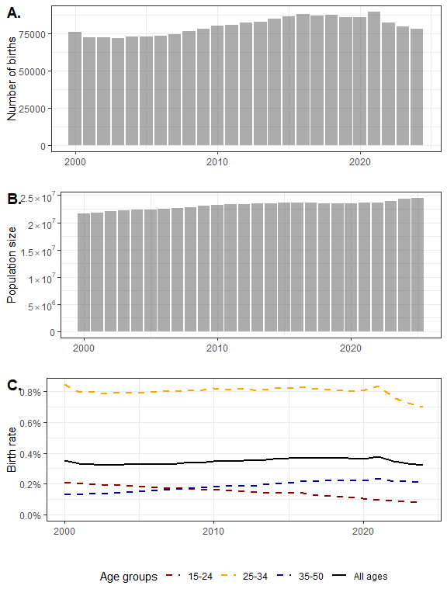
Figure 1: A. Number of births by year. B. Female population aged 15-50 by year. C. Birth rates by year and age group.

1.2 Objectives
- Quantify Switzerland’s birth decline over 2000–2024, adjusting for demographic changes and delayed childbearing,
- Counterfactual approach (‘birth excess’) keeping the overall fertility level constant while allowing for changes in population structure and the timing of childbearing,
- Examine temporal and geographical heterogeneity in birth decline,
- Explore socio-economic-demographic factors associated with variations in birth excess.

2. Methods

2.1 Birth prediction model
We model age-specific births using a negative binomial regression with an overdispersion parameter. Let:
- $y_{a,t}$ = number of births at maternal age $a$ in year $t$
- $N_{a,t}$ = population of women at age $a$ in year $t$
Then:
$$y_{a,t}∼\text{NegBinom}\left(μ_{a,t},ϕ\right), logμ_{a,t}=f\left(a+δ_{t}\right)+γ_{m}+γ_{y}+logN_{a,t},$$

where:
- $f\left(a\right)$ is the age-specific fertility function modeled with a Gaussian Process (GP),
- $δ_{t}$ is the calendar-year-specific age shift capturing delayed childbearing (also modeled with a GP),
- $γ_{m}$ is a fixed effect for calendar month $m$,
- $γ_{y}∼\text{N}\left(0,σ_{y}^{2}\right)$ is a random effect for calendar year $y\left(t\right)$ of standard deviation $σ_{y}$,
- $ϕ$ is the negative binomial overdispersion parameter.
This formulation allows the fertility curve to shift over time while accounting for seasonality and overdispersion in birth counts.
We can then define the predicted number of birth:
$${\hat{μ}}_{a,t}∼\text{NegBinom}\left(μ_{a,t},ϕ\right), logμ_{a,t}=f\left(a+δ_{t}\right)+γ_{m}+{\hat{γ}}_{y}+logN_{a,t},$$
where ${\hat{γ}}_{y}$ is the distributed random effect of year, ${\hat{γ}}_{y}∼\text{N}\left(0,σ_{y}^{2}\right)$.

2.2 Excess births

2.2.1 National-level
The excess is:
$${\text{Excess}}_{a,t}=y_{a,t}-{\hat{μ}}_{a,t}, {\text{Relative Excess}}_{a,t}=\frac{y_{a,t}-{\hat{μ}}_{a,t}}{{\hat{μ}}_{a,t}}.$$
This gives the absolute and relative deviations between observed and expected births.

2.2.2 Region-level
Let $d$ denote a region and $y_{d,a,t}$ the observed births in region $d$ (unknown at prediction stage). We distribute the national posterior predicted births ${\hat{μ}}_{a,t}$ across regions using a multinomial distribution:
$${\hat{μ}}_{1⋯D,a,t}∼\text{Multinomial}\left({\hat{μ}}_{a,t},p_{1⋯D,a,t}\right).$$
Where $p_{d,a,t}$ is the proportion of women of age $a$ in region $d$ relative to the total national population of age $a$:
pd,a,t=Nd,a,td'​Nd',a,t.
The regional excess is then:
$${\text{Excess}}_{d,a,t}=y_{d,a,t}-{\hat{μ}}_{d,a,t}, {\text{Relative Excess}}_{d,a,t}=\frac{y_{d,a,t}-{\hat{μ}}_{d,a,t}}{{\hat{μ}}_{d,a,t}}.$$
This allows us to quantify deviations at a finer spatial scale while respecting the national posterior predictions.

2.3 Explaining heterogeneity
- Temporal and geographical differences analyzed with covariates
- Focus on structural factors beyond age composition
- Sub-group analysis

3. Results: excess

3.1 Model parameters
save.date="20260309"
save.date2="20260320"
seed_id=1
mod_name = "mod8"
#load results
gamma_month_df1 = readRDS(paste0(code_root_path,"results/",save.date,"_",mod_name,"_seedid",seed_id,"_gammamonth.RDS"))
gamma_month_df2 = readRDS(paste0(code_root_path,"results/",save.date,"_",mod_name,"_swiss","_seedid",seed_id,"_gammamonth.RDS"))
gamma_month_df3 = readRDS(paste0(code_root_path,"results/",save.date,"_",mod_name,"_non-swiss","_seedid",seed_id,"_gammamonth.RDS"))
b_year_df1= readRDS(paste0(code_root_path,"results/",save.date,"_",mod_name,"_seedid",seed_id,"_byear.RDS"))
b_year_df2= readRDS(paste0(code_root_path,"results/",save.date,"_",mod_name,"_swiss","_seedid",seed_id,"_byear.RDS"))
b_year_df3= readRDS(paste0(code_root_path,"results/",save.date,"_",mod_name,"_non-swiss","_seedid",seed_id,"_byear.RDS"))
birth_prob_by_age_df1 = readRDS(paste0(code_root_path,"results/",save.date,"_",mod_name,"_seedid",seed_id,"_birthprob.RDS"))
birth_prob_by_age_df2 = readRDS(paste0(code_root_path,"results/",save.date,"_",mod_name,"_swiss","_seedid",seed_id,"_birthprob.RDS"))
birth_prob_by_age_df3 = readRDS(paste0(code_root_path,"results/",save.date,"_",mod_name,"_non-swiss","_seedid",seed_id,"_birthprob.RDS"))
birth_prob_by_age_df4 = readRDS(paste0(code_root_path,"results/",save.date2,"_",mod_name,"_first","_seedid",seed_id,"_birthprob.RDS"))
birth_prob_by_age_df5 = readRDS(paste0(code_root_path,"results/",save.date2,"_",mod_name,"_second","_seedid",seed_id,"_birthprob.RDS"))
gp_rel_df1 = readRDS(paste0(code_root_path,"results/",save.date,"_",mod_name,"_seedid",seed_id,"_gp_rel.RDS"))
gp_rel_df2 = readRDS(paste0(code_root_path,"results/",save.date,"_",mod_name,"_swiss","_seedid",seed_id,"_gp_rel.RDS"))
gp_rel_df3 = readRDS(paste0(code_root_path,"results/",save.date,"_",mod_name,"_non-swiss","_seedid",seed_id,"_gp_rel.RDS"))
gp_rel_df4 = readRDS(paste0(code_root_path,"results/",save.date2,"_",mod_name,"_first","_seedid",seed_id,"_gp_rel.RDS"))
gp_rel_df5 = readRDS(paste0(code_root_path,"results/",save.date2,"_",mod_name,"_second","_seedid",seed_id,"_gp_rel.RDS"))
#load excess
excess_birth_year_df1 = readRDS(paste0(code_root_path,"results/",save.date,"_",mod_name,"_","seedid",seed_id,"_","excess_birth_year_df",".RDS"))
excess_birth_year_df2 = readRDS(paste0(code_root_path,"results/",save.date,"_",mod_name,"_swiss","_","seedid",seed_id,"_","excess_birth_year_df",".RDS"))
excess_birth_year_df3 = readRDS(paste0(code_root_path,"results/",save.date,"_",mod_name,"_non-swiss","_","seedid",seed_id,"_","excess_birth_year_df",".RDS"))
excess_birth_year_month_df1 = readRDS(paste0(code_root_path,"results/",save.date,"_",mod_name,"_","seedid",seed_id,"_","excess_birth_year_month_df",".RDS"))
#excess by citizenship for all ctz model
excess_birth_year_ctz_df1 = readRDS(paste0(code_root_path,"results/",save.date,"_",mod_name,"_","seedid",seed_id,"_","excess_birth_year_ctz_df",".RDS"))
#excess by municipality
excess_birth_adj2_mun_df1 = readRDS(paste0(code_root_path,"results/",save.date,"_",mod_name,"_","seedid",seed_id,"_","excess_birth_adj2_mun_df",".RDS"))
excess_birth_adj2_mun_df2 = readRDS(paste0(code_root_path,"results/",save.date,"_",mod_name,"_swiss","_","seedid",seed_id,"_","excess_birth_adj2_mun_df",".RDS"))
excess_birth_adj2_mun_df3 = readRDS(paste0(code_root_path,"results/",save.date,"_",mod_name,"_non-swiss","_","seedid",seed_id,"_","excess_birth_adj2_mun_df",".RDS"))

3.1.1 Fertility curve
birth_prob_by_age_df1 %>%
filter(year %in% c(2000,2010,2024)) %>%
ggplot(aes(x=mother_age,y=est,ymin=lwb,ymax=upb))+
geom_ribbon(aes(fill=factor(year)),alpha=0.2)+
geom_line(aes(col=factor(year)))+
scale_y_continuous(labels = scales::percent)
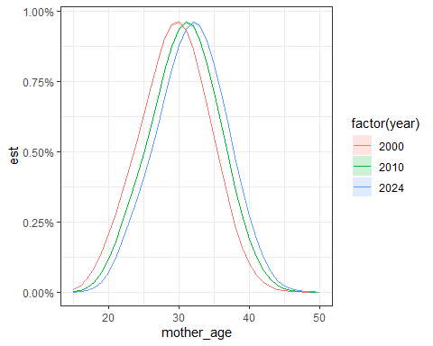

3.1.2 Age shift
gp_rel_df1 %>%
ggplot(aes(x=year,y=est,ymin=lwb,ymax=upb))+
geom_ribbon(fill="blue",alpha=0.2)+
geom_line(col="blue")+
scale_y_continuous(name="Change in age of fertility peak (relative to 2000)")
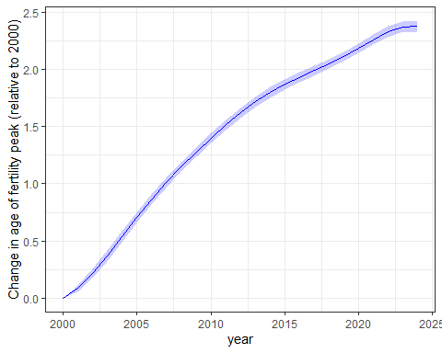

3.1.3 Monthly effect
gamma_month_df1 %>%
ggplot(aes(x=month_id,y=est,ymin=lwb,ymax=upb)) +
geom_ribbon(fill="blue",alpha=0.2)+
geom_line(col="blue")
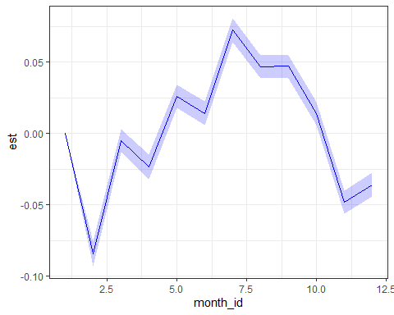

3.2 Excess birth

3.2.1 National level
#national, year
plot_df = excess_birth_year_df1 %>%
pivot_longer(cols = c(n_exp_mean, n_exp_lwb, n_exp_upb,
n_exc_mean, n_exc_lwb, n_exc_upb,
rel_exc_mean, rel_exc_lwb, rel_exc_upb),
names_to = c("var", "stat"),
names_pattern = "(.*)_(mean|lwb|upb)",
values_to = "value" ) %>%
pivot_wider(names_from = "stat",values_from = "value") %>%
dplyr::mutate(var = factor(var,levels=c("n_exp","n_exc","rel_exc"),labels=c("Expected birth","Excess birth","Relative excess")))
plot_df %>%
ggplot(aes(x = year, y = mean))+
geom_ribbon(aes(ymin = lwb,ymax=upb),alpha = 0.2) +
geom_line() +
geom_hline(data = subset(plot_df, var %in% c("Excess birth", "Relative excess")),
aes(yintercept = 0),
linetype = 2) +
geom_line(data = subset(plot_df, var %in% c("Expected birth")),
aes(y=n_birth),col="darkred",
linetype = 2 ) +
facet_grid(var~.,scale="free_y")
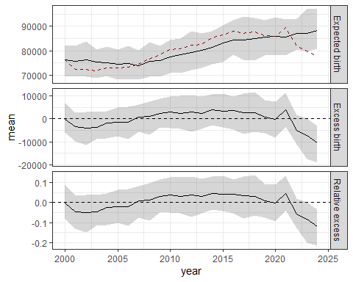

3.2.2 By month
2020-2024
#national, year, month
plot_df = excess_birth_year_month_df1 %>%
pivot_longer(cols = c(n_exp_mean, n_exp_lwb, n_exp_upb,
n_exc_mean, n_exc_lwb, n_exc_upb,
rel_exc_mean, rel_exc_lwb, rel_exc_upb),
names_to = c("var", "stat"),
names_pattern = "(.*)_(mean|lwb|upb)",
values_to = "value" ) %>%
pivot_wider(names_from = "stat",values_from = "value") %>%
dplyr::mutate(var = factor(var,levels=c("n_exp","n_exc","rel_exc"),labels=c("Expected birth","Excess birth","Relative excess")))
plot_df %>%
filter(year>=2020) %>%
ggplot(aes(x = date, y = mean))+
geom_ribbon(aes(ymin = lwb,ymax=upb),alpha = 0.2) +
geom_line() +
geom_hline(data = subset(plot_df %>% filter(year>=2020) , var %in% c("Excess birth", "Relative excess")),
aes(yintercept = 0),
linetype = 2) +
geom_line(data = subset(plot_df %>% filter(year>=2020), var %in% c("Expected birth")),
aes(y=n_birth),col="darkred",
linetype = 2 ) +
facet_grid(var~.,scale="free_y")
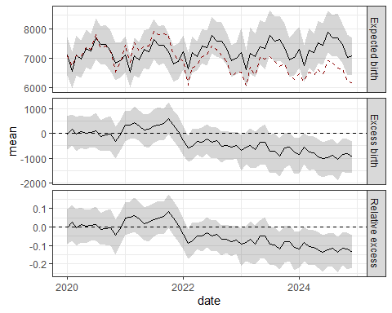

3.2.3 By citizenship
fig_i = 10
#national, year
plot_df = excess_birth_year_ctz_df1 %>%
pivot_longer(cols = c(n_exp_mean, n_exp_lwb, n_exp_upb,
n_exc_mean, n_exc_lwb, n_exc_upb,
rel_exc_mean, rel_exc_lwb, rel_exc_upb),
names_to = c("var", "stat"),
names_pattern = "(.*)_(mean|lwb|upb)",
values_to = "value" ) %>%
pivot_wider(names_from = "stat",values_from = "value") %>%
dplyr::mutate(var = factor(var,levels=c("n_exp","n_exc","rel_exc"),labels=c("Expected birth","Excess birth","Relative excess")))
plot_df %>%
ggplot(aes(x = year, y = mean))+
geom_ribbon(aes(ymin = lwb,ymax=upb),alpha = 0.2) +
geom_line() +
geom_hline(data = subset(plot_df, var %in% c("Excess birth", "Relative excess")),
aes(yintercept = 0),
linetype = 2) +
geom_line(data = subset(plot_df, var %in% c("Expected birth")),
aes(y=n_birth),col="darkred",
linetype = 2 ) +
facet_grid(var~citizenship,scale="free_y")
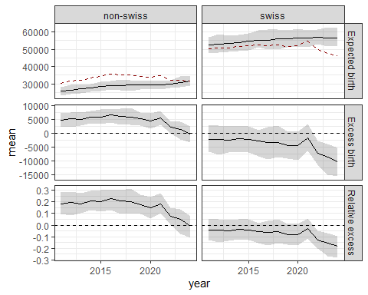
Figure 10: Excess birth by municipality for 2017-2024.

3.2.4 Municipality-level

3.2.4.1 All citizenship
2017-2024
Smoothed
- For each municipality, we smooth estimates by computing a weighted sum of excess births over Queen neighbors (i.e., regions sharing a boundary).
- We use hybrid weighting: 50% weight for the municipality itself and 50% distributed among neighbors, as in spatial mixing models (e.g., BYM).
- Conceptually similar to Getis–Ord Gi*, computing the averaged deviation between local (observed births) and global (predicted births) values, but Bayesian: posterior draws directly provide distributions of local deviation.
- Two key differences in weighting: 1) not standardized, giving more influence to municipalities with high number of births, 2)the municipality itself has the same weight as all neighbors combined, unlike Gi* where it has the same weight as any single neighbor.
excess_birth_adj2_mun_df1 %>%
left_join(new_mun_df %>% dplyr::select(mun_id,dist_id) %>% distinct(), by="mun_id") %>%
left_join(new_mun_sf %>% dplyr::mutate(mun_id=as.numeric(mun_id)), by = c("mun_id")) %>%
st_as_sf() %>%
ggplot() +
geom_sf(aes(fill = rel_exc_mean), color = NA) + # communes sans bordure
geom_sf(data = regions_sf %>% mutate(dist_id = as.numeric(dist_id)),
fill = NA, color = "black", size = 0.3) + # contours districts
geom_sf(data = lake_sf, fill = "lightblue", color = NA, alpha = 0.5) +
scale_fill_gradient2(
name = "Relative excess birth",
low = "red",
mid = "lightyellow",
high = "green",
midpoint = 0,
labels = scales::percent_format(accuracy = 1),
#limits=c(-0.4,0.4)
) +
theme(legend.position = "bottom",
legend.direction = "horizontal")
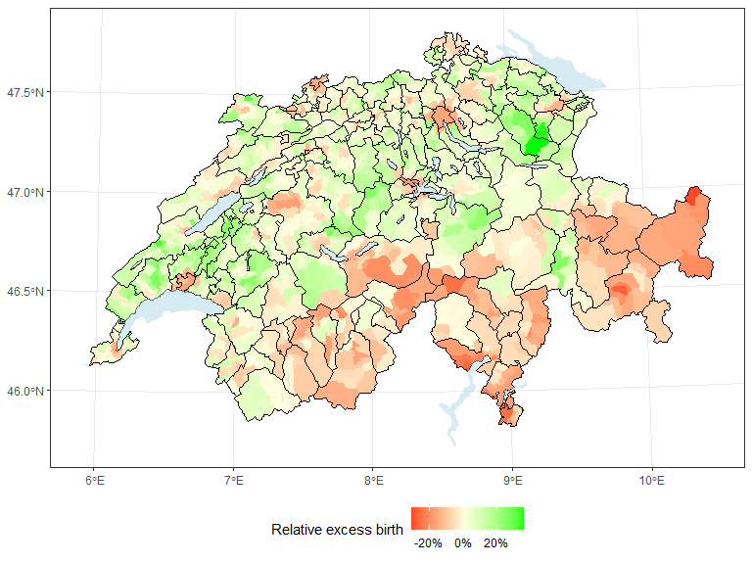
Figure XX: Smoothed estimates of excess birth by municipality for 2017-2024.

3.3 Results

3.3.1 All citizenship
new_pop_mun_df = pop_mun_df %>%
dplyr::mutate(mun_name = if_else(mun_id %in% mun_ids_to_agg, "Appenzell (aggregated)",mun_name),
mun_id = if_else(mun_id %in% mun_ids_to_agg, 31010,mun_id))
excess_birth_year_mun_draw_df1 = readRDS(paste0(code_root_path,"results/",save.date,"_",mod_name,"_","seedid",seed_id,"_","excess_birth_year_mun_draw_df",".RDS"))
excess_birth_year_mun_draw_df2 = readRDS(paste0(code_root_path,"results/",save.date,"_",mod_name,"_swiss","_","seedid",seed_id,"_","excess_birth_year_mun_draw_df",".RDS"))
excess_birth_year_mun_draw_df3 = readRDS(paste0(code_root_path,"results/",save.date,"_",mod_name,"_non-swiss","_","seedid",seed_id,"_","excess_birth_year_mun_draw_df",".RDS"))
df_var = excess_birth_year_mun_draw_df1 %>% dplyr::select(mun_id,mun_name) %>% distinct() %>%
left_join(new_pop_mun_df %>% filter(year==2024,month==1) %>%
group_by(mun_id) %>% dplyr::summarise(n_pop = sum(n),.groups="drop"), by=c("mun_id")) %>%
left_join(rural_urban_df %>% dplyr::select(mun_id,urban_rural_type2),by="mun_id") %>%
left_join(pop_dens_df %>% pivot_wider(id_cols = mun_id,names_from = "variable",values_from = "value"),by="mun_id") %>%
left_join(sep_df3 %>% dplyr::select(mun_id,sep=ssep3_d_mean),by="mun_id")
make_pop_ntile <- function(data, var, n = 5) {
total_pop = sum(data$n_pop)
data %>%
arrange({{ var }}) %>%
dplyr::mutate(cum_pop = cumsum(n_pop),
group = cut(cum_pop,breaks = seq(0, total_pop, length.out = n+1),labels = FALSE, include.lowest = TRUE )) %>%
dplyr::select(-cum_pop) %>%
arrange(mun_id) %>%
pull(group)
}
vars <- c("n_pop", "pop_dens_building") #setdiff(names(df_var), c("urban_rural_type2", "mun_id", "mun_name"))
for (v in vars) {
df_var[[paste0(v, "_ntile")]] <-make_pop_ntile(df_var, !!rlang::sym(v), 10)
}
df_var$urban_rural_type2_ntile = dense_rank(df_var$urban_rural_type2)
if(FALSE){
#check that the number of pop is more or less the same between groups (except for urban_rural_type2)
df_var %>% group_by(n_pop_ntile) %>%
dplyr::summarise(n_pop = sum(n_pop),
n=n())
}
#aggregate excess by group
excess_df = list()
for(v in paste0(c(vars), "_ntile")){
excess_df[[v]] = get_excess_est(var_group=c("ntile"),
excess_birth_year_mun_draw_df1 %>%
filter(year %in% 2017:2024) %>%
left_join(df_var %>% dplyr::select(mun_id,ntile = !!v),by="mun_id")) %>%
dplyr::mutate(explanatory_var=!!v)
}
excess_df = rbindlist(excess_df)
#plot
plot_df = excess_df %>%
pivot_longer(cols = c(n_exp_mean, n_exp_lwb, n_exp_upb,
n_exc_mean, n_exc_lwb, n_exc_upb,
rel_exc_mean, rel_exc_lwb, rel_exc_upb),
names_to = c("var", "stat"),
names_pattern = "(.*)_(mean|lwb|upb)",
values_to = "value" ) %>%
pivot_wider(names_from = "stat",values_from = "value") %>%
dplyr::mutate(var = factor(var,levels=c("n_exp","n_exc","rel_exc"),labels=c("Expected birth","Excess birth","Relative excess")))
excess_df %>%
filter(explanatory_var %in% c("n_pop_ntile","pop_dens_building_ntile", "prop_building_ntile", "prop_individual_houses_ntile","sep_ntile","urban_rural_type2_ntile")) %>%
ggplot(aes(x = ntile, y = rel_exc_mean, ymin = rel_exc_lwb, ymax = rel_exc_upb))+
geom_ribbon(aes(),alpha = 0.2) +
geom_line() +
geom_point() +
geom_hline(aes(yintercept = 0), linetype = 2)+
scale_y_continuous(name="Relative excess birth",labels = scales::percent)+
facet_wrap(explanatory_var~.,ncol=2)
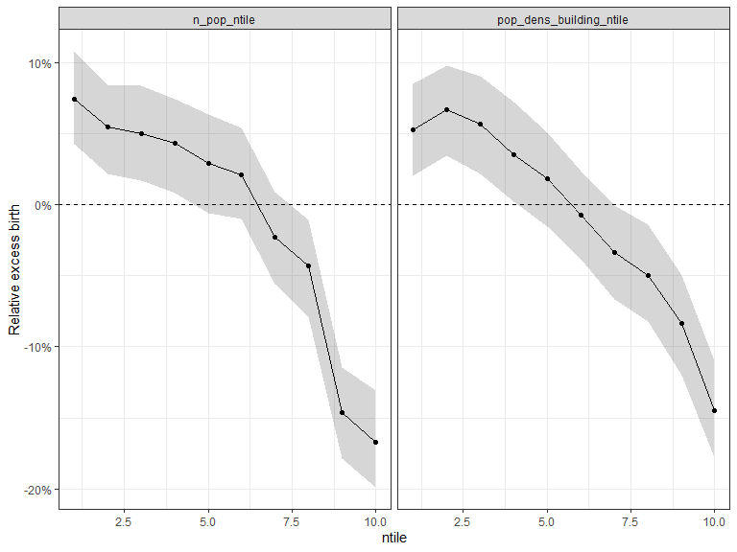
Figure XX: Relative excess birth estimates by decile of explanatory variables.

3.4 Sub-group analysis

3.4.1 By nationality

3.4.1.1 Fertility curve
rbind(birth_prob_by_age_df2 %>% filter(year==2000) %>% dplyr::mutate(ctz="swiss"),
birth_prob_by_age_df3 %>% filter(year==2000) %>% dplyr::mutate(ctz="non-swiss")) %>%
ggplot(aes(x=mother_age,y=est,ymin=lwb,ymax=upb))+
geom_ribbon(aes(fill=factor(ctz)),alpha=0.2)+
geom_line(aes(col=factor(ctz)))+
scale_y_continuous(labels = scales::percent)
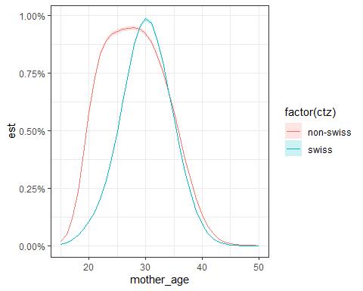

3.4.1.2 Age shift
rbind(gp_rel_df2 %>% dplyr::mutate(ctz="swiss"),
gp_rel_df3 %>% dplyr::mutate(ctz="non-swiss")) %>%
ggplot(aes(x=year,y=est,ymin=lwb,ymax=upb))+
geom_ribbon(aes(fill=ctz),alpha=0.2)+
geom_line(aes(col=ctz))+
scale_y_continuous(name="Change in age of fertility peak (relative to 2000)")
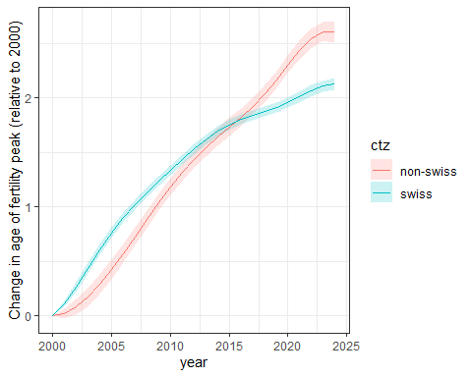

3.4.1.3 Excess
Swiss
mod_name=paste0("mod8_","swiss")
readRDS(paste0(code_root_path,paste0("excess_df_",mod_name,".RDS"))) %>%
ggplot(aes(x = ntile, y = rel_exc_mean, ymin = rel_exc_lwb, ymax = rel_exc_upb))+
geom_ribbon(aes(fill=childless),alpha = 0.2) +
geom_line(aes(col=childless)) +
geom_point(aes(col=childless)) +
geom_hline(aes(yintercept = 0), linetype = 2)+
scale_y_continuous(name="Relative excess birth",labels = scales::percent)+
facet_wrap(explanatory_var~.,ncol=2)
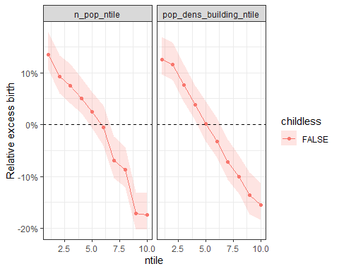
Non-Swiss
mod_name=paste0("mod8_","non-swiss")
readRDS(paste0(code_root_path,paste0("excess_df_",mod_name,".RDS")))%>%
ggplot(aes(x = ntile, y = rel_exc_mean, ymin = rel_exc_lwb, ymax = rel_exc_upb))+
geom_ribbon(aes(fill=childless),alpha = 0.2) +
geom_line(aes(col=childless)) +
geom_point(aes(col=childless)) +
geom_hline(aes(yintercept = 0), linetype = 2)+
scale_y_continuous(name="Relative excess birth",labels = scales::percent)+
facet_wrap(explanatory_var~.,ncol=2)
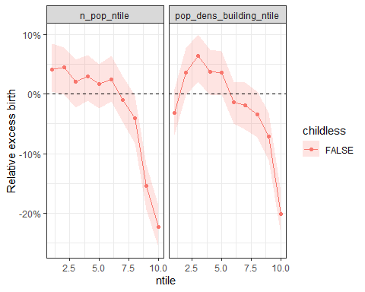

3.4.2 By parity

3.4.2.1 Fertility curve
rbind(birth_prob_by_age_df4 %>% filter(year==2005) %>% dplyr::mutate(ctz="first child"),
birth_prob_by_age_df5 %>% filter(year==2005) %>% dplyr::mutate(ctz="second + child")) %>%
ggplot(aes(x=mother_age,y=est,ymin=lwb,ymax=upb))+
geom_ribbon(aes(fill=factor(ctz)),alpha=0.2)+
geom_line(aes(col=factor(ctz)))+
scale_y_continuous(labels = scales::percent)
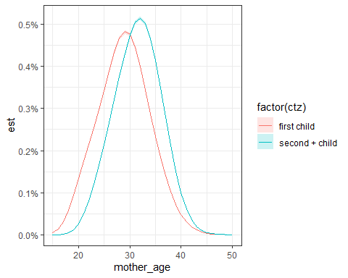

3.4.2.2 Age shift
rbind(gp_rel_df4 %>% dplyr::mutate(ctz="first_child"),
gp_rel_df5 %>% dplyr::mutate(ctz="second + child")) %>%
ggplot(aes(x=year,y=est,ymin=lwb,ymax=upb))+
geom_ribbon(aes(fill=ctz),alpha=0.2)+
geom_line(aes(col=ctz))+
scale_y_continuous(name="Change in age of fertility peak (relative to 2000)")
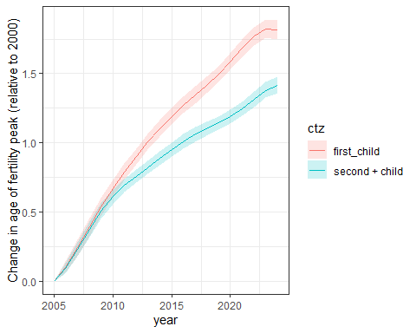

3.4.2.3 Excess
First child
mod_name=paste0("mod8_","first")
readRDS(paste0(code_root_path,paste0("excess_df_",mod_name,".RDS"))) %>%
ggplot(aes(x = ntile, y = rel_exc_mean, ymin = rel_exc_lwb, ymax = rel_exc_upb))+
geom_ribbon(aes(fill=childless),alpha = 0.2) +
geom_line(aes(col=childless)) +
geom_point(aes(col=childless)) +
geom_hline(aes(yintercept = 0), linetype = 2)+
scale_y_continuous(name="Relative excess birth",labels = scales::percent)+
facet_wrap(explanatory_var~.,ncol=2)
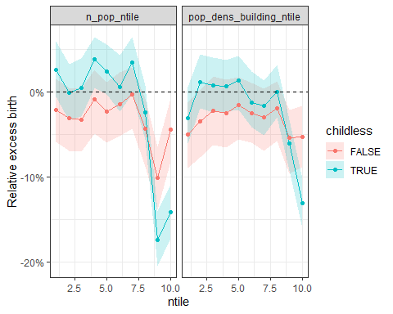
Second child
mod_name=paste0("mod8_","second")
readRDS(paste0(code_root_path,paste0("excess_df_",mod_name,".RDS")))%>%
ggplot(aes(x = ntile, y = rel_exc_mean, ymin = rel_exc_lwb, ymax = rel_exc_upb))+
geom_ribbon(aes(fill=childless),alpha = 0.2) +
geom_line(aes(col=childless)) +
geom_point(aes(col=childless)) +
geom_hline(aes(yintercept = 0), linetype = 2)+
scale_y_continuous(name="Relative excess birth",labels = scales::percent)+
facet_wrap(explanatory_var~.,ncol=2)
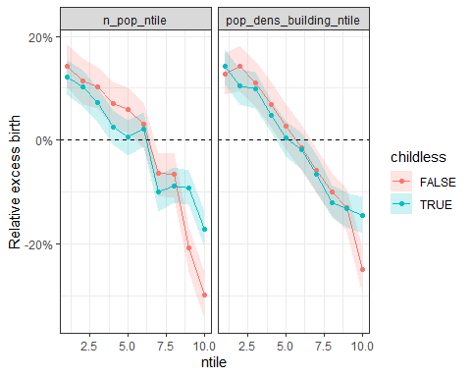

4. Data: explanatory variables

4.1 Swiss Household Panel (SHP) data
p_df = readRDS(paste0(code_root_path,"savepoint/cleaned_shp_p_df.RDS"))
#variables
#personal data
variables_p_df = data.frame(var= c("idhous","year", "idpers", "filter","pdate", "status","plingu",#"idint",
"age","sex",
"pd80", "pd81", "pd82",
"pd90", "pd91", "pd92", "pd93", "pd94", "pd95",
"pp20", "pp21", "pp22", "pp23"),
def = c("Identification number of household",
"Year",
"identification number of the person",
"Identification of the survey",
"Date of personal interview",
"Type of interviews completed: grid, proxy, personal",
"Interview language",# "Identification number of interviewer",
"Age in year of interview",
"Sex",
"Total number children wanted",
"Child wanted in the next 24 months",
"Ideal family size",
"Opinion on family: marriage is an outdated institution",
"Opinion on family: job preserves independance",
"Opinion on family: child suffers with working mother",
"Opinion on family: child suffers with unmaried parents",
"Opinion on family: happiness of a child living with a single parent",
"Opinion on family: happiness of a child living with same-sex parents",
"Gender: Women in general penalized",
"Gender: Personnally penalized",
"Gender: In favour of measures",
"Gender: Personal action" ))
#household data
variables_h_df = data.frame(var= c("idhous","year", "refper", "filter", "hmode","hdate","stathh","sthhre",#"idint"
"nbkid",
"canton",
"ctn_abbr",
"hf52"),
def = c("Identification number of household",
"Year",
"Identification of reference person",
"Identification of the survey",
"Mode of data collection",
"Date of household interview with reference person",
"Status household questionnaire",
"Reason for not completing household questionnaire",#"Identification number of interviewer",
"Number of children in household: 0 to 17 years",
"Canton of residence",
"Canton of residence (abbr)",
"External help: Child care: Monthly expenses"))
#all variables
variables_df = rbind(variables_p_df,
variables_h_df %>% filter(!(var %in% variables_p_df$var))) %>%
dplyr::mutate(group = dplyr::case_when(
var %in% c("idhous", "idpers", "refper") ~ "identifiers",
var %in% c("year", "pdate", "hdate") ~ "time",
var %in% c("status", "hmode", "filter", "stathh", "sthhre") ~ "survey_process",
var %in% c("age", "sex", "plingu", "canton") ~ "sociodemographics",
var %in% c("pd80","nbkid") ~ "number_of_children",
var %in% c("pd81") ~ "child_wanted",
grepl("^pd", var) ~ "family_opinions_preferences",
grepl("^pp", var) ~ "gender_attitudes",
var %in% c("hf52") ~ "household_children_economics",
TRUE ~ NA )) %>%
dplyr::mutate(is_reg_var = ifelse(group %in% c("family_opinions_preferences","gender_attitudes","household_children_economics",
"number_of_children","child_wanted"), 1, 0),
type = case_when(var %in% c("pd81") ~ "factor_2lev_n_y",
var %in% c("pd90", "pd91", "pd92", "pd93", "pp20", "pp21", "pp22", "pp23") ~ "factor_11lev_0_10",
var %in% c("pd80", "pd82","nbkid") ~ "numeric_max10",
var %in% c("pd94", "pd95") ~ "factor_11lev_0_10",
var %in% c("hf52") ~ "numeric",
TRUE ~ NA))
df = p_df %>%
dplyr::mutate(dplyr::across(everything(), as.character)) %>%
dplyr::mutate(row_id = dplyr::row_number()) %>%
tidyr::pivot_longer(cols = -c(year,row_id), names_to = "var", values_to = "value") %>%
dplyr::group_by(var,year) %>%
dplyr::summarise(p_na = mean(is.na(value)),
n_tot = n(),
n_nna = sum(!is.na(value)), .groups = "drop") %>%
left_join(variables_df,by="var") %>%
filter(is_reg_var==1) %>%
dplyr::mutate(year = ymd(paste0(year,"-01-01")))
df %>%
ggplot(aes(x=year,y=n_nna))+
geom_line(aes(x=year,y=n_tot),col="black",linetype = 2)+
geom_point(aes(col=var))+geom_line(aes(col=var))+
scale_y_continuous(name="Number of non-missing")+
scale_color_discrete(breaks=variables_df$var,labels=variables_df$def,
guide = guide_legend(ncol = 2)) +
expand_limits(y=0)+
facet_wrap(group~.)+
theme(legend.position = "bottom")
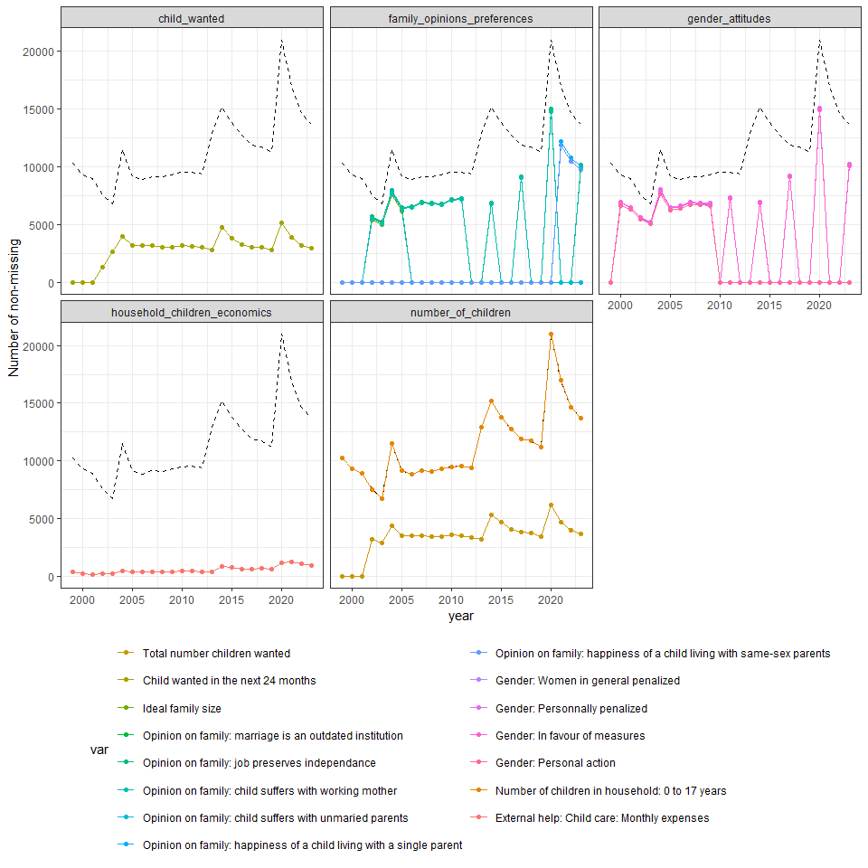
Figure XX: Number of responses.
df %>%
ggplot(aes(x=year,y=1-p_na,col=var))+
geom_point()+geom_line()+
scale_y_continuous(labels = scales::percent,name="Proportion of non-missing")+
scale_color_discrete(breaks=variables_df$var,labels=variables_df$def,
guide = guide_legend(ncol = 2)) +
expand_limits(y=0)+
facet_wrap(group~.)+
theme(legend.position = "bottom")
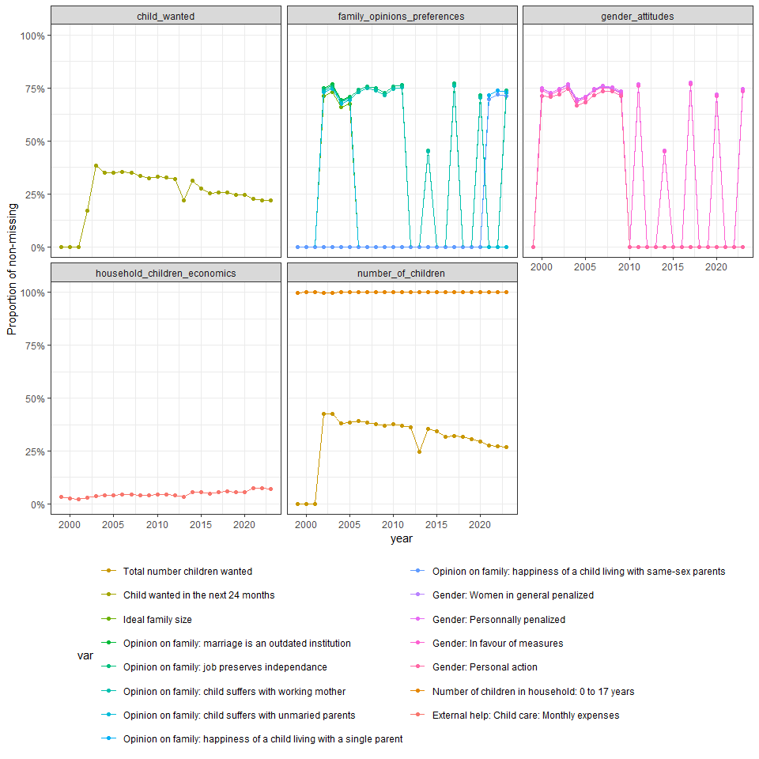
Figure XX: Proportion of non-missing responses.
#number of new participants per year
p_df %>%
dplyr::mutate(is_woman_15_50 = factor(as.numeric(sex=="woman" & age>=15 & age<=50))) %>%
group_by(year_start,is_woman_15_50) %>%
dplyr::summarise(n_new = length(unique(idpers)),.groups="drop") %>%
ggplot(aes(x=year_start,y=n_new,fill=is_woman_15_50))+
geom_bar(stat="identity",position = "stack")+
scale_y_continuous(name="Number of new participants")+
scale_fill_manual(name="Participants",values=c("gray","blue"),breaks = c(0,1),labels=c("All","Woman 15-50"))
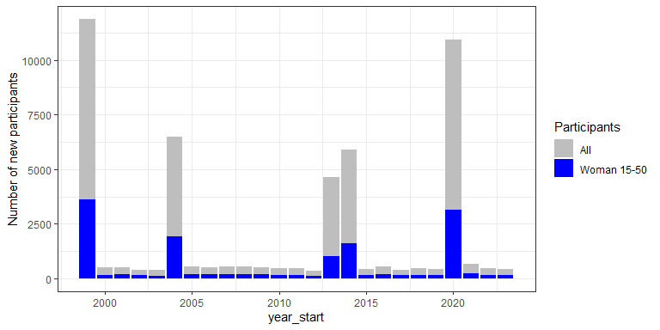
Figure XX: Number of new participants per year
#mean
df = p_df %>%
filter(year_start %in% c(2010:2024),sex=="woman",age_start %in% 15:50) %>%
dplyr::mutate(dplyr::across(everything(), as.character)) %>%
dplyr::mutate(row_id = dplyr::row_number()) %>%
tidyr::pivot_longer(cols = -c(year,row_id), names_to = "var", values_to = "value") %>%
left_join(variables_df,by="var") %>%
filter(is_reg_var==1,!is.na(value)) %>%
dplyr::mutate(value=as.numeric(value)) %>%
group_by(year,var,def,group) %>%
dplyr::summarise(mean = mean(value),
n_values = n(),.groups="drop") %>%
dplyr::mutate(year = ymd(paste0(year,"-01-01"))) %>%
group_by(year,group) %>%
dplyr::mutate(n_values_min = min(n_values),
n_values_max = max(n_values),
ymax=max(mean)*1.1) %>% ungroup() %>%
group_by(group) %>%
dplyr::mutate(ymax=max(mean)*1.1) %>% ungroup()
plots <- df %>%
filter(n_values>=10) %>%
dplyr::mutate(def = str_wrap(def, width = 20)) %>%
split(.$group) %>%
map(~ ggplot(.x, aes(x = year, y = mean)) +
geom_point(aes(col = def)) + geom_line(aes(col = def)) +
geom_text(aes(y = 0, label = n_values_min),
vjust = 0, show.legend = FALSE) +
geom_text(aes(y = ymax, label = n_values_max),
vjust = 0, show.legend = FALSE) +
expand_limits(y = 0) +
expand_limits(y = max(.x$ymax*1.05, na.rm = TRUE))+
ggtitle(unique(.x$group)) +
theme(legend.position = "bottom"))
cowplot::plot_grid(plotlist = plots, ncol = 1)
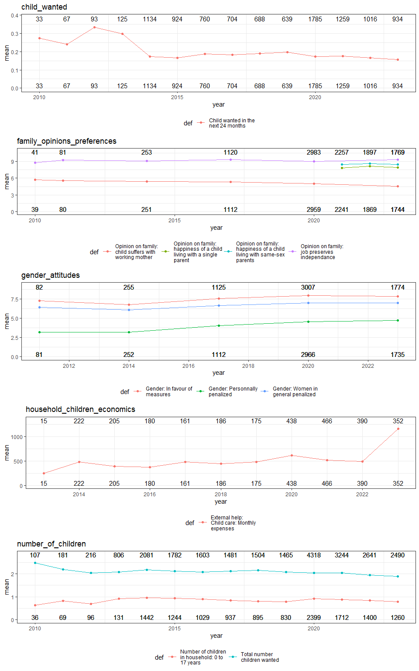
Figure XX: Responses from female participants aged 15-50.
p_df %>%
filter(year_start %in% c(2010:2015),sex=="woman",age_start %in% 15:50) %>%
dplyr::select(idhous,idpers,year,year_start,plingu,age,ctn_abbr,pp21) %>%
left_join(canton_df %>% dplyr::select(ctn_abbr=ctn,NUTS2_name),by="ctn_abbr") %>%
filter(!is.na(pp21),!is.na(ctn_abbr)) %>%
group_by(year,NUTS2_name) %>%
dplyr::summarise(mean = mean(pp21),
n_values = n()) %>% ungroup() %>%
dplyr::mutate(year = ymd(paste0(year,"-01-01"))) %>%
ggplot(aes(x = year, y = mean)) +
geom_point(aes(col = NUTS2_name)) + geom_line(aes(col = NUTS2_name)) +
geom_text(aes(y = mean, label = n_values),
vjust = 0, show.legend = FALSE) +
scale_y_continuous(name="Gender: Personnally penalized")+
expand_limits(y = 0)
`summarise()` has grouped output by 'year'. You can override using the
`.groups` argument.
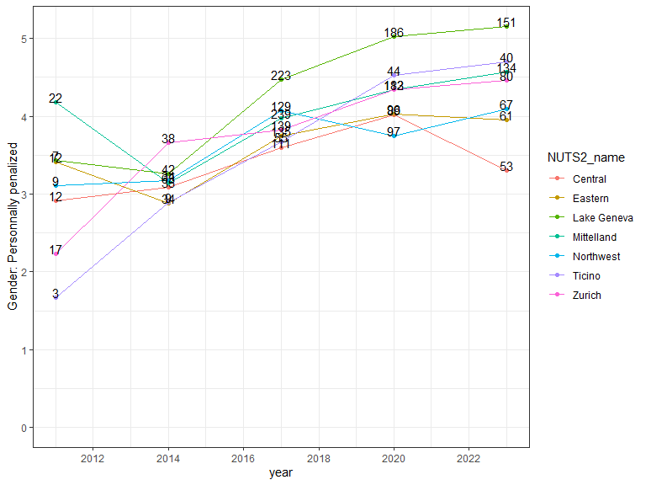
Figure XX: Variation over regions.

5. To do
- SHP data: explore
- Municipality level (by year): 25 * 2154: cluster/hotspot
- urbanisation level

6. Conclusion
- Persistent birth deficit in Switzerland after accounting for demographic shifts and delayed motherhood
- Stronger deficit in urban areas and among Swiss residents
- Monthly analysis suggests short-term pandemic effects
- Next steps: link heterogeneity to socio-economic and policy factors

