COVID-19 disrupted patterns of cause-specific mortality in Switzerland
Anthony Hauser* (1), Moritz Wagner (2), Anne Laube (2), Julien Riou (1)
Report generated on Date: 2025-04-23 Time: 15:02
- Department of Epidemiology and Health Systems, Unisanté, Center for Primary Care and Public Health and University of Lausanne, Lausanne, Switzerland;
- Federal Office of Public Health, Bern, Switzerland; (*) Corresponding author: anthony.hauser@unisante.ch
#Setup
wd = getwd()
code_root_path = paste0(strsplit(wd, split="/manuscript")[[1]][1],"/")
print(code_root_path)
## [1] "C:/TEMP/projects/causes-of-deaths/"
source(paste0(code_root_path,"R/000_setup.R"))
## Warning: le package 'pacman' a été compilé avec la version R 4.4.2
## Warning: le package 'cmdstanr' a été compilé avec la version R 4.4.2
## This is cmdstanr version 0.8.1
## - CmdStanR documentation and vignettes: mc-stan.org/cmdstanr
## - CmdStan path: C:/Users/an4818/.cmdstan/cmdstan-2.35.0
## - CmdStan version: 2.35.0
##
## A newer version of CmdStan is available. See ?install_cmdstan() to install it.
## To disable this check set option or environment variable cmdstanr_no_ver_check=TRUE.
## CmdStan path set to: C:/TEMP/.cmdstan/cmdstan-2.35.0
## ── Attaching core tidyverse packages ──────────────────────── tidyverse 2.0.0 ──
## ✔ forcats 1.0.0 ✔ tibble 3.2.1
## ✔ readr 2.1.5
## ── Conflicts ────────────────────────────────────────── tidyverse_conflicts() ──
## ✖ dplyr::between() masks data.table::between()
## ✖ dplyr::filter() masks stats::filter()
## ✖ dplyr::first() masks data.table::first()
## ✖ data.table::hour() masks lubridate::hour()
## ✖ data.table::isoweek() masks lubridate::isoweek()
## ✖ dplyr::lag() masks stats::lag()
## ✖ dplyr::last() masks data.table::last()
## ✖ data.table::mday() masks lubridate::mday()
## ✖ data.table::minute() masks lubridate::minute()
## ✖ data.table::month() masks lubridate::month()
## ✖ data.table::quarter() masks lubridate::quarter()
## ✖ data.table::second() masks lubridate::second()
## ✖ purrr::transpose() masks data.table::transpose()
## ✖ data.table::wday() masks lubridate::wday()
## ✖ data.table::week() masks lubridate::week()
## ✖ data.table::yday() masks lubridate::yday()
## ✖ data.table::year() masks lubridate::year()
## ℹ Use the conflicted package (<http://conflicted.r-lib.org/>) to force all conflicts to become errors
##
## Attachement du package : 'flextable'
##
##
## L'objet suivant est masqué depuis 'package:purrr':
##
## compose
##
##
##
## Attachement du package : 'readxl'
##
##
## L'objet suivant est masqué depuis 'package:officer':
##
## read_xlsx
##
##
##
## Attachement du package : 'scales'
##
##
## L'objet suivant est masqué depuis 'package:readr':
##
## col_factor
##
##
## L'objet suivant est masqué depuis 'package:purrr':
##
## discard
##
##
## Joining with `by = join_by(ctn)`
## [1] "C:/TEMP/projects/causes-of-deaths//R/001_data_cleaning.R"
## [2] "C:/TEMP/projects/causes-of-deaths//R/002_load_pop.R"
## [3] "C:/TEMP/projects/causes-of-deaths//R/003_get_pop_by_age_sex_year_ctn.R"
## [4] "C:/TEMP/projects/causes-of-deaths//R/010_tuning_parameter_cond_EQ.R"
## [5] "C:/TEMP/projects/causes-of-deaths//R/011_tuning_parameter_cond_periodic.R"
## [6] "C:/TEMP/projects/causes-of-deaths//R/020_aggregate_fit_deaths.R"
## [7] "C:/TEMP/projects/causes-of-deaths//R/021_aggregate_pand_deaths.R"
## [8] "C:/TEMP/projects/causes-of-deaths//R/030_run_stan_mod3_by_age_cause.R"
## [9] "C:/TEMP/projects/causes-of-deaths//R/101_get_icd10.R"
## [10] "C:/TEMP/projects/causes-of-deaths//R/102_combine_cod_icd10.R"
## [11] "C:/TEMP/projects/causes-of-deaths//R/103_aggregate_cod.R"
## [12] "C:/TEMP/projects/causes-of-deaths//R/104_load_attribute_pop.R"
## [13] "C:/TEMP/projects/causes-of-deaths//R/105_load_attribute_pop_ctn.R"
## [14] "C:/TEMP/projects/causes-of-deaths//R/130_run_stan_mod4_by_age_cod.R"
## [15] "C:/TEMP/projects/causes-of-deaths//R/131_run_stan_mod5_by_age_cod.R"
## [16] "C:/TEMP/projects/causes-of-deaths//R/132_run_stan_mod5_by_cod.R"
## [17] "C:/TEMP/projects/causes-of-deaths//R/133_run_stan_mod6_by_cod.R"
## [18] "C:/TEMP/projects/causes-of-deaths//R/134_run_stan_mod7_by_cod.R"
## [19] "C:/TEMP/projects/causes-of-deaths//R/135_run_stan_mod8_by_cod.R"
## [20] "C:/TEMP/projects/causes-of-deaths//R/140_aggregate_pand_stan.R"
## [21] "C:/TEMP/projects/causes-of-deaths//R/141_aggregate_fit_stan.R"
## [22] "C:/TEMP/projects/causes-of-deaths//R/142_aggregate_stan_mod6.R"
## [23] "C:/TEMP/projects/causes-of-deaths//R/150_load_results_mod4.R"
## [24] "C:/TEMP/projects/causes-of-deaths//R/151_load_results_mod6.R"
## [25] "C:/TEMP/projects/causes-of-deaths//R/generic_functions.R"
knitr::opts_chunk$set(echo = FALSE, warning =FALSE, message=FALSE)
wd_ofsp = "L:/UNISANTE_DESS/S_SUMAC/OFSP_2023/"
data_folder = paste0(wd_ofsp,"02_data/cause_of_death/")
## [1] "-------------------------"
## [1] "C:/TEMP/projects/causes-of-deaths/"
## [1] "C:/TEMP/projects/causes-of-deaths/savepoint/cod_ind_df.RDS"

1 Abstract
Introduction
Methods and Findings
Conclusion

2 Introduction

3 Methods

3.1 Data

3.2 Model

3.3 Outcome

3.4 Inference

4 Results

4.1 Before 2020

4.2 Excess all-cause

4.3 CV, cancer, dementia and infectious or respiratory diseases

5 Discussion
Summary
Comparison with other studies
Natural experiment: synchronicity between flu and CV/dementia
Potential explanations for the observed patterns: 3 types of disruption
Strengths, limitations, perspectives
Conclusion

6 Figures
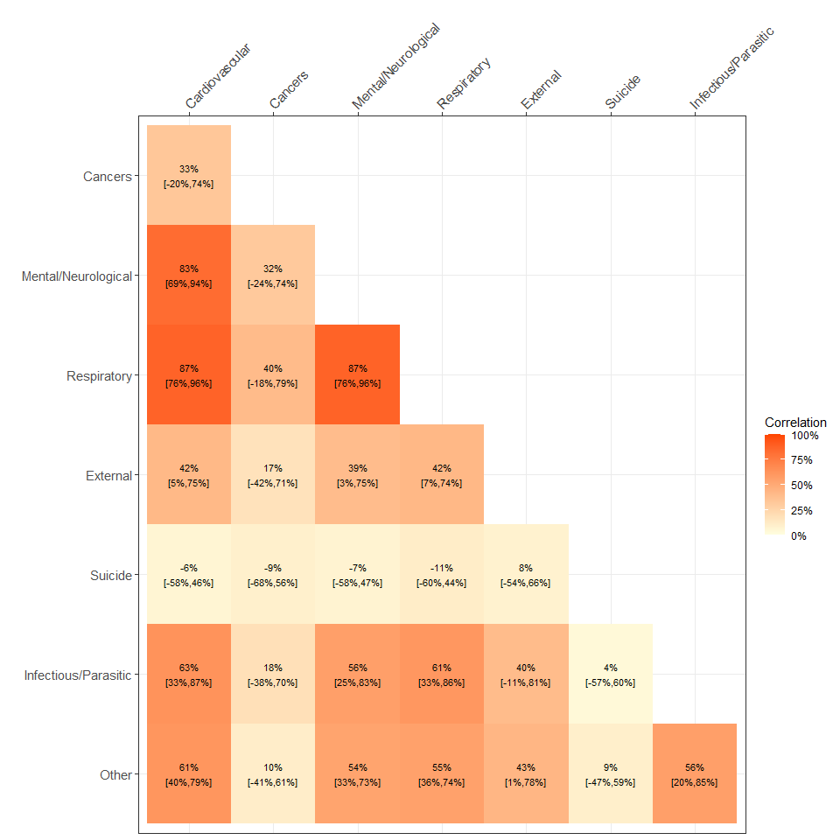
Figure 1. Social contact data and mobility data. (A) Number of participants by survey wave and by country. The opaque part corresponds to the newly enrolled participations (i.e., contributing for the first time), while the more transparent part corresponds to participants that have already taken part in the survey before. (B) Age distribution. The colored bars display the number of participants by age classes for the four countries. The grey bars in the backgrounds reflect the age distribution in the general population. (C) Distribution of the number of survey round participated. (D) Google work-related mobility data. The mobility levels during the weekdays (Monday-Friday) and weekends (Saturday-Sunday) are averaged weekly.
Figure 2. Survey fatigue and effect of mobility on contacts. (A) Survey fatigue on the probability of reporting no contact $θ$. The odds ratio (OR) of reporting zero contact is displayed according to the survey round and country (B) Survey fatigue on the contact rate $λ$. The relative number of contacts (relatively to the contact rate $λ$) is displayed according to the survey round and country. (C) Effect of mobility on the probability of reporting no contact and on the contact rate. The estimated effects are displayed for the four countries and with or without adjusting for long-term trend through Gaussian process (GP).
Figure 3. Model fits for the UK. (A) Probability of having contacts at work, as estimated by the survey model (red points with vertical lines) and as predicted by the mobility model (colored lines). We shows the predictions of three versions of the mobility model: 1) considering the full period (black), 2) adjusting for the long-term change of contact rate (blue) and 3) limiting to the period until February 2021 (green). For the probability of having contacts at work, we do not show the results of the full period without adjustment of the long-term change, as it is almost indistinguishable from the analysis when adjusting for it. The red points corresponds to the mean posterior estimates by survey wave, and the vertical line shows the related 95% credibility interval (95%CrI). The colored lines correspond to the (weekly) mean posterior estimates and the gray area corresponds to the 95%CrI. The exact definition of the posterior estimates is given in Supplementary S1.3.2. (B) Contact rate at work as estimated by the survey model (red) and as predicted by the mobility model (black). (C) Probability of having contacts at work as estimated by the survey model (red) and as predicted by the mobility model (black), according to mobility level. The different levels of darkness in the red estimates of the survey model depicts the different survey waves.
Figure 4. Baseline estimates. (A) Baseline proportion of individuals having work-related contacts as estimated by various prepandemic data and by the mobility model, stratified by age classes. The points corresponds to the mean estimate and the vertical bars to the 95%CrI. (B) Baseline conditional number of work-related contacts as estimated by various prepandemic data and by the mobility model, stratified by age classes.

7 Data sharing statement

8 Acknowledgements

9 References

