COVID-19 disrupted patterns of cause-specific mortality in Switzerland
Anthony Hauser* (1), Garyfallos Konstantinoudis (2), Julien Riou (1)
Report generated on Date: 2025-07-03 Time: 16:00
- Department of Epidemiology and Health Systems, Unisanté, Center for Primary Care and Public Health and University of Lausanne, Lausanne, Switzerland;
- MRC Centre for Environment and Health, Department of Epidemiology and Biostatistics, School of Public Health, Imperial College London, London, UK
(*) Corresponding author: anthony.hauser@unisante.ch

1 Abstract
The COVID-19 pandemic has disrupted mortality patterns far beyond deaths directly attributed to SARS-CoV-2 infection. To understand these disruptions, we analysed Swiss weekly deaths (2011-2021) aggregated by age, sex, region and nine ICD-10 groups. For each age group, we fitted a Bayesian multivariate Poisson model to 2011–2019 data, including seasonality, long-term trends, and a multivariate random effect capturing cross-cause dependence. We then compared these predictions with observed 2020–2021 counts to derive age- and cause-specific death excesses. Cardiovascular deaths spiked during the autumn 2020 wave, whereas none of the studied causes showed sustained excess over 2020-2021. In those ≥80 years, non-COVID respiratory (–25 %) and mental/neurological (–12 %) deaths decreased, largely offset by recorded COVID-19 deaths, leaving a modest +4.5 % all-cause excess. Cardiovascular and mental/neurological excesses correlated positively with excess mortality attributed to COVID-19 and other respiratory, echoing strong pre-pandemic cross-cause correlations ($ρ>0.80$). These findings suggest that mortality disruptions during the pandemic likely reflect three overlapping mechanisms: reduced circulation of non-COVID respiratory pathogens, misclassification of COVID-19 deaths (especially as cardiovascular), and mortality displacement; and indicate that the true respiratory burden remains underestimated.

2 Introduction
The COVID-19 pandemic has had a profound impact on mortality around the world. While much attention has focused on deaths directly attributed to SARS-CoV-2 infection, mortality burden during the pandemic extends well beyond these immediate effects, disrupting mortality patterns in many ways. Control measures considerably reduced deaths from respiratory diseases by limiting the circulation of seasonal viruses [1]. Changes in mobility and social behavior affected deaths from external causes, including accidents and suicides [2]. In some countries, healthcare disruptions delayed diagnoses and treatment—particularly for cancer—potentially increasing mortality from certain chronic illnesses [3]. SARS-CoV-2 infection itself may have contributed indirectly to other deaths, especially from cardiovascular causes, either through undiagnosed infection at the time of death or long-term complications following recovery [4]. Finally, mortality displacement—over time or across causes—likely influenced patterns among frail individuals, such as the very elderly or those with poor prognoses [5]. This broader impact is supported by studies showing that, after excluding COVID-19 deaths, mortality from other causes fell below expected levels—highlighting the indirect effects of the pandemic on mortality [6].
To monitor mortality during COVID-19 pandemic, several metrics have been used. COVID-19-related mortality provides an immediate but often incomplete picture, as it only considers direct deaths due to COVID-19, which is subject to underascertainment [6]. All-cause excess mortality, as the difference between observed deaths and the number that would have been expected in the absence of pandemic, is more robust, as it does not rely on cause-of-death classification capturing the total mortality impact. However, as it is a composite measure, it cannot assess whether apparent increases in some causes might be offset by decreases in others. A natural extension is to estimate cause-specific excess mortality, which allows for several advantages. First, it helps decompose the overall mortality impact into its underlying components, clarifying change in relative contributions over time. Second, when aggregated, cause-specific estimates can improve the accuracy of total excess mortality estimates [7]. However, most studies estimating cause-specific excess mortality analyse each cause independently and do not account for correlations across causes [4], [8]–[11]. This limits interpretability, as understanding these dependencies—both before and during the pandemic—is key to identifying the mechanisms driving disrupted mortality patterns.
In this study, we aim to fill this gap by estimating cause-specific excess mortality in Switzerland from 2011 to 2021, with a particular focus on cross-cause correlations. We use a Bayesian multivariate model that captures seasonal and long-term trends, accounts for population dynamics, and models correlation across causes through a shared random structure. By examining both the pre-pandemic synchrony in cause-specific mortality and its disruption during the pandemic, we aim to identify signals of misclassification, mortality displacement, and indirect effects of COVID-19. This approach, by highlighting the interdependence of mortality processes, offers new insight into the mechanisms by which the pandemic and its response have disrupted mortality patterns.

3 Methods

3.1 Data
We received individual-level data on cause-specific deaths for the years 2011–2021 from the Federal Statistical Office (FSO), which we aggregated by age group (0–17, 18–39, 40–64, 65–79, 80+), sex, NUTS-2 region, calendar week, and calendar year. The data include information recorded in the death certificate—such as the immediate, underlying, and contributing causes of death—as well as the official underlying cause of death, which is determined by the FSO based on the coding rules of the International Classification of Diseases, 10th Revision (ICD-10) [12]. All causes of death are coded using ICD-10 and were grouped into nine categories for analysis: cardiovascular diseases (Chapter IX), cancers (Chapter II), mental and neurological disorders (Chapters V and VI), respiratory diseases (Chapter X), External causes (Chapter XX), suicide (Chapter XX), infectious and parasitic diseases (Chapter I), other causes (Chapters III, IV, VII, VIII, XI–XIX, XXI, XXII), and COVID-19 (Chapter XXII). Population data by sex, NUTS-2 region, and age group for the years 2011–2021 were also provided by the Federal Statistical Office (FSO). We applied linear interpolation to obtain weekly population estimates.

3.2 Model
We modeled the weekly number of deaths by cause for each age group using a Poisson distribution with a multivariate structure under a Bayesian framework.
The model accounts for changes in population size $N$ over time via an offset term, and includes fixed effects $β$ and $γ$ for differences in mortality risk by region and sex, respectively.
Temporal variation is captured by two components: a seasonal trend modeled with a periodic Gaussian Process (GP) $f\left(t\right)$, and a long-term trend modeled using a GP with an exponentiated quadratic (squared exponential) kernel $g\left(t\right)$ [13].
To account for the correlation between mortality risks across causes, the model incorporates a multivariate random effect $ϵ∼N\left(0,Σ\right)$, where $Σ$ is the covariance matrix.
The model is specified as follows:
$$y_{irs}\left(t\right)∼\text{Poisson}\left(μ_{irs}\left(t\right)\right)$$
with
$$logμ_{irs}\left(t\right)=α_{i}+β_{ir}+γ_{is}+f\left(t\right)+g\left(t\right)+ϵ_{i}+logN_{irst},$$
where $y_{irs}\left(t\right)$ denotes the observed number of deaths due to cause $i$ in week $t$, region $r$, and sex $s$, and $α_{i}$ is the baseline log-transformed mortality risk.
The model was run independently for each age group and fitted to the weekly number of cause-specific deaths $y_{irs}\left(t\right)$ observed between 2011 and 2019. It was then used to estimate the weekly expected number of deaths ${\tilde{y}}_{irs}\left(t\right)$ through the end of 2021, defined as the posterior predictive distribution after removing the random effect $ϵ$ from the log mortality risk $μ_{irs}\left(t\right)$.
We excluded $ϵ$ because it is designed to capture excess mortality—that is, unexplained or anomalous variation beyond structured trends.
Excess mortality $E_{irs}\left(t\right)$ was then defined as the difference between observed and expected deaths:
$$E_{irs}\left(t\right):=y_{irs}\left(t\right)-{\tilde{y}}_{irs}\left(t\right).$$
We also reported aggregated estimates of excess mortality, such as all-cause excess mortality (aggregated over causes of death) or aggregated over time period.

3.3 Further analysis
We examined how excess deaths from specific causes were related over time to excess deaths from COVID-19 during 2020–21. To do this, we computed partial correlations between posterior samples of cause-specific excess deaths and COVID-19 deaths, while controlling for excess deaths from other respiratory diseases. This adjustment aimed to separate the association with COVID-19 from that with other circulating respiratory pathogens. We also explored the effect of time lags, by shifting the time series of cause-specific excess deaths up to 8 weeks forward and backward, to assess whether the strength of association varied depending on timing. We performed the same analysis to assess the relationship between cause-specific excess deaths and excess deaths due to (non-COVID) respiratory diseases, this time adjusting for COVID-19 mortality.
We performed all the analyses in R version 4.4.1 and Stan version 2.35.0 [14]. All code is available from https://github.com/anthonyhauser/causes-of-deaths.

4 Results

4.1 Distribution of deaths
In Switzerland, deaths are heavily concentrated among older adults: 88% occurred in individuals aged 65 and over, while fewer than 2% were among those under 40 in 2020-21 (Fig 1A). Cardiovascular diseases were the leading cause of death overall, followed by cancers and mental or neurological disorders, though the distribution varied by age group (Fig 1B). Among individuals aged 80 and above, cardiovascular disease accounted for 33% of all deaths. In contrast, for those aged 40–79, cancer was the predominant cause, responsible for approximately 40% of deaths. The relative impact of COVID-19 was greatest in older age groups, contributing to 9% of deaths among those aged 65–79 and 12% among those aged 80 and over.

4.2 Prepandemic mortality trends
The model successfully captures both the seasonal and long-term trends in cause-specific mortality observed between 2011 and 2019 (Fig 2A for individuals aged 80+, and Fig S1–S4 for other age groups). We observe notable similarities in mortality trends across different causes, both in the expected seasonal patterns and in intermittent episodes of excess mortality that often occur synchronously (e.g., during the winters of 2014/15 and 2016/17). For the 80+ age group, Fig 2C highlights this synchrony in timing, showing that the expected mean mortality peak (in black) occurs consistently across causes between January and February. During the pre-pandemic period (2011–2019), observed peak timings (colored circles) align closely with these expectations. However, during the pandemic years, we observe a marked shift: mortality peaks occur earlier than expected (colored squares). In addition, the model reveals strong positive correlations in cause-specific excess mortality, mostly among individuals aged 80 and over (Fig 2B. Specifically, excess deaths from respiratory diseases, mental or neurological disorders, and cardiovascular diseases are highly correlated, with pairwise correlations exceeding 80%.

4.3 COVID-19 mortality
The model also captures all-cause mortality, obtained by aggregating deaths across causes. Among individuals aged 65 and over, the impact of the first two COVID-19 waves—spring 2020 and fall/winter 2020–21—clearly exceeded any episodes of excess mortality observed between 2011 and 2019 (Fig 3A). Cumulative excess mortality highlights the substantial increase in deaths during these waves, followed by a gradual mortality deficit in the subsequent weeks (Fig 3B). When excluding deaths attributed to COVID-19, we also observe that mortality from other causes was lower than expected in 2020–21 for people aged 65 and over.

4.4 Cause-specific excess mortality over time
Among individuals aged below 64, almost all cause-specific mortalities remained within expected levels, suggesting no evidence of excess mortality during 2020–21 (Fig 3A&B and Fig S5-S8). A slight excess in suicides was observed among 0-17 (16 [2-28], +54%), but the small number of observed deaths (43) limits interpretation (Fig S5). In contrast, among individuals aged 65–79, a deficit in deaths due to cancers and mental or neurological disorders was observed in 2020–21, with approximately 5% fewer deaths than expected (Fig 3C). The largest decrease occurred during the Alpha wave in January–February 2021. Mortality due to cardiovascular diseases in this group remained within the expected range, although a localized excess was noted during the autumn 2020 wave (+14%).
Similar patterns were seen in the 80+ age group (Fig 3D). A marked decrease in mortality from mental and neurological disorders was observed in 2020–21 (−12%), with levels below expectation in all phases except the autumn 2020 wave, when a slight increase occurred. The most pronounced decrease was during the Alpha wave (−24%). For cancer, the mortality deficit was also concentrated almost entirely during the Alpha wave. Cumulative mortality due to cardiovascular diseases among the 80+ was within expected levels overall, but showed substantial variation across phases. Excess mortality was concentrated during COVID-19 waves, while mortality deficits were more common at the beginning of both 2020 and 2021. Finally, we observed a consistent deficit in deaths due to respiratory diseases (excluding COVID-19) across all age groups, with the magnitude of the deficit increasing with age. Fig S5-S9 display phase- and cause-specific excess mortality estimates for all causes and for each of the five age groups.
To better understand the apparent decrease in cancer-related mortality, we examined deaths among individuals with a cancer diagnosis, stratified by cancer types grouped according to baseline survival. Unlike previous analyses based on the underlying cause of death, this also included individuals with cancer who died from other causes. Unlike the number of deaths due to cancer (pink), the number of individuals dying with cancer did not decline during the pandemic and even increased among those aged 80 and over (Fig S10A). We notice that the decrease in deaths due to cancer was concentrated among cancers with low baseline survival (Fig S10B). Conversely, among individuals with cancer dying from another cause, the largest excess was observed in those with high-survival cancer type (Fig S10C).

4.5 Correlation with respiratory diseases in 2020-21
We examined the temporal correlation between excess mortality from specific causes and excess mortality due to either COVID-19 or other respiratory diseases during 2020–21. For cardiovascular and mental/neurological diseases, we observed positive partial correlations with COVID-19 mortality, reaching nearly 50% among individuals aged 80 and over (Fig 5 and Fig S11). Similar correlations were also found with other respiratory diseases, reflecting the high correlations inferred by the model for the prepandemic period 2011-2019. The strongest correlations with COVID-19 were seen at lags of 1 to 3 weeks, meaning that COVID-19-related excess deaths happened around the same time as, but slightly after, those from cardiovascular or mental/neurological causes. In contrast, we observed slightly negative correlations between cancer and COVID-19 mortality, particularly among those aged 65–79.

5 Discussion

5.1 Summary
We modelled cause-specific mortality trends in Switzerland from 2011 to 2019 to assess excess mortality during the COVID-19 pandemic in 2020–2021. Compared with the prepandemic baseline, we identified several disruptions in mortality patterns. Cardiovascular deaths rose temporarily during COVID-19 waves, especially among people aged 65 years and older. By contrast, respiratory-disease mortality declined consistently throughout the pandemic. Among older adults, deaths attributed to mental/neurological diseases and to cancer fell below expectation, but mainly in 2021. These deficits were offset by COVID-19 deaths, resulting in persistent all-cause excess mortality. These shifts likely reflect a combination of mechanisms, including mortality displacement, competing risks, and reduced circulation of other pathogens due to public-health measures.

5.2 Potential explanations for the observed patterns: 4 types of disruption
Four broad disruptions could explain the observed patterns. First, under-ascertainment of COVID-19 deaths inflated the counts attributed to other causes. Modelling work by Riou et al. suggests that only 72% of COVID-19 deaths were certified as such in Switzerland during 2020-21, with even lower proportions in epidemic peaks [6]. Because infection with SARS-CoV-2 can trigger cardiovascular complications, through inflammation, thrombosis, and direct cardiac injury, misclassified COVID-19 deaths likely contributed to the cardiovascular excesses seen in autumn 2020 and autumn 2021.
Second, sequelae of SARS-CoV-2 infection may increase cause-specific mortality. Cohort studies have documented a higher individual risk of delayed complications—particularly cardiovascular events—months after infection [15], [16]. Population-level analyses show that these late effects contributed to sustained excess cardiovascular mortality in 2021 in countries such as the United States [4] and the United Kingdom [17]. Such effects are difficult to detect in the comparatively healthy Swiss population and may overlap with other disruptions—such as misclassified COVID-19 deaths or mortality displacement—complicating interpretation.
The clearest signal appears in mental and neurological disorders: among people aged 65 and over, deaths remained below baseline for several weeks after the autumn 2020 and winter 2020-21 COVID-19 waves. Nordic countries show a similar “harvesting” pattern: some individuals with dementia died during COVID-19 waves rather than later, leaving fewer dementia deaths afterward [11]. While displacement can persist for months in disorders that decline slowly, such as dementia, its impact may appear almost immediately when remaining life expectancy is short—for example, in certain advanced cancers. We showed that the apparent fall in cancer deaths at the end of 2020 was offset by an increase in cancer patients dying from other causes, mainly COVID-19. The decline was concentrated in cancers with low baseline survival, where strong competing risk with COVID-19 intensifies displacement from cancer to COVID-19, a mechanism also reproduced theoretically through simulation-based modelling work [18]. This mechanism also explains the negative temporal correlation between cancer excess mortality and COVID-19 deaths, a pattern likewise observed across US states [19].
Finally, pandemic response—both mandated restrictions and voluntary (or unintentional) behavioral changes— affected mortality in various ways. Non-pharmaceutical interventions (NPIs) have reduced the circulation of common respiratory pathogens such as influenza, leading to a marked decrease in mortality caused by respiratory diseases in January-February 2021, a period that normally sees peak winter infections. Because respiratory infections can precipitate deaths from other conditions, their absence likely reduced mortality from causes that depend on them, especially in adults aged 80 and over; this mechanism may account for the mental- and neurological-disease deficits observed in early 2021 among the 65–79 and 80 + age groups. On the other hand, the implementation of NPIs has been also used to explain the slight decrease in mortality due to cancer during COVID-19, e.g., observed in the UK [3], by delaying diagnosis. However, this effect is unlikely in Switzerland, where oncology care stayed accessible and control measures remained moderate [20].

5.3 Cross-cause correlation
Our multivariate model reveals two layers of pre-2020 cause-specific mortality correlation: first, most causes share a winter peak across age groups; second, even after removing this seasonal component, excess deaths from respiratory, cardiovascular, and mental-neurological diseases remain tightly coupled. The correlation is highest in winters with the largest influenza epidemics, implying that a substantial share of the apparent cardiovascular excess is actually infection-related (either biologically triggered events or misclassified deaths) [21], [22]. While extreme weather or pollution could still contribute, previous studies have suggested that they only explain a minor fraction of the observed excess mortality. Evidence from 2020-21 reinforces this assumption, as excess cardiovascular and mental/neurological deaths correlate with both COVID-19 and non-COVID respiratory excesses during a period when mortality patterns were disrupted. In this context, the COVID-19 disruption served as a natural experiment, as COVID-19 wave occurred at unusual periods for a respiratory disease and flu waves were almost non-existent in winter 2020-21. While the exact mechanisms need to be investigated in more depth, this strongly suggests that the contribution of respiratory pathogens on overall mortality remained underestimated.

5.4 Strengths, limitations and perspectives
The study has several strengths. We exploited the COVID-19 disruption, which temporarily decoupled normally synchronized causes of death, to probe how they are linked. We built a multi-dimensional Bayesian model that captures population change, long-term trends, seasonal patterns, and cross-cause correlation. Gaussian processes give this model more flexibility than generalized linear models with splines or seasonal ARIMA, resulting in sharper estimates and more realistic uncertainty [4], [8]–[11], [23]. Other approaches that have formally modeled cross-cause correlation, used tensors or multi-cause Gaussian processes, but their complexity often prevents a clear understanding of how cause-specific mortalities are related [7], [24]. Our Bayesian framework explicitly propagates uncertainty, a critical feature when excess-mortality estimates depend on counterfactual predictions. The analysis also benefits from Switzerland’s high-quality death-certificate data, which follow consistent coding guidelines and achieve near-complete coverage. Weekly aggregation preserves temporal granularity and allows us to detect fine-scale synchrony between causes.
The study also has limitations. First, most analyses rely solely on the underlying cause of death, limiting our ability to capture mechanisms such as mortality displacement. Still, the cancer example illustrates how multiple-cause-of-death data can account for an apparent drop in mortality. Systematic use of such data would support two complementary approaches: frailty-survival models to capture temporal displacement by account for unobserved heterogeneity, and competing-risk models to capture displacement across causes by redistributing deaths among alternatives [5], [25]. Misclassification, however, may persist even with richer cause-of-death information. Second, excess-mortality estimates carry unavoidable uncertainty because they are compared to an unobserved counterfactual baseline. Third, some model assumptions—static effects across sex, region, and broad age bands—may oversimplify reality. Fourth, reliance on aggregated data raises the risk of ecological bias: correlations seen at the population level—for example between COVID-19 and cardiovascular mortality—do not imply causation for individual cases. Finally, the dataset ends in 2021, limiting our ability to assess the long-term effects of COVID-19 on cause-specific mortality.
In the future, cause-specific mortality data could serve different purposes. First, it shows how disruption in one cause—such as a respiratory epidemic—can cascade into shifts in other mortality patterns, revealing hidden dependencies. Second, incorporating these dependencies to predict all-cause mortality might improve accuracy [7]. Third, such data could be used to explain the divergences in excess mortality patterns observed between countries during the COVID-19 pandemic. More immediately, several extensions are feasible. We could apply the same framework to other countries to test whether the correlation patterns we observed in Switzerland are generalisable. Further, stratifying the analysis by socio-economic status would allow us to characterize the mortality burden across different levels of vulnerability. Finally, extending the series through 2023 and 2024 will clarify whether the different effects responsible for the disruption of mortality persist after 2021.

6 Figures
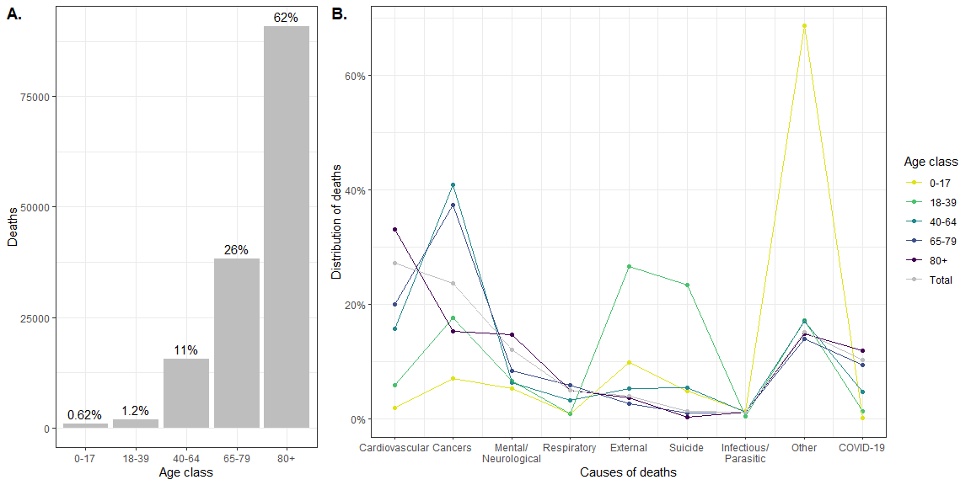
Figure 1. Cause-of-death data in 2020-21. A. Number of deaths by age groups in 2020-21. B. Distribution of the deaths occured in 2020-21 over the nine groups of causes of deaths for each age group.
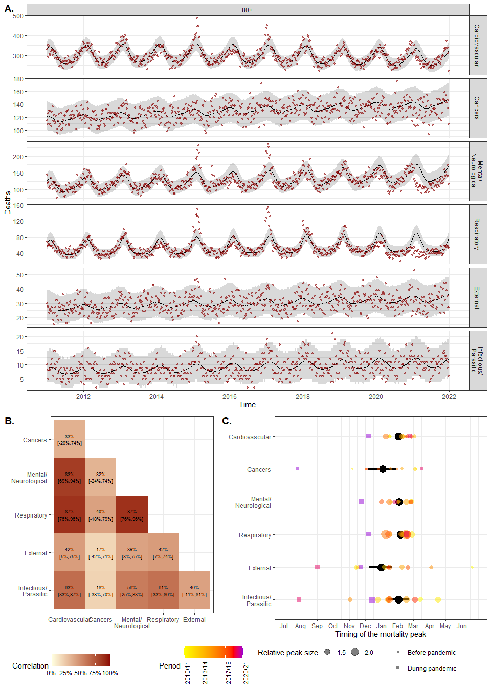
Figure 2. Model fit and cross-cause dependencies for the 80+ age group. A. Model fit. Number of weekly deaths observed in 2011-21 (red points) and model estimates (before 2020) and predictions (2020-21) (black line) with 95% credibility intervals (95% CrI, gray area), for the six main causes of deaths for the 80+ age group. B. Cross-cause correlation matrix of the excess mortality for 80+ age group. C. Timing of the mortality peak. The color points and squares correspond to observed peak for each winter (we considered the period from July to June of the next year as peak usually occured during winter). The black points and lines represent the posterior estimate of the peak with 95% CrI.
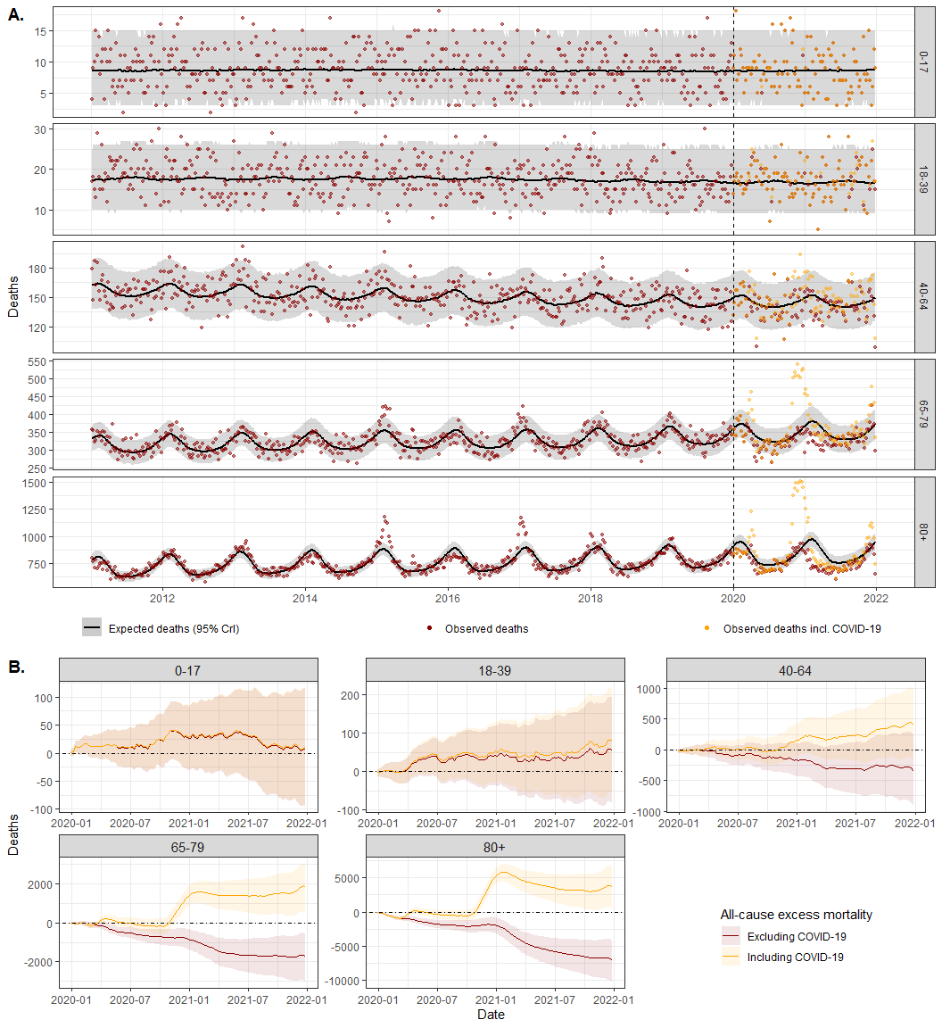
Figure 3. All-cause mortality. A. Number of weekly all-cause deaths (i.e., aggregated over all causes of deaths) for each age group. The red points correspond to the observed mortality without COVID-19 and the yellow ones with COVID-19. Black lines and shaded areas correspond to the model posterior mean (i.e., expected mortality) with 95% CrI. B. Cumulative number of excess deaths with (in yellow) or without (in red) COVID-19 deaths, for each age group.
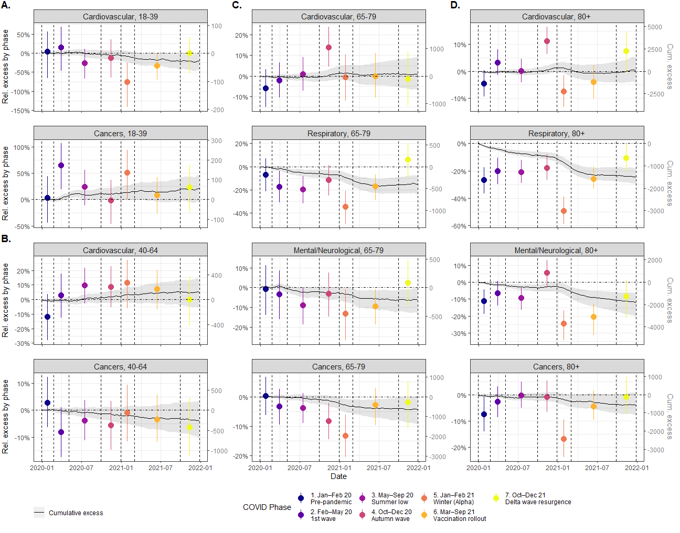
Figure 4. Cause-specific excess mortality by phase. Black lines and gray area correspond to posterior mean and 95% CrI of the cumulative (relative and absolute) excess mortality over 2020-21, respectively. The colored points and vertical lines correspond to posterior mean and 95% CrI of the relative excess mortality by phase, respectively. The phases are delimited by the dashed vertical lines. Panels A to D represents the different age groups. See Fig S5-S9 for the excess mortality by phase for each cause and each age group.
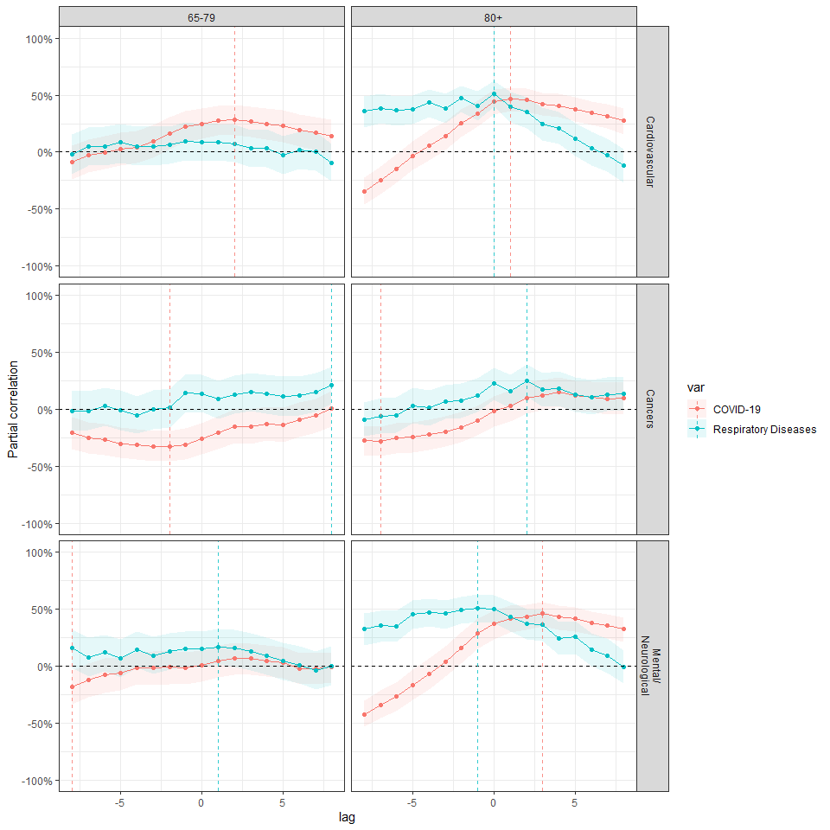
Figure 5. Partial correlation between excess mortality due to either COVID-19 (red) or to other respiratory diseases (blue, tagged as “Respiratory Diseases”) and excess mortality due to cardiovascular diseases, cancers or mental/neurological diseases, for 65-79 and 80+ age groups, considering different lags (in weeks). Solid color lines correspond to the posterior mean and shaded colored area to the 95% CrI. A positive lag corresponds to the situation where either excess mortality due to respiratory diseases (either COVID-19 or other respiratory diseases) occurs slightly after excess mortality due to considered cause.

7 Data sharing statement

8 Acknowledgements

References
[1] S. J. Olsen et al., “Decreased influenza activity during the COVID-19 pandemic—United States, Australia, Chile, and South Africa, 2020,” American Journal of Transplantation, vol. 20, no. 12, pp. 3681–3685, Dec. 2020, doi: 10.1111/ajt.16381.
[2] T. Lantos and T. A. Nyári, “The impact of the first year of COVID-19 pandemic on suicides in a collection of 27 EU-related countries,” Scientific Reports, vol. 14, no. 1, p. 17671, Jul. 2024, doi: 10.1038/s41598-024-68604-3.
[3] C. Maringe et al., “The impact of the COVID-19 pandemic on cancer deaths due to delays in diagnosis in England, UK: A national, population-based, modelling study,” The Lancet. Oncology, vol. 21, no. 8, pp. 1023–1034, Aug. 2020, doi: 10.1016/S1470-2045(20)30388-0.
[4] L. Han et al., “Excess cardiovascular mortality across multiple COVID-19 waves in the United States from March 2020 to March 2022,” Nature Cardiovascular Research, vol. 2, no. 3, pp. 322–333, Mar. 2023, doi: 10.1038/s44161-023-00220-2.
[5] R. J. Holleyman et al., “Adjusting expected deaths for mortality displacement during the COVID-19 pandemic: A model based counterfactual approach at the level of individuals,” BMC medical research methodology, vol. 23, no. 1, p. 241, Oct. 2023, doi: 10.1186/s12874-023-01984-8.
[6] J. Riou, A. Hauser, A. Fesser, C. L. Althaus, M. Egger, and G. Konstantinoudis, “Direct and indirect effects of the COVID-19 pandemic on mortality in Switzerland,” Nature Communications, vol. 14, p. 90, Jan. 2023, doi: 10.1038/s41467-022-35770-9.
[7] N. Huynh and M. Ludkovski, “Joint models for cause-of-death mortality in multiple populations,” Annals of Actuarial Science, vol. 18, no. 1, pp. 51–77, Mar. 2024, doi: 10.1017/S1748499523000118.
[8] M. Pizzato, C. Santucci, N. Islam, C. La Vecchia, and G. Alicandro, “Relationship between COVID-19 cases and monthly mortality from all causes, cancer, cardiovascular diseases and diabetes in 16 countries, 2020–21,” International Journal of Epidemiology, vol. 54, no. 1, p. dyaf006, Feb. 2025, doi: 10.1093/ije/dyaf006.
[9] E. Paglino, “Cause-Specific Excess Mortality During the COVID-19 Pandemic,” 2024.
[10] V. V. Beeks et al., “Cause-Specific Excess Mortality During the COVID-19 Pandemic (2020–2021) in 12 Countries of the C-MOR Consortium,” Journal of Epidemiology and Global Health, vol. 14, no. 2, pp. 337–348, Jun. 2024, doi: 10.1007/s44197-024-00242-4.
[11] A. Nilsson et al., “Cause-specific excess mortality in Denmark, Finland, Norway, and Sweden during the COVID-19 pandemic 2020–2022: A study using nationwide population data,” European Journal of Epidemiology, vol. 39, no. 9, pp. 1037–1050, 2024, doi: 10.1007/s10654-024-01154-0.
[12] World Health Organization, “Classification statistique internationale des maladies et des problèmes de santé connexes,” International statistical classification of diseases and related health problems, p. 3, 2009, Accessed: Dec. 19, 2024. [Online]. Available: https://iris.who.int/handle/10665/44082
[13] G. Riutort-Mayol, P.-C. Bürkner, M. R. Andersen, A. Solin, and A. Vehtari, “Practical Hilbert space approximate Bayesian Gaussian processes for probabilistic programming.” arXiv, Mar. 2022. doi: 10.48550/arXiv.2004.11408.
[14] B. Carpenter et al., “Stan: A Probabilistic Programming Language,” Journal of Statistical Software, vol. 76, pp. 1–32, Jan. 2017, doi: 10.18637/jss.v076.i01.
[15] M. Cai, Y. Xie, E. J. Topol, and Z. Al-Aly, “Three-year outcomes of post-acute sequelae of COVID-19,” Nature Medicine, vol. 30, no. 6, pp. 1564–1573, Jun. 2024, doi: 10.1038/s41591-024-02987-8.
[16] Y. Xie, E. Xu, B. Bowe, and Z. Al-Aly, “Long-term cardiovascular outcomes of COVID-19,” Nature Medicine, vol. 28, no. 3, pp. 583–590, 2022, doi: 10.1038/s41591-022-01689-3.
[17] {British Heart Foundation}, “Excess deaths involving CVD in England since the onset of the Covid-19 pandemic: An analysis and explainer.”
[18] C. L. Hansen, C. Viboud, and L. Simonsen, “Disentangling the relationship between cancer mortality and COVID-19 in the US,” eLife, vol. 13, Jul. 2024, doi: 10.7554/eLife.93758.2.
[19] A. N. Luck, A. C. Stokes, K. Hempstead, E. Paglino, and S. H. Preston, “Associations between mortality from COVID-19 and other causes: A state-level analysis,” PLOS ONE, vol. 18, no. 3, p. e0281683, Mar. 2023, doi: 10.1371/journal.pone.0281683.
[20] L. Brunner et al., “Comparative inpatient care of cancer vs. Non-cancer patients in Switzerland during the national COVID-19 lockdown: A nationwide interrupted time series analysis,” BMC Cancer, vol. 25, no. 1, p. 477, Mar. 2025, doi: 10.1186/s12885-025-13818-5.
[21] A. Fares, “Winter Cardiovascular Diseases Phenomenon,” North American Journal of Medical Sciences, vol. 5, no. 4, pp. 266–279, Apr. 2013, doi: 10.4103/1947-2714.110430.
[22] C. Warren-Gash, L. Smeeth, and A. C. Hayward, “Influenza as a trigger for acute myocardial infarction or death from cardiovascular disease: A systematic review,” The Lancet Infectious Diseases, vol. 9, no. 10, pp. 601–610, Oct. 2009, doi: 10.1016/S1473-3099(09)70233-6.
[23] S. Achilleos et al., “Excess all-cause mortality and COVID-19-related mortality: A temporal analysis in 22 countries, from January until August 2020,” International Journal of Epidemiology, vol. 51, no. 1, pp. 35–53, Feb. 2022, doi: 10.1093/ije/dyab123.
[24] H. Zhang et al., “Age-Related Risk Factors and Complications of Patients With COVID-19: A Population-Based Retrospective Study,” Frontiers in Medicine, vol. 8, p. 757459, Jan. 2022, doi: 10.3389/fmed.2021.757459.
[25] A. Carollo, H. Putter, P. H. C. Eilers, and J. Gampe, “Competing risks models with two time scales,” arXiv.org. Aug. 2024. Accessed: Jun. 19, 2025. [Online]. Available: https://arxiv.org/abs/2408.15058v1

