

## Ho Chi Minh University of Technology Faculty of Computer Science and Engineering

**SOFTWARE ENGINEERING**

**Project report #**

**Sequence Diagram, Activity Diagram, State Diagram**

**Student’s Name**: Nguyen Phuc Hung

**Student’s ID**: 1752259

**Project**: Smart Parking

# List of content

1. Sequence diagram
2. Activity diagram
3. State diagram
4. **Sequence diagram**

The diagram shows use case “View user’s profile”

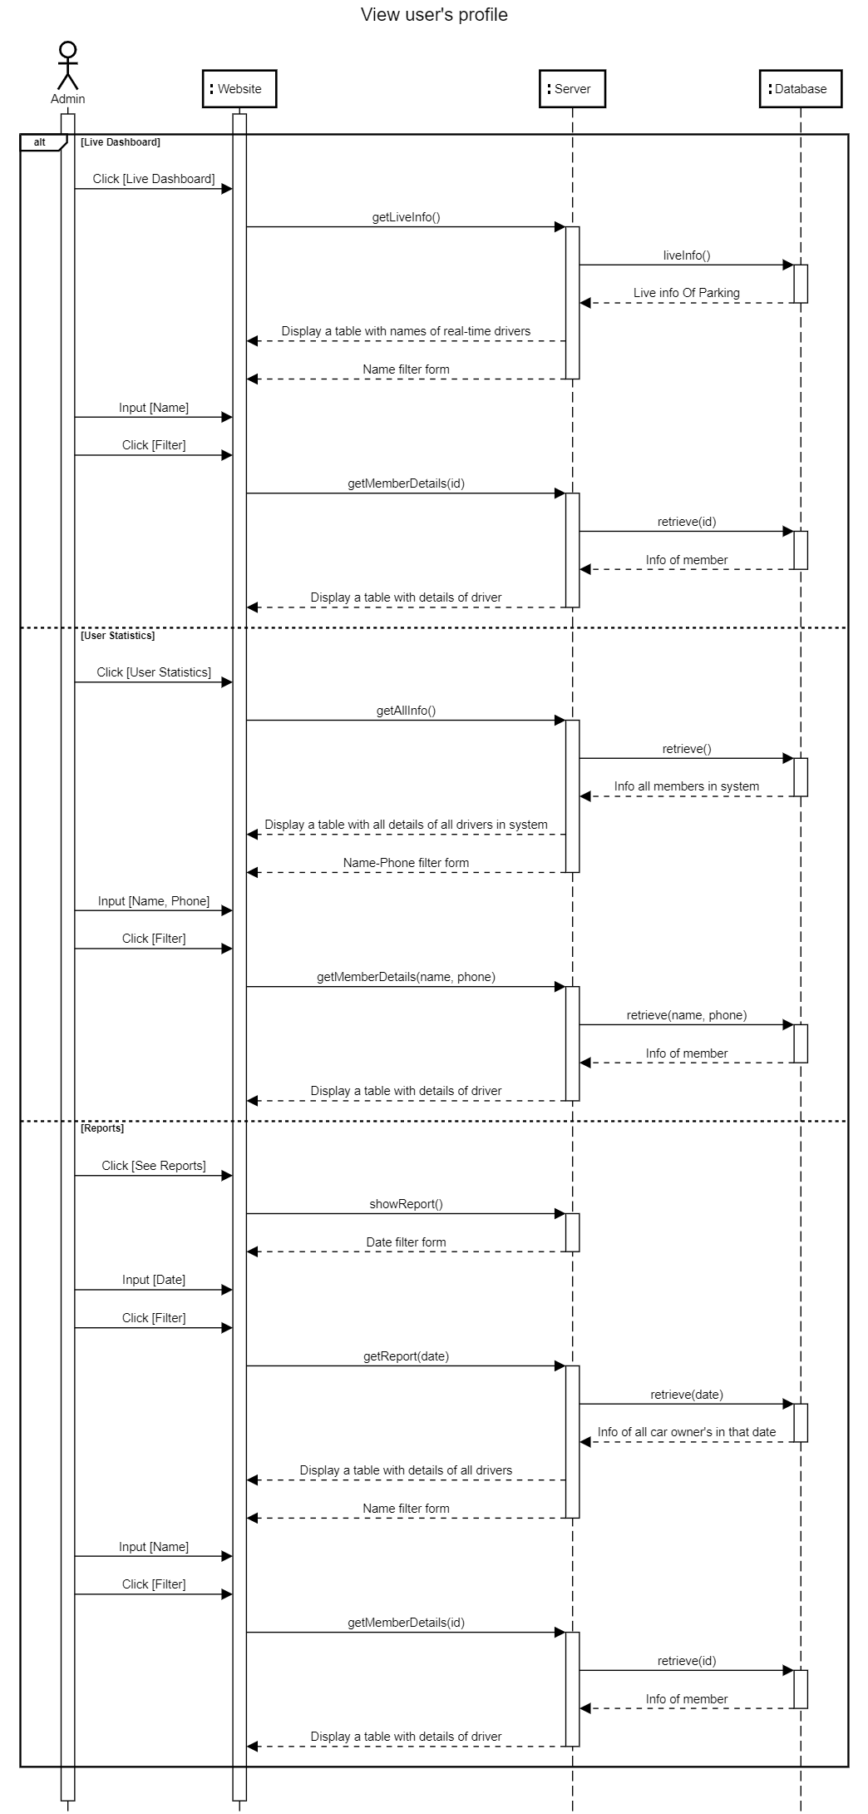

1. **Activity diagram**

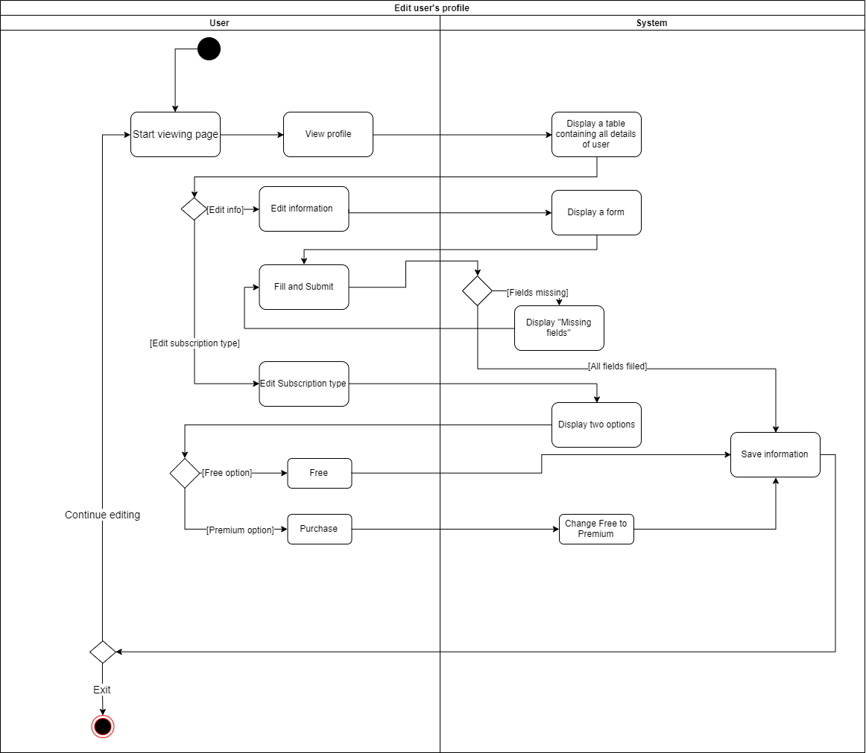The diagram shows the task of editing the user’s profile of user

1. **State diagram**

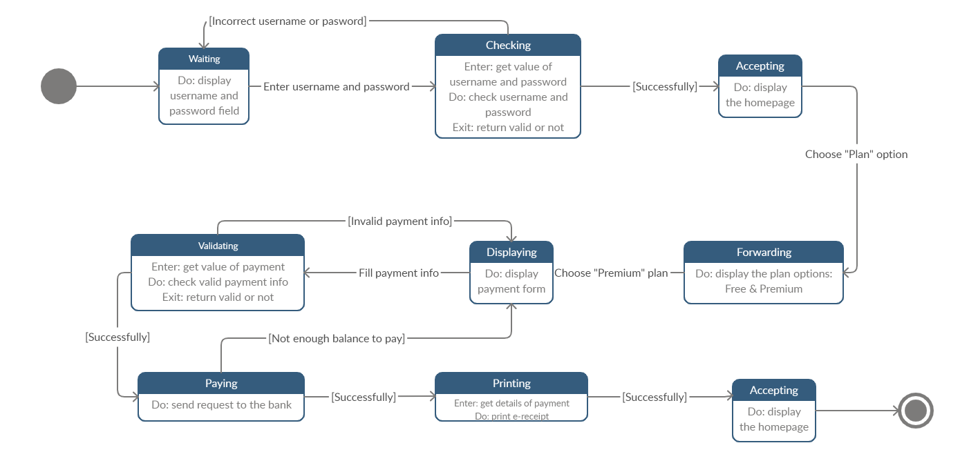State diagram for online payment system.