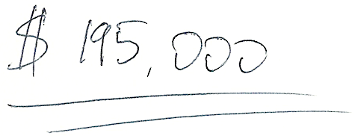Your Name

Your Phone Number

Your Email Address

April 1, 2018

Hi Mike,

My name is Anton and I’m a real estate investor from San Diego, CA. I recently visited Kansas City and absolutely fell in love with the area. I bought 3 properties on Pinkston Ave in Grandview last year and I’d like to buy more properties in the same neighborhood ASAP.

I know this is a little out of the blue, but I wanted to see if you’re interested in selling your property at 123 Willow Ave. This isn’t a random mass mailing – I’m only interested in buying similar properties next to the ones I already own.

You probably know that local home prices have gone up considerably in the last few years. Several properties just like yours appraised and sold for $180k - $185k this year, but I’m offering you **$195,000** for your building.

In addition, I want to make the process as fast and hassle-free for you as possible:

* **No Agents** – I want to do the purchase without a buyer’s or seller’s agent, and save you over $10,000 in commission fees. I have a great escrow company that can handle all of the required paperwork.
* **As-Is Condition** – I’ll buy your property in the exact condition it is, with no maintenance contingencies and no questions asked.

I’m ready to buy TODAY, so please call me at Your Phone Number or email at Your Email Address as soon as possible to discuss this.

I’m looking forward to hearing from you!

Sincerely,

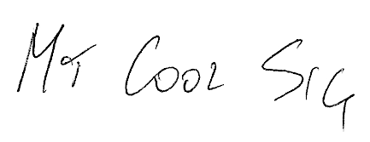

Anton Ivanov

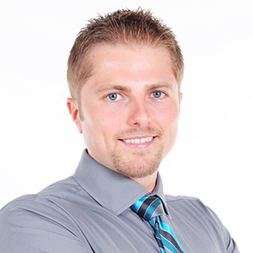

**Created by Anton Ivanov**

Anton is a real estate investor and entrepreneur with a 35 unit rental portfolio spread out across 4 states. He is the founder of [DealCheck](https://dealcheck.io/) - the leading real estate analysis platform used by 50,000+ investors and agents to quickly analyze and compare investment properties.

[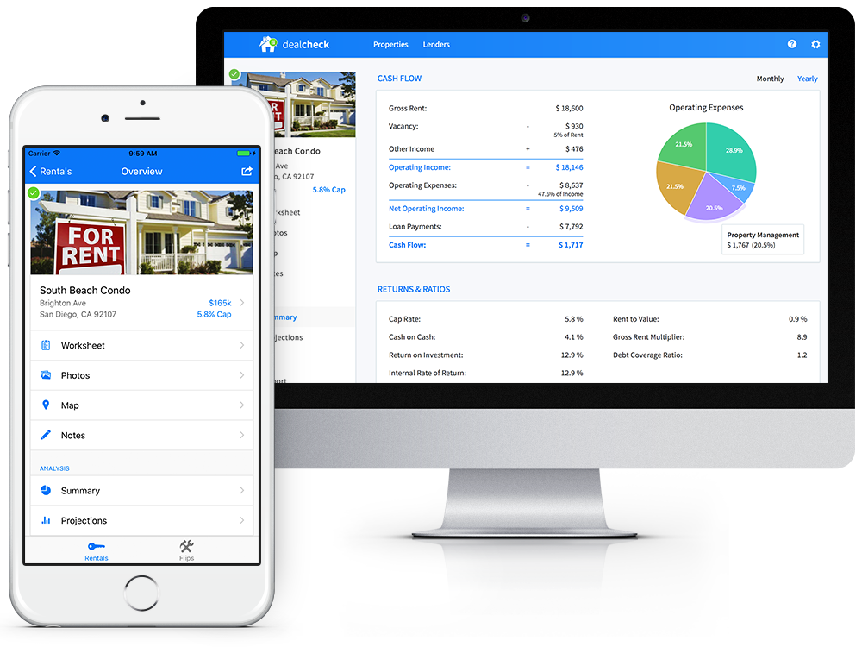](https://dealcheck.io/)