Assignment 3 by Garcia Anthony John Abril (4321819)

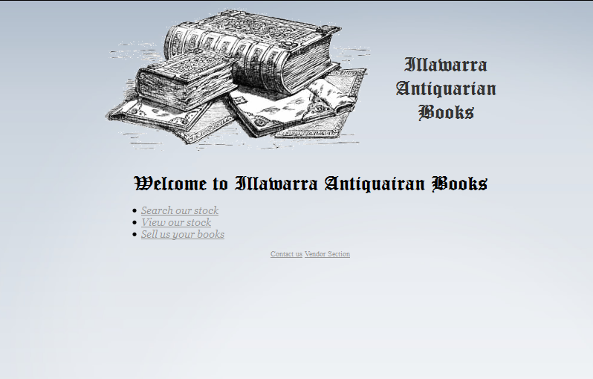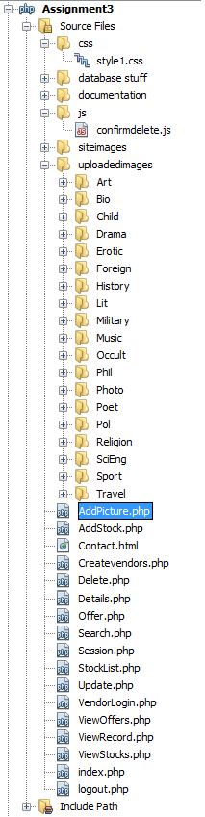Left side: The file and folder structure for assignment 3.

Top: The main page of the site (index.php)

* Search stocks allows guests to search stock by genre
* View stocks allows guests to view all stock available
* Sell books allows for guests to send in offers for thei rare books
* Contact us if for contacting the web admin
* Vendor section is for vendors to access more options for their stocks.

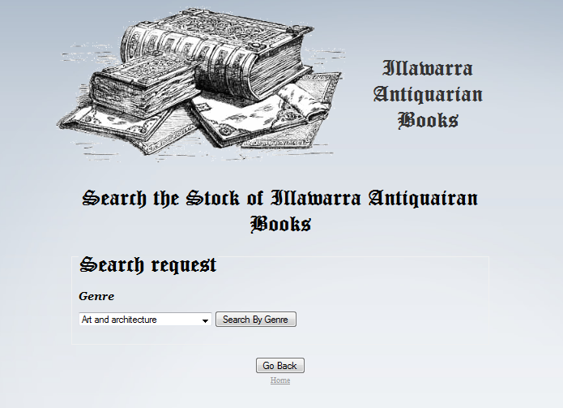

Search page for guests. Allow searching of books by genre. Guest is informed if no books found in a specific genre.

Search outputs in a table form and the title, author and prices are shown. The title is clickable to show more information about the book.

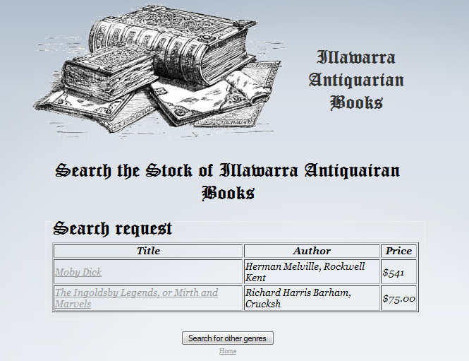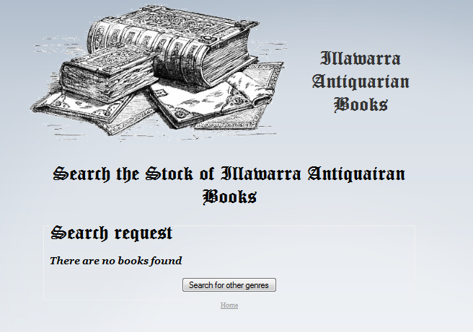

No books found output Records found output

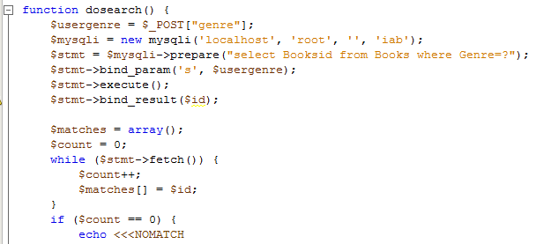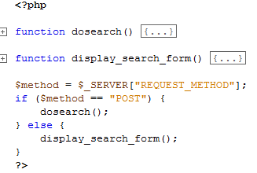

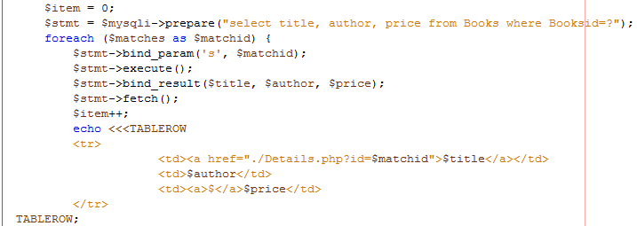

Two functions are used. One is to get data from user. The other is to process and output the data. Display_search_form function output a html page and gets data from users. It calls back itself using a phpself function. The dosearch function accesses the database and obtains ids with the specific genre. Then a count is done and if result is 0 then no records are found and an html is shown. Otherwise more data is obtained and output into a table using a foreach loop.

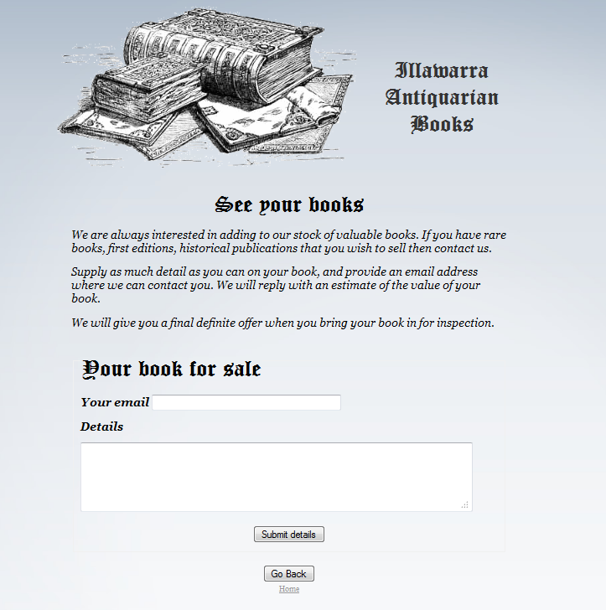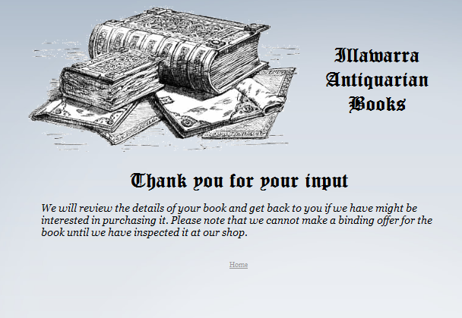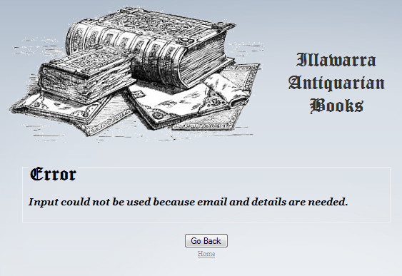Top left shows the form for submission of offers from guests. Top left shows an error when either email or comment section is left out blank. And a thank you message is shown upon successful submission.

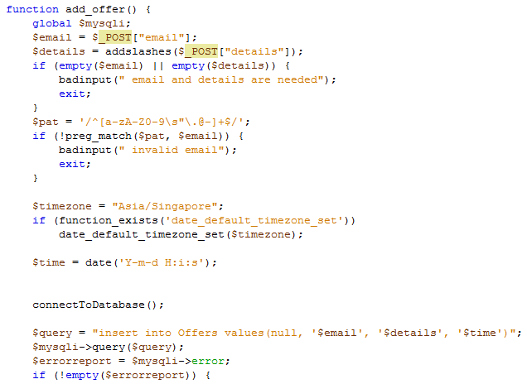

The function shows the processing of data for the offer. Firstly, data are obtained by POST and then checked if they are empty. Then a check on the email is done whether characters that are not supposed to be in emails are present. Addslashes ensures that ‘ character can go through the sql database.

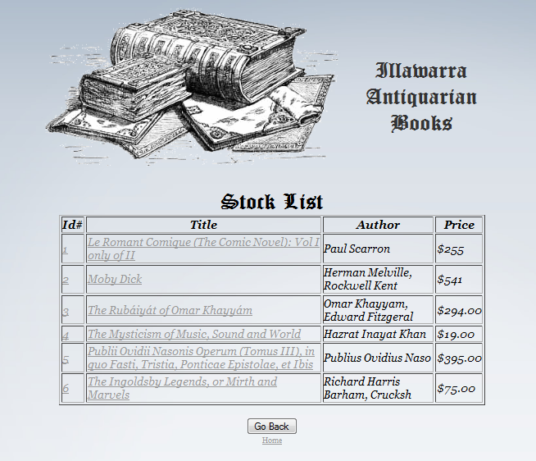

Viewstock.php allows viewing of all available stocks to the guests and lets them click on the title to get more information about a specific book. More about the code in stocklist.php as they are almost the same.



Contact page from a html file without processed data.

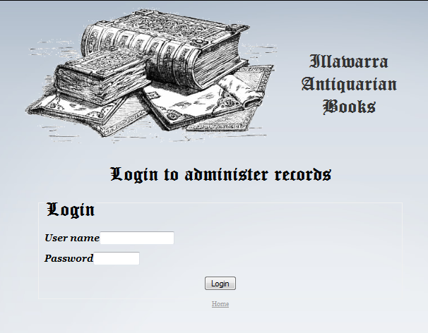

This is the login page for the vendors. It checks the username and password with the database and outputs error if no such user is found. Password is encoded by md5 encryption to ensure security.

Also, a cookie is created so that the vendor can stay logged in until he logs out manually.

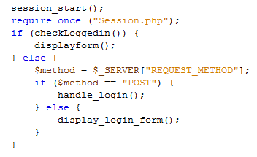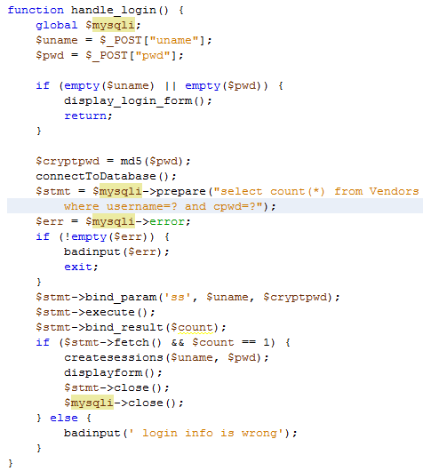

(Top) Session is started to allow cookies. Session.php is called to store cookies and to check if they exist. Login status is checked (session.php) and displays vendor menu. Otherwise (left) user input checked and session is created where cookies are stored.

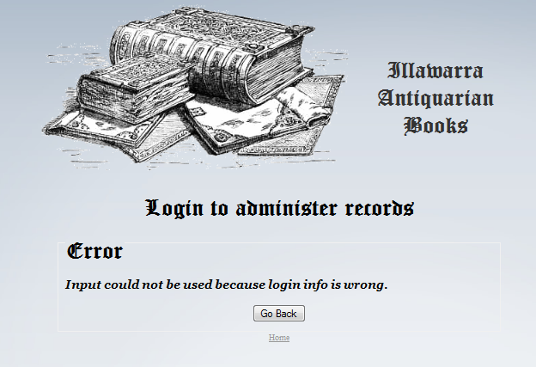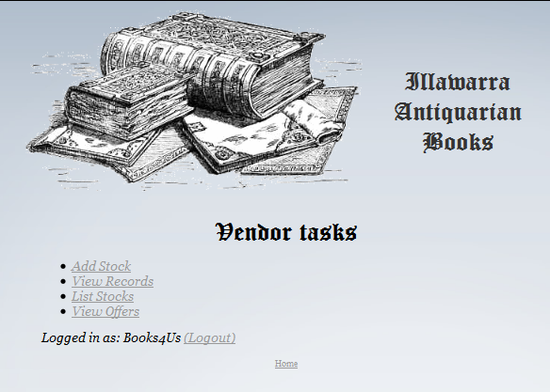

Log in information not found in database Main menu after successful log in

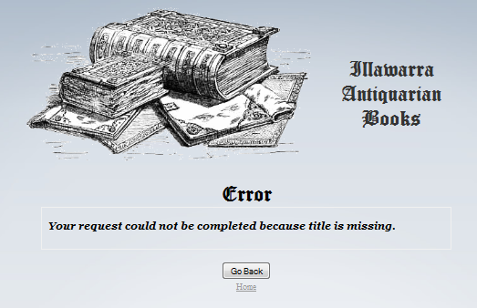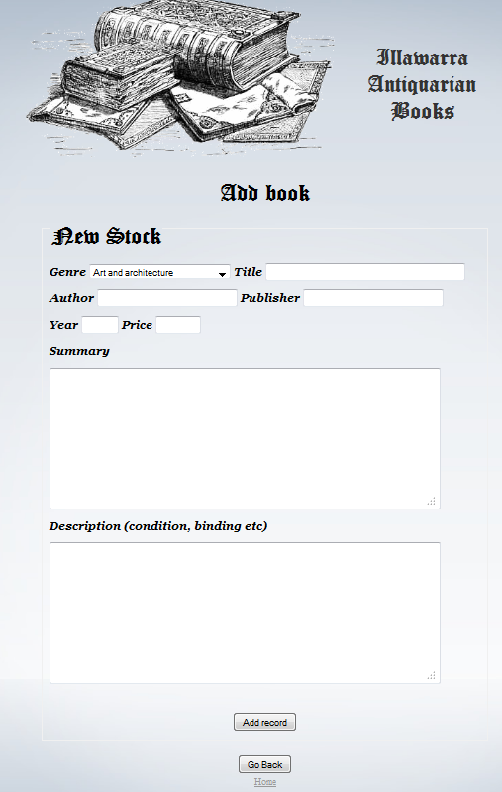Addstock.php allows new records to be created. All sections are required to be filled except description. The genre is a drop down menu and the rest are text input. Addslashes are also in place to prevent error.

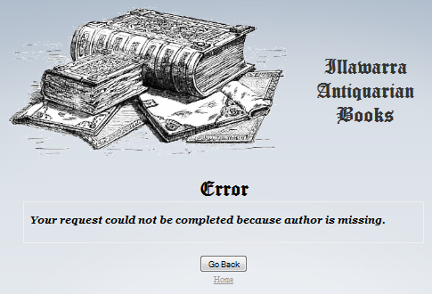

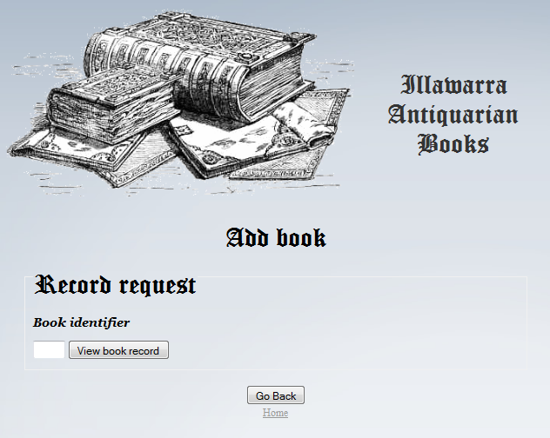

The record request function allows of searching of records via book id. This allows for quick searching of a specific record without having to go through a list. This is effective when the database becomes huge.

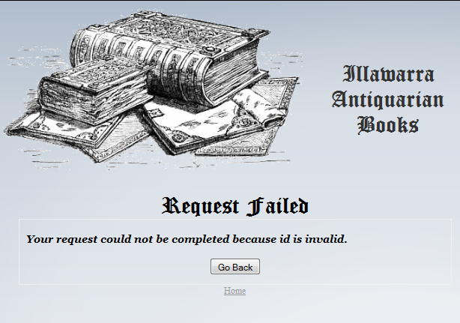

When input is a non-digit, an error is shown.

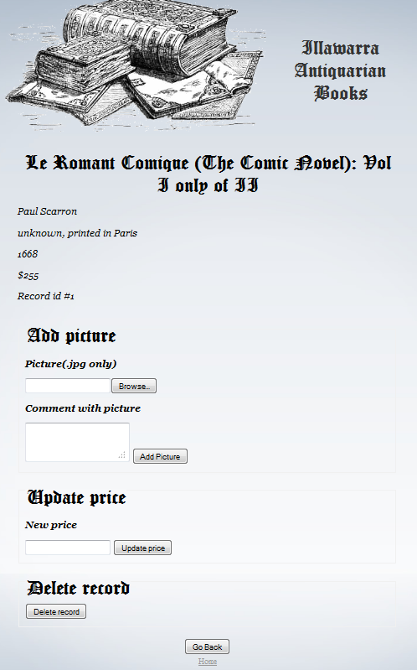

Addpicture.php allows addition of pictures with comments to a book record. It also allows update of price and record deletion. The photos are stored in genre specific folders and only the url are stored in the database to prevent the database from having a huge size.

Update price leads to update.php which updates the database with the new price.

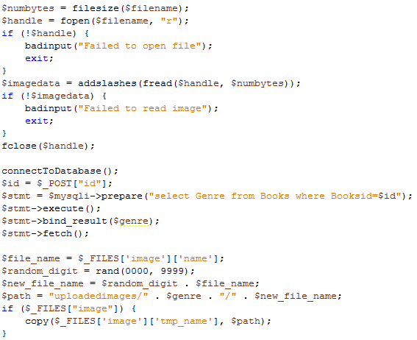Delete record function uses a javascript to confirm deletion then redirect page to delete.php which deleted the record from the database.

Uploaded file is checked if it can be opened and read. Then it is copied to the folder using copy().

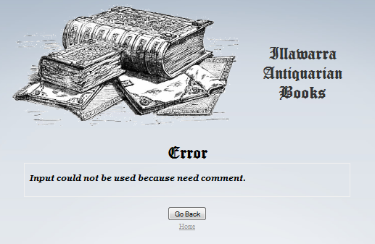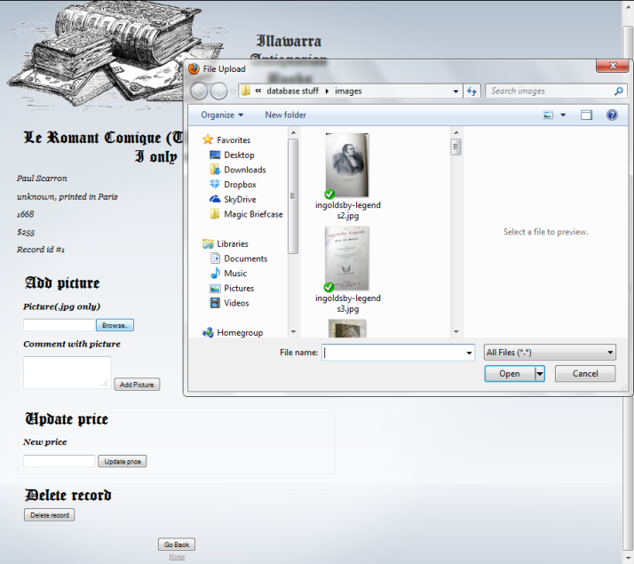Addition of photos

When there is no comment, error is shown.

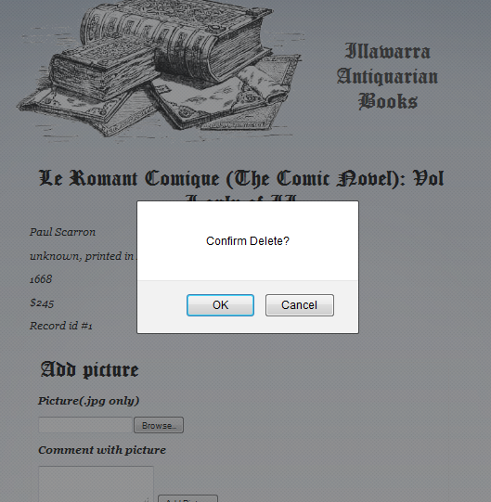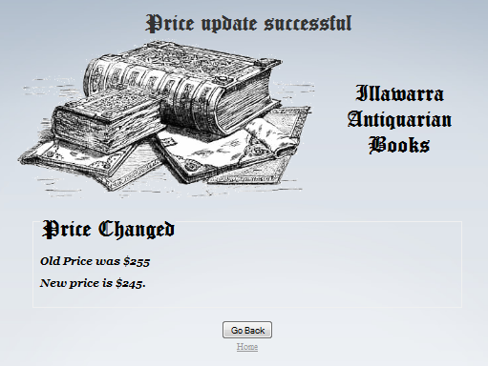Change of price shown(top), confirm delete dialog box(left)

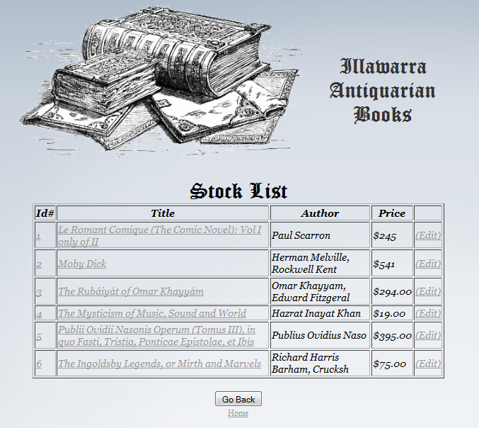

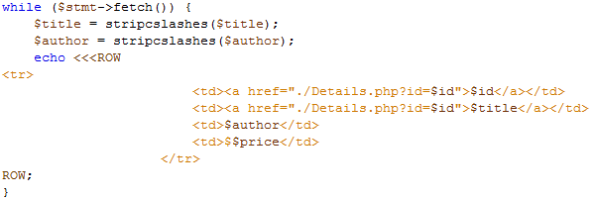

ViewStock.php shows the list of available books in the database. It is sorted by the book id and the Id and title are clickable which shows more details of the books. An edit button is added to the side to allow vendors to access AddPicture.php. A while loop is used (top) to obtain the records and show them in each row in the table.

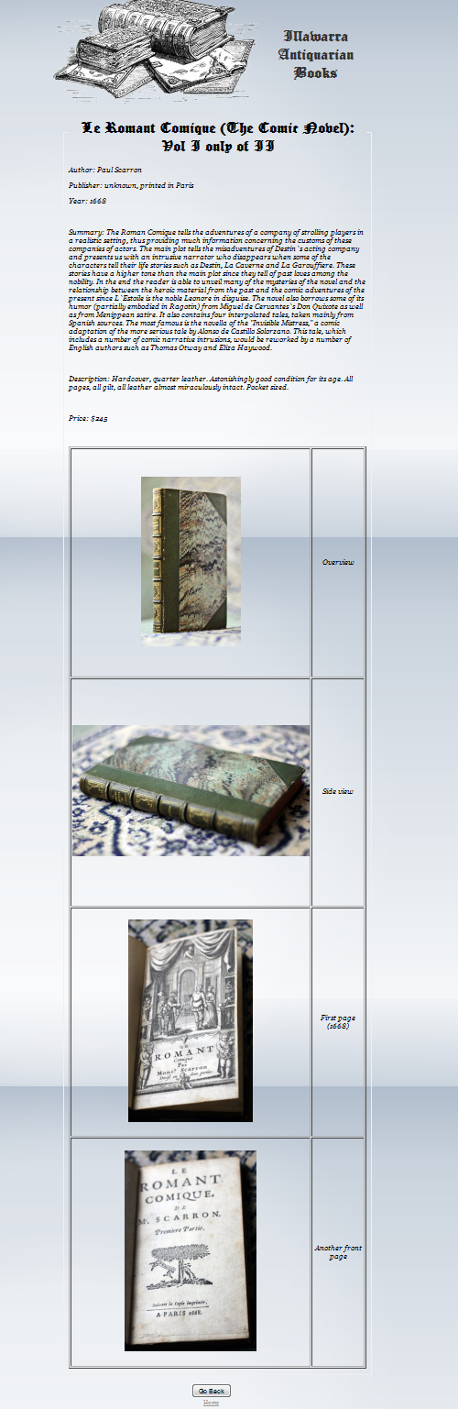

All data of a record is shown. All are obtained from both the books and pictures tables from the database. The pictures and comments are shown in a tabular form and a while loop was used to output the photos. The same book id is used in both tables in the database to ensure that both record tallies. The Book id in books table is its primary key and it’s the foreign key in the pictures table.

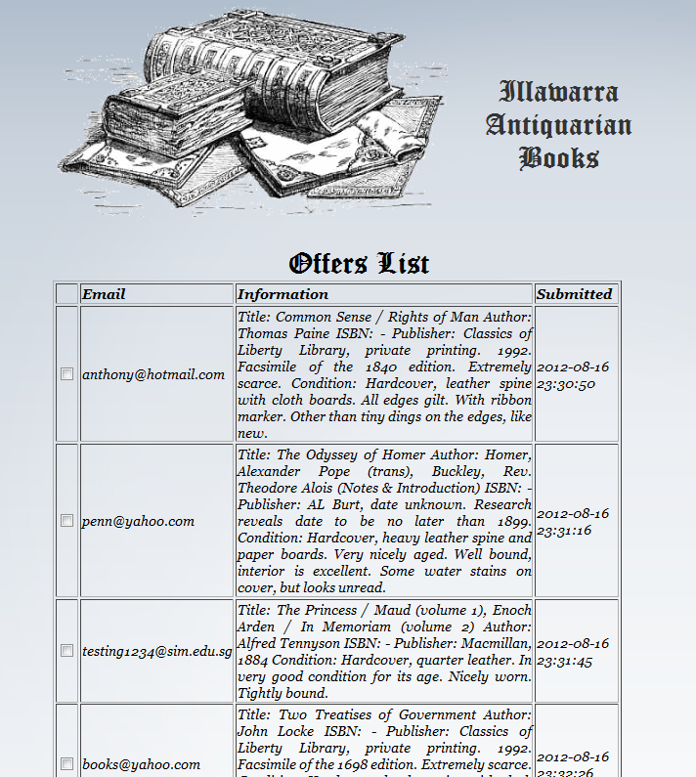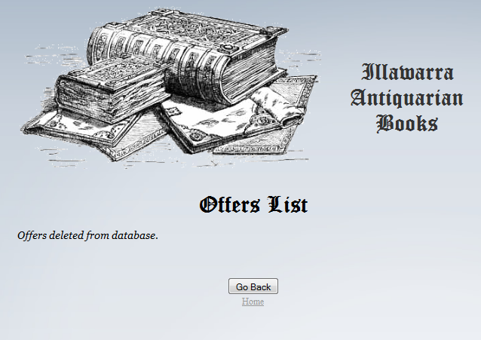

Offers list show offers made by guests. It contains their email, information and date it was submitted. The checkbox allows multiple records to be deleted at one go. Successful deletion page will show upon deletion.