Part 1: Github-anthony.kapiti@gmail.com

Part 3: What is GitHub? When was it created? Why? By who? What similar platforms exist? Why would you use such a platform? (Answer between 5 and 10 lines)

Github is a web base hosting service, which uses Git created by the same man who created Linux, for version control of amongst a group of people or just an one person working on a project. Github was created/founded in 2008 by a man named Tom Preston-Werner. A similar platform to Github is GitLab which is almost exactly the same in functionality but also allows users to download open source software on their servers. Another alternative is BitBucket and it is good because it has a bunch of other integrated tools which is good for both private users and big enterprises. However, the two alterntives I mentioned more or less do the same thing as Github. Github is a platform that I would use because it makes developing with partners seamless with the whole concept of version control, so whenever revisions are made I can easily pull the changes and work on the revised project.

Part 4:

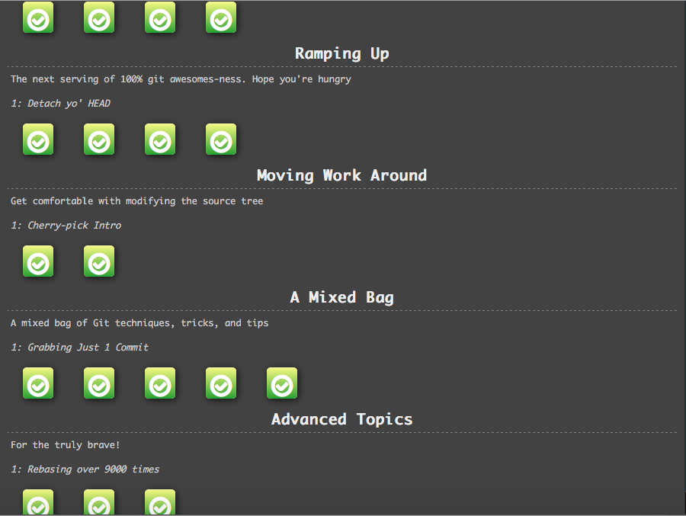

Part 5:

Repository- A set of commit objects. A set of references to commit objects, called heads.

Commit- records changes to the repository.

Push- Updates remote refs along with associated objects

Branch-  Lightweight movable pointer to commits.

Fork- copy of a repository so experiment can be done without messing with the original version.

Merge-  This command lets you take the independent lines of development created by git branch and integrate them into a single branch

Clone- Copy of the target repository.

Pull-git pull runs git fetch with the given parameters and calls git merge to merge the retrieved branch heads into the current branch.

Pull request- method of submitting contributions to an open development project.