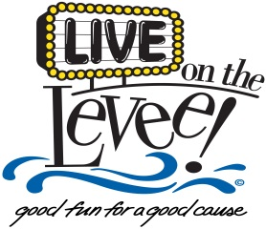

Thank you for your interest in playing in the *Live on the Levee* Concert Series. The concerts for *Live on the Levee* are every Friday night from Memorial Day to Labor Day. All opportunities are outdoors and are subject to cancellation due to weather conditions. The concert series provides a stage and professional sound and lights at each event.

This completed form can be emailed to cari.morris@cityofcharleston.org or mailed to City Hall at P.O. Box 2749, Charleston, WV 25330 with attention to Cari A. Morris. A CD or flash drive can also be mailed with the form; however, website links are always preferred. The deadline for submissions is January 12th, 2018.

Name of Band____________________________________ Contact Name ___________________________

Phone Number ________________________ Email _____________________________________________

Genre of music __________________________________ # of band members ________________________

List the instruments your band utilizes at shows ________________________________________________

________________________________________________________________________________________

Recent appearances/festivals and approx. attendance____________________________________________

________________________________________________________________________________________

How do you market your band? (Facebook, YouTube, newsletters, website, etc.)______________________

________________________________________________________________________________________

Do you have performance samples online? Please share. __________________________________________

________________________________________________________________________________________

Has your band ever performed at Live on the Levee? If so, when? __________________________________

________________________________________________________________________________________

Is there anything else that you’d like to explain about your band? ___________________________________

________________________________________________________________________________________

________________________________________________________________________________________

**liveontheleveecharleston.com**