BenepiKnow: A Multilingual Retrieval-Augmented Generation Chatbot for Philippine Family Planning Rights and Benefits

Alexsandra Duhac
Department of Computer Studies & Engineering (CSE)
José Rizal University
Mandaluyong, Philippines
alexsandra.duhac@my.jru.edu
Anthony S. Mijares
Department of Computer Studies & Engineering (CSE)
José Rizal University
Mandaluyong, Philippines
anthony.mijares@my.jru.edu
Jude Emmanuele D. Pineda
Department of Computer Studies & Engineering (CSE)
José Rizal University
Mandaluyong, Philippines
judeemmanuele.pineda@my.jru.edu

Abstract—In the Philippines, the official answers to common family planning questions are written in English in long documents for health providers, such as a 348-page handbook. BenepiKnow is a retrieval-augmented generation chatbot that answers questions on family planning services, PhilHealth coverage, and client rights in English, Filipino, and Taglish, using six official documents and citing the page used. The pipeline uses 800-character chunks with a 150-character overlap, multilingual-e5-small, Chroma, and Qwen-SEA-LION-v4.5-27B-IT, and rewrites Filipino and follow-up questions in English before a combined dense and keyword search. A chunking experiment found the evidence for 80 percent of 15 prompts in three languages, and the deployed chatbot passed 8 of 12 questions in the official evaluation. After the retrieval changes, the evidence hit rate rose from 73 to 91 percent, and the final version passed 10 of the 12 questions with no failures.
Keywords—chunk size, family planning, multilingual retrieval, prompt engineering, query rewriting, retrieval-augmented generation

Introduction
The official answers to common family planning questions in the Philippines are hard for clients to find and read. The answers on family planning methods, consent, confidentiality, and coverage by the Philippine Health Insurance Corporation (PhilHealth) are written in long English documents for health providers and administrators instead of clients. For example, the Philippine Family Planning Handbook has 348 pages, and PhilHealth Circular No. 2024-0037 on case rates has 283 pages. The need for the information is still high, since the 2022 National Demographic and Health Survey (NDHS) reported an unmet need for family planning of 12% among married women and 42% among sexually active unmarried women [1]. Because of the high unmet need and the length of the documents, a tool that finds the official answer for a client can support access to family planning information.
Retrieval-augmented generation (RAG) is a method that first retrieves passages from a document collection and then gives the passages to a large language model (LLM) as the evidence for the answer [2]. Because the answer comes from the retrieved passages, a RAG chatbot can show the document and page behind each answer. A RAG chatbot can also decline a question when the retrieved passages do not contain the answer. BenepiKnow applies RAG to six official Philippine documents to support Sustainable Development Goal (SDG) 3, Target 3.7, which calls for universal access to family planning information and education.
The main research question of the project was how accurately a RAG chatbot restricted to official Department of Health (DOH) and PhilHealth documents can answer common contraceptive-misconception questions. The answers were judged on correctness, on faithfulness to the documents, and on staying within what the documents support. Besides misconception questions, the final chatbot also answers questions on family planning rights, PhilHealth benefits, and administrative requirements. To answer the research question, a chunking experiment first selected the chunk size, the overlap, and the number of retrieved passages. The selected pipeline was then deployed as a public website with a separate back end and was evaluated on 12 frozen questions that include misconception, unanswerable, and out-of-scope questions. Based on the failures in the evaluation, the prompt and the retrieval were improved and were tested again as a separate experiment.

Methodology

Documents and Preprocessing
The knowledge base contained seven Portable Document Format (PDF) files from the DOH, the World Health Organization (WHO) Philippines, PhilHealth, and the Congress of the Philippines (Table I). The seven files covered six documents. The six documents were the 2023 Philippine Family Planning Handbook [3], PhilHealth Circular No. 2024-0037 on case rates [4], Republic Act (RA) No. 10354, the Implementing Rules and Regulations (IRR) of RA 10354, DOH Administrative Order (AO) No. 2017-0002, and PhilHealth Circular No. 2018-0005. The IRR came in two files, and one of the two files was a scanned copy without a text layer.
The Handbook was the main source for the misconception questions, and the other five documents added family planning rights, PhilHealth benefits, and legal requirements. The same six documents were used in the group chunking experiment, so the selected chunk settings were tested on the same text as the deployed chatbot.
Each page was read with PyPDFLoader, and empty pages and repeated pages were removed before chunking. Out of the 756 pages loaded, 57 pages were empty and 171 pages were duplicates, so 528 pages were kept. All 53 pages of the scanned IRR copy were empty, but no document content was lost because the same IRR text came from the second IRR file. The 171 duplicate pages came from pages repeated inside the Handbook file. The 528 pages were then split with RecursiveCharacterTextSplitter into 3,480 chunks with an average length of 734.9 characters.
- Knowledge Base Documents
Document | Issuer | Content kept
Document | Issuer | Pages | Chunks
Philippine Family Planning Handbook, 2023 ed. | DOH and WHO Philippines | 173 | 1,099
PhilHealth Circular No. 2024-0037 | PhilHealth | 283 | 2,008
IRR of RA 10354 (text copy) | DOH | 54 | 266
IRR of RA 10354 (scanned copy) | DOH | 0 | 0
RA 10354 | Congress of the Philippines | 13 | 72
DOH AO No. 2017-0002 | DOH | 4 | 19
PhilHealth Circular No. 2018-0005 | PhilHealth | 1 | 16
Total |  | 528 | 3,480

Chunking Experiment
Before the group experiment, each member ran an individual chunking study on one document with an exact inner-product index of the Faiss library [5]. Each study tested 12 settings of chunk size and overlap at top-3 on nine questions. The retrieved chunks were scored with Precision@3, Recall@3, and mean reciprocal rank (MRR). Precision@k is the share of the k retrieved chunks that are relevant, and Recall@k is the share of questions with the evidence among the k retrieved chunks. MRR is the average of one over the rank of the first relevant chunk.
On the Handbook, with the all-MiniLM-L6-v2 embedding model, Recall@3 rose with chunk size and reached 0.667 at a chunk size of 3,000 characters with an overlap of 600. On the IRR, also with all-MiniLM-L6-v2, Recall@3 reached 0.722 at 500/50, 500/100, and 1,000/100. On Circular No. 2024-0037, with the SEA-LION-ModernBERT-Embedding-600M model of the Southeast Asian Languages in One Network (SEA-LION) family, the best Recall@3 was 0.556 at 500/0, and the best MRR was 0.667 at 500/50. Since no single setting was best on every document and mid-size chunks gave the best Recall@3 on two of the three documents, the group experiment tested chunk sizes from 400 to 1,200 characters.
The group experiment used all six documents and the same models as the final chatbot. Only one parameter was changed at a time, since chunk size and overlap change retrieval quality and need to be tested on representative questions [6]. Step 1 compared chunk sizes of 400, 800, and 1,200 characters with an overlap of 100. Step 2 kept the chunk size at 800 and compared overlaps of 50, 100, 150, and 200. Step 3 kept the chunk size at 800 and the overlap at 150 and compared top-k values of 1, 3, and 5.
The test set had five questions, and each question was written in English, Filipino, and Taglish, which gave 15 prompts. A retrieved chunk was counted as relevant only when the chunk contained the expected evidence phrase. After the three steps, a benchmark ran four configurations three times each on two Google Colab runtimes with the five English questions. The first runtime was the central processing unit (CPU) runtime with 8 virtual CPUs, and the second runtime was a T4 graphics processing unit (GPU). The GPU speedup S of each stage was computed with (1), where TCPU and TGPU are the average times of the same stage on the CPU and on the GPU.
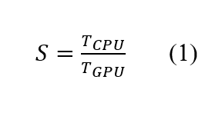

Models and Retrieval
Each chunk and each question was embedded with intfloat/multilingual-e5-small [7]. The model produces vectors with 384 dimensions and expects the prefix “passage” before each chunk and the prefix “query” before each question. The vectors were normalized and stored in Chroma, and the three chunks closest to each question were retrieved. Since Chroma uses approximate search, the top-3 results of Chroma were compared with exact cosine search on the 15 test prompts. Both searches returned the same chunks in the same order for all 15 prompts, so Chroma was kept in place of the exact Faiss index.
The answers were generated by Qwen-SEA-LION-v4.5-27B-IT, a model of the SEA-LION family [8], through the SEA-LION application programming interface (API). The model has a context window of 262K tokens [9]. The temperature was set to 0.2, and the thinking mode of the model was turned off. The answer limit was 256 tokens in the experiment and 400 tokens in the deployed chatbot. The free API allows 10 requests per minute, so the back end sends one request at a time with at least 6.5 s between requests.

Prompt Design
The prompt followed the usual structure of a RAG prompt, with a system message, a context block, and the user question [10]. Version 1 of the system message came from the experiment notebook and had 77 tokens. Version 1 set the role, asked the model to use the context as the main evidence, and asked the model to say when the documents were not enough. Version 2 split the rules into labeled sections for evidence, citations, reply language, length, missing evidence, and scope. In version 2, each claim has to cite a passage as [Source N], and each answer is limited to five sentences.
Version 3 added a task line, a rule against instructions typed into the question, and three short examples of the expected output. Version 3 also raised the answer limit to 400 tokens and added a token check (Table II). When a prompt goes over 6,000 tokens, the token check drops the lowest-ranked passage.
Version 4 was made after the official evaluation and added the last two exchanges of the chat as conversation history. Version 4 also added a rule to answer yes or no only when a passage states the answer directly, and a rule against telling users what to do about the user’s own case. Version 4b changed the rewrite step to ask for a faithful English translation of the question. Version 4c added a short list of Filipino family planning terms with English meanings, such as baog for infertile and regla for menstruation. Because of the added rules, the system message grew from 77 tokens in version 1 to 844 tokens in version 4c. A full prompt with three passages used 1,052 to 1,629 tokens in the official run and 1,336 to 1,918 tokens in version 4c, which is less than 1% of the context window.
- Prompt Versions
Version | System message
Version | Main change | Tokens
1 | Template from the experiment notebook | 77
2 | Labeled sections, citations, fallbacks, scope | 332
3 | Task line, injection guard, format examples, token budget | 569
4 | Conversation history, yes or no rule, personal advice rule | 705
4b | Faithful English rewrite | 705
4c | Filipino family planning terms | 844

Deployment
The back end was written with FastAPI and packaged in Docker together with the prebuilt index, the embedding model, and the SEA-LION tokenizer. The container runs on Google Cloud Run in the asia-southeast1 region with 2 GiB of memory. Cloud Run was limited to one instance, so the limit of 10 requests per minute applies to all users together. The API key is kept in Secret Manager and is not stored in the code. Six Cloud Run revisions were deployed, and each container build took 5 min 1 s to 6 min 5 s.
The website was built with React and Vite and is hosted on Vercel. The website streams each answer and shows the document and page of each source. For follow-up questions, the website sends the last two exchanges of the chat to the back end. The chat is kept only in the browser, and the server log records token counts and times but not the question text, since family planning questions are sensitive health information. However, each question is still sent to the SEA-LION API to produce the answer, so a self-hosted copy of the open SEA-LION model would be needed to keep the questions fully private.

Evaluation Design
The evaluation used 12 questions with reference answers. The questions were frozen before the official run and were kept separate from the questions used for prompt testing. The 15 experiment prompts and 10 edge-case prompts served as the development questions.
The 12 questions were grouped by question type to test both answering and declining. The set had four direct lookup questions, two multi-section questions, one cross-document question, two unanswerable questions, and three out-of-scope questions. Six questions were written in English, three in Filipino, and three in Taglish.
Each answer was graded on correctness against the reference answer with a score of 1, 0.5, or 0. Faithfulness to the retrieved passages was graded in the same way, as defined in Retrieval Augmented Generation Assessment (RAGAS) [11]. Citation was graded on whether each claim cited the right document and page, and language was graded on whether the reply used the language of the question. Each answer then received a verdict of pass, partial, or fail. The official run used prompt version 3 on Cloud Run revision 00003, and the later versions were run on the same 12 questions as separate experiments.

Retrieval Improvement Study
The official evaluation showed retrieval misses on Filipino questions. Because of the misses, six retrieval options were compared offline on 22 questions made up of the 15 experiment prompts and the 7 answerable evaluation questions. The options were dense search at top-3, dense search at top-5, dense search on an English rewrite of the question, and fusions of dense search with Best Matching 25 (BM25) keyword search through reciprocal rank fusion (RRF). In the offline test, the English rewrites were written by hand to represent the rewrite of the language model.
In the deployed version, the rewrite step follows the rewrite-retrieve-read approach [12]. The language model rewrites each Filipino, Taglish, or follow-up question as one standalone English question, using the last two exchanges of the chat. The dense results and the keyword results are then combined, as in hybrid retrieval [13], and the top three passages are kept.

Results

Evaluation Design
The 800/150/3 configuration gave the highest Recall@3 of 0.800 and the highest MRR at top-3 of 0.633 (Table III). In Step 1, chunks of 400 characters reached a Recall@3 of only 0.400, and chunks of 1,200 characters reached 0.467. A likely reason is that small chunks split the evidence across chunks, while large chunks mix the evidence with unrelated text. In Step 2, an overlap of 150 raised Recall@3 from 0.667 to 0.800 compared with an overlap of 100. An overlap of 200 lowered Recall@3 to 0.733 and increased the chunks from 3,480 to 3,723.
A top-k of 3 was selected because a top-k of 3 kept the highest recall with fewer unrelated chunks. A larger top-k adds more chunks that do not contain the evidence, while a smaller top-k can miss the evidence completely. In Step 3, a top-k of 5 kept Recall@k at 0.800 but lowered Precision@k from 0.311 to 0.187, and a top-k of 1 reached a Recall@k of only 0.467. Because of these results, the deployed chatbot retrieves three chunks for each question.
Retrieval quality also depended on the language of the question as per, Fig. 1. Since all six documents are written in English, English questions share more words with the chunks than Filipino questions. For the 800/150/3 configuration, Recall@3 was 1.0 for English, 0.8 for Taglish, and 0.6 for Filipino, and Filipino Recall@3 did not go above 0.6 in any configuration. Based on these results, the selected configuration retrieved the English evidence well but still missed part of the Filipino evidence.
Prompt length did not limit the choice of configuration. The model has a context window of 262K tokens, so a prompt with three chunks uses only a small part of the window. A prompt with three chunks of the selected configuration used 1,209 tokens on average, which is 0.46% of the context window. Because of the small prompt size, the configuration was chosen on the retrieval scores alone.
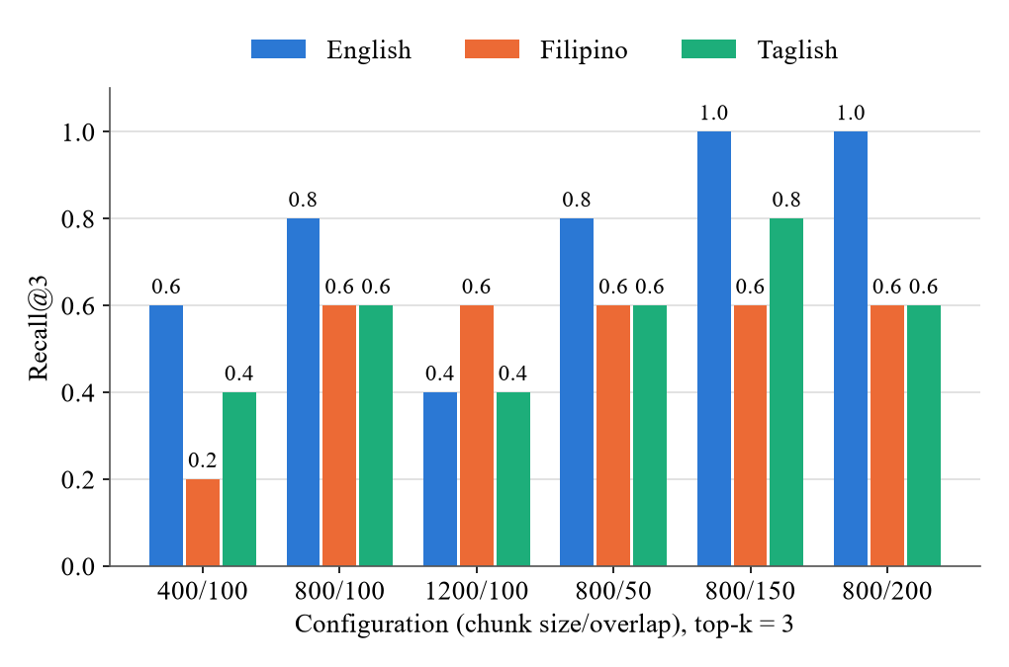
- Recall@3 by question language.
- Chunking Experiment Results
Step | Configuration | Chunks | Retrieval score
Step | Configuration | Chunks | Precision | Recall | Mean reciprocal rank
Chunk size | 400/100/3 | 7,429 | 0.133 | 0.400 | 0.300
 | 800/100/3 | 3,298 | 0.222 | 0.667 | 0.467
 | 1200/100/3 | 2,213 | 0.156 | 0.467 | 0.322
Overlap | 800/50/3 | 3,138 | 0.222 | 0.667 | 0.500
 | 800/150/3 | 3,480 | 0.311 | 0.800 | 0.633
 | 800/200/3 | 3,723 | 0.244 | 0.733 | 0.556
Top-k | 800/150/1 | 3,480 | 0.467 | 0.467 | 0.467
 | 800/150/5 | 3,480 | 0.187 | 0.800 | 0.633

CPU and GPU Performance
The T4 GPU indexed the 3,480 chunks of the selected configuration in 27.2 s, while the CPU took 275.6 s, which gives a speedup of 10.12 (Table IV). Retrieval was also faster on the GPU, with a speedup of 1.37, because each question is embedded on the Colab device. Generation was not faster on the GPU, with a speedup of 0.69. Since the SEA-LION API generates the answers on remote servers, the generation time depends on the network and the load of the API instead of the Colab hardware. Over three runs on the five English questions, the selected configuration reached a Recall@3 of 1.00, an MRR of 0.80, and a Precision@3 of 0.40 on both devices. The CPU and GPU runs also gave the same retrieval scores for every chunking configuration.
The 15 answers of the selected configuration were graded as correct, partially correct, or not answered. All five English answers were correct. Four Taglish answers were correct, and one Taglish answer was partially correct. Three Filipino answers were correct, and two Filipino answers were not answered because the evidence was not retrieved. Four Filipino answers on the CPU and three on the GPU were cut at the limit of 256 tokens, so the deployed chatbot uses a limit of 400 tokens.

Official Chatbot Evaluation
Out of the 12 questions in the official run, 8 answers passed, 2 were partial, and 2 failed (Table V). For the seven answerable questions, the average correctness was 0.64, the average faithfulness was 0.79, and the citation accuracy was 0.86. Since the evidence was fully retrieved for only four of the seven answerable questions, the correctness score was lower than the faithfulness score. For the unanswerable and out-of-scope questions, the chatbot gave four passes and one partial. The partial answer told a user with headaches not to stop the pill, which is personal advice that should have been declined. All 12 replies used the same language as the question.
- Average Execution Time of the Selected Configuration
Stage | Average execution time (s) |  | Speedup
Stage | CPU | T4 GPU | Speedup
Indexing | 275.601 | 27.246 | 10.12
Retrieval | 0.0222 | 0.0162 | 1.37
Generation | 4.591 | 6.655 | 0.69
Total response | 4.613 | 6.671 | 0.69

Both failed answers came from Filipino questions with evidence that was not retrieved. Without the right Handbook passages, the chatbot either answered from unrelated passages or replied that the documents did not cover the question. The first question was “Nakakabaog ba ang IUD?”, which asks whether the intrauterine device (IUD) causes infertility. Handbook page 152 was not among the retrieved passages, and the answer said yes based on passages about emergency contraception, which contradicts the Handbook. The second question asked whether blood builds up inside the body when an injectable or implant stops monthly bleeding, and the evidence on pages 98 and 116 was not retrieved, so the chatbot replied that the documents did not cover the question. Based on the two failures, retrieval misses on Filipino questions were the main cause of the failed answers in the official run.

Retrieval Study and Later Versions
Query rewriting gave the largest gain in the offline study (Table VI). Dense search at top-3, as deployed in version 3, found the evidence for 0.727 of the 22 questions and for only 0.429 of the Filipino questions. Dense search at top-5 gave the same results as top-3. Dense search on English rewrites raised the hit rate to 0.909, with 0.857 for Filipino and 1.000 for Taglish. The fusion of dense search on the question with dense and BM25 search on the rewrite reached the same hit rate of 0.909 and the highest MRR of 0.803. The fused option was deployed in version 4 because the fusion still searches with the original question.
The rewrite step handled the IUD question correctly only in version 4c. The rewrite depends on how the language model translates Filipino family planning words, and the prompts of versions 4 and 4b did not define Filipino family planning terms. In version 4, the rewrite step changed “Nakakabaog ba ang IUD?” into a question on PhilHealth coverage. In version 4b, the rewrite step translated the question as “Does the IUD cause bloating?”, and the answer said yes with the reason that the IUD is a long-acting reversible method. In version 4c, the question was rewritten as “Does the IUD cause infertility?”, and the answer stated that the IUD does not cause infertility and that fertility returns right after removal, with citations to Handbook pages 152 and 150. Based on the three versions, the IUD question needed the list of Filipino terms, while the faithful rewrite of version 4b was enough to find the evidence for the blood question.
- Evaluation Results by Chatbot Version
Measure | Chatbot version
Measure | Official (v3) | v4 | v4b | v4c
Pass, partial, fail | 8, 2, 2 | 9, 1, 2 | 9, 2, 1 | 10, 2, 0
Answerable correctness | 0.64 | 0.64 | 0.79 | 0.93
Answerable faithfulness | 0.79 | 0.93 | 0.71 | 0.93
Citation accuracy | 0.86 | 1.00 | 0.86 | 1.00
Evidence fully retrieved | 4 of 7 | 4 of 7 | 5 of 7 | 5 of 7
Unanswerable and out of scope | 4 pass, 1 partial | 5 pass | 5 pass | 5 pass
Average time (s) | 5.81 | 15.08 | 9.59 | 8.71

- Retrieval Options on 22 Question
Option | Hit rate |  |  |  | Mean reciprocal rank
Option | All | English | Filipino | Taglish | Mean reciprocal rank
Dense, top-3 (deployed in v3) | 0.727 | 0.889 | 0.429 | 0.833 | 0.591
Dense, top-5 | 0.727 | 0.889 | 0.429 | 0.833 | 0.591
Dense on English rewrite | 0.909 | 0.889 | 0.857 | 1.000 | 0.765
Fusion of question and rewrite | 0.818 | 0.889 | 0.714 | 0.833 | 0.705
Dense and BM25 on question | 0.818 | 0.889 | 0.571 | 1.000 | 0.742
Dense question, dense and BM25 rewrite (v4) | 0.909 | 0.889 | 0.857 | 1.000 | 0.803

The final version passed 10 of the 12 questions, with 2 partial answers and no failures (Fig. 2). The answerable correctness rose from 0.64 in the official run to 0.93 in version 4c. The average response time rose from 5.81 s to 8.71 s, because a rewritten question needs a second API call.
The conversation history was tested with a three-turn chat in each later version. In every later version, the third question, “Gaano kadalas pwedeng i-avail yung implant package?”, was rewritten with the earlier turns. The chatbot then answered that the implant package can be availed once every 730 days, with a citation to Handbook page 280. The second turn passed in version 4 but was partial in versions 4b and 4c. In versions 4b and 4c, the rewrite of the second turn kept PhilHealth but dropped the free-standing clinics named in the first turn.

Discussion
For the main research question, the misconception questions had the lowest results in the evaluation. In the official run, both misconception questions failed because the Handbook passages were not retrieved, and one of the two answers repeated the misconception. In version 4c, the IUD question passed and the blood question was partial, and both answers cited the Handbook. Every version declined the unanswerable questions without guessing, and from version 4 on, every out-of-scope question was declined. Based on these results, the answers stayed within what the documents support, while the correctness of misconception answers depended on retrieving the Handbook sections.
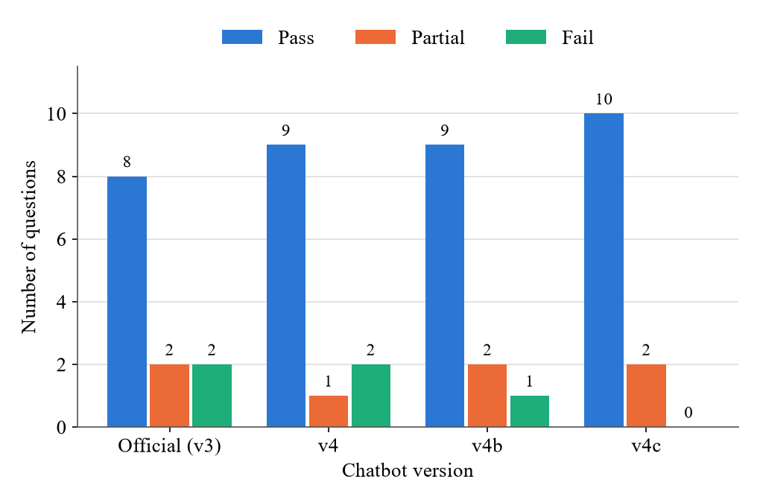
- Evaluation verdicts by chatbot version.
Filipino questions had the weakest retrieval in both the chunking experiment and the evaluation. Filipino Recall@3 did not go above 0.6 in any chunking configuration, and both failures in the official run came from short Filipino questions. A likely reason is that everyday Filipino words, such as nakakabaog and regla, do not appear in the English text of the documents. Based on the offline study, an English rewrite raised the Filipino hit rate from 0.429 to 0.857, while the English hit rate stayed at 0.889. Because of this result, rewriting the question in English was the main retrieval change for Filipino questions.
The IUD question showed that a prompt rule alone could not fix a retrieval miss. The yes or no rule in version 4 only stops the model from answering when no passage states the answer, so the rule could not bring back page 152 of the Handbook when the page was not retrieved. In version 4b, page 152 was retrieved, but the rewrite still turned the question into a question about bloating, and the answer still said yes. After the list of Filipino terms was added in version 4c, the rewrite and the answer were both correct. Based on the results of versions 4b and 4c, the IUD question needed both the retrieval change and the list of Filipino terms to be answered correctly.
The retrieval changes made the answers slower. Since a rewritten question needs two API calls, each answer waits for the rewrite before the search starts. The average response time rose by 2.90 s, from 5.81 s in the official run to 8.71 s in version 4c, and the free limit of 10 requests per minute serves fewer questions. Because of the longer response time and the request limit, the gains in correctness came with lower speed and capacity.
A top-k of 3 was kept even though a cross-document question needs passages from two documents. Top-5 search did not add evidence in the offline study, and long contexts can also lower answer quality when the relevant passage is placed among other passages [14]. However, with only three passages, a question that needs two documents can lose one of the two documents, and the cross-document IUD question stayed partial in every version. Based on these results, questions that need two documents remain a limit of the current retrieval.
The size of the test sets limits how far the results can be generalized. The test sets were small, with 15 prompts in the chunking experiment, 5 English questions in the benchmark, and 12 questions in the evaluation. The answers were graded by the group without an outside grader, and the rewrites in the offline study were written by hand. Since the later versions were tuned after the official run on the same 12 questions, the gains of the later versions may be smaller on new questions. Because of these limits, the scores of the final version apply to the current 12 questions and need a larger frozen test set to be confirmed.
The knowledge base and the chunking also limit what the chatbot can answer. The chatbot can only answer from the text that was loaded and chunked. The scanned IRR copy added no text, although the same IRR was available in a second file. The knowledge base also did not include the 2014 Clinical Standards Manual on Family Planning or the WHO Medical Eligibility Criteria, so answers on clinical details were limited to what the Handbook states, and the chunks followed fixed sizes with page metadata instead of section boundaries. Based on these gaps, adding the clinical documents and chunking by section can widen what the chatbot can answer.

Conclusion
BenepiKnow answered family planning questions from six official Philippine documents in English, Filipino, and Taglish, with the page of each source. The chunking experiment selected a chunk size of 800, an overlap of 150, and a top-k of 3, which reached a Recall@3 of 0.800. The official evaluation passed 8 of the 12 questions, and both failures came from Filipino questions with retrieval misses. Query rewriting with conversation history, the fusion of dense and BM25 search, and a list of Filipino terms raised the evidence hit rate from 0.727 to 0.909. With these changes, the final version passed 10 of the 12 questions with no failures.
For the research question, the misconception answers were correct only when the Handbook passages were retrieved, so the retrieval of Filipino questions was the main factor in correctness. Future work includes a larger frozen test set graded by outside reviewers and a reranker for questions that need two documents. A longer list of Filipino health terms and text recognition for scanned files can also improve retrieval. A self-hosted SEA-LION model can keep the questions private, and optional sign-in for saved chats can be added with consent and data deletion under the Data Privacy Act of 2012.

References

- Philippine Statistics Authority and ICF, Philippines National Demographic and Health Survey 2022: Final Report. Quezon City, Philippines, and Rockville, MD, USA: PSA and ICF, 2023.
- Y. Gao et al., “Retrieval-augmented generation for large language models: A survey,” arXiv:2312.10997, 2023.
- Department of Health and World Health Organization Philippines, The Philippine Family Planning Handbook, 2023 ed. Manila, Philippines, 2023.
- Philippine Health Insurance Corporation, “Fifty percent (50%) adjustment of select case rates,” PhilHealth Circular No. 2024-0037, Pasig City, Philippines, 2024.
- M. Douze et al., “The Faiss library,” arXiv:2401.08281, 2024.
- B. Smith and A. Troynikov, “Evaluating chunking strategies for retrieval,” Chroma, Tech. Rep., Jul. 2024. [Online]. Available: https://research.trychroma.com/evaluating-chunking
- L. Wang et al., “Multilingual E5 text embeddings: A technical report,” arXiv:2402.05672, 2024.
- R. Ng et al., “SEA-LION: Southeast Asian languages in one network,” arXiv:2504.05747, 2025.
- AI Singapore, “Qwen-SEA-LION-v4.5-27B-IT,” Hugging Face model card, 2026. [Online]. Available: https://huggingface.co/aisingapore/Qwen-SEA-LION-v4.5-27B-IT
- S. Schulhoff et al., “The prompt report: A systematic survey of prompt engineering techniques,” arXiv:2406.06608, 2024.
- S. Es, J. James, L. Espinosa-Anke, and S. Schockaert, “RAGAS: Automated evaluation of retrieval augmented generation,” in Proc. 18th Conf. European Chapter of the Association for Computational Linguistics, System Demonstrations, 2024.
- X. Ma, Y. Gong, P. He, H. Zhao, and N. Duan, “Query rewriting in retrieval-augmented large language models,” in Proc. 2023 Conf. Empirical Methods in Natural Language Processing (EMNLP), Singapore, 2023, pp. 5303–5315.
- X. Wang et al., “Searching for best practices in retrieval-augmented generation,” in Proc. 2024 Conf. Empirical Methods in Natural Language Processing (EMNLP), 2024.
- N. F. Liu et al., “Lost in the middle: How language models use long contexts,” Trans. Assoc. Comput. Linguistics, vol. 12, pp. 157–173, 2024.

