**Bus Arrival Sign FAQ for Business Owners/Community Centers**

**What is it? What does it do?**

This sign fetches up-to-date information on New Jersey Transit buses inbound to neighborhood area. By installing it in your business, you can create a useful information service that will make customers and community members more likely to drop in, linger, and spend time while they wait for the next bus. We will pre-program the sign to show an arrival board for up to 4 different routes at stops near your location. For each service, the sign will show the day of the week and current time, the route number and the next 2-3 predicted arrival times in minutes.

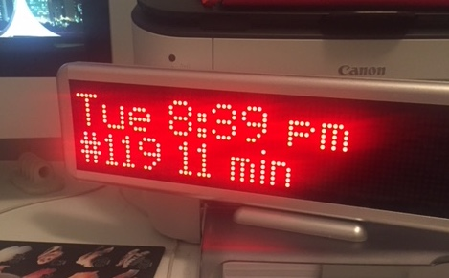

**How accurate are the arrival times and how do you calculate them?**

The arrival times are real-time predictions – not scheduled times – so they are quite accurate. They come from the New Jersey Transit MyBusNow service, so they are the same data that is used in NJTransit’s apps, as well as apps like Google Maps and Transit.app. Occasionally, due to hiccups in the internet and our own code, we may be a minute or two off from those apps, but usually we’re the same.

**What do I need to provide? Does it cost anything? Is it permanent?**

All we need from you is a place to mount the sign, a single grounded AC power plug, and WiFi access (including password). No cost beyond their existing internet service and it is completely temporary can be dismantled in 5 minutes and up to them to place sign in a stand (provided or hang on wall picture hooks)

**How will I know if something is broken or it stopped working? Who will fix it?**

The first indication is the clock will be out of whack. The time won’t be updated unless the arrival times are, and those won’t be updated if the internet connection goes out or the Raspberry Pi is dead. If the clock stops, try unplugging the power on the Raspberry Pi and plugging it back in. If it doesn’t start working again in 5 minutes, email me. I’ll respond ASAP and we’ll commit to fixing it within 72 hours.

Contact: Anthony Townsend, anthony@bitsandatoms.net