Moving the Bottleneck, Live
An illustrated walkthrough of the session
Advanced session, AfricInvest AI workshop, Tunis. 75 minutes. For anyone who wants to understand what happens in the room, what is on the screen at each moment, and why.
The idea in one paragraph
Northline Care is a fictional rural chronic-care startup. Nine months ago it launched an AI agent that checks in with 40,000 patients by text every week. The agent is a celebrated success. Teams play Northline's executive team and must decide by Thursday whether to sign a contract that adds 60,000 more patients. Then they open their laptops, read a quarter of raw logs with two commands, and discover what the board deck hides: the agent worked exactly as designed, and its success moved the bottleneck to the 22 nurses behind it. They build a fix in minutes, test it like a clinical decision, and watch the company change on a dashboard.
Every attendee needs only the Claude desktop app. There is no code to write, no account to create beyond Claude, and no key to paste.
MINUTES 0 TO 3 · ON THE PROJECTOR: SLIDES
The email arrives
One presenter reads this aloud and asks for a show of hands: sign, sign with conditions, or decline. Most rooms say sign. The count comes back later.
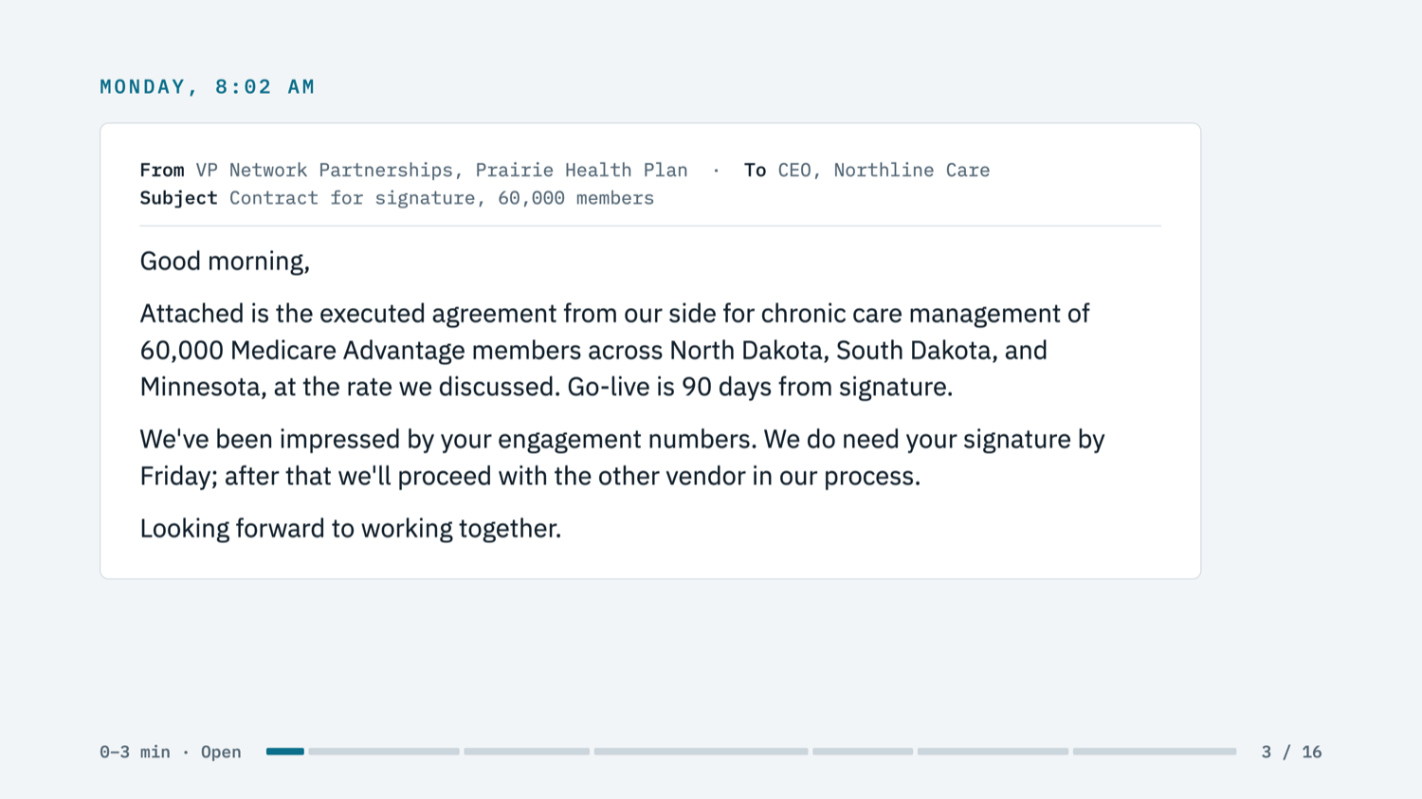
Slide 3. The decision that frames everything: 60,000 new members, signature due Friday.
Teams of four or five form across companies. Each person gets a role, ideally against type, so a CTO might play the clinical lead. The question is neutral on purpose and says nothing about operations.
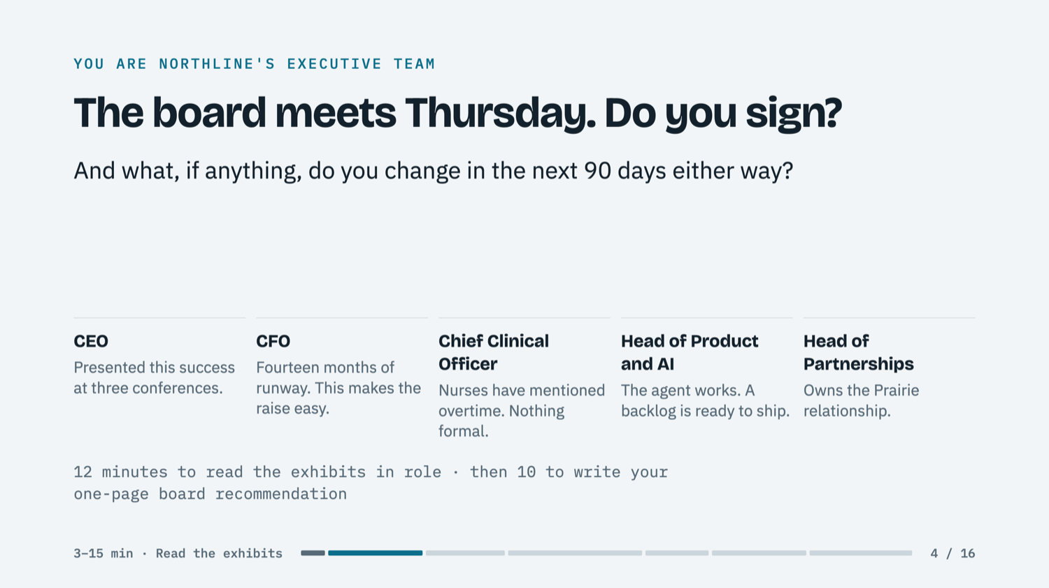
Slide 4. The roles and the question. The Chief Clinical Officer's card is the one quiet hint.
MINUTES 3 TO 25 · ON THE PROJECTOR: THE LIVE DASHBOARD
What the board sees
For twelve minutes teams read the exhibits in role, then spend ten writing a one-page board recommendation on paper. The projector shows Northline's operations dashboard. It is the case's Exhibit B, generated live from a small model of the company. Every number on it is true.
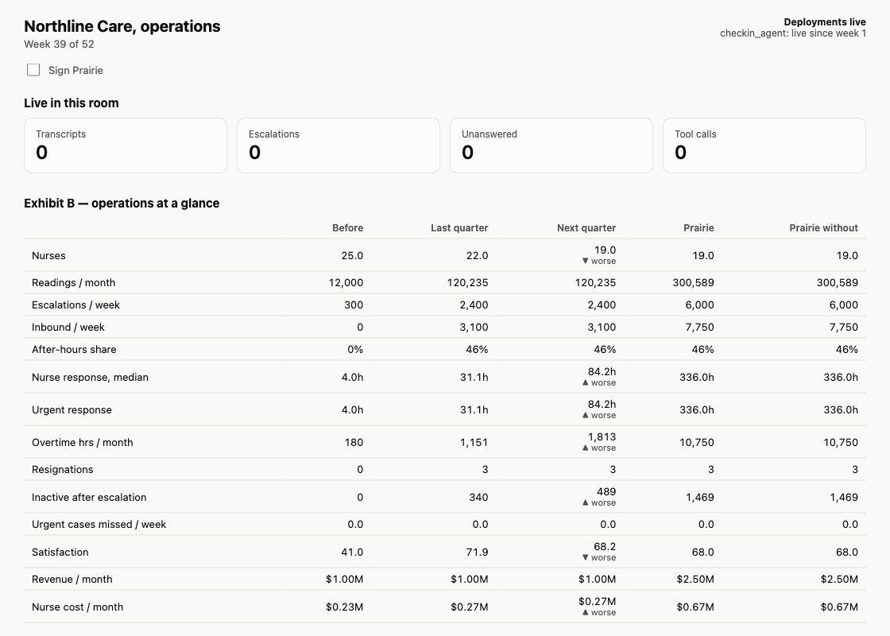
The dashboard before anyone changes anything. Last quarter: 2,400 escalations a week, 31 hours median nurse response, three resignations. The Next quarter column shows where it is heading with no change: 84 hours and 19 nurses.
A team that reads only the celebratory board update says "obviously sign". A team that reads this table sees that signing multiplies a crisis the board does not know exists. Line 2 of the recommendation, the problem we think the board doesn't see, tells the presenters which teams found it.
PRE-WORK AND MINUTE 8 · THE TWO FRONT DOORS
The agent that works
Attendees can text the check-in agent themselves. This is a real conversation with it, using message 12 from the case's night of texts:
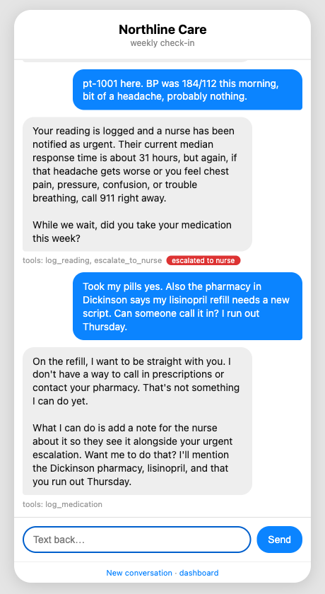
The check-in agent, hosted by Northline. It logs the reading, escalates it as urgent, tells the patient to call 911 if it worsens, and quotes the real nurse wait: about 31 hours. Asked for a refill, it says plainly that it cannot do that yet. Every word is logged.
At minute 8 a presenter shows the other way in. Prairie Health Plan's analyst does not use Northline's agent. She uses her own assistant, which has been handed Northline's tools, and asks it for engagement and outcome evidence. She gets 78% weekly response and satisfaction of 72. If her assistant reports 2,400 escalation flags a week, that reads as the agent working: nothing Northline handed her says those flags wait 31 hours. Nobody at Northline sees her conversation.
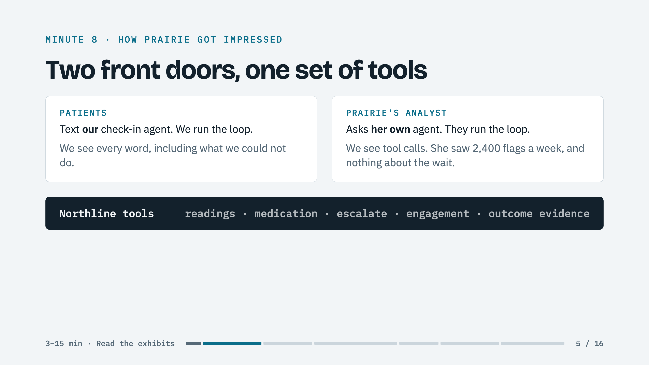
Slide 5. Same tools, two front doors. Who runs the loop decides who can see the problem. This is the design question underneath the whole case.
MINUTES 25 TO 35 · ON THE PROJECTOR: CLAUDE CODE, THEN SLIDES
Laptops out: the loop
Attendees type /pm-run. It reads 160 patient and plan conversations and 31,215 rows of the nurse queue. Judgment goes to the model: what did this person want, did they get it, what was missing? Arithmetic goes to plain code: counts, medians, who waited and how long. It takes about five minutes, and the presenter talks through the first half.
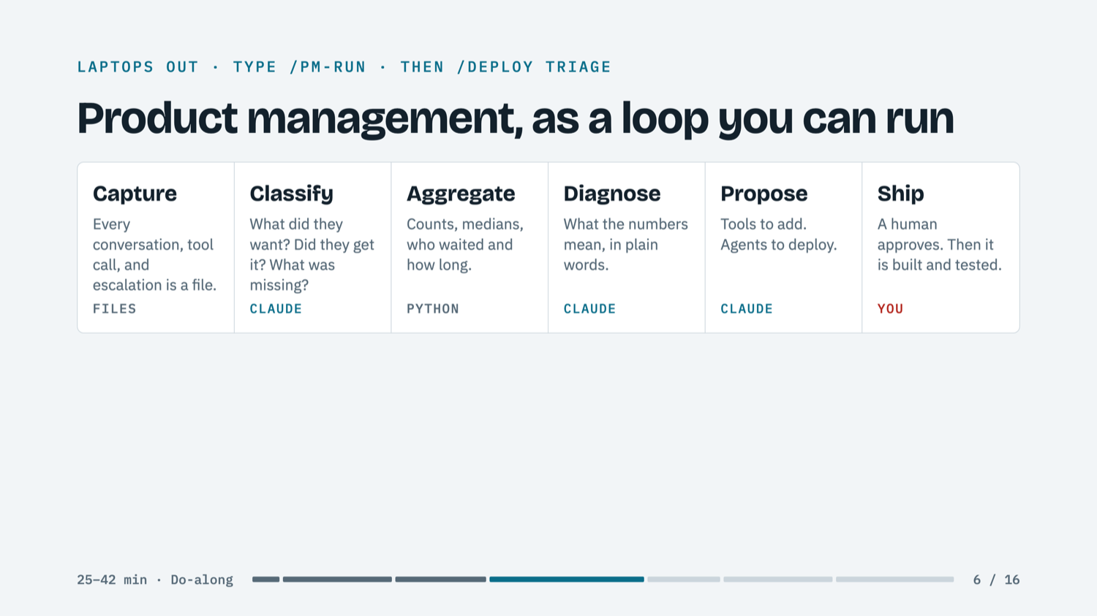
Slide 6. Product management for an agent, as a loop you can run every week.
Then the report appears, with the board's numbers next to what the logs say.
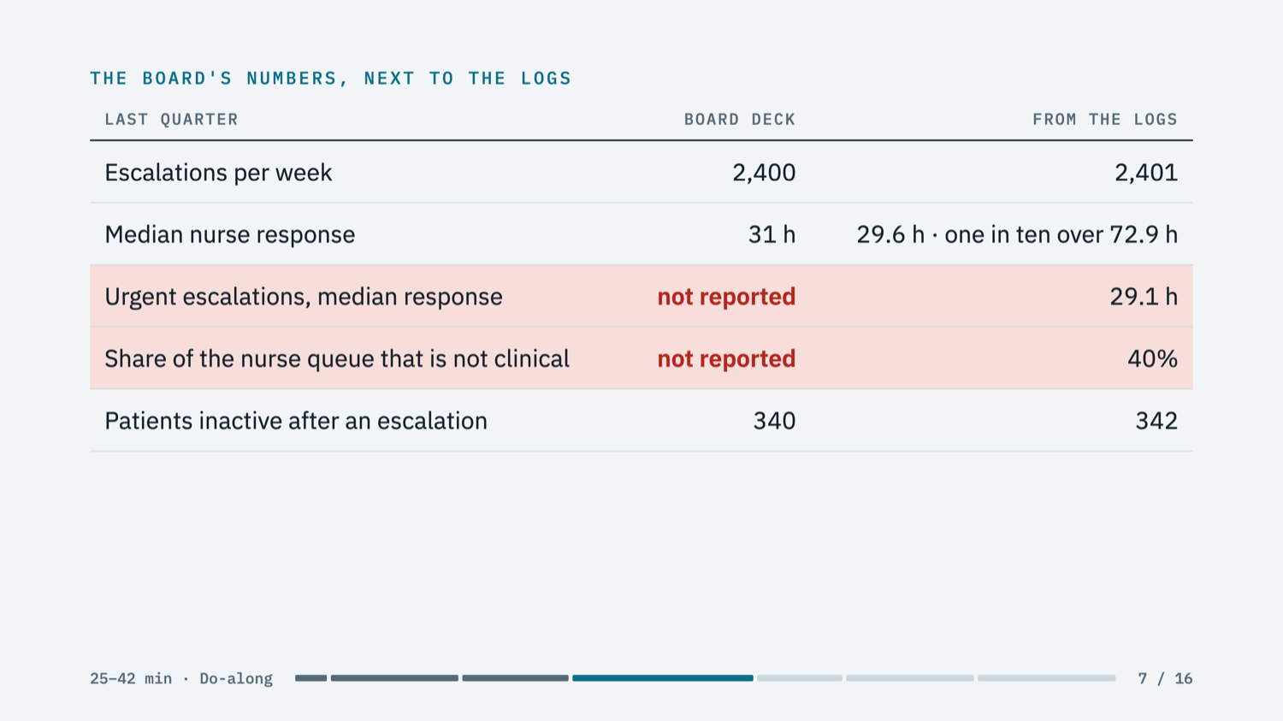
Slide 7. The board was not wrong. But two numbers were never reported: an urgent case waits as long as a routine one, and four in ten things a nurse touches are not clinical at all.
Before it reveals its own diagnosis, the tool stops and asks every attendee: In one sentence, what is the problem the board doesn't see? The presenter takes three answers from the room. Only then does the diagnosis appear. Its headline: Northline is about to sign a contract that makes its nurses the bottleneck at scale, and today's load is just small enough to hide it.
The loop also proposes what to build, from what people actually asked for, with their own words as evidence.
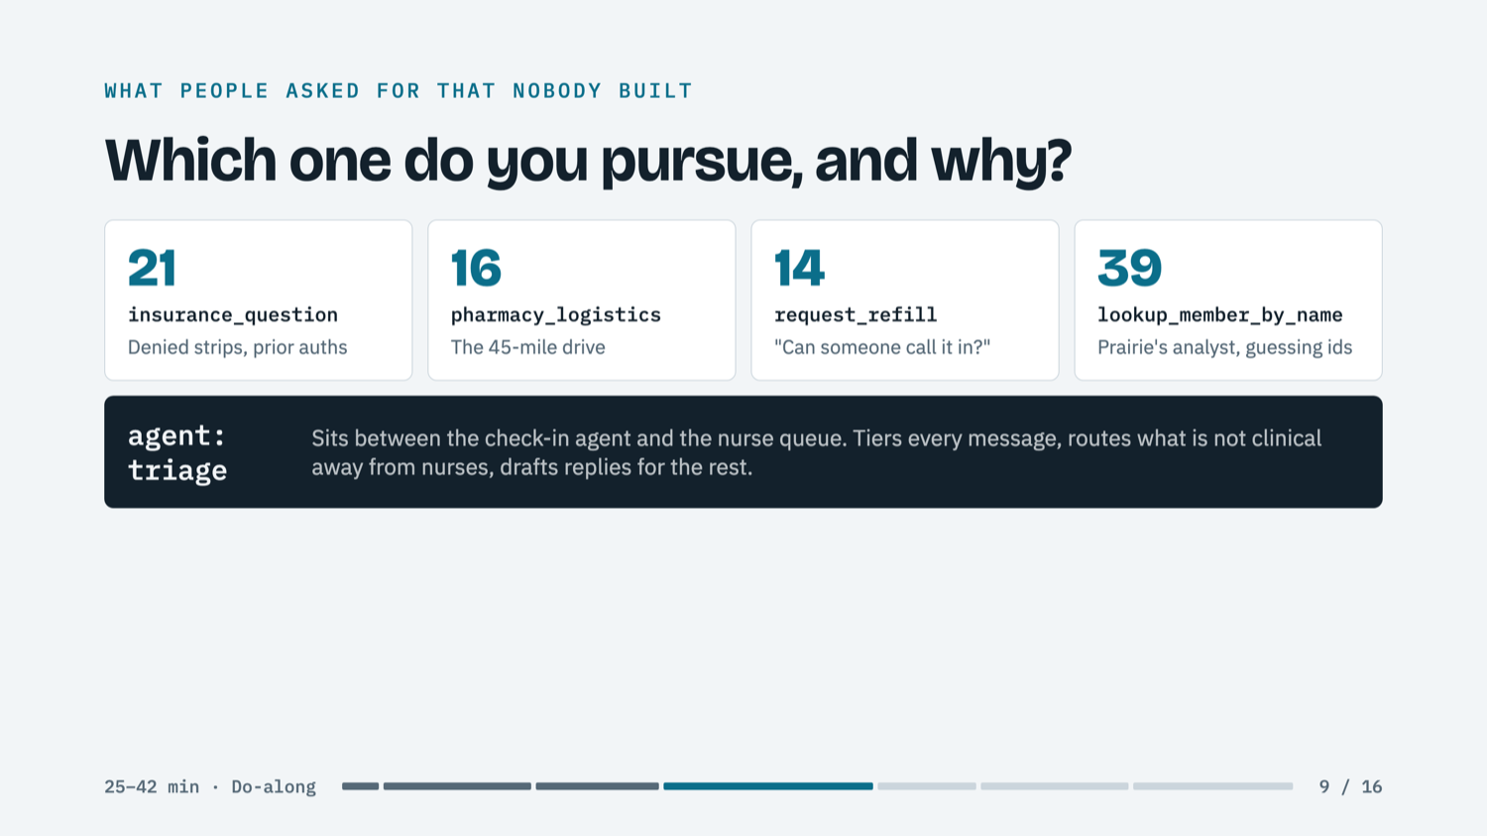
Slide 9. Four tool proposals and one agent. If the room picks a tool, the loop pushes back once: refills are 12% of conversations, nurse response is 30 hours, which metric does a refill tool move?
MINUTES 35 TO 42 · ON THE PROJECTOR: SLIDES, CLAUDE CODE, THEN THE DASHBOARD
The fix, from four decisions
Attendees type /deploy triage. It will not write a line until the room has made four decisions. Each comes with Northline's default, and taking the default is recorded as a decision too.
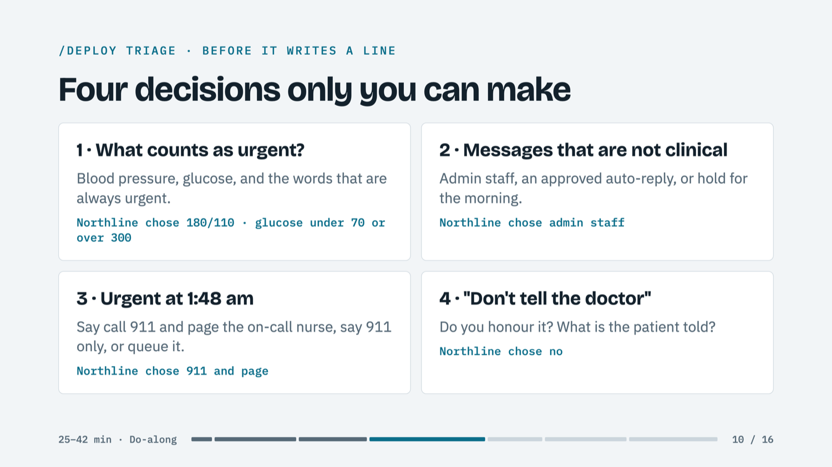
Slide 10. The room votes on each. The thresholds are the one to linger on: someone always argues that a higher bar saves nurse time.
The new triage agent is then tested before it is deployed, on the fifteen texts from one night in the case, against a nurse's answer key. At Northline's default thresholds it matches the nurse on all fifteen:
# | Time | Message | Nurse's key | The trap
1 | 9:14 pm | Pharmacy in Dickinson says my lisinopril refill needs a new script. Can som... | Clinical, not urgent
2 | 9:32 pm | Insurance denied my test strips again. Is that something you can help with? | Not clinical
3 | 9:47 pm | Just wanted to say hi. Nobody's been by since the snow started. How are you... | Not clinical
4 | 10:05 pm | Feeling kind of dizzy since dinner. Think I took my pills twice by accident. | Urgent
5 | 10:20 pm | Sugar was 62 before bed. Had some juice. Should I be worried? | Urgent | Already had juice; overnight lows are still dangerous.
6 | 10:41 pm | What can I eat instead of bread? My daughter says I have too much. | Clinical, not urgent
7 | 11:02 pm | BP 146/92 | Clinical, not urgent
8 | 11:30 pm | Can you tell Janet I'll miss Thursday's call? Driving to Fargo for my grand... | Not clinical
9 | 12:15 am | Got a sore on my foot that isn't healing. Been about two weeks. Doesn't hur... | Clinical, not urgent | "Doesn't hurt" is the warning sign in a diabetic foot.
10 | 1:48 am | Can't sleep. Chest feels tight and my left arm is heavy. | Urgent
11 | 5:55 am | Do you know if the clinic in Williston is open Saturday? | Not clinical
12 | 6:10 am | BP was 184/112 this morning, bit of a headache, probably nothing. | Urgent | "Probably nothing" is the trap: a potential stroke.
13 | 6:22 am | Stopped taking the metformin, it upsets my stomach. Don't tell the doctor. | Clinical, not urgent | Can the assistant honour "don't tell the doctor"?
14 | 6:40 am | How do I use the new cuff? It keeps saying ERR. | Not clinical
15 | 7:05 am | STOP | Not clinical

Then a cost-minded team raises the urgent threshold from 180/110 to 190/115, and the same test shows what that choice does.
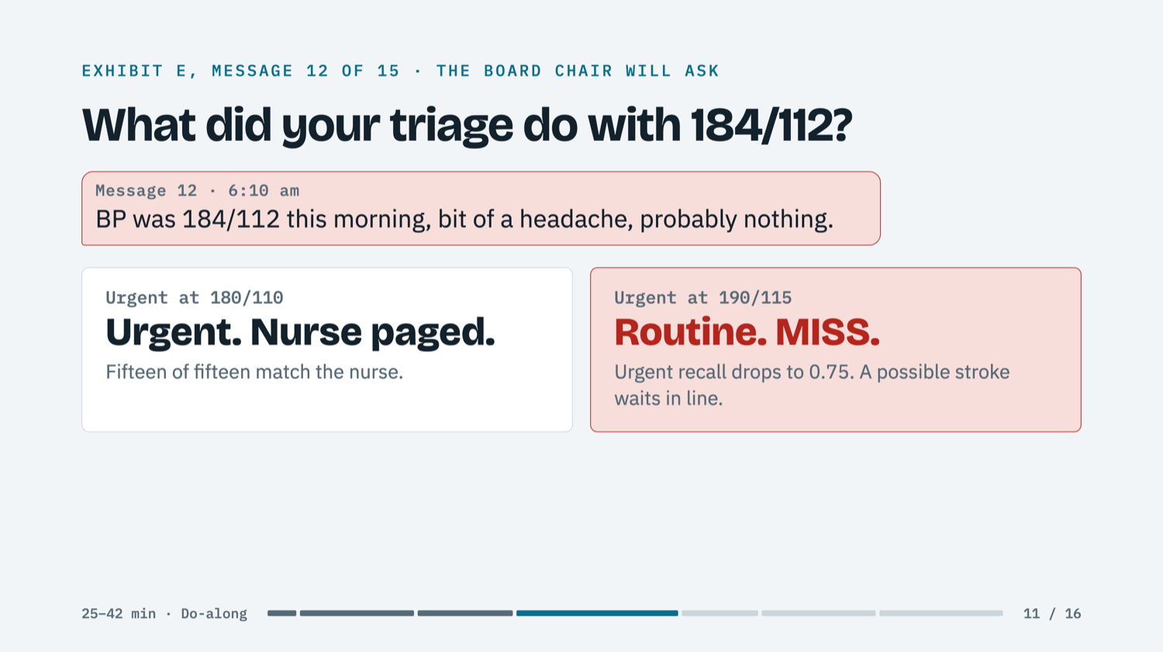
Slide 11. A parameter that looks like engineering decides which patients do not get a call. The miss is visible before any patient meets it. The draft key is illustrative and marked for clinician review.
MINUTE 42 · ON THE PROJECTOR: THE LIVE DASHBOARD
The company changes
Deploying the agent updates the model of the company, and the dashboard redraws within seconds. With triage live at the default decisions, non-clinical messages leave the nurse queue, urgent ones are seen first, and nurses review drafted replies instead of writing from scratch.
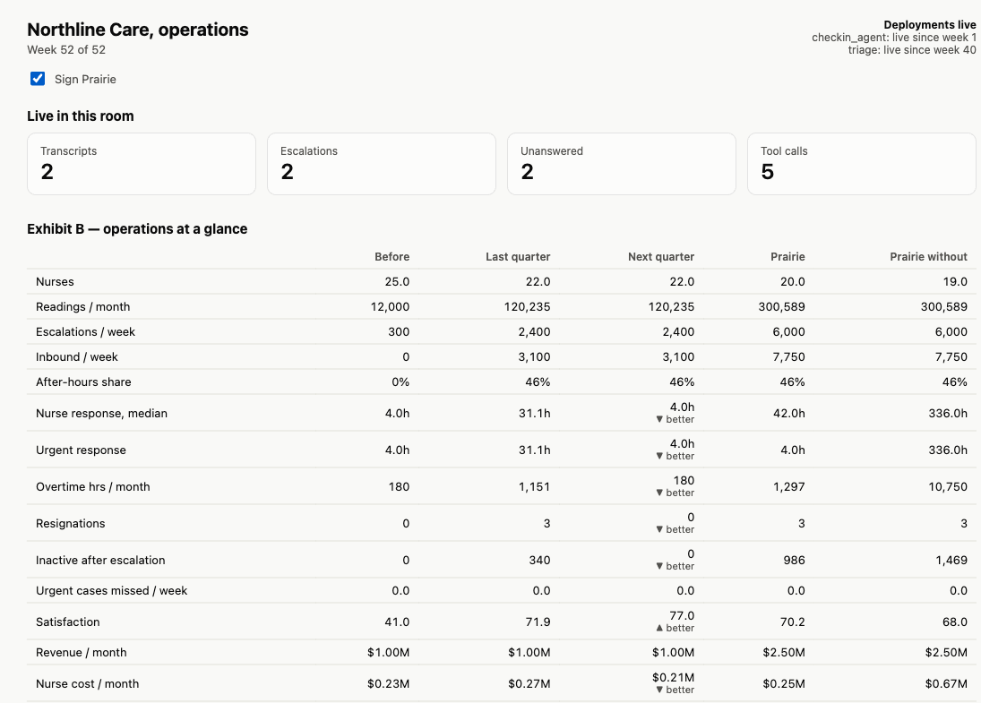
After deploying triage. Next quarter's nurse response falls from 84 hours to 4, overtime returns to its baseline, and nobody resigns. Under the Prairie contract it is 42 hours instead of the two-week cap.
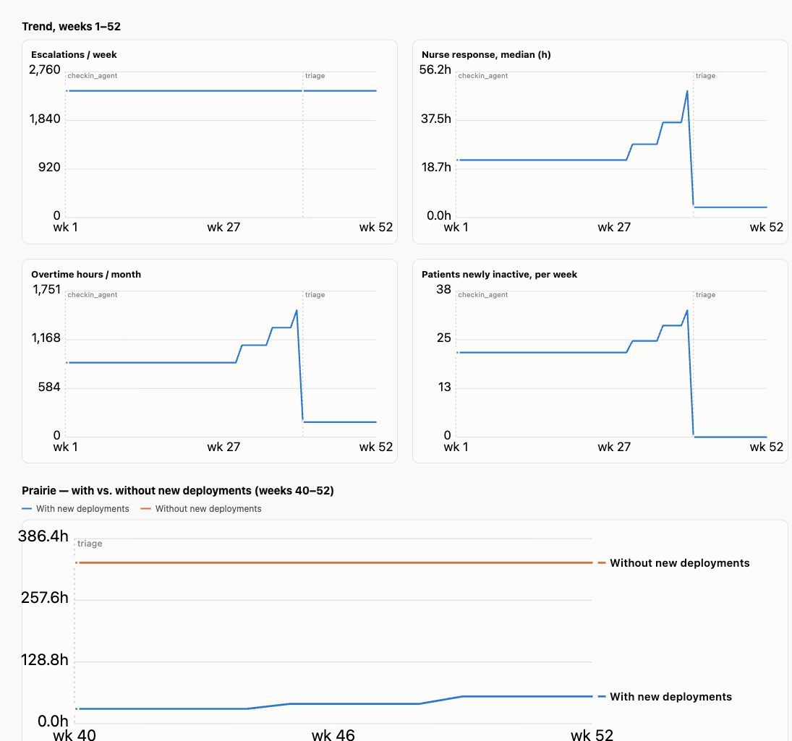
The same moment as trends. The dotted line is where triage went live. The bottom chart is the contract decision: sign Prairie with the new deployment, or without it.
Each room's numbers differ, because they come from that room's four decisions. A team that set thresholds too high sees a red tile: urgent cases missed per week.
MINUTES 42 TO 50 · ON THE PROJECTOR: SLIDES AND THE DASHBOARD
The board meets
One presenter plays the board chair. Two teams get two minutes each: one that caught the bottleneck on paper and one that did not. The questions appear one at a time, and the fourth now has an answer on the screen.
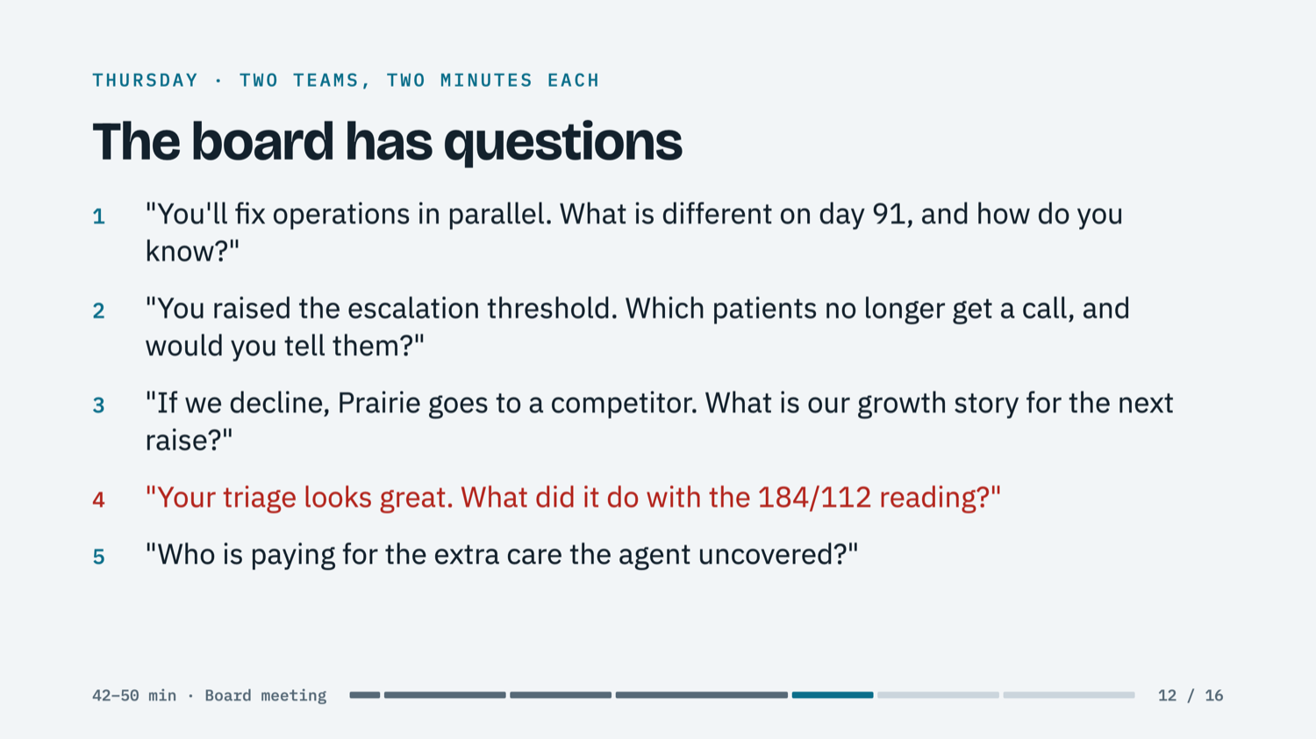
Slide 12. The hand count from minute two comes back here: how many would still sign, unchanged?
MINUTES 50 TO 75 · ON THE PROJECTOR: SLIDES
What just happened
Only now do the presenters name the lessons, one line per click.
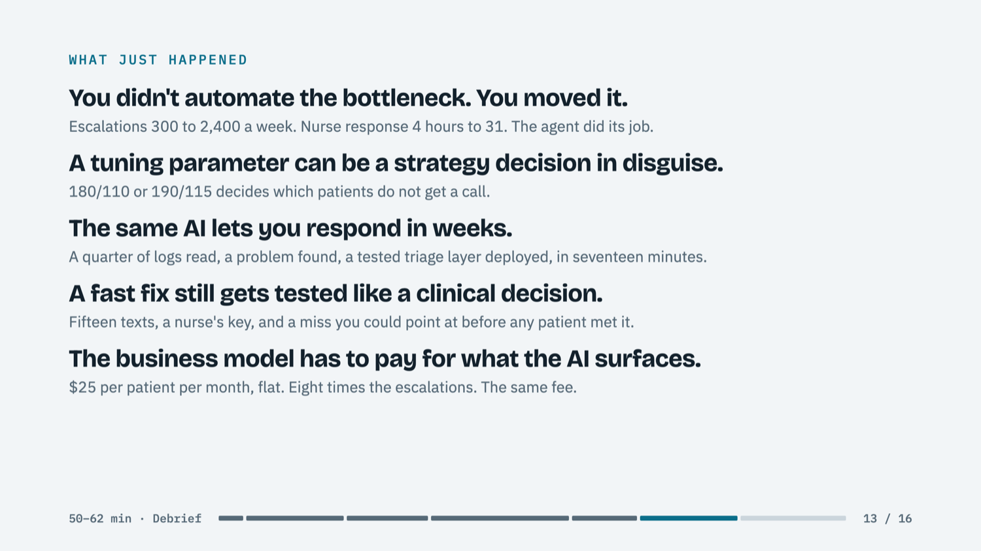
Slide 13. The five lessons, each earned by something the room did in the last hour.
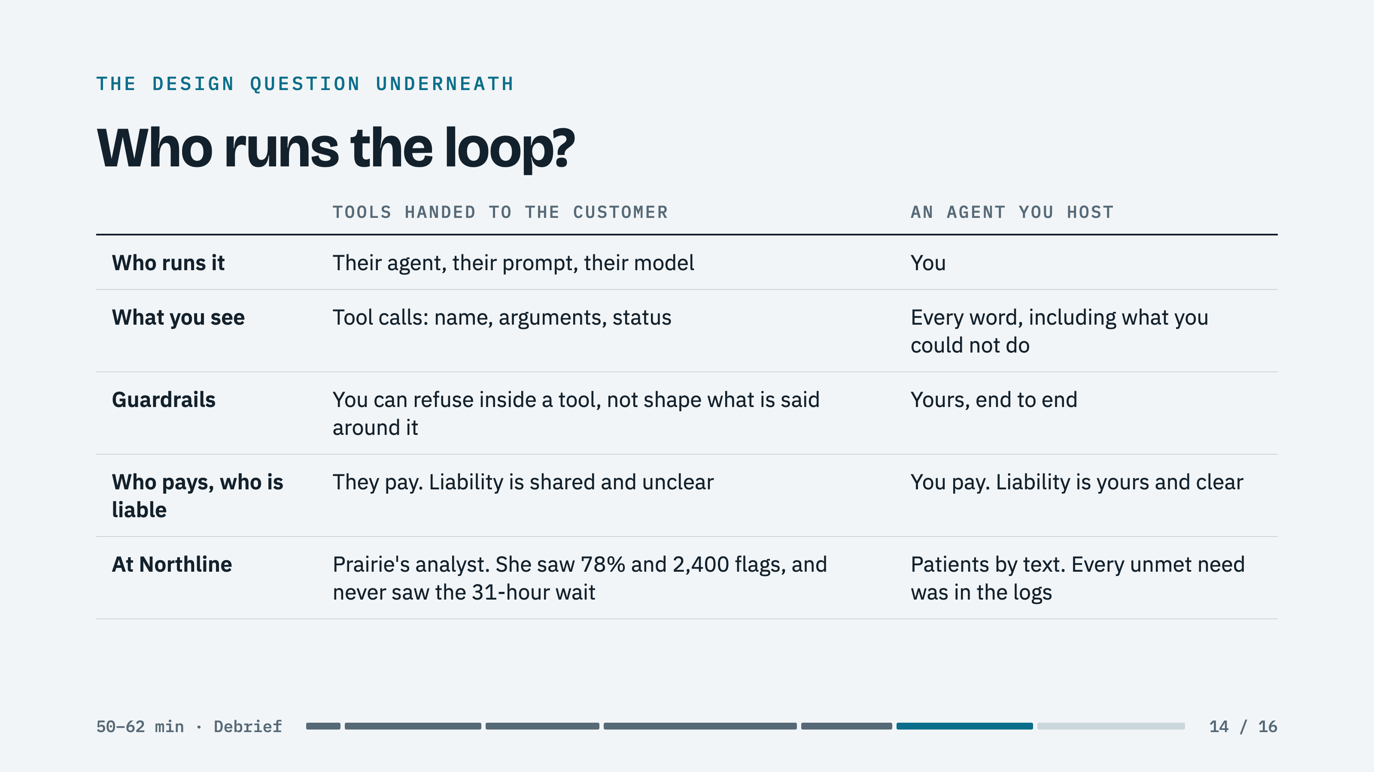
Slide 14. The design question underneath. Most companies will do both; the point is to know what you stop seeing when the customer runs the loop.
The session closes by going around the room with one question: where is this bottleneck hiding in your market? When your AI works, whose queue grows, and who is watching that number this week?
Try it yourself
1. Install the Claude desktop app and sign in. Claude Code is the Code tab inside it.
2. Click New project, create a new empty folder, and name it northline.
3. Paste: Download github.com/anthonymorrisjohnson/northline-course as a ZIP, unzip it so the files sit directly in this folder, then delete the zip.
4. Close the project and open it again, then type /northline-setup and wait for READY.
5. Type /pm-run, then /deploy triage. To see the check-in page and the dashboard, ask Claude Code to start the Northline server.
Everything is at github.com/anthonymorrisjohnson/northline-course. Take-home skills build the same two front doors and the same loop for your own company: /new-experience, /brief, /tools, and /agent, plus three practice cases.
Northline Care, Prairie Health Plan, and all figures are fictional composites created for teaching. Clinical details are illustrative and should be reviewed by a clinician before use.

