1
To reduce rural-urban migration, the government should
- A. establish commodity boards
- B. provide social infrastructure
- C. establish tractor-hiring units
- D. provide extension services to farmers
WAEC 2022
2
The establishment of cooperative farming is encouraged by governments because it
- A. enables farmers to control soil erosion
- B. facilitates the use of hand tools
- C. enables individual farmers to acquire capital
- D. allows farmers to cultivate small and scattered plots
WAEC 2022
3
A non-governmental organization involved in agricultural development in West Africa is
- A. Operation Feed the Nation
- B. River Basin Development Authority
- C. Agricultural Development Project
- D. International Institute of Tropical Agriculture
WAEC 2022



4
The diagram below illustrates a farm implement. Use it to answer this question.
The illustrated farm implement i used for
- A. pulverizing soil into fine tilth
- B. breaking up soil into clods
- C. gathering top soil
- D. levelling soil surface
WAEC 2022
5
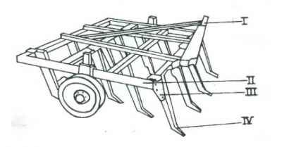
The diagram above illustrates a farm implement. Use it to answer this question.
The part of the illustrated farm implement that enables it to roll over obstacles is labelled
- A. I
- B. II
- C. III
- D. IV

6
The diagram below illustrates a farm implement. Use it to answer this question.
The function of the part labelled II is to
- A. remove soil
- B. turn soil
- C. break clods
- D. cut stumps
WAEC 2022
7
A combine harvester can be used simultaneously to harvest
- A. legumes and apply fertilizer
- B. grains and eradicate weeds
- C. tubers and distribute fertilizer
- D. cereals and winnow grains
WAEC 2022
8
Ranging poles used in farm surveying have characteristic
- A. green and white bands
- B. blue and white bands
- C. red and white bands
- D. black and red bands
WAEC 2022



9
Decomposition of soil organic matter is mainly caused by
- A. bacteria
- B. algae
- C. fungi
- D. nematodes
WAEC 2022
10
The main factors responsible for rock weathering in the desert are high temperature and
- A. animal activity
- B. water
- C. wind
- D. root growth
11
A difference between physical and chemical weathering is that
- A. there is a change in the mineral composition of rock in physical weathering
- B. the mineral composition of rock is changed in chemical weathering.
- C. carbonation is necessary in physical weathering.
- D. wind is necessary in chemical weathering.
WAEC 2022
12
Use the information below to answer this question.
In an experiment on soil porosity, the following results were obtained:
Volume of dry soil = 52cm³
Volume of water= 48cm³
Volume of soil and water=78cm³
Determine the volume of airspace in the soil sample.
- A. 22cm³
- B. 26cm³
- C. 30cm³
- D. 100cm³
WAEC 2022
13
Use the information below to answer this question.
In an experiment on soil porosity, the following results were obtained:
Volume of dry soil = 52cm³
Volume of water= 48cm³
Volume of soil and water=78cm³
Calculate the porosity of the soil sample
- A. 28.21%
- B. 42.31%
- C. 45.83%
- D. 61.54%
WAEC 2022



14
The diagram below illustrates a tool used to analyse a soil sample in an experiment. Use it to answer this question.
The aim of the experiment is to determine the soil
- A. structure
- B. texture
- C. mineral matter
- D. organic matter
WAEC 2022
15
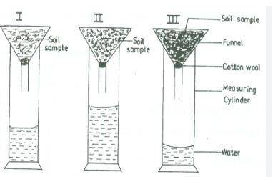
The diagram above illustrates a tool used to analyse a soil sample in an experiment. Use it to answer this question.
The part labelled Ill will contain
- A. clay
- B. silt
- C. coarse sand
- D. fine sand

