1
One-millionth of a second is also referred to as
- A. nanosecond
- B. microsecond
- C. millisecond
- D. picosecond
WAEC 2022
2
Examples of quantitative data type are?
- A. continuous and discrete
- B. local and foreign
- C. nominal and ordinal
- D. primary and secondary
WAEC 2022
3
One difference between data and information is that ?
- A. data is meaningful while information is not meaningful
- B. data are raw facts and figures while information is computed
- C. information is independent of data while data is dependent on information
- D. information is the raw material while data is the end product of information
WAEC 2022



4
The following options are examples of information except?
- A. area of a circle
- B. circumference of a circle
- C. perimeter of a rectangle
- D. plain shape of a rectangle
WAEC 2022
5
Modem computers Compared to earlier computers are ?
- A. less reliable
- B. faster and larger
- C. larger and stronger
- D. faster and smaller
6
What type of computer would be most suitable for a student who lives in a remote village without constant electricity
- A. Desktop computer
- B. Laptop computer
- C. Mainframe computer
- D. Minicomputer
WAEC 2022
7
EDSAC was produced using a concept known as
- A. Circuit switching
- B. Packet routing
- C. Packet switching
- D. Stored program
WAEC 2022
8
The process of running more than one program concurrently is known as
- A. multithreading
- B. multitasking
- C. multiprogramming
- D. multipurpose
WAEC 2022



9
How many binary digits are contained in 10MB of a memory stick?
- A. 10x 1024
- B. 10x 1024 x8
- C. 10 x 1024 x 1024
- D. 10 x 1024 x 1024 x 8
WAEC 2022
10
A student would require the following devices to online application form except?
- A. keyboard
- B. mouse
- C. printer
- D. webcam
11
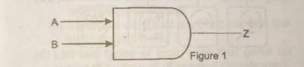
Computer2022/image1.jpeg
use the diagram above to answer questions below
The logic gate in the diagram above is called a
- A. AND gate
- B. NAND gate
- C. NOR gate
- D. OR gate
WAEC 2022
12

Computer2022/image2.jpeg

The logic equation for the logic gate in the figure above is?
- A. Z=A+B
- B. Z=A.B
- C. Z= A+B
- D. Z=A.B.C
WAEC 2022
13
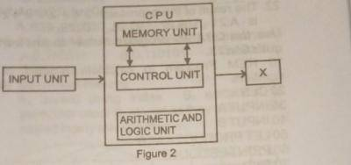
Computer2022/image3.jpeg
The part labelled X in the figure above is called?
- A. auxiliary memory
- B. output unit
- C. secondary memory
- D. storage unit
WAEC 2022



14
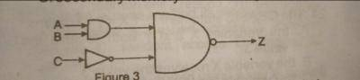
Computer2022/image4.jpeg

The logic equation for the logic-circuit in the diagram above is?
- A. Z=A+B+C
- B. Z=A.B+C
- C. Z=A+B+C
- D. Z=A.B.C
WAEC 2022
15
The program that is loaded into a special area on a microprocessor or ROM on a one-time basis and becomes part of the hardware is called?
- A. firmware
- B. liveware
- C. software
- D. utility
16
Thy following programs are general purpose application software except
- A. corel draw
- B. payroll system
- C. Ms software
- D. MS word
WAEC 2022
17
One similarity between be spoke software and application packages is that they are?
- A. both available off the shelf
- B. highly standardized
- C. both written by computer users
- D. meant to be used by computer end users
WAEC 2022
18
The process of testing the logic of algorithm to ensure they give correct result is known as ?
- A. debbuging
- B. desk checking
- C. flow charting
- D. pseudo coding
WAEC 2022



19
The following instructions are guidelines for drawing flowcharts except that?
- A. flowcharts must have a logical start and finish
- B. it should follow a direction of left to right or top to bottom
- C. it should follow a direction of right to left or bottom to top
- D. it should be clear, neat and easy to follow
WAEC 2022
20
Key skills of a system analyst include the following except
- A. ability to troubleshoot
- B. interest in learning new skills
- C. motivational skills
- D. proficiency in programming languages
21
The result of the expression 2 * 6 + 2/4 * 2 * 4^2
- A. 21
- B. 27
- C. 28
- D. 29
WAEC 2022
22
Use the QBASIC program below to answer question below
10 REM Program to calculate product of numbers
20 CLS
30 INPUT A
40 INPUT B
50 LET PRODUCT=A*B
60 PRINT PRODUCT
70 END

The number 10, 20,30, 40, 50, 60 and 70 as stated in the program indicate
- A. bullet numbering
- B. codes
- C. bullet numbering
- D. line number
WAEC 2022
23
he QBASIC statement LETX=Y-3 means
- A. the variables X and Y both receive the value 3
- B. the variable X receives the value3.
- C. the variable X receives the value of Y less 3
- D. an error message has occured due to type mismatch
WAEC 2022



24
Computer2022/image5.jpeg

The part labelled Y in the compiler interface in the diagram represents
- A. intermediate code
- B. binary code
- C. object code
- D. pseudocode
WAEC 2022
25
The virtual communication platform where many people keep in contact with family and friends is known as
- A. microsoft visio
- B. social engineering
- C. cyberspace
- D. virtual reality
26
The protocol used for email transmission is known as ?
- A. HTTP
- B. DHCP
- C. IP
- D. SMTP
WAEC 2022
27
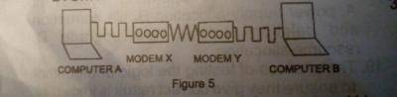
Computer2022/image5.jpeg

The signals from Ato modem X in the diagram above are
- A. analogue
- B. digital
- C. electrons
- D. protons
WAEC 2022
28
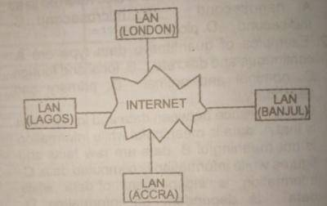

Computer2022/image6.jpeg

what type of network is represented in the diagram above?
- A. local area network
- B. metropolitan area network
- C. personal area network
- D. wide area network
WAEC 2022



29
In the URL https://waec.org.ng, the domain name is?
- A. waec.org.ng
- B. http://www.
- C. //www/.waec.
- D. org.ng.
WAEC 2022
30
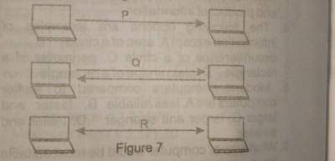
Computer2022/image7.jpeg

The type of transmission in the part labelled q in the diagram above is called
- A. broadcast
- B. full duplex
- C. half duplex
- D. simplex
31
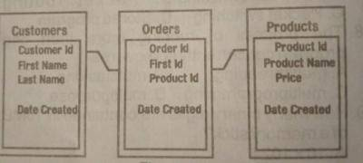
Computer2022/image8.jpeg
The number of entries in the diagram above is
- A. 3
- B. 4
- C. 5
- D. 12
WAEC 2022
32
The maximum length of a text field in MS Access is?
- A. 75
- B. 120
- C. 255
- D. 265
WAEC 2022
33
One function of operating system is ?
- A. power supply allocation
- B. file corruption and deletion
- C. flowcharting
- D. resource allocation
WAEC 2022



34
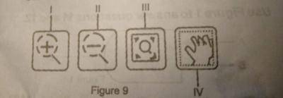
Computer2022/image9.jpeg

The shortcut key for the open dialog box in MS Word is ?
- A. Alt + F12
- B. Ctrl + F12
- C. F12
- D. shift + f12
WAEC 2022
35

Computer2022/image10.jpeg

The part of the Corel Draw window labelled II in the diagram above is called?
- A. zoom in
- B. pan
- C. zoom out
- D. zoom to fit
36
Which of the following operations will not run a slide show in MS PowerPoint?
- A. pressing F5
- B. pressing shift +f5
- C. choosing the slide show tab
- D. clicking on the slide show icon bar
WAEC 2022
37
What will be the result of writing the formula=year[now[][ + 3 in a worksheet,of a spread sheet,if the current calendar is 14 august ,1960?
- A. 17 august 196003
- B. 14 aug,1963
- C. 11 august,1963
- D. 1963
WAEC 2022
38
If A is in cell A1 and B is in Cell B1 of a worksheet in a spreadsheet application,write a formula to calculate
x= A2=B1/2100
- A. ((A1^2)+(B1^(1/2)))/100
- B. ((A1^2)+(B1^(1/2)))/100
- C. ((A1^2+(B1^(1/2))/100
- D. ((A1^2)+(B1^(1/2)))/100
WAEC 2022



39
The pictorial representation of an object or application in the computer is called?
- A. diagram
- B. graphic
- C. Icon
- D. image
WAEC 2022
40
Deleted items in the computers are temporarily stored in the?
- A. memory unit
- B. processor
- C. recycle bin
- D. task manager
41
The keyboard key combination ALT + F4 in microsoft windows will
- A. close active programmes
- B. open a file
- C. restart the computer
- D. Select two stages of booting from the following list
WAEC 2022
42
Select two stages of booting from the following list:
i. Power on Self Test;
ii. Loading of Operating System;
iii. Loading of e-mails;
iv. Start in safe mode.
iv. Save all active files
- A. I and II only
- B. I and III only
- C. II and IV only
- D. III and IV only
WAEC 2022
43
In number system ,base 16 is called ?
- A. hexadecimal
- B. decimal
- C. duodecimal
- D. octal
WAEC 2022



44
Add 12716
to 50A16
- A. 62916
• • B. 63016
• • C. 63116
• • D. 63216

WAEC 2022
45
The octal fraction 0.65 converts to binary as
- A. 0.110011
- B. 0.110101
- C. 101101
- D. 101101
46
Sequential files are?
- A. sorted using index
- B. sorted in a particular order
- C. stored as they come
- D. stored in any storage media
WAEC 2022
47
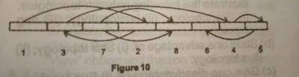
Computer2022/image11.jpeg
The file access method illustrated in the diagram above is called?
- A. hashed access
- B. indexed access
- C. random access
- D. sequential access
WAEC 2022
48
Serial files are
- A. stored using a key
- B. sorted in a particular order
- C. stored as they come
- D. stored in any storage media
WAEC 2022



49
Duplicating copyrighted electronic or digital content without the authors approval is considered?
- A. felonious
- B. ethical
- C. treasonable
- D. unethical
WAEC 2022
50
Ethical practice requires a computer user to
- A. shutdown properly
- B. hack into other peoples computer
- C. intrude into peoples privacy
- D. copy software without the license

