1
correct 0.007985 to three significant figures.
- A. 0.0109
- B. 0.0800
- C. 0.00799
- D. 0.008
WAEC 2021
2
Simplify: (11\(_{two}\))\(^2\)
- A. 1001\(_2\)
- B. 1101\(_2\)
- C. 101\(_2\)
- D. 10001\(_2\)
WAEC 2021
3
Solve: 2\(^{\sqrt{2x + 1}}\) = 32
- A. 13
- B. 24
- C. 12
- D. 11
WAEC 2021



4
If log\(_{10}\) 2 = m and log\(_{10}\) 3 = n, find log\(_{10}\) 24 in terms of m and n.
- A. 3m + n
- B. m + 3n
- C. 4mn
- D. 3mn
WAEC 2021
5
Find the 5th term of the sequence 2,5,10,17....?
- A. 22
- B. 24
- C. 36
- D. 26

6
if p = {-3<x<1} and Q = {-1<x<3}, where x is a real number, find P n Q.
- A. 0
- B. -3, -2, -1, 0 and 1
- C. -2, -1 and 0
- D. -1, 0 and 1
WAEC 2021
7
Factorize 6pq-3rs-3ps+6qr
- A. 3(r -p)(2q + s)
- B. 3(p + r)( 2q - 2q - s)
- C. 3(2q - s)(p + r)
- D. 3(r - p)(s - 2q)
WAEC 2021
8
What number should be subtracted from the sum of 2 16
and 2712 to give 314
?
- A. 13
• • B. 112
• • C. 116
• • D. 12

WAEC 2021



9
Mensah is 5 years old and joyce is thrice as old as mensah. In how many years will joyce be twice as old as Mensah?
- A. 3 years
- B. 10 years
- C. 5 years
- D. 15 years
WAEC 2021
10
If 16 * 2(x+1)
= 4x * 8(1−x)
, find the value of x.
- A. -4
- B. 4
- C. 1
- D. -1
11
The circumference of a circular track is 9km. A cyclist rides round it a number of times and stops after covering a distance of 302km. How far is the cyclist from the starting point?
- A. 5km
- B. 6km
- C. 7km
- D. 3km
WAEC 2021
12
Simplify 2√7- 14√7+7√21
- A. √2121
• • B. 7√2121
• • C. √213

- D. 3√21
WAEC 2021
13
If 4x+2y=16 and 6x-2y=4 , find the value of (y-x).
- A. 8
- B. 2
- C. 4
- D. 6
WAEC 2021



14
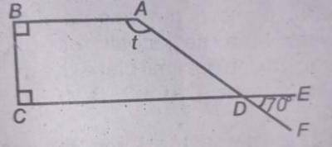
In the diagram, ∠ABC and ∠BCD are right angles, ∠BAD = t and ∠EDF = 70°. Find the value of t.
- A. 70°
- B. 165°
- C. 140°
- D. 110°
WAEC 2021
15
The sum of the interior angles of a regular polygon with k sides is (3k-10) right angles. Find the size of the exterior angle?
- A. 60°
- B. 40°
- C. 90°
- D. 120°
WAEC 2021
16
make u the subject in x =2u−33u+2
- A. u = 2x+33x−2
• • B. u = 2x−33x−2
• • C. u = 2x+32−3x
• • D. u = 2x+33x+2

WAEC 2021
17
A trader paid import duty of 38 kobo in the naira on the cost of an engine. If a total of #22,800.00 was paid as import duty, calculate the cost of the engine.
- A. #60,000.00
- B. #120,000.00
- C. #24,000.00
- D. #18,000.00
WAEC 2021
18
The height of an equilateral triangle of side is 10 3√ cm. calculate its perimeter.
- A. 20cm
- B. 60cm
- C. 40cm
- D. 30cm
WAEC 2021



19
In △LMN, |LM| = 6cm, ∠LNM = x and sin x = sin x = 35
.
Find the area of △LMN
- A. 60cm2
• • B. 48cm2
• • C. 24cm2
• • D. 30cm2

WAEC 2021
20
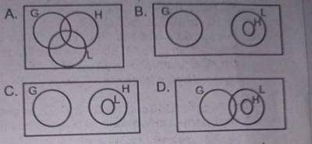
consider the statements:
P = All students offering Literature(L) also offer History(H);
Q = Students offering History(H) do not offer Geography(G).
Which of the Venn diagram correctly illustrate the two statements?
- A. A
- B. B
- C. C
- D. D
21
Find The quadratic Equation Whose Roots Are -2q And 5q.
- A. 3x2
+ 3qx - 10q2
• • B. x2 + 3qx + 10q2
• • C. x2 - 3qx + 10q2
• • D. x2 - 3qx - 10q2

WAEC 2021
22
if tanθ = frac34
, 180° < θ < 270°, find the value of cosθ.
- A. 45
• • B. 35
• • C. -45
• • D. -35

WAEC 2021
23
If 2x−3
- 3x−2 = p(x−3)(x−2)
, find p.
- A. 5 - x
- B. - (x + 5)
- C. 13 - x
- D. - (5x - 13)
WAEC 2021



24
The diagonal of a rhombus are 12cm and 5cm. calculate its perimeter
- A. 26cm
- B. 24cm
- C. 17cm
- D. 34cm
WAEC 2021
25
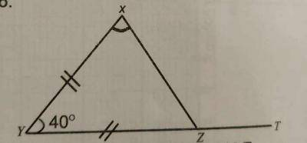
In the diagram, △XYZ is produced to T. if |XY| = |ZY| and ∠XYT = 40°, find ∠XZT
- A. 110°
- B. 130°
- C. 140°
- D. 180°
WAEC 2021
26
A solid brass cube is melted and recast as a solid cone of height h and base radius r. If the height of the cube is h, find r in terms of h.
- A. r = h
- B. r = √3h2π
• • C. r = πh
• D. r = h √3h

WAEC 2021
27
Which of the following is not an exterior angle of a regular polygon?
- A. 66°
- B. 72°
- C. 24°
- D. 15°
WAEC 2021
28
From a point T, a man moves 12km due west and then moves 12km due south to another point Q. Calculate the bearing of T from Q.
- A. 225°
- B. 315°
- C. 045°
- D. 135°
WAEC 2021



29
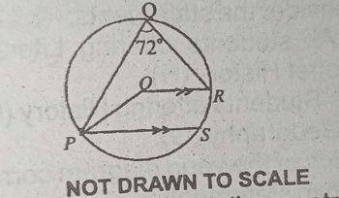
In the diagram, O is the centre of the circle PQRS, ∠PQR = 72° and OR is parallel to PS. Find ∠ OPS.
- A. 18°
- B. 108°
- C. 54°
- D. 36°
WAEC 2021
30
A trapezium of parellel sides 10cm and 21cm and height 8cm is inscribed in a circle of radius 7cm. calculate the area of the region not covered by the trapezium.
π =227

- A. 84cm2
• • B. 80cm2
• • C. 30cm2
• • D. 94cm2

WAEC 2021

31
Find, correct to two decimal, the mean of 112
, 223, 334, 445, and 556
.
- A. 3.71
- B. 3.70
- C. 3.69
- D. 3.72
WAEC 2021
32
A cyclist moved at a speed of Xkm/h for 2 hours. He then increased his speed by 2 km/h for the next 3 hours.
If the total distance covered is 36 km, calculate his initials speed.
- A. 12km/h
- B. 3km/h
- C. 4km/h
- D. 6km/h
WAEC 2021
33
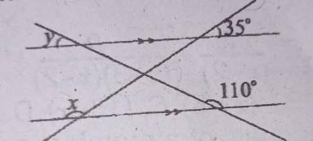
find the value of (x+y)
- A. 215°
- B. 70°
- C. 135°
- D. 145°
WAEC 2021



34
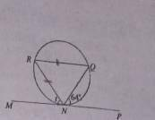
In the diagram, MP¯¯¯¯¯¯¯¯¯
is a tangent to the circle NQR, ∠NQR, ∠PNQ = 64 and | RQ¯¯¯¯¯¯¯¯ | = | RN¯¯¯¯¯¯¯¯
|. Find the angle market t.
- A. 130°
- B. 115°
- C. 58°
- D. 68°
WAEC 2021
35
find the first quartile of 7,8,7,9,11,8,7,9,6 and 8.
- A. 8.5
- B. 7.0
- C. 7.5
- D. 8.0

36
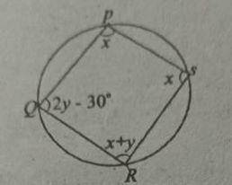
In the diagram, PQRS is a circle. find the value of x.
- A. 50°
- B. 30°
- C. 80°
- D. 100°
WAEC 2021
37
A cone has a base radius of 8cm and height 11cm. calculate , correct to 2d.p, the curved surface area
- A. 341.98cm2
• • B. 276.57cm2
• • C. 201.14cm2
• • D. 477.71cm2

WAEC 2021
38
Given that sin x = 35
, 0 ≤ x ≤ 90, evaluate (tan x + 2cosx)

- A. 21120
• • B. 2720
• • C. 1120
• • D. 120

WAEC 2021



39
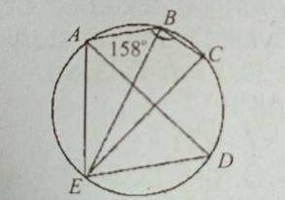
In the diagram, line EC¯¯¯¯¯¯¯¯
is a diameter of the circle ABCDE.
If angle ABC equals 158°, find ∠ADE
- A. 112
- B. 90
- C. 68
- D. 22
WAEC 2021
40
Height(cm) | 160 | 161 | 162 | 163 | 164 | 165
No. of players | 4 | 6 | 3 | 7 | 8 | 9
the table shows the height of 37 players of a basketball team calculates correct to one decimal place the mean height of the players.
- A. 163.0
- B. 162.0
- C. 160.0
- D. 165.0
WAEC 2021

41
XY¯¯¯¯¯¯¯¯
is a line segments with the coordinates X (- 8,- 12) and Y(p,q). if the midpoint of XY¯¯¯¯¯¯¯¯
is (-4,-2) find the coordinates of Y.
- A. (-6,-2)
- B. (0,8)
- C. (4,10)
- D. (0,4)
WAEC 2021
42
500 tickets were sold for a concert tickets for adults and children were sold at $4.50 and $3.00 respectively if the total receipts for the concerts was $1987.50 how many tickets for adults were sold?
- A. 325
- B. 235
- C. 175
- D. 400
WAEC 2021
43
The distance d between two villages east more than 18 KM but not more than 23KM.
which of these inequalities represents the statements?
- A. 18 ≤ d ≤ 23
- B. 18 < d < 23
- C. 18 ≤ d < 23
- D. 18 < d ≤ 23
WAEC 2021



44
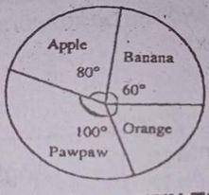
The pie chart represents the distribution of fruits on display in the shop if there are 60 apples on display how many oranges are there?
- A. 80
- B. 270
- C. 120
- D. 90
WAEC 2021
45
A box contains 40 identical balls of which 10 are red and 12 are blue. if a ball is selected at random from the box what is the probability that it is neither red nor blue?
- A. 920
• • B. 310
• • C. 14
• • D. 1120
46
A fair die is tossed twice what is the probability of get a sum of at least 10.
- A. 536
• • B. 23
• • C. 518
• • D. 16

WAEC 2021
47
A man will be (x+10)years old in 8years time. If 2years ago he was 63 years., find the value of x
- A. 55
- B. 63
- C. 57
- D. 67
WAEC 2021
48
The equation of a line is given as 3 x - 5y = 7. Find its gradient (slope)

- A. 53
• .
• B. 35
• .
• C. −35
• .
• D. −53
- .
WAEC 2021



49
For what value of x is 4−2xx+1
undefined.
- A. 2
- B. -1
- C. 1
- D. -2
WAEC 2021
Mr. Sarfo borrowed $25,000 from Afiak Financial Services at 21% simple interest per annum for 3 years. If he repaid the loan in two equal yearly installments, how much did he pay each year?
A) $18,500
B) $20,375
C) $21,000
D) $22,500

