Blunt trauma resulting in bilateral page kidney

Search terms “page kidney” AND “trauma”

Pubmed March 21, 2023, with 55 results

Embase and JBI EBP Database with 64 results

Total 119 included.

86 abstracts after removal of duplicates

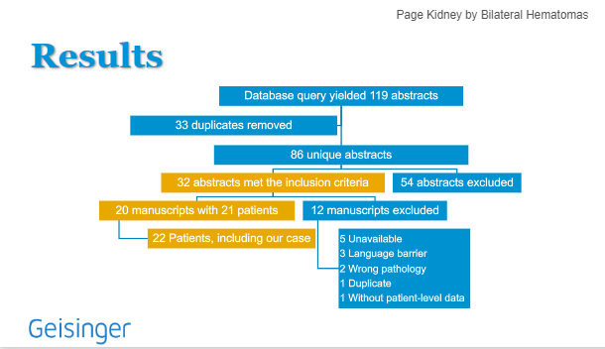

CASE DETAILS

MRN: 9019283

1/27/23

54 yo M L2 trauma MVC, 35mph, unrestrained, +airbags

Bilateral renal hematoma

R 9-12 rib fx

5cm lac repaired on L parietal scalp

Worsening renal function on hospital day 4, hgb drop

CTA with worsening perinephric hematomas

2/1/23 ex lap and evacuation of hematoma zone 2, 4 laps left in, 2 in RP L & R

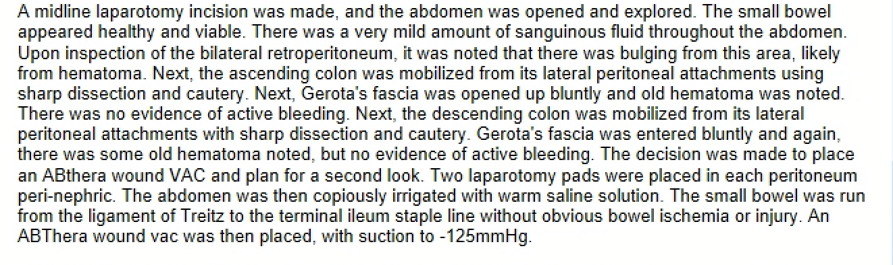

Upgraded to ICU postoperatively.

2/3/23 re opening of previous ex lap, abd washout, and closure

